Sử dụng từ chỉ quá khứ.
Went
Had
Took
Came

The man look handsome in his bright smile

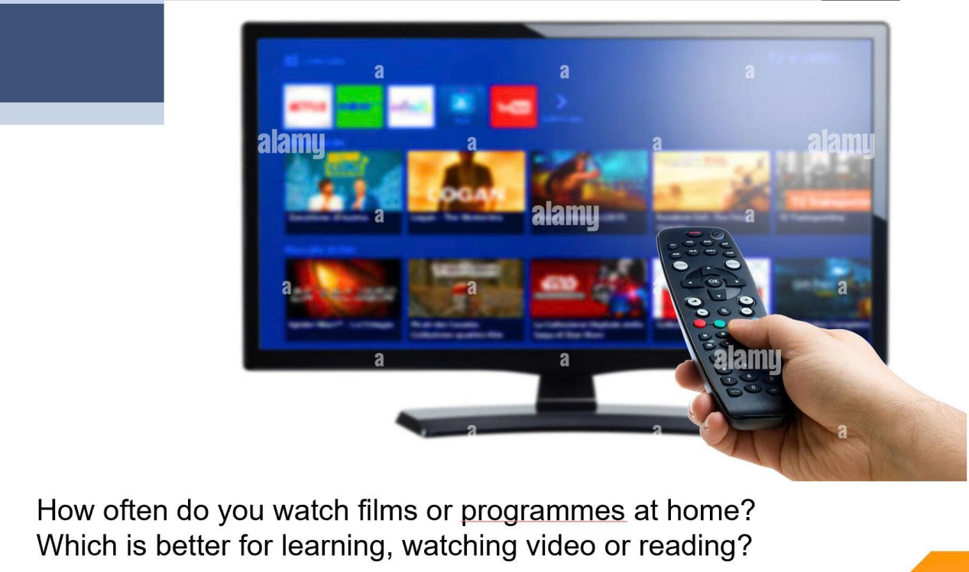

Televison,
screen with many film options,
The arm in the photo is male.
man holding remote control,
choose film, I think living room

easy to understand, interesting, not bored

Dear ….,
I’m writing to express my feeling and suggestion about the notification that I have just received from the club.
I feel [over the moon, excited, disappointed] when I heard that [summarize the situation].
Firstly, it may be beneficial to + Vo. Secondly,………….(suggestion)
Thank you for considering my input. I hope these suggestions and insights are helpful. Please feel free to reach out if further clarification is needed.
Best regards/ Yours sincerely,

Both picture show…., but they are in different contexts.
The firs picture on the left describes [first different], whereas the second picture on the right depicts [first different]
Besides, while people in the first picture

nutritional imbalance

