Practise 1: Environment Setup

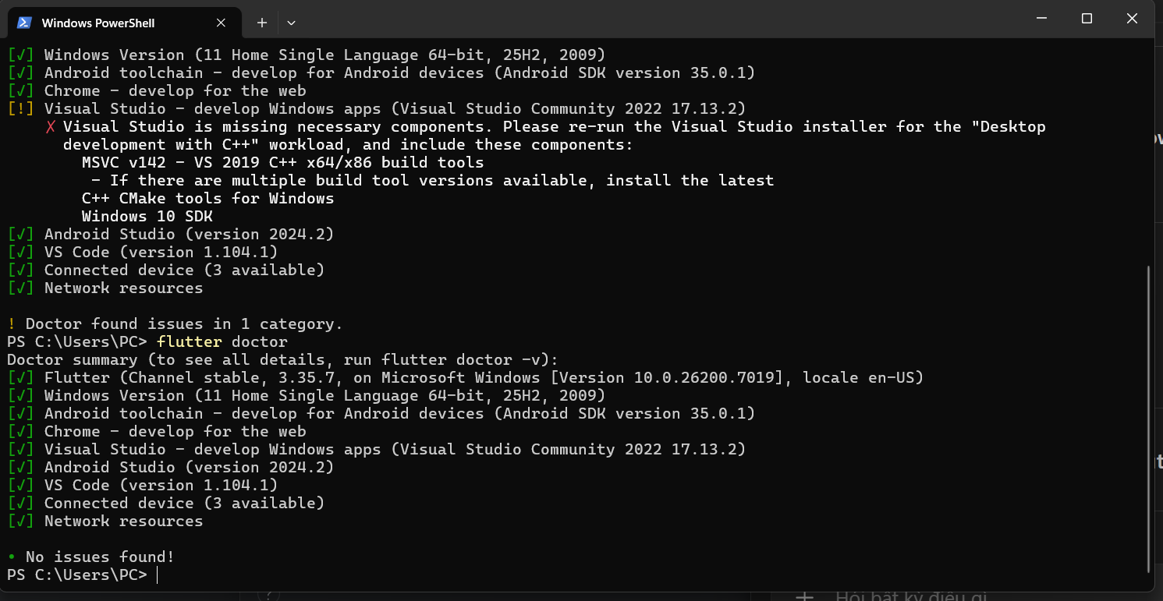

Practise 2: Create Your First Flutter Project (By Terminal)

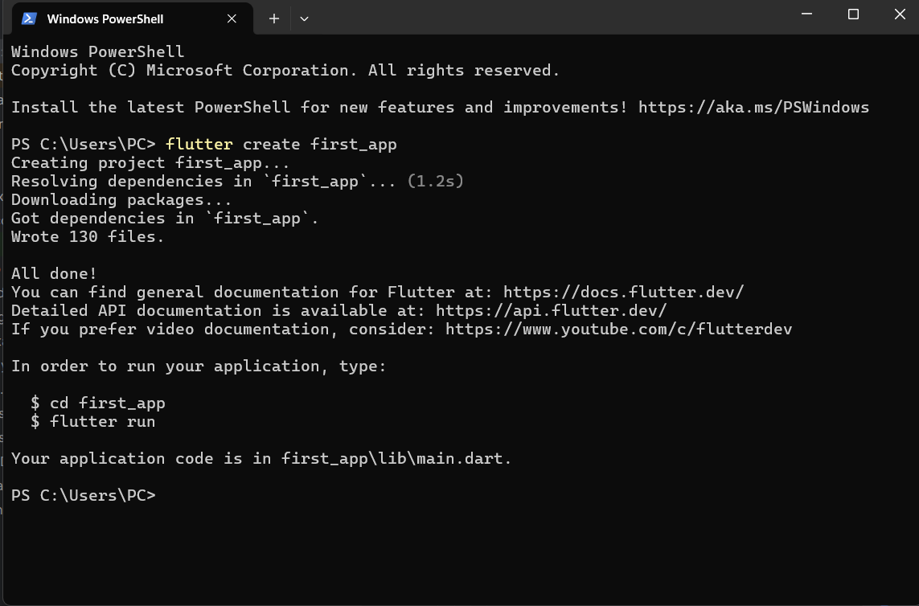

Practise 2: Create Your First Flutter Project (By Terminal)

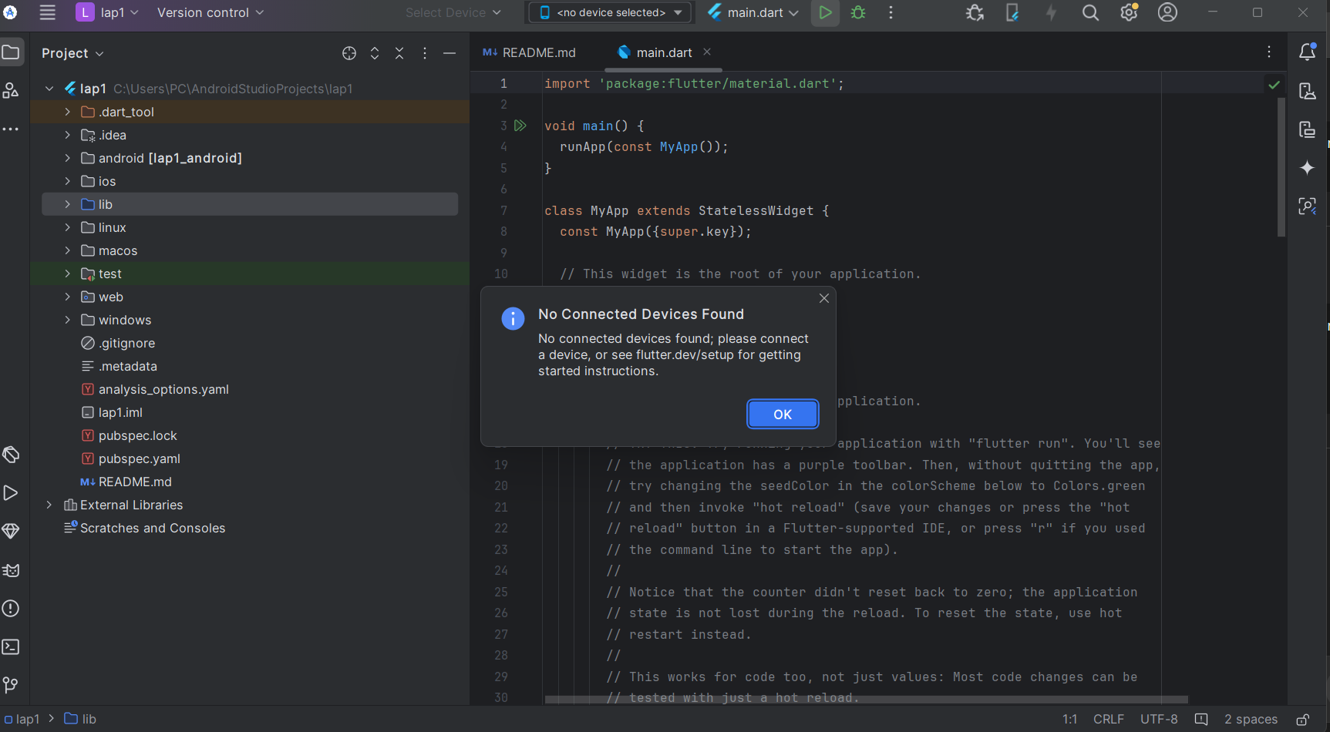
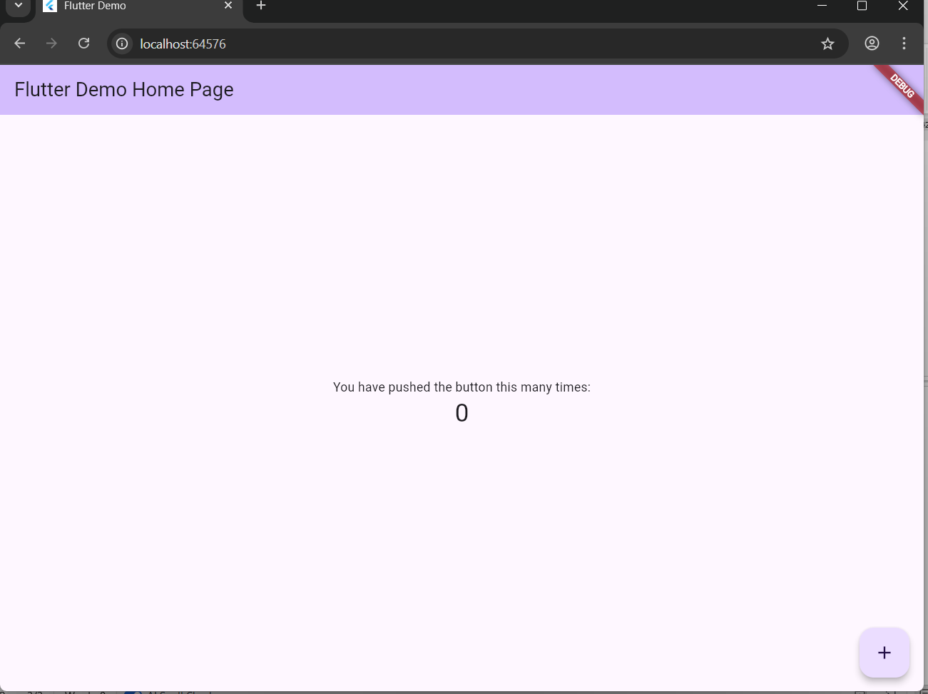

Practise 4: Modify the Default UI

