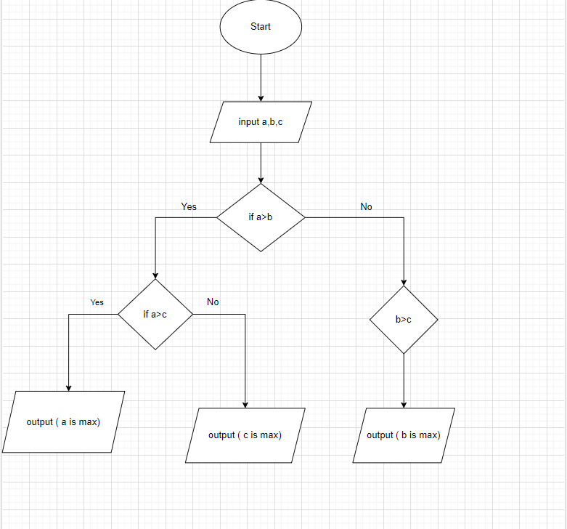Pseudo-code

Start

Input a,b,c

If a>b then

1. C

a is max

Else

c is max

Endif.

If b>a then

1. C

b is max

Endif.

End.