Box Office Revenue Prediction

Project Final Report

Nhan Nguyen  
 Computer Science  
 University of Colorado Boulder  
 Colorado United States  
 Nhan.N.Nguyen@colorado.edu

Melissa Pollich  
 Computer Science  
 University of Colorado Boulder  
 Colorado United States  
 Melissa.Pollich@colorado.edu

Benjamin Breyfogle  
 Computer Science  
 University of Colorado Boulder  
 Colorado United States  
Benjamin.Breyfogle@colorado.edu

ABSTRACT

In this paper, we want to see how various elements of a movie contribute to its revenue in box office, which are divided in to external (vote, popularity…) and internal factors (budget, languages…). These factors are quantified by online data sources from Kaggle so some attributes are available partially or unavailable. A lot of cleaning and processing had been done, as well as the removal of some unnecessary attributes before the data can be used to analyze and predict revenue. We use both numerical and categorical attributes of the dataset to establish linear, random forest and decision tree regression. The predicted values are not close to the reported data values as we had hoped to achieve, but they are not too far off from the actual data. Furthermore, the predicted values are consistent between three regression model, which indicate that adding textual data like plot summary, movie name could help improve the result. Knowing about the interactions outside the data like the amount of likes for each trailer, the popularity of actors- directors and better technique like Deep Neural Network could help make the prediction more accurate.

INTRODUCTION

As of 2018, it has been reported that the global box office is worth approximately $41.7 billion. However, when the home entertainment revenue is included, the global film industry is worth over three times that at roughly $136 billion. Despite massive profits, movie industry is one of the riskiest markets for investors due to its uncertainty and unpredictability. Once a movie fails to meet expectation, it can potentially place a stress on the financial status of the movie studio, and lead to the withdrawal of funds from the investors. Therefore, through analyzing the performance of movies on the market, we could find the correlation between attributes of a movie and predict the revenue upon the release.

∗Article Title Footnote needs to be captured as Title Note

†Author Footnote to be captured as Author Note

Permission to make digital or hard copies of part or all of this work for personal or classroom use is granted without fee provided that copies are not made or distributed for profit or commercial advantage and that copies bear this notice and the full citation on the first page. Copyrights for third-party components of this work must be honored. For all other uses, contact the owner/author(s).

*WOODSTOCK’18, June, 2018, El Paso, Texas USA*

© 2018 Copyright held by the owner/author(s). 978-1-4503-0000-0/18/06...$15.00

https://doi.org/10.1145/1234567890

CCS CONCEPTS

• **Computing methodologies** → Retrieval model and ranking

KEYWORDS

Revenue, box office, profitability, variables, data, regression

ACM Reference format:

N. Nguyen, M. Pollich and B. Breyfogle. 2018. Box Office Revenue Prediction : Project Proposal Paper. In *Proceedings of ACM Woodstock conference (WOODSTOCK’18). ACM, New York, NY, USA, 2 pages.* https://doi.org/10.1145/1234567890

RELATED WORK

Galvão, M. and Henriques, R. (2018). Forecasting Movie Box Office Profitability. Journal of Information Systems Engineering & Management, 3(3), 22. <https://doi.org/10.20897/jisem/2658>

The revenue of a movie can be predicted by constructing a predictive model based on regression, decision trees or neural networks. The paper proposed 3 different variables to use: an interval variable for the value of profitability of individual movies, a categorical variable with multiple classes of profitability values, and a binary variable that shows whether the movie is profitable or not. Using these three variables can increase the accuracy of the prediction and help answer how the market behaves, what appeal to the audiences and the risk associated with movies production.

**MAIN TECHNIQUES USED**

Overall, our proposed methodology has three components: Data Collection, Data Cleaning, Data Analysis and Prediction. Cleaning the dataset and discarding the irrelevant data from the datasets as well as thorough analysis of the data within these sets. We compare the attributes that are provided across all of the datasets and build a database that encompasses only the attributes that we care about.

1. **Data Collection**

We looked through the three different datasets that all contain different attributes for all the movies that were produced within the last decade or so. Within these selected datasets, some common attributes included: ratings (IMDB), title, actors, actresses, studio, and release date. Then, we explored in more detail which attributes we wanted to focus on within the datasets and used them for our analysis.

The Movies Dataset was chosen since it contained most of the attributes that we were looking for. We chose not to collect data from the IMDB dataset due to multiple reviews expressing difficulty with the formatting of the data set.

The Box Office Mojo Dataset was originally chosen because the data within the dataset was the most up-to-date data that we could find. While it did not contain many attributes that would be relevant for making our prediction model even more accurate, we nonetheless chose to include it in our new dataset. Lastly, the attributes that we included from the dataset were: Title, Studio, Lifetime Gross, and Year.

The last dataset that we looked at was the MovieLens Dataset. While many previous projects used it and found the data to help with their analysis and prediction model, we ultimately decided that the attributes within the set would either: be duplicates from the other two datasets, or be irrelevant/useful for our analysis.

Once the datasets and the attributes were selected, we combined the data to create a metadata file called the ‘movies_metadata.csv’.

1. **Data Cleaning**

In order to clean the data from the Movies Dataset and the Box Office Mojo Dataset, we started by constructing a relational database to make finding duplicates and unnecessary attributes easier. With this database we were able to write various queries in order to narrow down relevant information. Many attributes were dropped such as: collection, homepage, original title, and rank. These attributes were dropped since we did not need them for our predictive model in order to accurately predict movie revenues.

Moreover, some of the numerical attributes like budget and popularity were formatted in string and contains 0 values so they need to be reformatted to float or removed. Some categorical attributes were also converted to numerical values for consistency in the dataset, though using them as textual data could have preserved interrelations and make the prediction better.

1. **Data Analysis and Prediction**

After the data was cleaned and organized efficiently and too our liking, we analyzed it in order to discover distinguishing patterns and/or trends in the data. As proven to be effective in the surveyed literature, our prediction model was based on three regression models and had some moderate success in predicting the revenue.

DATASETS

* Box Office Mojo Alltime Domestic Data

The data contains 16223 unique values of the lifetime gross, ranking, title, studio and production year of Hollywood movies. They were scrapped from BoxofficeMojo’s listing and based on domestic gross.

<https://www.kaggle.com/eliasdabbas/boxofficemojo-alltime-domestic-data/version/3>

* The Movies Dataset

This dataset contains files containing metadata for all 45,000 movies listed in the Full MovieLens Dataset. The dataset consists of movies released on or before July 2017. Data points include cast, crew, plot keywords, budget, revenue, posters, release dates, languages, production companies, countries, TMDB vote counts and vote averages. This dataset also has files containing 26 million ratings from 270,000 users for all 45,000 movies. Ratings are on a scale of 1-5 and have been obtained from the official GroupLens website.

<https://www.kaggle.com/rounakbanik/the-movies-dataset/downloads/the-movies-dataset.zip/7>

* MovieLens Dataset

This dataset contains six files: genome-scores.csv, genome-tags.csv, links.csv, movies.csv, ratings.csv and tags.csv and describes 5-star rating and free-text tagging activity from MovieLens, a movie recommendation service. It contains 20000263 ratings and 465564 tag applications across 27278 movies. These datasets were created by 138493 users between January 09, 1995 and March 31, 2015 and was generated on October 17, 2016. Users were selected at random for inclusion. All selected users had rated at least 20 movies. No demographic information is included. Each user is represented by an id, and no other information is provided.

<https://grouplens.org/datasets/movielens/20m/>

MAIN TECHNIQUES APPLIED

* Overall, the techniques that we used throughout the project included:
* Data cleaning to make a new, better dataset for analysis.
* Data processing to remove unwanted attributes, missing data values, and duplicates.
* Mapping of budget to vote count, which were the two most strongly correlated attributes.
* Training set and testing data set for analysis. This allowed us to determine our models’ accuracies and inaccuracies.
* Different factors were evaluated to see their contributions on movie revenue at the box office
* Additionally, most of the attributes that we used in the project were adopted from previous studies that have found especially useful and relevant. We considered not only the most relevant studies with a higher success rate (popularity, actor, director, budget, nominations, genre), but also other attributes that are not as commonly considered (vote average, runtime, spoken language). Some of the attributes that we had found to be used across all studies included:
* Budget

Previous studies have shown that the budget of a movie is strongly correlated with the predictability of its popularity and reception. However, while some argue that big budgets represent better quality and positive reviews from both the audience and movie critics, the studies have shown that a big budget does not ensure a high revenue. Despite this finding, this attribute proved valuable in our analysis and design of the prediction model.

* Genre

While many authors and critics state through their studies that action movies and thrillers are the most significant and popular among audiences, the evaluation of each genre and its correlation to the film’s overall success can ultimately help weed out variables that are not relevant.

* Premier Date

The movies premiere date is a variable that influences box office revenue. This is due to the fact that movie attendance, overall, tends to increase significantly on holidays or festive seasons.

OTHER TOOLS USED

The tools that we used throughout the project included:

* + Jupyter Notebooks – used as the environment in which all of our code including data cleaning, data analysis, regression, and developing the predictive model was written and executed

Within Jupyter Notebooks, we used the following libraries:

* + - Pandas
    - Dataframe
    - Numpy
    - Sklearn
    - Seaborn
  + Python – the language that we used to code and execute he tasks listed above
  + Github – used to store all of our progress throughout the project including things such as: milestones, project deliverables, code, datasets, etc.
  + Discord – used as our main source of communication within the group
  + Slack – used as a secondary source of communication throughout the project

VISUALIZATION

The movies dataset (more specifically, movies_metadata.csv) was chosen because in contains the necessary attributes like genres, budget, vote count, vote average, popularity… and revenue.

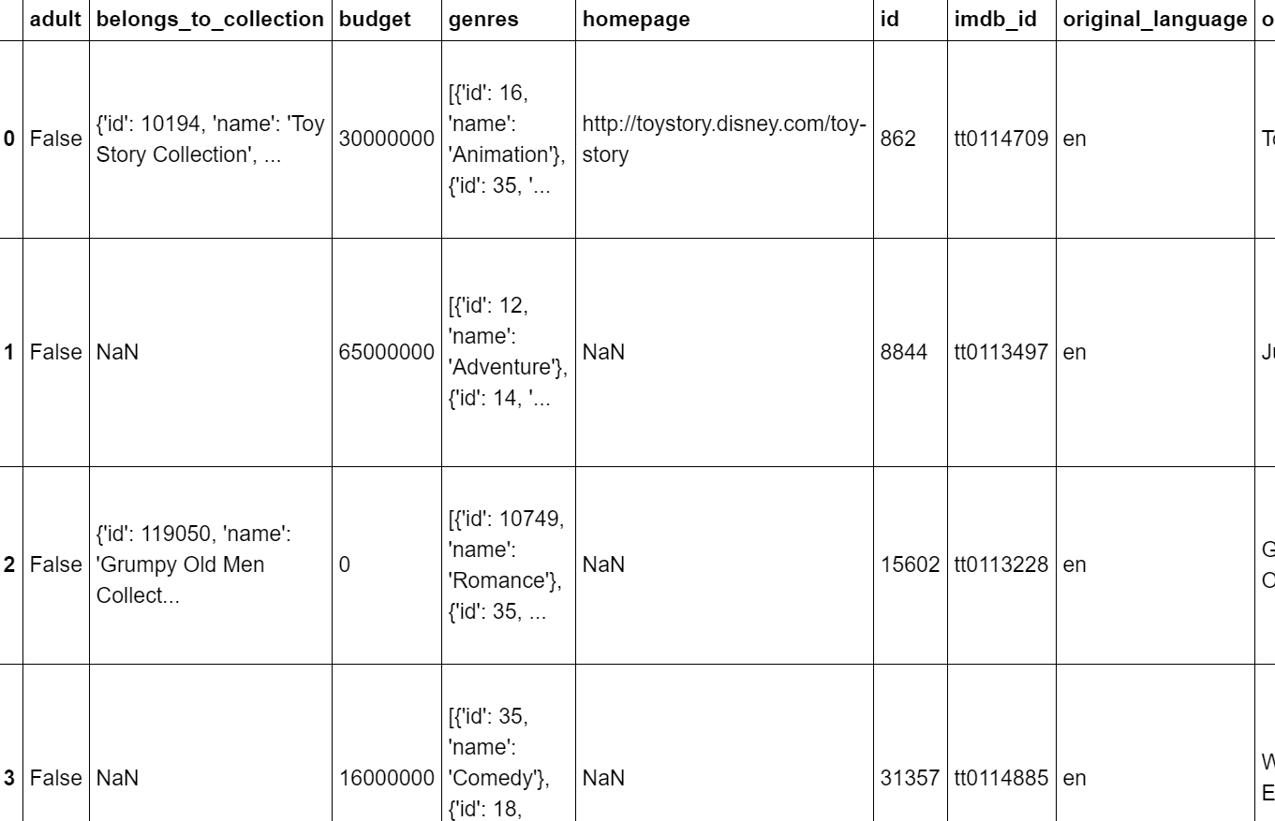

There were a lot of empty data in the original list (NaN value), and the values in budget and popularity was classified as string type instead of int and float type. Also, there was some movies with no budget, or no revenue, so they need to be removed as well. Some attributes like collections, homepage, status… are not required so they should also be dropped from the table. Therefore, data cleaning and processing are required, and the new dataset is as followed:

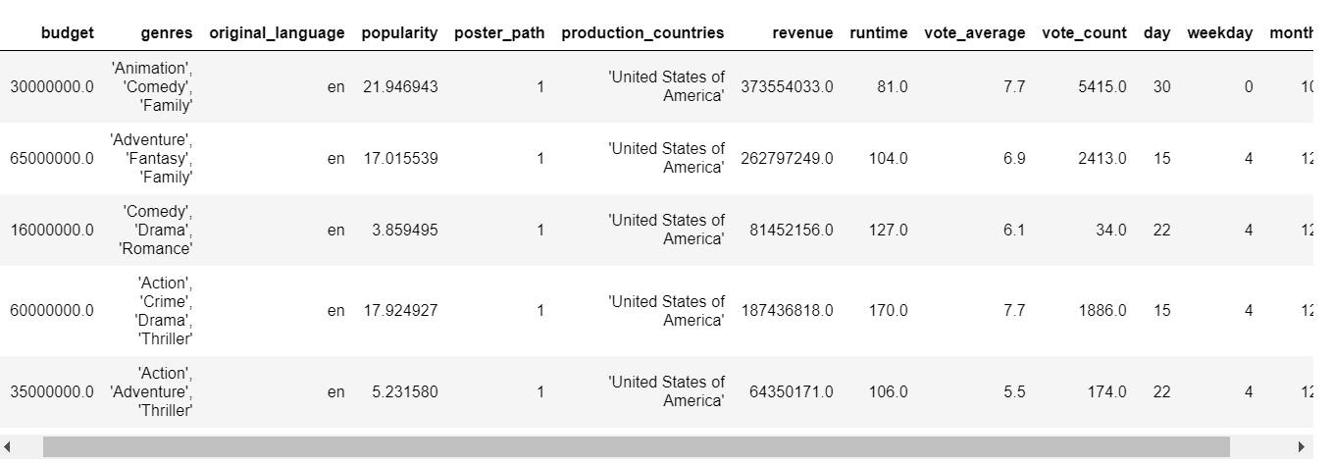

We then look at the relationship between revenue and some of the prominent attributes like budget, popularity, runtime, vote average, vote count. So far, budget and vote count show strong correlation with each other:

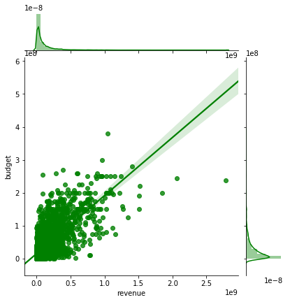

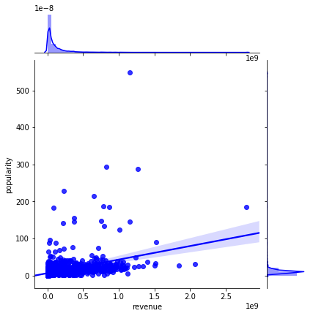

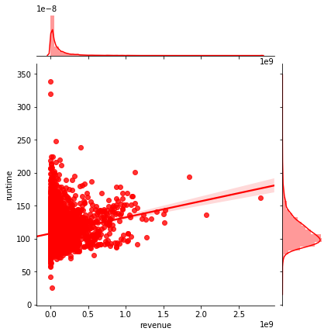

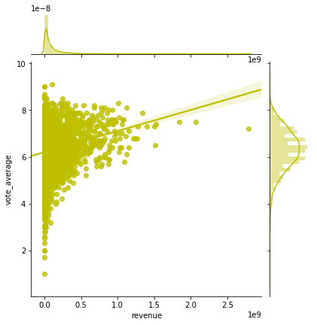

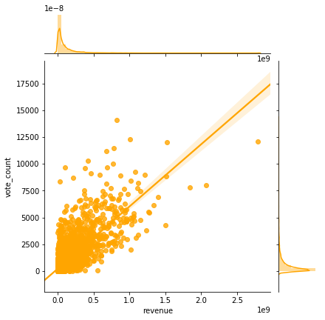

Some of the other attributes were also interesting. For example, most movies that have an average runtime are in English and none of the movies in the list are for adults:

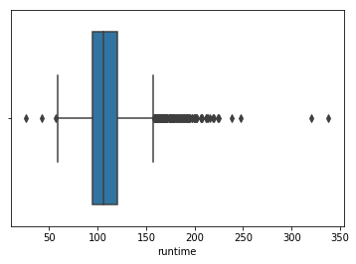

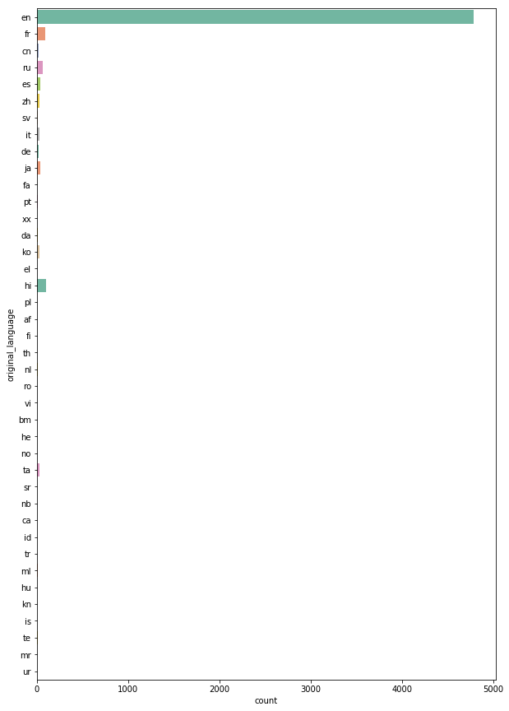

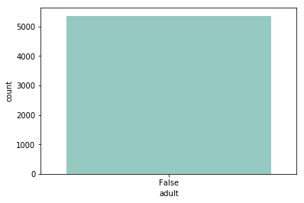

The revenue was also changed to log for easier observation.

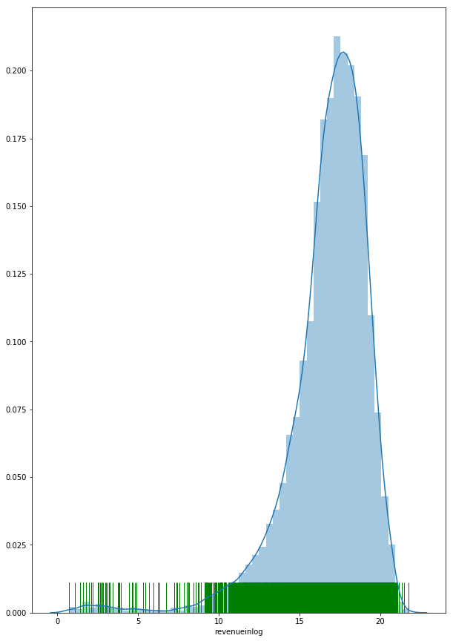

We also have a ‘budget – revenue’ heat map and its correlation:

KEY RESULTS

We used a train test split function (this does random splitting of the data) and multiple statistical values in order to calculate statistical measurements such as: Mean Absolute Error, Mean Squared Error, Median Absolute Error, Explained Var Score, R2 Score.

Additionally, for Linear Regression, we also calculated the Root Mean Squared Error, and Root Mean Squared Logarithmic Error to see how accurate our predictive model was.

Linear regression on all values:

Regression Scores(train_test_split):

Mean Absolute Error: 39.43043039854889

Mean Squared Error: 6817.850459880546

Median Absolute Error: 17.201820528760287

Explained Var Score: 0.7808385785290977

R^2 Score: 0.7804132535210337

Root Mean Squared Error: 82.57027588594183

Root Mean Squared Logarithmic Error: 1.0133662599662634

Random Forest Regression:

Regression Scores(train_test_split):

Mean Absolute Error: 44.32481404481044

Mean Squared Error: 7290.243562892095

Median Absolute Error: 19.789213599999997

Explained Var Score: 0.7602265722831311

R^2 Score: 0.7600637723525838

Decision Tree Regression:

Regression Scores(train_test_split):

Mean Absolute Error: 59.009372080795515

Mean Squared Error: 14342.770276189405

Median Absolute Error: 22.663409

Explained Var Score: 0.5280692922902059

R^2 Score: 0.5279512729040885

Regression Performance Evaluation for revenue prediction of all 3 models:

|  |  |  |  |
| --- | --- | --- | --- |
| Metrics | Linear | Random Forest | Decision Tree |
| Mean Absolute Error | 39.430 | 44.325 | 59.009 |
| Mean Squared Error | 6817.850 | 7290.244 | 14342.770 |
| Median Absolute Error | 17.202 | 19.789 | 22.663 |
| Explained Var Score | 0.781 | 0.760 | 0.528 |
| R2 Score | 0.780 | 0.760 | 0.528 |

Other data (Linear Regression):

Root Mean Squared Error: 82.570

Root Mean Squared Logarithmic Error: 1.013

APPLICATIONS

Based off of our findings once the predictive model was tested, we concluded that our model was not that accurate in predicting the box office revenue for the movies that have already been released. However, we can use our model as a reference for revenues of unreleased movies because of the finding that some of the attributes were strongly correlated like the attributes budget and vote count were.

These models could be improved in the future with better techniques like Scaling, Transforming, analyzing of Textual attributes like plot summary, preview reviews, hype ratings, etc.

With that, including the amount of interactions and talk regarding upcoming films on social media could help further improve our predictive model because many other projects have found a strong correlation between a film’s social media hype and the revenue that it brings into the box office. Furthermore, data that is included in other datasets such as the IMDB Dataset which contains data such as: the actors and directors of the films, the IMDB scores, IMDB reviews, etc., could also help further improve the predictive model.

ACKNOWLEDGMENTS

REFERENCES

[1] Galvão, M. and Henriques, R. (2018). Forecasting Movie Box Office Profitability. Journal of Information Systems Engineering & Management, 3(3), 22. <https://doi.org/10.20897/jisem/2658>

[2] F. Maxwell Harper and Joseph A. Konstan. 2015. The MovieLens Datasets: History and Context. ACM Transactions on Interactive Intelligent Systems (TiiS) 5, 4, Article 19 (December 2015), 19 pages. <http://dx.doi.org/10.1145/2827872>

Conference Name:ACM Woodstock conference

Conference Short Name:WOODSTOCK’18

Conference Location:El Paso, Texas USA

ISBN:978-1-4503-0000-0/18/06

Year:2018

Date:June

Copyright Year:2018

Copyright Statement:rightsretained

DOI:10.1145/1234567890

RRH: F. Surname et al.

Price:$15.00