Step 1: go to <https://cayenne.mydevices.com/> and sign up an account for a free server

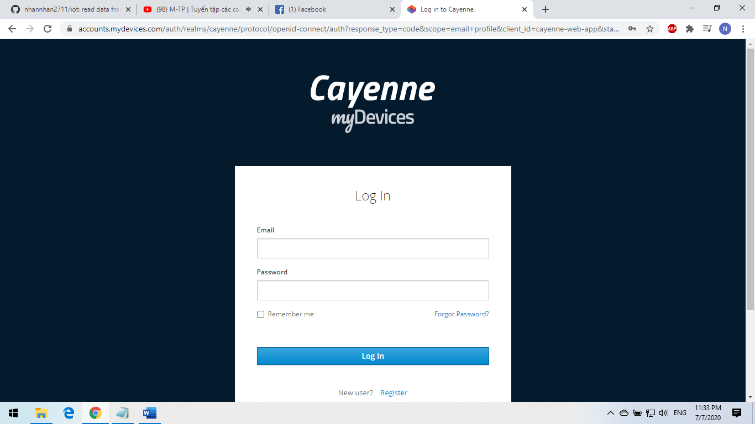

Step 2: click Bring your own thing

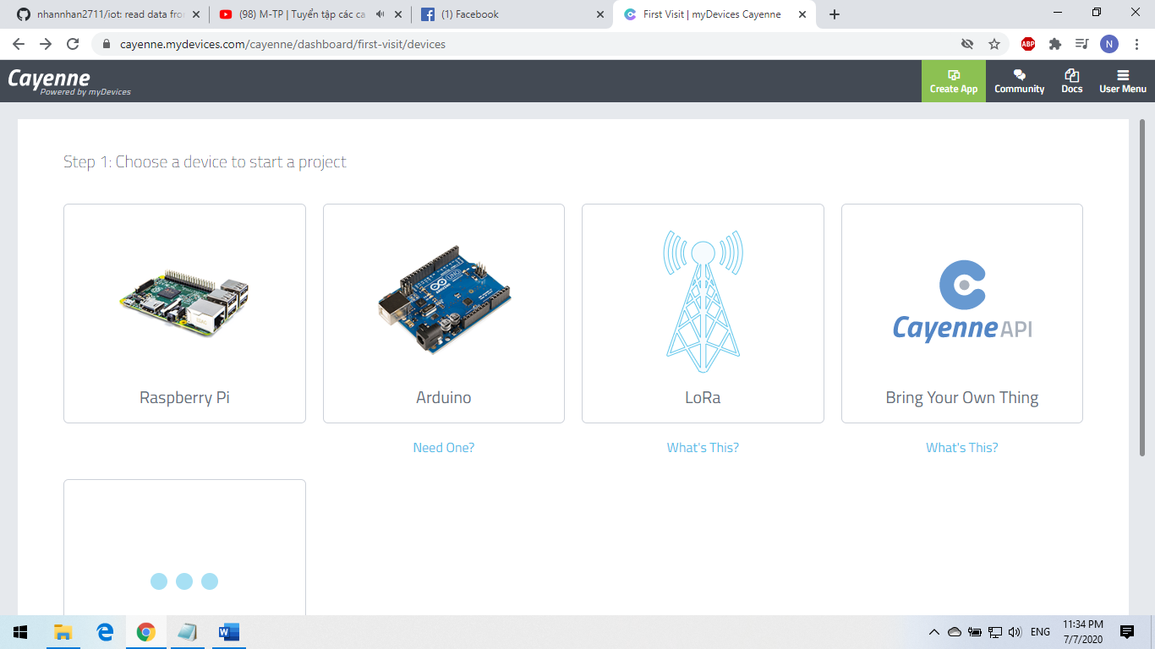

Step 3: as you can see MQTT USERNAME, MQTT PASSWORD, CLIENT ID. Copy and paste into Ras.py

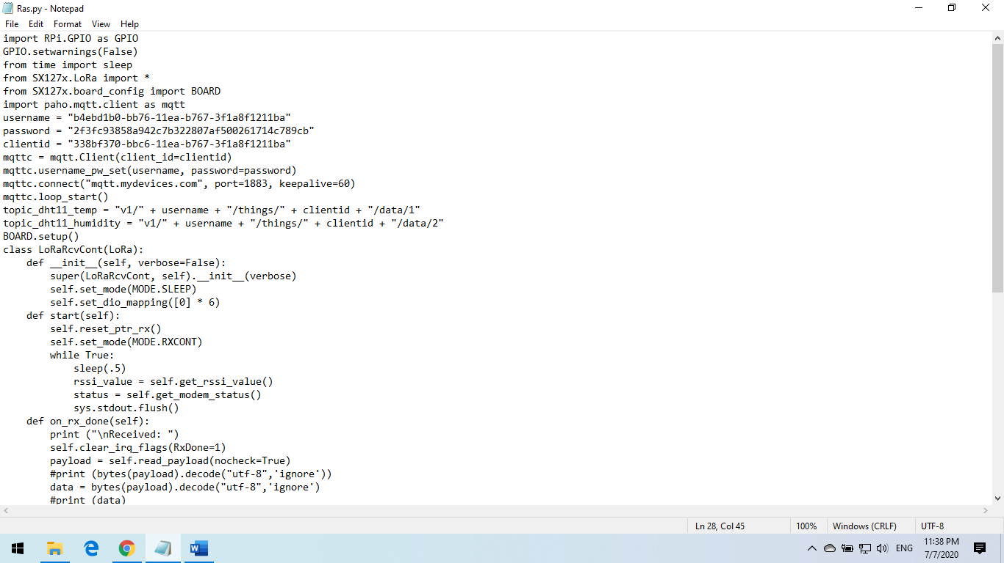

Finally. Copy Ras.py and SX127x into your raspberry and run it with this command:

* python3 Ras.py