larva@phoenix

Table of Contents
1. On centos 7:
1.1. Install samba: dùng một trong 2 cách sau
1.2. Set up samba:
1.3. Truy cập Samba server từ window:
1.4. truy cập vào vùng share ngay trên linux có smb server
1.4.1. 10.211.182.168 là ip ở căn tin trường
1.5. Smb.conf:

On centos 7:

Install samba: dùng một trong 2 cách sau
- yum install samba
- yum repoquery –location samba |xargs wget |rpm -i samba.*.rpm
- ngoài ra một số distro cần thêm sambaclient và một số dependences khác ta cũng làm tương tự.

Set up samba:
- Trên linux, ta tạo file /etc/config/smb.conf vì samba không mặc định file này
- Ta cũng có thể copy/download smb.conf example từ trên internet, nguồn uy tín nhất là từ chính source code của samba: smb.conf examble
- Ta config một số thứ trên samba.conf
  - log file = /var/log/samba/%m.log #vì mặc đinh samba chỗ này là một dir không có quyền write, nếu ta không phân quyền sẽ xảy ra bug.
  - smb.conf mẫu đạt ở cuối bài here
[global]
...
security = user
printing = cups printcap name = cups
hosts allow = 192.168.1.
hosts deny = ALL
[Public Directory]
path = /Public/Files
guest ok = yes
read only = no
browseable = yes
Private Directory
path = /private/files/
valid users = me
read only = yes
browseable = no
Dùng lệnh smbpaswd -a *user add user mới hoặc đổi mật khẩu của một user hiện có
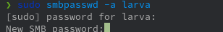
- Ta chỉnh trên smb.conf
[username]
path = <path muốn share>
valid user = <username>
read only = yes
browseable = yes
guest ok = yes

Truy cập Samba server từ window:
- trên Window 7 dùng mở cửa sổ Run, gõ vào \\<samba server host ip>
gõ tên và mật khẩu vào
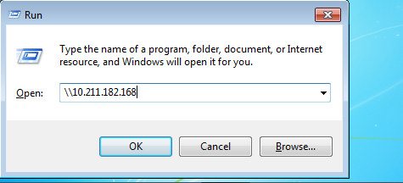
ip là ip của linux host,ta tìm bằng ip addr hoặc ifconfig
- hoặc ta dùng file explorer cũng có tác dụng tương tự
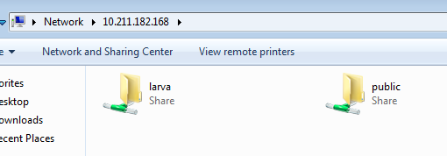

truy cập vào vùng share ngay trên linux có smb server

10.211.182.168 là ip ở căn tin trường
- List các service đang chạy ở samba server
/usr/bin/smbclient -L <samba host ip>
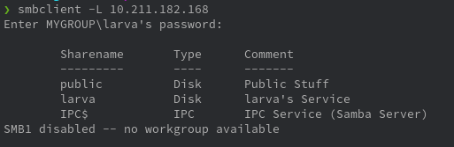
- Loggin to that service
/usr/bin/smbclient "\\\\ip\\service-name" <password here>
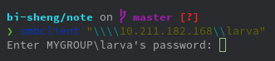
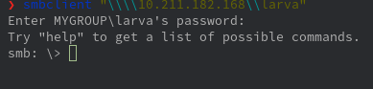

Smb.conf:
# This is the main Samba configuration file. You should read the
# smb.conf(5) manual page in order to understand the options listed
# here. Samba has a huge number of configurable options (perhaps too
# many!) most of which are not shown in this example
#
# For a step to step guide on installing, configuring and using samba,
# read the Samba-HOWTO-Collection. This may be obtained from:
# http://www.samba.org/samba/docs/Samba-HOWTO-Collection.pdf
#
# Many working examples of smb.conf files can be found in the
# Samba-Guide which is generated daily and can be downloaded from:
# http://www.samba.org/samba/docs/Samba-Guide.pdf
#
# Any line which starts with a ; (semi-colon) or a # (hash)
# is a comment and is ignored. In this example we will use a #
# for commentry and a ; for parts of the config file that you
# may wish to enable
#
# NOTE: Whenever you modify this file you should run the command "testparm"
# to check that you have not made any basic syntactic errors.
#
#======================= Global Settings =====================================
[global]

# workgroup = NT-Domain-Name or Workgroup-Name, eg: MIDEARTH
workgroup = MYGROUP

# server string is the equivalent of the NT Description field
server string = Samba Server

# Server role. Defines in which mode Samba will operate. Possible
# values are "standalone server", "member server", "classic primary
# domain controller", "classic backup domain controller", "active
# directory domain controller".
#
# Most people will want "standalone server" or "member server".
# Running as "active directory domain controller" will require first
# running "samba-tool domain provision" to wipe databases and create a
# new domain.
server role = standalone server

# This option is important for security. It allows you to restrict
# connections to machines which are on your local network. The
# following example restricts access to two C class networks and
# the "loopback" interface. For more examples of the syntax see
# the smb.conf man page
hosts allow = 192.168.1. 127. 10.
hosts deny = ALL
# Uncomment this if you want a guest account, you must add this to /etc/passwd
# otherwise the user "nobody" is used
; guest account = pcguest

# this tells Samba to use a separate log file for each machine
# that connects
log file = /var/local/samba/log.%m

# Put a capping on the size of the log files (in Kb).
max log size = 50

# Specifies the Kerberos or Active Directory realm the host is part of
; realm = MY_REALM

# Backend to store user information in. New installations should
# use either tdbsam or ldapsam. smbpasswd is available for backwards
# compatibility. tdbsam requires no further configuration.
; passdb backend = tdbsam

# Using the following line enables you to customise your configuration
# on a per machine basis. The %m gets replaced with the netbios name
# of the machine that is connecting.
# Note: Consider carefully the location in the configuration file of
# this line. The included file is read at that point.
; include = /usr/local/samba/lib/smb.conf.%m

# Configure Samba to use multiple interfaces
# If you have multiple network interfaces then you must list them
# here. See the man page for details.
; interfaces = 192.168.12.2/24 192.168.13.2/24

# Where to store roving profiles (only for Win95 and WinNT)
# %L substitutes for this servers netbios name, %U is username
# You must uncomment the [Profiles] share below
; logon path = \\%L\Profiles\%U

# Windows Internet Name Serving Support Section:
# WINS Support - Tells the NMBD component of Samba to enable it's WINS Server
; wins support = yes

# WINS Server - Tells the NMBD components of Samba to be a WINS Client
# Note: Samba can be either a WINS Server, or a WINS Client, but NOT both
; wins server = w.x.y.z

# WINS Proxy - Tells Samba to answer name resolution queries on
# behalf of a non WINS capable client, for this to work there must be
# at least one WINS Server on the network. The default is NO.
; wins proxy = yes

# DNS Proxy - tells Samba whether or not to try to resolve NetBIOS names
# via DNS nslookups. The default is NO.
dns proxy = no

# These scripts are used on a domain controller or stand-alone
# machine to add or delete corresponding unix accounts
; add user script = /usr/sbin/useradd %u
; add group script = /usr/sbin/groupadd %g
; add machine script = /usr/sbin/adduser -n -g machines -c Machine -d /dev/null -s /bin/false %u
; delete user script = /usr/sbin/userdel %u
; delete user from group script = /usr/sbin/deluser %u %g
; delete group script = /usr/sbin/groupdel %g

#============================ Share Definitions ==============================
[homes]
comment = Home Directories
browseable = no
writable = yes

# Un-comment the following and create the netlogon directory for Domain Logons
; [netlogon]
; comment = Network Logon Service
; path = /usr/local/samba/lib/netlogon
; guest ok = yes
; writable = no
; share modes = no

# Un-comment the following to provide a specific roving profile share
# the default is to use the user's home directory
# [larva]
# path = /
# browseable = no
# guest ok = yes

# NOTE: If you have a BSD-style print system there is no need to
# specifically define each individual printer
[printers]
comment = All Printers
path = /usr/spool/samba
browseable = no
# Set public = yes to allow user 'guest account' to print
guest ok = no
writable = no
printable = yes

# This one is useful for people to share files
;[tmp]
; comment = Temporary file space
; path = /tmp
; read only = no
; public = yes

# A publicly accessible directory, but read only, except for people in
# the "staff" group
[public]
comment = Public Stuff
path = /home/samba
public = yes
writable = no
printable = no
write list = @staff

# Other examples.
#
# A private printer, usable only by fred. Spool data will be placed in fred's
# home directory. Note that fred must have write access to the spool directory,
# wherever it is.
;[fredsprn]
; comment = Fred's Printer
; valid users = fred
; path = /homes/fred
; printer = freds_printer
; public = no
; writable = no
; printable = yes

# A private directory, usable only by fred. Note that fred requires write
# access to the directory.
[larva]
comment = larva's Service
path = /home/larva/temp/
valid users = larva
public = no
writable = yes
printable = no
read only = yes
browseable = yes
guest ok = yes

# a service which has a different directory for each machine that connects
# this allows you to tailor configurations to incoming machines. You could
# also use the %U option to tailor it by user name.
# The %m gets replaced with the machine name that is connecting.
;[pchome]
; comment = PC Directories
; path = /usr/pc/%m
; public = no
; writable = yes

# A publicly accessible directory, read/write to all users. Note that all files
# created in the directory by users will be owned by the default user, so
# any user with access can delete any other user's files. Obviously this
# directory must be writable by the default user. Another user could of course
# be specified, in which case all files would be owned by that user instead.
;[public]
; path = /usr/somewhere/else/public
; public = yes
; only guest = yes
; writable = yes
; printable = no

# The following two entries demonstrate how to share a directory so that two
# users can place files there that will be owned by the specific users. In this
# setup, the directory should be writable by both users and should have the
# sticky bit set on it to prevent abuse. Obviously this could be extended to
# as many users as required.
;[myshare]
; comment = Mary's and Fred's stuff
; path = /usr/somewhere/shared
; valid users = mary fred
; public = no
; writable = yes
; printable = no
; create mask = 0765

