# Acknowledgments

First, I would like to express my sincerest and deepest thanks to my teachers, friends, and organizations and individuals who have facilitated and helped me in the process of studying and starting to research and complete the project. this case.

Along with deep gratitude, I would like to send to teacher Quoc Dung, who encouraged and reminded me when I neglected to study. Thank you for your dedication and valuable knowledge to us during the past study period. Thanks to his enthusiastic support and guidance, my team was able to successfully complete this project.

Once again, I sincerely thank Mr. Quoc Dung for helping me complete this report in the past time.

This report was made in the last 3 weeks. The first time starting to work, there are many surprises and inexperience, so mistakes and omissions are inevitable. I look forward to receiving feedback from teachers to supplement my knowledge, improve my experience to be able to improve myself.

*Thank you sincerely!*

# Instructor’s Assessment Sheet

# TABLE OF CONTENTS

Acknowledgments 1

Instructor’s Assessment Sheet 2

TABLE OF CONTENTS 3

CHAPTER I: OVERVIEW 4

**1. Executive Summary** 4

*a) Objective* 4

*b) Mission* 4

**2. Project requirements** 5

**3. Project plan** 5

CHAPTER II: SYSTEM ANALYSIS AND DESIGN 6

**1. Functional specification of System** 6

a) Header 6

b) Footer 6

c) Home 6

d) Blog 7

e) About 7

f) Contact 7

g)Searching 7

h) Shopping Cart 7

i)Login 7

**2. Use a case diagram** 8

**3. Use case specification** 9

**4. Flowchart** 10

**5. Sitemap** 13

CHAPTER III: PROGRAMMING 14

**1. Technology development** 14

CHAPTER IV: CHECKLIST 16

**1. Check the List of Validation** 16

2. Submission Checklist 16

CHAPTER V: SYSTEM DEMO 17

**1. HEADER** 17

**2. FOOTER** 17

3. HOME 17

4**. BLOG** 18

5. ABOUT 19

6**. CONTACT** 19

7**. SHOPPING CART** 20

8**. LOGIN** 20

CHAPTER VI: CONCLUSION AND ORIENTED DEVELOPMENT 21

**1. Conclusion** 21

***a) Achievement*** 21

***b) Drawbacks*** 21

***2. Oriented development*** 21

REFERENCES 22

# CHAPTER I: OVERVIEW

## **1. Executive Summary**

a) Objective

The objective of this program is to give a sample project to work on real-life projects. These applications help you build a larger more robust application. The objective is not to teach you JSON/JavaScript/Dreamweaver/HTML5 but to provide you with a real-life scenario and help you create basic applications using the tools. You can revise the chapters before you start the project. This project is meant for students who have completed the module of HTML5. These

programs should be done in the Lab sessions with the assistance of the faculty if required. A student must have a clear understanding of the subject. Students should go through the project and solve the assignments as per the requirements given. Kindly get back to the projects Team in case of any doubts regarding the application or

its objectives.

b) Mission

## We are a young company, founded with the purpose of helping to take care of everyone's beauty and skin. Along with the research and study of the safe - smart skin care philosophy of Brancy, is committed to and accompanies every customer's journey to find the most beautiful skin. Products are researched, working with your skin. Based on each skin care need, each product formula created is expected to deliver results from clear scientific research.

## We explore skin care facts with you, sharing real stories that help you get closer to your own healthy and beautiful skin.

## **2. Project requirements**

You should create a Single-Page-Application and responsive Website for them with the requirements below.

The website is to be developed for the Windows Platform using HTML5, Jquery, Angular JS, JavaScript, and Geolocation. The site should work well in all leading browsers including Chrome, IE, Firefox, etc.

**Functional Requirement Specification:**

The portal will be designed as a Single-Page-Application and responsive Website with a set of pages and menus that represent the choice of activities to be performed. The pages, menus, and other visual elements must be designed in a visually appealing manner with attractive fonts, colors, and animations.

All of these should also be laid out responsively.

## **3. Project plan**

**PROJECT TASK LIST**

|  |  |  |  |  |
| --- | --- | --- | --- | --- |
| **No** | **Tasks** | **Name** | **Start Date** | **End Date** |
| **1** | Header | Tran Gia Hoang | 30/01/2023 | 15/03/2023 |
| **2** | Footer | Tran Gia Hoang | 30/01/2023 | 15/03/2023 |
| **3** | Home page | Tran Gia Hoang | 30/01/2023 | 15/03/2023 |
| **4** | Product page | To Anh Tu | 30/01/2023 | 15/03/2023 |
| **5** | Blog page | Tran Minh Vu | 30/01/2023 | 15/03/2023 |
| **6** | About page | Tran Minh Vu | 30/01/2023 | 15/03/2023 |
| **7** | Contact page | Tran Minh Vu | 30/01/2023 | 15/03/2023 |
| **8** | Shopping cart | To Anh Tu | 30/01/2023 | 15/03/2023 |
| **9** | Login | To Anh Tu | 30/01/2023 | 15/03/2023 |
| **10** | Report and Slide | To Anh Tu  Tran Minh Vu  Tran Gia Hoang | 10/03/2023 | 15/03/2023 |

# CHAPTER II: SYSTEM ANALYSIS AND DESIGN

## **1. Functional specification of System**

a) Header

The header is the top (top) part of the web page. It is the introductory area of ​​the website where people see first before diving deeper. The header is considered an "invitation" to provide core information about digital products so that users can grasp the information in just a few seconds.

b) Footer

The footer is the last section of a web page, displaying the same content on all pages of that web page. The information displayed is very important and useful for the brand.

c) Home

The goal is to impress customers who visit your website for the first time. From there, users go "deeper" to other pages on the website. Besides, the function of the homepage is to direct users to visit. Here gives you the page titles, images, and sitemap. Thanks to that, users can easily search for information about the web's governing units through the name and image of the business, information about phone numbers or emails, etc.

d) Blog

Users know more information about the news, ongoing activities and guide customers to choose the right products for themselves.

e) About

General introduction of the product, its origin, and its value. In addition, the page provides more information about the company's other products.

### **f) Contact**

Allow staff to talk directly to answer questions and introduce product lines and services suitable for customers' needs.

### **g) Searching**

The main task of the search module is to help customers easily find the required product or service in the shortest time based on keywords.

### **h) Shopping Cart**

Help buyers easily order favorite items by entering personal information including full name, address, phone number, and some other requirements related to the purchase.

### **i) Login**

Users can log in to receive many notifications of offers, events, and discount codes, if users do not have an account, they can click the register button to proceed with creating an account.

## **2. Use a case diagram**

*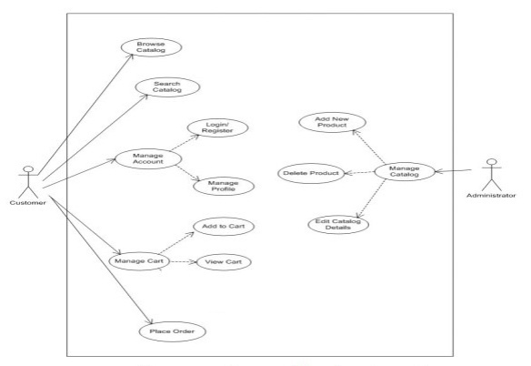Use a case diagram of the shopping cart*

*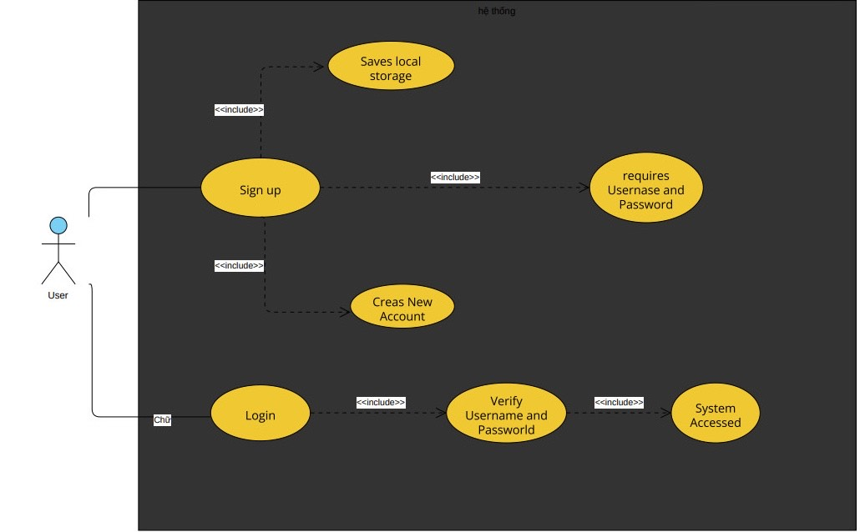Use a case diagram of the login*

## **3. Use case specification**

|  |  |  |  |
| --- | --- | --- | --- |
| **USE CASE SPECIFICATION** | | | |
| **Use-case No.** | UC01 | **Use-case Version** | 1.0 |
| **Use-case Name** | *Sign up/ Sign in* | | |
| **Purpose:**  Exploit customer information so that employees select information and advice on what is suitable for customers.  **Input:**  Full name, password.  **Output:**  Allows logging into the system to use the correct purchasing function and consultant | | | |

|  |  |  |  |
| --- | --- | --- | --- |
| **USE CASE SPECIFICATION** | | | |
| **Use-case No.** | UC02 | **Use-case Version** | 1.0 |
| **Use-case Name** | *The shopping cart* | | |
| **Purpose:**  Summary of the number of products, and the price of the product selected by the user on the products page.  **Input:**  The product selected by the user on the products page  **Output:**  Display product information, total. | | | |

## **4. Flowchart**

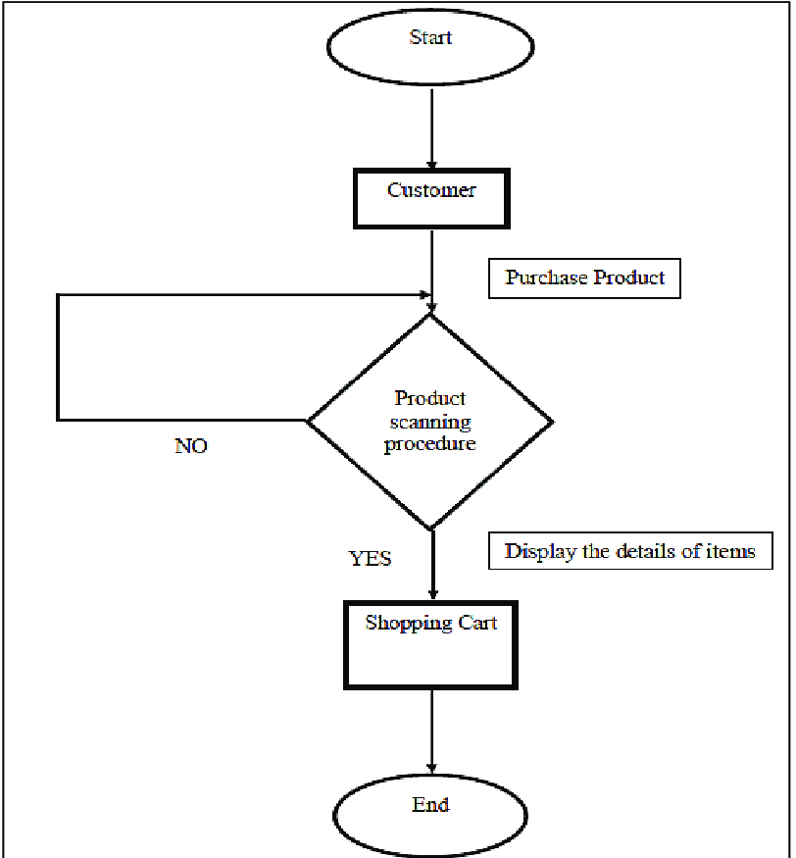

*Flow chart of the shopping cart*

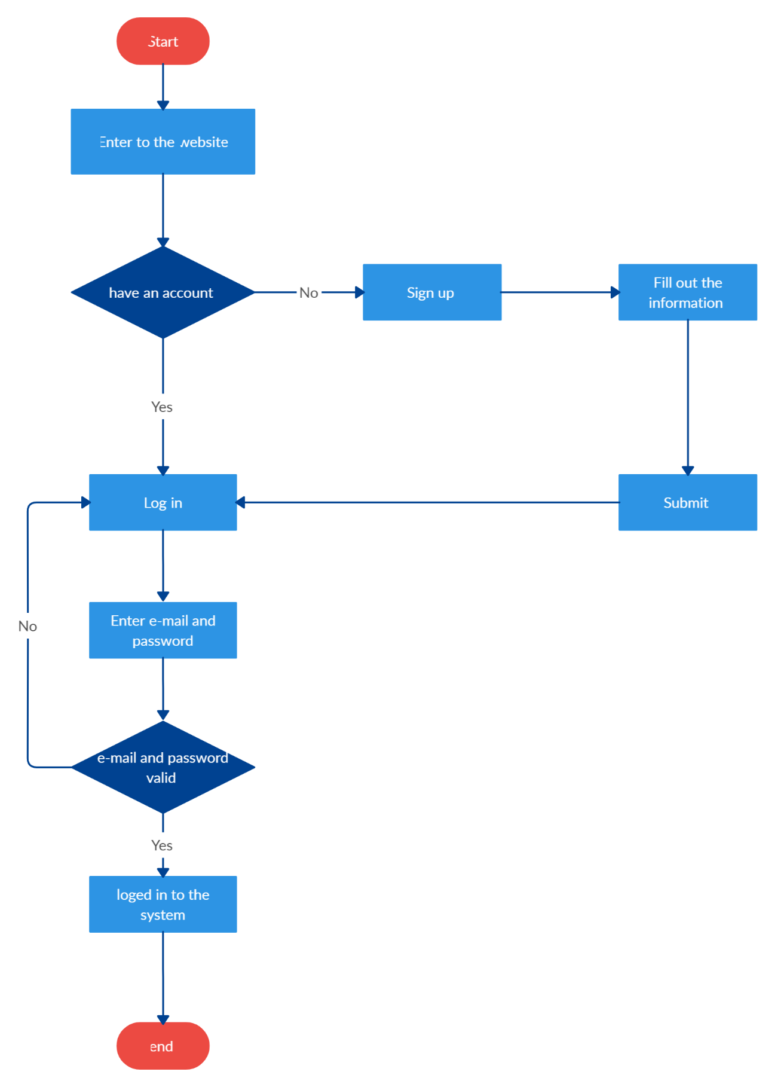

*Flow chart of the login*

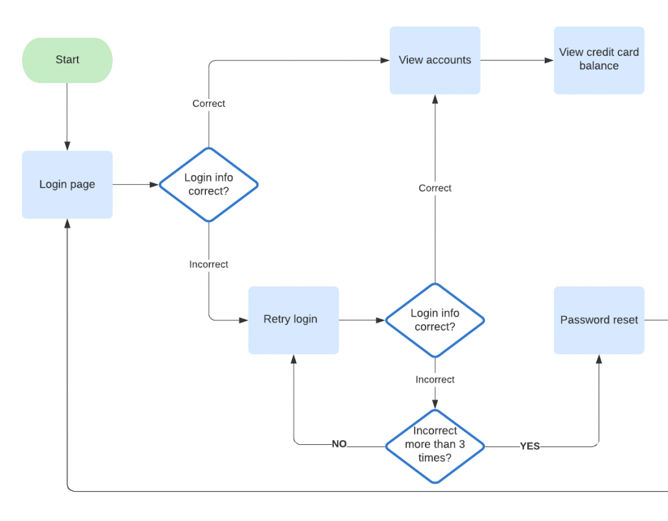

*Process diagram of login*

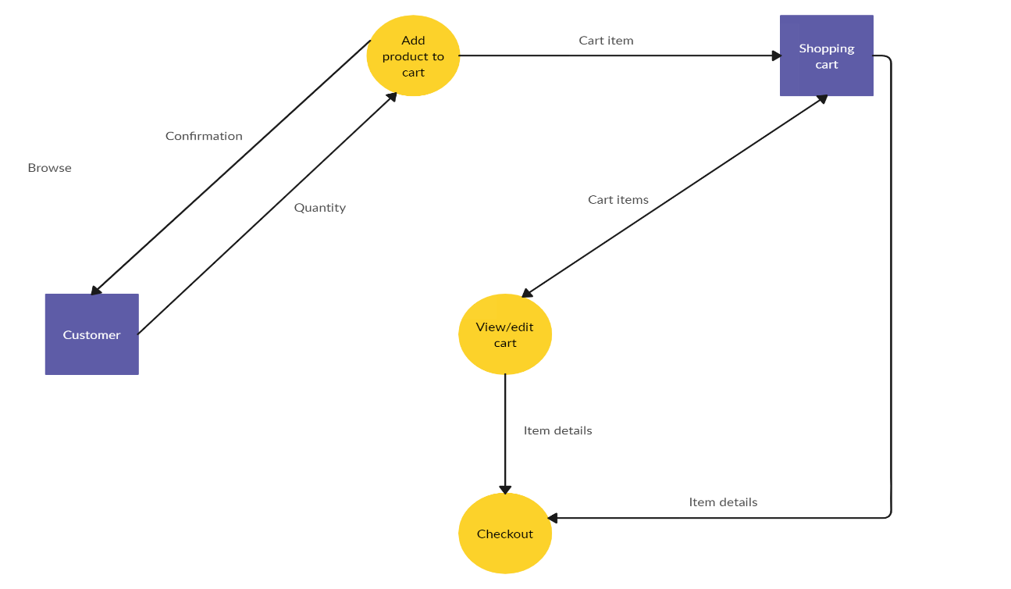

*Process diagram of the shopping cart*

## **5. Sitemap**

*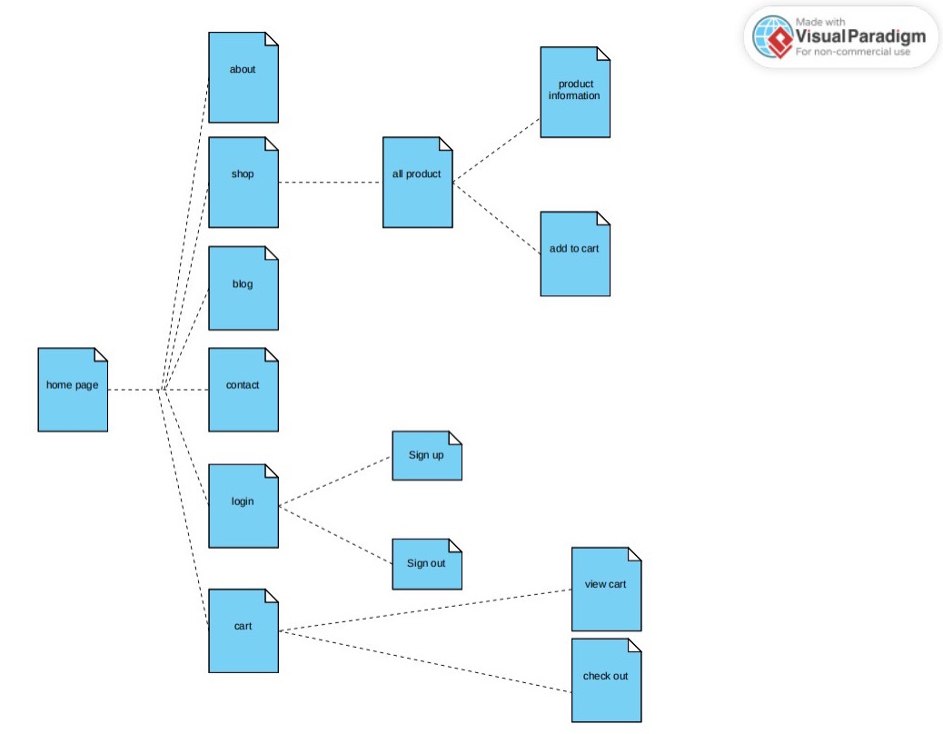Sitemap of website*

# CHAPTER III: PROGRAMMING

## **1. Technology development**

Software: Visual Studio Code

Web Browser: Opera, Chrome, Firefox support design Responsive

The technique used to build the Website:

* HTML5 & CSS3.
* Responsive Bootstrap.
* Validation for bootstrap.
* jQuery & JavaScript.
* AJAX and JSON.
* Session Storage.
* Material for bootstrap:
* JS popover.
* JS scroll spy.
* Modal.
* Bootstrap Carousel.
* Button.
* Form.
* Bootstrap Grid.

# CHAPTER IV: CHECKLIST

## **1. Check the List of Validation**

|  |  |
| --- | --- |
| **Option** | **Validate** |
| Fields in forms should not be null | **Yes** |
| Are all the program codes working? | **Yes** |
| The site name for publishing is unique | **Yes** |
| Hyperlinks have tooltip texts | **No** |
| Are there functions for the user to enter their comment | **No** |
| Do all the options present in the application display the correct result? | **Yes** |

## 

## 2. Submission Checklist

|  |  |  |  |  |  |
| --- | --- | --- | --- | --- | --- |
| **No.** | **Particulars** | **Yes** | **No** | **N/A** | **Comments** |
| **1** | Do all the web pages open? | **+** |  |  |  |
| **2** | Are all hyperlinks working? | **+** |  |  |  |
| **3** | Are the web page contents devoid of spelling mistakes? | **+** |  |  |  |
| **4** | Are all web components working? | **** |  | **+** | There are programs that run and don’t work |
| **5** | Is the application user-friendly? | **** | + |  | Windows GUI is familiar to everyone |

# CHAPTER V: SYSTEM DEMO

## **1. HEADER**

## **head2. FOOTER**

*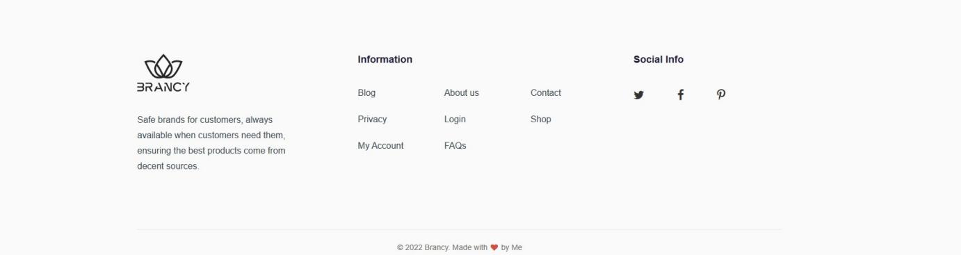Demo system footer*

## 3. HOME

*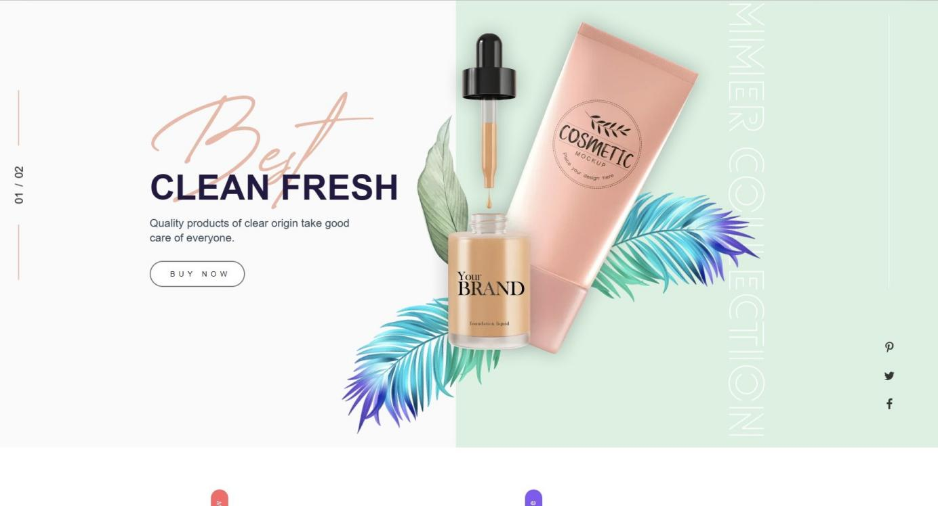Demo system home*

## **4. BLOG**

*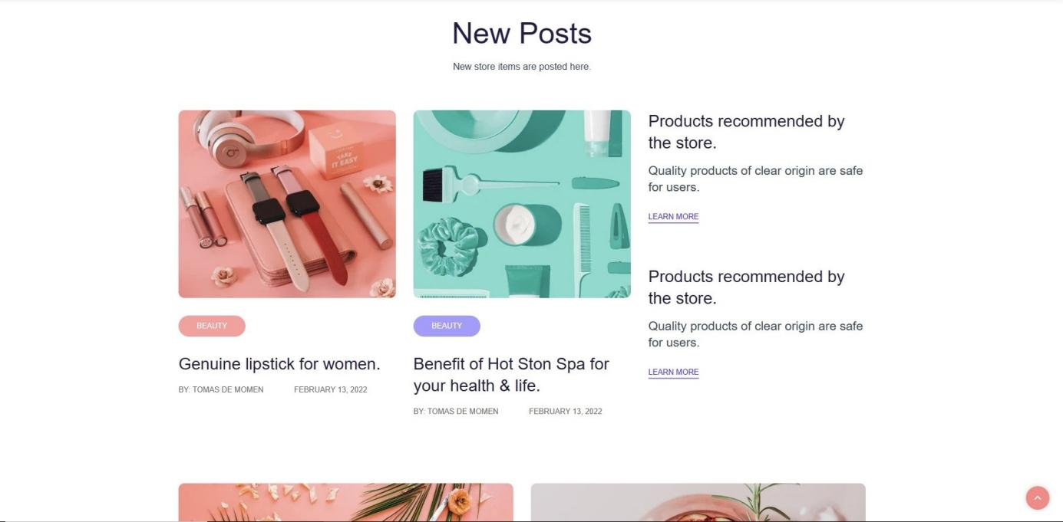Demo system blog*

## 5. ABOUT

*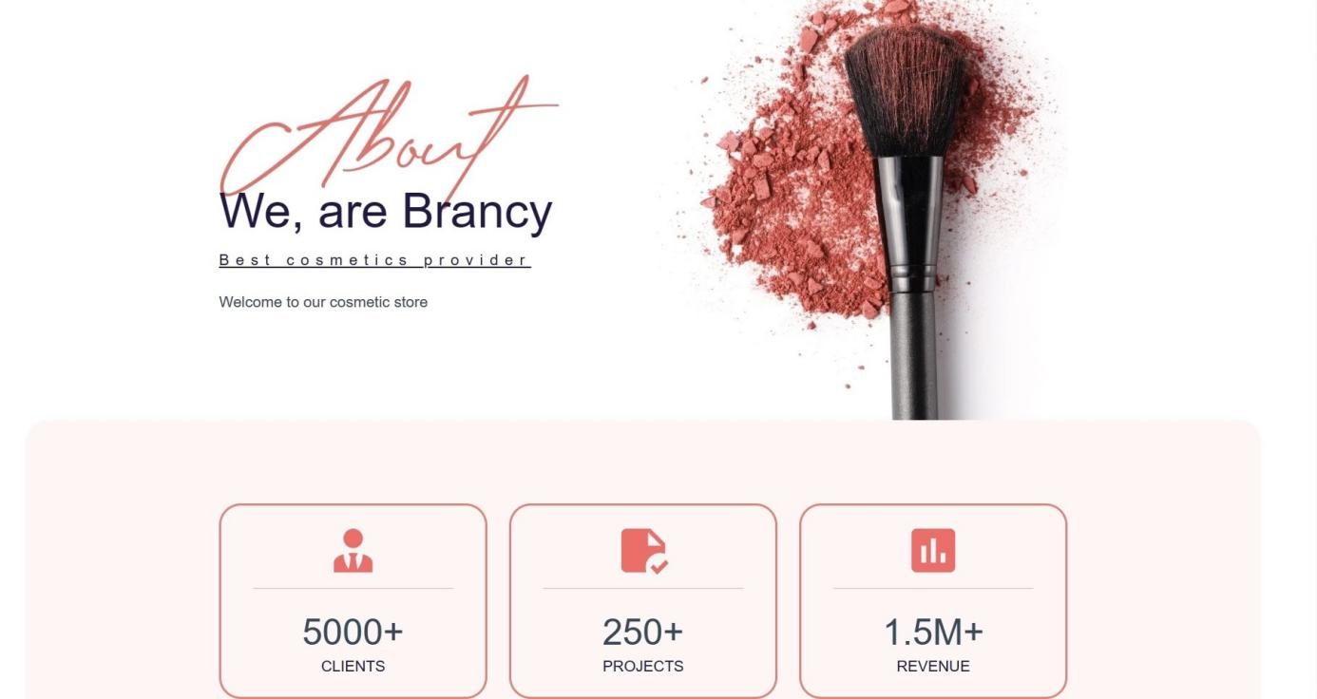Demo system about*

## **6. CONTACT**

*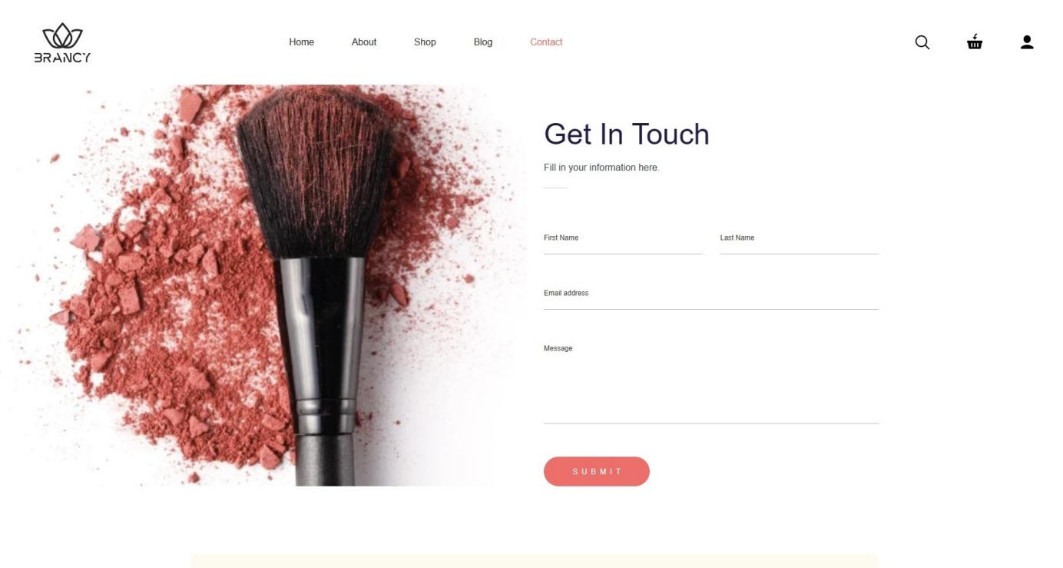Demo system contact*

## **7. SHOPPING CART**

*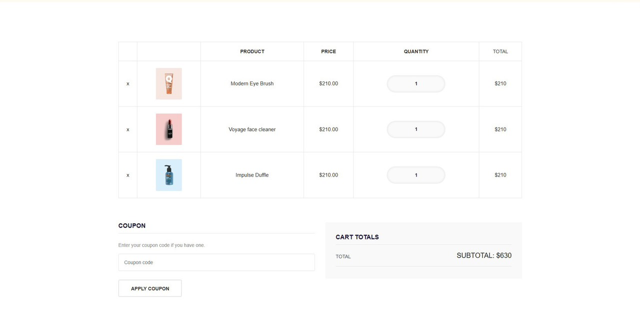Demo system shopping cart*

## **8. LOGIN**

*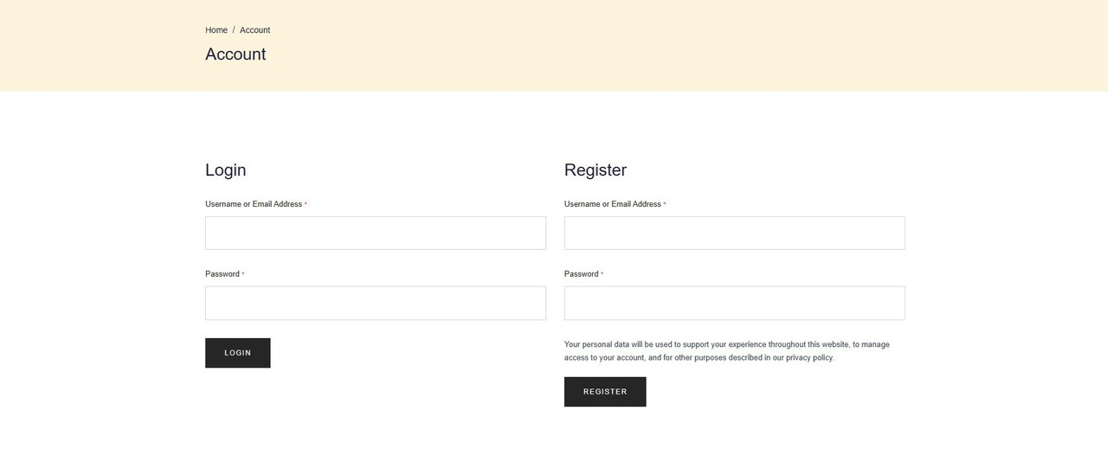Demo system login*

# CHAPTER VI: CONCLUSION AND ORIENTED DEVELOPMENT

## **1. Conclusion**

### ***a) Achievement***

+Completes most of the basic functions of a sales website.

+ Built on a 3-layer model to easily manage changes to the structure later.

+ Easy-to-see interface design.

+ Sort products by category.

+ Display information for each type of product, and news.

+ Allow customers to email product reviews and comments.

+ Design a shopping cart to help customers choose to buy easily and update the shopping cart.

### ***b) Drawbacks***

+ Unable to make online payment methods.

- About data.

+ Incomplete data.

+ The data on the current website is not true to reality, using a virtual data source.

- About the interface

+ The interface is not lively.

+ Hard interface, can't change the template for the interface.

## ***2. Oriented development***

+ Develop an e-commerce model according to a high-security mechanism for the establishment of data. Back up data.

+ Encrypt passwords and PINs according to a certain mechanism.

+ Make online payments.

+ Increase business services such as: Giving gifts to loyal customers and organizing promotions.

+ Improve the security of the program. Maximum prevention of system data intrusion cases.

+ Correct data to be accurate with reality and will gradually upgrade the website to meet the needs of customers in the new era.

# REFERENCES

We consulted information on the websites:

[1] <https://jquery.com/>

[2] <http://www.w3schools.com/>

[3] <http://www.getbootstrap.com/>

[4] https://tujavadeveloper.github.io/projectAptech/

[5] <https://app.creately.com>/