```

Nhan Nguyen

Assignment 1 - COMP 4300 - Chat gRPC

```

1. **Steps to run the chat**

*Make sure that you already completed all the setup steps for grpc: https://grpc.io/docs/languages/python/quickstart/*

**Activate virtual environment:**

```source chat-grpc-env/bin/activate```

**Install all necessary tools:**

```python3 -m pip install -r requirements.txt```

**Run server:**

```python3 server.py```

**Run client:**

```python3 client.py```

1. **After running client, this prompt will pop up:**

**Enter username:**

**Note:**

- Username can be any character(s) but empty.

- Username should be unique (my program has not verified this, but it should be for the sake of the database storage).

- As long as you enter something, that will be registered as your username and the GUI chatbox will pop up after this is successfully created.

1. **After login, the chat application is good to use, below are some commands users can use:**

**1. Help:**

```--help```

This will show what commands users can use:

**2. List of Chatrooms:**

**To see the list of available chatrooms, use this command:**

```--chat_list ```

**Note:**

- Initially, it loads the database from chat_db.json file to fetch some existing chatrooms and some users in that chats together with the history conversation, so it is expected to see some chatrooms there.

- chat_pb2.json currently has room Math, Eng, and CS so those will be listed.

**How to interpret the output:**

- The output is the list of available chatrooms from the time the server starts running, this includes any rooms that were loaded from the database.

- If any other user creates a new room during the time this command is executing, the new room will be showed in the list as well.

- The command is still executing (keep getting the response from the server stream) until the user enters new command.

i.e: If the list of chatrooms is: Math, Eng, CS. The output should look like

**3. List of connected users for each room:**

**To see the list of connected user for room Math for example, use this command:**

```--user_list Math```

**How to interpret the output:**

- The output is the list of connected users in the chat room. (Connected users include users that are executing --join_chat [room])

- If any other user joins the room during the time this command is executing, that new user will be showed in the list as well.

- The command is still executing (keep getting the response from the server stream) until the user enters new command.

i.e: If the list of connected users in room Math is: Alice, Clara, Thanh. The output should look like:

- The total number of users in the chat room is the last number before the last username.

- However, this list is staled if any user leaves the chat, the list show cannot remove the leaving user. The command needs to be called again to get the updated result.

- If the room does not exist, it will show a notification for that and terminate the execution, the output will be like this:

**4. Join existing chat room:**

**To join room CS (an existing room), use:**

```--join_chat CS```

**How to interpret the output:**

- The output loads all chat history of users in the chat room.

For example, there were some conversations in the CS room database, so it will look like this:

- If the user does not execute any other command (except --send), the user is still in the chat and will receive any new messages from others instantly

- If user enter any command rather than --send message, the user will automatically leave the room.

- If the room does not exist, the user is notified that.



- If the room is full, the user is also notified.



**5. Create a chat room:**

**To create a new room with room name is comp4300, use:**

```--create_chat comp 4300```

**How to interpret the output:**

- The output notifies to let the user know the new room is created.



- If the room name is occupied, the user is also notified the room cannot be created with exiting rooms names.



**Note: --create_chat will not let user join the new room, user needs to use --join_chat new room to join the new room.**

**6. Send a message:**

**To send a message "Hello wolrd!" in the room CS, firstly, user need to join the room:**

``` --join_chat CS```

and then user can send the message:

```--send Hello wolrd!```

- If the user is already in a chat, do not need to --join_chat again

**How to interpret the output:**

- If the user is in the chat, all users in the chat will see the new message shown.

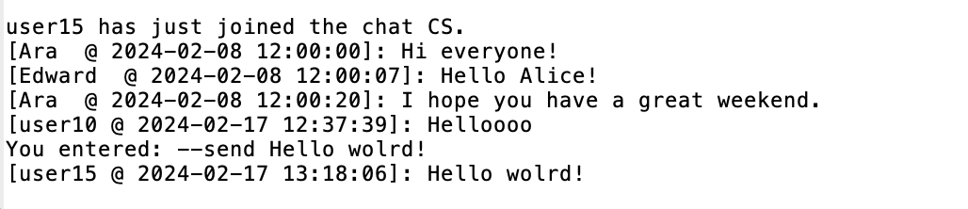

- If the user is not in the chat, the user will be notified.



**## 7. Leave chat**

**### To leave any chat user is currently in, use:**

```--leave_chat ```

**### How to interpret the output:**

- If the user was in a chat room, it would let the user know they successfully left the room.

- If the user was not in any chat, the user would be notified about that.

**# Live demo and testing:**

Please refer to the documentation in folder docs.