Software Requirements Specification
for
Learning
Version 1.0 approved
Prepared by nhannv
Personal
26/7/2015
Table of Contents
Table of Contents ii
1. Introduction 1
1.1 Purpose 1
1.2 Document Conventions 1
1.3 Intended Audience and Reading Suggestions 1
1.4 Product Scope 1
1.5 References 1
2. Overall Description 2
2.1 Product Perspective 2
2.2 Product Functions 2
2.3 User Classes and Characteristics 2
2.4 Operating Environment 2
2.5 Design and Implementation Constraints 2
2.6 User Documentation 2
2.7 Assumptions and Dependencies 2
3. External Interface Requirements 3
3.1 User Interfaces 3
3.2 Hardware Interfaces 3
3.3 Software Interfaces 3
3.4 Communications Interfaces 3
4. System Features 4
4.1 System Feature 1 4
4.2 System Feature 2 (and so on) 4
5. Other Nonfunctional Requirements 5
5.1 Performance Requirements 5
5.2 Safety Requirements 5
5.3 Security Requirements 5
5.4 Software Quality Attributes 5
5.5 Business Rules 5
6. Other Requirements 6
Appendix A: Glossary 6
Appendix B: Analysis Models 6
Appendix C: To Be Determined List 6

Revision History
Name | Date | Reason For Changes | Version
Nhannv | 26/07/2015 | Create section 1,2 | 0.01

Introduction

Purpose
Learning project. Which create to help student learn better, first version provide three subject: math, physical, chemistry. Student can learning, teacher create lesion to teach, exercise to do, and manage, share knowledge...

Document Conventions
NA

Intended Audience and Reading Suggestions
This document create for Software Engineer to create Soft Design and develop Software (maybe create to confirm with customer about software but this is personal project so it is not). Reader need to follow first section to last section.

Product Scope
This document cover all project, including all scenarios.

References
NA

Overall Description

Product Perspective
Product is all of learning product.

Product Functions
- Manage knowledge
- Learning subject
- Do exercise
- Create exercise, lesson
- Create topic to discuss
- Share knowledge

User Classes and Characteristics
Normal User: Can using web browser, basic using web functional which provide by product, basic knowledge about using computer or web in mobile…

Operating Environment
Environment: Window 7/8, Linux OS to run and develop
IDE: Eclipse
Programming language: PHP
Framework: Laravel
Font-end: HTML, JQuery, CSS
Database: MySQL

Design and Implementation Constraints
Language: PHP
Framework: Laravel
Database: MySQL

User Documentation
NA

Assumptions and Dependencies
Web server is running, Database is running, environment is running, connected to internet, PHP and PHP extension. (Recommend LAMP Server)

External Interface Requirements

User Interfaces
This will be update when design is fluently

Hardware Interfaces
NA

Software Interfaces
NA

Communications Interfaces
User will contact to system via Web Browser, protocol HTTPS, Ajax

System Features
Figure 4-1: System component
System component bellow
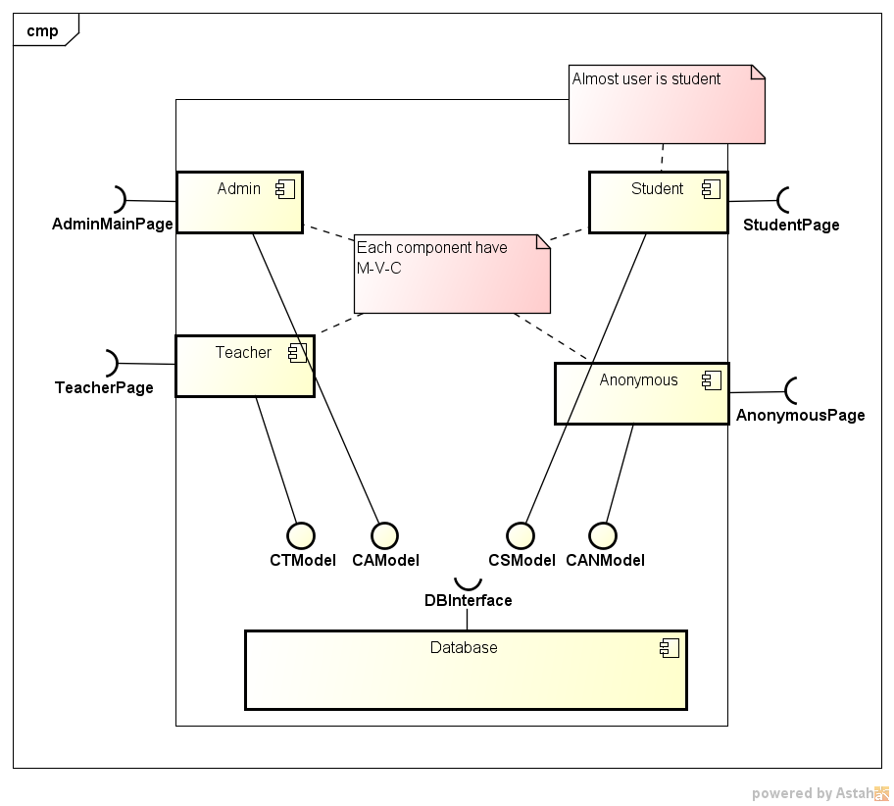
Figure 4-2 System component

Student Component
<Don’t really say “System Feature 1.” State the feature name in just a few words.>
4.1.1 Description and Priority
<Provide a short description of the feature and indicate whether it is of High, Medium, or Low priority. You could also include specific priority component ratings, such as benefit, penalty, cost, and risk (each rated on a relative scale from a low of 1 to a high of 9).>
4.1.2 Stimulus/Response Sequences
<List the sequences of user actions and system responses that stimulate the behavior defined for this feature. These will correspond to the dialog elements associated with use cases.>
4.1.3 Functional Requirements
<Itemize the detailed functional requirements associated with this feature. These are the software capabilities that must be present in order for the user to carry out the services provided by the feature, or to execute the use case. Include how the product should respond to anticipated error conditions or invalid inputs. Requirements should be concise, complete, unambiguous, verifiable, and necessary. Use “TBD” as a placeholder to indicate when necessary information is not yet available.>

<Each requirement should be uniquely identified with a sequence number or a meaningful tag of some kind.>

REQ-1:
REQ-2:

Teacher Component

Admin Component

Anonymous Component

Other Nonfunctional Requirements

Performance Requirements
<If there are performance requirements for the product under various circumstances, state them here and explain their rationale, to help the developers understand the intent and make suitable design choices. Specify the timing relationships for real time systems. Make such requirements as specific as possible. You may need to state performance requirements for individual functional requirements or features.>

Safety Requirements
<Specify those requirements that are concerned with possible loss, damage, or harm that could result from the use of the product. Define any safeguards or actions that must be taken, as well as actions that must be prevented. Refer to any external policies or regulations that state safety issues that affect the product’s design or use. Define any safety certifications that must be satisfied.>

Security Requirements
<Specify any requirements regarding security or privacy issues surrounding use of the product or protection of the data used or created by the product. Define any user identity authentication requirements. Refer to any external policies or regulations containing security issues that affect the product. Define any security or privacy certifications that must be satisfied.>

Software Quality Attributes
<Specify any additional quality characteristics for the product that will be important to either the customers or the developers. Some to consider are: adaptability, availability, correctness, flexibility, interoperability, maintainability, portability, reliability, reusability, robustness, testability, and usability. Write these to be specific, quantitative, and verifiable when possible. At the least, clarify the relative preferences for various attributes, such as ease of use over ease of learning.>

Business Rules
<List any operating principles about the product, such as which individuals or roles can perform which functions under specific circumstances. These are not functional requirements in themselves, but they may imply certain functional requirements to enforce the rules.>

Other Requirements
<Define any other requirements not covered elsewhere in the SRS. This might include database requirements, internationalization requirements, legal requirements, reuse objectives for the project, and so on. Add any new sections that are pertinent to the project.>
Appendix A: Glossary
<Define all the terms necessary to properly interpret the SRS, including acronyms and abbreviations. You may wish to build a separate glossary that spans multiple projects or the entire organization, and just include terms specific to a single project in each SRS.>
Appendix B: Analysis Models
<Optionally, include any pertinent analysis models, such as data flow diagrams, class diagrams, state-transition diagrams, or entity-relationship diagrams.>
Appendix C: To Be Determined List
<Collect a numbered list of the TBD (to be determined) references that remain in the SRS so they can be tracked to closure.>

Source: http://www.frontiernet.net/~kwiegers/process_assets/srs_template.doc

