Game documentation and HowTo guide.
Whack A Zombie Game Template

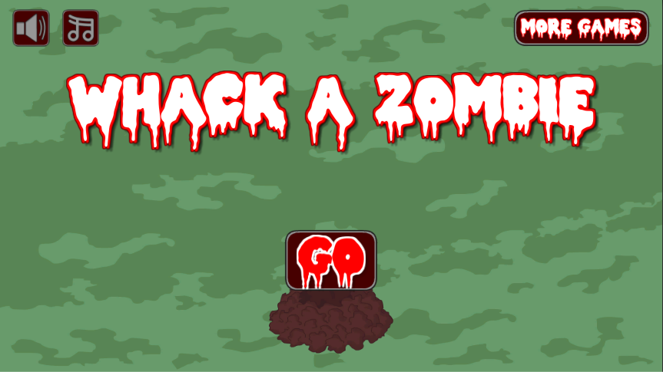

This document contains:

Package Description and features 2
1.10 (11.12.2018) 2
Credits 2
Overview of the game's library contents 3
Customization Guide 4
Getting started 4
The Game Controller 4
The Zombies 6
UnityAds Integration 7
Frequently Asked Questions 9
Does this package work on mobile? 9
My sprites are not showing on iOS 9
How to change font in the game? 9
More games by Puppeteer 11

Package Description and features
Whack a Zombie is an action packed game full of challenge and fun. The game is ready to release straight out of the box, and it can also be easily customized to make it even more engaging to your players. The game supports PC/Mac, iOS, Android, etc. It can be played with the mouse, keyboard, gamepad, or touch controls!

How to Play?

Hit those pesky Zombies on the head with your Mighty Mallet!
Features:
- Game ready for release straight out of the box, just build and play!
- Works on all platforms, PC, Mac, iOS, Android, etc
- Supports multiple resolutions and aspect ratios, automatically.
- Supports Mouse, Keyboard, Gamepad, and Touch controls.
- Easily customizable with lots of options to control game difficulty.
- Great learning resource with commented scripts and documentation.
- All assets included: graphics, sounds, and code.

Current version 1.10

1.10 (11.12.2018)
- Changed the way targets show up. You now set a list of points instead of targets, and a list of targets which are randomly chosen and created.
- You can set a bonus multiplier for each target.

1.05 (09.10.2017)

- Added support for Unity versions 5.5.0, 5.6.0, and 2017

Credits

The sounds are courtesy of the free sound project.
Music is Cold Silence (Public Domain)
Credits go to these authors for their great sound samples: titaniumturner, panikko, Oddworld, fins, boulderbuff64, Isaac200000, Harris85
Please rate my file, I’d appreciate it

Overview of the game's library contents
Let's take a look inside the game files. Open the main WAZAssets folder using Unity3D 5.3.2 or newer. Take a look at the project library, usually placed on the right or bottom side of the screen. Here are the various folders inside:

- Animations: Holds the animation clips made with Unity’s built-in animation system.
- FLA: Holds the object graphics made with Flash CS3. These are vector graphics than can be easily scaled without loss of quality and then exported as PNG to be used in Unity.
- Fonts: Holds the font used in the game.
- Prefabs: Holds all the prefabs used in the game. These are distributed to various folders for easier access, Buttons, Enemies, Objects, etc. It also holds all the canvases in the game which are used to hold buttons and other UI elements.
- Scenes: The first scene that runs in the game is MainMenu. From this scene you can get to the Game scene.
- Scripts: Holds all the scripts used in the game. Each prefab contains one or more of these scripts.
- Sounds: Holds all the sounds used in the game. Hit,Smack, etc
- Textures: Holds all the textures used in the game which are used as sprites in Unity.

Customization Guide

Getting started
Whack A Zombie Template (WAZ) is considered a complete project, and as such is supposed to work as the starting point of your planned game, rather than an addition to an existing project. That said, you may of course pick and choose some of the scripts/models to import into your existing project, but WAZ works best as a starter kit which you can customize any part of to your liking.

The Game Controller
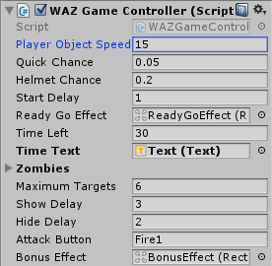
The Game Controller is the main prefab that controls all the progress of the game from start to finish. It controls the UI of the game, creates enemies and items and checks the level up condition.
Player Object Speed – How fast the player object moves. This is only for keyboard and gamepad controls.
Quick Chance – The chance for a quick Zombie to appear. This overrides the chance for a Zombie with a helmet to appear.
Helmet Chance – The chance for a Zombie with a helmet to appear.
Start Delay - How long to wait before starting the game. Ready?GO! time
ReadyGoEffect – The effect displayed before starting the game.
Time Left – How many seconds are left before game over.
Time Text – The text object that displays the time.
Zombies – A list of targets (The Zombies that appear and hide in the holes).
Maximum Targets – How many targets to show at once.
Show Delay – How long to wait before showing the targets.
Hide Delay - How long to wait before hiding the targets again.
Attack Button - The attack button, click it or tap it to attack with the hammer.
Hit Target Bonus - How many points we get when we hit a target. This bonus is increased as we hit more targets.
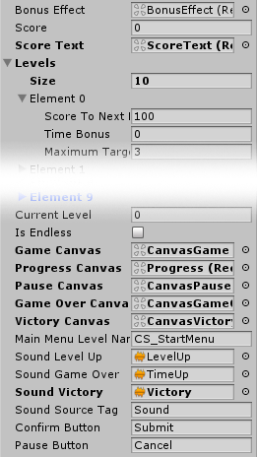
Bonus Effect - The bonus effect that shows how much bonus we got when we hit a target.
Score - The score of the player.
Score Text - The score text object which displays the current score of the player.
Levels - A list of levels, each with its own target score, target limit, and time bonus.
Current Level - The current level we are on. We must reach the target score in order to go to the next level.
Is Endless - If you set this to true the game will continue forever after the last level in the list. Otherwise you will get the victory screen after the last level.
Main Menu Level Name – The level of the main menu that can be loaded after the game ends.
Confirm Button – The keyboard/gamepad button that will restart the game after game over.
Pause Button – The keyboard/gamepad button that pauses the game.
User Interface – Various canvases for the UI, assign them from the scene.
Sounds – Various sounds that play during the game.
Sound Source Tag – The audio source from which the Game Over sound plays.

The Zombies
The Zombies are the targets you must hit with your hammer. There is a single Zombie object that contains all the different animations and types that appear (Regular, Quick, Helmet).
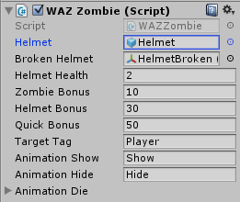
Helmet – The helmet object of this Zombie, assigned from inside the Zombie itself.
Broken Helmet – The broken helmet that appears when the helmet breaks. This is assigned from the project pane.
Helmet Health – The health of the Zombie when it's wearing a helmet.
Zombie Bonus - The bonus we get for killing a regular Zombie.
Helmet Bonus - The bonus we get for killing a helmet Zombie.
Quick Bonus - The bonus we get for killing a quick Zombie.
Target Tag - The tag of the object that can hit this Zombie.
Animation Show - The animation name when showing a Zombie.
Animation Hide - The animation name when hiding a Zombie.
Animation Die - A list of animations when the Zombie dies. The animation is chosen randomly from the list.

UnityAds Integration
Since Unity 5.2 UnityAds integration has been simplified, here’s how you can have full screen video ads in your game.
This video shows a quick process of integrating UnityAds into your project. In the example we used one of my templates, but it works on all my other templates too.
https://www.youtube.com/watch?v=EQNTgfV35DU
Here is what we did in the process:
- Sign in to your Unity account in order to allow Unity Services such as UnityAds to be activated.
- Open Build Settings and switch the platform to one of the supported ones (iOS, Android).
- Download Puppeteer's UnityAds package from: puppeteerinteractive.com/freebies/PUPUnityAds.unitypackage
- Drag the downloaded package into your Unity project, and import it. This UnityAds prefab can be used to display ads every several minutes.
- Drag the prefab into any scene where you want ads to be shown. Make sure to save changes.
- The time check is shared between all prefabs in all scenes, so you will never show too many ads.
- The final step is to activate UnityAds services and get your unique project ID.
- Open the services window and choose your organization, then click create.
- Choose UnityAds from the list and turn it On.
- Choose age group for your project ( Will affect the nature of ads shown ), and save changes.
- While working on your project keep Test Mode activated. But when you are ready to release the final project, switch Test Mode off.
- That's it! Now when you start the game, an ad will be shown after 3 minutes. The ad will never appear during gameplay or post-game screen. Instead, it will wait until the next level load ( restart, main menu, etc ) and then show the ad.

Before releasing a game, make sure you uncheck Enable Test Mode.
For more info about integrating UnityAds read this:
http://unityads.unity3d.com/help/monetization/integration-guide-unity

Frequently Asked Questions

Does this package work on mobile?
Yes, this package has been successfully tested on both Android and iOS devices. The scripts for each lock type include controls for mobile that are detected automatically based on the platform it’s built on.

My sprites are not showing on iOS
Sprite-based textures made with the new Unity 4.3 can sometimes disappear when working on the iOS platform.
You can notice this by opening a scene playing it. When you switch from your current platform to the iOS platform the sprite textures become invisible.
To solve this we must change the texture compression format for iOS. Follow these steps:
- Click on a texture in the project view.
- Click on the override for WAZone button on the right side.
- Change the format to 16bit.
- Click Apply.

How to change font in the game?
To change a font in the game do the following:
Find a font you like and drag the .ttf file over to the Fonts folder in your game.
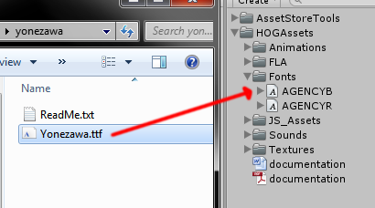
Click on the font you added and edit its attributes. I personally set all my fonts to a high number (and then scale the text object down) so that they look crisper in-game.
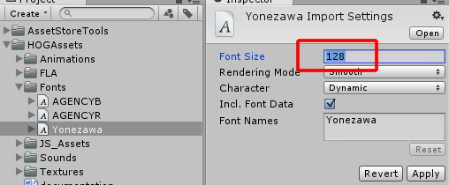
Select any text object in the game and change its font to the new font you have. Sometimes the text might disappear, but it's normal. Just write something in the text box above and it will refresh. Also, make sure you change the text for the shadow; you can select both the main text and its shadow and edit them together.
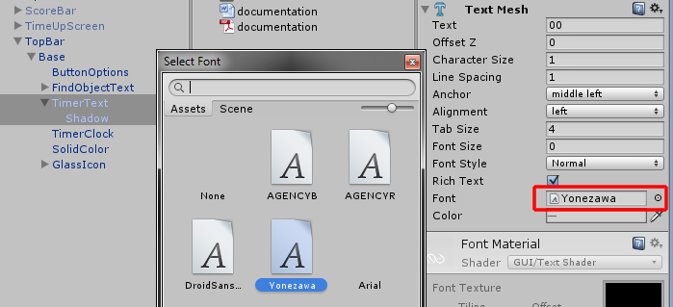

More games by Puppeteer
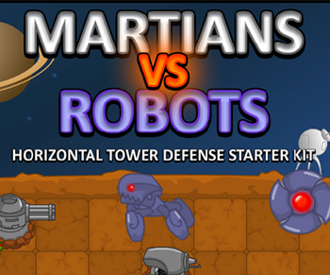
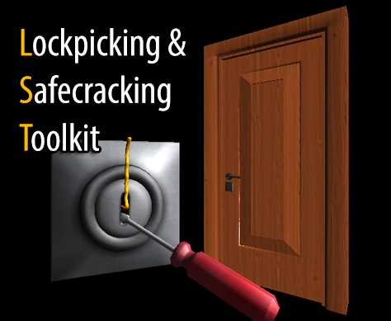
Click here to see the full catalogue of Asset Store files!
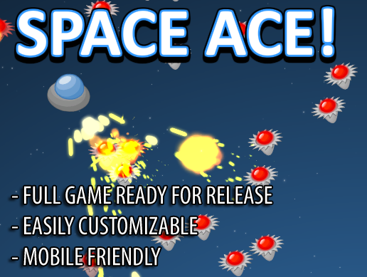
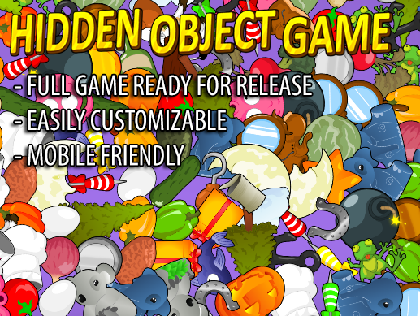

It is highly advised, whether you are a designer or a developer to look further into the code and customize it to your pleasing. See what can be improved upon or changed to make this file work better and faster. Don't hesitate to send me suggestions and feedback to puppeteerint@gmail.com
Follow me on twitter for updates and freebies!
Good luck with your modifications!

