Apache OpenNLP
Installation & Configuration Guide
Table of Contents
1. Installation 1
2. Configuration in Maven 2

1. Installation
- Download the latest version of OpenNLP from opennlp.apache.org
- Unzip and copy folder apache-opennlp-2.0.0 to C:\Apache
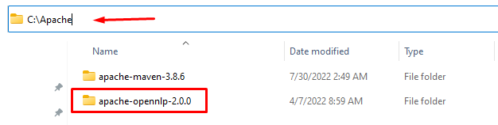
- Add OPENNLP_HOME in “System variables” and %OPENNLP_HOME%\bin to “Path”
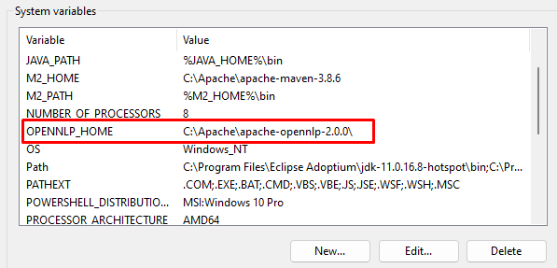
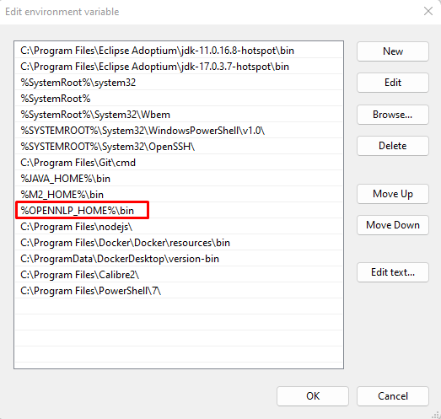
- In Command Prompt, check if OpenNLP was installed properly

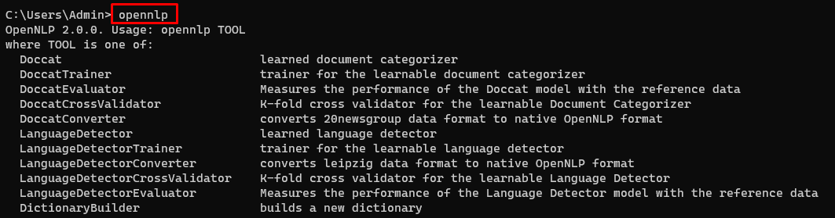
2. Configuration in Maven
Copy the following dependency into pom.xml file. Complete guide can be found at here
<!--https://opennlp.apache.org/maven-dependency-->
<dependency>
<groupId>org.apache.opennlp</groupId>
<artifactId>opennlp-tools</artifactId>
<version>2.0.0</version>
</dependency>

