**Date Submitted: 10/19/19**

**------------------------------------------------------------------------------------**

**Task 01:**

Youtube Link: <https://www.youtube.com/watch?v=tr27sTP2TSI>

**Modified Schematic (if applicable):**

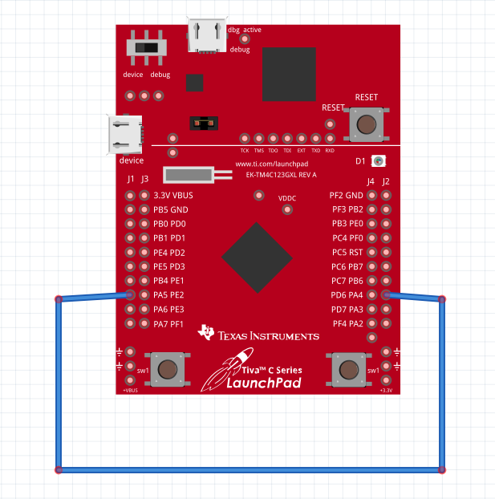

**Modified Code:**

**#include <stdint.h>**

**#include <stdbool.h>**

**#include <stdlib.h>**

**#include "inc/hw_memmap.h"**

**#include "inc/hw_ssi.h"**

**#include "inc/hw_types.h"**

**#include "driverlib/ssi.h"**

**#include "driverlib/gpio.h"**

**#include "driverlib/pin_map.h"**

**#include "driverlib/sysctl.h"**

**#include "utils/uartstdio.h"**

**#include "utils/uartstdio.c"**

**#include "driverlib/adc.h"**

**#include "inc/hw_ints.h"**

**#include "driverlib/interrupt.h"**

**#include "driverlib/debug.h"**

**#define NUM_SSI_DATA 2**

**void initADC(void)**

**{**

**SysCtlPeripheralEnable(SYSCTL_PERIPH_ADC0); // enable ADC0**

**ADCHardwareOversampleConfigure(ADC0_BASE, 32);**

**ADCSequenceConfigure(ADC0_BASE, 1, ADC_TRIGGER_PROCESSOR, 0);**

**ADCSequenceStepConfigure(ADC0_BASE, 1, 0, ADC_CTL_TS);**

**ADCSequenceStepConfigure(ADC0_BASE, 1, 1, ADC_CTL_TS);**

**ADCSequenceStepConfigure(ADC0_BASE, 1, 2, ADC_CTL_TS);**

**ADCSequenceStepConfigure(ADC0_BASE, 1, 3, ADC_CTL_TS|ADC_CTL_IE|ADC_CTL_END);**

**}**

**int main(void)**

**{**

**SysCtlClockSet(SYSCTL_SYSDIV_5|SYSCTL_USE_PLL|SYSCTL_OSC_MAIN|SYSCTL_XTAL_16MHZ); //40mhz clock**

**initADC();**

**//I had the following UART initialization lines in the init Console function**

**//but my program kept going to the FaultISR so I moved them to main and then it began working**

**// Enable GPIO port A which is used for UART0 pins.**

**SysCtlPeripheralEnable(SYSCTL_PERIPH_GPIOA);**

**// Configure the pin muxing for UART0 functions on port A0 and A1.**

**GPIOPinConfigure(GPIO_PA0_U0RX);**

**GPIOPinConfigure(GPIO_PA1_U0TX);**

**// Enable UART0 so that we can configure the clock.**

**SysCtlPeripheralEnable(SYSCTL_PERIPH_UART0);**

**// Use the internal 16MHz oscillator as the UART clock source.**

**UARTClockSourceSet(UART0_BASE, UART_CLOCK_PIOSC);**

**// Select the alternate (UART) function for these pins.**

**GPIOPinTypeUART(GPIO_PORTA_BASE, GPIO_PIN_0 | GPIO_PIN_1);**

**// Initialize the UART for console I/O.**

**UARTStdioConfig(0, 115200, 16000000);**

**// The SSI0 peripheral must be enabled for use.**

**SysCtlPeripheralEnable(SYSCTL_PERIPH_SSI0);**

**// Configure the pin muxing for SSI0 functions on port A2, A3, A4, and A5.**

**// This step is not necessary if your part does not support pin muxing.**

**GPIOPinConfigure(GPIO_PA2_SSI0CLK);**

**GPIOPinConfigure(GPIO_PA3_SSI0FSS);**

**GPIOPinConfigure(GPIO_PA4_SSI0RX);**

**GPIOPinConfigure(GPIO_PA5_SSI0TX);**

**// Configure the GPIO settings for the SSI pins. This function also gives**

**// control of these pins to the SSI hardware. Consult the data sheet to**

**// see which functions are allocated per pin.**

**// The pins are assigned as follows:**

**// PA5 - SSI0Tx**

**// PA4 - SSI0Rx**

**// PA3 - SSI0Fss**

**// PA2 - SSI0CLK**

**GPIOPinTypeSSI(GPIO_PORTA_BASE, GPIO_PIN_5 | GPIO_PIN_4 | GPIO_PIN_3 |**

**GPIO_PIN_2);**

**GPIOPinWrite(GPIO_PORTA_BASE, GPIO_PIN_4, GPIO_PIN_4);**

**// Configure and enable the SSI port for SPI master mode. Use SSI0,**

**// system clock supply, idle clock level low and active low clock in**

**// freescale SPI mode, master mode, 1MHz SSI frequency, and 8-bit data.**

**SSIClockSourceSet(SSI0_BASE, SSI_CLOCK_SYSTEM);**

**SSIConfigSetExpClk(SSI0_BASE, SysCtlClockGet(), SSI_FRF_MOTO_MODE_0,**

**SSI_MODE_MASTER, 1000000, 8);**

**// Enable the SSI0 module.**

**SSIEnable(SSI0_BASE);**

**// Display the setup on the console.**

**UARTprintf("SSI ->\r\n");**

**UARTprintf(" Mode: SPI\r\n");**

**UARTprintf(" Data: 8-bit\r\n\r\n");**

**//SSI variables**

**//uint32_t pui32DataTx[NUM_SSI_DATA];**

**uint32_t pui32DataRx[NUM_SSI_DATA];**

**uint32_t ui32Index;**

**//ADC variables**

**uint32_t ui32ADC0Value[4];**

**uint32_t ui32TempAvg;**

**uint32_t ui32TempValueC;**

**uint32_t ui32TempValueF;**

**char temperatureTx[10];**

**while(1)**

**{**

**while(SSIDataGetNonBlocking(SSI0_BASE, &pui32DataRx[0]))**

**{**

**}**

**// turn on ADC**

**ADCIntClear(ADC0_BASE, 1);**

**ADCSequenceEnable(ADC0_BASE, 1);**

**ADCProcessorTrigger(ADC0_BASE, 1);**

**while(!ADCIntStatus(ADC0_BASE, 1, false))**

**{**

**//wait until ADC finishes**

**}**

**//Get ADC values from SS1**

**ADCSequenceDataGet(ADC0_BASE, 1, ui32ADC0Value);**

**//Average and Calculate Temperature**

**ui32TempAvg = (ui32ADC0Value[0] + ui32ADC0Value[1] + ui32ADC0Value[2] + ui32ADC0Value[3] + 2)/4;**

**ui32TempValueC = (1475 - ((2475 * ui32TempAvg)) / 4096)/10;**

**ui32TempValueF = ((ui32TempValueC * 9) + 160) / 5;**

**//Convert Temperature to Character string**

**ltoa(ui32TempValueF, temperatureTx);**

**ADCSequenceDisable(ADC0_BASE, 0);**

**// Display indication that the SSI is transmitting data.**

**UARTprintf("\r\nSent:\r\n '");**

**// Send 2 bytes of data.**

**for(ui32Index = 0; ui32Index < NUM_SSI_DATA; ui32Index++)**

**{**

**// Display the data that SSI is transferring.**

**UARTprintf("%c", temperatureTx[ui32Index]);**

**// Send the data using the "blocking" put function. This function**

**// will wait until there is room in the send FIFO before returning.**

**SSIDataPut(SSI0_BASE, temperatureTx[ui32Index]);**

**}**

**UARTprintf("'F");**

**// Wait until SSI0 is done transferring all the data in the transmit FIFO**

**while(SSIBusy(SSI0_BASE))**

**{**

**}**

**UARTprintf("\r\nReceived:\r\n '");**

**// Receive 2 bytes of data.**

**for(ui32Index = 0; ui32Index < NUM_SSI_DATA; ui32Index++)**

**{**

**// Receive the data using the "blocking" Get function. This function**

**// will wait until there is data in the receive FIFO before returning.**

**SSIDataGet(SSI0_BASE, &pui32DataRx[ui32Index]);**

**// Since we are using 8-bit data, mask off the MSB.**

**pui32DataRx[ui32Index] &= 0x00FF;**

**// Display the data that SSI0 received.**

**UARTprintf("%c", pui32DataRx[ui32Index]);**

**}**

**UARTprintf("'F");**

**SysCtlDelay(5000000);**

**}**

**}**

**------------------------------------------------------------------------------------**

**Task 02:**

Youtube Link: <https://www.youtube.com/watch?v=f2ms46w2_4c>

**Modified Schematic (if applicable):**

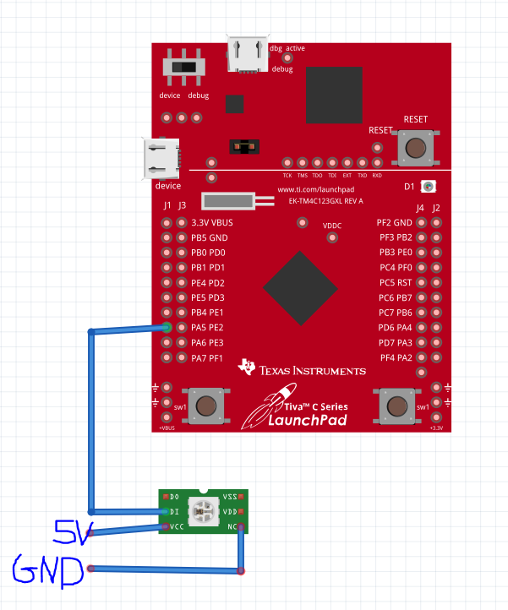

**Used single LED since fritzing doesn’t have the WS2818 model.**

**Modified Code:**

**#include <stdint.h>**

**#include <stdbool.h>**

**#include <stdlib.h>**

**#include "inc/hw_memmap.h"**

**#include "inc/hw_ssi.h"**

**#include "inc/hw_types.h"**

**#include "driverlib/ssi.h"**

**#include "driverlib/gpio.h"**

**#include "driverlib/fpu.h"**

**#include "driverlib/rom.h"**

**#include "driverlib/pin_map.h"**

**#include "driverlib/sysctl.h"**

**#include "utils/uartstdio.h"**

**#include "utils/uartstdio.c"**

**#include "driverlib/debug.h"**

**#define NUM_LEDS 8**

**uint8_t frame_buffer[NUM_LEDS*3];**

**void send_data(uint8_t* data, uint8_t num_leds);**

**void fill_frame_buffer(uint8_t r, uint8_t g, uint8_t b, uint32_t num_leds);**

**static volatile uint32_t ssi_lut[] = {**

**0b100100100,**

**0b110100100,**

**0b100110100,**

**0b110110100,**

**0b100100110,**

**0b110100110,**

**0b100110110,**

**0b110110110**

**};**

**int main(void) {**

**FPULazyStackingEnable();**

**// 80MHz**

**SysCtlClockSet(SYSCTL_SYSDIV_2_5 | SYSCTL_USE_PLL | SYSCTL_XTAL_16MHZ |**

**SYSCTL_OSC_MAIN);**

**SysCtlPeripheralEnable(SYSCTL_PERIPH_GPIOA);**

**SysCtlDelay(50000);**

**SysCtlPeripheralEnable(SYSCTL_PERIPH_SSI0);**

**SysCtlDelay(50000);**

**GPIOPinConfigure(GPIO_PA5_SSI0TX);**

**GPIOPinConfigure(GPIO_PA2_SSI0CLK);**

**GPIOPinConfigure(GPIO_PA4_SSI0RX);**

**GPIOPinConfigure(GPIO_PA3_SSI0FSS);**

**GPIOPinTypeSSI(GPIO_PORTA_BASE, GPIO_PIN_5);**

**GPIOPinTypeSSI(GPIO_PORTA_BASE, GPIO_PIN_2);**

**GPIOPinTypeSSI(GPIO_PORTA_BASE, GPIO_PIN_4);**

**GPIOPinTypeSSI(GPIO_PORTA_BASE, GPIO_PIN_3);**

**//20 MHz data rate**

**SSIConfigSetExpClk(SSI0_BASE, 80000000, SSI_FRF_MOTO_MODE_0, SSI_MODE_MASTER, 2400000, 9);**

**SSIEnable(SSI0_BASE);**

**while(1)**

**{**

**fill_frame_buffer(255, 0, 0, NUM_LEDS);**

**send_data(frame_buffer, NUM_LEDS);**

**fill_frame_buffer(0, 255, 0, NUM_LEDS);**

**send_data(frame_buffer, NUM_LEDS);**

**fill_frame_buffer(0, 0, 255, NUM_LEDS);**

**send_data(frame_buffer, NUM_LEDS);**

**fill_frame_buffer(255, 255, 0, NUM_LEDS);**

**send_data(frame_buffer, NUM_LEDS);**

**fill_frame_buffer(255, 0, 255, NUM_LEDS);**

**send_data(frame_buffer, NUM_LEDS);**

**fill_frame_buffer(0, 255, 255, NUM_LEDS);**

**send_data(frame_buffer, NUM_LEDS);**

**fill_frame_buffer(255, 255, 255, NUM_LEDS);**

**send_data(frame_buffer, NUM_LEDS);**

**}**

**return 0;**

**}**

**void send_data(uint8_t* data, uint8_t num_leds)**

**{**

**uint32_t i, j, curr_lut_index, curr_rgb;**

**for(i = 0; i < (num_leds*3); i = i + 3) {**

**curr_rgb = (((uint32_t)data[i + 2]) << 16) | (((uint32_t)data[i + 1]) << 8) | data[i];**

**for(j = 0; j < 24; j = j + 3) {**

**curr_lut_index = ((curr_rgb>>j) & 0b111);**

**SSIDataPut(SSI0_BASE, ssi_lut[curr_lut_index]);**

**}**

**}**

**SysCtlDelay(5000000); //delay**

**}**

**void fill_frame_buffer(uint8_t r, uint8_t g, uint8_t b, uint32_t num_leds)**

**{**

**uint32_t i;**

**uint8_t* frame_buffer_index = frame_buffer;**

**for(i = 0; i < num_leds; i++) {**

**\*(frame_buffer_index++) = g;**

**\*(frame_buffer_index++) = r;**

**\*(frame_buffer_index++) = b;**

**}**

**}**

**------------------------------------------------------------------------------------**