**Date Submitted: 10/20/19**

**------------------------------------------------------------------------------------**

**Task 01:**

Youtube Link: None

**Modified Schematic (if applicable): N/A**

**Modified Code:**

**#include <stdint.h>**

**#include <stdbool.h>**

**#include <stdlib.h>**

**#include <math.h>**

**#include "inc/hw_memmap.h"**

**#include "inc/hw_types.h"**

**#include "driverlib/gpio.h"**

**#include "driverlib/pin_map.h"**

**#include "driverlib/fpu.h"**

**#include "driverlib/sysctl.h"**

**#include "driverlib/debug.h"**

**#include "driverlib/rom.h"**

**#ifndef M_PI**

**#define M_PI 3.14159265358979323846**

**#endif**

**#define SERIES_LENGTH 100**

**float gSeriesData[SERIES_LENGTH]; //Define array for sine values**

**int32_t i32DataCount = 0; //Counter for sine wave**

**int main(void)**

**{**

**float fRadians;**

**//Enable Lazy Stack**

**ROM_FPULazyStackingEnable();**

**//Turn on FPU**

**ROM_FPUEnable();**

**//Set Clock to 50MHz**

**ROM_SysCtlClockSet(SYSCTL_SYSDIV_4 | SYSCTL_USE_PLL | SYSCTL_XTAL_16MHZ | SYSCTL_OSC_MAIN);**

**//(2pi rads)/ 100 to get full cycle of sine wave**

**fRadians = ((2 * M_PI) / SERIES_LENGTH);**

**//loop until sine wave is calculated**

**while(i32DataCount < SERIES_LENGTH)**

**{**

**gSeriesData[i32DataCount] = sinf(fRadians * i32DataCount); //calculate sine wave values**

**i32DataCount++; //get next data value**

**}**

**while(1)**

**{**

**//loop continuously**

**}**

**}**

**------------------------------------------------------------------------------------**

**Task 02:**

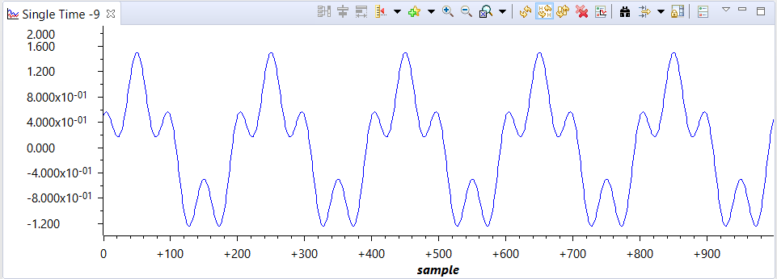Youtube Link: None

**Modified Schematic (if applicable): N/A**

**Modified Code:**

**#include <stdint.h>**

**#include <stdbool.h>**

**#include <stdlib.h>**

**#include <math.h>**

**#include "inc/hw_memmap.h"**

**#include "inc/hw_types.h"**

**#include "driverlib/gpio.h"**

**#include "driverlib/pin_map.h"**

**#include "driverlib/fpu.h"**

**#include "driverlib/sysctl.h"**

**#include "driverlib/debug.h"**

**#include "driverlib/rom.h"**

**#ifndef M_PI**

**#define M_PI 3.14159265358979323846**

**#endif**

**#define SERIES_LENGTH 200**

**float gSeriesData[SERIES_LENGTH*5]; //Define array for sine values**

**int32_t i32DataCount = 0; //Counter for sine wave**

**int main(void)**

**{**

**float fRadians;**

**//Enable Lazy Stack**

**ROM_FPULazyStackingEnable();**

**//Turn on FPU**

**ROM_FPUEnable();**

**//Set Clock to 50MHz**

**ROM_SysCtlClockSet(SYSCTL_SYSDIV_4 | SYSCTL_USE_PLL | SYSCTL_XTAL_16MHZ | SYSCTL_OSC_MAIN);**

**fRadians = ((2 * M_PI) / SERIES_LENGTH);**

**//loop until sine wave is calculated**

**while(i32DataCount < SERIES_LENGTH*5)**

**{**

**gSeriesData[i32DataCount] = sinf(fRadians * i32DataCount) + .5 * cosf(fRadians * 4 * i32DataCount); //calculate values**

**i32DataCount++;**

**}**

**while(1)**

**{**

**//loop continuously**

**}**

**}**

**------------------------------------------------------------------------------------**