Steps: (Video: <https://www.youtube.com/watch?v=FwMwO8pXfq0>)

1. Goto <https://www.mongodb.com/download-center/community>
2. Select OS to Windows x64, Click on Download.

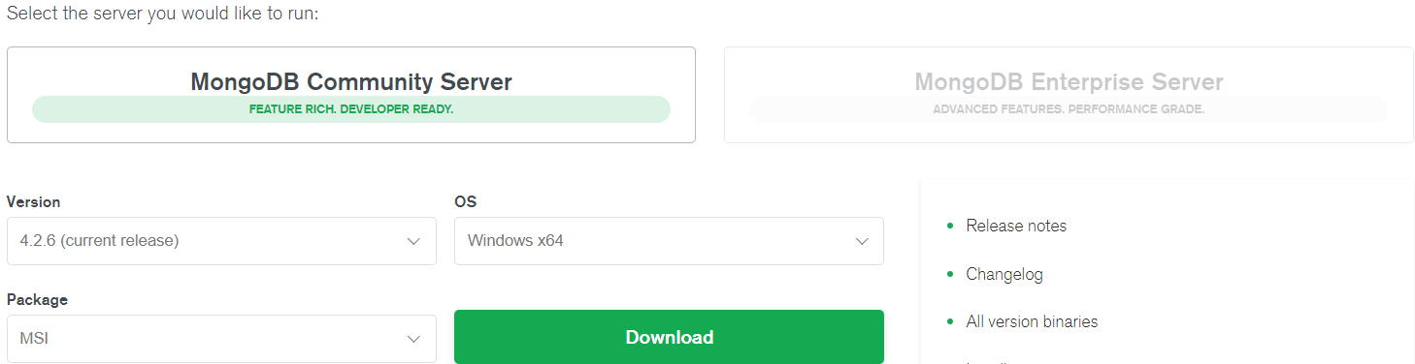

1. Double click on the downloaded file.
2. Click on Next.

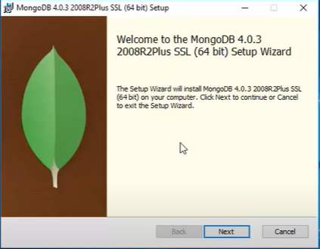

1. Accept the license and click on Next.

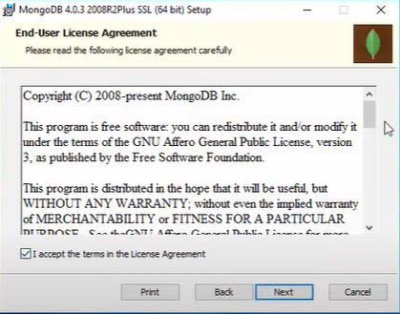

Select Complete and click on Next.

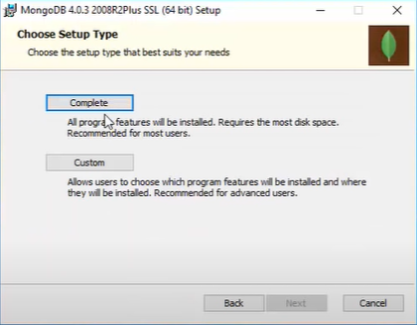

1. Leave as delfault and click on Next, Next and click on Finish.

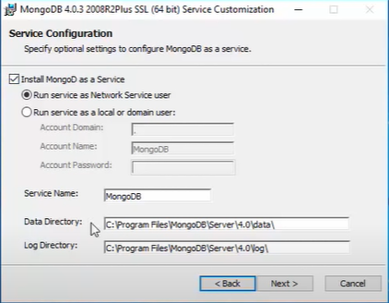

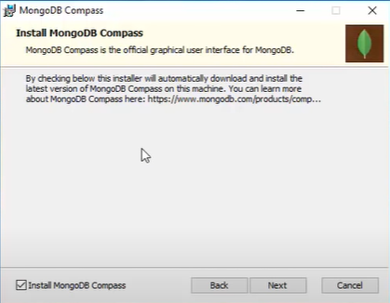

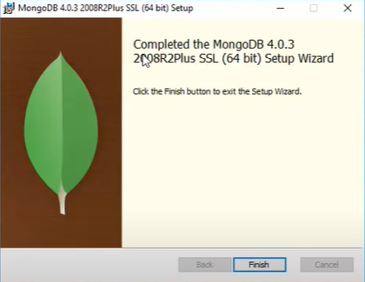

1. Please follow the below video for remaining steps:

<https://www.youtube.com/watch?v=FwMwO8pXfq0>