How to configure the MongoDB Atlas:

1. Open the below url.

<https://www.mongodb.com/cloud/atlas/lp/try2?utm_source=google&utm_campaign=gs_apac_india_search_brand_atlas_desktop&utm_term=mongodb%20atlas&utm_medium=cpc_paid_search&utm_ad=e&gclid=EAIaIQobChMI9ouokqe86QIVQlRgCh0NRgstEAAYASAAEgJ-evD_BwE>

1. Click on start free.

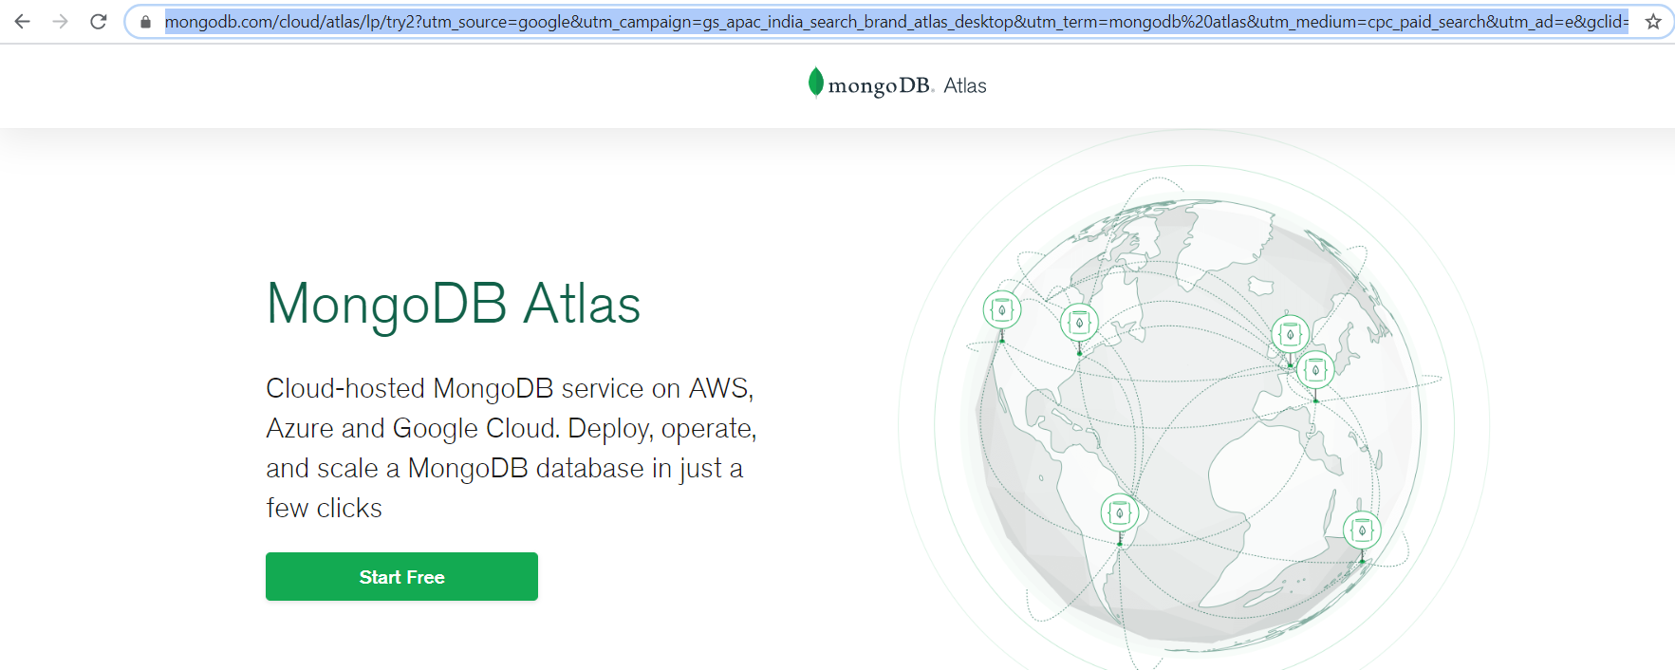

1. Please provide the signup details.

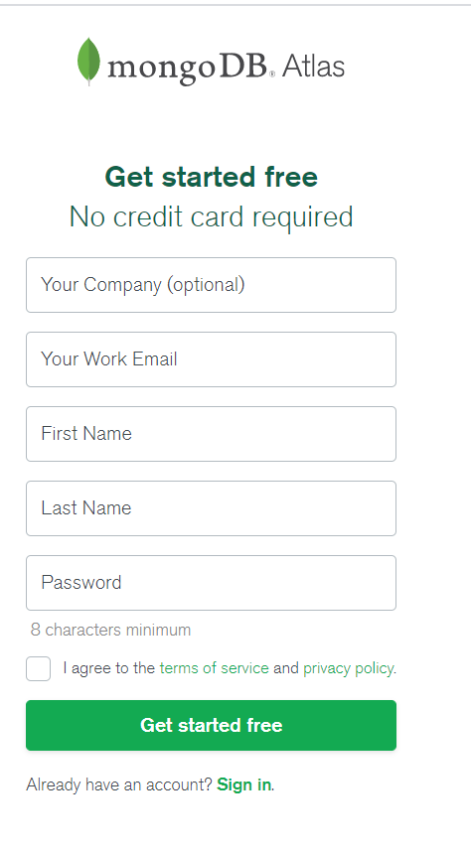

1. Then you will be sign in into MangoDB and it will ask you for cluster type. Here I have selected “Create cluster for free”

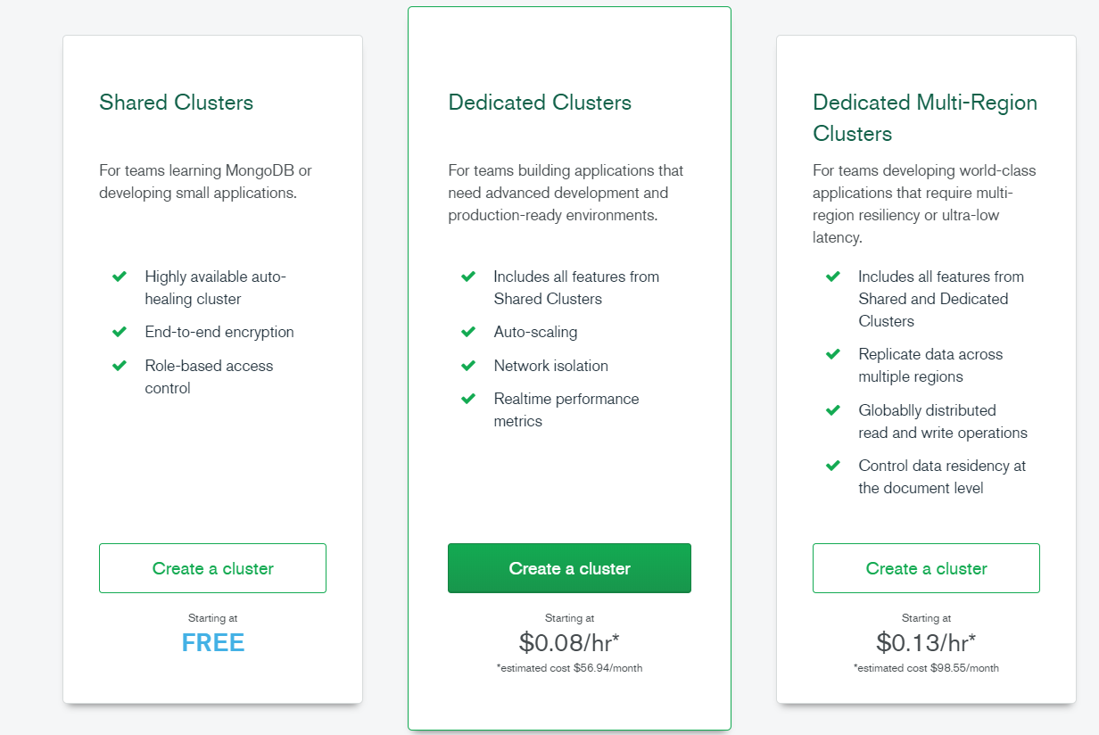

1. Then it will ask you cloud provider and region. Select your provider and region click on create. It will take few mins to create the cluster.

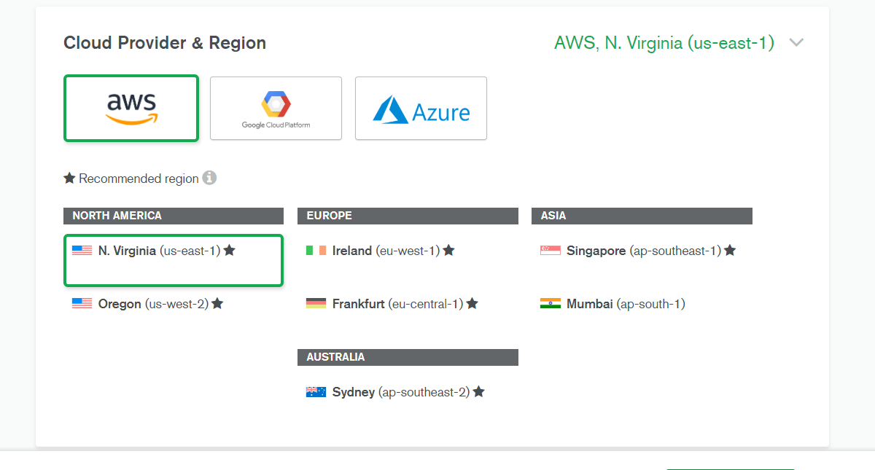

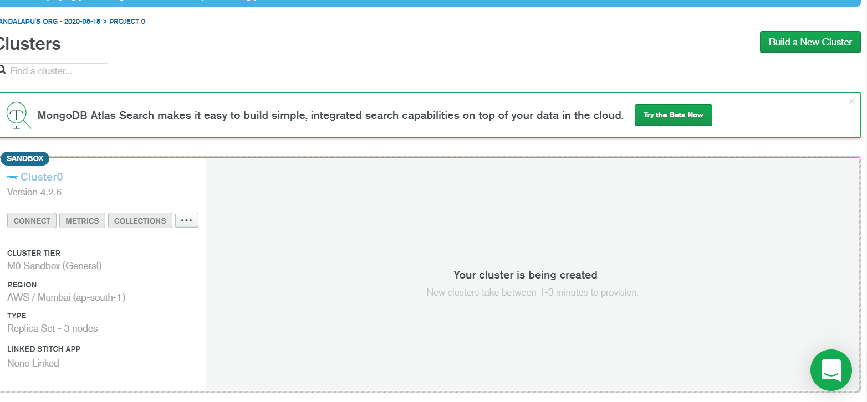

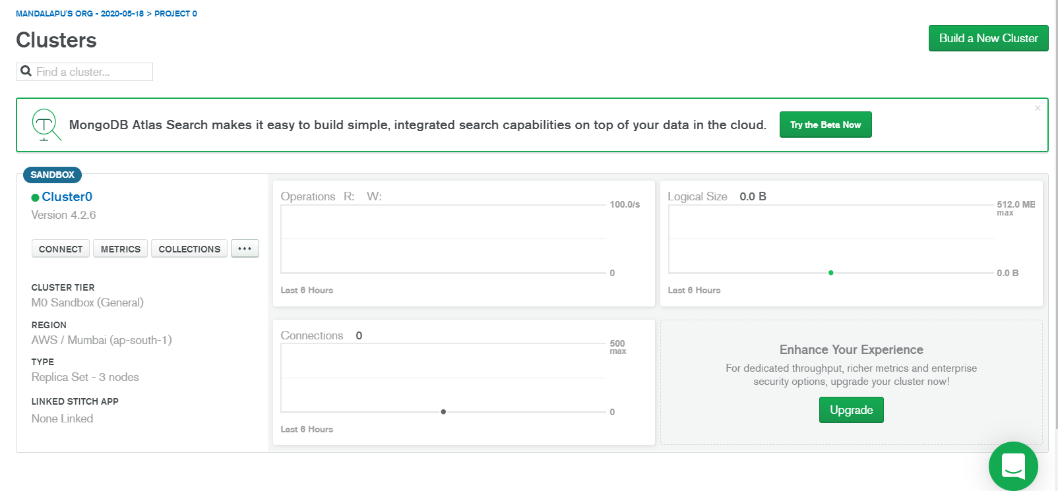

1. Then click on cluster name. select collections.

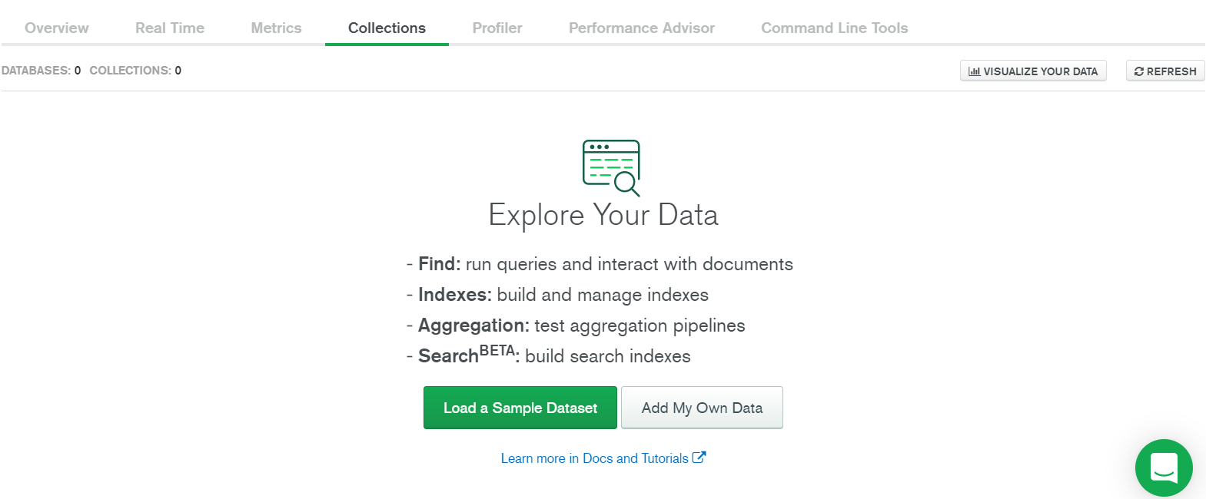

1. Here you can select as you required. I selected load sample dataset, then it is create the sample db’s and sample collections. This will take few mins to completed.

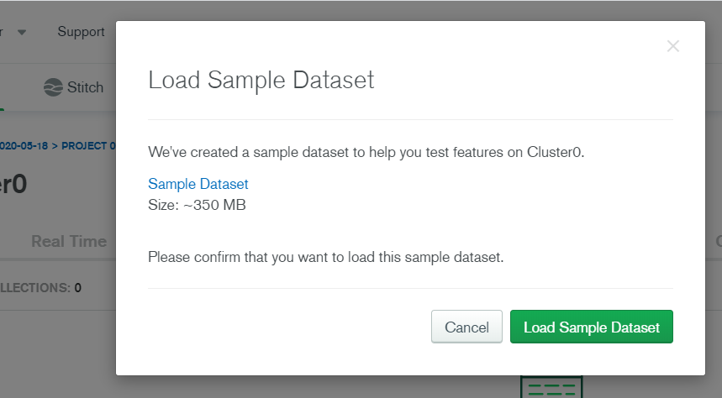

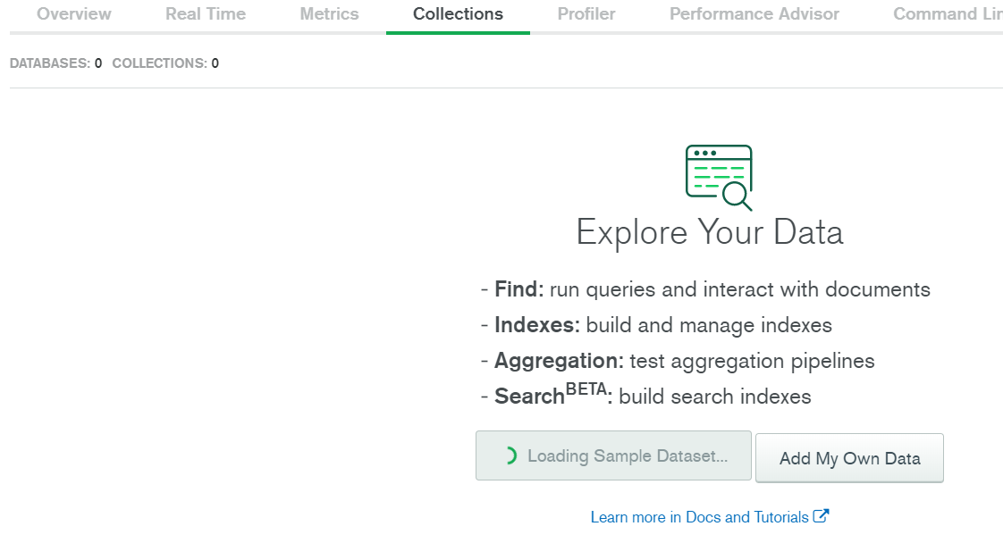

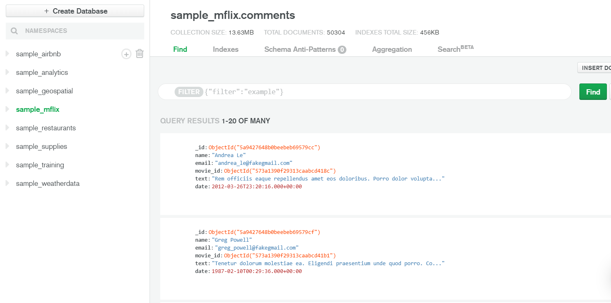

8.to give the access to users. Please click on “database access” in security.

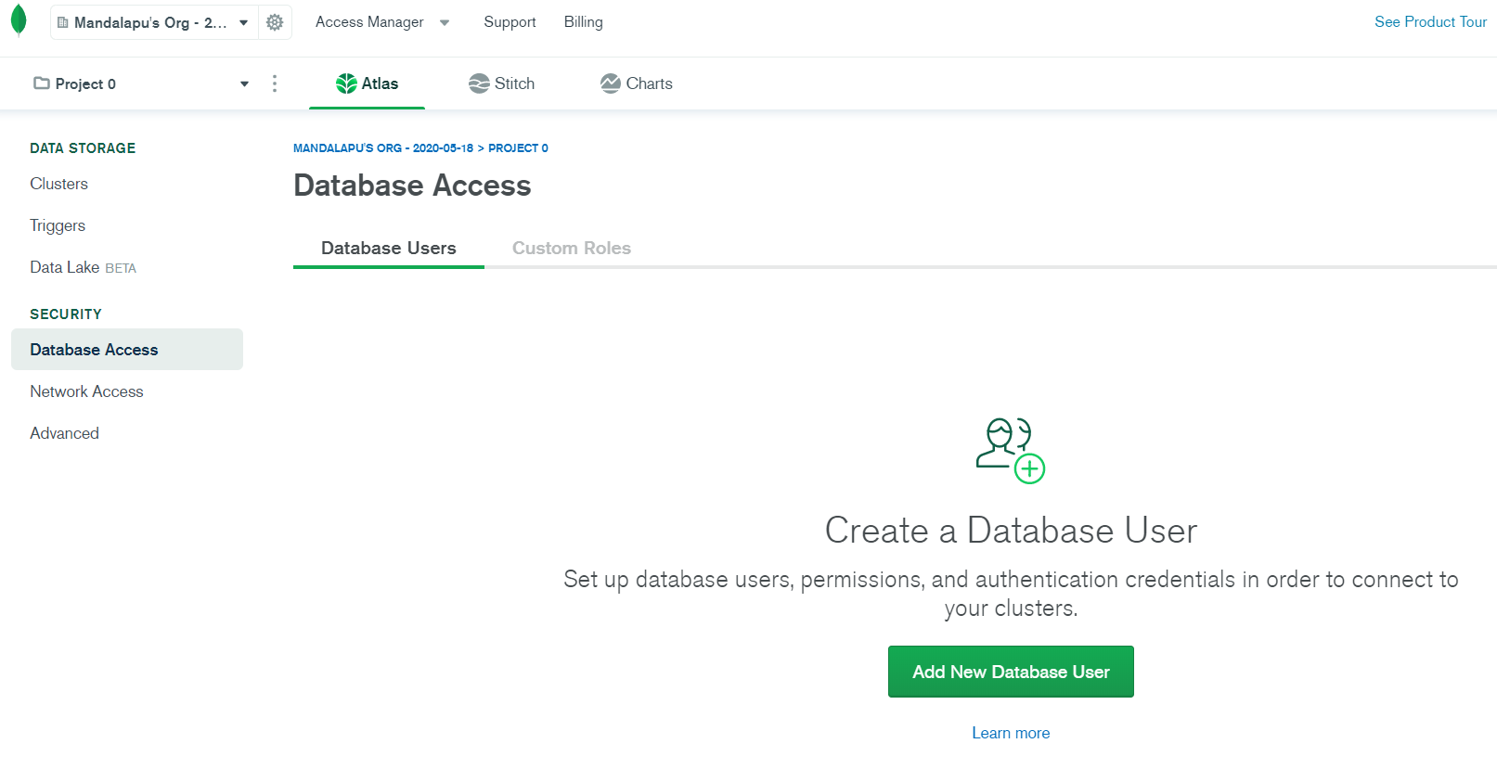

1. Click on add new database user then you can add username and password.

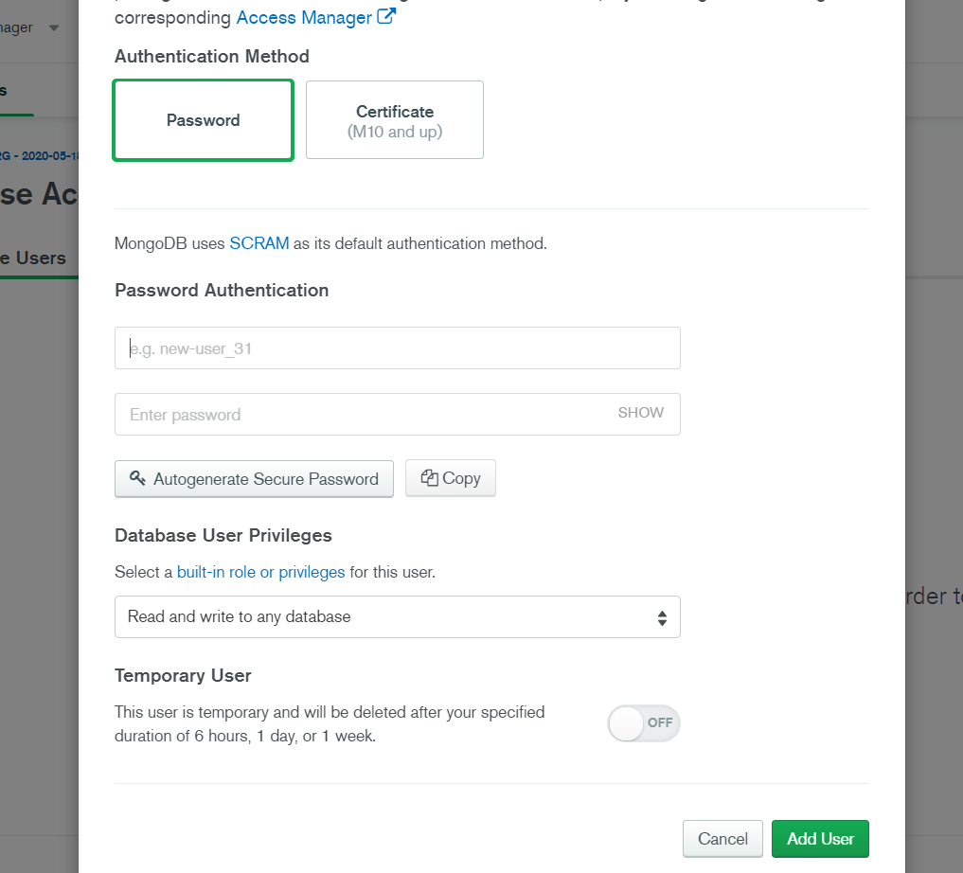

If you click on “Autogenarate secure Password”. It will generate the auto generated password for user authentication.

1. Also you can select user privileges as required.

**Network access: -**

You cann’t access the database if you are not configure the net access. For this

1. Click on the “network access” in security. An you can add your white list IP’s. to access the DB.

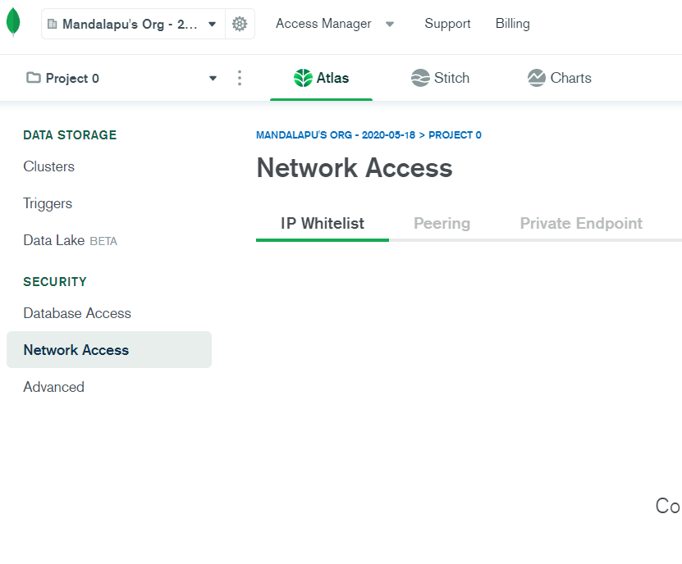

If you want allow the all IP’s please click on “Allow access from anywhere”

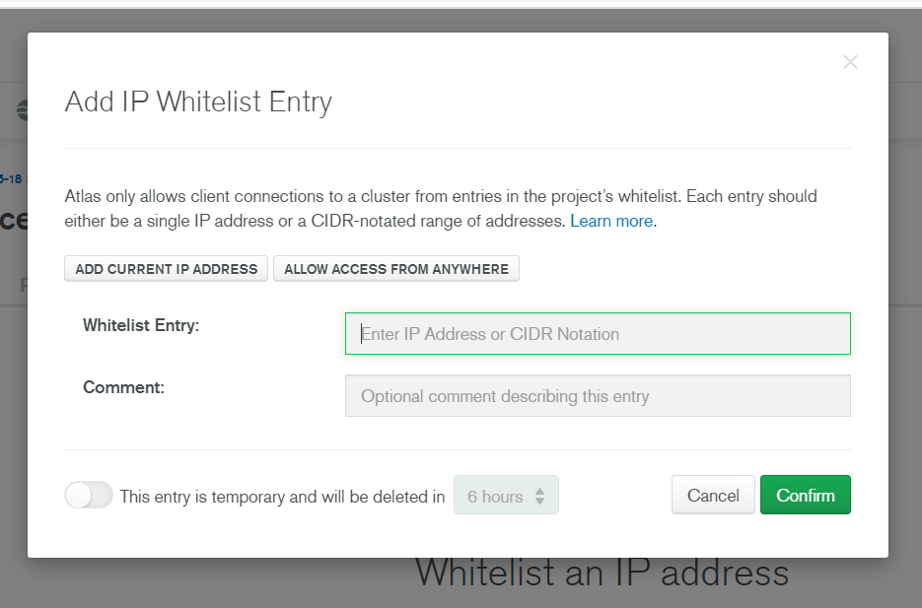

To know your DB connection string.

1. Click on “Cluster name” and select “command line tools”.

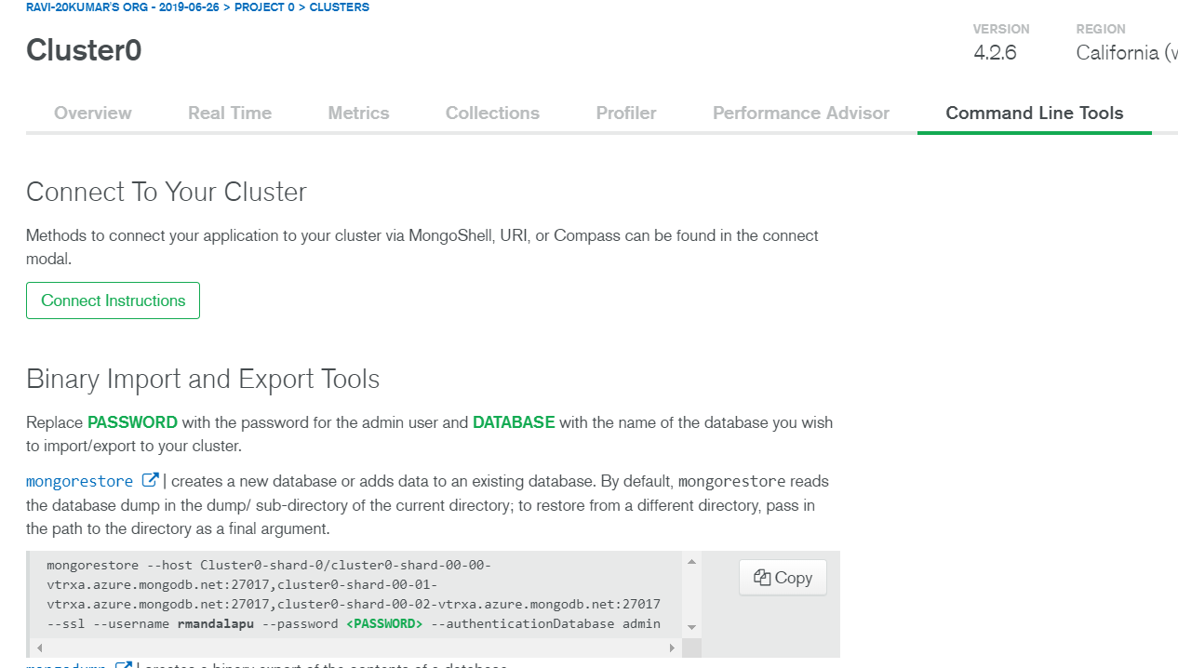

1. Click on Connect Instructions and select your access method. Based on that it will give you the connection string.

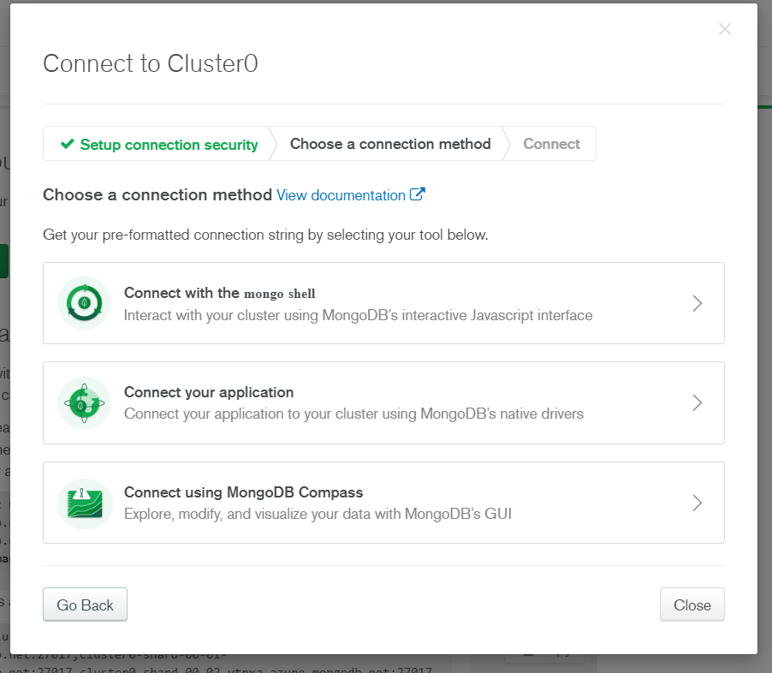

Ex:- if I selected the “connect your application” it will give you the connection string as below. You can add your username and password then you can use it for application connectivity.

