**csvfile2mongodb: -**

Executed below command on command prompt to run batch

spark-submit --packages org.mongodb.spark:mongo-spark-connector_2.11:2.4.1 D:\NisumCopy\ingestionframework\src\main.py D:\NisumCopy\ingestionframework\src\resources\config_sample_csvfile2mongodb.json

Configure file:-

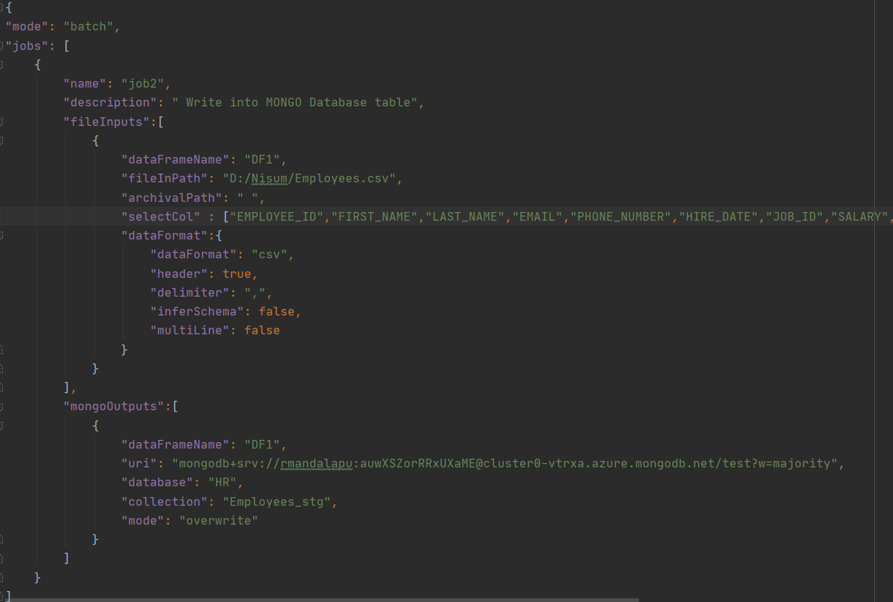

Status of Batch is:-

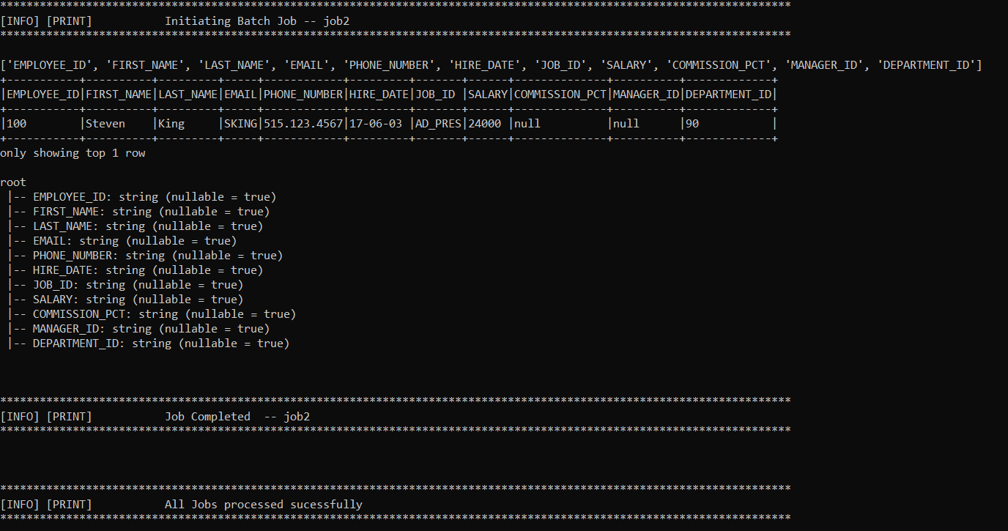

Result:-

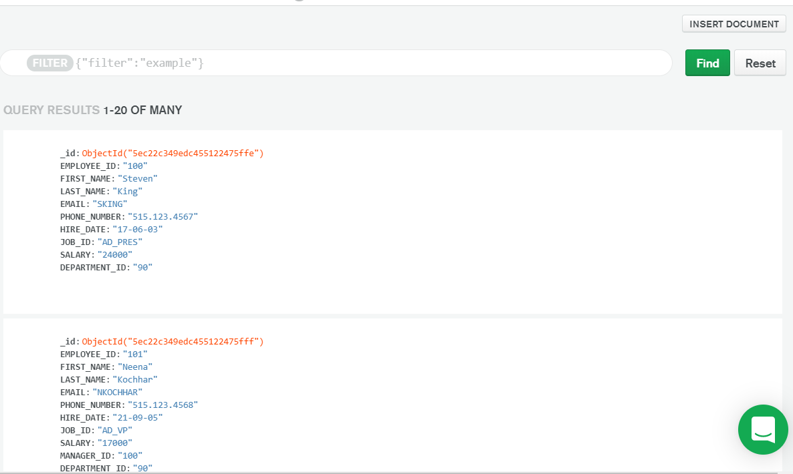

**Mongodb2 csvfile: -**

Executed command :-

spark-submit --packages org.mongodb.spark:mongo-spark-connector_2.11:2.4.1 D:\NisumCopy\ingestionframework\src\main.py D:\NisumCopy\ingestionframework\src\resources\config_sample_mongodb2csvfile.json

Config File:-

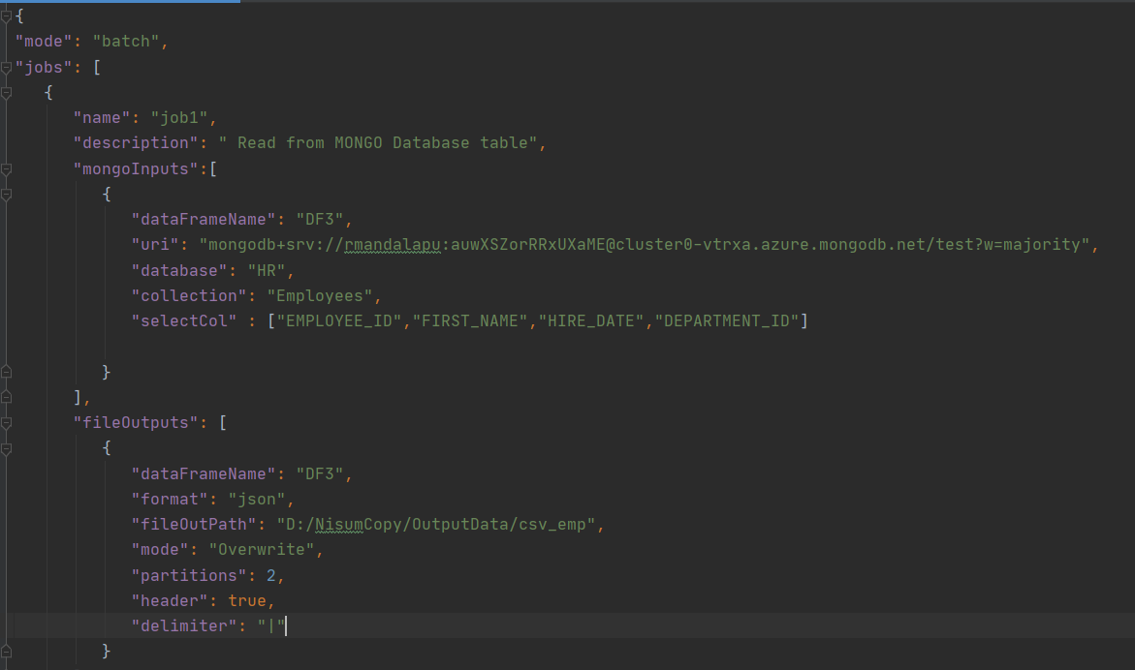

Batch status is:-

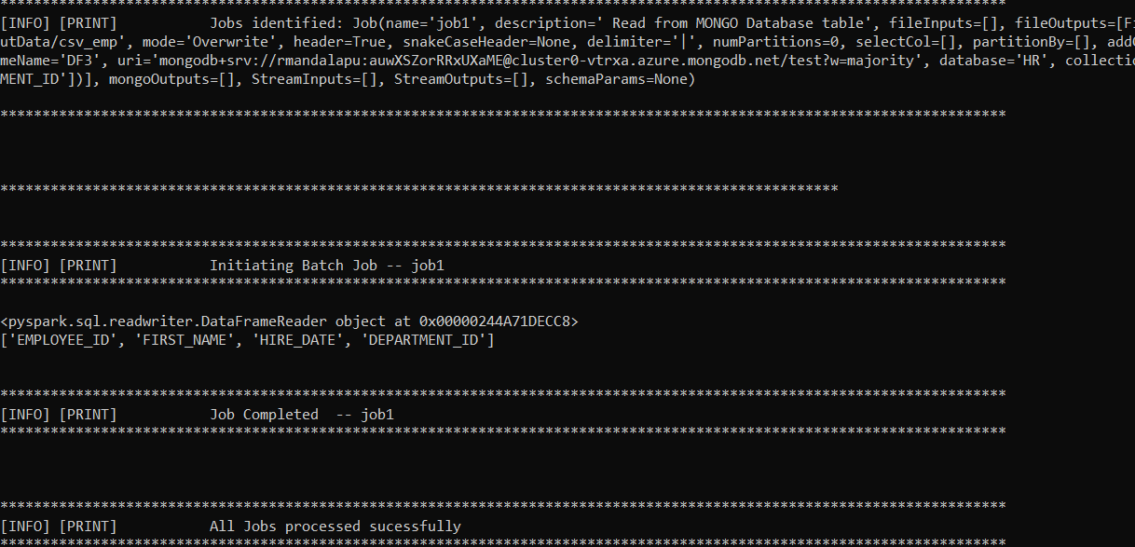

Result:-

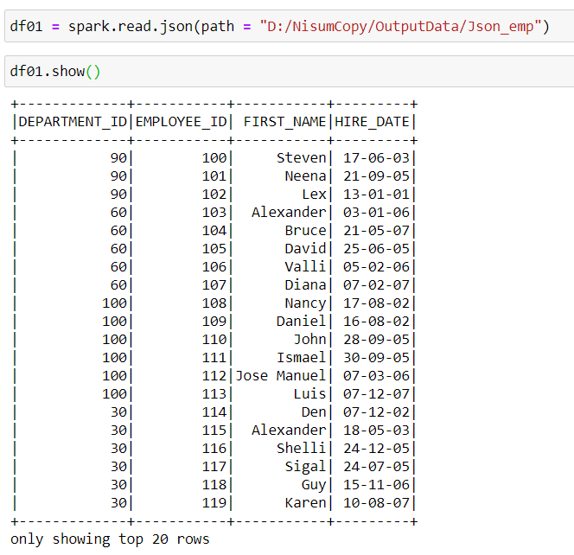

Mongodb2Jsonfile:-

Executed command:-

spark-submit --packages org.mongodb.spark:mongo-spark-connector_2.11:2.4.1 D:\NisumCopy\ingestionframework\src\main.py D:\NisumCopy\ingestionframework\src\resources\config_sample_mongodb2Jsonfile.json

Config file:-

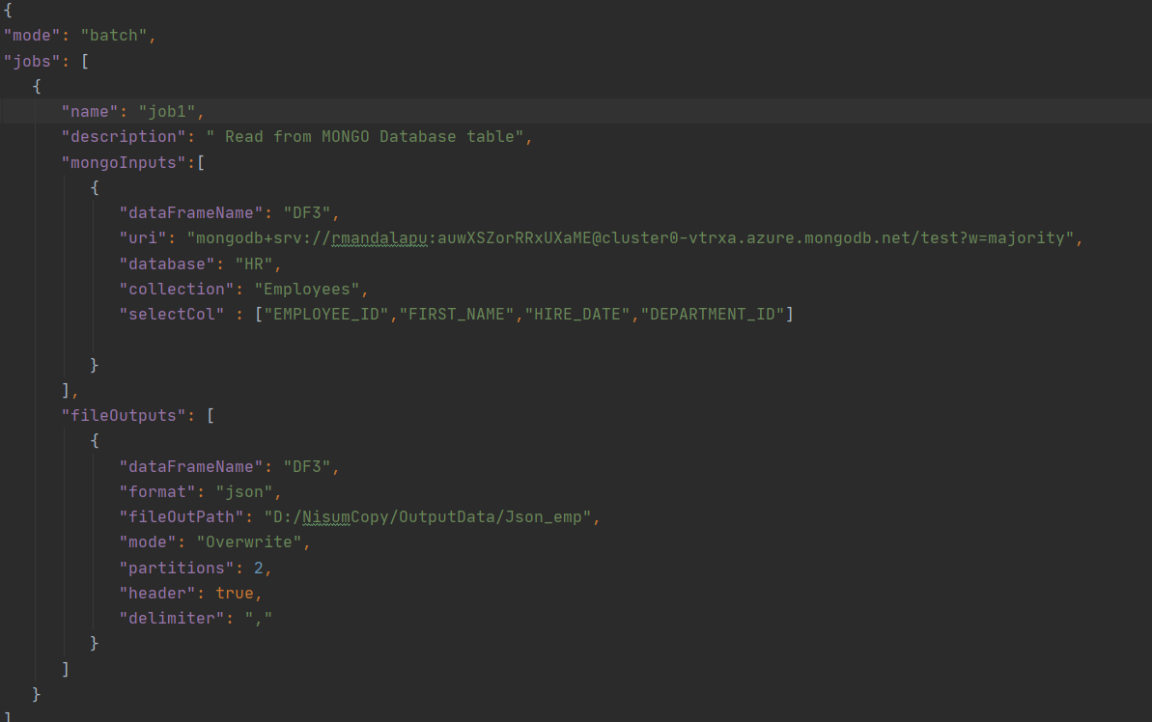

Batch status:-

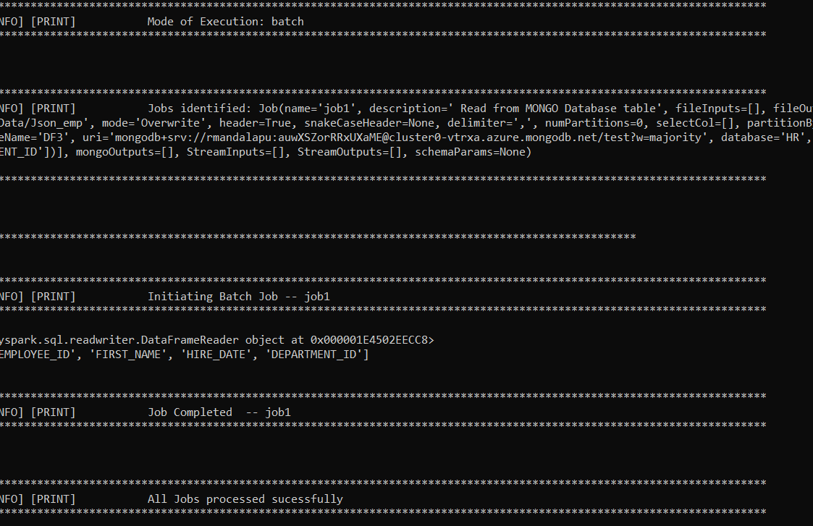

Result:-

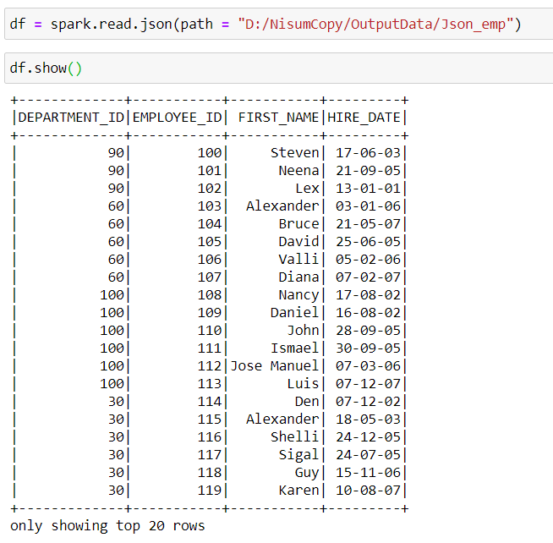

**Jsonfile2mongodb: -**

Executed command: -

spark-submit --packages org.mongodb.spark:mongo-spark-connector_2.11:2.4.1 D:\NisumCopy\ingestionframework\src\main.py D:\NisumCopy\ingestionframework\src\resources\config_sample_Jsonfile2mongodb.json

Config file:-

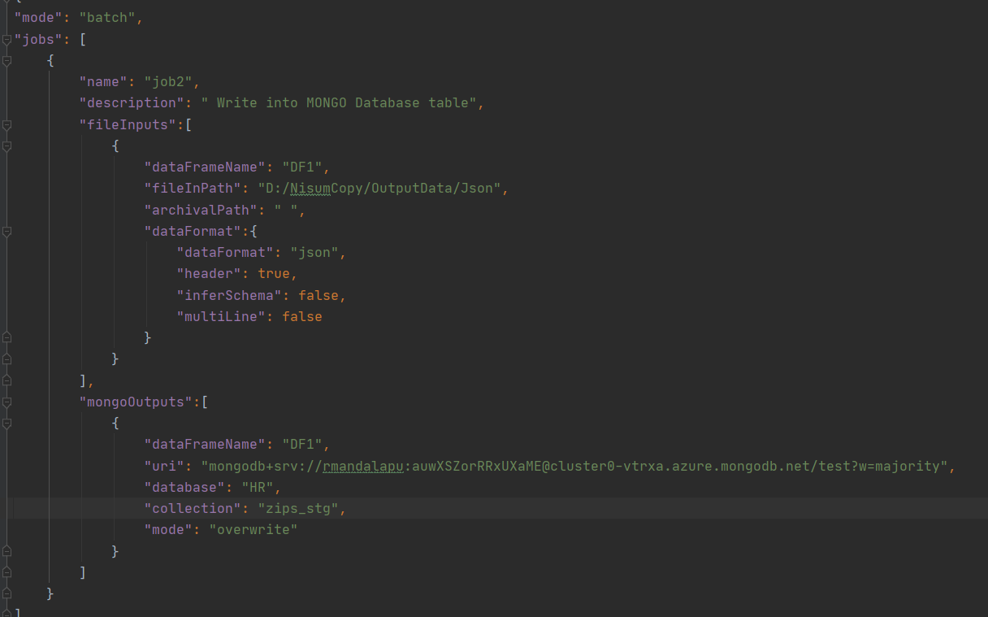

Batch status: -

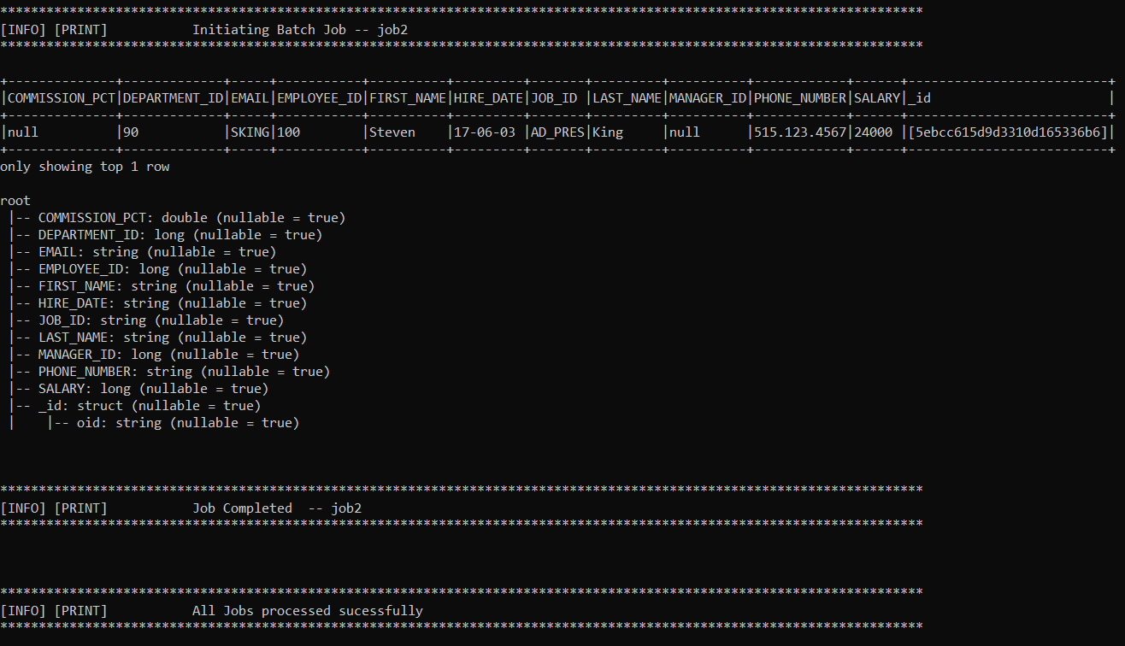

Result:-

