Domain-specific working memory loads selectively increase negative interpertations of surprised facial expressions

|  |
| --- |
| Nicholas R. Harp1 & Maital Neta1 |
| 1 University of Nebraska-Lincoln |
|  |

# Author note

Correspondence concerning this article should be addressed to Nicholas R. Harp. E-mail: [nharp@huskers.unl.edu](mailto:nharp@huskers.unl.edu)

Domain-specific working memory loads selectively increase negative interpretations of surprised facial expressions

# Introduction

## Facial expressions and individual differences

Facial expressions are important social signals; they communicate emotion between individuals and even spark emotional responses in others (Frith, 2009). Researchers have long argued that facial expressions are universal signals of emotion, positing humans’ innate ability to associate facial expressions with emotional experience (Darwin, 1872; Ekman & Friesen, 1971; Izard, 1994). More recently, Barrett and colleagues suggested that the relationship between facial expressions and emotions is more complex, stating that facial expression of an emotion may vary across cultures, social context, or even individuals (Barrett, Adolphs, Marsella, Martinez, & Pollak, 2019). Other work has shown individual differences in interpretations of facial expressions (Green & Guo, 2018; Neta, Norris, & Whalen, 2009). Regardless of this variability in emotional expressions, experience, and interpretations, humans readily make judgments about personality traits (e.g., trustworthiness), aesthetics (e.g., attractiveness), and emotions from faces (Carroll & Russell, 1996; Said & Todorov, 2011; Todorov, Baron, & Oosterhof, 2008). Interpretations of valence (i.e., the inherent positive or negative emotional value of a stimulus) are one instance of judgments of facial expressions guiding potential social (i.e., approach-avoidance) behavior (Krieglmeyer, Deutsch, De Houwer, & De Raedt, 2010).

While most people can accurately differentiate the emotional valence of many facial expressions, such as consistently interpreting angry (happy) faces as negative (positive), there are individual differences in valence judgments of emotionally ambiguous facial expressions, like a surprised face (Neta et al., 2009; Petro, Tong, Henley, & Neta, 2018 ). This difference in valence interpretations of surprised expressions is attributable to such stimuli’s predictive value for both positive and negative outcomes in an individual’s previous experience. For instance, a surprised expression could signal positive (e.g., winning the lottery) or negative (e.g., a car accident) events. These differences in valence interpretations represent an important individual difference, as the same stimulus can result in two alternative interpretations between individuals–likely leading to different downstream behaviors (e.g., Krieglmeyer et al., 2010). This individual difference in interpretations of emotionally ambiguous stimuli is known as one’s *valence bias*, and a growing body of work has used both facial expressions and scenes to better understand this individual difference (Neta, Kelley, & Whalen, 2013; Neta et al., 2009; Neta & Whalen, 2010).

Despite one’s valence bias, the initial response to ambiguity appears to be negativity (Neta, Davis, & Whalen, 2011; Neta et al., 2009; Neta & Whalen, 2010; Petro et al., 2018). Under this framework, which is known as the *initial negativity* hypothesis, positive interpretations rely on the implementation of some emotion regulation strategy, perhaps similar to cognitive reappraisal. During cognitive reappraisal, individuals work to change intial perceptions of an emotional stimulus (Lazarus & Alfert, 1964). Similarly, the initial negativity hypothesis posits that individuals’ initial perception of surprised expressions is negative, and that those arriving at a positive interpretation must implement a regulatory mechanism to alter their interpretation.

Behavioral evidence supports the initial negativity hypothesis. For instance, reaction time data show that individuals with more positive biases take longer to reach a valence judgment for surprised expressions than those with a more negative bias (Neta et al., 2009), suggesting a more time-intensive (regulatory) process for positive interpretations. Other work demonstrates the faster and default nature of negative interpretations through manipulating the spatial frequency of images of surprised expressions. The images with only low spatial frequency information, which is processed earlier than high spatial frequency information, were rated more negatively than the high spatial frequency images (Neta & Whalen, 2010). Additionally, surprised facial expressions are more quickly detected in an emotional oddball paradigm among happy (positive) than angry (negative) faces (Neta et al., 2011), suggesting that surprised expressions are more readily perceived as similar to angry faces (i.e., perceived as negative) than happy faces.

There is also support for the initial negativity hypothesis in neuroimaging studies. Ventromedial prefrontal cortex, a putative regulatory region, and amygdala actively are inversely correlated, and participants with more negative biases show higher activity in the amygdala while more positive participants show higher activity in vmPFC (Kim, Somerville, Johnstone, Alexander, & Whalen, 2003). More recently, Petro and colleagues (2018) showed that participants with a more positive valence bias show more activity for surprised faces in emotion regulation-related brain regions (vmPFC).Taken together, both behavioral and brain data support the notion that negative interpretations of surprised faces are a faster, default process and positive interpretations rely on slower regulatory processes, which may be susceptible to demands from other cognitive processes.

## Cognitive loads and task interference

In daily life, cognitive resources are often shared among several processes as stimuli compete for our attention. For example, imagine a student attending a lecture. If the student is frequently distracted by notifications and directing cognitive resources towards a text message conversation or computer applications, then the student’s ability to understand and remember the lecture will likely suffer. Indeed, cognitive resource competition leads to a phenomenon known as cognitive load, which negatively impacts executive processes (Lavie, Hirst, Fockert, & Viding, 2004; Murphy, Groeger, & Greene, 2016). High levels of cognitive load alter performance on a variety of tasks, including those in both cognitive and emotional domains (Jiaping et al., 2017; Kron, Schul, Cohen, & Hassin, 2010; Nagamatsu et al., 2011; Pontari & Schlenker, 2000; Thomas, Donohue-Porter, & Stein Fishbein, 2017). Working memory tasks, which require participants to maintain some stimulus representation in working memory, are often used for testing cognitive load effects (e.g., Burnham, 2010; Lavie & De Fockert, 2005; or see Murphy et al., 2016 for a review).

The cognitive demands of active working memory maintenance often interact with concurrent affective processes (e.g., face categorization, subjective emotional experience), perhaps as a result of a shared resource pool for these processes. For instance, Ahmed (2018) showed that performance on a facial expression categorization task suffers when participants are under high cognitive load. Other work has linked cognitive load to changes in emotional responses (Blair et al., 2007; Van Dillen, Heslenfeld, & Koole, 2009). For example, higher loads during a working memory task reduce subjective emotional experience, as well as amygdala activity (Van Dillen et al., 2009). Other neuroimaging work has shown that Stroop interference effects were exaggerated during trials temporally surrounded by emotional stimuli, while emotional responses in the brain (i.e., amygdala and inferior frontal gyrus activation) were lower during trials with Stroop task demands compared to trials with no concurrent task demands (Blair et al., 2007). Other work highlights the importance of cognitive load task characteristics on a syllogistic reasoning task, demonstrating that participants perform worse on tasks with emotional, rather than neutral, content when under high cognitive load (Trémolière, Gagnon, & Blanchette, 2016). Together, these effects suggest an overlap between cognitive demands and emotional processes, with high cognitive demands interfering with typical emotion processing.

Previous work has tested the effects of cognitive load on valence bias to assess both subjective ratings of surprise and the underlying cognitive-motor dynamics of the ratings via mousetracking. While there was no effect of load on subjective interpretations of surprised expressions, participants did show altered mouse trajectories, such that mouse movements were less drawn towards the response option (i.e., positive or negative) in line with one’s bias (Mattek, Whalen, Berkowitz, & Freeman, 2016). One potential explanation for the null effect of load on ratings is the domain-specificity of the cognitive load. While there are some domain-general effects of cognitive load on emotional processing (Blair et al., 2007; Van Dillen et al., 2009), which helps explain the effects of load on mouse trajectories, other lines of work have shown dissociable processing of emotional and non-emotional task stimuli (Egner, Etkin, Gale, & Hirsch, 2008). Critically, Mattek and colleagues (2016) used non-emotional stimuli (i.e., number sequence) in their manipulation of cognitive load during interpretations of surprised facial expressions. The cognitive demand required for maintaining emotional information in working memory may tax resources used for emotion regulation more so than non-emotional information. Under the initial negativity framework, this would lead to more negative interpretations of surprise during cognitive load with emotional stimuli.

## The present study

In the present study we test the effects of both low and high cognitive load across emotional and non-emotional domains. We expect to find a main effect of load domain, emotional or non-emotional, on interpretations of surprise, such that interpretations made under emotional working memory loads are more negative than those made under non-emotional working memory loads. Further, we predict an interaction effect, such that emotional working memory loads with more content (high load) will result in more negative interpetations than emotional working memory loads with less content (low load).

# Methods

## Participants

Fifty-eight participants (*M*age = XX years, SD = XX years, XX female) were recruited from the undergraduate research pool at the University of Nebraska-Lincoln. The data from eight participants were excluded due to technical difficulties that prevented data from being saved (?). The final sample included the remaining 50 participants (*M*age = 18.82 years, SD = 1.19 years, XX female), and all identified as White/Caucasian without Hispanic/Latinx ethnicity). All subjects provided written informed consent in accordance with the Declaration of Helsinki and all procedures were approved by the University of Nebraska-Lincoln Institutional Review Board (Approval #20141014670EP). Each participant received course credit for completing the study.

## Material

### Stimuli

The stimuli included faces from the NimStim (Tottenham et al., 2009) and Karolinska Directed Emotional Faces (Lundqvist, Flykt, & Öhman, 1998) stimuli sets, as in previous work (Brown et al., 2017; Neta & Whalen, 2010). The faces consisted of 34 unique identities including 11 angry, 12 happy, and 24 surprised expressions organized pseudorandomly. The scene stimuli were selected from the International Affective Picture System (Lang, Bradley, & Cuthbert, 2008). A total of 288 scenes (72 positive, 72 negative, and 144 neutral) were selected for the image matrices. The positive and negative images did not differ in arousal (Z = -0.23, p = 0.82). The scenes were organized into low (two images) and high (six images) cognitive load of either neutral or emotional (equal number of positive and negative) images (Figure 1).

## Procedure

After arriving at the lab, participants provided informed consent prior to completing the task. Participants were randomly assigned to complete one of the task versions, which included 144[1] trials split between working memory probe and face rating trials. The task was completed using MouseTracker software (Freeman & Ambady, 2010) and participants responded with a mouse to indicate the appropriate response for the face ratings (i.e., “POSITIVE” or “NEGATIVE”) and the memory probe (i.e., “YES” or “NO”). The trials were self-initiated; that is, the participant clicked a “start” button at the bottom of the screen at the beginning of each trial at their own pace. After initiating the trial, a fixation cross appeared (1000 ms), then participants viewed an image matrix, which the participants were instructed to remember for the duration of the trial. The image matrix was presented for 4000 ms and the image was either a low or high load matrix consisting of either emotional (equal positive and negative) or neutral images. After the image matrix a happy, angry, or surprised face appeared for 1000 ms and the participants rated the face by clicking on either the positive or negative response option. After the face rating, a single image probe appeared (5000 ms), and participants indicated whether or not the image probe was present in the previous image matrix.

## Data analysis

We used R (Version 3.6.0; **???**) and the R-packages * }dplyr* [@ }R-dplyr], *BayesFactor* (Version 0.9.12.4.2; **???**), *broom* (Version 0.5.2; **???**), *circlize* (Version 0.4.6; **???**), *coda* (Version 0.19.2; **???**), *cstab* (Version 0.2.2; **???**), *diptest* (Version 0.75.7; **???**), *dotCall64* (Version 1.0.0; **???**; **???**), *fastcluster* (Version 1.1.25; **???**), *fields* (Version 9.8.3; **???**), *forcats* (Version 0.4.0; **???**), *foreach* (Version 1.4.7; **???**), *ggplot2* (Version 3.1.1; **???**), *jpeg* (Version 0.1.8; **???**), *lattice* (Version 0.20.38; **???**), *magrittr* (Version 1.5; **???**), *maps* (Version 3.3.0; **???**), *Matrix* (Version 1.2.17; **???**), *mousetrap* (Version 3.1.2; **???**), *openxlsx* (Version 4.1.0; **???**), *papaja* (Version 0.1.0.9842; **???**), *plyr* (Version 1.8.4; @ }R-dplyr; **???**), *pracma* (Version 2.2.5; **???**), *processx* (Version 3.3.1; **???**), *psych* (Version 1.8.12; **???**), *purrr* (Version 0.3.2; **???**), *RColorBrewer* (Version 1.1.2; **???**), *Rcpp* (Version 1.0.1; **???**; **???**), *readbulk* (Version 1.1.2; **???**), *readr* (Version 1.3.1; **???**), *readxl* (Version 1.3.1; **???**), *Rmisc* (Version 1.5; **???**), *scales* (Version 1.0.0; **???**), *spam* (Version 2.2.2; **???**; **???**; **???**), *stringr* (Version 1.4.0; **???**), *tibble* (Version 2.1.3; **???**), *tidyr* (Version 0.8.3.9000; **???**), *tidyverse* (Version 1.2.1; **???**), and *yarrr* (Version 0.1.5; **???**) for all our analyses. Data preprocessing was completed in R using the mousetrap package (**???**). First, percent negative ratings were calculated for happy, angry, and surprised faces across all trial types, as well as a percent correct score for the memory probe trials. After, trials were screened for RT outliers. Any trials that were greater than three standard deviations from the mean were removed from the analyses. Additionally, we removed the preceding face rating trial for any incorrect memory probe trials, as these trials can be considered a manipulation failure.

For the main test of our hypothesis, wPrior to completing the analyses, all data were assessed for normality using Shapiro-Wilks tests. Friedman’s test was used to assess overall differences and pairwise comparisons were completed using Wilcoxon signed rank tests using Bonferroni correction. Next, given a normal distribution, we tested for differences among maximum deviations in each working memory load condition using a Load (low, high) X Domain (emotional, neutral) repeated-measures ANOVA.

# Results

## Subjective ratings

Friedman’s test results showed significantly different rank-order distributions across the conditions $χ^{2}$ (3.00) = 27.79, p < .001. Follow up Wilcoxon signed rank tests revealed that surprise is rated as more negative when holding emotional content in working memory compared to neutral content, and this was true for both low and high loads. Low emotional load ratings were significantly more negative than low neutral, Z = 3.27, p = .001, and high neutral loads, Z = 3.67, p < .001. Similarly, high emotional load ratings were also significantly more negative than low neutral, Z = 4.55, p < .001, and high neutral loads, Z = 3.81, p < .001. However, there was no significant difference between low emotional and high emotional load (Z = -1.35, p = .176) or between low neutral and high neutral load (Z = -0.06, p = .954). 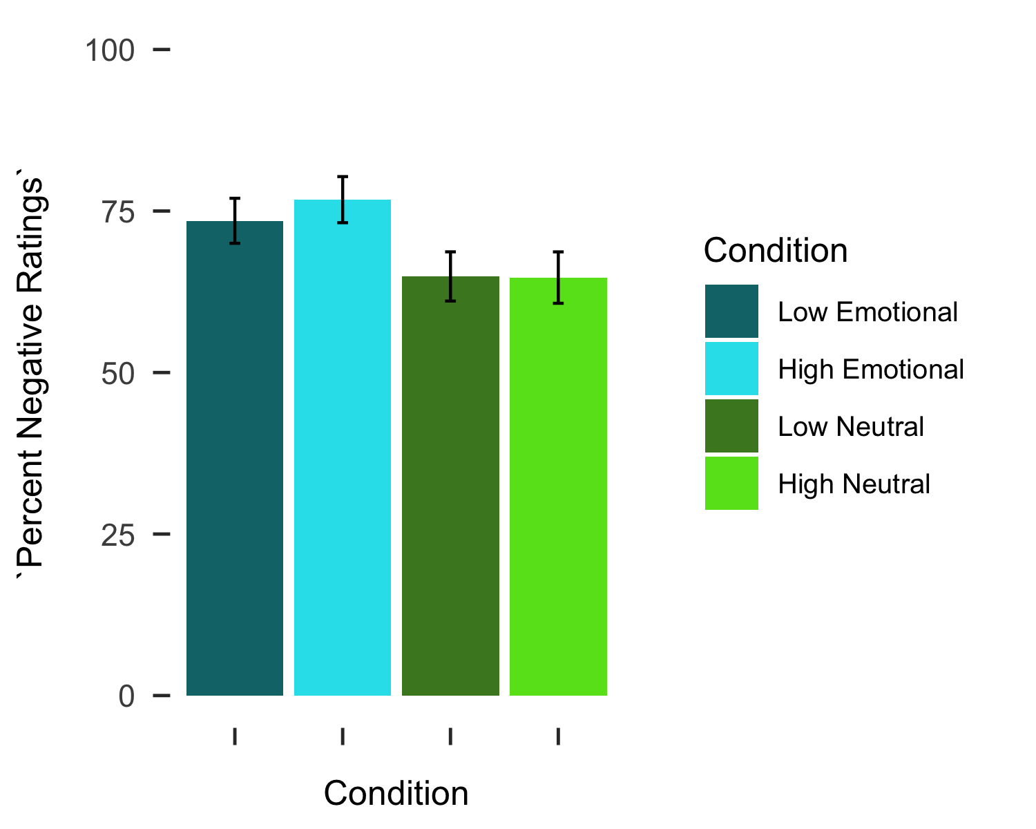

Next, we assessed differences in absolute maximum deviation (MD) across the working memory trial conditions. There was a significant effect of Load, F(1.00,196.00) = 5.51, p = .020, such that MD was larger on trials with a high load compared to those with a low load. There was no significant effect of Domain (emotional versus neutral load) on MDs, F(1.00 196.00) = 0.01, p = .912, nor a significant Load x Domain interaction, F(1.00 196.00) = 0.00, p = .960. 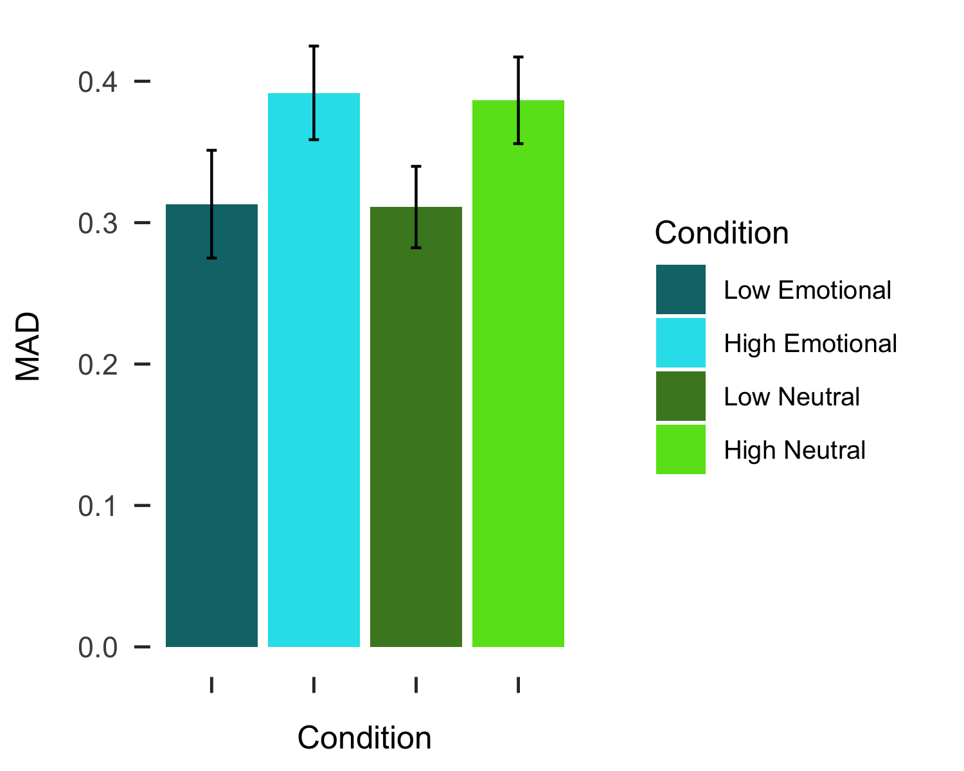

# References

Baddeley, A. D. (1986). Working memory. *Philosophical Transactions of the Royal Society of London*, *302*(110), 311–324.

Brown, C. C., Raio, C. M., & Neta, M. (2017). Cortisol responses enhance negative valence perception for ambiguous facial expressions. *Scientific Reports*, *7*(1), 15107. doi:[10.1038/s41598-017-14846-3](https://doi.org/10.1038/s41598-017-14846-3)

Burnham, B. R., Sabia, M., & Langan, C. (2014). Components of working memory and visual selective attention. *Journal of Experimental Psychology. Human Perception and Performance*, *40*(1), 391–403. doi:[10.1037/a0033753](https://doi.org/10.1037/a0033753)

Egner, T., Etkin, A., Gale, S., & Hirsch, J. (2008). Dissociable neural systems resolve conflict from emotional versus nonemotional distracters. *Cerebral Cortex (New York, N.Y.: 1991)*, *18*(6), 1475–1484. doi:[10.1093/cercor/bhm179](https://doi.org/10.1093/cercor/bhm179)

Freeman, J. B., & Ambady, N. (2010). MouseTracker: Software for studying real-time mental processing using a computer mouse-tracking method. *Behavior Research Methods*, *42*(1), 226–241. doi:[10.3758/BRM.42.1.226](https://doi.org/10.3758/BRM.42.1.226)

Gerin, W., Davidson, K. W., Christenfeld, N. J. S., Goyal, T., & Schwartz, J. E. (2006). The role of angry rumination and distraction in blood pressure recovery from emotional arousal. *Psychosomatic Medicine*, *68*(1), 64–72. doi:[10.1097/01.psy.0000195747.12404.aa](https://doi.org/10.1097/01.psy.0000195747.12404.aa)

Hodsoll, S., Viding, E., & Lavie, N. (2011). Attentional capture by irrelevant emotional distractor faces. *Emotion*, *11*(2), 346–353. doi:[10.1037/a0022771](https://doi.org/10.1037/a0022771)

Hofmann, W., Schmeichel, B. J., & Baddeley, A. D. (2012). Executive functions and self-regulation. *Trends in Cognitive Sciences*, *16*(3), 174–180. doi:[10.1016/j.tics.2012.01.006](https://doi.org/10.1016/j.tics.2012.01.006)

Kensinger, E. A., & Corkin, S. (2003). Effect of negative emotional content on working memory and long-term memory. *Emotion*, 378–393.

Lang, P., Bradley, M. M., & Cuthbert, B. N. (2008). International affective picture system (IAPS): Affective ratings of pictures and instruction manual., Technical Report A–8. University of Florida, Gainesville, FL.

Lavie, N., Hirst, A., Fockert, J. W. de, & Viding, E. (2004). Load theory of selective attention and cognitive control. *Journal of Experimental Psychology: General*, *133*(3), 339–354. doi:[10.1037/0096-3445.133.3.339](https://doi.org/10.1037/0096-3445.133.3.339)

Lundqvist, D., Flykt, A., & Öhman, A. (1998). The karolinska directed emotional faces—KDEF (CD ROM)., Stockholm: Karolinska Institute, Departmentof Clinical Neuroscience, PsychologySection.

Mathews, A., & MacLeod, C. (2005). Cognitive vulnerability to emotional disorders. *Annual Review of Clinical Psychology*, *1*, 167–195. doi:[10.1146/annurev.clinpsy.1.102803.143916](https://doi.org/10.1146/annurev.clinpsy.1.102803.143916)

Mattek, A. M., Whalen, P. J., Berkowitz, J. L., & Freeman, J. B. (2016). Differential effects of cognitive load on subjective versus motor responses to ambiguously valenced facial expressions. *Emotion*, *16*(6), 929–936. doi:[10.1037/emo0000148](https://doi.org/10.1037/emo0000148)

Neta, M., & Dodd, M. D. (2018). Through the eyes of the beholder: Simulated eye-movement experience (“SEE”) modulates valence bias in response to emotional ambiguity. *Emotion*, *18*(8), 1122–1127. doi:[10.1037/emo0000421](https://doi.org/10.1037/emo0000421)

Neta, M., Kelley, W. M., & Whalen, P. J. (2013). Neural responses to ambiguity involve domain-general and domain-specific emotion processing systems. *Journal of Cognitive Neuroscience*, *25*(4), 547–557. doi:[10.1162/jocn_a_00363](https://doi.org/10.1162/jocn_a_00363)

Neta, M., Norris, C. J., & Whalen, P. J. (2009). Corrugator muscle responses are associated with individual differences in positivity-negativity bias. *Emotion (Washington, D.C.)*, *9*(5), 640–648. doi:[10.1037/a0016819](https://doi.org/10.1037/a0016819)

Neta, M., & Tong, T. T. (2016). Don’t like what you see? Give it time: Longer reaction times associated with increased positive affect. *Emotion (Washington, D.C.)*, *16*(5), 730–739. doi:[10.1037/emo0000181](https://doi.org/10.1037/emo0000181)

Neta, M., Tong, T. T., & Henley, D. J. (2018). It’s a matter of time (perspectives): Shifting valence responses to emotional ambiguity. *Motivation and Emotion*, *42*, 258–266. doi:[10.1007/s11031-018-9665-7](https://doi.org/10.1007/s11031-018-9665-7)

Neta, M., Tong, T. T., Rosen, M. L., Enersen, A., Kim, M. J., & Dodd, M. D. (2017). All in the first glance: First fixation predicts individual differences in valence bias. *Cognition & Emotion*, *31*(4), 772–780. doi:[10.1080/02699931.2016.1152231](https://doi.org/10.1080/02699931.2016.1152231)

Neta, M., & Whalen, P. J. (2010). The primacy of negative interpretations when resolving the valence of ambiguous facial expressions. *Psychological Science*, *21*(7), 901–907. doi:[10.1177/0956797610373934](https://doi.org/10.1177/0956797610373934)

Petro, N. M., Tong, T. T., Henley, D. J., & Neta, M. (2018). Individual differences in valence bias: fMRI evidence of the initial negativity hypothesis. *Social Cognitive and Affective Neuroscience*, *13*(7), 687–698. doi:[10.1093/scan/nsy049](https://doi.org/10.1093/scan/nsy049)

Piech, R. M., McHugo, M., Smith, S. D., Dukic, M. S., Van Der Meer, J., Abou-Khalil, B., … Zald, D. H. (2011). Attentional capture by emotional stimuli is preserved in patients with amygdala lesions. *Neuropsychologia*, *49*(12), 3314–3319. doi:[10.1016/j.neuropsychologia.2011.08.004](https://doi.org/10.1016/j.neuropsychologia.2011.08.004)

Schmeichel, B. J., Volokhov, R. N., & Demaree, H. A. (2008). Working memory capacity and the self-regulation of emotional expression and experience. *Journal of Personality and Social Psychology*, *95*(6), 1526–1540. doi:[10.1037/a0013345](https://doi.org/10.1037/a0013345)

Shaw, J., & Tiggemann, M. (2004). Dieting and working memory: Preoccupying cognitions and the role of the articulatory control process. *British Journal of Health Psychology*, *9*(Pt 2), 175–185. doi:[10.1348/135910704773891032](https://doi.org/10.1348/135910704773891032)

Stroop, J. R. (1935). Studies of interference in serial verbal reactions. *Journal of Experimental Psychology*, *18*(6), 643–662. doi:[10.1037/h0054651](https://doi.org/10.1037/h0054651)

Tottenham, N., Tanaka, J. W., Leon, A. C., McCarry, T., Nurse, M., Hare, T. A., … Nelson, C. (2009). The NimStim set of facial expressions: Judgments from untrained research participants. *Psychiatry Research*, *168*(3), 242–249. doi:[10.1016/j.psychres.2008.05.006](https://doi.org/10.1016/j.psychres.2008.05.006)

Van Dillen, L. F., Heslenfeld, D. J., & Koole, S. L. (2009). Tuning down the emotional brain: An fMRI study of the effects of cognitive load on the processing of affective images. *NeuroImage*, *45*(4), 1212–1219. doi:[10.1016/j.neuroimage.2009.01.016](https://doi.org/10.1016/j.neuroimage.2009.01.016)

Whalen, P. J., Bush, G., Shin, L. M., & Rauch, S. L. (2006). The emotional counting stroop: A task for assessing emotional interference during brain imaging. *Nature Protocols*, *1*(1), 293–296. doi:[10.1038/nprot.2006.45](https://doi.org/10.1038/nprot.2006.45)

Yang, H., Yang, S., & Isen, A. M. (2013). Positive affect improves working memory: Implications for controlled cognitive processing. *Cognition and Emotion*, *27*(3), 474–482. doi:[10.1080/02699931.2012.713325](https://doi.org/10.1080/02699931.2012.713325)

1. Some versions of the task only included 142 trials due to a programming error.