Domain-specific working memory loads selectively increase negative interpertations of surprised facial expressions

|  |
| --- |
| Nicholas R. Harp1 & Maital Neta1 |
| 1 University of Nebraska-Lincoln |
|  |

# Author note

Correspondence concerning this article should be addressed to Nicholas R. Harp. E-mail: [nharp@huskers.unl.edu](mailto:nharp@huskers.unl.edu)

Domain-specific working memory loads selectively increase negative interpretations of surprised facial expressions

# Introduction

Facial expressions are important social signals; they communicate emotion between individuals and even spark emotional responses in others (Frith, 2009). Indeed, humans readily make judgments about personality traits (e.g., trustworthiness), aesthetics (e.g., attractiveness), and emotions from faces (Carroll & Russell, 1996; Bar, Neta, & Linz, 2006; Said & Todorov, 2011; Todorov, Baron, & Oosterhof, 2008). Interpretations of valence (i.e., the inherent positive or negative emotional value of a stimulus) are one instance of judgments of facial expressions guiding potential social (i.e., approach-avoidance) behavior (Krieglmeyer, Deutsch, De Houwer, & De Raedt, 2010).

While most people can accurately differentiate the emotional valence of facial expressions, such as consistently interpreting angry faces as negative and happy faces as positive, there are individual differences in valence judgments of emotionally ambiguous facial expressions, like a surprised face (Neta et al., 2009; Petro, Tong, Henley, & Neta, 2018 ). This difference in valence interpretations of surprised expressions is attributable to this expression’s predictive value for both positive (e.g., winning the lottery) and negative (e.g., a car accident) outcomes. This individual difference in interpretations of emotionally ambiguous stimuli is known as one’s *valence bias*, and a growing body of work has used both facial expressions and emotional scenes to better understand this bias (Neta, Kelley, & Whalen, 2013; Neta et al., 2009; Neta & Whalen, 2010). The valence bias represents an important individual difference, as these two equally valid but alternative interpretations likely lead to different downstream behaviors (e.g., Krieglmeyer et al., 2010). For instance, individuals that interpret ambiguous expressions negatively may avoid the expresser, and vice-a-versa, given the relevance of emotional valence in approach-avoidance behaviors (Bradley, 2009; Frijda, 1986; Lang, 1985).

Despite one’s valence bias, the initial response to ambiguity appears to be negativity (Neta, Davis, & Whalen, 2011; Neta et al., 2009; Neta & Whalen, 2010; Petro et al., 2018). Under this framework, which is known as the *initial negativity* hypothesis, positive interpretations rely on the implementation of some emotion regulation strategy in order to override the initial negativity. Several studies provide evidence to support this hypothesis. For instance, containing fasteraretheir counterparts Additionally.

Conversely, other research supports the notion that positive interpretations rely on a regulatory process. a A recent study manipulated reaction times and demonstrated that instructions to delay reaction times result in a shift towards positivity for those with a negative baseline bias (Neta & Tong, 2016). Neuroimaging work has shown that vthat a valence ed greateramygdala ed greater ventromedial prefrontal cortex (vmPFC)foundedgreaterbrain regions recruited during an explicit (cognitive reappraisal) task Taken together, initial responses to ambiguity appear to be negative, and positive interpretations rely on regulatory processes, perhaps through an emotion regulation mechanism like cognitive reappraisal. However, given the cognitive cost of regulatory strategies, concurrent cognitive demands will likely interfere with individuals’ ability to effectively implement regulatory strategies in the face of ambiguity.

## Cognitive loads and task interference

In daily life, cognitive resources are limited, which can lead to difficulty in effortful self-regulation of cognitive and affective processes (Baumeister & Heatherton, 1996; Kahneman, 1973; Storbeck, 2012; Scalf, Torralbo, Tapia, & Beck, 2013). For example, imagine a student attending a lecture. If the student is frequently distracted by notifications and directing cognitive resources towards a text message conversation, then the student’s ability to understand and remember the lecture material will likely suffer. Directing cognitive resources between different tasks in this manner taxes an already limited pool of cognitive resources (Baumeister & Heatherton, 1996; Kahneman, 1973). Indeed, cognitive resource competition leads to a phenomenon known as cognitive load, which negatively impacts executive processes (Lavie, Hirst, Fockert, & Viding, 2004; Murphy, Groeger, & Greene, 2016). High levels of cognitive load alter performance on cognitively demanding tasks, including those in both cognitive and emotional domains (Jiaping et al., 2017; Kron, Schul, Cohen, & Hassin, 2010; Nagamatsu et al., 2011; Pontari & Schlenker, 2000; Thomas, Donohue-Porter, & Stein Fishbein, 2017; Mather & Knight, 2005; Knight et al., 2007). For instance, individuals show greater neural responses to others’ pain under high cognitive load (Jiaping et al., 2017), perhaps a sign of emotion dysregulation. Other work demonstrated the negative effects of cognitive load on affective bias in older adults, showing that cognitively demanding tasks (e.g., distraction during memory encoding) reduce age-related positivity bias (Mather & Knight, 2005; Knight et al., 2007).

Further, cognitively demanding tasks often interact with concurrent affective processes (e.g., face categorization, subjective emotional experience), perhaps as a result of a shared resource pool for these processes (Ahmed, 2018, Blair et al., 2007; Muraven, Tice, & Baumeister, 1998; Mather & Knight, 2005; Knight et al., 2007). For instance, Ahmed (2018) showed that performance on a facial expression categorization task suffers when participants are under high cognitive load. Other work has linked cognitive load to changes in emotional responses (Blair et al., 2007; Van Dillen, Heslenfeld, & Koole, 2009). For example, higher loads during a working memory task (Van Dillen et al., 2009) and increased cognitive demands (Blair et al., 2007) reduce subjective emotional experience, as well as brain responses to emotion (i.e., amygdala and inferior frontal gyrus activation). This study also showed evidence that behavioral performance of a cognitively demanding task (i.e., Stroop task) suffers during trials with emotional, rather than neutral, distractors (Blair et al., 2007). Other work highlights the importance of cognitive load on a logical reasoning task, in which participants assessed the logic of a conclusion given some provided premises. The authors demonstrated that participants perform worse on tasks with emotional, rather than neutral, content when under high cognitive load (Trémolière, Gagnon, & Blanchette, 2016). Together, these effects suggest an overlap between cognitive demands and emotional processes, with high cognitive demands interfering with typical emotion processing.

Given the initial negativity hypothesis, we would have predicted that cognitive load, specifically one which taxes the same resources used for emotion regulation, would result in a more negative valence bias. Previous work revealed, in contrast, no effect of load on subjective interpretations of surprised expressions, but participants did show altered response (computer mouse) trajectories, such that mouse movements were less drawn towards their modal response option (e.g., positive ratings for individuals with a positive bias; Mattek, Whalen, Berkowitz, & Freeman, 2016). That is, the cognitive load did not interfere with the tendency to interpret surprised expressions as positive or negative, but instead interfered with the cognitive-motor dynamics of *how* one arrived at a response. One potential explanation for the null effect of load on ratings is the domain-specificity of the cognitive load. In other words, some research has shown that one task (i.e., Stroop task) can recruit different brain regions depending upon the emotional properties of the task stimuli, highlighting the dissociable processing of emotional and non-emotional stimuli within similar tasks (Egner, Etkin, Gale, & Hirsch, 2008). Critically, Mattek and colleagues (2016) used non-emotional stimuli (i.e., number sequence) in their manipulation of cognitive load during interpretations of surprised facial expressions. The cognitive demand required for maintaining emotional (but perhaps not non-emotional) information in working memory may be necessary for taxing resources used for emotion regulation.

## The present study

In the present study we tested the effect of high cognitive load on valence bias, and directly compare the effects of load that carries emotional versus non-emotional properties. First, we predict a null main effect of load on valence bias (i.e., ratings of surprised faces will not differ under low versus high load), replicating Mattek et al (2016). Notably, we expect to find a main effect of load type (emotional versus non-emotional) on interpretations of surprise, such that interpretations made under emotional load are more negative than those made under non-emotional working memory loads. Further, we predict an interaction effect, such that high emotional working memory load will result in more negative interpetations than low emotional working memory load.

# Methods

## Participants

Fifty-eight participants (*M*age = XX years, SD = XX years, XX female) were recruited from the undergraduate research pool at the University of Nebraska-Lincoln. The data from eight participants were excluded due to technical difficulties that prevented data from being saved (?). The final sample included the remaining 50 participants (*M*age = 18.82 years, SD = 1.19 years, XX female), and all identified as White/Caucasian without Hispanic/Latinx ethnicity). All subjects provided written informed consent in accordance with the Declaration of Helsinki and all procedures were approved by the University of Nebraska-Lincoln Institutional Review Board (Approval #20141014670EP). Each participant received course credit for completing the study.

## Material

### Stimuli

The stimuli included faces from the NimStim (Tottenham et al., 2009) and Karolinska Directed Emotional Faces (Lundqvist, Flykt, & Öhman, 1998) stimuli sets, as in previous work (Brown et al., 2017; Neta & Whalen, 2010). The faces consisted of 34 unique identities including 11 angry, 12 happy, and 24 surprised expressions organized pseudorandomly. The scene stimuli were selected from the International Affective Picture System (Lang, Bradley, & Cuthbert, 2008). A total of 288 scenes (72 positive, 72 negative, and 144 neutral) were selected for the image matrices. The positive and negative images did not differ in arousal (Z = -0.23, p = 0.82). The scenes were organized into low (two images) and high (six images) cognitive load of either neutral or emotional (equal number of positive and negative) images (Figure 1).

## Procedure

After arriving at the lab, participants provided informed consent prior to completing the task. Participants were randomly assigned to complete one of the task versions, which included 144[1] trials split between working memory probe and face rating trials. The task was completed using MouseTracker software (Freeman & Ambady, 2010) and participants responded with a mouse to indicate the appropriate response for the face ratings (i.e., “POSITIVE” or “NEGATIVE”) and the memory probe (i.e., “YES” or “NO”). The trials were self-initiated; that is, the participant clicked a “start” button at the bottom of the screen at the beginning of each trial at their own pace. After initiating the trial, a fixation cross appeared (1000 ms), then participants viewed an image matrix, which the participants were instructed to remember for the duration of the trial. The image matrix was presented for 4000 ms and the image was either a low or high load matrix consisting of either emotional (equal positive and negative) or neutral images. After the image matrix a happy, angry, or surprised face appeared for 1000 ms and the participants rated the face by clicking on either the positive or negative response option. After the face rating, a single image probe appeared (5000 ms), and participants indicated whether or not the image probe was present in the previous image matrix.

## Data analysis

We used R (Version 3.6.0; **???**) and the R-packages * }dplyr* [@ }R-dplyr], *BayesFactor* (Version 0.9.12.4.2; **???**), *broom* (Version 0.5.2; **???**), *circlize* (Version 0.4.6; **???**), *coda* (Version 0.19.2; **???**), *cstab* (Version 0.2.2; **???**), *diptest* (Version 0.75.7; **???**), *dotCall64* (Version 1.0.0; **???**; **???**), *fastcluster* (Version 1.1.25; **???**), *fields* (Version 9.8.3; **???**), *forcats* (Version 0.4.0; **???**), *foreach* (Version 1.4.7; **???**), *ggplot2* (Version 3.1.1; **???**), *jpeg* (Version 0.1.8; **???**), *lattice* (Version 0.20.38; **???**), *magrittr* (Version 1.5; **???**), *maps* (Version 3.3.0; **???**), *Matrix* (Version 1.2.17; **???**), *mousetrap* (Version 3.1.2; **???**), *openxlsx* (Version 4.1.0; **???**), *papaja* (Version 0.1.0.9842; **???**), *plyr* (Version 1.8.4; @ }R-dplyr; **???**), *pracma* (Version 2.2.5; **???**), *processx* (Version 3.3.1; **???**), *psych* (Version 1.8.12; **???**), *purrr* (Version 0.3.2; **???**), *RColorBrewer* (Version 1.1.2; **???**), *Rcpp* (Version 1.0.1; **???**; **???**), *readbulk* (Version 1.1.2; **???**), *readr* (Version 1.3.1; **???**), *readxl* (Version 1.3.1; **???**), *Rmisc* (Version 1.5; **???**), *scales* (Version 1.0.0; **???**), *spam* (Version 2.2.2; **???**; **???**; **???**), *stringr* (Version 1.4.0; **???**), *tibble* (Version 2.1.3; **???**), *tidyr* (Version 0.8.3.9000; **???**), *tidyverse* (Version 1.2.1; **???**), and *yarrr* (Version 0.1.5; **???**) for all our analyses. Data preprocessing was completed in R using the mousetrap package (**???**). First and subsequently removed Any trials that were greater than three standard deviations from the mean were removed from the analyses. Additionally, we removed the preceding face rating trial for any incorrect memory probe trials, as these trials can be considered a manipulation failure. Next, percent negative ratings were calculated for happy, angry, and surprised faces across all trial types, as well as a percent correct score for the memory probe trials.

For the main test of our hypothesis, wIn order to account for the interdependence among measurements from the repeated measures design, we used multilevel modeling. The intraclass correlation was .19, further supporting the decision to use multilevel modeling. Prior to completing the analyses, all rating data were assessed for normality using Shapiro-Wilks tests. , as ratings of ambiguity are typically negatively skewedrobust standard errorsto account for the violation of the assumption of normalityNext, while the mouse trajectory data complied with normal distribution assumptions, we tested for differences among each working memory load condition using a multilevel modeling approach as well. We employed the model building approach suggested by Raudenbush and Bryk (2001), assessing model fit using *X*2 difference tests for each new parameter. All model comparisons were completed with full information maximum likelihood estimation.

# Results

## Subjective ratings

First, an intercept-only model was tested, which included a random component of the intercept. The results support the decision to model the intercept randomly across individuals (*X* 2(49)=610.24 , p < .001).After, a fixed component for the effect of load type (i.e., emotional vs. non-emotional) to the model uncentered at level one. The effect of load type significantly contributed to the model (ß10 = .10, *t*(149) = 7.82, p < .001), such that the emotional load ratings were predicted to be more negative than the non-emotional load ratings. Nested model comparison assessed the fit of the model compared to the intercept-only model and supported the inclusion of the load type effect (*X* 2(1)= 32.02, p < .001); however, the addition of a random component to the load type effect was not supported (*X* 2(2)= 1.62, p > .500), and thus the effect remained fixed. An effect of load (i.e., low vs. high) was next added to the model uncentered at level one. The effect did not significantly contribute to the model (*t*(148) = .92, p = .361), and nested model comparisons favored the model without an effect of load (*X*2(1) = .80, p > .500). As such, load was left out of the model and these results suggest that load did not differentially affect ratings. The final model consisted of a fixed effect for load type and random intercepts.

**Level-1 Model:** Percent Negative Ratingsti = π0i + π1i*(Load Typeti) + eti

**Level-2 Model:** π0i = β00 + r0i

π1i = β10

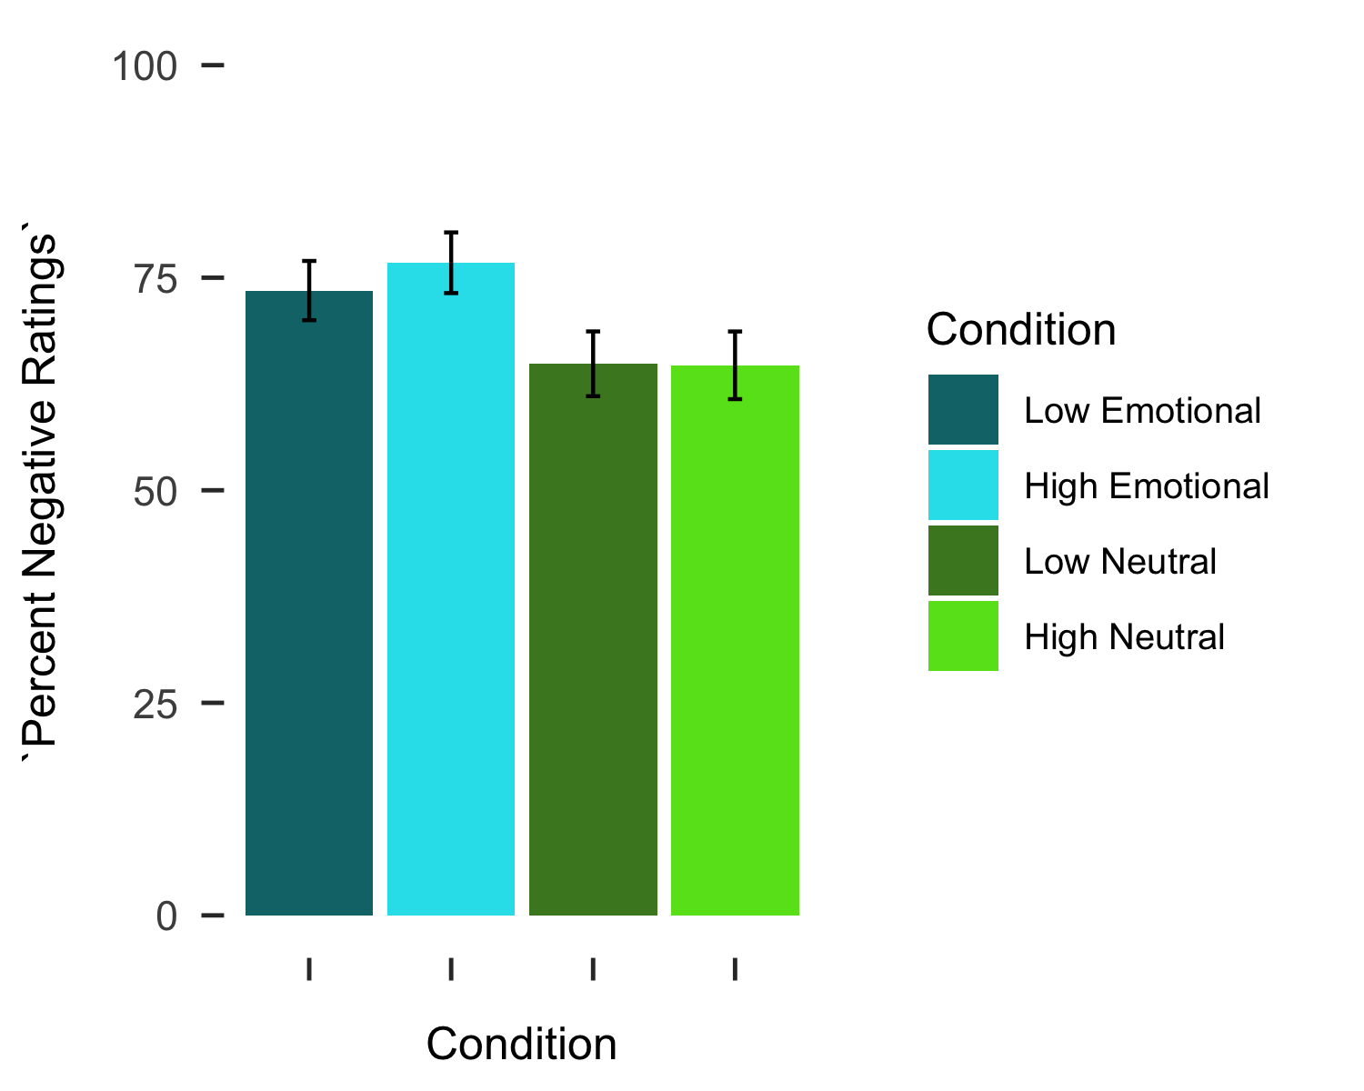

Next, an intercept-only model was tested for absolute maximum deviation, which included a random component of the intercept. The results support the decision to model the intercept with both a fixed and random component (*X* 2(49)= 167.85, p < .001).After, a fixed component for the effect of load type (i.e., emotional vs. non-emotional) to the model uncentered at level one. The effect of load type did not significantly contributed to the model (*t*(149) = .14, p = .886), additionally the nested model comparison suggested that the effect of load type did not improve the fit of the model (*X* 2(2)= 3.80, p = .148). The effect of load (i.e., low vs. high) was added to the model next, uncentered at level one. The effect significantly contributed to the model (ß10 = .08, *t*(149) = 2.81, p =.006), and nested model comparisons favored the model with an effect of load (*X*2(2) = 12.72, p = .002. We next assessed whether variability in the slopes for the effect of load would be best modeled with a free random parameter, but the random effect for the slope of load did not reach statistical significance (*X*2(49) = 63.68, p = .08), nor did the model fit improve (*X*2(2) = 1.46, p > .500.As such, the random parameter was not included in the model and the effect of load remained fixed. The final model consisted of a fixed effect for load and random intercepts.

**Level-1 Model:** Maximum Deviationti = π0i + π1i*(Loadti) + eti

**Level-2 Model:** π0i = β00 + r0i

π1i = β10

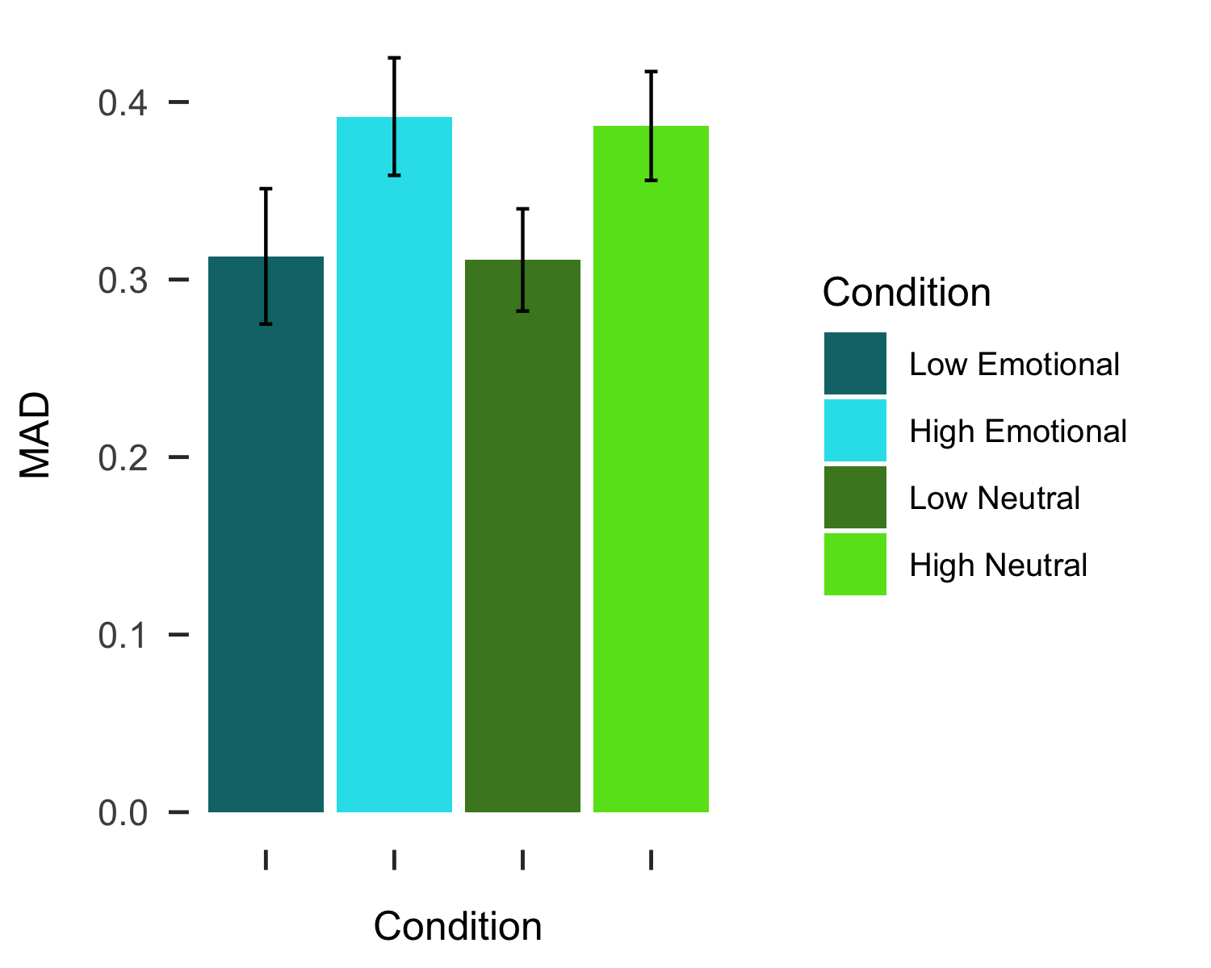

# Discussion

Here we tested the effects of high cognitive loads with either emotional or non-emotional properties on valence bias. As predicted, interpretations of surprise were more negative under cognitive loads with emotional properties than loads with non-emotional properties. This result deviates from previous work testing the effects of cognitive load on valence bias (Mattek et al., 2016), but aligns with other literature demonstrating that the emotional properties of the task affect both task performance and the neural systems engaged during tasks (Egner et al., 2007). We also found evidence that maximum deviations were larger during high cognitive load, suggesting that response competition increased with the cognitive demands of the task. This effect of increased response competition parallels other work suggesting that high cognitive load increases distractor processing (Lavie, 2005). We discuss these results in the context of the initial negativity hypothesis below.

The intial negativity hypothesis posits that positive interpretations of ambiguous stimuli rely on regulatory resources (Neta et al., 2009; Petro et al., 2018…). We used a standard working memory paradigm (Ahmed, 2018; Burnham, 2010; Lavie & De Fockert, 2005) to induce high cognitive load with either emotional or non-emotional properties while participants made valence judgments of surprised facial expressions. Participants interpreted surprise as more negative during cognitive loads with emotional properties, suggesting that these loads specifically taxed the resources required for positive interpretations of ambiguity. There was no effect of high cognitive load on subjective interpretations, providing a conceptual replication of previous work (Mattek et al., 2016). Notably, this was true for both low and high cognitive load, suggesting that domain-specificity of cognitive load matters more than the load demands for altering interpretations of ambiguity.

Previous work has shown that emotional ambiguity resolution relies on a domina-general task control network called the cingulo-opercular network (Neta et al., 2013); though speculative, the cognitive loads with emotional properties may have taxed these resources due to the dual valence of the emotional load (i.e., both positive and negative images were included in the matrices), as this network is recruited in response to many types of ambiguity (Neta et al., 2013; Neta et al., 2004; Sterzer, Russ, Preibisch, & Kleinschmidt, 2002; Thompson-Schill, D’Esposito, Aguirre, & Farah, 1997). Other neuroimaging work supports the notion that cognitive loads would preoccupy resources in the cingulo-opercular network; for instance, regions in the network (i.e., anterior cingulate cortex and anterior insula) regularly show activity increases during cognitively demanding tasks, such as those requiring increased attention and control (Duncan & Owen, 2000; Nee, Wager, & Jonides, 2007). Indeed, the emotional Stroop task differentially activates anterior cingulate cortex when compared to a non-emotional Stroop task (i.e., gender judgment; Etkin et al., 2006). Taken together, we interpret this effect of load type on interpretations of ambiguity as evidence that regulatory resources needed for positive interpretations of ambiguity are susceptible to domain-specific cognitive load demands, and that domain-general cognitive resources are less critical for regulating responses to emotional ambiguity.

While subjective interpertations of ambiguity were susceptible to load type, the underlying cognitive-motor dynamics (i.e., maximum deviations) of these decisions were more susceptible to the cognitive load demands. That is, maximum deviations varied as a function of low compared to high cognitive load, but not when the emotional properties of the load changed. Specifically, there was evidence that high cognitive loads of any type result in larger maximum deviations. In two-choice designs, maximum deviations are often conceptualized as a measure of response competition for ultimately unchosen responses or the degree of uncertainty during the response process (Calcagni, Lombardi, & Sulpizio, 2017; Freeman, Dale, & Farmer, 2011; Hehman, Stolier, & Freeman, 2015). The tendency for indviduals to be more drawn towards an unselected response may reflect a type of distraction effect (Spivey, Grosjean, & Knoblich, 2005). This mirrors effects seen in the cognitive load literature, where high cognitive loads lead to deficits in the ability to filter out task-irrelevant information (Lavie, Hirst, de Fockert, & Vidling, 2004). Although Mattek and colleagues (2016) did not observe a main effect of cognitive load on the deviations of response trajectories, there was a disruptive effect on participants tendency to show smaller deviations for their modal response (i.e., a response consistent with their general tendency or bias). At the least, high cognitive load appears to interfere with typical mouse-based response trajectories during resolution of emotional ambiguity.

However, the present study is subject to several limitations. For instance, despite the effect of cognitive load type on subjective interpretations of ambiguity and the effect of high load on response trajectories, working memory performance was near ceiling across all conditions (i.e., greater than 90% correct). This suggests that the high cognitive load may not have taxed resources to the fullest extent possible, perhaps weakening some effects. Future work could address this by increasing the demands of the task, either through larger sets of image matrices (e.g., eight, ten, or more) or increasing the number of trials and repeating images in the working memory conditions, which would require participants to differentitate whether more familiar images (i.e., that had been seen several times) were seen in the previous trial or not. Additionally, positive and negative loads were not manipulated independently. Whether or not there are differential effects of image valence (i.e., positive vs. negative) for cognitive load remains an open question. Future work could manipulate load valence independently, but disambiguating the effects of positive and negative valence loads would prove difficult as these valence effects could results in priming effects (e.g., Flexas, Rosselló, Christensen, Nada, La Rosa, & Munar, 2013). Indeed, when surprised expressions are consistently preceded and followed by either angry or happy faces, participants’ valence bias shifts towards the valence of the more common faces (Neta et al., 2011).

Here we have provided both a conceptual replication and extension of previous work which tested the effects of high cognitive load on subjective interpretations of ambiguity, highlighting the importance of domain-specificty. In other words, only cognitive loads which tax the resources used for interpreting ambiguity as positive will alter interpretations during cognitive load. We posit that this effect relies on taxing neural resources related to ambiguity resolution and results in an increase in negativity, which is in line with our initial negativity hypothesis. We also demonstrated a domain-general effect of cognitive load on mouse trajectories, which could be further understood in future research. Future work should explore these effects to verify the neural processes underlying these behavioral phenomena.

# References

Baddeley, A. D. (1986). Working memory. *Philosophical Transactions of the Royal Society of London*, *302*(110), 311–324.

Brown, C. C., Raio, C. M., & Neta, M. (2017). Cortisol responses enhance negative valence perception for ambiguous facial expressions. *Scientific Reports*, *7*(1), 15107. doi:[10.1038/s41598-017-14846-3](https://doi.org/10.1038/s41598-017-14846-3)

Burnham, B. R., Sabia, M., & Langan, C. (2014). Components of working memory and visual selective attention. *Journal of Experimental Psychology. Human Perception and Performance*, *40*(1), 391–403. doi:[10.1037/a0033753](https://doi.org/10.1037/a0033753)

Egner, T., Etkin, A., Gale, S., & Hirsch, J. (2008). Dissociable neural systems resolve conflict from emotional versus nonemotional distracters. *Cerebral Cortex (New York, N.Y.: 1991)*, *18*(6), 1475–1484. doi:[10.1093/cercor/bhm179](https://doi.org/10.1093/cercor/bhm179)

Freeman, J. B., & Ambady, N. (2010). MouseTracker: Software for studying real-time mental processing using a computer mouse-tracking method. *Behavior Research Methods*, *42*(1), 226–241. doi:[10.3758/BRM.42.1.226](https://doi.org/10.3758/BRM.42.1.226)

Gerin, W., Davidson, K. W., Christenfeld, N. J. S., Goyal, T., & Schwartz, J. E. (2006). The role of angry rumination and distraction in blood pressure recovery from emotional arousal. *Psychosomatic Medicine*, *68*(1), 64–72. doi:[10.1097/01.psy.0000195747.12404.aa](https://doi.org/10.1097/01.psy.0000195747.12404.aa)

Hodsoll, S., Viding, E., & Lavie, N. (2011). Attentional capture by irrelevant emotional distractor faces. *Emotion*, *11*(2), 346–353. doi:[10.1037/a0022771](https://doi.org/10.1037/a0022771)

Hofmann, W., Schmeichel, B. J., & Baddeley, A. D. (2012). Executive functions and self-regulation. *Trends in Cognitive Sciences*, *16*(3), 174–180. doi:[10.1016/j.tics.2012.01.006](https://doi.org/10.1016/j.tics.2012.01.006)

Kensinger, E. A., & Corkin, S. (2003). Effect of negative emotional content on working memory and long-term memory. *Emotion*, 378–393.

Lang, P., Bradley, M. M., & Cuthbert, B. N. (2008). International affective picture system (IAPS): Affective ratings of pictures and instruction manual., Technical Report A–8. University of Florida, Gainesville, FL.

Lavie, N., Hirst, A., Fockert, J. W. de, & Viding, E. (2004). Load theory of selective attention and cognitive control. *Journal of Experimental Psychology: General*, *133*(3), 339–354. doi:[10.1037/0096-3445.133.3.339](https://doi.org/10.1037/0096-3445.133.3.339)

Lundqvist, D., Flykt, A., & Öhman, A. (1998). The karolinska directed emotional faces—KDEF (CD ROM)., Stockholm: Karolinska Institute, Departmentof Clinical Neuroscience, PsychologySection.

Mathews, A., & MacLeod, C. (2005). Cognitive vulnerability to emotional disorders. *Annual Review of Clinical Psychology*, *1*, 167–195. doi:[10.1146/annurev.clinpsy.1.102803.143916](https://doi.org/10.1146/annurev.clinpsy.1.102803.143916)

Mattek, A. M., Whalen, P. J., Berkowitz, J. L., & Freeman, J. B. (2016). Differential effects of cognitive load on subjective versus motor responses to ambiguously valenced facial expressions. *Emotion*, *16*(6), 929–936. doi:[10.1037/emo0000148](https://doi.org/10.1037/emo0000148)

Neta, M., & Dodd, M. D. (2018). Through the eyes of the beholder: Simulated eye-movement experience (“SEE”) modulates valence bias in response to emotional ambiguity. *Emotion*, *18*(8), 1122–1127. doi:[10.1037/emo0000421](https://doi.org/10.1037/emo0000421)

Neta, M., Kelley, W. M., & Whalen, P. J. (2013). Neural responses to ambiguity involve domain-general and domain-specific emotion processing systems. *Journal of Cognitive Neuroscience*, *25*(4), 547–557. doi:[10.1162/jocn_a_00363](https://doi.org/10.1162/jocn_a_00363)

Neta, M., Norris, C. J., & Whalen, P. J. (2009). Corrugator muscle responses are associated with individual differences in positivity-negativity bias. *Emotion (Washington, D.C.)*, *9*(5), 640–648. doi:[10.1037/a0016819](https://doi.org/10.1037/a0016819)

Neta, M., & Tong, T. T. (2016). Don’t like what you see? Give it time: Longer reaction times associated with increased positive affect. *Emotion (Washington, D.C.)*, *16*(5), 730–739. doi:[10.1037/emo0000181](https://doi.org/10.1037/emo0000181)

Neta, M., Tong, T. T., & Henley, D. J. (2018). It’s a matter of time (perspectives): Shifting valence responses to emotional ambiguity. *Motivation and Emotion*, *42*, 258–266. doi:[10.1007/s11031-018-9665-7](https://doi.org/10.1007/s11031-018-9665-7)

Neta, M., Tong, T. T., Rosen, M. L., Enersen, A., Kim, M. J., & Dodd, M. D. (2017). All in the first glance: First fixation predicts individual differences in valence bias. *Cognition & Emotion*, *31*(4), 772–780. doi:[10.1080/02699931.2016.1152231](https://doi.org/10.1080/02699931.2016.1152231)

Neta, M., & Whalen, P. J. (2010). The primacy of negative interpretations when resolving the valence of ambiguous facial expressions. *Psychological Science*, *21*(7), 901–907. doi:[10.1177/0956797610373934](https://doi.org/10.1177/0956797610373934)

Petro, N. M., Tong, T. T., Henley, D. J., & Neta, M. (2018). Individual differences in valence bias: fMRI evidence of the initial negativity hypothesis. *Social Cognitive and Affective Neuroscience*, *13*(7), 687–698. doi:[10.1093/scan/nsy049](https://doi.org/10.1093/scan/nsy049)

Piech, R. M., McHugo, M., Smith, S. D., Dukic, M. S., Van Der Meer, J., Abou-Khalil, B., … Zald, D. H. (2011). Attentional capture by emotional stimuli is preserved in patients with amygdala lesions. *Neuropsychologia*, *49*(12), 3314–3319. doi:[10.1016/j.neuropsychologia.2011.08.004](https://doi.org/10.1016/j.neuropsychologia.2011.08.004)

Schmeichel, B. J., Volokhov, R. N., & Demaree, H. A. (2008). Working memory capacity and the self-regulation of emotional expression and experience. *Journal of Personality and Social Psychology*, *95*(6), 1526–1540. doi:[10.1037/a0013345](https://doi.org/10.1037/a0013345)

Shaw, J., & Tiggemann, M. (2004). Dieting and working memory: Preoccupying cognitions and the role of the articulatory control process. *British Journal of Health Psychology*, *9*(Pt 2), 175–185. doi:[10.1348/135910704773891032](https://doi.org/10.1348/135910704773891032)

Stroop, J. R. (1935). Studies of interference in serial verbal reactions. *Journal of Experimental Psychology*, *18*(6), 643–662. doi:[10.1037/h0054651](https://doi.org/10.1037/h0054651)

Tottenham, N., Tanaka, J. W., Leon, A. C., McCarry, T., Nurse, M., Hare, T. A., … Nelson, C. (2009). The NimStim set of facial expressions: Judgments from untrained research participants. *Psychiatry Research*, *168*(3), 242–249. doi:[10.1016/j.psychres.2008.05.006](https://doi.org/10.1016/j.psychres.2008.05.006)

Van Dillen, L. F., Heslenfeld, D. J., & Koole, S. L. (2009). Tuning down the emotional brain: An fMRI study of the effects of cognitive load on the processing of affective images. *NeuroImage*, *45*(4), 1212–1219. doi:[10.1016/j.neuroimage.2009.01.016](https://doi.org/10.1016/j.neuroimage.2009.01.016)

Whalen, P. J., Bush, G., Shin, L. M., & Rauch, S. L. (2006). The emotional counting stroop: A task for assessing emotional interference during brain imaging. *Nature Protocols*, *1*(1), 293–296. doi:[10.1038/nprot.2006.45](https://doi.org/10.1038/nprot.2006.45)

Yang, H., Yang, S., & Isen, A. M. (2013). Positive affect improves working memory: Implications for controlled cognitive processing. *Cognition and Emotion*, *27*(3), 474–482. doi:[10.1080/02699931.2012.713325](https://doi.org/10.1080/02699931.2012.713325)

1. Some versions of the task only included 142 trials due to a programming error.