Domain-specific working memory loads selectively increase negative interpertations of surprised facial expressions

|  |
| --- |
| Nicholas R. Harp1 & Maital Neta1 |
| 1 University of Nebraska-Lincoln |
|  |

# Author note

Correspondence concerning this article should be addressed to Nicholas R. Harp. E-mail: [nharp@huskers.unl.edu](mailto:nharp@huskers.unl.edu)

Domain-specific working memory loads selectively increase negative interpretations of surprised facial expressions

# Introduction

Facial expressions are important social signals; they communicate emotion between individuals and even spark emotional responses in others (Frith, 2009). Indeed, humans readily make judgments about personality traits (e.g., trustworthiness), aesthetics (e.g., attractiveness), and emotions from faces (Carroll & Russell, 1996; Bar, Neta, & Linz, 2006; Said & Todorov, 2011; Todorov, Baron, & Oosterhof, 2008). Interpretations of valence (i.e., the inherent positive or negative emotional value of a stimulus) are one instance of judgments of facial expressions guiding potential social (i.e., approach-avoidance) behavior (Krieglmeyer, Deutsch, De Houwer, & De Raedt, 2010).

While most people can accurately differentiate the emotional valence of facial expressions, such as consistently interpreting angry faces as negative and happy faces as positive, there are individual differences in valence judgments of emotionally ambiguous facial expressions, like a surprised face (Neta et al., 2009; Petro, Tong, Henley, & Neta, 2018 ). This difference in valence interpretations of surprised expressions is attributable to this expression’s predictive value for both positive (e.g., winning the lottery) and negative (e.g., a car accident) outcomes. This individual difference in interpretations of emotionally ambiguous stimuli is known as one’s *valence bias*, and a growing body of work has used both facial expressions and emotional scenes to better understand this bias (Neta, Kelley, & Whalen, 2013; Neta et al., 2009; Neta & Whalen, 2010). The valence bias represents an important individual difference, as these two equally valid but alternative interpretations likely lead to different downstream behaviors (e.g., Krieglmeyer et al., 2010). For instance, individuals that interpret ambiguous expressions negatively may avoid the expresser, and vice-a-versa, given the relevance of emotional valence in approach-avoidance behaviors (Bradley, 2009; Frijda, 1986; Lang, 1985).

Despite one’s valence bias, the initial response to ambiguity appears to be negativity (Neta, Davis, & Whalen, 2011; Neta et al., 2009; Neta & Whalen, 2010; Petro et al., 2018). Under this framework, which is known as the *initial negativity* hypothesis, positive interpretations rely on the implementation of some emotion regulation strategy in order to override the initial negativity. Several studies provide evidence to support this hypothesis. For instance, images containing only low spatial frequency information, which is processed faster than high spatial frequency information, are rated more negatively than their high spatial frequency counterparts (Neta & Whalen, 2010). Additionally, surprised facial expressions are more quickly detected in an emotional oddball paradigm among happy (positive) than angry (negative) faces (Neta et al., 2011), suggesting that surprised expressions are more readily perceived as similar to angry faces than happy faces.

Conversely, other research supports the notion that positive interpretations rely on a regulatory process. For instance, reaction time data show that individuals with a more positive bias take longer to reach a valence judgment for surprised expressions than those with a more negative bias (Neta et al., 2009), suggesting a more time-intensive (regulatory) process for positive interpretations. A recent study manipulated reaction times and demonstrated that instructions to delay reaction times result in a shift towards positivity for those with a negative baseline bias (Neta & Tong, 2016). Neuroimaging work has shown that ventromedial prefrontal cortex, a putative regulatory region, and amygdala actively are inversely correlated, and that participants with a more negative valence bias showed greater amygdala activity while more positive participants showed greater ventromedial prefrontal cortex (vmPFC) activity (Kim, Somerville, Johnstone, Alexander, & Whalen, 2003). More recently, Petro and colleagues (2018) found that participants with a more positive valence bias showed greater activity for surprised faces in brain regions recruited during an explicit emotion regulation (cognitive reappraisal) task. Taken together, initial responses to ambiguity appear to be negative, and positive interpretations rely on regulatory processes, perhaps through an emotion regulation mechanism like cognitive reappraisal. However, given the cognitive cost of regulatory strategies (Richards & Gross, 2000; Sheppes & Meiran, 2008), concurrent cognitive demands will likely interfere with individuals’ ability to effectively implement regulatory strategies in the face of ambiguity.

## Cognitive loads and task interference

In daily life, cognitive resources are limited, which can lead to difficulty in effortful self-regulation of cognitive and affective processes (Baumeister & Heatherton, 1996; Kahneman, 1973; Storbeck, 2012; Scalf, Torralbo, Tapia, & Beck, 2013). For example, imagine a student attending a lecture. If the student is frequently distracted by notifications and directing cognitive resources towards a text message conversation, then the student’s ability to understand and remember the lecture material will likely suffer. Directing cognitive resources between different tasks in this manner taxes an already limited pool of cognitive resources (Baumeister & Heatherton, 1996; Kahneman, 1973). Indeed, cognitive resource competition leads to a phenomenon known as cognitive load, which negatively impacts executive processes (Lavie, Hirst, Fockert, & Viding, 2004; Murphy, Groeger, & Greene, 2016). High levels of cognitive load alter performance on cognitively demanding tasks, including those in both cognitive and emotional domains (Jiaping et al., 2017; Kron, Schul, Cohen, & Hassin, 2010; Nagamatsu et al., 2011; Pontari & Schlenker, 2000; Thomas, Donohue-Porter, & Stein Fishbein, 2017; Mather & Knight, 2005; Knight et al., 2007). For instance, reducing cognitive load (e.g., through integration of diagrams and text information to reduce split-attention) facilitates better learning of complex topics (e.g., geometry, physics, and anatomy) which already have intrinsic cognitive demands (Chandler & Sweller, 1991). The affective qualities of cognitive load also matter, as performance on a deductive reasoning task, in which participants assessed the logic of a conclusion given some provided premises, was worse when the premises included emotional words (e.g., there are torturers who are introverts, introverts do not hurt people, no torturers hurt people) rather than emotionally neutral words (e.g., the sky is blue, blue is not green, the sky is green; Trémolière, Gagnon, & Blanchette, 2016). These studies highlight the susceptibility of cognitive processes to cognitive load, as well as the importance of load characteristics (i.e., emotional vs. non-emotional qualities)

Further, cognitively demanding tasks often interact with concurrent affective processes (e.g., face categorization, subjective emotional experience), perhaps as a result of a shared resource pool for these processes (Ahmed, 2018, Blair et al., 2007; Muraven, Tice, & Baumeister, 1998; Mather & Knight, 2005; Knight et al., 2007). For instance, Ahmed (2018) showed that performance on a facial expression categorization task suffers when participants are under high cognitive load. Additionally, cognitive load has been linked to changes in emotional responses (Blair et al., 2007; Van Dillen, Heslenfeld, & Koole, 2009). For example, higher loads during a working memory task (Van Dillen et al., 2009) and increased cognitive demands (Blair et al., 2007) reduce subjective emotional experience, as well as brain responses to emotion (i.e., amygdala and inferior frontal gyrus activation). This study also showed evidence that behavioral performance of a cognitively demanding task (i.e., Stroop task) suffers during trials with emotional distractors (Blair et al., 2007). Other work has demonstrated the negative effects of cognitive load on affective bias in older adults, showing that cognitively demanding tasks (e.g., distraction during memory encoding) reduces age-related positivity bias (Mather & Knight, 2005; Knight et al., 2007). Together, these effects suggest an overlap between cognitive demands and emotional processes, with high cognitive demands interfering with typical emotion processing.

Given the initial negativity hypothesis, we would have predicted that cognitive load, specifically one which taxes the same resources used for emotion regulation, would result in a more negative valence bias. Previous work revealed, in contrast, no effect of load on subjective interpretations of surprised expressions, but participants did show altered response (computer mouse) trajectories, such that mouse movements were less drawn towards their modal response option (e.g., positive ratings for individuals with a positive bias; Mattek, Whalen, Berkowitz, & Freeman, 2016). That is, the cognitive load did not interfere with the tendency to interpret surprised expressions as positive or negative, but instead interfered with the cognitive-motor dynamics of *how* one arrived at a response. One potential explanation for the null effect of load on ratings is the domain-specificity of the cognitive load. In other words, some research has shown that one task (i.e., Stroop task) can recruit different brain regions depending upon the emotional properties of the task and stimuli (i.e., gender judgments of neutral faces vs. expression judgments of emotional faces), highlighting the dissociable processing of emotional and non-emotional stimuli within similar tasks (Egner, Etkin, Gale, & Hirsch, 2008). Critically, Mattek and colleagues (2016) used non-emotional stimuli (i.e., number sequence) in their manipulation of cognitive load during interpretations of surprised facial expressions. The cognitive demand required for maintaining emotional (but perhaps not non-emotional) information in working memory may be necessary for taxing resources used for emotion regulation.

## The present study

In the present study we tested the effect of high cognitive load on valence bias, and directly compare the effects of load that carries emotional versus non-emotional properties. First, we predict a null main effect of load on valence bias (i.e., ratings of surprised faces will not differ under low versus high load), replicating Mattek and colleagues (2016). Notably, we expect to find a main effect of load type (emotional versus non-emotional) on interpretations of surprise, such that interpretations made under emotional load are more negative than those made under non-emotional working memory loads. Further, we predict an interaction effect, such that high emotional working memory load will result in more negative interpetations than low emotional working memory load.

# Methods

## Participants

Fifty-nine participants (*M*age = 19.03 years, SD = 1.70 years, 49 female) were recruited from the undergraduate research pool at the University of Nebraska-Lincoln. The data from eight participants were excluded due to technical difficulties that prevented data from being saved. The final sample included the remaining 50 participants (*M*age = 18.82 years, SD = 1.19 years, 41 female), and all identified as White/Caucasian without Hispanic/Latinx ethnicity). All subjects provided written informed consent in accordance with the Declaration of Helsinki and all procedures were approved by the University of Nebraska-Lincoln Institutional Review Board (Approval #20141014670EP). Each participant received course credit for completing the study.

## Material

### Stimuli

The stimuli included faces from the NimStim (Tottenham et al., 2009) and Karolinska Directed Emotional Faces (Lundqvist, Flykt, & Öhman, 1998) stimuli sets, as in previous work (Brown et al., 2017; Neta & Whalen, 2010). The faces consisted of 34 unique identities including 11 angry, 12 happy, and 24 surprised expressions organized pseudorandomly. The scene stimuli were selected from the International Affective Picture System (Lang, Bradley, & Cuthbert, 2008). A total of 288 scenes (72 positive, 72 negative, and 144 neutral) were selected for the image matrices. The positive and negative images did not differ in arousal (Z = -0.23, p = 0.82).

## Procedure

After arriving at the lab, participants provided informed consent prior to completing the task. Participants were randomly assigned to complete one of the task versions, which included 144[1] trials split between working memory probe and face rating trials. The task was completed using MouseTracker software (Freeman & Ambady, 2010) and participants responded with a mouse to indicate the appropriate response for both the face ratings and the memory probe. The trials were self-initiated; that is, the participant clicked a “start” button at the bottom of the screen at the beginning of each trial at their own pace. After initiating the trial, a fixation cross appeared (1000 ms), then participants viewed an image matrix, which the participants were instructed to remember for the duration of the trial. The image matrices were designed to induce either low (two images) or high (six images) cognitive load with either non-emotional or emotional properties (Figure 1). For the matrices with emotional properties, positive and negative loads were not manipulated independently; that is, there were an equal number of positive and negative images within a matrix. Disambiguating the effects of positive and negative valence loads would prove difficult as these valence effects could results in priming effects (e.g., Flexas, Rosselló, Christensen, Nada, La Rosa, & Munar, 2013), and previous work has shown that participants’ valence bias shifts towards the valence of more frequently occurring stimuli when surprised expressions are consistently preceded and followed by either angry or happy faces, After the image matrix, either a happy, angry, or surprised face appeared for 1000 ms and the participants rated the face by clicking on either the positive or negative response option. After the face rating, a single image probe appeared (5000 ms), and participants indicated whether or not the image probe was present in the previous image matrix by clicking either yes (i.e., the image was present) or no (i.e., the image was not present).A screenshot of a cell phone

## Figure 1: Instructions for the working memory and valence bias task and sample images.

## Data analysis

We used R (Version 3.6.0; **???**) for all our analyses. Data preprocessing was completed in R using the mousetrap package (**???**). First, trials were screened for reaction time outliers (i.e., > three standard devations above the mean) and subsequently removed. Additionally, we removed the preceding face rating trial for any incorrect memory probe trials, as these trials can be considered a manipulation failure. Next, percent negative ratings were calculated for happy, angry, and surprised faces across all trial types, as well as a percent correct score for the memory probe trials.

For the main test of our hypothesis, we tested for differences in valence bias among the different working memory load conditions. In order to account for the interdependence among measurements from the repeated measures design, we used a multilevel modeling approach. The intraclass correlation was .19, providing additional support for the decision to use multilevel modeling. Prior to completing the analyses, all rating data were assessed for normality using Shapiro-Wilks tests. The results of all four tests were highly significant (p’s < .001), as ratings of ambiguity are typically negatively skewed. As such, robust standard errors were used to account for the violation of the assumption of normality. Next, we assessed the distribution of the mouse trajectory data, which was normally distributed except for one condition. Robust standard errors were used for the maximum deviation analyses as well. We tested for differences among each working memory load condition with a multilevel modeling approach here as well. We employed the model building approach suggested by Raudenbush and Bryk (2001), assessing model fit using *X*2 difference tests for each parameter added to the model. All model comparisons were completed with full information maximum likelihood estimation to account for the addition of fixed parameters.

# Results

## Subjective ratings

First, a random intercept-only model was tested. The results supported the decision to model the intercept randomly across individuals (*X* 2(49)= 610.24 , p < .001), suggesting that individuals varied randomly in percent negative ratings at baseline (i.e., low, non-emotional cognitive loads).After, a fixed component for the effect of load type (i.e., non-emotional vs. non-emotional) to the model uncentered at level one. The effect of load type significantly contributed to the model (ß10 = .10, *t*(149) = 7.82, p < .001), such that the emotional load ratings were predicted to be more negative than the non-emotional load ratings. Nested model comparison assessed the fit of the model compared to the intercept-only model and supported the inclusion of the load type effect (*X* 2(1)= 32.02, p < .001); however, the addition of a random effect to the load type slope was not supported (*X* 2(2)= 1.62, p > .500), and thus the effect remained fixed. An effect of load (i.e., low vs. high) was next added to the model uncentered at level one. The effect did not significantly contribute to the model (*t*(148) = .92, p = .361), and nested model comparisons favored the model without an effect of load (*X*2(1) = .80, p > .500). As such, load was left out of the model and these results suggest that load did not differentially affect ratings. The final model consisted of a fixed effect for load type and random intercepts.

**Level-1 Model:** Percent Negative Ratingsti = π0i + π1i*(Load Typeti) + eti

**Level-2 Model:** π0i = β00 + r0i

π1i = β10

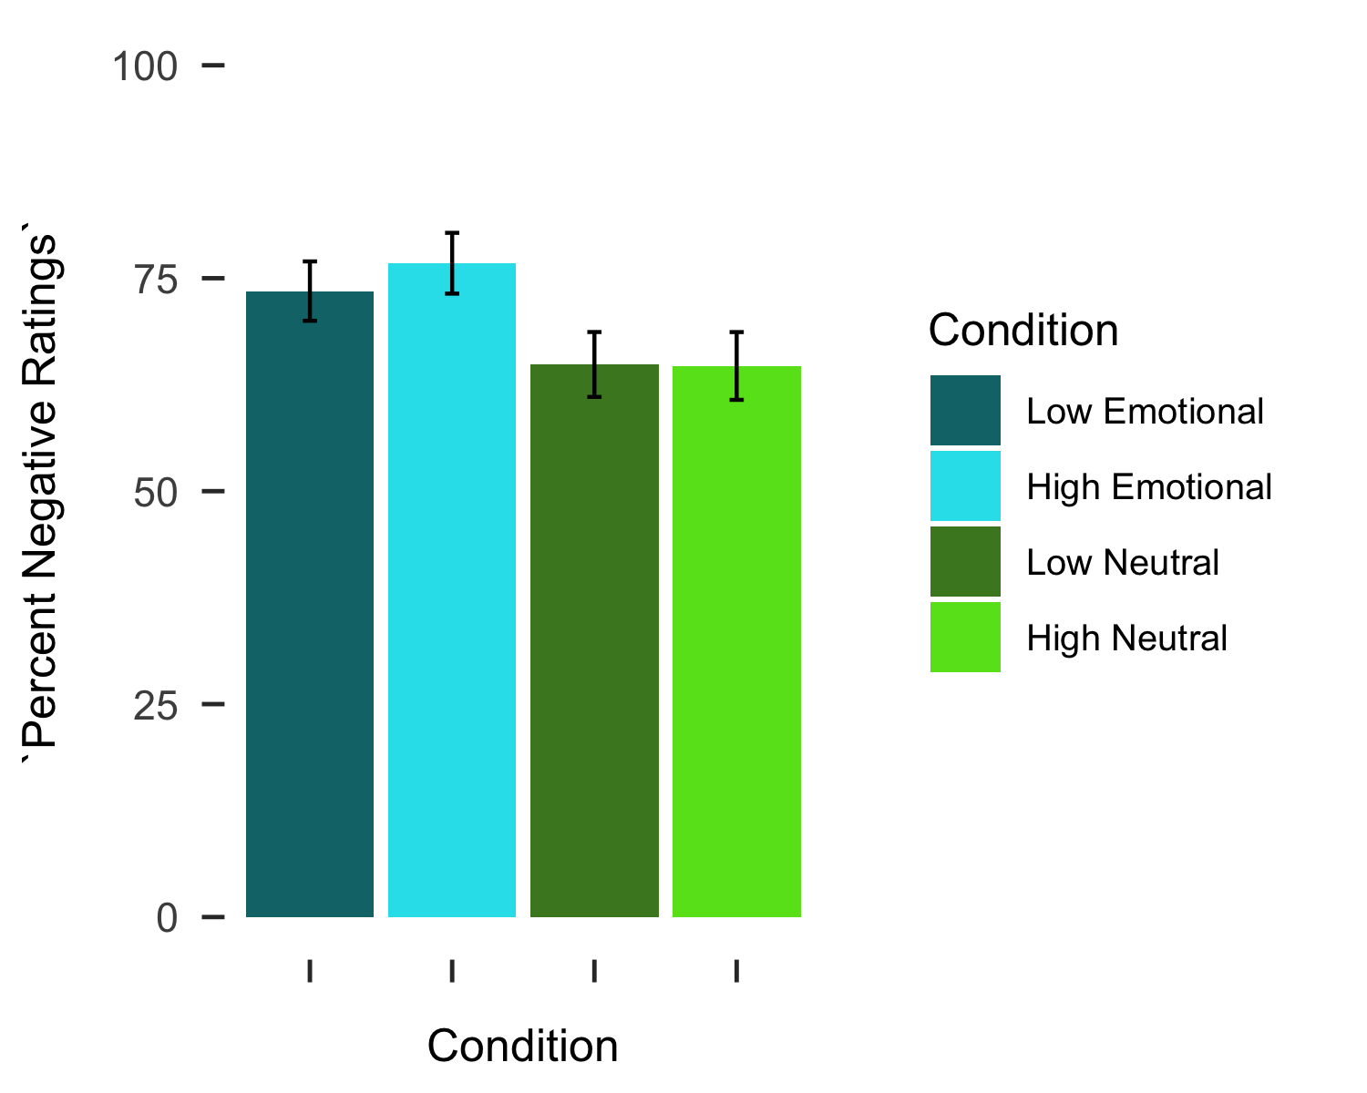

**Figure 2: Percent negative ratings across the working memory load conditions. Ratings during loads with emotional properties were more negative than ratings during loads with non-emotional properties, but there was no difference between ratings under low or high cognitive load.**

Next, a random intercept-only model was tested for absolute maximum deviation of mouse trajectories. The results supported the decision to model the intercept randomly (*X* 2(49)= 167.85, p < .001), meaning individuals differed in their average maximum deviations at baseline (i.e., low, non-emotional cognitive loads).After, a fixed component for the effect of load type (i.e., non-emotional vs. emotional) was added to the model uncentered at level one. The effect of load type did not significantly contribute to the model (*t*(149) = .14, p = .886), additionally the nested model comparison suggested that the effect of load type did not improve the fit of the model (*X* 2(2)= 3.80, p = .148). The effect of load (i.e., low vs. high) was added to the model next, uncentered at level one. The effect significantly contributed to the model (ß10 = .08, *t*(149) = 2.81, p =.006), and nested model comparisons favored the model with an effect of load (*X*2(2) = 12.72, p = .002). We next assessed whether variability in the slopes for the effect of load would be best modeled with a random effect, but the random effect for the slope of load did not reach statistical significance (*X*2(49) = 63.68, p = .08), nor did the model fit improve (*X*2(2) = 1.46, p > .500.As such, the random parameter was not included in the model and the effect of load remained fixed. The final model consisted of a fixed effect for load and random intercepts.

**Level-1 Model:** Maximum Deviationti = π0i + π1i*(Loadti) + eti

**Level-2 Model:** π0i = β00 + r0i

π1i = β10

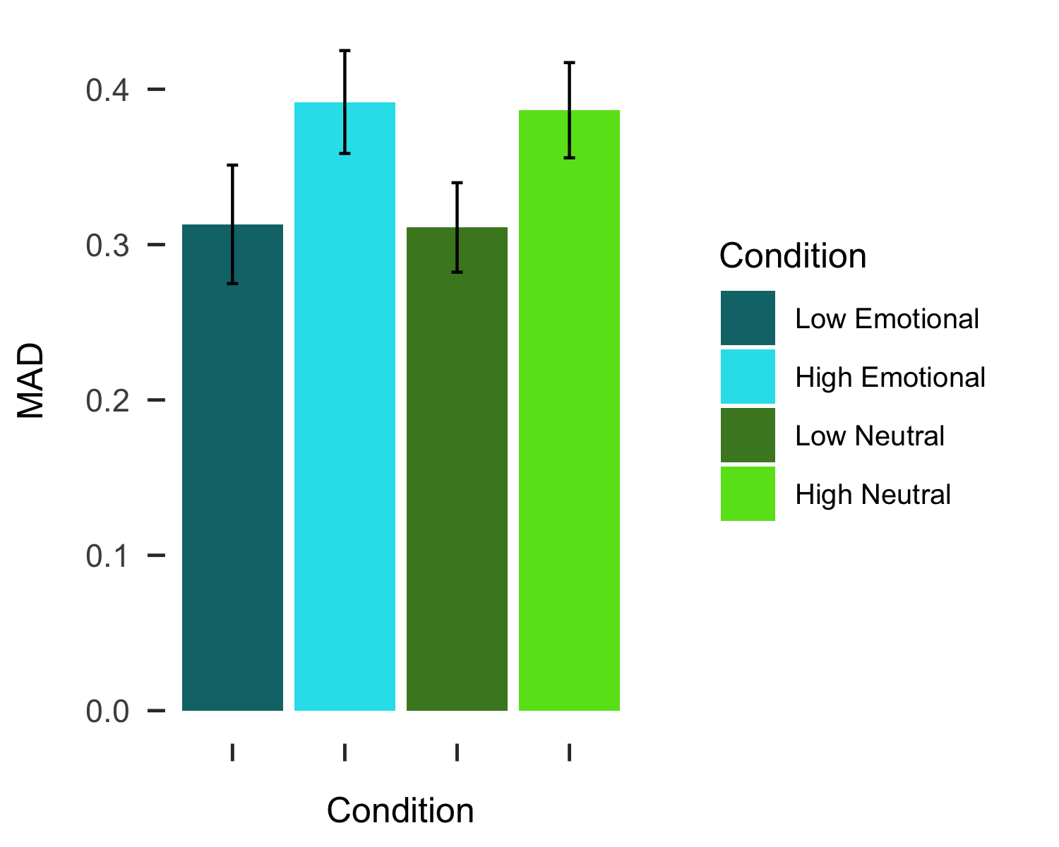

**Figure 3: Maximum deviations across the working memory load conditions. Maximum deviations during high cognitive load were greater than maximum deviations during low cognitive load, but there was no difference between maximum deviations during loads with emotional compared to non-emotional properties.**

# Discussion

Here we tested the effects of high cognitive loads with either emotional or non-emotional properties on valence bias. As predicted, interpretations of surprise were more negative under cognitive loads with emotional properties than loads with non-emotional properties. This result replicates previous work testing the effects of cognitive load on valence bias (Mattek et al., 2016), and aligns with literature demonstrating that the emotional properties of cognitively demanding tasks affect both task performance and the neural systems engaged during tasks (Egner et al., 2008). We also found evidence that maximum deviations were larger during high cognitive load, suggesting that response competition increased with the cognitive demands of the task. This effect of increased response competition parallels other work suggesting that high cognitive load increases distractor processing (Lavie & De Fockert, 2005) and that increased cognitive control demands (i.e., incongruent trials within a Stroop task) increase response competition measured with mouse-based response trajectories (Bundt, Ruitenberg, Abrahamse, & Notebaert, 2018). We discuss these results in the context of the initial negativity hypothesis below.

**Domain-specific effects**

The intial negativity hypothesis posits that positive interpretations of ambiguous stimuli rely on regulatory resources (Neta et al., 2009; Petro et al., 2018). We used a standard working memory paradigm (Ahmed, 2018; Burnham, 2010; Lavie & De Fockert, 2005) to induce high cognitive load with either emotional or non-emotional properties while participants made valence judgments of surprised facial expressions. Participants interpreted surprise as more negative during cognitive loads with emotional properties, suggesting that these loads specifically taxed the resources required for positive interpretations of ambiguity. There was no effect of high cognitive load on subjective interpretations, providing a conceptual replication of previous work (Mattek et al., 2016). Notably, this was true for both low and high cognitive load, suggesting that domain-specificity of cognitive load matters more than the load demands for altering interpretations of ambiguity.

Previous work supports the idea that emotional properties of tasks or stimuli recruit neural processes associated with emotion processes (Etkin et al., 2006; Neta et al., 2011). For instance, Neta et al. (2011) found that performing an emotional expression-based n-back task recruited greater amygdala activation when compared to an identity-based task. Given the initial negativity hypothesis’ prediction that positivity relies on regulation, it may be that working memory loads with emotional properties interfered with regions known to regulate amygdala activity. One such region, the anterior cingulate cortex, is known to correlate positively with amygdala during emotional face processing (i.e., increases in anterior cingulate and amygdala activity occur together) in youth and young adults with higher levels of anxiety (Kujawa, Wu, Klumpp, Pine, Swain, Fitzgerald, Monk, & Phan, 2017). Indeed, the emotional Stroop task differentially activates anterior cingulate cortex when compared to a non-emotional Stroop task (i.e., gender judgment; Etkin et al., 2006), suggesting that the working memory loads with emotional properties may have done so as well. Taken together, we interpret this effect of load type on interpretations of ambiguity as evidence that regulatory resources needed for positive interpretations of ambiguity are susceptible to domain-specific cognitive load demands, and that domain-general cognitive resources are less critical for regulating responses to emotional ambiguity.

**Domain-general effects**

While subjective interpertations of ambiguity were susceptible to load type, the underlying cognitive-motor dynamics (i.e., maximum deviations) of these decisions were more susceptible to more domain-general cognitive load demands. That is, maximum deviations varied as a function of low compared to high cognitive load, but not when the emotional properties of the load changed. Specifically, there was evidence that high cognitive loads of any type result in larger maximum deviations. In two-choice designs, maximum deviations are often conceptualized as a measure of response competition for ultimately unchosen responses or the degree of uncertainty during the response process (Calcagni, Lombardi, & Sulpizio, 2017; Freeman, Dale, & Farmer, 2011; Hehman, Stolier, & Freeman, 2015). The tendency for indviduals to be more drawn towards an unselected response may reflect a type of distraction effect (Spivey, Grosjean, & Knoblich, 2005). This mirrors effects seen in the cognitive load literature, where high cognitive loads lead to deficits in the ability to filter out task-irrelevant information (Lavie, Hirst, de Fockert, & Vidling, 2004). Although Mattek and colleagues (2016) did not observe a main effect of cognitive load on the deviations of response trajectories, there was a disruptive effect on participants tendency to show smaller deviations for their modal response (i.e., a response consistent with their general tendency or bias). At the least, high cognitive load appears to interfere with typical mouse-based response trajectories during resolution of emotional ambiguity.

Previous work has shown that emotional ambiguity resolution relies on a domain-general task control network called the cingulo-opercular network (Neta et al., 2013); though speculative, the cognitive loads may have taxed these resources, as this network is recruited in response to many types of ambiguity (Neta et al., 2013; Neta et al., 2014; Sterzer, Russ, Preibisch, & Kleinschmidt, 2002; Thompson-Schill, D’Esposito, Aguirre, & Farah, 1997). As such, the demands induced during high cognitive load, regardless of the emotional properties of the load, likely increased demands in this network. Ultimately, this increase in demands for this domain-general network are one explanation for the observed increase in response competition (i.e., maximum deviations) during high cognitive loads.

**Limitations and conclusions**

However, the present study is subject to limitations. For instance, despite the effect of cognitive load type on subjective interpretations of ambiguity and the effect of high load on response trajectories, working memory performance was near ceiling across all conditions (i.e., greater than 90% correct). This suggests that the high cognitive load may not have taxed resources to the fullest extent possible, perhaps weakening some effects. Future work could address this by increasing the demands of the task, either through larger sets of image matrices (e.g., eight, ten, or more) or increasing the number of trials so that participants view the same images across several matrices. In the present study, each image appeared within only one image matrix and each matrix was only presented once, perhaps facilitating participants’ ability to recognize the image during the memory probe.

Here we have provided both a conceptual replication and extension of previous work which tested the effects of high cognitive load on subjective interpretations of ambiguity, highlighting the importance of domain-specificty. In other words, only cognitive loads which tax emotion-related processing will lead to more negative interpretations of ambiguity. We posit that this effect relies on taxing neural resources related to ambiguity resolution and results in an increase in negativity, which is in line with our initial negativity hypothesis. We also demonstrated a domain-general effect of cognitive load on mouse trajectories, which could be further understood in future research, but likely relies on the more domain-general demands of high cognitive load within the cingulo-opercular network. Future work should explore these effects to verify the neural processes underlying these behavioral phenomena.

# References

Ahmed, L. Knowing how you are feeling depends on what’s on my mind: Cognitive load and expression categorization. *Emotion*, *18*(2), 190–201. doi:[10.1037/emo0000312](https://doi.org/10.1037/emo0000312)

Baddeley, A. D. (1986). Working memory. *Philosophical Transactions of the Royal Society of London*, *302*(110), 311–324.

Barrett, L. F., Adolphs, R., Marsella, S., Martinez, A. Pollak, S. 2019). Emotional expressions reconsidered: Challenges to inferring emotion from human facial movements. *Psychological Science in the Public Interest: A Journal of the American Psychological Society*, *20*(1), 1–68. doi:[10.1177/1529100619832930](https://doi.org/10.1177/1529100619832930)

Baumeister, R. F., & Heatherton, T. F. (1996). Self-regulation failure: An overview. *Psychological Inquiry*, *7*(1), 1–15. doi:[10.1207/s15327965pli0701_1](https://doi.org/10.1207/s15327965pli0701_1)

Blair, K. S., Smith, B. Mitchell, D. G. V., Morton, J., Vythilingam, M., Pessoa, L., … Blair, R.R. (2007). Modulation of emotion by cognition and cognition by emotion. *NeuroImage*, *35*(1), 430–440. doi:[10.1016/j.neuroimage.2006.11.048](https://doi.org/10.1016/j.neuroimage.2006.11.048)

Brown, C. C., Raio, C. M., & Neta, M. (2017). Cortisol responses enhance negative valence perception for ambiguous facial expressions. *Scientific Reports*, *7*(1), 15107. doi:[10.1038/s41598-017-14846-3](https://doi.org/10.1038/s41598-017-14846-3)

Bundt, C., Ruitenberg, M. F. L., Abrahamse, E. L., & Notebaert, W. (2018). Early and late indications of item-specific control in a stroop mouse tracking study. *PLOS ONE*, *13*(5), e0197278. doi:[10.1371/journal.pone.0197278](https://doi.org/10.1371/journal.pone.0197278)

Burnham, B. R. (2010). Cognitive load modulates attentional capture by color singletons during effortful visual search. *Acta Psychologica*, *135*(1), 50–58. doi:[10.1016/j.actpsy.2010.05.003](https://doi.org/10.1016/j.actpsy.2010.05.003)

Calcagnì, A., Lombardi, L., & Sulpizio, S. Analyzing spatial data from mouse tracker methodology: An entropic approach. *Behavior Research Methods*, *49*(6), 2012–2030. doi:[10.3758/s13428-016-0839-5](https://doi.org/10.3758/s13428-016-0839-5)

Carroll, J.& Russell, J. A. (1996). Do facial expressions signal specific emotions? Judging emotion from the face in context. *Journal of Personality and Social Psychology*, *70*(2), 205–218. doi:[10.1037//0022-3514.70.2.205](https://doi.org/10.1037//0022-3514.70.2.205)

Chandler, P., & Sweller, J. (1991). Cognitive load theory and the format of instruction. *Cognition and Instruction*, *8*(4), 293–332. doi:[10.1207/s1532690xci0804_2](https://doi.org/10.1207/s1532690xci0804_2)

Darwin, C. (1872). *The expression of the emotions in man and animals*. John Murray.

Duncan, J., & Owen, A. M. (2000). Common regions of the human frontal lobe recruited by diverse cognitive demands. *Trends in Neurosciences*, *23*(10), 475–483. doi:[10.1016/s0166-2236(00)01633-7](https://doi.org/10.1016/s0166-2236(00)01633-7)

Egner, T., Etkin, A., Gale, S., & Hirsch, J. (2008). Dissociable neural systems resolve conflict from emotional versus nonemotional distracters. *Cerebral Cortex (New York, N.Y.: 1991)*, *18*(6), 1475–1484. doi:[10.1093/cercor/bhm179](https://doi.org/10.1093/cercor/bhm179)

Ekman, P., & Friesen, W. V. (1971). Constants across cultures in the face and emotion. *Journal of Personality and Social Psychology*, *17*(2), 124–129. doi:[10.1037/h0030377](https://doi.org/10.1037/h0030377)

Etkin, A., Egner, T., Peraza, D. M., Kandel, E. R., & Hirsch, J. (2006). Resolving emotional conflict: A role for the rostral anterior cingulate cortex in modulating activity in the amygdala. *Neuron*, *51*(6), 871–882. doi:[10.1016/j.neuron.2006.07.029](https://doi.org/10.1016/j.neuron.2006.07.029)

Flexas, A., Rosselló, J., Christensen, J. F., Nadal, M., Rosa, A. O. L., & Munar, E. Affective priming using facial expressions modulates liking for abstract art. *PLOS ONE*, *8*(11), e80154. doi:[10.1371/journal.pone.0080154](https://doi.org/10.1371/journal.pone.0080154)

Freeman, J. B., & Ambady, N. (2010). MouseTracker: Software for studying real-time mental processing using a computer mouse-tracking method. *Behavior Research Methods*, *42*(1), 226–241. doi:[10.3758/BRM.42.1.226](https://doi.org/10.3758/BRM.42.1.226)

Freeman, J., Dale, R., & Farmer, T. (2011). Hand in motion reveals mind in motion. *Frontiers in Psychology*, *2*. doi:[10.3389/fpsyg.2011.00059](https://doi.org/10.3389/fpsyg.2011.00059)

Frijda, N. 1986). *The emotions*. Paris, France: Editions de la Maison des Sciences de l’Homme.

Frith, C. (2009). Role of facial expressions in social interactions. *Philosophical Transactions of the Royal Society B: Biological Sciences*, *364*(1535), 3453–3458. doi:[10.1098/rstb.2009.0142](https://doi.org/10.1098/rstb.2009.0142)

Green, C., & Guo, K. (2018). Factors contributing to individual differences in facial expression categorisation. *Cognition & Emotion*, *32*(1), 37–48. doi:[10.1080/02699931.2016.1273200](https://doi.org/10.1080/02699931.2016.1273200)

Hehman, E., Stolier, R.& Freeman, J. B. (2015). Advanced mouse-tracking analytic techniques for enhancing psychological science. *Group Processes & Intergroup Relations*, *18*(3), 384–401. doi:[10.1177/1368430214538325](https://doi.org/10.1177/1368430214538325)

Izard, C. E. (1994). Innate and universal facial expressions: Evidence from developmental and cross-cultural research. *Psychological Bulletin*, *115*(2), 288–299. doi:[10.1037/0033-2909.115.2.288](https://doi.org/10.1037/0033-2909.115.2.288)

Jiaping, C., Yuejia, L. U. O., Fang, C. U. I., Jiaping, C., Yuejia, L. U. O., & Fang, C. U. I. (2017). Empathy for pain influenced by cognitive load: Evidence from an ERP study. *Acta Psychologica Sinica*, *49*(5), 622–630. doi:[10.3724/SP.J.1041.2017.00622](https://doi.org/10.3724/SP.J.1041.2017.00622)

Kim, H., Somerville, L.Johnstone, T., Alexander, A. L., & Whalen, P. JInverse amygdala and medial prefrontal cortex responses to surprised faces. *Neuroreport*, *14*(18), 2317–2322. doi:[10.1097/00001756-200312190-00006](https://doi.org/10.1097/00001756-200312190-00006)

Kim, H., Somerville, L. H., Johnstone, T., Polis, S., Alexander, A. L& Whalen, P. J. (2004). Contextual modulation of amygdala responsivity to surprised faces. *Journal of Cognitive Neuroscience*, *16*(10), 1730–1745. doi:[10.1162/0898929042947865](https://doi.org/10.1162/0898929042947865)

Knight, M., Seymour, T. L., Gaunt, J. T., Baker, C., Nesmith, K., & Mather, M. (2007). Aging and goal-directed emotional attention: Distraction reverses emotional biases. *Emotion*, *7*(4), 705–714. doi:[10.1037/1528-3542.7.4.705](https://doi.org/10.1037/1528-3542.7.4.705)

Krieglmeyer, R., Deutsch, R., De Houwer, J., & De Raedt, R. (2010). Being moved: Valence activates approach-avoidance behavior independently of evaluation and approach-avoidance intentions. *Psychological Science*, *21*(4), 607–613. doi:[10.1177/0956797610365131](https://doi.org/10.1177/0956797610365131)

Kron, A., Schul, Y., Cohen, A., & Hassin, R. R. (2010). Feelings don’t come easy: Studies on the effortful nature of feelings. *Journal of Experimental Psychology: General*, *139*(3), 520–534. doi:[10.1037/a0020008](https://doi.org/10.1037/a0020008)

Kujawa, A., Wu, M., Klumpp, H., Pine, D. S., Swain, J. E., Fitzgerald, K. D., … Phan, K. L. (2016). Altered development of amygdala-anterior cingulate cortex connectivity in anxious youth and young adults. *Biological Psychiatry : Cognitive Neuroscience and Neuroimaging*, *1*(4), 345–352. doi:[10.1016/j.bpsc.2016.01.006](https://doi.org/10.1016/j.bpsc.2016.01.006)

Lang, P., Bradley, M. M., & Cuthbert, B. N. (2008). International affective picture system (IAPS): Affective ratings of pictures and instruction manual., Technical Report A–8. University of Florida, Gainesville, FL.

Lavie, N., & De Fockert, J. (2005). The role of working memory in attentional capture. *Psychonomic Bulletin & Review*, *12*(4), 669–674. doi:[10.3758/BF03196756](https://doi.org/10.3758/BF03196756)

Lavie, N., Hirst, A., Fockert, J. W. de, & Viding, E. (2004). Load theory of selective attention and cognitive control. *Journal of Experimental Psychology. General*, *133*(3), 339–354. doi:[10.1037/0096-3445.133.3.339](https://doi.org/10.1037/0096-3445.133.3.339)

Lazarus, R.Alfert, E. (1964). Short-circuiting of threat by experimentally altering cognitive appraisal. *The Journal of Abnormal and Social Psychology*, *69*(2), 195–205. doi:[10.1037/h0044635](https://doi.org/10.1037/h0044635)

Lundqvist, D., Flykt, A., & Öhman, A. (1998). The karolinska directed emotional faces—KDEF (CD ROM)., Stockholm: Karolinska Institute, Departmentof Clinical Neuroscience, PsychologySection.

Mather, M., & Carstensen, L. L. (2005). Aging and motivated cognition: The positivity effect in attention and memory. *Trends in Cognitive Sciences*, *9*(10), 496–502. doi:[10.1016/j.tics.2005.08.005](https://doi.org/10.1016/j.tics.2005.08.005)

Mattek, A. M., Whalen, P. J., Berkowitz, J. L., & Freeman, J. B. (2016). Differential effects of cognitive load on subjective versus motor responses to ambiguously valenced facial expressions. *Emotion*, *16*(6), 929–936. doi:[10.1037/emo0000148](https://doi.org/10.1037/emo0000148)

Muraven, M., Tice, D. M., & Baumeister, R. F. (1998). Self-control as a limited resource: Regulatory depletion patterns. *Journal of Personality and Social Psychology*, *74*(3), 774–789. doi:[10.1037/0022-3514.74.3.774](https://doi.org/10.1037/0022-3514.74.3.774)

Murphy, G., Groeger, J. A., & Greene, C. M. (2016). Twenty years of load theory—where are we now, and where should we go next? *Psychonomic Bulletin & Review*, *23*(5), 1316–1340. doi:[10.3758/s13423-015-0982-5](https://doi.org/10.3758/s13423-015-0982-5)

Nagamatsu, L. S., Voss, M., Neider, M. B., Gaspar, J. G., Handy, T. C., Kramer, A. F., & Liu-Ambrose, T. Y. L. (2011). Increased cognitive load leads to impaired mobility decisions in seniors at risk for falls. *Psychology and Aging*, *26*(2), 253–259. doi:[10.1037/a0022929](https://doi.org/10.1037/a0022929)

Nee, D. E., Wager, T. D., & Jonides, J. (2007). Interference resolution: Insights from a meta-analysis of neuroimaging tasks. *Cognitive, Affective, & Behavioral Neuroscience*, *7*(1), 1–17. doi:[10.3758/CABN.7.1.1](https://doi.org/10.3758/CABN.7.1.1)

Davis, F. C., & Whalen, P. J. (2011). Valence resolution of ambiguous facial expressions using an emotional oddball task. *Emotion*, *11*(6), 1425–1433. doi:[10.1037/a0022993](https://doi.org/10.1037/a0022993)

Neta, M., Kelley, W. M., & Whalen, P. J. (2013). Neural responses to ambiguity involve domain-general and domain-specific emotion processing systems. *Journal of Cognitive Neuroscience*, *25*(4), 547–557. doi:[10.1162/jocn_a_00363](https://doi.org/10.1162/jocn_a_00363)

Neta, M., Norris, C. J., & Whalen, P. J. (2009). Corrugator muscle responses are associated with individual differences in positivity-negativity bias. *Emotion (Washington, D.C.)*, *9*(5), 640–648. doi:[10.1037/a0016819](https://doi.org/10.1037/a0016819)

Neta, M., Schlaggar, B. L., & Petersen, S. E. (2014). Separable responses to error, ambiguity, and reaction time in cingulo-opercular task control regions. *NeuroImage*, *99*, 59–68. doi:[10.1016/j.neuroimage.2014.05.053](https://doi.org/10.1016/j.neuroimage.2014.05.053)

Neta, M., & Tong, T. T. (2016). Don’t like what you see? Give it time: Longer reaction times associated with increased positive affect. *Emotion*, *16*(5), 730–739. doi:[10.1037/emo0000181](https://doi.org/10.1037/emo0000181)

Neta, M., & Whalen, P. J. (2010). The primacy of negative interpretations when resolving the valence of ambiguous facial expressions. *Psychological Science*, *21*(7), 901–907. doi:[10.1177/0956797610373934](https://doi.org/10.1177/0956797610373934)

Petro, N. M., Tong, T. T., Henley, D. J., & Neta, M. (2018). Individual differences in valence bias: fMRI evidence of the initial negativity hypothesis. *Social Cognitive and Affective Neuroscience*, *13*(7), 687–698. doi:[10.1093/scan/nsy049](https://doi.org/10.1093/scan/nsy049)

Pontari, B. A., & Schlenker, B. R. (2000). The influence of cognitive load on self-presentation: Can cognitive busyness help as well as harm social performance? *Journal of Personality and Social Psychology*, *78*(6), 1092–1108. doi:[10.1037/0022-3514.78.6.1092](https://doi.org/10.1037/0022-3514.78.6.1092)

Said, C. P., & Todorov, A. (2011). A statistical model of facial attractiveness. *Psychological Science*, *22*(9), 1183–1190. doi:[10.1177/0956797611419169](https://doi.org/10.1177/0956797611419169)

Scalf, P. E., Torralbo, A., Tapia, E., & Beck, D. M. (2013). Competition explains limited attention and perceptual resources: Implications for perceptual load and dilution theories. *Frontiers in Psychology*, *4*. doi:[10.3389/fpsyg.2013.00243](https://doi.org/10.3389/fpsyg.2013.00243)

Sheppes, G., & Meiran, N. (2008). Divergent cognitive costs for online forms of reappraisal and distraction. *Emotion*, *8*(6), 870–874. doi:[10.1037/a0013711](https://doi.org/10.1037/a0013711)

Sterzer, P., Russ, M. O., Preibisch, C., & Kleinschmidt, A. (2002). Neural correlates of spontaneous direction reversals in ambiguous apparent visual motion. *NeuroImage*, *15*(4), 908–916. doi:[10.1006/nimg.2001.1030](https://doi.org/10.1006/nimg.2001.1030)

Storbeck, J. (2012). Performance costs when emotion tunes inappropriate cognitive abilities: Implications for mental resources and behavior. *Journal of Experimental Psychology: General*, *141*(3), 411–416. doi:[10.1037/a0026322](https://doi.org/10.1037/a0026322)

Thomas, L., Donohue-Porter, P., & Stein Fishbein, J. (2017). Impact of interruptions, distractions, and cognitive load on procedure failures and medication administration errors: *Journal of Nursing Care Quality*, *32*(4), 309–317. doi:[10.1097/NCQ.0000000000000256](https://doi.org/10.1097/NCQ.0000000000000256)

Thompson-Schill, S. L., D’Esposito, M., Aguirre, G. K., & Farah, M. J. (1997). Role of left inferior prefrontal cortex in retrieval of semantic knowledge: A reevaluation. *Proceedings of the National Academy of Sciences of the United States of America*, *94*(26), 14792–14797. doi:[10.1073/pnas.94.26.14792](https://doi.org/10.1073/pnas.94.26.14792)

Todorov, A., Baron, S. G., & Oosterhof, N. N. (2008). Evaluating face trustworthiness: A model based approach. *Social Cognitive and Affective Neuroscience*, *3*(2), 119–127. doi:[10.1093/scan/nsn009](https://doi.org/10.1093/scan/nsn009)

Tottenham, N., Tanaka, J. W., Leon, A. C., McCarry, T., Nurse, M., Hare, T. A., … Nelson, C. (2009a). The NimStim set of facial expressions: Judgments from untrained research participants. *Psychiatry Research*, *168*(3), 242–249. doi:[10.1016/j.psychres.2008.05.006](https://doi.org/10.1016/j.psychres.2008.05.006)

Tottenham, N., Tanaka, J. W., Leon, A. C., McCarry, T., Nurse, M., Hare, T. A., … Nelson, C. (2009b). The NimStim set of facial expressions: Judgments from untrained research participants. *Psychiatry Research*, *168*(3), 242–249. doi:[10.1016/j.psychres.2008.05.006](https://doi.org/10.1016/j.psychres.2008.05.006)

Trémolière, B., Gagnon, M.-È., & Blanchette, I. (2016). Cognitive load mediates the effect of emotion on analytical thinking. *Experimental Psychology*, *63*(6), 343–350. doi:[10.1027/1618-3169/a000333](https://doi.org/10.1027/1618-3169/a000333)

Van Dillen, L. F., Heslenfeld, D. J., & Koole, S. L. (2009). Tuning down the emotional brain: An fMRI study of the effects of cognitive load on the processing of affective images. *NeuroImage*, *45*(4), 1212–1219. doi:[10.1016/j.neuroimage.2009.01.016](https://doi.org/10.1016/j.neuroimage.2009.01.016)

1. Some versions of the task only included 142 trials due to a programming error.