

**INVITATION LETTER**

|  |
| --- |
| Dear PhapYName, |
| PhapYAddress |
| PhapYOrganization |

On behalf of The Asian Forensic Sciences Network 2019’s host, I am pleased to invite you to participate in a four-days meeting to assess the world’s latest knowledge and techniques in the field of forensic science. The conference will be held at Convention Center 272 (272 Vo Thi Sau street, District 3, HCM City, Vietnam) on September 17th-20th, 2019 from 8h30 am to 5h30 pm.

The Asian Forensic Sciences Network is a nonprofit educational and scientific organization, which takes place annually from 2009. We are very honored to be the host of the 11th AFSN meeting, which will provide a facilitator to help their individual member achieve the work more effectively and efficiently. We would like to accomplish this meeting with all of our members who play important roles in simultaneously working and seeking out the truth for human being and country’s safety.

Directions to Convention Center 272 are enclosed, along with informational materials so that you may begin preparing.

Please reply no later than July 30th, 2019, by emailing us at customerscare@afsn2019.vn. We are looking forward to having you join with other community partners to take a close look at our state-of-the-art technology and information.

Sincerely,

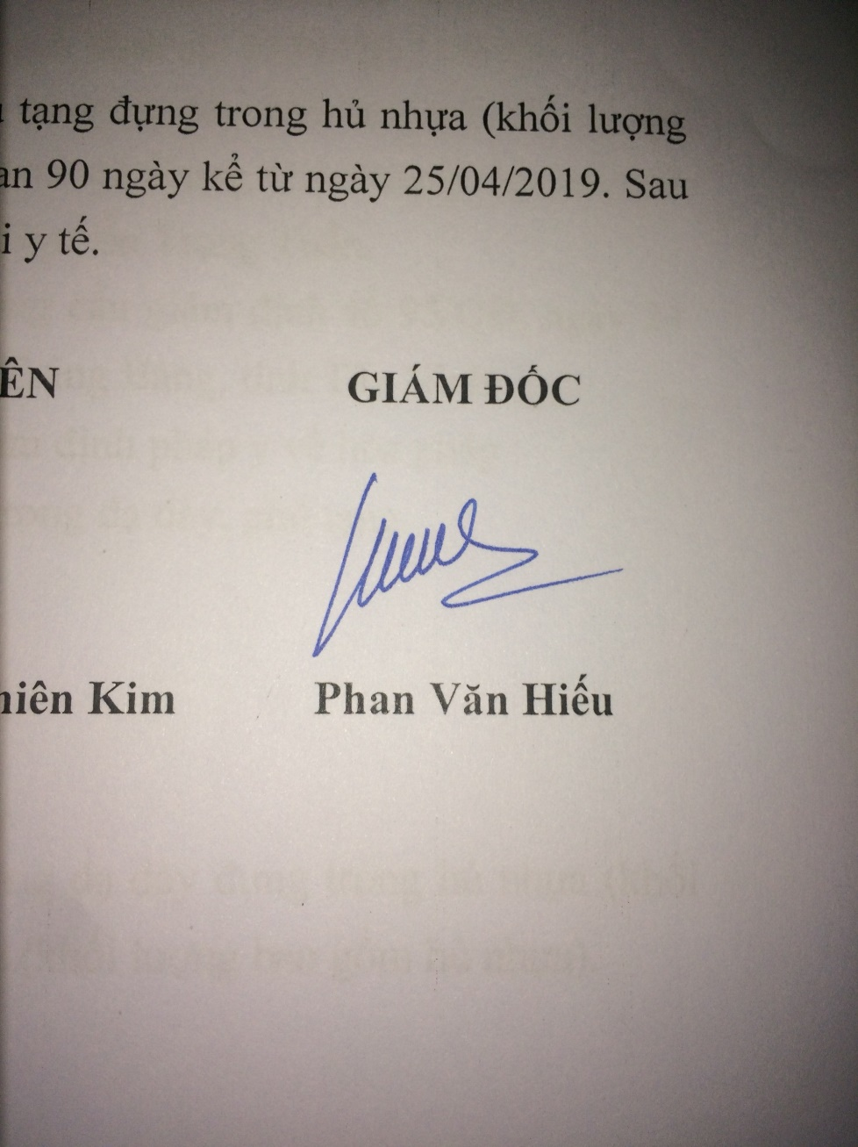

**Phan Van Hieu, MD, MSc.**

Director of Forensic Medicine Center

of Ho Chi Minh City, Vietnam

Chairman of 11th AFSN

Annual Meeting & Symposium Organising Committee