

COS30045 Data Visualization

Data Visualization Project Process Book

Visualization on Global Issue: Migration in Ukraine

Group members:

* Nguyen Cuong Nhat
* Phan Huy Quang

Instructor: Dr. Hoang Xuan Tung

1. **Introduction**

**1.1 Background and Motivation**

Migration has been a fundamental aspect of human history, driven by various factors including economic opportunities, family reunification, political instability, environmental changes, and conflicts. In recent years, however, the scale and complexity of migration have intensified due to a confluence of global events such as armed conflicts, climate change impacts, economic disparities, and political unrest. According to the United Nations, the number of international migrants worldwide reached an estimated 281 million in 2020, reflecting a significant increase over the past decade.

Understanding the dynamics and patterns of human migration is crucial for policymakers, humanitarian organizations, researchers, and the general public. Policymakers need insights into migration trends to develop effective migration policies and strategies. Humanitarian organizations require data to provide assistance and protection to displaced populations. Researchers aim to analyze migration patterns to identify underlying causes and potential solutions. Moreover, the general public's perceptions and attitudes towards migration play a significant role in shaping policies and societal responses to migrants.

Given the multifaceted nature of migration, there is a growing need for comprehensive visualizations that can provide insights into the various dimensions of this complex phenomenon. This project aims to address this need by designing and building a visualization tool that elucidates the context and patterns of human migration, focusing on recent events and trends.

**1.2 Visualization Purpose**

The visualization developed for the Ukraine migration dataset aims to achieve the following objectives:

- Understanding Migration Trends: Users will be able to explore the trends in migration within Ukraine over the period from January 2021 to January 2022. This includes visualizing the monthly fluctuations in the number of migrants across different regions of Ukraine, with a particular focus on areas directly affected by the ongoing conflict with Russia.

- Analyzing the Impact of War on Migration: The visualization will provide insights into how the conflict with Russia has influenced internal migration patterns in Ukraine. Users can examine the correlation between military activity, such as attacks or sieges, and spikes in migration from affected regions. This will help in understanding the direct impact of the war on population displacement within Ukraine.

- Comparing Migration Patterns Across Regions: Users will be able to compare migration patterns across different regions of Ukraine, including both urban and rural areas. This includes visualizing the relative magnitude of migration flows in regions experiencing varying levels of conflict intensity and economic stability.

- Examining International Migration: In addition to internal migration trends, the visualization will incorporate data from the UN on migration from Ukraine to other countries. Users can explore the destinations of Ukrainian migrants abroad and assess how the conflict has influenced international migration patterns. This will provide a broader perspective on the impact of the war on population movements beyond Ukraine's borders.

- Identifying Hotspots of Displacement: The visualization will identify hotspots of population displacement within Ukraine, highlighting regions with the highest levels of outmigration or influx of displaced persons. Users can drill down into specific regions to understand the underlying factors driving migration, such as proximity to conflict zones, availability of resources, and accessibility to transportation networks.

Overall, the visualization tool seeks to answer the following questions:

- What are the overall migration trends in Ukraine during the period from January 2021 to January 2022?

- How has the conflict with Russia impacted internal migration patterns within Ukraine?

- Are there correlations between military activities (e.g., attacks, sieges) and spikes in migration from affected regions?

- Which regions of Ukraine have experienced the highest levels of population displacement, and what are the underlying factors driving migration in these areas?

- What are the types of migration occurring in Ukraine, and how do they differ in terms of magnitude and temporal dynamics?

- What are the destinations of Ukrainian migrants abroad, and how has the conflict influenced international migration patterns?

Based on these, the visualization can inform decision-making, facilitating humanitarian response, and promoting empathy and support for affected populations.

**1.3 Project Schedule**

To ensure effective project management and timely completion, the following schedule is proposed:

- Week 1-3: Project kickoff and preliminary research on migration data sources, visualization techniques, and project requirements.

- Week 4-6: Data collection and preprocessing, including obtaining datasets on migration flows, displacement events, and relevant contextual factors.

- Week 7-8: Designing the visualization and selecting appropriate visualization techniques based on the requirements and data characteristics.

- Week 9-10: Implementation of the visualization prototype, including data integration, interactive features, and user interface design.

- Week 11-12: Testing, evaluation and finalizing the visualization based on project objectives, documenting the design process and technical implementation, and preparing the final project report and presentation.

By adhering to this schedule, the project aims to deliver a high-quality visualization tool that effectively addresses the complexities of human migration and contributes to a better understanding of this critical global issue.

1. **Dataset**

**2.1 Data source**

The dataset is collected from **Ukrainian State Statistics Service (SSSU).** It covers population migration in Ukraine, including indicators related to migration population growth and reduction. It provides detailed breakdowns by region, terrain type, gender, and age groups. The data spans from 1 January 2021 to 1 February 2022. It cover most of the states and metropolis in Ukraine, except for Crimea (Krym) and Sevastopol, as they are under the control to the Russian. With a war going on in Ukraine, we could link the number of migrants as an impact of the war (for example a city under attacked will cause the migration in that month to explode). There are the following important data:

* Type of migration: Categorical
* Region: Categorical
* Number of migrants monthly: ratio data

Here's a breakdown of the columns:

* Indicator: This column indicates the type of data being recorded. In this case, it's "Migration population growth".
* Region: This column specifies the region in Ukraine for which the data is recorded.
* Frequency: This column indicates the frequency of data recording. In this case, it's "Monthly".
* 2021-M01 to 2022-M01: These columns represent the months from January 2021 to January 2022. The numbers in these columns likely represent the number of people who migrated to the respective region in that month.

It's important to note that some regions, like "Avtonomna Respublika Krym" and "Sevastopol", don't have any data recorded.

We also consider the dataset from the UN in which it provides the number of migrant from Ukraine to other country, as they can convey how the war have caused Ukraine citizen to leave their country.

**2.2 Data Preprocessing**

Some several transformations on the data we use in the data processing phrase:

* Data Cleaning: Handle missing values in the dataset. For instance, the regions "Avtonomna Respublika Krym" and "Sevastopol" have no data. We can either fill these missing values with a specific number (like 0), or we can remove these rows entirely if they are not needed for our analysis.
* Data Transformation: Convert the data from wide format to long format. Currently, each month is a separate column. We can reshape the data so that we have a single 'Month' column and a 'Value' column that contains the migration population growth for that month.
* Data Aggregation: Aggregate the data to get insights. For example, calculate the total migration population growth for the entire year 2021 for each region.
* Data Filtering: Filter the data based on specific conditions. For example, analyze data for a specific region or a specific month.

1. **Requirements**

**3.1 Must-Have Features**

- Visualization of Migration Trends: Visualize the migration trends in Ukraine from January 2021 to January 2022, including the monthly fluctuations in the number of migrants across different regions.

- Analysis of War Impact on Migration: Analyze the impact of the conflict with Russia on internal migration patterns in Ukraine, including correlations between military activities and spikes in migration from affected regions.

- Identification of Displacement Hotspots: Identify hotspots of population displacement within Ukraine, highlighting regions with the highest levels of outmigration or influx of displaced persons.

- Comparison of Migration Patterns: Allowing users to compare migration patterns across different regions of Ukraine, including urban and rural areas, to understand disparities and underlying factors driving migration.

- Interactive Mapping: Incorporating interactive mapping features to allow users to visualize migration flows geographically, enabling a spatial understanding of migration patterns.

All the must-have features were delivered as they are critical for achieving the primary objectives of the project, which is to provide comprehensive insights into migration dynamics in Ukraine during the conflict with Russia.

**3.2 Optional Features**

- International Migration Analysis: The ability to incorporate data from the UN on migration from Ukraine to other countries, enabling users to explore international migration destinations and trends.

- Informative Humanitarian Response Insights: Providing insights to inform humanitarian response efforts, such as identifying areas with the greatest humanitarian needs and facilitating resource allocation for displaced populations.

- User-Friendly Interface: A user-friendly interface that allows for easy navigation and exploration of migration data, ensuring accessibility for policymakers, researchers, humanitarian organizations, and the general public.

While these optional features would enhance the usability and interactivity of the visualization tool, they were not critical for achieving the project's primary objectives. However, they could be considered for future iterations or enhancements of the project to further enrich the user experience and analytical capabilities.

1. **Visualization Design**

* Line Chart: A line chart could be used to show the trend of migration growth over time for each region. The x-axis would represent time (months), and the y-axis would represent the migration growth. Each line would represent a different region. This would allow you to easily compare the trends between different regions.
* Area map: An area map could be used to compare the total migration growth for each region. implemented a map of Ukraine using the data from geoJSON. It has borders between states, and can be zoomed in and out. It requires a JSON file that contains the latitude and longitude coordination of states, which correspond to the cities to add to the map visualization.

Example:

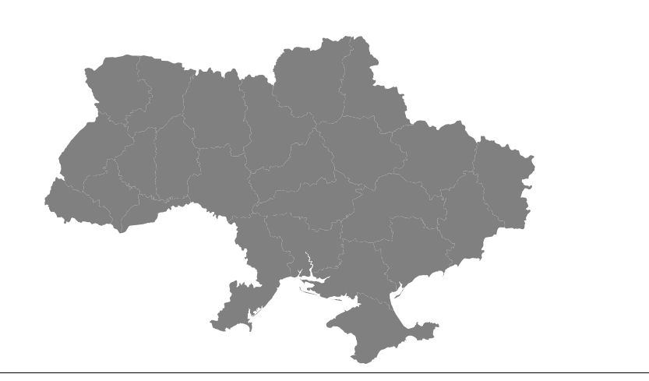

* Heatmap: A heatmap could be used to show the migration growth for each region over time. The x-axis would represent time (months), the y-axis would represent the regions, and the color intensity would represent the migration growth. This would allow you to easily see which regions and months had the highest migration growth. For visual encoding, color could be used to differentiate between different regions in the line chart and bar chart. In the heatmap, color intensity would be used to represent the migration growth.