# BORDEAUX UNIVERSITY

# Class: MINF18

**Instructor: Pascal**

**Professional Project**

**License Plate Number Recognition System**

**(LPNRS)**

**Members:**

**Phan Thanh Son**

**Tran Quang Nhat**

**References:** [**http://javaanpr.sourceforge.net/**](http://javaanpr.sourceforge.net/)

Contents

BORDEAUX UNIVERSITY 1

Class: MINF18 1

1. Introduction 2

**1.1 LPNRS systems as a practical application of artificial intelligence** 2

**1.2 Mathematical aspects of number plate recognition systems** 2

**1.3 Physical aspects of number plate recognition systems** 3

**2.** **Principles of number plate area detection** 3

**2.1** **Edge detection and rank filtering** 4

**2.1.1** **Convolution matrices** 4

2.2 Horizontal and vertical image projection 9

# Introduction

Nowaday, The License plate number of cars be very common and be applied very many in the life. Such as: toll fee stations on the highway, parking, etc... The purpose of this project be research the way which how to do that we are able to detect the content on images be captured. And also be make a simple demo for detecting the license plate from images.

## **1.1 LPNRS systems as a practical application of artificial intelligence**

A standalone information system without data will be not able work and has sense for detecting and analysis for the exactly result. We must have a standard data set for the purpose detecting the content in The license plate.This data such as images in a standard for the size and can be collected by human or by some modern equipments which can capture the images of license plate of cars, for example that is the camera which be installed in toll fee station on the highway or in the parking system also will have the cameras for the purpose be capture and collect the images after that The LPNRS will use these images for standard data.

In toll-fees collection station on the highway, number plates be captured and calculate the fees when the car go over the station.The owner of cars will have to register a user which link with their car’s number plate. On the system will have data of users link with the number plate of the car therefore after that camera capture the image of number plate that the system will know be who be owner of the car and will charge toll fee exactly.

In the parking, numberplate be captured and calculate the time in duration of the parking.When a car enters an input gate , number plate will be stored in database.When this car exists a output gate, the number plate will also captured one again and will compare with the last number plate in database if be matched then will calculate the duration and allowing the car exists.

For the other example be LPNRS system be used for control cars of the staff in a company. The only cars of staff have to grant to access the gate.

In some developed countries, LPNRS system will store all number license plate of the vehicles therefore will be very easy to checking some cars has be in black list or not, also helping the management and checking violation of the vehicle easier and fastly.

## **1.2 Mathematical aspects of number plate recognition systems**

In most cases, number plate be used to identify the vehicle. Every vehicle will have only one the number plate and this number is unique. Human can be easily to read the number plate in their eyes but The computer be not.With the machine, a number plate be only a grey picture defined as a two-dimensional function f(x,y), where x and y are spatial coordinates, and f is a light intensity at that point.Therefore, we need to design a roboust mathematic machine which will be able to extract semantics from spatial domain of the captured images. The function which we will implement in professional project be called is **LPNRS (Full name is License Plate Number Recognition System).**

The Design and research in professional project for LPNRS is a field of artificial intelligence, machine learning, pattern recognition and netural network

## **1.3 Physical aspects of number plate recognition systems**

License Plate Number Recognition System is a set of hardware and software components.Hardware such as camera ,sensors to detect the cars when it go over station by the sensors and the camera will capture the images which has number plate of the cars.

The hardwards necessary when build a LPNRS includes:

* Cameras: Cameras be installed at station to capture number plate images of cars go over the station
* Sensors: Detecting the cars go over the station and trigger Camera capture
* Computers at stations: Computer has software to control and collect,detecting images and after that sending to SERVER
* Servers : SERVER be used to store number plate and information of user in Database.
* The other equipments: necessary to setup the system.

# **Principles of number plate area detection**

The first step in a process of automatic number plate recognition is a detection of a number plate  
area. We have to find and build a algorithm be able to detect number range in the images. This range is a rectangle.The machine do not understand what “Road” and “vehicle” or whatever else is.Because of this, we need to find a alternative definition of a number plate based on descriptors that will be comprehensible for machines.

We will define the number plate as a “rectangular area with increased occurrence of horizontal and vertical edges”.

The high density of horizontal and vertical edges on a small area  
is in many cases caused by contrast characters of a number plate, but not in every case. This  
process can sometimes detect a wrong area that does not correspond to a number plate. Because  
of this, we often detect several candidates for the plate by this algorithm, and then we choose  
the best one by a further heuristic analysis

Let a input image be defined by function f(x,y), where x and y are spatial coordinates, and f is an intensity of light at that points.This function is always discrete on computers such as denotes the set of natural numbers including zero.

We define operations such as edge detection or rank filtering as mathematical  
transformations of function f.

The detection of a number plate area consists of a series of convolve operations. Modified  
snapshot is then projected into axes x and y . These projections are used to determine an area  
of a number plate

## **Edge detection and rank filtering**

We can use a periodical convolution of the function f with specific types of matrices m to  
detect various types of edges in an image:

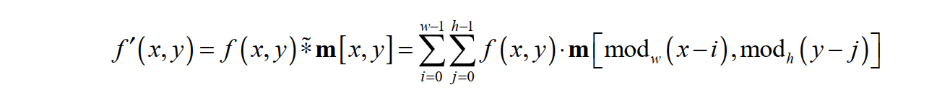

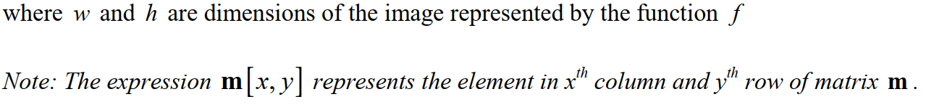

(Source: http://javaanpr.sourceforge.net/)

### **Convolution matrices**

Each image operation (or filter) is defined by a convolution matrix. The convolution matrix  
defines how the specific pixel is affected by neighboring pixels in the process of convolution.

Individual cells in the matrix represent the neighbors related to the pixel situated in the centre of  
the matrix. The pixel represented by the cell y in the destination image (fig. 2.1) is affected by  
the pixels x0…..x8 according to the formula:

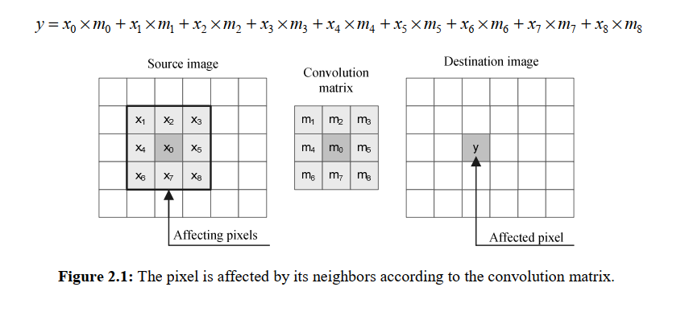

(Source: http://javaanpr.sourceforge.net/)

**Horizontal and vertical edge detection**

To detect horizontal and vertical edges, we convolve source image with matrices mhe and mve .  
The convolution matrices are usually much smaller than the actual image. Also, we can use  
bigger matrices to detect rougher edges

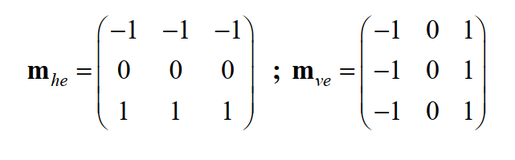

**Sobel edge detector**

The Sobel edge detector uses a pair of 3x3 convolution matrices. The first is dedicated for  
evaluation of vertical edges, and the second for evaluation of horizontal edges .

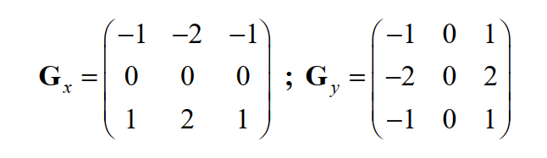



**Horizontal and vertical rank filtering**

Horizontally and vertically oriented rank filters are often used to detect clusters of high density  
of bright edges in the area of the number plate. The width of the horizontally oriented rank filter  
matrix is much larger than the height of the matrix ( w h ≫ ), and vice versa for the vertical rank  
filter ( w h ≪ ).  
To preserve the global intensity of an image, it is necessary to each pixel be replaced with  
an average pixel intensity in the area covered by the rank filter matrix. In general, the  
convolution matrix should meet the following condition:

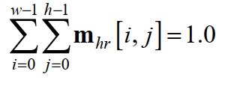



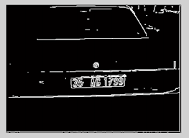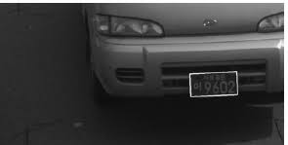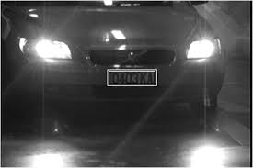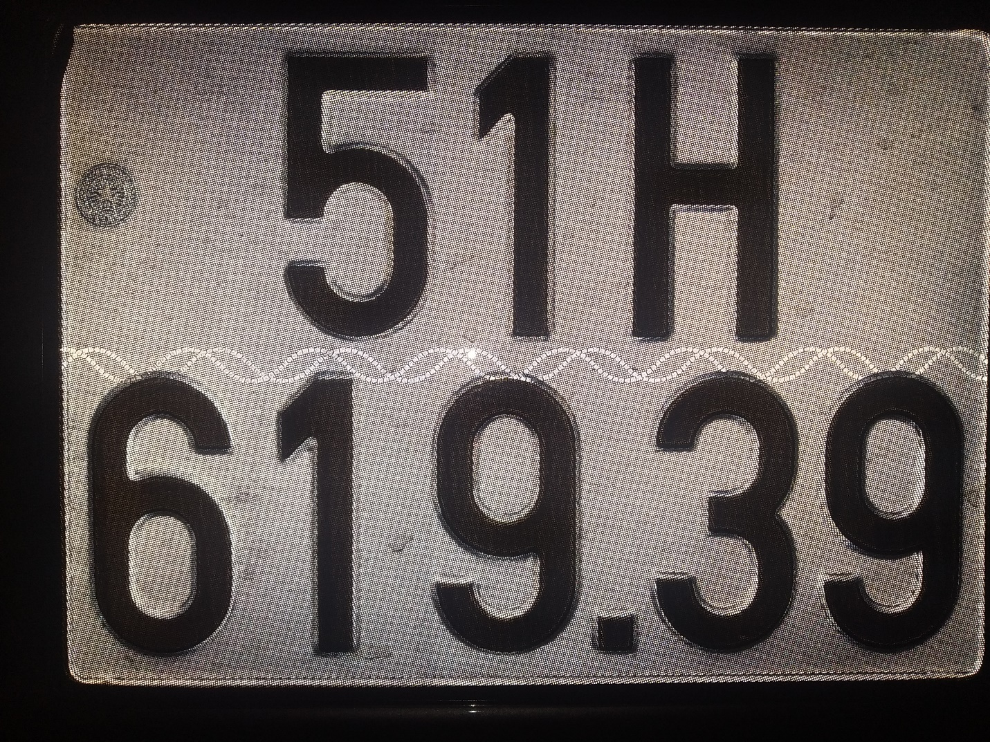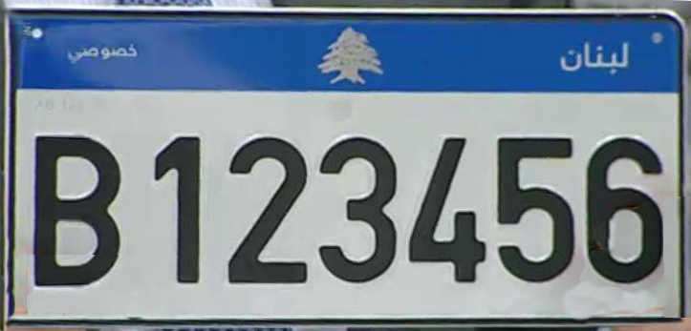

## 2.2 Horizontal and vertical image projection

We can detect an area of the number plate according to a statistics of the image. We will use horizontal and vertical projection of an image into the axes *x* and *y*.

The vertical projection of the image is a graph,