

HUMAN COMPUTER INTERACTION AND DESIGN

ASSIGNMENT

Learner’s name: NGUYEN DUC NHAT

Learner’s ID: GCS17259

Class: TCS2007_PPT

Subject’s ID: COMP1649

Assignment due:Assignment submitted

1. **Introduction**

Interaction design is an important part of the user experience design and development process. This is the work of designing the user interaction with the prototypes. The prototypes in the report mentioned are software products, mobile applications for health training.

**Table of Contents**

**1. Introduction 1**

**2. Backgrounds 1**

**2.1. Processes and Frameworks for Interaction Design 2**

**2.2. Cognitive Psychology 5**

**2.3. Interaction Design Theory 5**

**3. Design Process 8**

**3.1. Interaction Design Research 8**

**3.2. Conceptual Design 9**

**4. Prototype 10**

**4.1. High-level prototype 10**

**5. Research study 18**

**5.1. Assumption 18**

**5.2. Participants in research 19**

**5.3. Data types 19**

**5.3.1. Primary data 19**

**5.3.2. Secondary data 19**

**5.4. Data collections 19**

**5.4.1. Interview 19**

**5.4.2. Survey 20**

**5.5. Data Analysis 20**

**a) Quantitative Data Analysis 20**

**b) Qualitative Data Analysis 20**

**6. Conclusion 20**

**6.1. Summary 20**

**6.2. Some difficulties 20**

**6.3. Improvement 20**

**6.4. Next steps 21**

**7. References 21**

1. **Backgrounds**

Some definitions of key terms are used in this report:

* **Smart gym equipment**: It is a gym device that connects to smart hand held devices such as smart phones, smart bracelets, ... and an app to track and record your workouts. The gym equipment is connected to the Internet through a smart phone or a smart bracelet and data mining based on cloud data, from which a workout goal, diet, and fitness goal can be set. Training history to create short-term or long-term training plans. And thanks to the application of technology to exercise devices, the training session will become more enjoyable and entertaining. Smart training devices are deployed thanks to technologies such as the Internet Of Things (IoT), artificial intelligence (AI), ..., thereby increasing connectivity between training equipment and smart phones. smart device or smart device.
* **Smart phone**: It is a phone that integrates multi-functions for each user's needs, today's smart phones not only perform functions of listening, calling and texting, but also can listen to music, Internet access, take pictures, watch movies with high quality, ...Smart phone manufacturers are constantly improving and upgrading in terms of hardware and software, so smart phones are getting smarter and more powerful.
* **Smart wearable**: It is a device that supports the connection to a smartphone, it assists the user as smart control, notification, and display of messages, receiving calls,shows current date and time as well as current weather ...and the most important function manufacturers have focused on developing most is health monitoring. Functions such as heart rate measurement, blood pressure, and sleep monitoring are indispensable. Besides, it also supports users in workouts and gyms such as tracking steps, exercise intensity, connecting to exercise equipment as a tracking device.
  1. **Processes and Frameworks for Interaction Design**
     1. **User-Centred Design**

1. **What is User-Centred Design?**

**User-Centred Design(UCD)** is a set of design processes, steps in which designers focus on the user, with the user as the center for product design and development. This means that designers need to meet the needs and wants of the users throughout the product design process, focusing on user requirements is a top priority for designing a user-centred framework. At UCD, designers will use research and design techniques, to create products that meet the user's wishes and receive positive feedback from them. The User-centred Design also provides designers with techniques to create emotions for their products.

1. **User-Centered Design Principles.**

The five main principles of UCD:

* It is important to understand user requirements, which is the most important of the UCD guidelines. Designers need to analyze user requirements seriously, being able to suggest adjustments to the business requirements to fit the needs of the user.
* Always note the user feedback, maybe present a few designs for user evaluation in order to define the requirement more clearly.
* User participation is required at the initial steps to receive timely feedback and evaluation for the product.
* Integrate a User-centred Design framework for product design and development activities.
* Iterative design process. Improved user experience for better products.

1. **User-Centred Design Processes.**

User-centred design can be performed using the following processes:

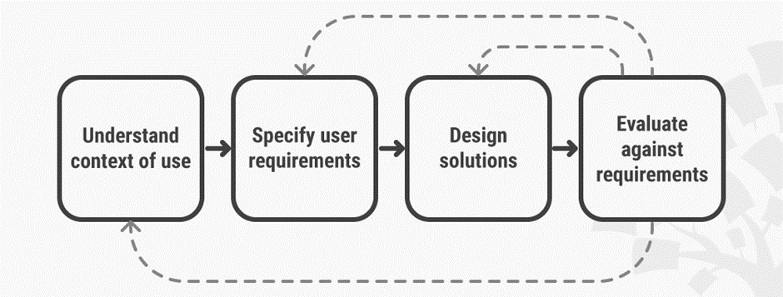

*Figure 1: User-Centred Design diagram.*

* Process 1: The development team begins the product design process by defining the end-user, the product's goal, and the user's context of use. By taking this step, the development team will determine why users are interested in this product and how they use it.
* Process 2: from the data and information gathered in Process 1, combine them to form a set of user requirements and product goals. This procedure should satisfy the needs of the users identified in Process 1.
* Process 3: After completing the above 2 processes, the development team proceeds to design the solutions. This stage can be iterative and can go from a rudimentary concept or design to a complete design.
* Process 4: the development team reassesses the product they have designed, some of the methods that can be applied to this evaluation are to testing follow the test cases, collect user feedback. This process should be repeated to achieve the best design.
  + 1. **Goal-Oriented Design**

1. **What is Goal-Oriented Design**

Goal-Oriented Design was founded by Alan Cooper. It is designed so that designers can understand the nature of the requirements, the needs of the users and the behavior, in order to create a product with functions and interfaces that satisfy user requirements. . In addition, this technique also helps you create strategies to interact, negotiate with users, ensure that customers will receive products and continue to use them.

1. **Goal-Oriented Design Processes**

Goal-Oriented Design can be performed using the following processes:

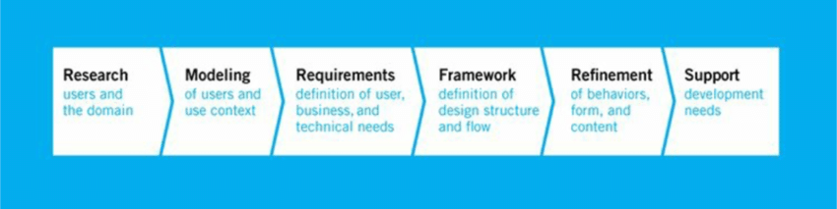

*Figure 2: Goal-Oriented Design diagram*

* **Research**: The goal at this stage is to collect relevant data about your users and customers. Some data collection techniques can be used such as: interviews (including users and stakeholders), surveys, market research ... You can use one or a combination of techniques. narrative together in order to get maximum data from users. The end result of the data collection is that a user behavior pattern must be produced. Designers will rely on that to create a model for a product or analyze a product that users have experienced before. These models will be very helpful in defining the goals for the project.
* **Modeling**: The purpose of this stage is to create prototypes to visually detail user requirements such as graphs, schemas, etc. analysis in the Research phase and synthesize them together.Personas are an edge-to-edge design that is based on narrative scenario, user data, and helps you better understand your users' needs and needs. This facilitates designers to significantly improve the user experience of their products.
* **Requirements Definition**: Instead of focusing on common user tasks, the purpose of this phase is to perform tasks that are broken down, and the design focuses on the details and specific situations of behavior. Connections to models in the project are established during this phase. This phase helps establish a purely goal-oriented process. And finally, this creates definitions for user requirements, technology, business, user experience, consumer needs, etc. and puts these requirements at a level. equal to priority.
* **Framework Definition:** With any software project, you need to sketch it out. Make a map showing the locations for each of the different functions to create a design suitable for each function. To solve different problems, we need different interaction models to solve them, models should be arranged in a ranking manner. A complete framework definition is the result of this process, which will show the overall structure and interface idea of the project. These definitions can be improved in more detail for the purpose of concretizing the problem.
* **Refinement:** The aim at this stage is to evaluate the design specifications and finalize the goals. This process only focuses on improving and refining the functions and structure of the project to be more consistent.One of the problems that interface designers face is having to create products that are suitable for regular users and inexperienced users. It is a great challenge. The purpose-centered design technique uses behavioral analysis to better understand the behaviors and experiences of these two types of people. Helping the product to be balanced and well received from the user. And finally, this technique helps developers to focus more on the user as well as the functions of the project, to make the product better user-oriented, to create interaction among developers, the user and the manager by focusing on the end product and end.
* **Development Support**: Technology is always changing, which poses challenges for developers to keep your designs consistent, keeping the original structure. Designers need skills or a team capable of maintaining the core, structural characteristics of the project.
  + 1. **Participatory design**

1. **What is participatory design**

Participatory design is a design approach in which the user, the client is engaged as a co-designer in the design process, is a product-centered design approach, providing product inputs, helping to focus on product development and improvement. A participatory design approach can be implemented at any point in the development process. A leader can make decisions when to apply and how this process happens. This simple approach might be to bring together a small group of consumers to review and evaluate your software product. Depending on the size of the project, you can extend the length of time that the group of participants is maintained, including the pay as well as the incentives attached, which should take into consideration the needs and budget of the project to make the right decision.

1. **Benefits of Participatory design**

* The great benefit of this approach is to give designers many new and unique design ideas, along with improvements, contributions from many sides, sharing their views to contribute to development. develop better products.
* Completed software products will be easily accepted by users and will be ranked for higher approval.
* Easily detect areas that need improvement, missed design values.
* Participants can contribute thoughts and ideas for developers to explore the new design potentials of products.
  1. **Cognitive Psychology**

Cognitive Psychology is a small branch of psychology, is a field of study, discovering how people perceive, think, solve, remembers a certain problem. Cognitive psychology has studied human behaviors through everyday actions such as receiving information, processing, and acting on reflex. Discover and note the effects of the outside world on human perception.

In design, cognitive psychology helps describe the user's behavior, the habits of interacting on the user interfaces, thereby giving appropriate UX design solutions. The ultimate goal is to create designs that provide a good experience for the user and their reception.

Some basic cognitive psychology rules:

* **Remove unnecessary items**

Every user when visiting a website or an application, they have their own goals. An application with too many items will confuse users, difficult to focus on what they want. So for beginners, reduce unnecessary content, or design a space to guide them with clear instructions.

It is also important to leave blank spaces even if there is no content. This keeps users more focused on what they do. Avoid using autoplay options, links, images, ads or videos, which will mostly annoy the user.

* **Simplify Navigation**

The navigation bar is an indispensable part of any software product, this is the part that the user should be seen when starting into the application, and will be permanently displayed on each screen for users to easily navigate. to another screen. You should clearly classify according to the category of screens, hierarchy for them instead of bringing all of them directly to the navigation bar. In addition, it is necessary to be consistent in understanding the navigation bar at different devices such as smartphones, tablets, PCs.

* **Symbol**

The selection of icons to represent each certain function is also important, icons need to be meaningful and make users think of that function or even illiterate people can use them.

* 1. **Interaction Design Theory**

1. Manipulating

A common type of interaction that any prototype applies to, some common actions like tapping, tapping, swiping, and scrolling. Direct interaction with objects designed in prototypes, often applied with touch devices.The strength of this type of interaction is its ease of interaction, which can be applied to many devices. On mobile applications, the gesture type is used to move back and forth through each different screen through pressing buttons, swiping on the touch screen.

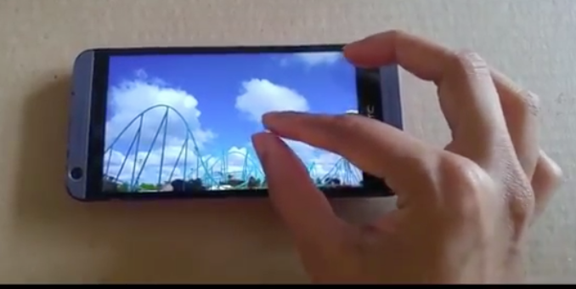

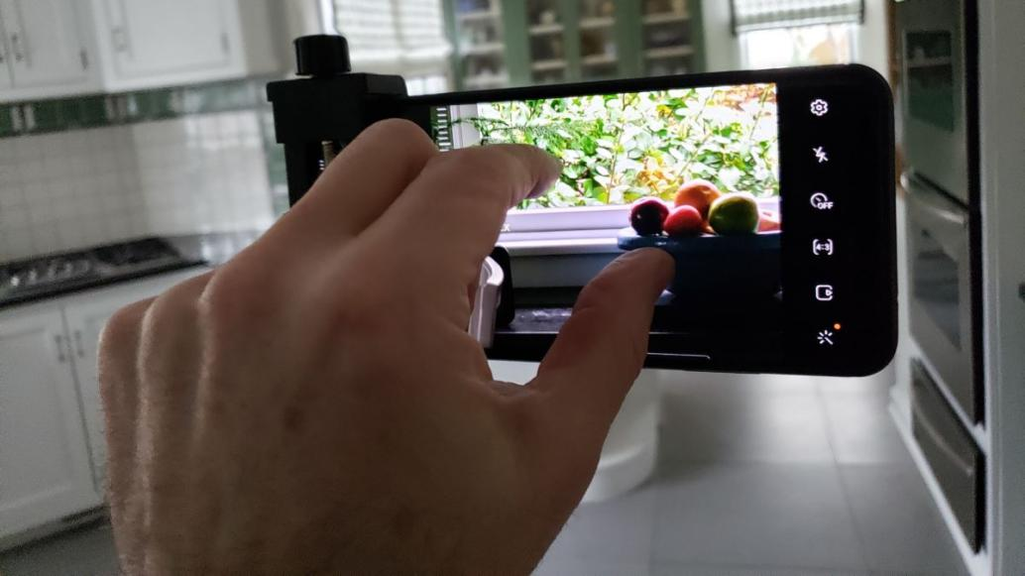

1. Conversing

It is an interactive type that uses the user's voice to command the device to perform a function. Examples are virtual assistants on mobile devices such as Apple's Siri, Google Assistant, Alexa. Most users love this type of interaction because they are easy to use, just voice commands and do not to do anything more.

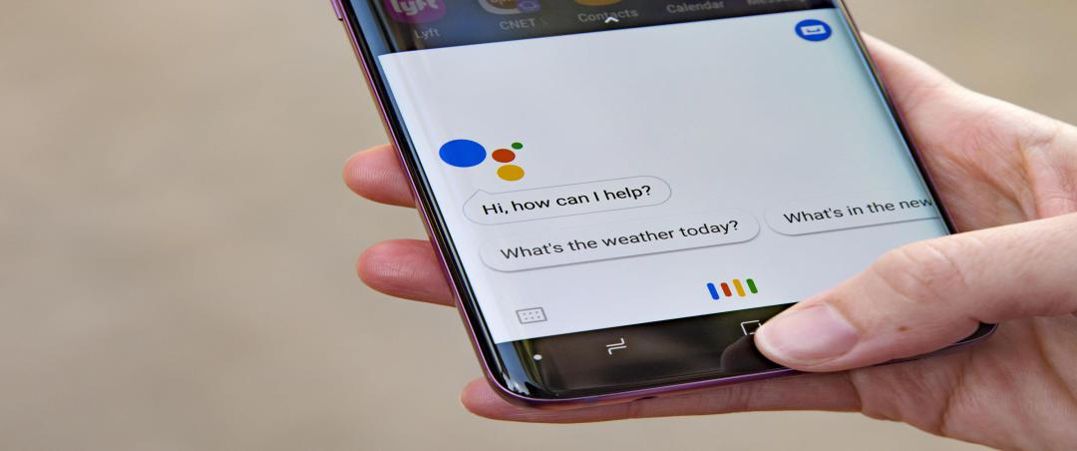

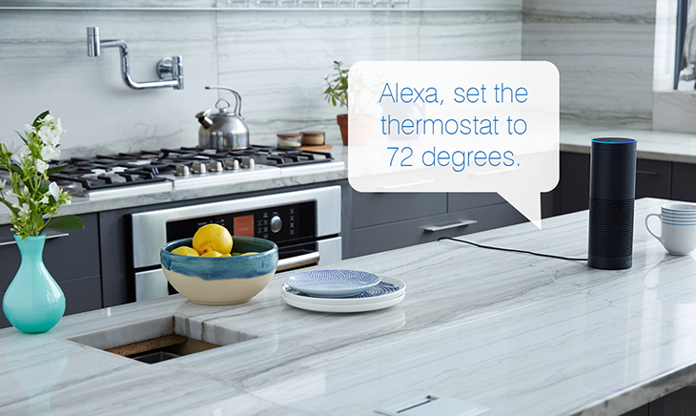

1. Instructing

This is the type of interaction that uses the keyboard or function keys to use the prototype's functions. This is also a common type of interaction, requiring the device to have physical function keys to operate.

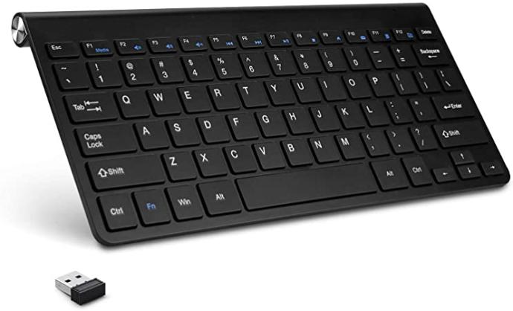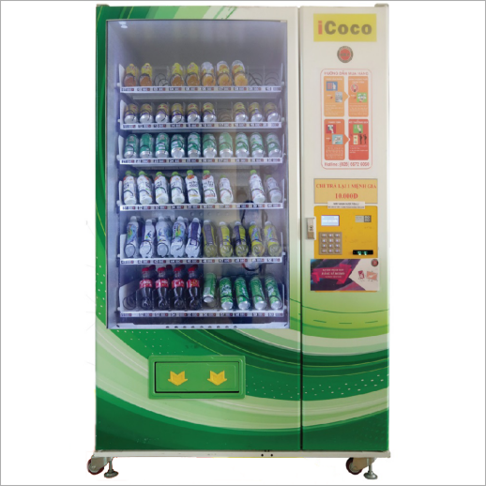

1. Virtual reality

it is an interactive type that brings people into the virtual world through hardware devices such as headsets, virtual reality glasses, and interactive controllers. For example, virtual reality games, graphic design, ... This is a new type of interaction and brings a very interesting experience for users.

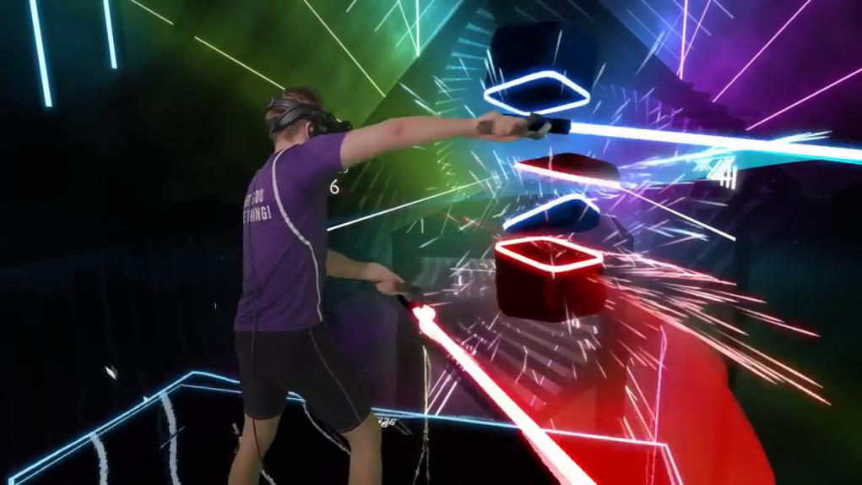

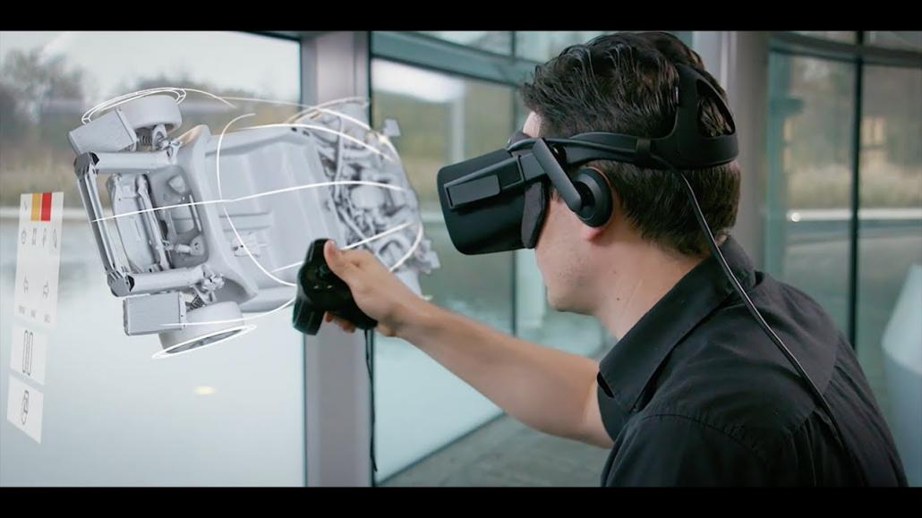

1. **Design Process** 
   1. **Interaction Design Research**
      1. **Processes and Frameworks for Interaction Design**

For this subject, I have researched and applied the **Goal-Oriented Design** approach, since it requires defining and clarifying pre-design requirements, this is intended to create what the project's ultimate goal is to be achieved. From that big goal, we will need to analyze the project into many different aspects, from which we can understand the problem in detail, to avoid errors and misses in design.

With this method, setting the user's goals is the first priority, specifically in this project the goal of the course is set out, helping the product to fully meet the requirements of the subject.Besides, along with the diversity and abundance of user data, we can enhance the user experience in terms of user interface design.

Frame: Iphone 11 Pro. This frame measures 144 x 71.4, which is a popular frame and is compatible with many different phones.

* + 1. **Cognitive Psychology**

Some rules apply in this design

* Simplified navigation bar: in this design, instead of placing a menu button at the top of an app, the app's items are placed right in the home screen, simplifying the user operation.

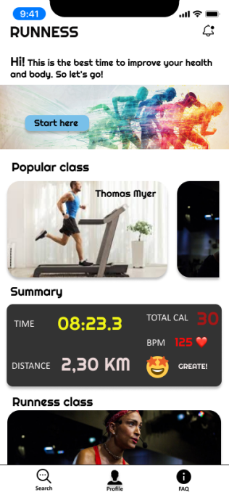

* Icons: In the footer is designed to add a submenu bar for the main screen, it is placed a few icons to represent that function so that the user can easily understand and relate to them.

Footer (Custom)

* + 1. **Interaction Design Theory**

In this design only the main type of interaction is used. Actions directly on the device screen, such as touch, swipe, press, ... It is simple to use and popular with users.

* 1. **Conceptual Design**
     1. **Introduction of concept**

The idea of this project is to give people better access to fitness courses. This is an application that can provide users with online courses that can be used on different devices such as smart TVs, smart phones, tablets, and can connect to smart wearable devices. The app can connect to smart wearable devices to track your workouts. The prototype is also designed to be compatible with another device such as a tablet or an iPad that can be mounted on a treadmill. It will provide the necessary parameters for monitoring your exercise intensity and display it to the user with a user-friendly interface.

Concept details:

1. Main functional requirements

* Provides a space for users to search for courses according to their needs or interests.
* One screen shows the course overview, and the students' comments and ratings on the course.
* Participating in the course, this screen needs to be intelligently designed so that users can view the classroom and display the user's parameters during practice.

In addition, the application also needs some of the designs of the secondary screens such as:

* Registration screen, login
* User survey screen
* Dashboard screen
* User information screen
* The course search screen
* Screen list of courses
* Notification tab

1. Audiences

Suitable for people > 12 years old

1. Flow chart

This is a simple conceptual diagram of the application flow through each screen

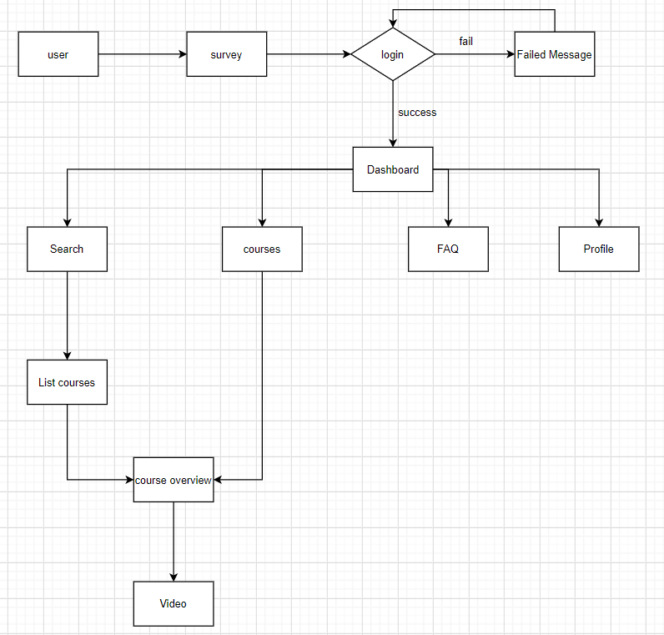

1. Interaction Type

Because it wants to provide the user with a familiar and simple experience, the app uses the interactive type is **Manipulating**: using familiar gestures such as swiping, tapping, and moving between screens. Adopting **Manipulating** aims to focus the user on app use and practice

1. **Prototype**
   1. **High-level prototype**
      1. **General**
2. Main color: Choosing white is the main color because it expresses simplicity, harmony, and easy to combine with different color objects, white background also helps to highlight interactive components of the application.

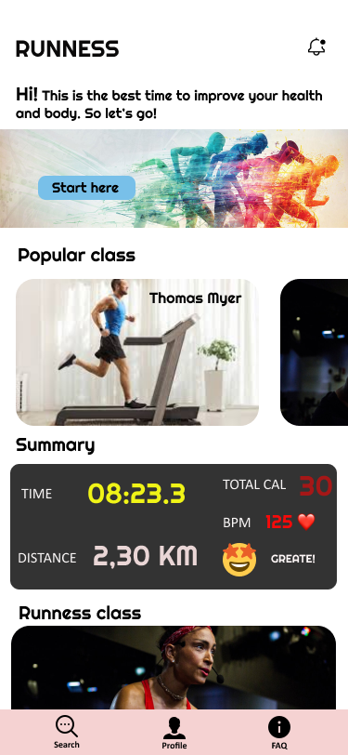 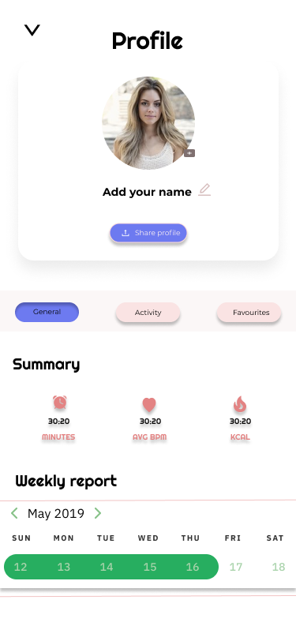

1. Font: Righteous
2. Types of interactions

* Manipulating: Touch, touch, swipe,

1. Compatibility

* Smart phone: prototype is designed on Iphone 11 Pro.
* Ipad Pro 11”
  + 1. **Login/Register screen/Forgot password screen**

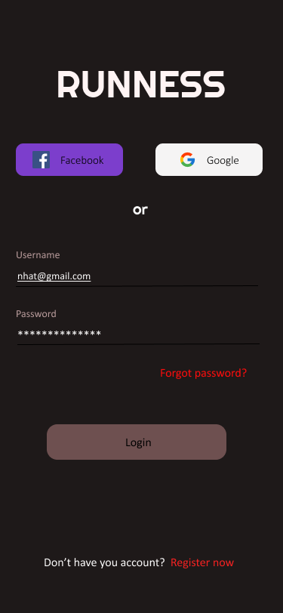 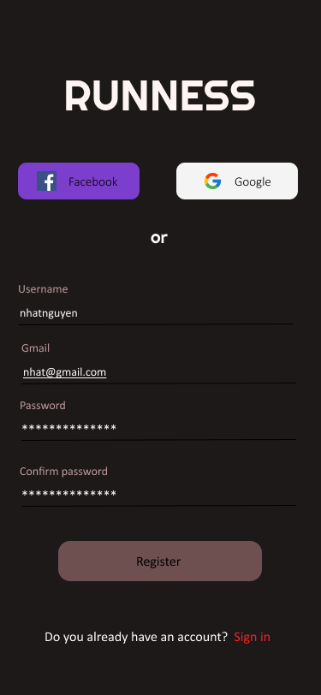 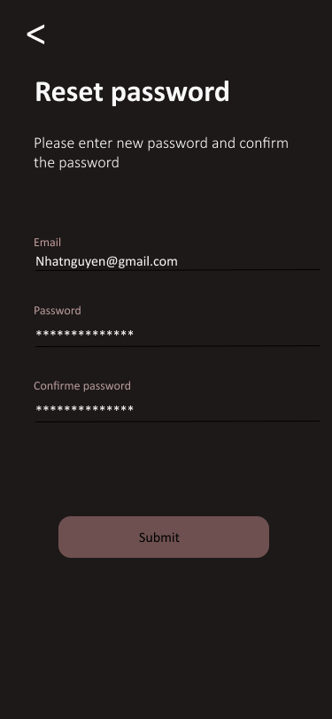

*Step1: Login screen Step2: Register screen Step3: Reset password screen*

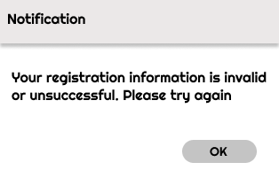

*Step 4: Pop up notification*

1. **Layout login screen (Step 1)**

* The application logo is placed on top and the font size is 50 to highlight the name of the application, the name of the logo is "RUNNESS" which stands for Tread mill Run and fitness, this is an app that focuses primarily on running, but it also mentions a few other fitness areas as well.
* The two Facebook and Google login buttons are located below the logo, the purpose of which is to encourage or suggest two forms of login beyond the traditional way, help users login to the system quickly and avoid wasting time in reset password when forgetting.
* Below that is the login area, the username can be the personal email address or the user name of your choice, the password is a string of characters including letters and numbers, length greater than 8, not contains special characters (! @, #, $,%, ^, &, *,?) and space. By default the button "Login" will be disabled, when the user enters all information ,this button will activate, press the Login button to login to the system (Step 9 - Dashboard screen).
* The button "Forgot password?" navigate the user to the password reset screen when the user forgot it (Step 3 - Reset password screen). The red color makes the button stand out more when placed against a black background-color. Similar to the "Register now" button, this button directs the user to the new account registration screen (Step 2 - Register screen)

1. **Layout Register screen(Step 2) and Reset password screen(Step 3)**

* The layout of these two monitors is similar to step 1, different not too much from step 1.
* At step 2 - the registration screen, by default the button "Register" will be disabled, when the user enters all information and matches the requirements of each field, this button will activate, click will navigate the user to the login screen (step 1 - Login screen).
* At step 3 - the password reset screen, by default the "Submit" button will be disabled, when the user enters complete information in the fields (Email, new password, confirmation), responds to the request, this button will activate, click will display a notification pop-up (step 4), press the "OK" button will return to the login screen (step 1)

1. **Main color**

* Background-color: Black **#000000**, Black brings power to the application, and at the same time it helps to highlight interactive elements such as logos, buttons, and text. Make it easier for users to notice them.
* The Gray ( **#808080**) color is used for the register, login, and submit buttons, it helps to harmonize the user's eyes, not too prominent when it is activated.
  + 1. **Dashboard**

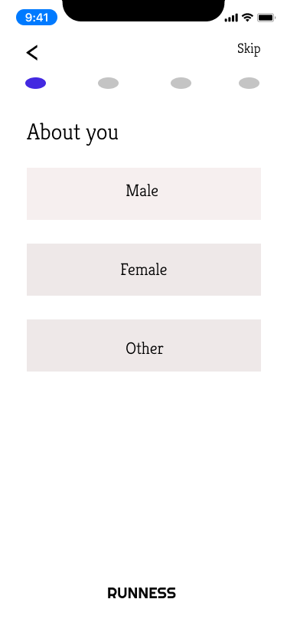 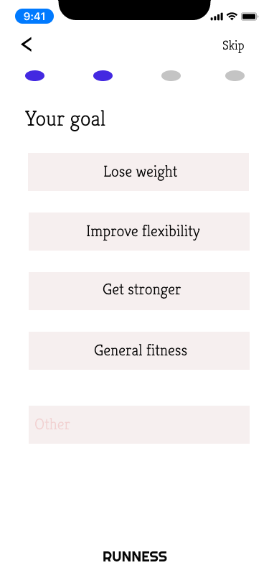 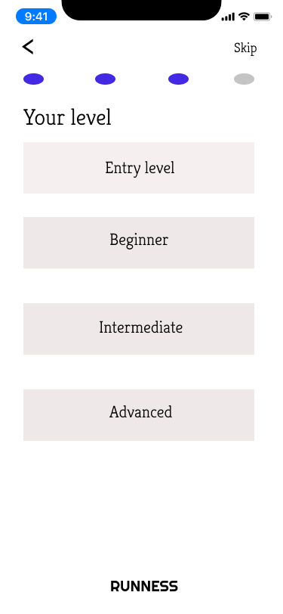

*Step 5: Servey - Gender Step 6: Servey - Goal Step 7: Servey - Level*

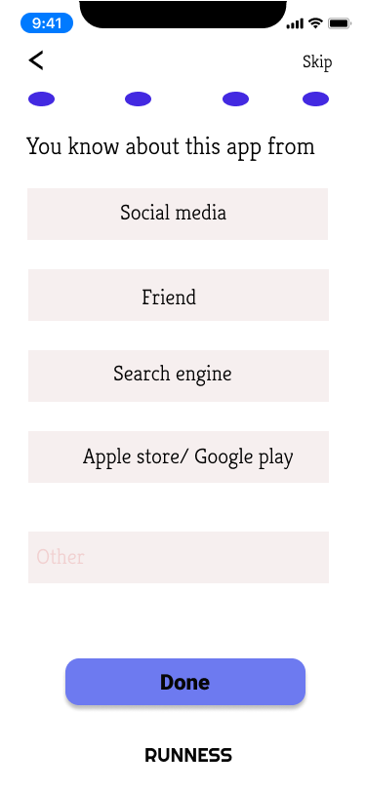

*Step 8: Servey - last screen*

1. **Layout**

* In this group of survey screens, the screens are designed similarly, including the title of each survey screen, the keyword buttons suggesting the answer.
* The blue dots above are intended to mark which steps the user is in and which steps have been taken.
* When clicking each item, it will automatically go to next step in sequence (step 5 -> step 6 -> step 7 -> step 8).
* When the last step is reached (step 8), the "Done" button will be displayed, clicking will direct the user to the Dashboard screen (Step 9 - Dashboard screen).
* At each survey screen, the top right of the screen will have a "Skip" button, clicking will move the user to the Dashboard screen if the user does not want to perform this survey.
* A small logo is placed below, to introduce the application name and restrict the spaces.

1. **Main color**

* From the survey screen onwards, white will be the main color of the application, it will help the overview of the application become brighter and more dynamic. At the same time, it is easy to combine with many other colors to highlight the element.
* The color of the buttons used is a light color (**#EEE8E8**), making the color layout harmonious, not too prominent
  + 1. **Dashboard screen**

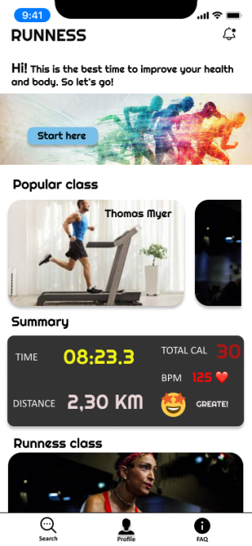 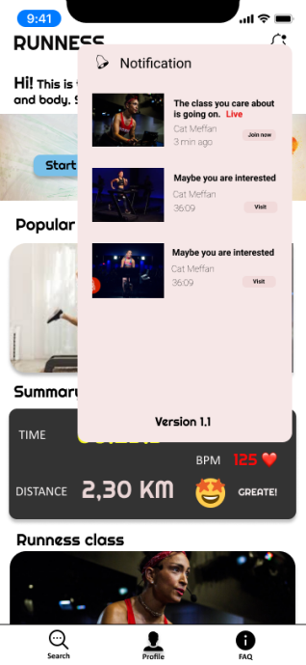 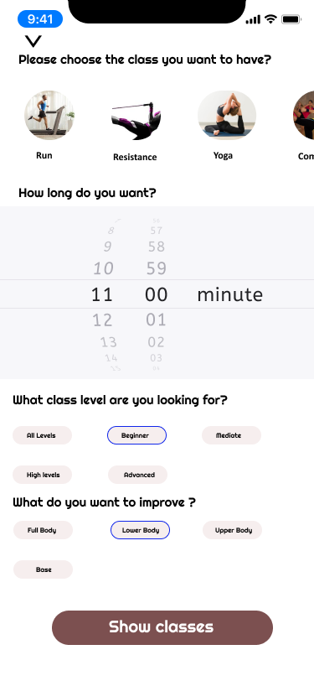

*Step 9: Dashboard Step 10: Dashboard - notification Step 11: Search class screen*

1. **Layout Dashboard screen(step 9)**

* At the top is the Logo of the application on the left, the right is an icon for the ongoing courses, the courses that the user is interested in (step 10).
* Next is a slogan to express the spirit of the application and motivate participants.
* The screen overview will be displayed in a top-down list. The first item is instructions, pressing the "Start here" button will direct the user to the course search screen (step 11). It is placed first so that the user can easily see it if it is a new user.
* Next is the popular classes section, the classes will be shown their respective avatars, along with the curator's name written on the picture for the convenience of users. Swipe sideways to see other classes in the list. Click on any class, the user will be taken to the preview screen for that class (step 12).
* In summary, this is the place to aggregate the user's exercise results, including the parameters: total exercise time, total calories consumed, average heart rate, running distance, automatic evaluation of the system. statistics from the above results. This item is for listing only, there is no interaction here.
* The Runness class section, similar to a popular class section, lists the running classes. Use the class avatar to display, below each image there will be summary information such as the course name, curator, if the user wants to save the course, click on the heart icon, it will change to red heart.
* Other class items, showing the list of corresponding avatars for different subjects. The avatar is shown in a circle with the subject name below. The purpose is to avoid appearance repetition with the above items, and to facilitate the selection, increase user experience. Swipe sideways to view, click on any item, it will direct the user to the screen list of classes of that subject (step).
* The footer section, it will be fixed at the bottom of the screen, there will be three icons representing 3 functional screens, search, profile, FAQ. Icon is used to represent that function, in order to help users understand its meaning, the color tone of the icon is black, making it stand out when combined with a white background and creating simplicity for the application. Attached below is the name of the corresponding function.

1. **Layout search class screen (step 11)**

* On the Dashboard screen (step 9), the user clicking on the Search icon will immediately navigate to the class search screen, where the user selects the class criteria they want.
* Above is the list of course categories, when clicked, it will display a prominent blue border, helping users to identify their chosen.
* Next is to choose the duration of the course, users choose the time by scrolling up or down when scrolling will have sound effects accompanying. Using this date-time picker is both simple and increases the user experience.
* Next is to choose the level of the user and the improvement target, designed by button, the user selects any button, the button will display a prominent blue border.
* Finally, there is the "Show classes" button, by default this button will be disabled, if the user has selected all of the above options, this button will activate, press will go to the list of courses by filter screen (step).

1. **Color**

* Color used for buttons: Rectangle 26 (#F6EEEE): This color helps to harmonize the white background and buttons, when combined with the blue border, it will become more prominent.
  + 1. **List of courses / Preview class screen**

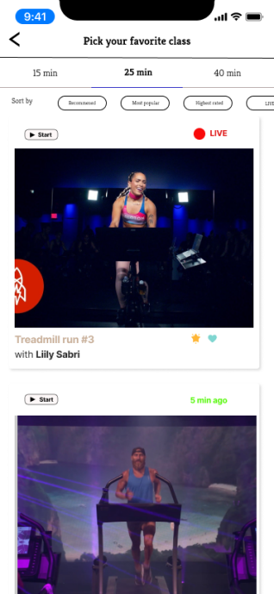 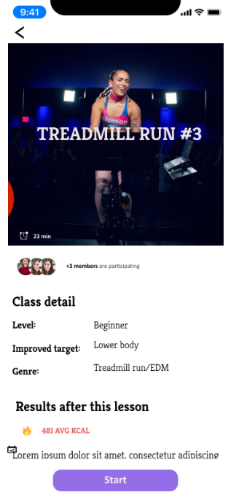

*Step 12: List of courses screen Step 13: preview class screen*

1. **Layout List of courses screen (step 12)**

* On this screen, you will find a simple filter above for the list of courses. The above filter will be to filter the courses with the corresponding duration, it will be tabbed, clicking on each tab will display a corresponding list. The purpose is to help users filter quickly, limiting the need to enter or choose exactly the desired duration. Below will be the filter buttons by criteria such as Recommended, Most popular, Highest rated, LIVE,… This filter will be fixed.
* Part of the course list is designed as shown (step 12), above is the "Start" button, it will direct users to the course view screen without going through the course preview screen. It is useful when the user doesn't want to be late to the preview screen or join the class.
* If the class is in progress, an icon LIVE will appear, otherwise, the time the course was posted to the app will be displayed.
* An avatar for the course will be highlighted in the middle, below will be the name of the course and the curator, to the left will be two icons to rate the course, click on the star icon to rate one like, Click on the heart icon will save the course to the profile screen (step). Clicking on any course will direct the user to the course preview screen (step 13).

1. **Layout Preview class screen (step 13)**

* At this screen, the avatar of the course will take up nearly half of the screen space, which will make the user focus on it and easily impress the user.
* Below are statistics of the number of people who have been participating in this course.
* This is followed by some brief information about the course, results achieved after the course, and an introduction to the course.
* Finally the "Start" button, it is fixed at the foot of the screen, users do not need to scroll down to the bottom to press it, which helps some people who are less interested in this review screen. Click the "Start" button, it will direct the user to the video viewing screen, enjoy the lesson.
  + 1. **The course view screen**

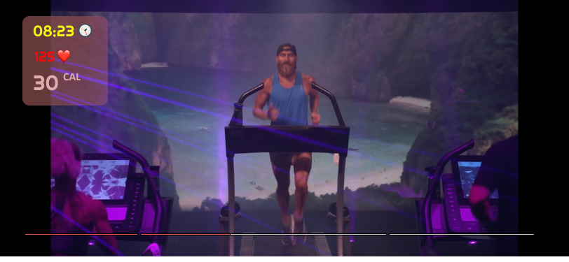

*Step 14: The course full view screen*

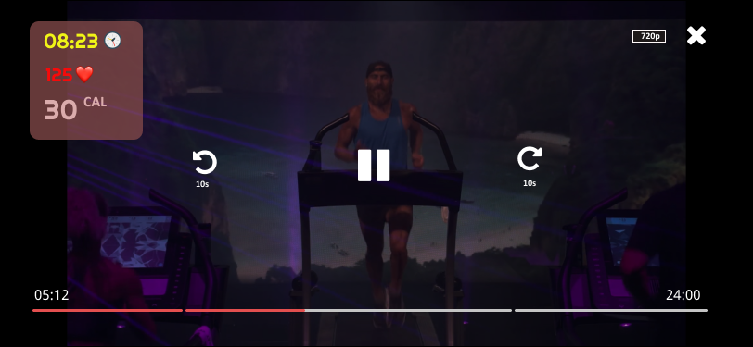

*Step 15: The course view screen with options*

1. **Layout The course full view screen ( step 14)**

* The layout is designed to be minimal, most of the space focuses on the ongoing course display. Helping users to focus on the lesson.
* The frame displays exercise parameters that display the basic parameters of the training session and the users who are most interested in such as exercise time, heart rate, total calories consumed. These parameters are always monitored and updated continuously in real-time, through popular smart wearable devices. The layout is placed in the upper corner for the convenience of users to monitor the intensity of the training and course. The selected background color is moderately transparent, it will not hide the displayed content.
* The bottom will have a bar showing the duration of the lesson, it is cut into sections, corresponding to each phase of the lesson, between each phase will be the break time.

1. **Layout The course view screen with options ( step 15)**

* When users touch the screen to watch the lesson (step 14), it will show the basic actions of the video viewing screen such as pause button, button to go forward or back 15 seconds, adjust video quality, exit button. When touched, the video display will darken to highlight the interactive buttons on it.
  + 1. **Summary screen (step 16)**

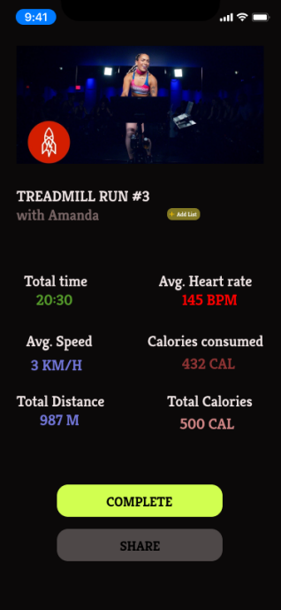

1. **Layout**

* After completing the course, or the user exits the class, they will be directed to the session summary screen. Here it will display your fitness parameters via smart wearable devices or treadmill.
* The top of the screen is the profile for the course, followed by the title of the course and the curator.
* Next to it is the Add button, when clicked, the course will save to the favorites list and will show up in the Profile screen.
* Next will display the necessary user parameters to monitor, each parameter will be displayed in a certain color, in order to easily distinguish and make the interface more vivid.
* Click the "Finish" button, will end the class and will go to the class list screen (step 12).
* The "Share" button will share this result on social networking forums such as FaceBook, Instagram. Clicking on it will bring up the default Facebook or Instagram post interface.
  1. **Links to prototypes**
     1. **Mid-level:**

**https://www.figma.com/file/8zYSbQkSD5ZUfrWnztJ2yt/MID-LEVEL-PROTOTYPE?node-id=0%3A1**

* + 1. **High-level**

**<https://www.figma.com/file/w3BArhBOc0CZ6lOSqd6n4o/RUNNESS-APP?node-id=0%3A1>**

1. **Research study**
   1. **Assumption**

In the era of technology 4.0, many people focus on work, and make money, but do not focus on their own health. This leads to a decrease in the body's resistance, making it easy for people to be infected with infectious diseases, especially cancer. Realizing the above shortcomings, I propose a study of living behaviors in personal health care, in addition to introducing the designed prototype to those wishing to use it.

* 1. **Participants in research**

The participants in this study were office workers, who worked for long hours in an office, wanting to improve their physical and mental health.

Ways to find people to participate in research:

* Since the study is mainly aimed at office workers, the survey can be conducted at companies and offices before or after work hours.
* Conducting surveys at the gym, parks.
* Post surveys on health care and practice forums on social networks such as Facebook, Instagram.
  1. **Data types**

In this study, there will be two types of data that should be covered in the research:

* + 1. Primary data

This is the most useful and relevant primary data for the study. Because it is collected directly from research participants, through other data collection methods such as interviews, surveys, testing, ...

* + 1. Secondary data

This type of data is collected from scientific documents, from studies that have been done before. It can be combined with primary data to form secondary data set. This type of data does not need to be collected through interviews or surveys, and researchers need to verify the validity and reliability of the source.

* 1. **Data collections**
     1. Interview

1. Interviewee: Mainly focusing on office workers, can expand to students, people over 30 years old.
2. Objective of the interview

* Data collection, personal health care behaviors of interviewees.
* Introduce their blueprints, collect their reviews and feedback.

1. Layout and question

* Introduction: Briefly introduce yourself, give reasons for interviewees to provide information, and commit to confidentiality.
* Object grouping questions: the purpose is to identify and classify groups of interviewees in order to give out appropriate questions. For example, how often do you exercise, have you ever been to the gym, ...
* Key question: Show the designs for the interviewee to experience and use and ask questions to explore. For example: How do you feel after seeing (or experiencing) the product? Which function do you like best? Why? Would you like to use this product as a daily workout tool? ...
* Sub-questions: in order to get more information needed, but to avoid repeating the questions mentioned above or annoying questions.
* Acknowledgments: Make a polite thank you.

1. Notes

* Should choose interviewers who speak fluently, easily to hear, not speak too fast or too slow.
* Avoid ambiguous words (sometimes, long, confusing).
* Avoid long talk, say the wrong purpose, so go straight to the point because they may not have much time.
* Limit specialized words, because not everyone understands, should be accompanied by a brief explanation.
  + 1. Survey

<https://docs.google.com/forms/d/e/1FAIpQLSeZDgMuNIPUc9yiNtm5SepLRutF9bzd3ZRIZmIXCk-u3ftm8A/viewform?usp=sf_link>

This is a survey form for data collection, this is not the final version, so the researcher can change or upgrade to serve the more efficient data collection.

Some notes when designing a survey:

* Use easy-to-understand words, limit the use of specialized words. If so, please explain clearly.
* Arrange questions properly, this is the most important and difficult thing.
* Use a clear survey layout, limit the use of fonts that are difficult to see, or cause eye-distraction. Limit the use of multiple colors in the survey, which will reduce the user's concentration when doing the survey.
  1. **Data Analysis**

Analyzing the data, this may be the last step to complete the study. Data analysis can be divided into two main categories:

1. **Quantitative Data Analysis**

This is data analysis by statistical method, you can use some tools to support statistics such as SPSS, Excel. It is necessary to define different variables such as frequency, duration, average exercise time, ... These variables can be changed after data collection is completed.

Representation of data that has been analyzed in many forms such as charts, schemas, tables, ... Data should be represented to be easy to read and understand.

1. **Qualitative Data Analysis**

The purpose of qualitative analysis is to understand user behavior, exploit the user's psychology, and think about health care. This data was collected qualitatively, by interview method

1. **Conclusion**
   1. **Summary**

Overview of the completed main functional screens of the RUNNESS application. Includes low to high mold design. All of which have been presented in the above sections. A study assumption has also been made, which includes research design patterns such as sample survey, interview, tool recommendations, data analysis techniques, and statistics.

* 1. **Some difficulties**
* Difficult to conceptualize design by theme, I seldom use practice-related applications myself, so there will be some designs that do not have the best user experience. The interactive design has not been optimized.
* Difficulty in choosing design tools
  1. **Improvement**

Some monitors can be enhanced or supplemented to enhance the user experience or re-adjust the previous layout.

* FAQ screen (Step 16): The layout of this screen is still simple, considering showing the answer directly without the user needing to click to see it.
* Overall color, in general, the designs have simple tones, mainly white, which can cause users to be glare or uncomfortable when using. More colors can be combined to reduce this discomfort, or add a night view to the designs
* Some functional screens can complement the design: training plan creation screens, training reminders, and direct interaction screens with the classroom curator.
  1. **Next steps**

In order to help prototypes evolve into products for the user to use. Some next steps can be taken:

* Experienced people can be consulted to take their judgments, as well as suggestions for improvements.
* Coding, programming to create real products.
* Putting the product on platforms like the App Store or Google play, which can be used for trial use by the user for a certain period of time, and then conducting a survey of satisfaction as well as user reviews. about the product.

1. **References**
2. Apple. 2020. Apple Fitness+. [online] Available at: <https://www.apple.com/apple-fitness-plus/> [Accessed 1 November 2020].
3. Ideas. 2020. User Centered Design Principles & Methods | Adobe XD Ideas. [online] Available at: <https://xd.adobe.com/ideas/principles/human-computer-interaction/user-centered-design/#:~:text=The%20fundamental%20principle%20of%20user,products%20that%20people%20will%20like.> [Accessed 1 November 2020].
4. Usability.gov. 2020. User-Centered Design Basics | Usability.Gov. [online] Available at: <https://www.usability.gov/what-and-why/user-centered-design.html> [Accessed 1 November 2020].
5. Digital Product Insights. 2020. 10 Key Principles Of User Centered Design. [online] Available at: <https://www.cognitiveclouds.com/insights/key-principles-of-user-centered-design/> [Accessed 1 November 2020].
6. The Interaction Design Foundation. 2020. The Ingredients Of Interaction Design. [online] Available at: <https://www.interaction-design.org/literature/article/the-ingredients-of-interaction-design#:~:text=Goal%20Oriented%20Design&text=The%20purpose%20of%20user%20research,life%20insurance%20from%20your%20website.> [Accessed 1 November 2020].
7. Confluence.sakaiproject.org. 2020. Goal-Directed Design - WG: User Experience (UX) - Confluence. [online] Available at: <https://confluence.sakaiproject.org/display/UX/Goal-Directed+Design> [Accessed 1 November 2020].
8. Sciencedirect.com. 2020. Participatory Design - An Overview | Sciencedirect Topics. [online] Available at: <https://www.sciencedirect.com/topics/computer-science/participatory-design#:~:text=Participatory%20design%20is%20a%20democratic,(Muller%20%26%20Kuhn%2C%201993)> [Accessed 1 November 2020].
9. Interactions.acm.org. 2020. Reimagining Participatory Design | ACM Interactions. [online] Available at: <https://interactions.acm.org/archive/view/january-february-2019/reimagining-participatory-design> [Accessed 1 November 2020].
10. Medium. 2020. Cognitive Psychology In UX: Minimising The Cognitive Load. [online] Available at: <https://medium.com/design-signals/cognitive-psychology-in-ux-minimising-the-cognitive-load-d97ad8e3115b#:~:text=Broadly%20put%2C%20cognitive%20psychology%20deals,relevant%20for%20us%20as%20designers.&text=In%20psychology%2C%20cognitive%20load%20describes,needed%20to%20use%20a%20product.> [Accessed 1 November 2020].
11. The Interaction Design Foundation. 2020. What Is Cognitive Psychology?. [online] Available at: <https://www.interaction-design.org/literature/topics/cognitive-psychology> [Accessed 1 November 2020].
12. Base, K., process, S. and design, H., 2020. Research Design | Types, Methods, And Examples. [online] Scribbr. Available at: <https://www.scribbr.com/research-process/research-design/> [Accessed 1 November 2020].
13. SurveyMonkey. 2020. How To Write Good Survey & Poll Questions | Surveymonkey. [online] Available at: <https://www.surveymonkey.com/mp/writing-survey-questions/> [Accessed 1 November 2020].
14. Lotame. 2020. What Are The Methods Of Data Collection? | How To Collect Data. [online] Available at: <https://www.lotame.com/what-are-the-methods-of-data-collection/> [Accessed 1 November 2020].
15. The Interaction Design Foundation. 2020. Assumptions. [online] Available at: <https://www.interaction-design.org/literature/topics/assumptions> [Accessed 1 November 2020].
16. Interactions.acm.org. 2020. Questioning Assumptions: UX Research That Really Matters | ACM Interactions. [online] Available at: <https://interactions.acm.org/archive/view/march-april-2014/questioning-assumptions-UX-research-that-really-matters> [Accessed 1 November 2020].
17. Research-Methodology. 2020. Quantitative Data Analysis - Research-Methodology. [online] Available at: <https://research-methodology.net/research-methods/data-analysis/quantitative-data-analysis/#:~:text=Quantitative%20data%20analysis%20may%20include,stages%20of%20your%20research%20process.> [Accessed 1 November 2020].
18. Research-Methodology. 2020. Qualitative Data Analysis - Research-Methodology. [online] Available at: <https://research-methodology.net/research-methods/data-analysis/qualitative-data-analysis/> [Accessed 1 November 2020].
19. Usability 2016. 2020. Interaction Design- Interaction Types. [online] Available at: <https://usability2016.wordpress.com/2016/02/20/interaction-design-interaction-types/> [Accessed 1 November 2020].
20. Harman, R., 2020. Using Cognitive Psychology In UX Design: What To Know. [online] noupe. Available at: <https://www.noupe.com/design/cognitive-psychology-in-ux.html> [Accessed 1 November 2020].
21. Jones, M. and Marsden, G., 2006. Mobile Interaction Design. Chichester, England: John Wiley & Sons.
22. Benyon, D., 2020. Designing User Experience. 4th ed. [ebook] Pearson UK, 2019. Available at: <https://books.google.com.vn/books?id=MXqFDwAAQBAJ&lpg=PP18&ots=v0-hPdlwaG&dq=interaction%20design%20UX&lr&hl=vi&pg=PP1#v=onepage&q=interaction%20design%20UX&f=false> [Accessed 5 November 2020].

**Check Turnitin**

