VIETNAM GENERAL CONFEDERATION OF LABOR

**TON DUC THANG UNIVERSITY**

**FACULTY OF INFORMATION TECHNOLOGY**



**BIG ASSIGNMENT**

**INTRODUCTION TO INFORMATION SECURITY**

*Instructor*: **HUYNH NGOC TU**

*Executor*: **VO NHAT HAO – 522H0090**

**PHAM VAN PHUC – 522H0068**

**NGUYEN THANH NHAN – 522H0051**

Class **: 22H50202**

Course  **: 26**

**HO CHI MINH CITY , YEAR 2024**

VIETNAM GENERAL CONFEDERATION OF LABOR

**TON DUC THANG UNIVERSITY**

**FACULTY OF INFORMATION TECHNOLOGY**



**BIG ASSIGNMENT**

**INTRODUCTION TO INFORMATION SECURITY**

*Instructor*: **HUYNH NGOC TU**

*Executor*: **VO NHAT HAO – 522H0090**

**PHAM VAN PHUC – 522H0068**

**NGUYEN THANH NHAN – 522H0051**

Class **: 22H50202**

Course  **: 26**

**HO CHI MINH CITY, YEAR 2024**

THANK YOU

* We are deeply grateful to Ms. Huynh Ngoc Tu for her constant support and enthusiastic direction throughout our investigation and final report.
* We also like to thank Ton Duc Thang University's Faculty of Information Technology for providing us with an enriching academic environment. The faculty's willingness to share vital expertise and reference materials has not only aided our research endeavor, but has also improved our overall educational experience at the university.
* As we wrap up our study project, we reflect on the vital lessons and insights learned from our educators. Regardless of our limitations and areas for improvement, we are willing to learn and grow. We really seek further assistance to improve our work and appreciate the critical input from our professors and classmates. With their continuous assistance, we are determined to improve our research talents in future initiatives.
* We wish all of our teachers and friends ongoing health and happiness, as their support and care have been invaluable to us on our path.

**WE THANK YOU!**

**THE PROJECT IS COMPLETED**

**AT TON DUC THANG UNIVERSITY**

I hereby declare that this is my own project product and is guided by Ms. Huynh Ngoc Tu. The research content and results in this topic are honest and have not been published in any form before. The data in the tables for analysis, comments, and evaluation were collected by the author from different sources and clearly stated in the reference section.

In addition, the project also uses a number of comments, assessments as well as data from other authors and other organizations, all with citations and source notes.

**If any fraud is discovered, I will take full responsibility for the content of my project**. Ton Duc Thang University is not involved in copyright violations caused by me during the implementation process (if any).

*Ho Chi Minh City, 20 May 2024*

*Author*

*(sign and write full name)*

*Vo Nhat Hao*

*Pham Van Phuc*

*Nguyen Thanh Nhan*

INSTRUCTOR VERIFICATION AND EVALUATION SECTION

**Confirmation from the instructor**

_______________________________________________________________________________________________________________________________________________________________________________________________________________________________________________________________________________________________________________________________________________________________________________________________________________

Ho Chi Minh City, day month year

(sign and write full name)

**The teacher's evaluation part marks the test**

_______________________________________________________________________________________________________________________________________________________________________________________________________________________________________________________________________________________________________________________________________________________________________________________________________________

Ho Chi Minh City, day month year

(sign and write full name)

TABLE OF CONTENTS

THANK YOU 3

INSTRUCTOR VERIFICATION AND EVALUATION SECTION 5

TABLE OF CONTENTS 6

EXERCISE 1: Study different privileges in OpenMRS Demo and list four of them that seems most important to you. 8

EXERCISE 2: Study different roles in OpenMRS Demo and name four main roles that have maximum set of privileges. 10

EXERCISE 3: 12

1. Create Some New Roles: Medical Student, Data Assistant, Data Manager 12

1.1. Create Medical Student 12

1.2. Create Data Assistant 12

13

1.3. Data Manager 13

2. Create users: Mary, Bob, Erica and assign roles 13

2.1. Create user Mary 13

2.2. Create user Bob 15

2.3. Create user Bob 16

EXERCISE 4: Now, you will work on a more complex scenario. Assume following roles are defined in an EHR system. Now, before defining these roles in OpenMRS, try to combine the roles that can inherit privileges from each other. You can define new roles if it makes managing your role hierarchy easier. Report your role hierarchy. 19

EXERCISE 5: Define your role hierarchy in OpenMRS. (You can add a new privilege If it’s not defined in OpenMRS). Attach the screen shot of your defined roles in OpenMRS. 21

EXERCISE 6: What are the challenges you encounter while working with access control model in OpenMRS? What are your suggestions for improving the access control model of OpenMRS? 23

REFERENCES 26

EXERCISE 1: Study different privileges in OpenMRS Demo and list four of them that seems most important to you.

The value of specific privileges is determined by their specific demands and roles within a healthcare system. However, based on a broad understanding of healthcare systems, the following four privileges appear important:

Determining the importance of specific privileges depends on the specific needs and roles within a healthcare system. However, based on a general understanding of healthcare systems, here are four privileges that seem important:

1. **Privilege: emr.ordering**

* Description: Able to order tests, procedures, and medications.
* Importance: This privilege is vital as it enables healthcare providers to prescribe medications, order laboratory tests, and schedule medical procedures. This is essential for diagnosing conditions, managing treatments, and ensuring that patients receive the necessary medical interventions in a timely manner.

1. **Privilege: tasks.manageschedules**

* Description: Able to manage provider schedules.
* Importance: Effective management of provider schedules is crucial for optimizing the utilization of healthcare resources, reducing patient wait times, and ensuring that providers can see patients efficiently. This privilege allows for the coordination of provider availability, ensuring that the healthcare system runs smoothly.

1. **Privilege: coreapps.editPatientDemographics**

* Description: Able to edit patient demographic information.
* Importance: Keeping accurate and up-to-date patient demographic information is critical for effective patient management and care coordination. This privilege allows authorized users to update important patient details such as contact information, address, and emergency contacts, which is essential for communication and care continuity.

1. **Privilege: appui.viewSystemMetrics**

* Description: Able to view system metrics and performance indicators.
* Importance: Monitoring system performance and metrics is important for maintaining the overall health of the healthcare information system. This privilege allows administrators and IT staff to access data on system usage, performance, and potential issues, enabling proactive management and troubleshooting to ensure the system operates efficiently and effectively.
* These additional privileges are crucial for tasks related to ordering medical services, managing provider schedules, maintaining accurate patient information, and overseeing system performance. They collectively contribute to the smooth operation and high-quality delivery of healthcare services.

EXERCISE 2: Study different roles in OpenMRS Demo and name four main roles that have maximum set of privileges.

The significance of jobs is determined by their specific context and responsibilities within a healthcare institution. However, based on general healthcare operations, the following four functions seem important:

|  |  |  |  |
| --- | --- | --- | --- |
| **Organizational** | **Description** | **Privileges** | **Importance** |
| Hospital Administrator. | Hospital Administrator. | Application: Schedules And Overbooks Appointments, Application: Configures Appointment Scheduling, and other administrative privileges. | Hospital Administrators play a key role in managing appointments and configuring scheduling systems, ensuring smooth operations within the healthcare facility. |
| Registration Clerk | Registration Clerk | Application: Sees Appointment Schedule, Application: Registers Patients, and other administrative privileges. | Registration Clerks are essential for managing patient registrations, appointments, and schedules, ensuring accurate and efficient administrative processes. |
| Doctor | Doctor | Application: Enters ADT Events, Application: Records Allergies, Application: Writes Clinical Notes, and other relevant clinical privileges. | The Doctor role is crucial as it encompasses privileges related to entering ADT events, recording allergies, and writing clinical notes essential tasks for healthcare providers involved in patient care. |
| Nurse | Nurse | Application: Enters ADT Events, Application: Records Allergies, and other clinical privileges. | The Nurse role is vital for tasks related to patient admissions, allergy recording, and other clinical documentation, contributing to patient care and coordination. |

* These positions reflect the variety of tasks found within a healthcare institution by combining clinical and administrative duties. Each role's significance varies based on the particular requirements and organizational design of the healthcare facility.

EXERCISE 3:

1. Create Some New Roles: Medical Student, Data Assistant, Data Manager
   1. 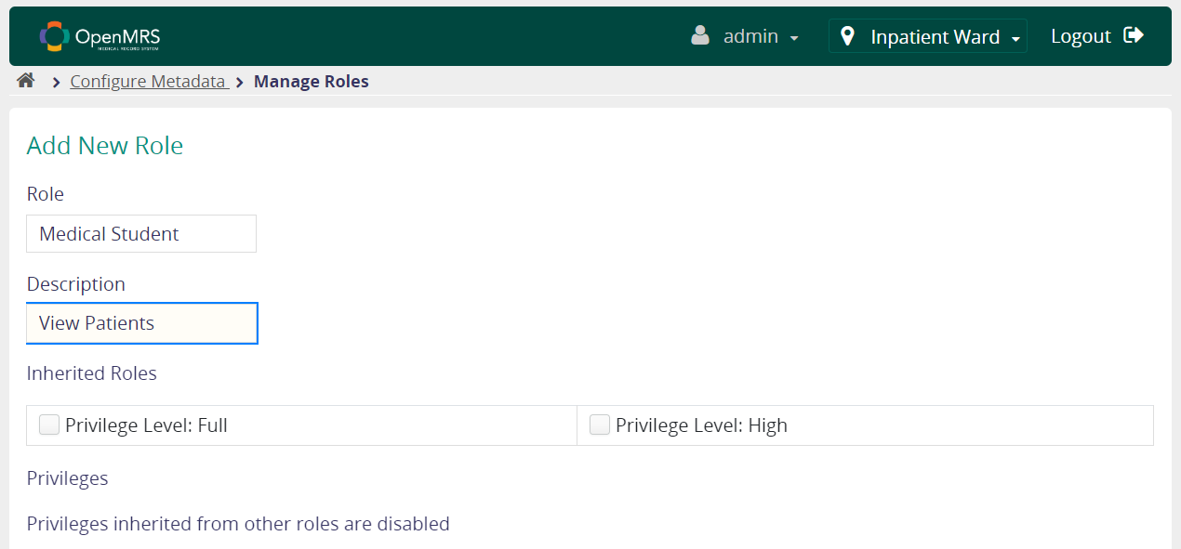 Create Medical Student
   2. 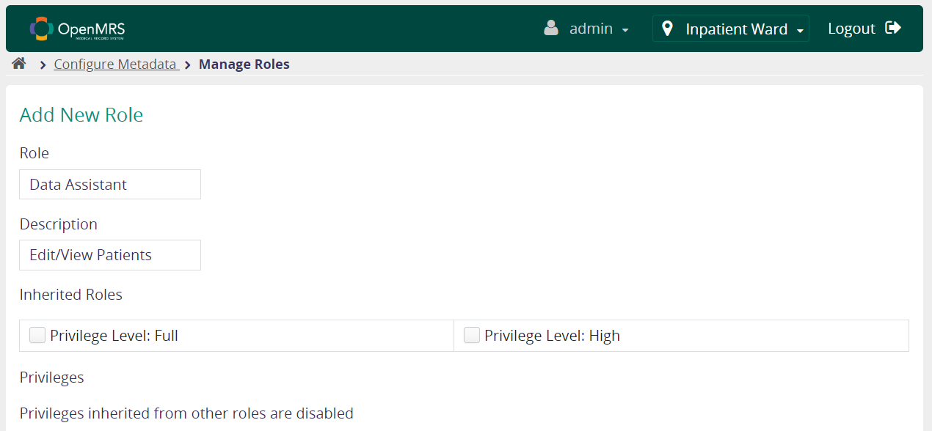Create Data Assistant

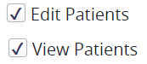

* 1. 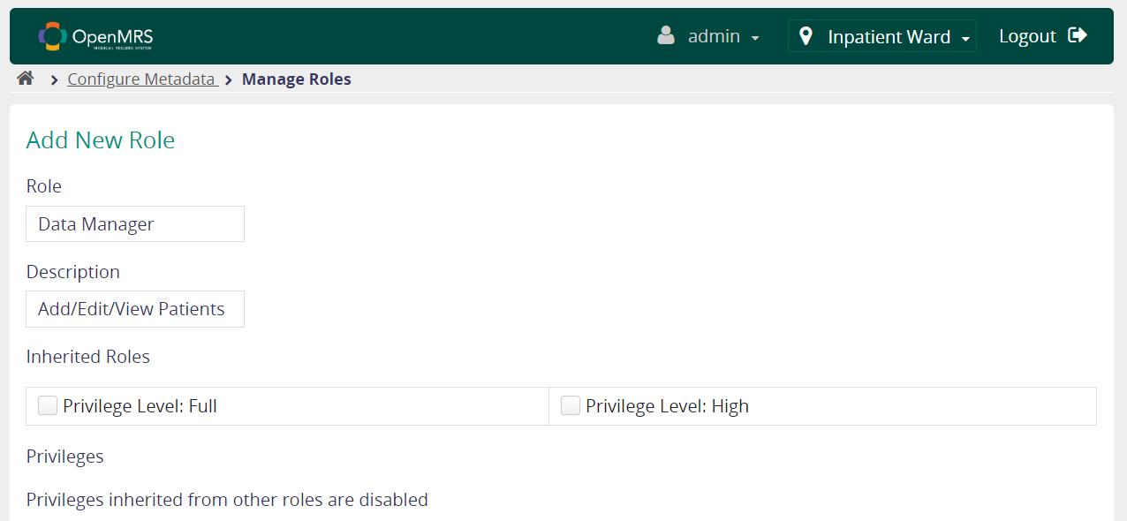Data Manager

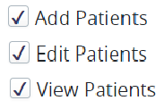

1. Create users: Mary, Bob, Erica and assign roles
   1. Create user Mary

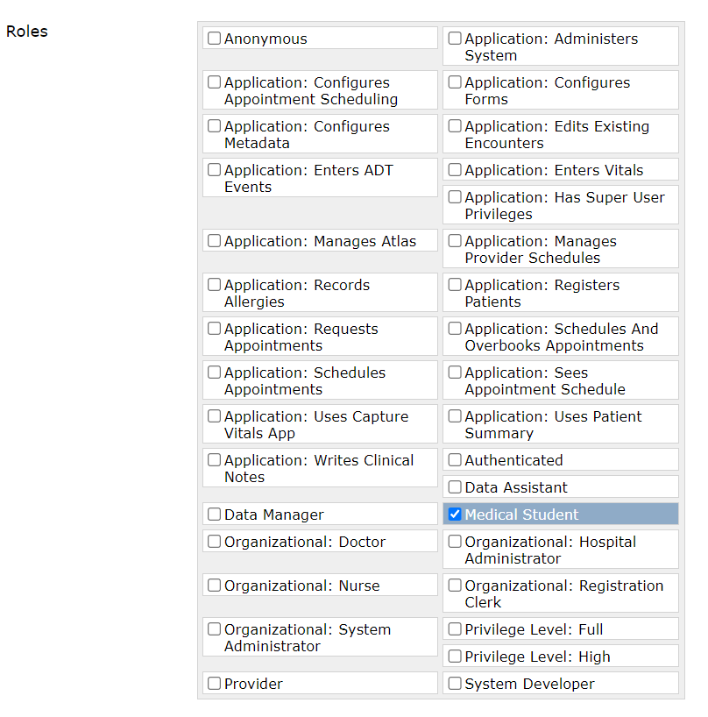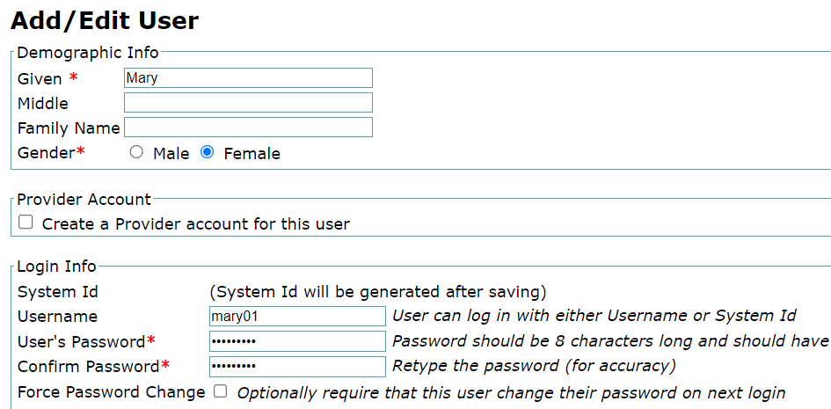

* 1. 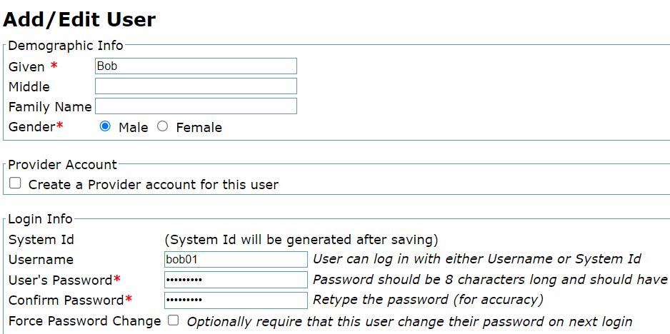Create user Bob

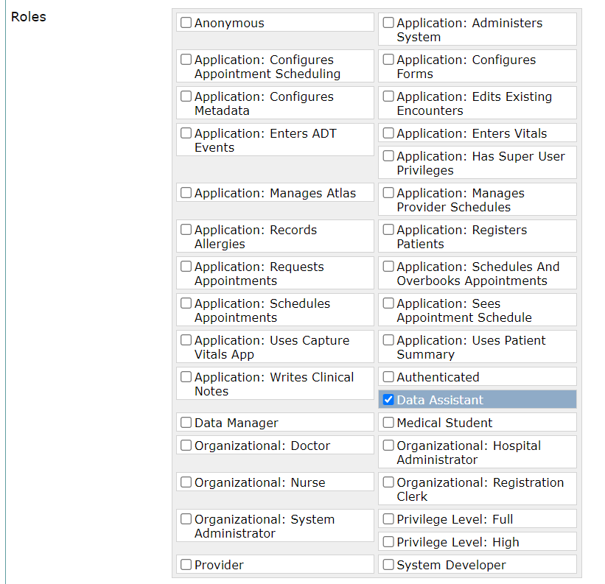

* 1. 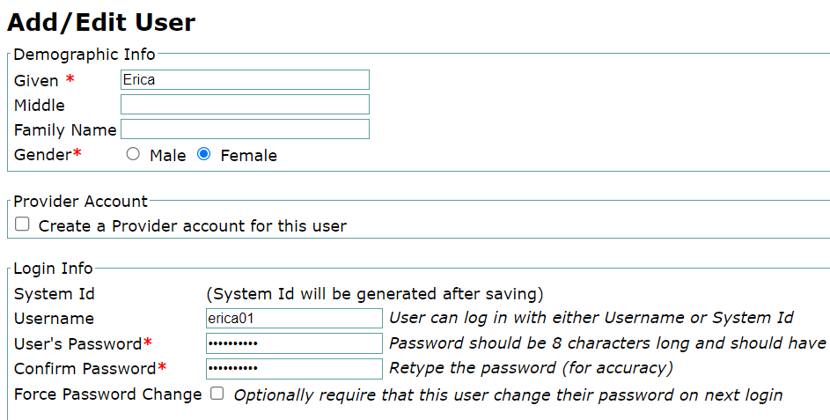Create user Bob

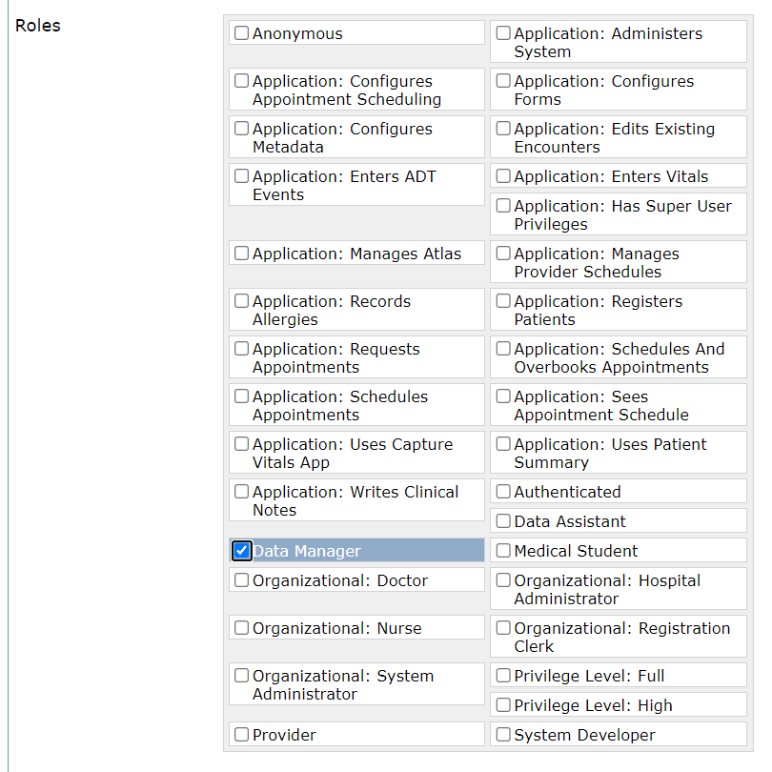

* 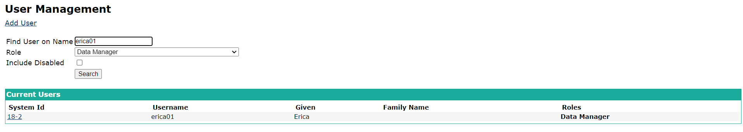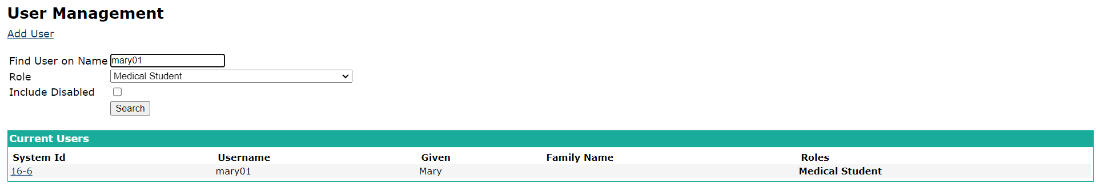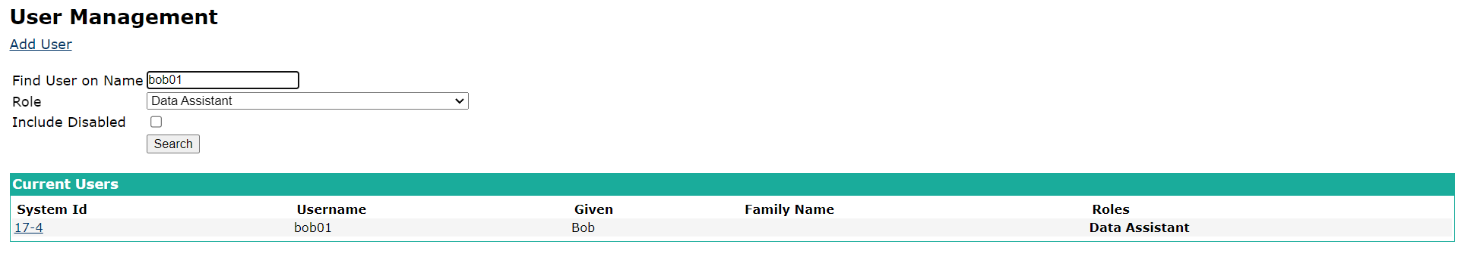The result for create users:

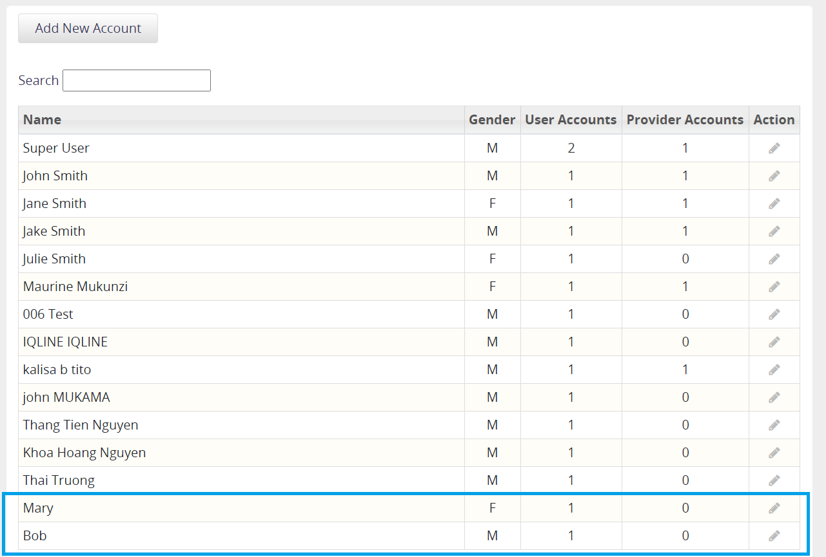

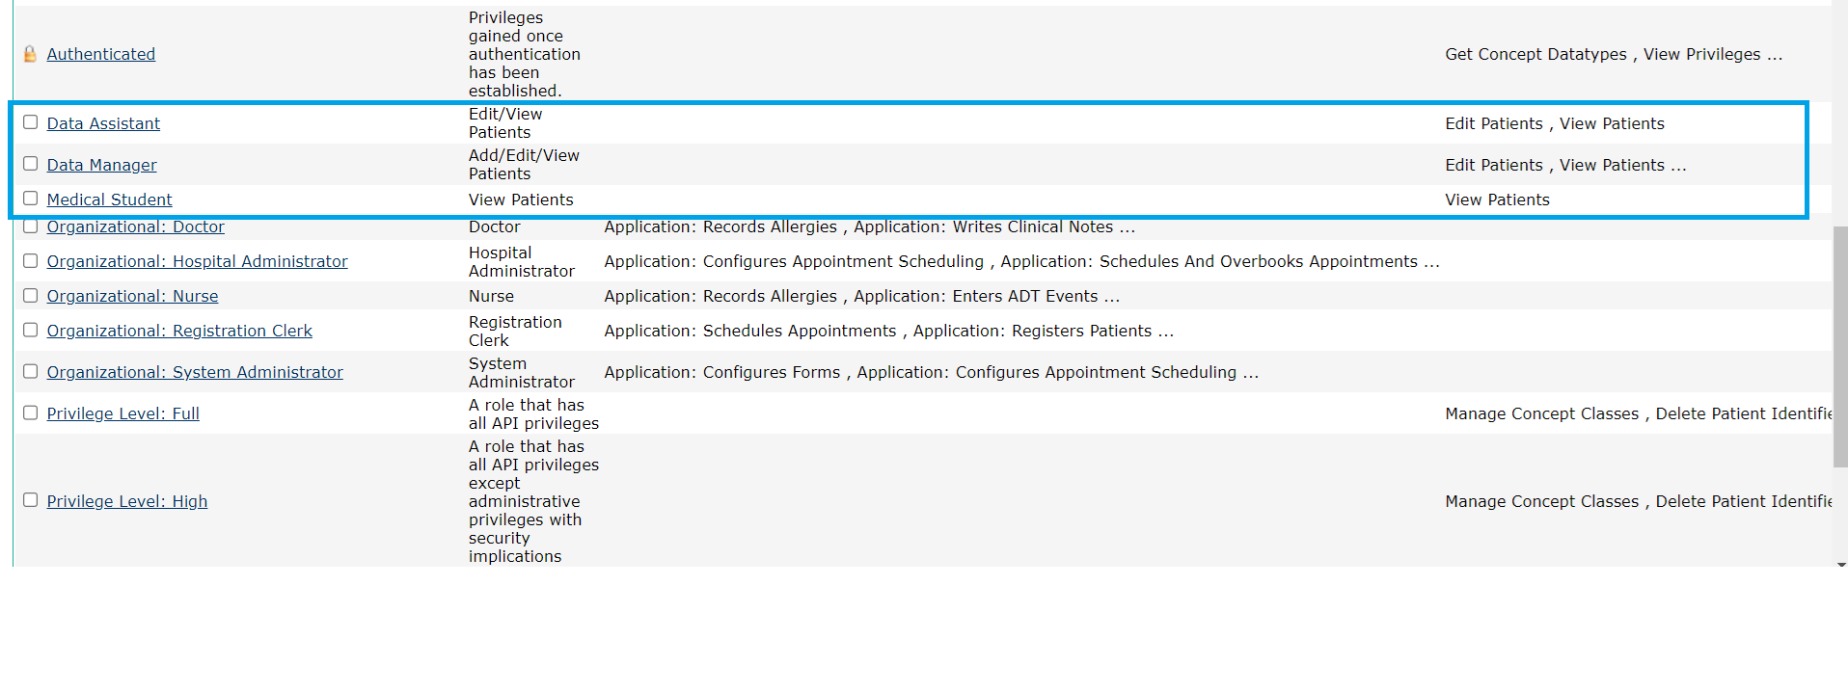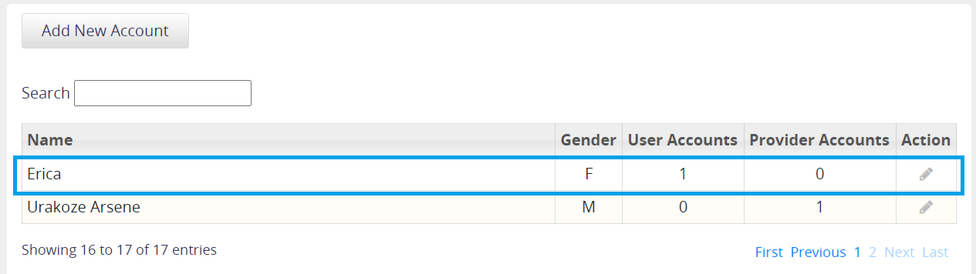

EXERCISE 4: Now, you will work on a more complex scenario. Assume following roles are defined in an EHR system. Now, before defining these roles in OpenMRS, try to combine the roles that can inherit privileges from each other. You can define new roles if it makes managing your role hierarchy easier. Report your role hierarchy.

|  |  |  |
| --- | --- | --- |
| **Role** | **Inherit** | **Privileges** |
| Senior Dentist | Dentist | Add/ Edit/ View Patients Add/ Edit/ View Laboratory Orders Add/ Edit/ View Encounters Add/ Edit/ View Visits  Add/View Reports |
| Specialist Dentist |  | Add/ Edit/ View Patients  Add/ View Laboratory Orders |
| Ambulance Personnel |  | View Patients Add Reports |
| Health Secretary |  | Add/ Edit/ View Encounters Add/ Edit/ View Diet Orders |
| Physiotherapist |  | Add/ Edit/ View Encounters Add/ Edit/ View Physiotherapy Orders |
| Psychologist |  | Add/ Edit/ View Encounters Add/ Edit/ View Psychology Orders |
| Radiologist |  | Add/ Edit/ View Laboratory Orders Add/ Edit/ View Radiology Orders |
| Dentist | Health Secretary | Add/ Edit/ View Encounters Add/ Edit/ View Diet Orders |
| Doctor |  | Add/ Edit/ View Patients Add/ Edit/ View Laboratory Orders Add/ Edit/ View Encounters Add/ Edit/ View Visits |
| Nurse |  | Add/ Edit/ View Patients Add/ Edit/ View Laboratory Orders Add/ Edit/ View Observations Add/ Edit/ View Reports |
| System Administrator |  | Add/ Edit/ View Users Add/ Edit User Passwords Add/ Edit/ View Roles |
| Registration clerk |  | Add/ Edit/ View Users Add/ Edit/ View Patients Add/ Edit/ View Appointments |
| Data Assistant |  | Edit/ View Patients |
| Data Manager | Data Assistant | Add/ Edit/ View Patients |
| Medical Student |  | View Patients |

EXERCISE 5: Define your role hierarchy in OpenMRS. (You can add a new privilege If it’s not defined in OpenMRS). Attach the screen shot of your defined roles in OpenMRS.

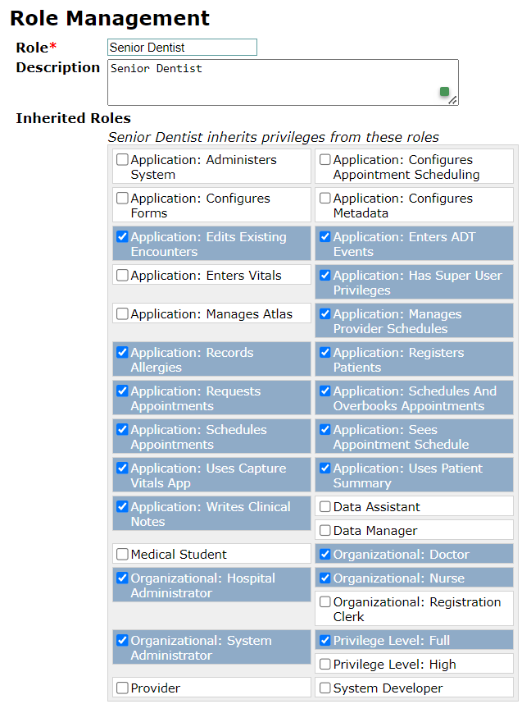

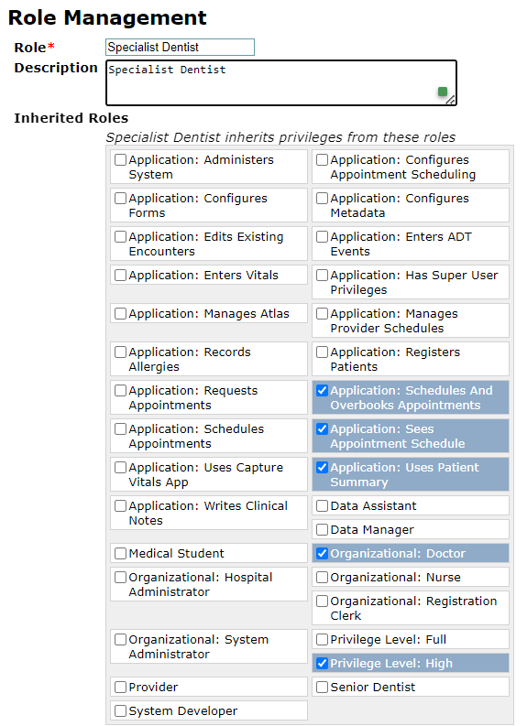

EXERCISE 6: What are the challenges you encounter while working with access control model in OpenMRS? What are your suggestions for improving the access control model of OpenMRS?

* **Challenges:**

1. Complicated Privilege and Role Management:

* The complexity of defining and administering roles and privileges in OpenMRS can be attributed to the diverse range of duties and responsibilities found in healthcare environments. It's difficult to make sure that every role gets the appropriate permissions, without any gaps or overlaps.
* Impact: Incorrectly configured roles may prevent healthcare providers from accessing essential information or allow unauthorized parties to obtain private information.

1. Problems with Scalability:

* Description: It becomes more challenging to effectively manage access control as healthcare companies expand due to the rise in users and responsibilities.
* Impact: If not handled correctly, this may result in administrative burden and possible security flaws.

1. Integration with Other Systems:

* Numerous software systems are used in healthcare institutions, and these systems must cooperate with one another. It might be challenging to maintain secure and uniform access control across various platforms.
* Impact: Inconsistencies in access control guidelines among various systems may result in security lapses and problems with compliance.

1. User Role Upkeep and Modifications:

* The roles of healthcare personnel frequently vary, necessitating frequent adjustments to access permissions.
* Impact: Manually keeping track of these changes is time-consuming and error-prone, which could result in out-of-date or erroneous access levels.

1. Exam and Adherence:

* Description: It is necessary, but difficult, to keep thorough audit logs and make sure that healthcare laws like HIPAA and GDPR are followed.
* Impact: It is challenging to monitor who accessed what data and when without strong auditing capabilities, which is essential for security and compliance.
* **Suggestions for improvement:**

1. Improved Role Personalization and Streamlined Administration:

* Implementation: Provide a more intuitive interface for role and privilege management so that administrators may quickly set and modify permissions and roles. Role models for frequently held positions may be part of this.
* Benefit: Lowers the possibility of misconfiguration and streamlines the role-management procedure.

1. Enhanced Features of Scalability:

* Implementation: As the organization expands, introduce solutions that can scale and automatically modify access controls. Group-based permissions and hierarchical role hierarchies may be examples of this.
* Benefit: Lessens administrative work and guarantees uniform access control in bigger companies.

1. Improved Integration Skills:

* Implementation: To guarantee uniform access control policies across the many systems utilized by a healthcare facility, offer strong APIs and integration tools.
* Benefit: Lowers security risks by ensuring smooth and secure access control across many platforms.

1. Automated User Administration:

* Implementation: Role-based access control (RBAC) in conjunction with attribute-based access control (ABAC) are examples of automated processes that can be used to manage user roles and permissions according to predetermined rules.
* Benefit: Guarantees timely modifications to user permissions and lessens the manual labor for administrators.

1. Advanced Monitoring and Auditing:

* Implementation: Improve the auditing functionality to offer thorough logs and in-the-moment access event tracking. Combine these features with mechanisms for reporting compliance.
* Benefit: Enhances data tracking capabilities, facilitating regulatory compliance and enhancing security in general.

1. Instruction and Record-Keeping:

* Implementation: Give administrators thorough instruction and documentation on the best ways to manage roles and privileges in OpenMRS.
* Benefit: Lowers the possibility of errors by ensuring that administrators are properly prepared to manage access control.

REFERENCES

* OpenMRS Guide:<https://guide.openmrs.org/administering-openmrs/user-management-and-access-control/>
* OpenMRS:<https://openmrs.atlassian.net/wiki/spaces/docs/pages/25477734/Administering+Users>