**LAB 2. ADO.NET**

**Exercise 1. Create an Internship Management database on SQL Server with 3 tables as follows:**

* Students (student ID, full name, hometown, date of birth, GPA):
* Project (Project ID, Project name, Supervisor, funding)
* Student_Project (student ID, Project ID, internship place, distance, results)
* **Student:**

|  |  |  |  |  |
| --- | --- | --- | --- | --- |
| **Student ID** | **Full name** | **Hometown** | **DOB** | **GPA** |
| SV01 | Trần Thanh Trâm | Sài Gòn | 23/03/1998 | 8.5 |
| SV02 | Nguyễn Hồng Linh | Thanh Hóa | 20/01/2000 | 9.0 |
| SV03 | Trần Thanh Phước | Tiền Giang | 12/07/2001 | 7.5 |
| SV04 | Nguyễn Minh Hải | Nghệ An | 28/02/1993 | 7.0 |
| SV05 | Trần Thị Hồng Nhung | Kiên Giang | 15/07/1998 | 9.0 |

* **Project**

|  |  |  |  |
| --- | --- | --- | --- |
| **Project ID** | **Project Name** | **Supervisor** | **Funding** |
| DT01 | Quản lý quán ăn | Nguyễn Thễ Hữu | 100.000.000 |
| DT02 | Quản lý khách sạn | Trần Trung Hiếu | 200.000.000 |
| DT03 | Quản lý sân bóng đá mini | Nguyễn Công Tâm | 300.000.000 |
| DT04 | Quản lý shop hoa tươi | Đặng Đức Trung | 150.000.000 |
| DT05 | Quản lý cửa hàng điện thoại | Trịnh Thanh Duy | 2.000.000.000 |

* **Student_Project:**

|  |  |  |  |  |
| --- | --- | --- | --- | --- |
| **Student ID** | **Project ID** | **Internship Place** | **Distance** | **Results** |
| SV01 | DT01 | Tiền Giang | 70 | 8.0 |
| SV02 | DT01 | Bình Dương | 50 | 7.0 |
| SV03 | DT02 | Vũng Tàu | 150 | 9.5 |
| SV03 | DT03 | Long An | 50 | 8.5 |
| SV04 | DT03 | Nha Trang | 500 | 10 |

**Requirements:**

1. Design the Student management form as follows:

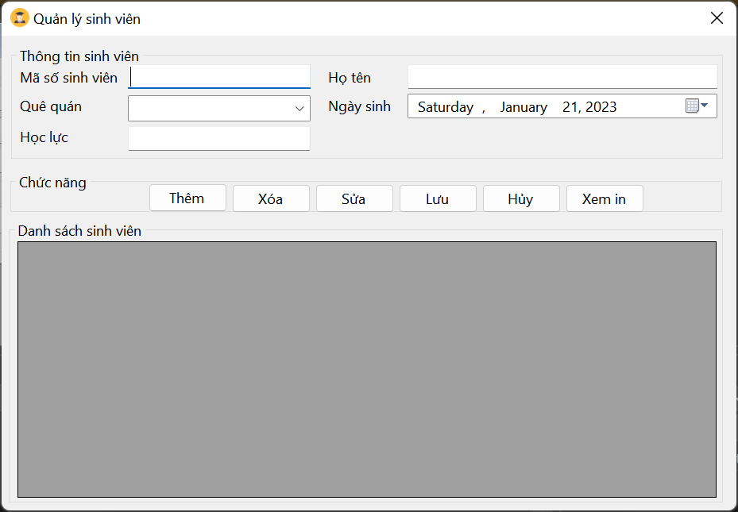

* Formload event:
  + Show Student list on gridview
  + Controls in Student Information are disabled
  + Hometown: Contains provinces: Saigon, Thanh Hoa, Nghe An, Long An, Quang Ngai, ....
  + Delete, Edit, Save buttons are disabled
* When the “Add” button is pressed:
  + Controls in student information are enabled.
  + Clean up the textboxes
  + Student ID textbox is focused.
  + GPA only allows entering numbers
  + “Save” button is enabled.
* When “Cancel” button is pressed: same as formload event.
* When clicking to select a row in gridview:
  + Selected data will be displayed on Student Information
  + Edit and Delete buttons are enabled.
* When the “Delete” button is pressed:
  + Confirm “Do you want to delete this student?”,
  + If you choose Yes:
    - Delete data in Student table
    - Update gridview
* When the “Edit” button is pressed:
  + Allows to edit information in Student Information except Student ID information
  + “Save” button is enabled.
  + Textbox full name in focus.
* When the “Save” button is selected:
  + Check if adding data or editing data
  + Update data to Student tabl
  + Update data to gridview.
  + Status like formload event.
* “Print PreView” button: Allows printing the list of students (self-study).

1. Design the Project management form.

Design form and handle similar to Student Management Form.

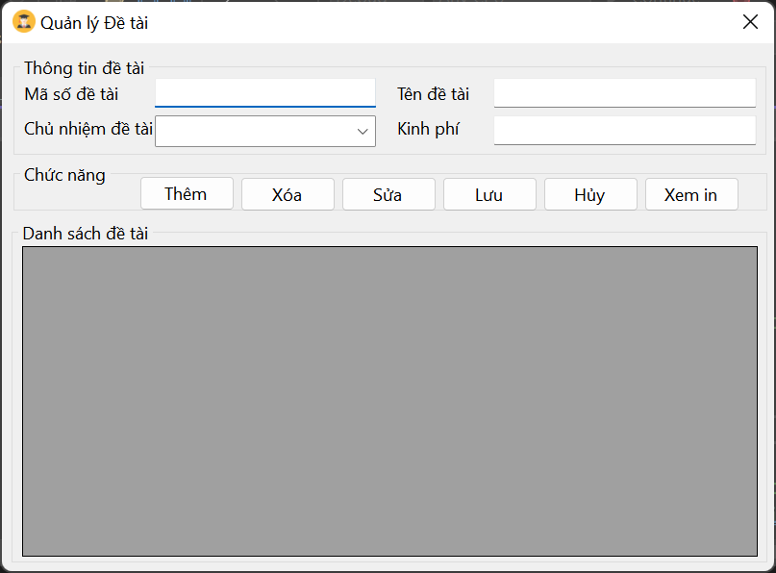

1. Design the form to manage internship results: Do it yourself according to the form above.