VIETNAM GENERAL CONFEDERATION OF LABOR

**TON DUC THANG UNIVERSITY**

**FACULTY OF INFORMATION TECHNOLOGY**



**MIDTERM ESSAY**

**DISCRETE STRUCTURES**

*Instructor*: **MAI DUY TAN**

*Executor*: **VO NHAT HAO– 522H0090**

Class **: 22H50202**

Course  **: 26**

**HO CHI MINH CITY , YEAR 2024**

VIETNAM GENERAL CONFEDERATION OF LABOR

**TON DUC THANG UNIVERSITY**

**FACULTY OF INFORMATION TECHNOLOGY**



**MIDTERM ESSAY**

**DISCRETE STRUCTURES**

*Instructor*: **MAI DUY TAN**

*Executor*: **VO NHAT HAO**

Class **: 22H50202**

Course  **: 26**

**HO CHI MINH CITY, YEAR 2024**

THANK YOU

I would like to sincerely thank Lecturers Mai Duy Tan and Lecturers Nguyen Quoc Binh for accompanying me. Thank you two teachers for teaching and guiding me to complete my midterm essay in Discrete Structures. Thank you to the Faculty of Information Technology for exposing me to this essay and I firmly believe that this essay will give me access to working skills in terms of reports and presentation skills in order to approach the future. work, when going to work, you can adapt to a new environment. I hope you will grade and give me feedback so I can develop and get better in this field. Finally, I would like to thank you for reading, grading and evaluating. Wishing you good health so you can convey new knowledge to me and my fellow students.

**THE PROJECT IS COMPLETED**

**AT TON DUC THANG UNIVERSITY**

I hereby declare that this is my own project product and is guided by Lecturers Mai Duy Tan and Lecturers Nguyen Quoc Binh. The research content and results in this topic are honest and have not been published in any form before. The data in the tables for analysis, comments, and evaluation were collected by the author from different sources and clearly stated in the reference section.

In addition, the project also uses a number of comments, assessments as well as data from other authors and other organizations, all with citations and source notes.

**If any fraud is discovered, I will take full responsibility for the content of my project**. Ton Duc Thang University is not involved in copyright violations caused by me during the implementation process (if any).

*Ho Chi Minh City, 14 April , 2024*

*Author*

*(sign and write full name)*

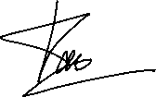

*Vo Nhat Hao*

INSTRUCTOR VERIFICATION AND EVALUATION SECTION

**Confirmation from the instructor**

_______________________________________________________________________________________________________________________________________________________________________________________________________________________________________________________________________________________________________________________________________________________________________________________________________________

Ho Chi Minh City, day month year

(sign and write full name)

**The teacher's evaluation part marks the test**

_______________________________________________________________________________________________________________________________________________________________________________________________________________________________________________________________________________________________________________________________________________________________________________________________________________

Ho Chi Minh City, day month year

(sign and write full name)

SUMMARY

* Problem 1: Help hacker to find the password.
* Problem 2: State the inverse, inverse, contradictory and unconditional negation of statements in natural language.
* Problem 3: Give real-life examples for each type of fallacy.
* Problem 4: Redraw the new Tarski world using student ID calculations. Determine the truth or falsity of every statement, based on Tarski's modified world.
* Problem 5: Use p, q, r, s and logical links to write symbols based on StudentID.
* Problem 6: Prove pairs of propositions are logically equivalent using two methods using truth value tables and using logical equivalence laws.
* Problem 7: Learn SWI-Prolog's and run the program.

TABLE OF CONTENTS

THANK YOU 1

INSTRUCTOR VERIFICATION AND EVALUATION SECTION 3

SUMMARY 4

TABLE OF CONTENTS 5

PROBLEMS 6

Part 1 6

Problem 1: Password 6

Problem 2: Conditional statements 7

Problem 3: Fallacies 10

Part 2 16

Problem 4: Tarski's world 16

Problem 5: Symbolic form 18

Problem 6: Equivalence 18

Part 3 20

Problem 7: Prolog 20

REFERENCE 24

PROBLEMS

Part 1

Problem 1: Password

A hacker is trying to hack a password. He knows that this password has 3 characters, each of which is a distinct number from 1 to 9. He also learns from his trials that:

a. 472: one number is correct but in an incorrect position.

b. 581: one number is correct but in an incorrect position.

c. 483: one number is correct and in the correct position.

d. 317: two numbers are correct but in incorrect positions.

e. 956: all numbers are incorrect.

Please help him to find the password with good reasoning.

**We have:**

Let's consider a:

* Suppose 4 is the correct number (but sentence c assumes that the number is correct and in the correct position) => Number 4 is not correct.
* Suppose 7 is the correct number.
* Suppose 2 is the correct number.

Let's consider b:

* Suppose 5 is the correct number (but sentence e assumes that 956 all numbers are incorrect) => Number 5 is not correct.
* Suppose 8 is the correct number (but sentence c assumes that the number is correct and in the correct position) => Number 8 is not correct.
* Number 1 is correct (because the numbers 5 and 8 are wrong).

Let's consider c:

* Number 4 is not correct (explain in sentence a).
* Number 8 is not correct (explain in sentence b).
* Number 3 is correct (because the numbers 4 and 8 are wrong).

Let's consider d:

* Number 3 and 1 are correct (explain in sentence b, c).
* Number 7 is not correct.

Let's review a:

* Number 7 is not correct (explain in sentence d).
* Number 2 is correct.

Consider the position of each number:

* Number 3 is in 3rd position. (sentence c)
* Number 1 is in 1st position. (because the number 1 in position 2 is wrong in sentence d).
* Number 2 is in 2nd position.
* **Password is 123.**

Problem 2: Conditional statements

State the converse, inverse, contrapositive, and non-conditional-form negation of these conditional statements in natural language:

1. “If a man, holding a belief which he was taught in childhood or persuaded of afterwards, keeps down and pushes away any doubts which arise about it in his mind, purposely avoids the reading of books and the company of men that call in question or discuss it, and regards as impious those questions which cannot easily be asked without disturbing it - the life of that man is one long sin against mankind.”

*The Ethics of Belief (1877) by William K. Clifford.*

**P:** “A man, holding a belief which he was taught in childhood or persuaded of afterwards, keeps down and pushes away any doubts which arise about it in his mind, purposely avoids the reading of books and the company of men that call in question or discuss it, and regards as impious those questions which cannot easily be asked without disturbing it.”

**Q:** “The life of that man is one long sin against mankind.”

* **Converse (If Q, then P):** “If the life of a man is one long sin against mankind, then that man is holding a belief which he was taught in childhood or persuaded of afterwards, keeps down and pushes away any doubts which arise about it in his mind, purposely avoids the reading of books and the company of men that call in question or discuss it, and regards as impious those questions which cannot easily be asked without disturbing it.”
* **Inverse (If not P, then not Q):** “If a man does not hold a belief which he was taught in childhood or persuaded of afterwards, does not keep down and push away any doubts which arise about it in his mind, does not purposely avoid the reading of books and the company of men that call in question or discuss it, and does not regard as impious those questions which cannot easily be asked without disturbing it, then the life of that man is not one long sin against mankind.”
* **Contrapositive (If not Q, then not P):** “If the life of a man is not one long sin against mankind, then that man does not hold a belief which he was taught in childhood or persuaded of afterwards, does not keep down and push away any doubts which arise about it in his mind, does not purposely avoid the reading of books and the company of men that call in question or discuss it, and does not regard as impious those questions which cannot easily be asked without disturbing it.”
* **Non-conditional-form negation (P and not Q):** “A man, holding a belief which he was taught in childhood or persuaded of afterwards, keeps down and pushes away any doubts which arise about it in his mind, purposely avoids the reading of books and the company of men that call in question or discuss it, and regards as impious those questions which cannot easily be asked without disturbing it, and the life of that man is not one long sin against mankind.”

1. “If existing agricultural knowledge were everywhere applied, the planet could feed twice its present population.”

*The Lessons of History (1968) by Will and Ariel Durant.*

**P:** “Existing agricultural knowledge were everywhere applied.”

**Q:** “The planet could feed twice its present population.”

* **Converse (If Q, then P):** “If the planet could feed twice its present population, then existing agricultural knowledge were everywhere applied.”
* **Inverse (If not P, then not Q):** “If existing agricultural knowledge were not everywhere applied, then the planet could not feed twice its present population.”
* **Contrapositive (If not Q, then not P):** “If the planet could not feed twice its present population, then existing agricultural knowledge were not everywhere applied.”
* **Non-conditional-form negation (P and not Q):** “Existing agricultural knowledge were everywhere applied, and the planet could not feed twice its present population.”

1. “But even if the initial colonists had consisted of only 100 people and their numbers had increased at a rate of only 1.1 percent per year, the colonists' descendants would have reached that population ceiling of 10 million people within a thousand years.”

*Guns, Germs, and Steel (1997) by Jared Diamond.*

**P:** "The initial colonists had consisted of only 100 people and their numbers had increased at a rate of only 1.1 percent per year."

**Q:** "The colonists' descendants would have reached that population ceiling of 10 million people within a thousand years."

* Converse (If Q, then P): "If the colonists' descendants would have reached that population ceiling of 10 million people within a thousand years, then the initial colonists had consisted of only 100 people and their numbers had increased at a rate of only 1.1 percent per year."
* Inverse (If not P, then not Q): "If the initial colonists had not consisted of only 100 people or their numbers had not increased at a rate of only 1.1 percent per year, then the colonists' descendants would not have reached that population ceiling of 10 million people within a thousand years."
* Contrapositive (If not Q, then not P): "If the colonists' descendants would not have reached that population ceiling of 10 million people within a thousand years, then the initial colonists had not consisted of only 100 people or their numbers had not increased at a rate of only 1.1 percent per year."
* Non-conditional-form negation (P and not Q): "The initial colonists had consisted of only 100 people and their numbers had increased at a rate of only 1.1 percent per year, and the colonists' descendants would not have reached that population ceiling of 10 million people within a thousand years."

1. “If anyone looked out of their window now, even beady-eyed Mrs. Dursley, they wouldn’t be able to see anything that was happening down on the pavement.”

*Harry Potter and the Philosopher's Stone (1997) by J. K. Rowling*

**P:** “Anyone looked out of their window now, even beady-eyed Mrs. Dursley.”

**Q:** “They wouldn’t be able to see anything that was happening down on the pavement.”

* **Converse (If Q, then P):** “If they wouldn’t be able to see anything that was happening down on the pavement, then anyone looked out of their window now, even beady-eyed Mrs. Dursley.”
* **Inverse (If not P, then not Q):** “If anyone did not look out of their window now, even beady-eyed Mrs. Dursley, then they would be able to see something that was happening down on the pavement.”
* **Contrapositive (If not Q, then not P):** “If they could see something that was happening down on the pavement, then anyone did not look out of their window now, even beady-eyed Mrs. Dursley.”
* **Non-conditional-form negation (P and not Q):** “Anyone looked out of their window now, even beady-eyed Mrs. Dursley, and they could see something that was happening down on the pavement.”

Problem 3: Fallacies

Give a real-life example for each type of fallacy in chapter 1. Reference materials are needed. Paraphrase the materials, using your own words.

* Using ambiguous premises:

**For example:**

Condition 1: Fast food contains lots of calories.

Condition 2: Calories are energy.

Condition 3: Energy is a sign of health.

Conclusion: Therefore, fast food is health food.

**Explain:**

Condition 1: “Fast food is high in calories.” Correct. Fast food is often high in calories.

Condition 2: “Calories are energy.” It's also true. In nutrition, a calorie is a unit of energy measurement.

Condition 3: “Energy is a sign of health.” This is where the argument gets vague. Although having energy (in the sense of vitality or strength) may be a sign of good health, this is not the type of “energy” mentioned in Condition 2. In Condition 2, “energy “calories” just means calories in food, not a feeling of vitality or strength.

Conclusion: “Therefore, fast food is nutritious food.” This conclusion is drawn based on the ambiguity of the word “energy”. It is wrong to equate high energy (a type of “energy”) with health.

**Reference:** <https://www.quora.com/What-is-an-example-of-ambiguity-as-a-logical-fallacy>

* Circular reasoning:

**For example:**

Person 1: “God must exist.”

Person 2: “How do you know?”

Person 1: “Because it says so in the Bible.”

Person 2: “Why should I believe the Bible? ”

Person 1: “Because it is the divine work of God.”

**Explain:**

In the argument you provided, the person is using a form of reasoning known as circular reasoning. This is a logical fallacy where the conclusion of an argument is used as a premise of that same argument. Basically, the argument assumes the conclusion is true without providing any new information or evidence.

**Reference:** <https://www.scribbr.com/fallacies/circular-reasoning-fallacy/>

* Jumping to a conclusion:

**For example:**

Mind-reading could involve thinking that someone must hate you, simply because they didn’t seem enthusiastic when you told them “good morning”.

**Explain:**

The person is assuming that someone must hate them simply because they didn’t seem enthusiastic when greeted with “good morning”.

This is a hasty conclusion because it’s based on a single, possibly insignificant, event. The person’s lack of enthusiasm could be due to a variety of reasons - they might be having a bad day, they might be preoccupied with something else, or they might just not be a morning person.

To conclude that they must hate you based on this one interaction is a leap that isn’t supported by enough evidence.

It’s important to have sufficient and relevant evidence before drawing conclusions, especially when those conclusions are about other people’s thoughts or feelings.

**Reference:** <https://effectiviology.com/jumping-to-conclusions/#Examples_of_ways_people_jump_to_conclusions>

* Converse Error:

**For example:**

“If I eat fast food for dinner, then I have a stomach ache in the evening. I had a stomach ache this evening. Therefore I ate fast food for dinner.”

**Explain:**

This argument is flawed because having a stomach ache could be caused by many other factors, not just eating fast food.

**Reference:** <https://www.thoughtco.com/what-is-a-converse-error-3126461>

* Inverse Error:

**For example:**

If I am President of the United States, then I can veto Congress.

I am not President.

Therefore, I cannot veto Congress.

**Explain:**

If I were President of the United States, I could veto Congress. This is a conditional statement, in which being President is the cause and being able to veto Congress is the effect.

I'm not the President. This is the denial of the premise (cause).

Therefore, I cannot veto Congress. This is the conclusion drawn from denying the premise.

The fallacy occurs when people assume that because the cause does not exist (I am not the President), the effect (I cannot veto Congress) must also not exist. However, this is not necessarily true. There may be other causes for the effect

**Reference:** <https://en.wikipedia.org/wiki/Denying_the_antecedent>

* A Valid Argument with a False Premise and a False Conclusion:

**For example:**

All elephants can fly.

Dumbo is an elephant.

Therefore, Dumbo can fly.

**Explain:**

Premise 1: All elephants can fly. This is a false premise because in reality, elephants cannot fly.

Premise 2: Dumbo is an elephant. This is a true premise if we consider Dumbo, the character from the Disney movie, who is indeed an elephant.

Conclusion: Therefore, Dumbo can fly. This is a false conclusion in the real world because real elephants cannot fly. However, in the context of the Disney movie, Dumbo can fly.

The argument is considered valid because the conclusion follows logically from the premises. If the premises were true (if all elephants could fly), then the conclusion would also be true (Dumbo, being an elephant, could fly).

However, because the first premise is false in the real world, the conclusion is also false in the real world. The truth of the conclusion depends on the truth of the premises. If the premises are false, the conclusion is likely to be false as well.

**Reference:** <https://www.quora.com/Can-a-valid-argument-have-all-false-premises-and-a-false-conclusion>

* An Invalid Argument with True Premises and a True Conclusion:

**For example:**

There are red apples in my friend John’s house.

There are green apples in my house.

Both my friend John’s house and my house are in the world.

Therefor, there are red and green apples in the world.

**Explain:**

This is a valid argument. The conclusion follows from the premises. The conclusion is also true. There are red and green apples in the world. But the premises are false. There are no apples of any color in either of our houses.

**Reference:** <https://www.quora.com/Can-a-valid-argument-have-all-false-premises-and-a-false-conclusion>

* Sound and Unsound Arguments:
* Sound Argument:

**For example:**

Apples are food.

All food is edible.

Anything that is edible, I am able to eat.

Therefore, I am able to eat apples.

**Explain:**

Premise 1: Apples are food. This is a true statement. Apples are indeed a type of food.

Premise 2: All food is edible. This is also true. By definition, food is a substance that can be eaten.

Premise 3: Anything that is edible, I am able to eat. This is generally true for most people, assuming there are no dietary restrictions or allergies.

Conclusion: Therefore, I am able to eat apples. This conclusion is true and follows logically from the premises.

Because all the premises are true and the conclusion follows logically from the premises, this is a sound argument.

**Reference:** <https://www.khanacademy.org/partner-content/wi-phi/wiphi-critical-thinking/wiphi-fundamentals/v/soundness>

* Unsound Argument:

**For example:**

All cows are mammals.

All dogs are mammals.

Therefore, dogs are cows.

**Explain:**

The above argument contains true premises, but it is invalid since the conclusion doesn’t logically follow from the premises. Therefore, it is also an unsound argument.

**Reference:** <https://www.differencebetween.com/difference-between-sound-and-unsound-argument/>

Part 2

Let $\overline{abcd}$ be the 4-digit number combined by the last 4 digits in your StudentID.

StudentID 522H0090 has $\overline{abcd}$ = 0090.

Problem 4: Tarski's world

1. Modify the above Tarski's world as follows:

(StudentID 522H0090, we have 0090 % 7 = 6, so we change the item at E6 into a red triangle).

|  |  |  |  |  |  |  |  |  |  |
| --- | --- | --- | --- | --- | --- | --- | --- | --- | --- |
|  | 1 | 2 | 3 | 4 | 5 | 6 | 7 | 8 | 9 |
| A |  |  |  |  |  |  |  |  |  |
| B |  |  |  |  |  |  |  |  |  |
| C |  |  |  |  |  |  |  |  |  |
| D |  |  |  |  |  |  |  |  |  |
| E |  |  |  |  |  |  |  |  |  |
| F |  |  |  |  |  |  |  |  |  |
| G |  |  |  |  |  |  |  |  |  |
| H |  |  |  |  |  |  |  |  |  |
| I |  |  |  |  |  |  |  |  |  |

1. Determine the truth or falsity of all the following statements, based on the modified Tarski's world. Give the reasons for your justification.
2. ∀x, Circle(x) → Green(x)

False, because there are red circles in A8, D2, E5, I1 and orange circles in H2.

1. ∀x, Triangle(x) → ~Orange(x)

True, because all the triangles are green and red.

1. ∃x such that Red(x) ∧ Triangle(x)

True, because there is a red triangle in D8.

1. ∃x such that ~Green(x) ∧ BelowOf(x, E4)

True, because below E4 there are red and orange colors.

1. ∀x, Square(x) → RightOf(E5, x).

False, because there is a square in D3, F1.

1. ∃x such that AboveOf(E5, x) ∧ LeftOf(x, E5).

True, because there is a red square, a red circle, and an orange circle below E5 and to the left of E5.

1. There is a triangle x such that for all squares y, x is above y.

True, because there is a triangle in A2 above all squares.

1. For all circles x, there is a square y such that y is to the right of x.

False, because there is a circle in D9 and that is the last column.

1. There is a circle x and there is a square y such that y is below x.

True, because there is square C3 under circle A8.

1. For all circles x and for all triangles y, x and y have the same color.

False, because there is a green circle at C4 and a red triangle at E4.

Problem 5: Symbolic form

(StudentID 522H0090, we have 0090 % 2 = 0)

Let p = “it is windy”; q = “it is thundering”; r = “it is raining”; s = “it is lightning”.

* Logical connectives:
* ∧ : and.
* $\sim$: not.
* → : implies / if...then.
* ↔ : if and only if .

a. It is windy but it isn't raining.

Symbolic form: p ∧ $\sim$ r

d. Windiness is a necessary condition for rain.

Symbolic form: r → p

f. Whenever it is lightning, it will be thundering.

Symbolic form: s → q

g. The necessary and sufficient condition for thundering is lightning.

Symbolic form: q ↔ s

Problem 6: Equivalence

(StudentID 522H0090, we have 0090 % 3 = 0)

~ [(~ p ∧ ~ ~ q) ∨ ~ (p ∨ r)] $≡$ (r ∨ p) ∧ (~ q ∨ p)

**(a) using truth table.**

|  |  |  |  |  |  |  |  |  |
| --- | --- | --- | --- | --- | --- | --- | --- | --- |
| p | q | r | ~p | ~q | ~r | ~p ∧ ~ ~q | p ∨ r | ~ (p ∨ r) |
| T | T | T | F | F | F | F | T | F |
| T | T | F | F | F | T | F | T | F |
| T | F | T | F | T | F | F | T | F |
| T | F | F | F | T | T | F | T | F |
| F | T | T | T | F | F | T | T | F |
| F | T | F | T | F | T | T | F | T |
| F | F | T | T | T | F | T | T | F |
| F | F | F | T | T | T | T | F | T |

|  |  |  |  |
| --- | --- | --- | --- |
| (r ∨ p) | ~ q ∨ p | ~ [(~ p ∧ ~ ~q) ∨ ~ (p ∨ r)] | (r ∨ p) ∧ (~ q ∨ p) |
| T | T | T | T |
| T | T | T | T |
| T | T | T | T |
| T | T | T | T |
| T | F | T | T |
| F | F | F | F |
| T | T | T | T |
| F | T | T | T |

**(b) using logical equivalence laws.**

* The left-hand side: ~ [(~ p ∧ ~ ~q) ∨ ~ (p ∨ r)]

**We have:** ~ [(~ p ∧ ~ ~q) ∨ ~ (p ∨ r)]

$≡$ ~ [(~ p ∧ q) ∨ ~ (p ∨ r)] (Double negation law)

$≡$ ~ [(~ p ∧ q) ∨ (~p ∧ ~r)] (De Morgan’s law)

$≡$ ~ [~ p ∧ (q ∨ ~r)] (Distributive law)

$≡$ p ∨ ~ (q ∨ ~r) (De Morgan’s law)

$≡$ p ∨ (~q ∧ r) (De Morgan’s law) (1)

* The right-hand side: (r ∨ p) ∧ (~ q ∨ p)

**We have:** (r ∨ p) ∧ (~ q ∨ p)

$≡$ (p ∨ r) ∧ (p ∨ ~q) (Commutative law)

$≡$ p ∨ (r ∧ ~q) (Distributive law)

$≡$ p ∨ (~q ∧ r) (Commutative law) (2)

* **From (1) and (2) we see that both sides are equal.**

Part 3

Problem 7: Prolog

1. Capture the results and explain:

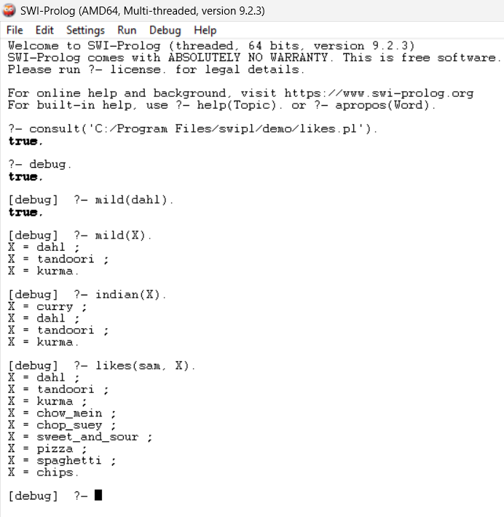

**Explain:**

* First find likes.pl file on your computer.
* Run the file likes.pl from the path 'C:/Program Files/swipl/demo/likes.pl'.
* ?- consult('C:/Program Files/swipl/demo/likes.pl'). This command loads the Prolog file likes.pl located in the specified path.
* ?- debug. This command enables debug mode in Prolog.
* ?- mild(dahl). This query checks if dahl is classified as a mild dish in your knowledge base. The response true indicates that dahl is indeed classified as mild.
* ?- mild(X). This query retrieves all dishes classified as mild in your knowledge base. The results indicate that dahl, tandoori, and kurma are all classified as mild dishes.
* ?- indian(X). This query retrieves all dishes classified as Indian in your knowledge base. The results indicate that curry, dahl, tandoori, and kurma are all classified as Indian dishes.
* ?- likes(sam, X). This query retrieves all dishes that sam likes according to your knowledge base. The results indicate that sam likes dahl, tandoori, kurma, chow_mein, chop_suey, sweet_and_sour, pizza, spaghetti, and chips.
* If you press ‘;’ after an answer, Prolog will try to find another answer. If no more answers can be found, Prolog will return false.

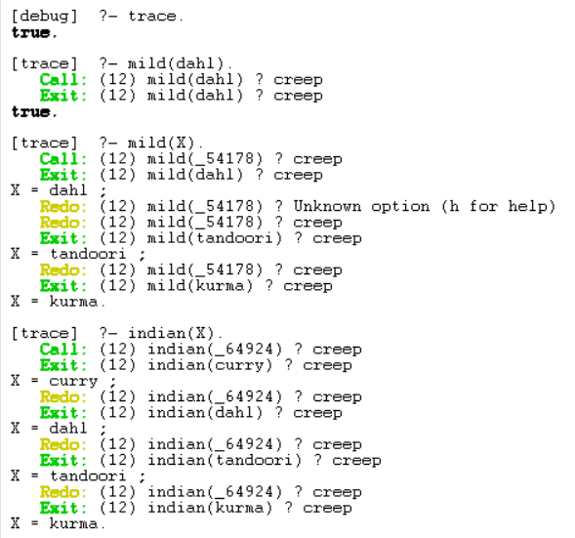**Using the trace command in Prolog, which allows you to see the step-by-step execution of your queries.**

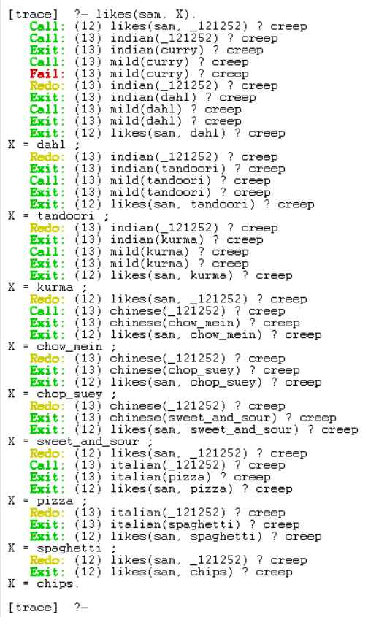

**Explain:**

* ?- trace. This command enables trace mode in Prolog.
* ?- mild(dahl). This query checks if dahl is classified as a mild dish in your knowledge base. The response true indicates that dahl is indeed classified as mild.
* ?- mild(X). This query retrieves all dishes classified as mild in your knowledge base. The results indicate that dahl, tandoori, and kurma are all classified as mild dishes.
* ?- indian(X). This query retrieves all dishes classified as Indian in your knowledge base. The results indicate that curry, dahl, tandoori, and kurma are all classified as Indian dishes.
* ?- likes(sam, X). This query retrieves all dishes that sam likes according to your knowledge base. The results indicate that sam likes dahl, tandoori, kurma, chow_mein, chop_suey, sweet_and_sour, pizza, spaghetti, and chips.

1. 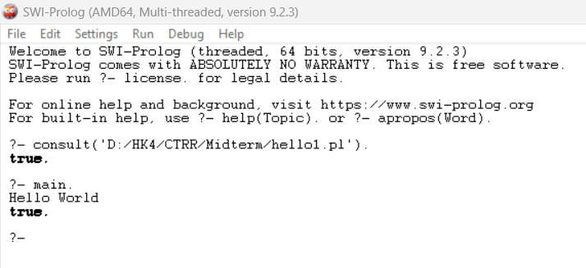Capture the result:
2. 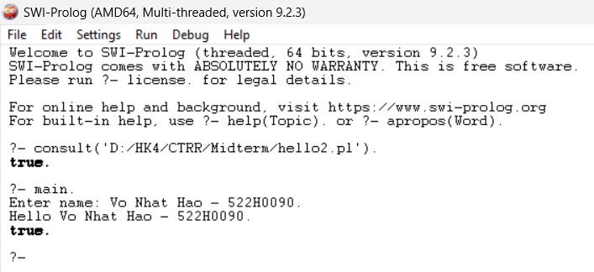Capture the result:

REFERENCE

* Using ambiguous premises: <https://www.quora.com/What-is-an-example-of-ambiguity-as-a-logical-fallacy>
* Circular reasoning: <https://www.scribbr.com/fallacies/circular-reasoning-fallacy/>
* Jumping to a conclusion: <https://effectiviology.com/jumping-to-conclusions/#Examples_of_ways_people_jump_to_conclusions>
* Converse Error: <https://www.thoughtco.com/what-is-a-converse-error-3126461>
* Inverse Error: <https://en.wikipedia.org/wiki/Denying_the_antecedent>
* A Valid Argument with a False Premise and a False Conclusion: <https://www.quora.com/Can-a-valid-argument-have-all-false-premises-and-a-false-conclusion>
* An Invalid Argument with True Premises and a True Conclusion: <https://www.quora.com/Can-a-valid-argument-have-all-false-premises-and-a-false-conclusion>
* Sound and Unsound Arguments:
* Sound Argument: <https://www.khanacademy.org/partner-content/wi-phi/wiphi-critical-thinking/wiphi-fundamentals/v/soundness>
* Unsound Argument: <https://www.differencebetween.com/difference-between-sound-and-unsound-argument/>
* Install SWI-Prolog: <https://www.swi-prolog.org/>
* Using SWI-Prolog: <https://www.swi-prolog.org/pldoc/man?section=quickstart>