**BÀI KIỂM TRA GIỮA KỲ “NGÔN NGỮ TRUY VẤN (SQL)”**

Nguyễn Đình Nhật Huy - SQL 12 - nhóm 2

**Câu 1:**

CREATE TABLE [dbo].[THANHVIEN](

[MaThanhVien] [nvarchar](10) NOT NULL,

[HoDem] [nvarchar](50) NULL,

[Ten] [nvarchar](15) NULL,

[NgaySinh] [date] NULL,

[GioiTinh] [bit] NULL,

[NoiSinh] [nvarchar](250) NULL,

CONSTRAINT [PK_THANHVIEN] PRIMARY KEY CLUSTERED

(

[MaThanhVien] ASC

)WITH (PAD_INDEX = OFF, STATISTICS_NORECOMPUTE = OFF, IGNORE_DUP_KEY = OFF, ALLOW_ROW_LOCKS = ON, ALLOW_PAGE_LOCKS = ON) ON [PRIMARY]

) ON [PRIMARY]

CREATE TABLE [dbo].[HOSOVAYVON_THANHVIEN](

[MaThanhVien] [nvarchar](10) NOT NULL,

[MaHoSo] [nvarchar](10) NOT NULL,

[SoVonVay] [bigint] NULL,

CONSTRAINT [PK_HOSOVAYVON_THANHVIEN_1] PRIMARY KEY CLUSTERED

(

[MaThanhVien] ASC,

[MaHoSo] ASC

)WITH (PAD_INDEX = OFF, STATISTICS_NORECOMPUTE = OFF, IGNORE_DUP_KEY = OFF, ALLOW_ROW_LOCKS = ON, ALLOW_PAGE_LOCKS = ON) ON [PRIMARY]

) ON [PRIMARY]

CREATE TABLE [dbo].[HOSOVAYVON](

[MaHoSo] [nvarchar](10) NOT NULL,

[LaiSuat] [float] NULL,

CONSTRAINT [PK_HOSOVAYVON] PRIMARY KEY CLUSTERED

(

[MaHoSo] ASC

)WITH (PAD_INDEX = OFF, STATISTICS_NORECOMPUTE = OFF, IGNORE_DUP_KEY = OFF, ALLOW_ROW_LOCKS = ON, ALLOW_PAGE_LOCKS = ON) ON [PRIMARY]

) ON [PRIMARY]

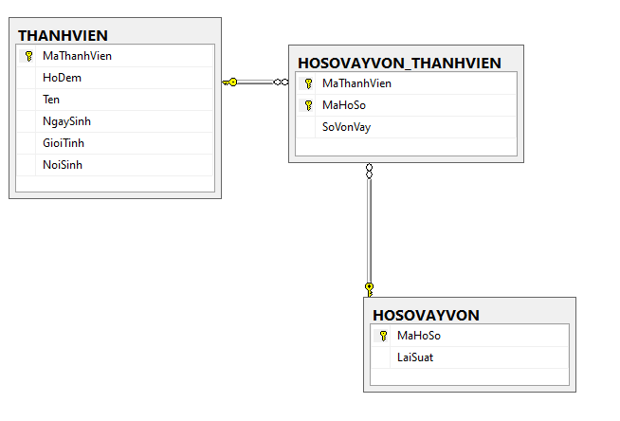

**Câu 2:**

**a)**

INSERT [dbo].[THANHVIEN] ([MaThanhVien], [HoDem], [Ten], [NgaySinh], [GioiTinh], [NoiSinh]) VALUES (N'TV01', N'Nguyễn Thị', N'Huế', CAST(N'1993-08-05' AS Date), 0, N'Đà Nẵng')

INSERT [dbo].[THANHVIEN] ([MaThanhVien], [HoDem], [Ten], [NgaySinh], [GioiTinh], [NoiSinh]) VALUES (N'TV02', N'Lê Văn', N'Lý', CAST(N'1992-09-21' AS Date), 1, N'TT Huế')

INSERT [dbo].[THANHVIEN] ([MaThanhVien], [HoDem], [Ten], [NgaySinh], [GioiTinh], [NoiSinh]) VALUES (N'TV03', N'Lê Thị Hồng', N'Nga', CAST(N'1991-07-24' AS Date), 0, NULL)

INSERT [dbo].[THANHVIEN] ([MaThanhVien], [HoDem], [Ten], [NgaySinh], [GioiTinh], [NoiSinh]) VALUES (N'TV04', N'Lương Nguyễn Nguyệt', N'Loan', CAST(N'1992-12-24' AS Date), 0, N'TT Huế')

INSERT [dbo].[THANHVIEN] ([MaThanhVien], [HoDem], [Ten], [NgaySinh], [GioiTinh], [NoiSinh]) VALUES (N'TV05', N'Nguyễn Thanh', N'Lĩnh', CAST(N'1992-04-21' AS Date), 1, N'Đà Nẵng')

INSERT [dbo].[THANHVIEN] ([MaThanhVien], [HoDem], [Ten], [NgaySinh], [GioiTinh], [NoiSinh]) VALUES (N'TV06', N'Võ Văn', N'Hậu', CAST(N'1992-09-21' AS Date), 1, N'Quảng Bình')

INSERT [dbo].[THANHVIEN] ([MaThanhVien], [HoDem], [Ten], [NgaySinh], [GioiTinh], [NoiSinh]) VALUES (N'TV07', N'Võ Thị Thu', N'Hằng', CAST(N'1993-05-21' AS Date), 0, N'Hà Nội')

INSERT [dbo].[THANHVIEN] ([MaThanhVien], [HoDem], [Ten], [NgaySinh], [GioiTinh], [NoiSinh]) VALUES (N'TV08', N'Trần Thị Khánh', N'Hòa', CAST(N'1992-06-24' AS Date), 0, NULL)

INSERT [dbo].[THANHVIEN] ([MaThanhVien], [HoDem], [Ten], [NgaySinh], [GioiTinh], [NoiSinh]) VALUES (N'TV09', N'Đỗ Thị Ngọc', N'Huyền', CAST(N'1991-03-29' AS Date), 0, N'Hà Nội')

INSERT [dbo].[THANHVIEN] ([MaThanhVien], [HoDem], [Ten], [NgaySinh], [GioiTinh], [NoiSinh]) VALUES (N'TV10', N'Nguyễn Thị Diễm', N'Hương', CAST(N'1994-02-26' AS Date), 0, NULL)

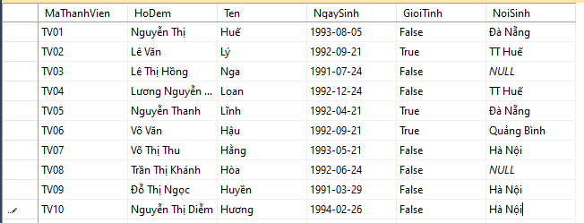

**b)**

INSERT [dbo].[HOSOVAYVON] ([MaHoSo], [LaiSuat]) VALUES (N'HS01', 0.6)

INSERT [dbo].[HOSOVAYVON] ([MaHoSo], [LaiSuat]) VALUES (N'HS02', 0.4)

INSERT [dbo].[HOSOVAYVON] ([MaHoSo], [LaiSuat]) VALUES (N'HS03', 0.7)

INSERT [dbo].[HOSOVAYVON] ([MaHoSo], [LaiSuat]) VALUES (N'HS04', 0.6)

INSERT [dbo].[HOSOVAYVON] ([MaHoSo], [LaiSuat]) VALUES (N'HS05', 0.9)

INSERT [dbo].[HOSOVAYVON] ([MaHoSo], [LaiSuat]) VALUES (N'HS06', 0.7)

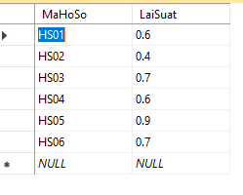

**c)**

INSERT [dbo].[HOSOVAYVON] ([MaHoSo], [LaiSuat]) VALUES (N'HS06', 0.7)

INSERT [dbo].[HOSOVAYVON_THANHVIEN] ([MaThanhVien], [MaHoSo], [SoVonVay]) VALUES (N'TV01', N'HS01', 15)

INSERT [dbo].[HOSOVAYVON_THANHVIEN] ([MaThanhVien], [MaHoSo], [SoVonVay]) VALUES (N'TV01', N'HS02', 8)

INSERT [dbo].[HOSOVAYVON_THANHVIEN] ([MaThanhVien], [MaHoSo], [SoVonVay]) VALUES (N'TV02', N'HS01', 27)

INSERT [dbo].[HOSOVAYVON_THANHVIEN] ([MaThanhVien], [MaHoSo], [SoVonVay]) VALUES (N'TV03', N'HS01', 35)

INSERT [dbo].[HOSOVAYVON_THANHVIEN] ([MaThanhVien], [MaHoSo], [SoVonVay]) VALUES (N'TV04', N'HS06', 56)

INSERT [dbo].[HOSOVAYVON_THANHVIEN] ([MaThanhVien], [MaHoSo], [SoVonVay]) VALUES (N'TV05', N'HS06', 45)

INSERT [dbo].[HOSOVAYVON_THANHVIEN] ([MaThanhVien], [MaHoSo], [SoVonVay]) VALUES (N'TV06', N'HS03', 37)

INSERT [dbo].[HOSOVAYVON_THANHVIEN] ([MaThanhVien], [MaHoSo], [SoVonVay]) VALUES (N'TV07', N'HS04', 69)

INSERT [dbo].[HOSOVAYVON_THANHVIEN] ([MaThanhVien], [MaHoSo], [SoVonVay]) VALUES (N'TV08', N'HS04', 14)

INSERT [dbo].[HOSOVAYVON_THANHVIEN] ([MaThanhVien], [MaHoSo], [SoVonVay]) VALUES (N'TV09', N'HS06', 78)

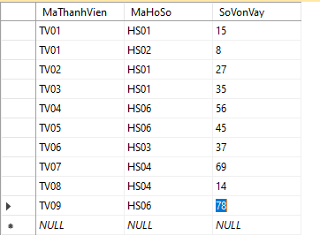

**Câu 3:**

select MaThanhVien, HoDem + ' ' + Ten as 'Ho Va Ten', NgaySinh, NoiSinh

from THANHVIEN

where NoiSinh like N'%Huế%'

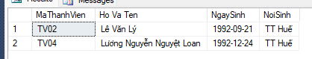

**Câu 4:**

select MaThanhVien, HoDem + ' ' + Ten as 'Ho Va Ten', NgaySinh, GioiTinh, NoiSinh

from THANHVIEN

where (MONTH(NgaySinh) between 3 and 11) and (year(NgaySinh) = 1992)

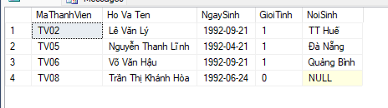

**Câu 5:**

select top 9

tv.MaThanhVien, HoDem + ' ' + Ten as 'Ho Va Ten', NgaySinh, MaHoSo, SoVonVay

from

THANHVIEN tv

join

HOSOVAYVON_THANHVIEN hstv

on tv.MaThanhVien = hstv.MaThanhVien

order by SoVonVay asc

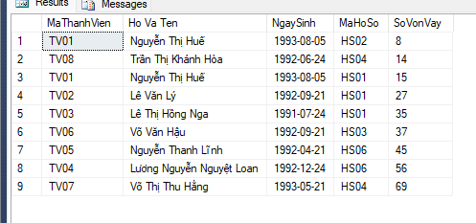

**Câu 6:**

select MaThanhVien, HoDem + ' ' + Ten as 'Ho Va Ten', NgaySinh, GioiTinh, NoiSinh

from THANHVIEN

where NoiSinh in (N'Đà Nẵng', N'TT Huế', N'Quảng Bình');

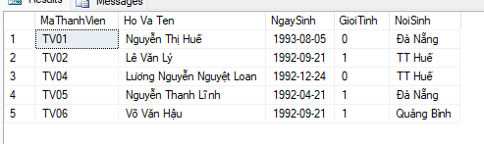

**Câu 7:**

select

*

from THANHVIEN

where MaThanhVien != all (select distinct

MaThanhVien

from HOSOVAYVON_THANHVIEN)

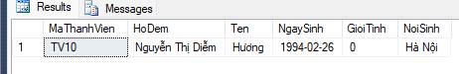

**Câu 8:**

select top 5

hstv.MaThanhVien, tv.HoDem + ' ' + tv.Ten as 'Ho Va Ten', SUM(SoVonVay) as 'tong von vay'

from

HOSOVAYVON_THANHVIEN hstv

join

THANHVIEN tv

on hstv.MaThanhVien = tv.MaThanhVien

group by hstv.MaThanhVien, HoDem, Ten

order by [tong von vay] desc

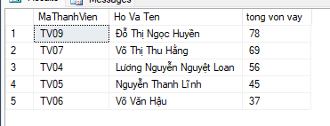

**Câu 9:**

select MaThanhVien, HoDem + ' ' + Ten as 'Ho Va Ten', NgaySinh, NoiSinh

from THANHVIEN

where NoiSinh = (select NoiSinh

from THANHVIEN

where MaThanhVien = 'TV01')

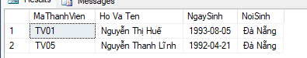

**Câu 10:**

**Câu 11:**

update HOSOVAYVON

set LaiSuat = LaiSuat + LaiSuat/2

where MaHoSo like N'%02'

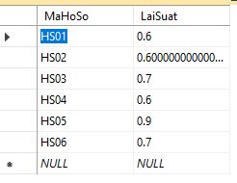

**Câu 12:**

ALTER TABLE HOSOVAYVON

ADD TongSoVay int;