University of Applied Sciences Worms
Degree: Applied Computer Science (B.Sc.)
Course: 507 IOT

IOT AI Gaming: Electronica Emporium Gamingstation

Electronica Emporium
Paul Sandler (inf3675), Nhat-Lam Luong's (inf3381)
SoSe24 with Prof. Dr. Volker Schwarzer

Project description

- Objective: Develop a versatile hardware board capable of supporting multiple games, including TicTacToe, Connect Four, and potentially others.
- Hardware Components:
  - Utilization of an LED display for visual output.
  - Integration of input mechanisms comprising buttons and a gyroscope for user interaction.
- Backend Logic:
  - Implementation of the backend logic on a Virtual Machine.
  - AI Integration:
    - Integration of an AI, specifically a Language Model, to serve as an opponent for users.
    - Communication with the AI only happens once the backend requires input.
- Reusability:
  - Designed for potential expansion to accommodate additional games, enhancing the board's versatility.
- Overall Aim:
  - To create a robust and adaptable hardware platform that provides engaging gaming experiences across various titles while leveraging modern technologies like AI.

Project plan
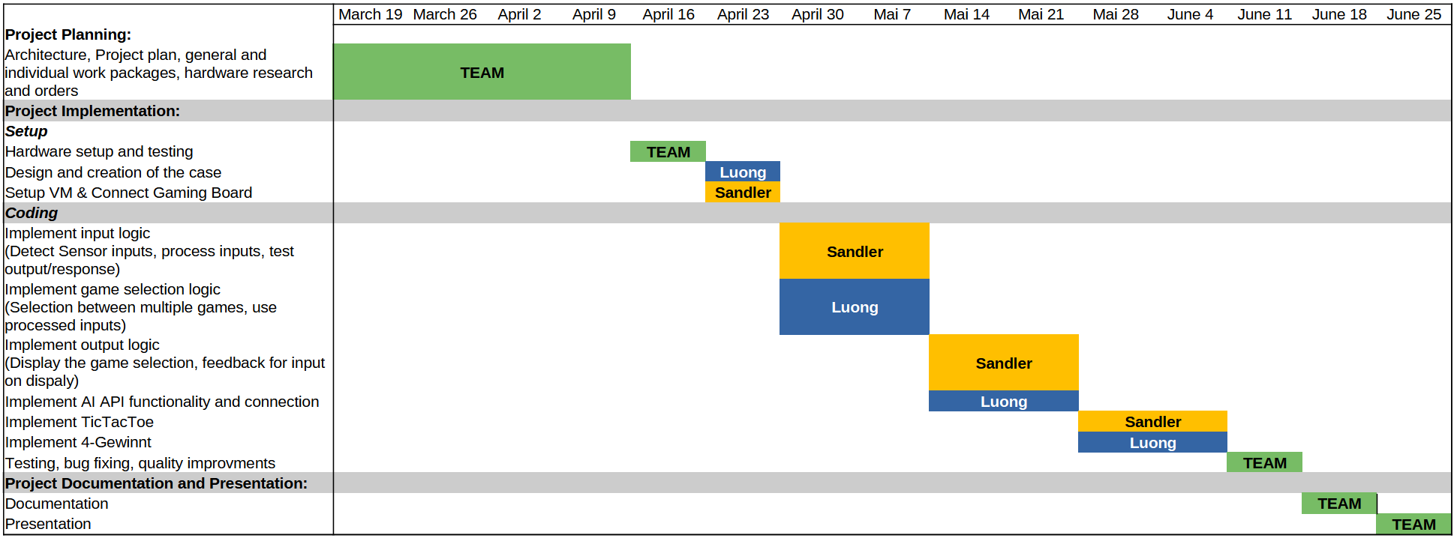

Architecture
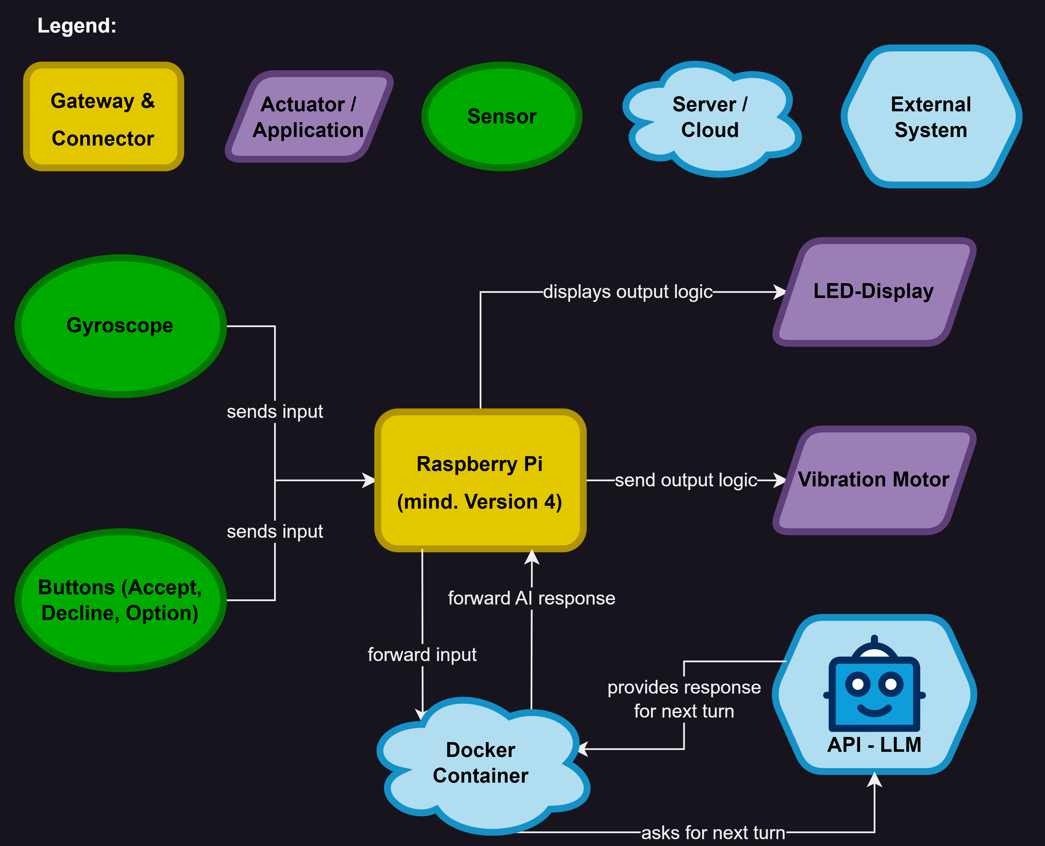

Requirements

Hardware

Type | Name | Quantity | Cost | Link
Gateway & Connector | RaspberryPi (min. V4) | 1 | 59,51€ OR 0,00€ | amazon.de OR In Stock
Other | Raspberry PI Power Supply | 1 | 9,64€ OR 0,00€ | amazon.de OR In Stock
Sensor | Buttons (Accept, Decline, Options) | 3 | 3,99€ OR 0,00€ | amazon.de OR In Stock
Sensor | Gyroscope | 1 | 4,99€ | amazon.de
Application | LED-Matrix-Panel | 1 | 0,00€ | In Stock
Actuator | Vibration Motor | 1 | 7,99€ | amazon.de

Software

- OpenAI's GPT-3 API & API Access/Key
- Python Libraries
  - Gyroscope: smbus
  - LED-matrix: rpi-rgb-led-matrix
  - Vibration motor & Buttons: Rpi.GPIO
  - Communication: paho-mqtt
- Protocol (RaspberryPI to Cloud): MQTT (via paho-mqtt)

Tools

- Soldering tools/station
- 3D-Design software
- 3D-Printer for case

