BIRD MEAL ORDER SYSTEM

**Project Assignment Requirement**

1. **Introduction**

- This project is aimed at developing an online shop system which supports for the online shopping & product online selling for a bird meals selling shop. This system support for the below types of user :

+ Guest : unregistered users or potential customers

+ Customer : they are registered users who are actual customers

+ Staff : They are employees of shop who manage product and support customers

+ Admin : the organization leader/manager, acts as the system administrator

1. **Functional Requirement**

1.Overall Description

- The to-be-developed system includes the 6 features with the functions for each feature are listed in the beneath sections. It needs to provide 27 user screens with the flow as the following diagram. The details for each screen/function are provided in the attached Excel file ( BMOS_Function Details.xlsx )

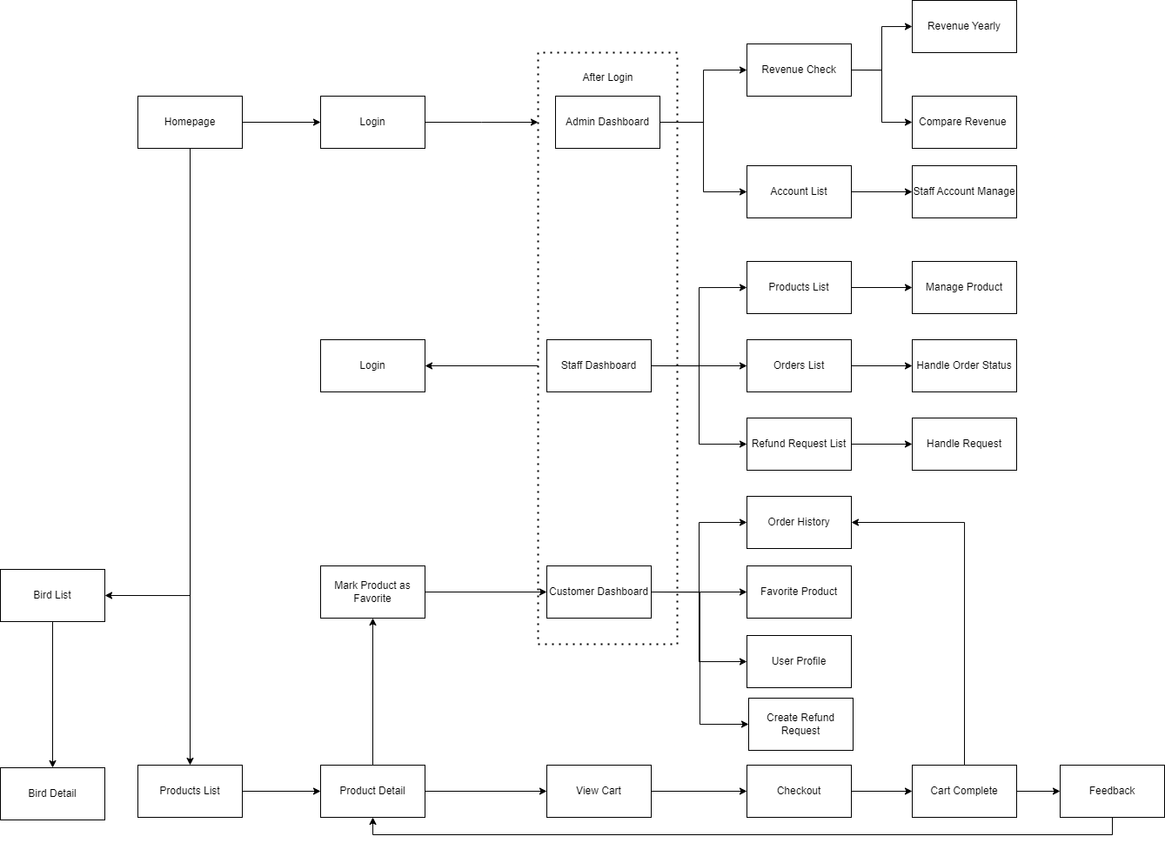

2. Public Feature

- This feature includes the screens used for the Guests, as listed below :

+ Homepage : the starting page of the system

+ Products List : list of the active products

+ Product Details : details of the selected product

+ View Cart : details of the user carts

+ Checkout : User fillup payment information

+ Cart Complete : Allow user completeing or canceling the order.

1. Common Feature

- The common functions/screens used for all types of users, as listed below:

+ User Login: authenticate the user to give him/her to access authorized features later on

+ User Register: register new user into the system, verified by the registered email

+ Reset Password: use in case the user forgot his/her password

+ Change Password: change user’s login password

+ User Profile: view & edit/update user profile

+ User Authorization: authorize user into the system functions based on his/her role

1. Customer Feature

- This includes the screens used for system customers, as listed below :

+ The same functions as guest

+ Update Information : update address, email, phone number and default payment method

+ Order History : check the order history

+ Favorite Product : check the list of favorite products

+ Mark product as favorite : add the product to the list of favorite products

+Feedback : feedback for quality of product after purchasing ( as guest / anonymous )

+ Create Refund Request : Customer can create refund request of confirmed order to be able to refund order

1. Staff Feature

- This includes the screens used for the staff, as listed below

+ Product List : list of the active products

+ Refund Request List : list of refund request of customer

+ Orders List : list of customer’s orders

+ Product Manage : Add / Update / Delete Product

+ Handle Request : Handle and reply refund request

+ Handle Order Status : Update and confirm Order’s status

1. Admin Feature

- The Admin feature includes the screens used for the organization manager and system administrator, as listed below :

+ Revenue check : check the revenue yearly

+ Compare Revenue : display profit ratio between this year and previous year

+ Account List : list of all customers and staff account

+ Staff Account Manage : Add / Delete Staff Account