Lab 7

I. Mục đích
Viết các đoạn mã hỗ trợ việc cài đặt phần mềm tự động

II. Yêu cầu
- Sinh viên đổi tên file: Labx_Lop_HoTen_MSSV.doc với các thông tin tương ứng của các bạn
- Sinh viên làm xong câu nào chụp hình lại câu đó lưu trực tiếp vào file: Labx_Lop_HoTen_MSSV.doc (chỉ cần chụp hình kết quả và một số bước cần thiết, không cần phải chụp từng bước)
- Cuối giờ nộp lại toàn bộ bài làm cho giáo viên (Hình thức nộp bài giáo viên thông báo trên lớp)
- Viết chương trình hỗ trợ cài đặt tự động phần mềm Foxit Reader
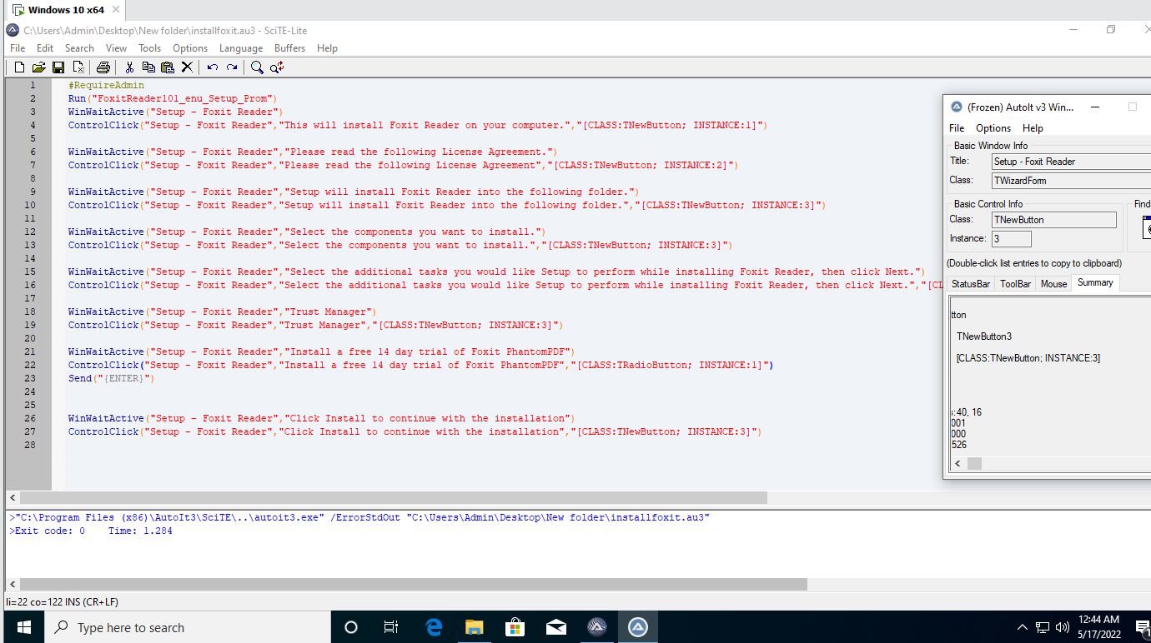
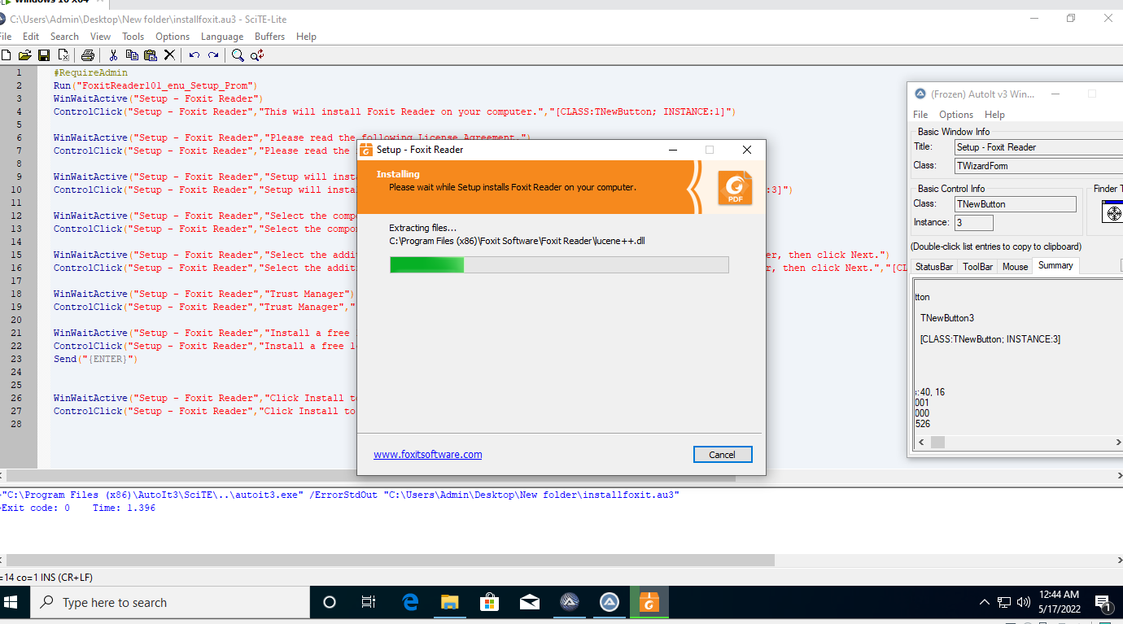
#RequireAdmin
Run("FoxitReader101_enu_Setup_Prom.EXE")
WinWaitActive("Setup - Foxit Reader")
Send("{ENTER}")
WinWaitActive("Setup - Foxit Reader","Please read the following License Agreement.")
Send("{ENTER}")
WinWaitActive("Setup - Foxit Reader","Setup will install Foxit Reader into the following folder")
Send("{ENTER}")
WinWaitActive("Setup - Foxit Reader","Select the components you want to install")
Send("{ENTER}")
WinWaitActive("Setup - Foxit Reader","Select the additional tasks you would like ")
Send("{ENTER}")
WinWaitActive("Setup - Foxit Reader","Safe Mode enables you to control unauthorized actions and data transmissions")
Send("{ENTER}")
WinWaitActive("Setup - Foxit Reader","Don't install a free 14 day trial of Foxit PhantomPDF")
Send("{ENTER}")
WinWaitActive("Setup - Foxit Reader","Click Install to continue with the installation")
Send("{ENTER}")
WinWaitActive("Setup - Foxit Reader","Completing the Foxit Reader Setup Wizard")
Send("{ENTER}")

- Viết chương trình hỗi trợ cài đặt tự động phần mềm Teamviewer
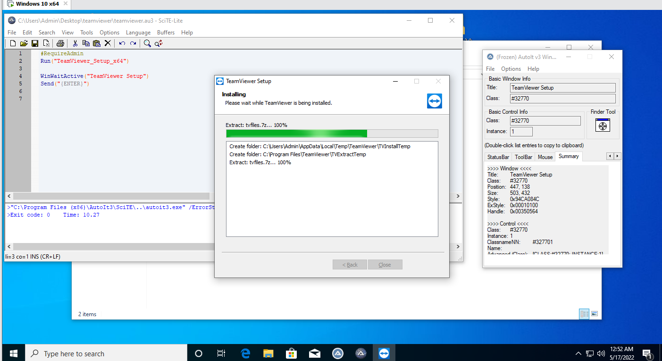
#RequireAdmin
Run("TeamViewer_Setup_x64.EXE")
WinWaitActive("TeamViewer Setup")
Send("{ENTER}")

- Viết chương trình hỗi trợ cài đặt tự động phần mềm Ultra ISO
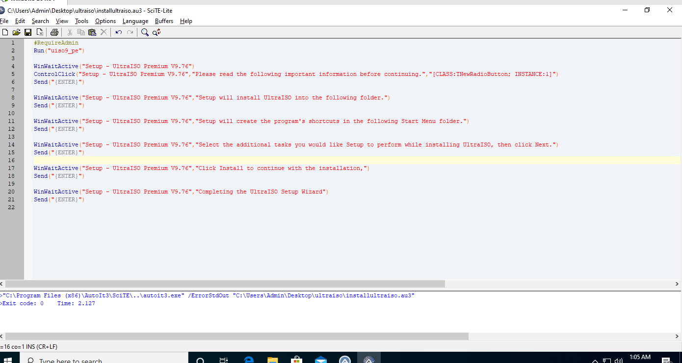
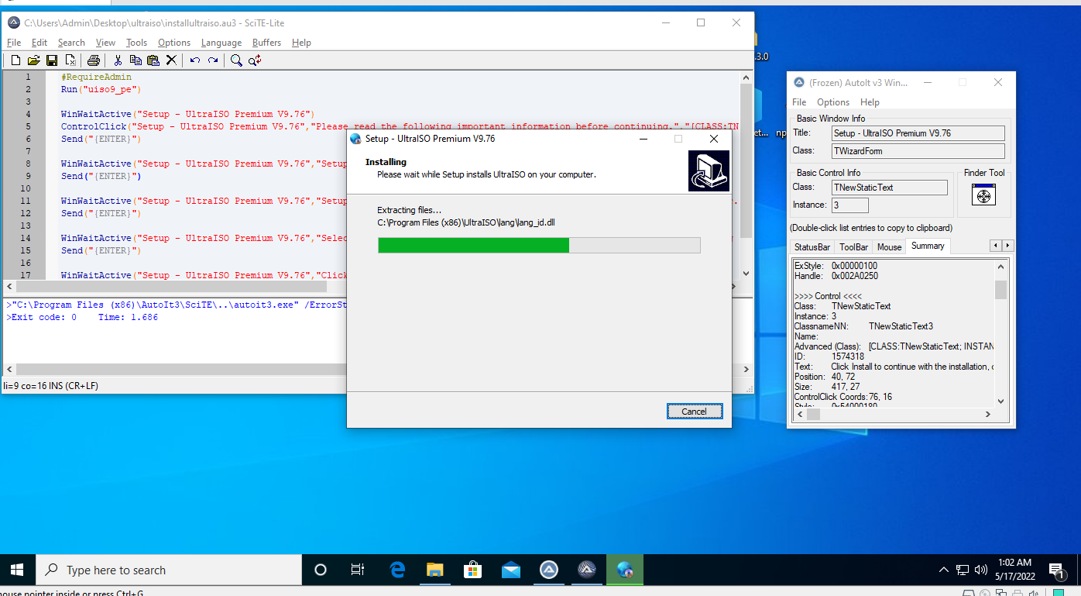
#RequireAdmin
Run("uiso9_pe.EXE")
WinWaitActive("Setup - UltraISO Premium V9.76")
ControlClick("Setup - UltraISO Premium V9.76","I &accept the agreement","[CLASS:TNewRadioButton; INSTANCE:1]")
Send("{ENTER}")
ControlClick("Setup - UltraISO Premium V9.76","&Next >","[CLASS:TPanel; INSTANCE:1]")
Send("{ENTER}")
WinWaitActive("Setup - UltraISO Premium V9.76","Which additional tasks should be performed?")
Send("{ENTER}")
WinWaitActive("Setup - UltraISO Premium V9.76","Ready to Install")
Send("{ENTER}")
WinWaitActive("Setup - UltraISO Premium V9.76","Completing the UltraISO Setup Wizard")
Send("{ENTER}")

- Viết chương trình hỗi trợ cài đặt tự động phần mềm Winrar
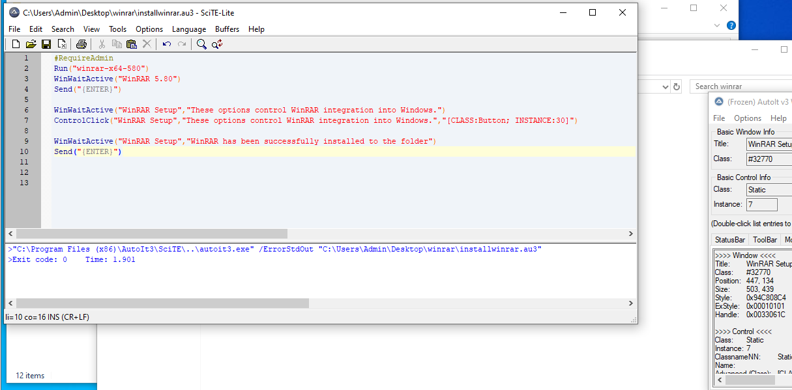
#RequireAdmin
Run("winrar-x64-580.EXE")
WinWaitActive("WinRAR 5.80")
Send("{ENTER}")
WinWaitActive("WinRAR Setup","These options control WinRAR integration into Windows.")
Send("{ENTER}")
WinWaitActive("WinRAR Setup","WinRAR has been successfully installed to the")
Send("{ENTER}")

- Viết chương trình hỗi trợ cài đặt tự động phần mềm K Lite Codec Pack
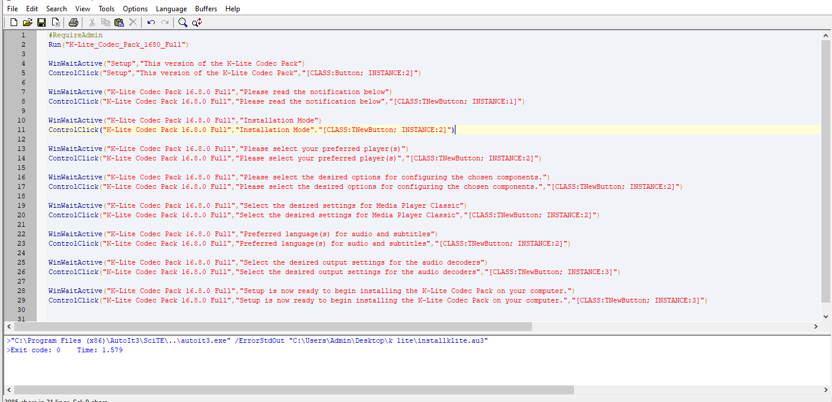
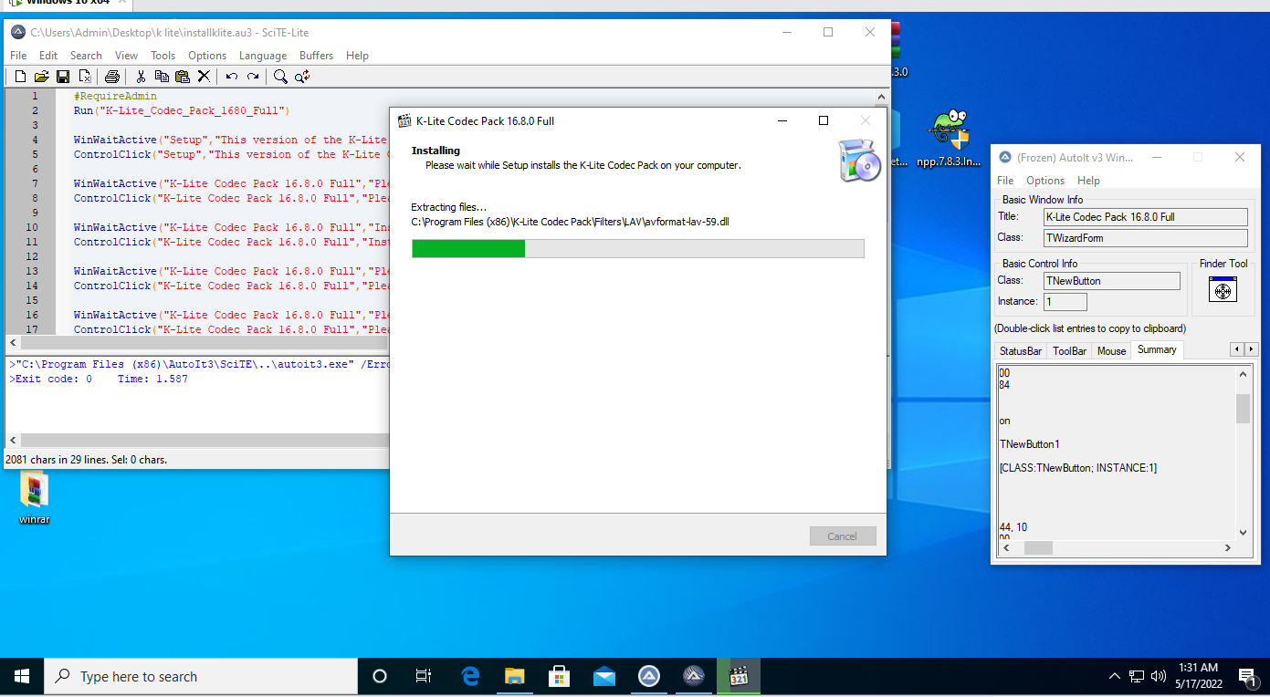
#RequireAdmin
Run("K-Lite_Codec_Pack_1680_Full.EXE")
WinWaitActive("Setup")
Send("{Enter}")
WinWaitActive("K-Lite Codec Pack 16.8.0 Full", "Graphics Driver Warning")
ControlClick("K-Lite Codec Pack 16.8.0 Full","Graphics Driver Warning","[CLASS:TNewButton; INSTANCE:1]")
WinWaitActive("K-Lite Codec Pack 16.8.0 Full", "Installation Update Mode")
ControlClick("K-Lite Codec Pack 16.8.0 Full","Installation Update Mode","[CLASS:TNewButton; INSTANCE:2]")
WinWaitActive("K-Lite Codec Pack 16.8.0 Full", "Select Components")
ControlClick("K-Lite Codec Pack 16.8.0 Full","Select Components","[CLASS:TNewButton; INSTANCE:2]")
WinWaitActive("K-Lite Codec Pack 16.8.0 Full", "Additional Tasks and Options")
ControlClick("K-Lite Codec Pack 16.8.0 Full","Additional Tasks and Options","[CLASS:TNewButton; INSTANCE:2]")
WinWaitActive("K-Lite Codec Pack 16.8.0 Full", "MPC-HC configuration")
ControlClick("K-Lite Codec Pack 16.8.0 Full","MPC-HC configuration","[CLASS:TNewButton; INSTANCE:2]")
WinWaitActive("K-Lite Codec Pack 16.8.0 Full", "Preferred language(s) for audio and subtitles")
ControlClick("K-Lite Codec Pack 16.8.0 Full","Preferred language(s) for audio and subtitles","[CLASS:TNewButton; INSTANCE:2]")
WinWaitActive("K-Lite Codec Pack 16.8.0 Full", "File associations")
ControlClick("K-Lite Codec Pack 16.8.0 Full","File associations","[CLASS:TNewButton; INSTANCE:2]")
WinWaitActive("K-Lite Codec Pack 16.8.0 Full", "Audio configuration")
ControlClick("K-Lite Codec Pack 16.8.0 Full","Audio configuration","[CLASS:TNewButton; INSTANCE:3]")
WinWaitActive("K-Lite Codec Pack 16.8.0 Full", "Thumbnails")
ControlClick("K-Lite Codec Pack 16.8.0 Full","Thumbnails","[CLASS:TNewButton; INSTANCE:5]")
WinWaitActive("K-Lite Codec Pack 16.8.0 Full", "Ready to Install")
ControlClick("K-Lite Codec Pack 16.8.0 Full","Ready to Install","[CLASS:TNewButton; INSTANCE:5]")
WinWaitActive("K-Lite Codec Pack 16.8.0 Full","Done!")
Send("{ENTER}")

- Viết chương trình hỗi trợ cài đặt tự động phần mềm Notepad++

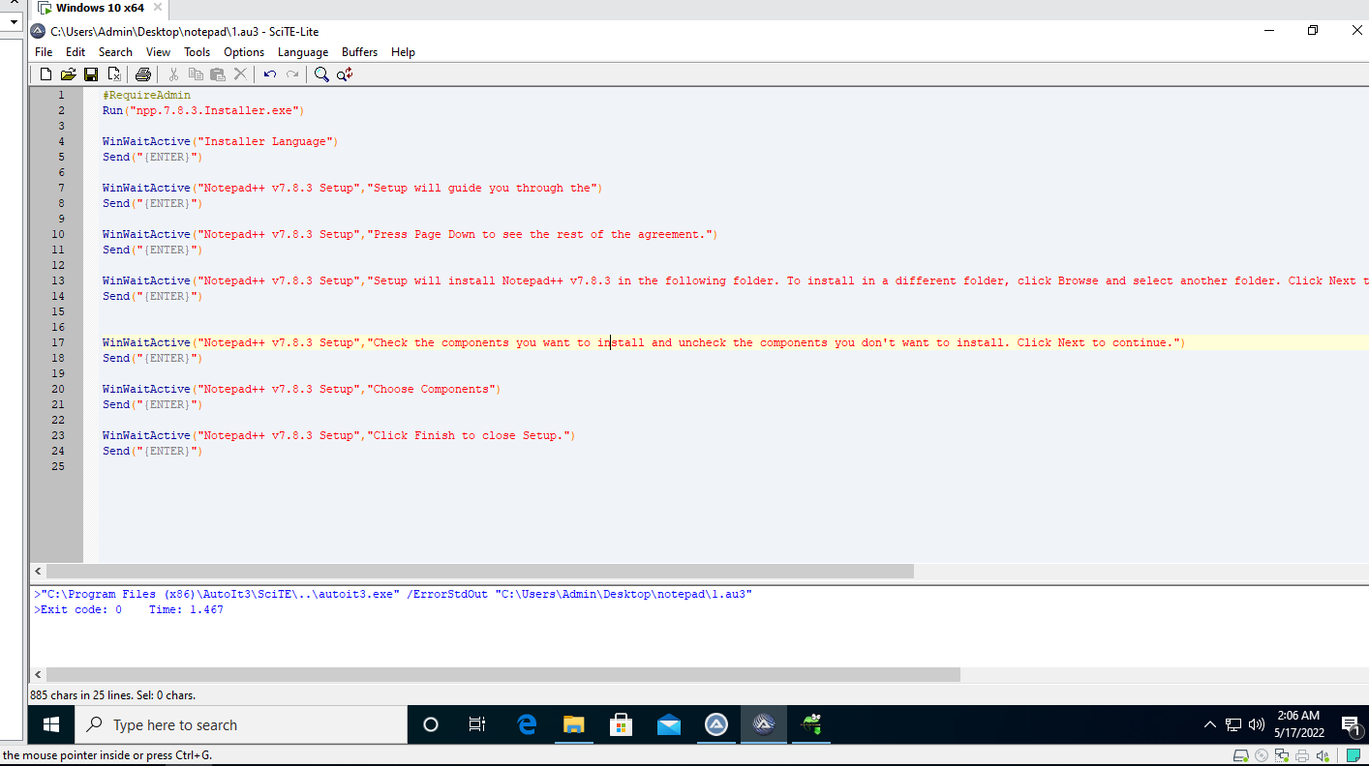
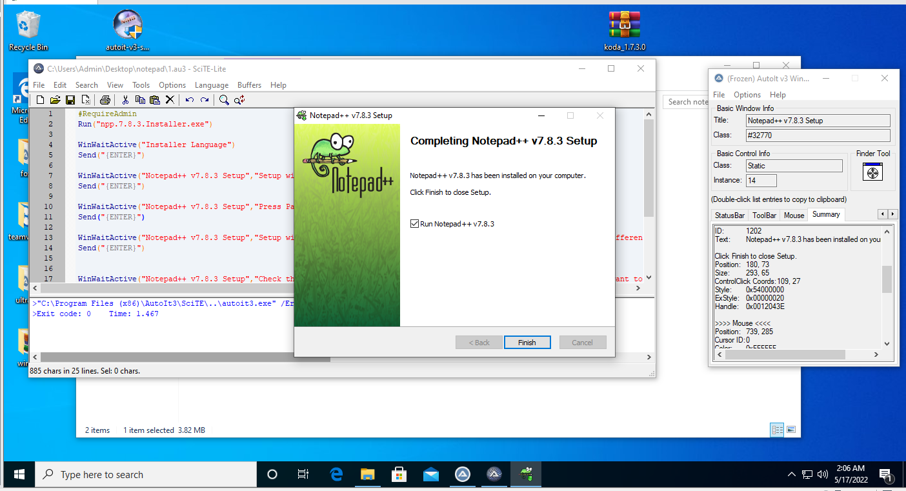
#RequireAdmin
Run("npp.7.8.3.Installer.x64.EXE")
WinWaitActive("Installer Language")
Send("{Enter}")
WinWaitActive("Notepad++ v7.8.3 Setup", "Welcome to Notepad++ v7.8.3 Setup")
Send("{Enter}")
WinWaitActive("Notepad++ v7.8.3 Setup", "If you accept the terms of the agreement")
Send("{Enter}")
WinWaitActive("Notepad++ v7.8.3 Setup", "Setup will install Notepad++ v7.8.3 in the following")
Send("{Enter}")
WinWaitActive("Notepad++ v7.8.3 Setup", "Check the components you want to install and uncheck the components you don't want to install")
Send("{Enter}")
WinWaitActive("Notepad++ v7.8.3 Setup", "Create Shortcut on Desktop")
ControlClick("Notepad++ v7.8.3 Setup","Create Shortcut on Desktop","[CLASS:Button; INSTANCE:4]")
Send("{Enter}")
WinWaitActive("Notepad++ v7.8.3 Setup", "Completing Notepad++ v7.8.3 Setup")
Send("{Enter}")
- Dùng Koda, tạo giao diện điều khiển việc cài chương trình với thứ tự và các phần mềm được chọn tùy ý, các thao tác tinh chỉnh hệ thống cũng được tùy chọn tùy ý

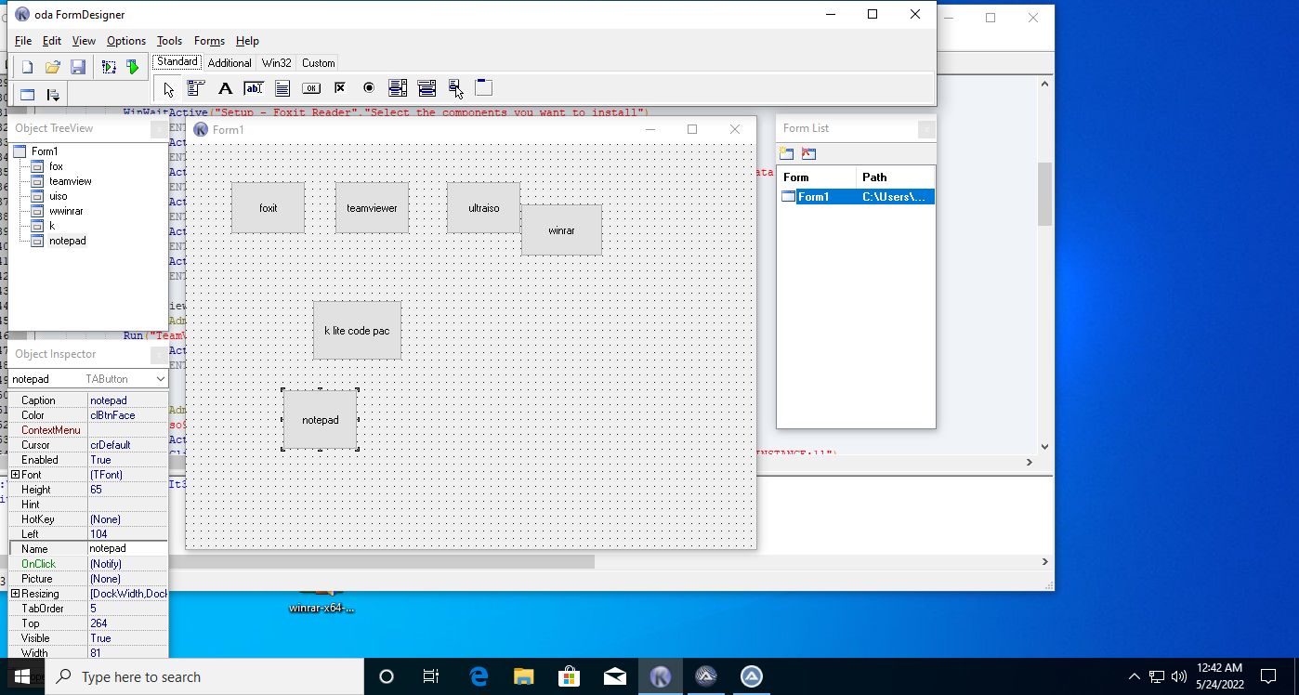

#include <ButtonConstants.au3>
#include <GUIConstantsEx.au3>
#include <WindowsConstants.au3>
#RequireAdmin
#Region ### START Koda GUI section ### Form=C:\Users\Admin\Desktop\Form1.kxf
$Form1 = GUICreate("Form1", 615, 437, 192, 124)
$fox = GUICtrlCreateButton("foxit", 48, 40, 81, 57)
$teamview = GUICtrlCreateButton("teamviewer", 160, 40, 81, 57)
$uiso = GUICtrlCreateButton("ultraiso", 280, 40, 81, 57)
$wwinrar = GUICtrlCreateButton("winrar", 360, 64, 89, 57)
$k = GUICtrlCreateButton("k lite code pac", 136, 168, 97, 65)
$notepad = GUICtrlCreateButton("notepad", 104, 264, 81, 65)
GUISetState(@SW_SHOW)
#EndRegion ### END Koda GUI section ###

While 1
$nMsg = GUIGetMsg()
Switch $nMsg
Case $GUI_EVENT_CLOSE
Exit

Case $fox
#RequireAdmin
Run("FoxitReader101_enu_Setup_Prom.EXE")
WinWaitActive("Setup - Foxit Reader")
Send("{ENTER}")
WinWaitActive("Setup - Foxit Reader","Please read the following License Agreement.")
Send("{ENTER}")
WinWaitActive("Setup - Foxit Reader","Setup will install Foxit Reader into the following folder")
Send("{ENTER}")
WinWaitActive("Setup - Foxit Reader","Select the components you want to install")
Send("{ENTER}")
WinWaitActive("Setup - Foxit Reader","Select the additional tasks you would like ")
Send("{ENTER}")
WinWaitActive("Setup - Foxit Reader","Safe Mode enables you to control unauthorized actions and data transmissions")
Send("{ENTER}")
WinWaitActive("Setup - Foxit Reader","Don't install a free 14 day trial of Foxit PhantomPDF")
Send("{ENTER}")
WinWaitActive("Setup - Foxit Reader","Click Install to continue with the installation")
Send("{ENTER}")
WinWaitActive("Setup - Foxit Reader","Completing the Foxit Reader Setup Wizard")
Send("{ENTER}")

Case $teamview
#RequireAdmin
Run("TeamViewer_Setup_x64.EXE")
WinWaitActive("TeamViewer Setup")
Send("{ENTER}")

Case $uiso
#RequireAdmin
Run("uiso9_pe.EXE")
WinWaitActive("Setup - UltraISO Premium V9.76")
ControlClick("Setup - UltraISO Premium V9.76","I &accept the agreement","[CLASS:TNewRadioButton; INSTANCE:1]")
Send("{ENTER}")

WinWaitActive("Setup - UltraISO Premium V9.76","Setup will install UltraISO into the following folder.")
ControlClick("Setup - UltraISO Premium V9.76","&Next >","[CLASS:TNewButton; INSTANCE:3]")

WinWaitActive("Setup - UltraISO Premium V9.76","To continue, click Next. If you would like to select a different folder, click Browse.")
ControlClick("Setup - UltraISO Premium V9.76","&Next >","[CLASS:TNewButton; INSTANCE:4]")

WinWaitActive("Setup - UltraISO Premium V9.76","Which additional tasks should be performed?")
ControlClick("Setup - UltraISO Premium V9.76","&Next >","[CLASS:TNewButton; INSTANCE:4]")

WinWaitActive("Setup - UltraISO Premium V9.76","Ready to Install")
ControlClick("Setup - UltraISO Premium V9.76","&Install","[CLASS:TNewButton; INSTANCE:4]")

WinWaitActive("Setup - UltraISO Premium V9.76","Completing the UltraISO Setup Wizard")
Send("{ENTER}")

Case $wwinrar
#RequireAdmin
Run("winrar-x64-580.EXE")
WinWaitActive("WinRAR 5.80")
Send("{ENTER}")
WinWaitActive("WinRAR Setup","These options control WinRAR integration into Windows.")
Send("{ENTER}")
WinWaitActive("WinRAR Setup","WinRAR has been successfully installed to the")
Send("{ENTER}")

Case $k
#RequireAdmin
Run("K-Lite_Codec_Pack_1680_Full.EXE")
WinWaitActive("Setup")
Send("{Enter}")
WinWaitActive("K-Lite Codec Pack 16.8.0 Full","Graphics Driver Warning")
ControlClick("K-Lite Codec Pack 16.8.0 Full","Graphics Driver Warning","[CLASS:TNewButton; INSTANCE:1]")
WinWaitActive("K-Lite Codec Pack 16.8.0 Full", "Installation Mode")
ControlClick("K-Lite Codec Pack 16.8.0 Full","Installation Mode","[CLASS:TNewButton; INSTANCE:2]")

WinWaitActive("K-Lite Codec Pack 16.8.0 Full","Installation Preferences")
ControlClick("K-Lite Codec Pack 16.8.0 Full","&Next","[CLASS:TNewButton; INSTANCE:2]")

WinWaitActive("K-Lite Codec Pack 16.8.0 Full","Additional Tasks and Options")
ControlClick("K-Lite Codec Pack 16.8.0 Full","Additional Tasks and Options","[CLASS:TNewButton; INSTANCE:2]")

WinWaitActive("K-Lite Codec Pack 16.8.0 Full","MPC-HC configuration")
ControlClick("K-Lite Codec Pack 16.8.0 Full","&Next","[CLASS:TNewButton; INSTANCE:2]")

WinWaitActive("K-Lite Codec Pack 16.8.0 Full","Preferred language(s) for audio and subtitles")
ControlClick("K-Lite Codec Pack 16.8.0 Full","Preferred language(s) for audio and subtitles","[CLASS:TNewButton; INSTANCE:2]")

WinWaitActive("K-Lite Codec Pack 16.8.0 Full","Audio configuration")
ControlClick("K-Lite Codec Pack 16.8.0 Full","&Next","[CLASS:TNewButton; INSTANCE:3]")

WinWaitActive("K-Lite Codec Pack 16.8.0 Full","Ready to Install")
ControlClick("K-Lite Codec Pack 16.8.0 Full","Ready to Install","[CLASS:TNewButton; INSTANCE:3]")

WinWaitActive("K-Lite Codec Pack 16.8.0 Full","Done!")
ControlClick("K-Lite Codec Pack 16.8.0 Full","&Finish","[CLASS:TNewButton; INSTANCE:3]")

Case $notepad
#RequireAdmin
Run("npp.7.8.3.Installer.x64.EXE")
WinWaitActive("Installer Language")
Send("{Enter}")
WinWaitActive("Notepad++ v7.8.3 Setup", "Welcome to Notepad++ v7.8.3 Setup")
Send("{Enter}")
WinWaitActive("Notepad++ v7.8.3 Setup", "If you accept the terms of the agreement")
Send("{Enter}")
WinWaitActive("Notepad++ v7.8.3 Setup", "Setup will install Notepad++ v7.8.3 in the following")
Send("{Enter}")
WinWaitActive("Notepad++ v7.8.3 Setup", "Check the components you want to install and uncheck the components you don't want to install")
Send("{Enter}")
WinWaitActive("Notepad++ v7.8.3 Setup", "Create Shortcut on Desktop")
ControlClick("Notepad++ v7.8.3 Setup","Create Shortcut on Desktop","[CLASS:Button; INSTANCE:4]")
Send("{Enter}")
WinWaitActive("Notepad++ v7.8.3 Setup", "Completing Notepad++ v7.8.3 Setup")
Send("{Enter}")

EndSwitch
WEnd

