3GPP TS 23.180 V18.0.0 (2024-05)
Technical Specification

3rd Generation Partnership Project;
Technical Specification Group Services and System Aspects;
Mission critical services support in the Isolated Operation for Public Safety (IOPS) mode of operation;
Functional architecture and information flows;
(Release 18)
 | 
The present document has been developed within the 3rd Generation Partnership Project (3GPP TM) and may be further elaborated for the purposes of 3GPP.
The present document has not been subject to any approval process by the 3GPP Organizational Partners and shall not be implemented.
This Specification is provided for future development work within 3GPP only. The Organizational Partners accept no liability for any use of this Specification.
Specifications and Reports for implementation of the 3GPP TM system should be obtained via the 3GPP Organizational Partners' Publications Offices.

3GPP
Postal address

3GPP support office address
650 Route des Lucioles - Sophia Antipolis
Valbonne - FRANCE
Tel.: +33 4 92 94 42 00 Fax: +33 4 93 65 47 16
Internet
https://www.3gpp.org

Copyright Notification
No part may be reproduced except as authorized by written permission.
The copyright and the foregoing restriction extend to reproduction in all media.

© 2024, 3GPP Organizational Partners (ARIB, ATIS, CCSA, ETSI, TSDSI, TTA, TTC).
All rights reserved.

UMTS™ is a Trade Mark of ETSI registered for the benefit of its members
3GPP™ is a Trade Mark of ETSI registered for the benefit of its Members and of the 3GPP Organizational Partners
LTE™ is a Trade Mark of ETSI registered for the benefit of its Members and of the 3GPP Organizational Partners
GSM® and the GSM logo are registered and owned by the GSM Association

Contents
Foreword 7
1 Scope 8
2 References 8
3 Definitions and abbreviations 9
3.1 Definitions 9
3.2 Abbreviations 9
4 Introduction 9
5 Architectural requirements 10
5.1 General requirements 10
5.1.1 Description 10
5.1.2 Requirements 10
5.2 MC service requirements 10
5.2.1 Description 10
5.2.2 Requirements 10
5.3 Network bearer requirements 10
5.3.1 Description 10
5.3.2 Requirements 10
5.4 IP connectivity functionality 11
5.4.1 Description 11
5.4.2 General requirements 11
5.4.3 Bearer management requirements 11
6 Involved business relationships 11
7 Functional model 12
7.1 General 12
7.2 Description of the planes 12
7.3 Functional model description 12
7.3.1 General 12
7.3.2 Functional model for the signalling control plane in the IOPS mode of operation 12
7.3.3 MCPTT functional model for the application plane in the IOPS mode of operation 12
7.3.4 MCData functional model for the application plane in the IOPS mode of operation 13
7.4 Functional entities description 14
7.4.1 Application plane 14
7.4.1.1 General 14
7.4.1.2 IOPS connectivity client 14
7.4.1.3 IOPS MC connectivity function 14
7.4.1.4 IOPS distribution function 15
7.4.1.5 MC service client 15
7.4.2 Signalling control plane 15
7.4.2.1 Signalling user agent client 15
7.4.2.2 Signalling application server 15
7.5 Reference points 15
7.5.1 Application plane 15
7.5.1.1 Reference point MC-IOPS-1 (between the IOPS MC connectivity function and the IOPS connectivity client) 15
7.5.1.2 Reference point MCPTT-IOPS-2 (between the IOPS MC connectivity function and the MCPTT client) 15
7.5.1.3 Reference point MCData-IOPS-2 (between the IOPS MC connectivity function and the MCData client) 16
7.5.1.4 Reference point MCPTT-IOPS-3 (between the IOPS distribution function and the MCPTT client) 16
7.5.1.5 Reference point MCData-IOPS-3 (between the IOPS distribution function and the MCData client) 16
7.5.1.6 Reference point MCPTT-IOPS-4 (between the IOPS distribution function and the MCPTT client) 16
7.5.1.7 Reference point MCData-IOPS-4 (between the IOPS distribution function and the MCData client) 16
7.5.1.8 Reference point MC-IOPS-5 (between the IOPS MC connectivity function and the 3GPP system (IOPS EPS)) 16
7.5.1.9 Reference point MC-IOPS-6 (between the IOPS MC connectivity function and the 3GPP system (IOPS EPS)) 16
7.5.2 Signalling control plane 16
7.5.2.1 Reference point MC-IOPS-X1 (between the signalling application server and the signalling user agent client) 16
8 Identities 17
8.1 Application plane 17
8.1.1 IOPS MC user identity (IOPS MC ID) 17
8.1.1.1 General 17
8.1.2 IOPS MC service user identity (IOPS MC service ID) 17
8.1.2.1 General 17
8.1.3 IOPS MC service group identity (IOPS MC service group ID) 17
8.1.3.1 General 17
8.1.3.2 IOPS MC service group ID management (IP connectivity functionality) 17
9 Application of functional model to deployments 18
9.1 Overview 18
9.2 IOPS architectural model diagram 18
9.2.1 IOPS application services support layer 19
9.2.2 IOPS EPS 19
9.2.3 UE 1 19
9.2.4 UE 2 19
10 Procedures and information flows 19
10.1 User authentication in the IOPS mode of operation 19
10.1.1 General 19
10.1.2 Procedure 19
10.2 IOPS discovery (IP connectivity functionality) 20
10.2.1 General 20
10.2.2 Information flows 20
10.2.2.1 IP connectivity request 20
10.2.2.2 IP connectivity response 20
10.2.2.3 IOPS discovery request 20
10.2.2.4 IOPS discovery response 21
10.2.3 Procedure 21
10.3 IOPS subscription and notification (IP connectivity functionality) 23
10.3.1 General 23
10.3.2 Information flows 23
10.3.2.1 IP connectivity subscribe request 23
10.3.2.2 IP connectivity subscribe response 24
10.3.2.3 IP connectivity notify request 24
10.3.2.4 IP connectivity notify response 24
10.3.2.5 IP connectivity group notify request 25
10.3.2.6 IP connectivity group notify response 25
10.3.3 Procedures 25
10.4 Use of MBMS transmissions 27
10.4.1 General 27
10.4.2 Information flows 27
10.4.2.1 MapIOPSGroupToBearer (IP connectivity functionality) 27
10.4.2.2 UnmapIOPSGroupFromBearer (IP connectivity functionality) 28
10.4.3 Use of pre-established MBMS bearers 28
10.4.4 Use of dynamic MBMS bearer establishment 28
10.4.5 Group session connect and disconnect over MBMS (IP connectivity functionality) 29
10.4.5.1 General 29
10.4.5.2 Procedure 29
10.4.5.2.1 Group Session connect over MBMS 29
10.4.5.2.2 Group session disconnect over MBMS 30
10.5 MCPTT service 31
10.5.1 IOPS group call (IP connectivity functionality) 31
10.5.1.1 General 31
10.5.1.2 Information flows 31
10.5.1.2.1 IOPS group call announcement 31
10.5.1.2.2 IOPS group call response 31
10.5.1.2.3 IOPS emergency group call upgrade 32
10.5.1.2.4 IOPS emergency group call state cancel 32
10.5.1.3 IOPS group call setup 32
10.5.1.4 IOPS emergency group call 34
10.5.1.5 IOPS group call release 36
10.5.2 IOPS private call (IP connectivity functionality) 36
10.5.2.1 General 36
10.5.2.2 Information flows 37
10.5.2.2.1 IOPS call setup request 37
10.5.2.2.2 IOPS call setup response 37
10.5.2.2.3 IOPS MCPTT ringing 37
10.5.2.2.4 IOPS call release request 38
10.5.2.2.5 IOPS call release response 38
10.5.2.2.6 IOPS emergency private call upgrade 38
10.5.2.3 IOPS private call setup in automatic commencement mode procedure 38
10.5.2.4 IOPS private call setup in manual commencement mode procedure 40
10.5.2.5 IOPS private call release 42
10.5.2.6 IOPS emergency private call 44
10.5.3 IOPS floor control (IP connectivity functionality) 46
10.5.3.1 General 46
10.5.3.2 Information flows 46
10.5.3.2.1 IOPS floor request 46
10.5.3.2.2 IOPS floor taken 47
10.5.3.3 IOPS floor control during silence 47
10.6 MCData service 49
10.6.1 IOPS short data service (IP connectivity functionality) 49
10.6.1.1 General 49
10.6.1.2 Information flows 49
10.6.1.2.1 IOPS MCData standalone data request 49
10.6.1.2.2 IOPS MCData data disposition notification 50
10.6.1.2.3 IOPS MCData group standalone data request 50
10.6.1.3 IOPS one-to-one standalone SDS using signalling control plane 50
10.6.1.3.1 General 50
10.6.1.3.2 Procedure 51
10.6.1.4 IOPS group standalone SDS using signalling control plane 52
10.6.1.4.1 General 52
10.6.1.4.2 Procedure 53
10.7 MC IOPS notification 55
10.7.1 General 55
10.7.2 Information flows 55
10.7.2.1 MC IOPS notification 55
10.7.3 MC IOPS notification procedure 56
Annex A (normative): Configuration data for the support of MC services in the IOPS mode of operation 59
A.1 General 59
A.2 MC service UE configuration data 60
A.3 MC service user profile configuration data 60
A.4 Group configuration data 61
A.5 MC service configuration data 62
A.6 Initial MC service UE configuration data 63
Annex B (informative): Change history 65

Foreword
This Technical Specification has been produced by the 3rd Generation Partnership Project (3GPP).
The contents of the present document are subject to continuing work within the TSG and may change following formal TSG approval. Should the TSG modify the contents of the present document, it will be re-released by the TSG with an identifying change of release date and an increase in version number as follows:
Version x.y.z
where:
x the first digit:
1 presented to TSG for information;
2 presented to TSG for approval;
3 or greater indicates TSG approved document under change control.
y the second digit is incremented for all changes of substance, i.e. technical enhancements, corrections, updates, etc.
z the third digit is incremented when editorial only changes have been incorporated in the document.

1 Scope
This document specifies the functional architecture, procedures and information flows needed to support mission critical services in the IOPS mode of operation. The IOPS mode of operation is defined in 3GPP TS 23.401 [2].
The corresponding service requirements are defined in 3GPP TS 22.346 [9] and 3GPP TS 22.280 [11].
The present document is applicable primarily to support mission critical services in the IOPS mode of operation defined in 3GPP TS 23.401 [2]. For that, the mission critical services are supported using E-UTRAN access based on the EPC architecture.
The functional architecture to support mission critical services in the IOPS mode of operation can be used for public safety applications and also for general commercial applications, e.g. utility companies and railways, for the case of a backhaul failure.

2 References
The following documents contain provisions which, through reference in this text, constitute provisions of the present document.
- References are either specific (identified by date of publication, edition number, version number, etc.) or non-specific.
- For a specific reference, subsequent revisions do not apply.
- For a non-specific reference, the latest version applies. In the case of a reference to a 3GPP document (including a GSM document), a non-specific reference implicitly refers to the latest version of that document in the same Release as the present document.
[1] 3GPP TR 21.905: "Vocabulary for 3GPP Specifications".
[2] 3GPP TS 23.401: "General Packet Radio Service (GPRS) enhancements for Evolved Universal Terrestrial Radio Access Network (E-UTRAN) access".
[3] 3GPP TS 23.280: "Common functional architecture to support mission critical services ".
[4] 3GPP TS 23.468: "Group Communication System Enablers for LTE (GCSE_LTE); Stage 2".
[5] 3GPP TS 23.379: "Functional architecture and information flows to support Mission Critical Push To Talk (MCPTT); Stage 2".
[6] 3GPP TS 23.282: "Functional architecture and information flows to support Mission Critical Data (MCData); Stage 2".
[7] 3GPP TS 23.002: "Network Architecture".
[8] 3GPP TS 23.203: "Policy and charging control architecture".
[9] 3GPP TS 22.346: "Isolated Evolved Universal Terrestrial Radio Access Network (E-UTRAN) operation for public safety; Stage 1".
[10] 3GPP TS 23.281: "Functional architecture and information flows to support Mission Critical Video (MCVideo); Stage 2".
[11] 3GPP TS 22.280: "Mission Critical Services Common Requirements (MCCoRe); Stage 1".

3 Definitions and abbreviations

3.1 Definitions
For the purposes of the present document, the terms and definitions given in 3GPP TR 21.905 [1] and the following apply. A term defined in the present document takes precedence over the definition of the same term, if any, in 3GPP TR 21.905 [1].
IOPS MC system: The collection of application functions and enabling capabilities required to support mission critical services in the IOPS mode of operation.
IOPS mode of operation: As described in 3GPP TS 23.401 Annex K [2].
For the purposes of the present document, the following terms given in 3GPP TS 23.280 [3] apply
MC service
MC service client
MC service group
MC service ID
MC service user
MC service UE
MC user

3.2 Abbreviations
For the purposes of the present document, the abbreviations given in 3GPP TR 21.905 [1] and the following apply. An abbreviation defined in the present document takes precedence over the definition of the same abbreviation, if any, in 3GPP TR 21.905 [1].
APN Access Point Name
IOPS Isolated Operation for Public Safety
EPC Evolved Packet Core
EPS Evolved Packet System
MBMS Multimedia Broadcast and Multicast Service
MC Mission Critical
PLMN Public Land Mobile Network

4 Introduction
For the case of a backhaul failure, mission critical (MC) services (e.g. MCPTT defined in 3GPP TS 23.379 [5] and MCData defined in 3GPP TS 23.282 [6]) can also be supported based on the availability of an isolated operation for public safety (IOPS) MC system. The IOPS MC system provides MC services support to the MC service UE via a single public land mobile network (PLMN) dedicated to the IOPS mode of operation. This IOPS dedicated PLMN is provided by an evolved packet system (EPS) supporting the IOPS mode of operation, as defined in 3GPP TS 23.401 [2].
A common functional architecture, including application plane and signalling plane, to support MC services in the IOPS mode of operation is specified in this document.

5 Architectural requirements

5.1 General requirements

5.1.1 Description
This clause specifies the general requirements for the support of MC services in the IOPS mode of operation.

5.1.2 Requirements
[AR-5.1.2-a] For the case of a backhaul failure between the radio access network and the macro EPC, the IOPS MC system shall provide support for MC services in the IOPS mode of operation until the failure is recovered.
[AR-5.1.2-b] MC service UEs within the coverage of the IOPS EPS shall be able to provide MC services over the IOPS MC system.
[AR-5.1.2-c] The IOPS MC system shall provide mechanisms to verify the availability of MC service UEs within the IOPS MC system.

5.2 MC service requirements

5.2.1 Description
This clause specifies the MC service requirements in the IOPS mode of operation.

5.2.2 Requirements
[AR-5.2.2-a] The following MCPTT service features shall be supported in the IOPS mode of operation
- MCPTT group call
- MCPTT emergency group call
- MCPTT private call
- MCPTT emergency private call
[AR-5.2.2-b] The following MCData service features shall be supported in the IOPS mode of operation
- MCData short data service

5.3 Network bearer requirements

5.3.1 Description
This clause specifies the network bearer requirements in the IOPS mode of operation.

5.3.2 Requirements
[AR-5.3.2-a] The IOPS MC system shall provide support for unicast bearer establishment and modification to support MC services via unicast transmissions in the IOPS mode of operation.
[AR-5.3.2-b] The IOPS MC system shall provide support for multicast bearer establishment and modification to support MC services via multicast transmissions in the IOPS mode of operation.
[AR-5.3.2-c] The IOPS MC system shall support announcement of multicast bearers to the MC service UEs.

5.4 IP connectivity functionality

5.4.1 Description
The support of MC services in the IOPS mode of operation can be based on the support of the IP connectivity functionality. The IP connectivity functionality enables that MC services are provided by the MC service clients via the IOPS MC connectivity function.
An IOPS MC connectivity function supporting the IP connectivity functionality does not provide MC services. Instead, the IOPS MC connectivity function enables discovering MC service users and provides IP connectivity for the communication among the discovered MC service users, i.e. it distributes the related IP traffic to the MC service UEs over IP unicast and/or multicast transmissions. A MC service UE supporting the IP connectivity functionality in the IOPS mode of operation enables transmitting the IP packets related to a MC service communication over the IOPS MC connectivity function.
This clause specifies requirements for the support of the IP connectivity functionality in the IOPS mode of operation.

5.4.2 General requirements
[AR-5.4.2-a] The IOPS MC connectivity function supporting the IP connectivity functionality shall support discovering MC service users within the coverage of the IOPS EPS.
[AR-5.4.2-b] The IOPS MC connectivity function supporting the IP connectivity functionality shall support announcement, subscription and notification mechanisms for discovered MC service users supporting the IP connectivity functionality.
[AR-5.4.2-c] The IOPS MC connectivity function supporting the IP connectivity functionality shall provide IP connectivity for communication among MC service users requesting the support of the IP connectivity functionality.
[AR-5.4.2-d] The MC service UEs supporting the IP connectivity functionality in the IOPS mode of operation shall enable transmitting the IP packets related to a MC service communication over the IOPS MC connectivity function.

5.4.3 Bearer management requirements
[AR-5.4.3-a] The MC service UEs shall use specific APNs for the support of the IP connectivity functionality, as follows:
- An APN for the IOPS related application signalling related to the IP connectivity functionality support, e.g. for IOPS discovery, subscription and notification.
- An MC service APN for the communication with another MC user or group via the IOPS MC connectivity function based on the IP connectivity functionality, e.g. for the signalling and media.
[AR-5.4.3-b] The APNs for the IP connectivity functionality support shall be made available to the MC service UEs either via UE (pre)configuration or via initial UE configuration, as described in 3GPP TS 23.280 [3].

6 Involved business relationships
The description of the involved business relationships for the support of MC services in the IOPS mode of operation is contained in clause 6 of 3GPP TS 23.280 [3].

7 Functional model

7.1 General
The functional model to support MC services in the IOPS mode of operation in case of a backhaul failure consists of a set of functions and reference points.
NOTE: Terminology such as client and server are not meant to imply specific physical implementation of a functional entity.

7.2 Description of the planes
The functional model for the support of MC services in the IOPS mode of operation is defined as a series of planes to allow for the breakdown of the architectural description.
The application plane supports all the necessary functions to establish and provide MC services in the IOPS mode of operation. The application plane uses the services of the signalling control plane to establish the association of the users involved in an MC service. The signalling control plane also offers access to and control of services across MC services.

7.3 Functional model description

7.3.1 General
The application plane and signalling plane supporting the functional model for the IOPS mode of operation are described in this clause.

7.3.2 Functional model for the signalling control plane in the IOPS mode of operation
Figure 7.3.2-1 shows the common functional model for the signalling control plane in the IOPS mode of operation.
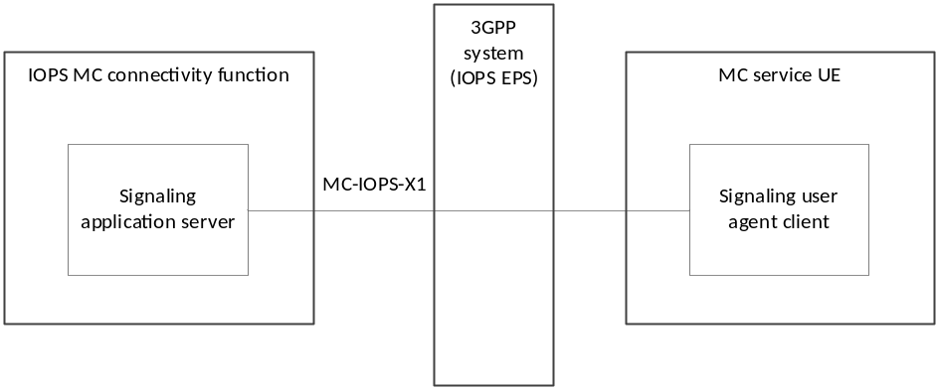
Figure 7.3.2-1 Functional model for the signalling control plane in the IOPS mode of operation
NOTE: The functional model for the signalling plane in the IOPS mode of operation is described as a common functional model across MC services.

7.3.3 MCPTT functional model for the application plane in the IOPS mode of operation
Figure 7.3.3-1 shows the MCPTT functional model for the application plane in the IOPS mode of operation.
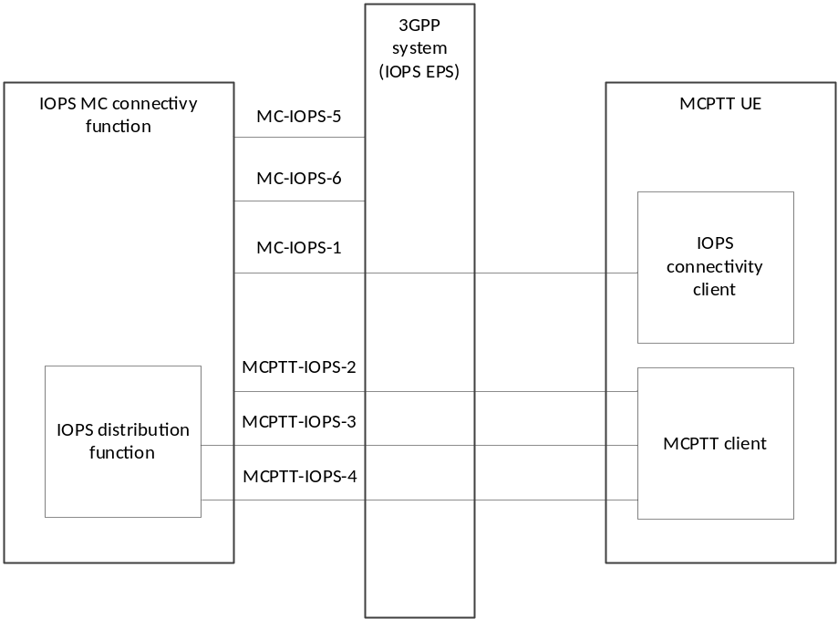
Figure 7.3.3-1 MCPTT functional model for the application plane in the IOPS mode of operation
NOTE: MC-IOPS-1, MC-IOPS-5 and MC-IOPS-6 reference points are common across MC services.
In the model shown in figure 7.3.3-1, the following apply:
- MCPTT-IOPS-2 carries signalling related to the support of multicast transmissions, e.g. MBMS bearer announcement, between the IOPS MC connectivity function and the MCPTT client.
- MCPTT-IOPS-3 carries signalling and media over IP unicast transmissions between the IOPS distribution function and the MCPTT client of the MCPTT UE.
- MCPTT-IOPS-4 carries signalling and media on downlink over IP multicast transmissions between the IOPS distribution function and the MCPTT client of the MCPTT UE.

7.3.4 MCData functional model for the application plane in the IOPS mode of operation
Figure 7.3.4-1 shows the MCData functional model for the application plane in the IOPS mode of operation.
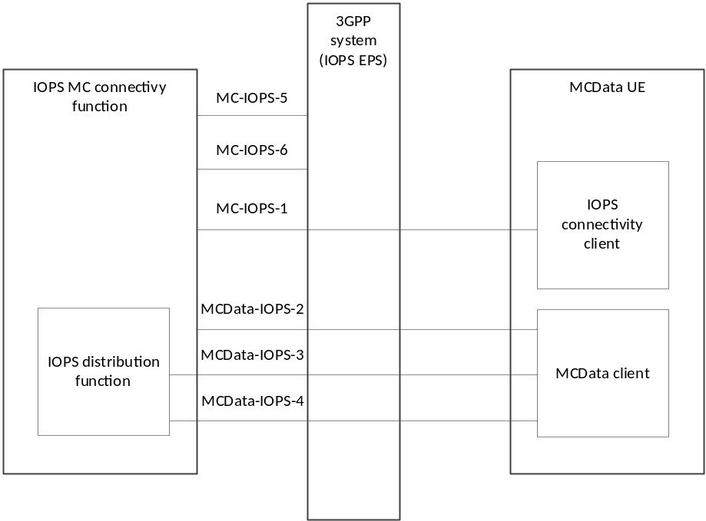
Figure 7.3.4-1 MCData functional model for the application plane in the IOPS mode of operation
NOTE: MC-IOPS-1, MC-IOPS-5 and MC-IOPS-6 reference points are common across MC services.
In the model shown in figure 7.3.4-1, the following apply:
- MCData-IOPS-2 carries signalling related to the support of multicast transmissions, e.g. MBMS bearer announcement, between the IOPS MC connectivity function and the MCData client.
- MCData-IOPS-3 carries signalling and media over IP unicast transmissions between the IOPS distribution function and the MCData client of the MCData UE.
- MCData-IOPS-4 carries signalling and media on downlink over IP multicast transmissions between the IOPS distribution function and the MCData client of the MCData UE.

7.4 Functional entities description

7.4.1 Application plane

7.4.1.1 General
Entities within the application plane of an IOPS MC system provide application specific functions to support MC services in the IOPS mode of operation.

7.4.1.2 IOPS connectivity client
The IOPS connectivity client functional entity provides support for enabling that a user at the MC service client is registered and discovered by the IOPS MC system in the IOPS mode of operation. This functional entity is located in the MC service UE.

7.4.1.3 IOPS MC connectivity function
The IOPS MC connectivity function entity provides supporting MC services in the IOPS mode of operation. It includes registering and discovering users within the IOPS MC system. The IOPS MC connectivity functional entity represents a specific instantiation of the GCS AS described in 3GPP TS 23.468 [4] to manage unicast and multicast transmissions for group communication related sessions.
The IOPS MC connectivity function entity is supported by the signalling application server functional entity of the signalling control plane.

7.4.1.4 IOPS distribution function
The IOPS distribution function entity provides support for distributing the IP packets containing the MC service application data received from a MC service UE in the IOPS mode of operation.
By means of information provided by the IOPS MC connectivity function (e.g. IP addresses, transport layer ports), it will provide the following functionality:
- receiving uplink IP transmissions from the MC service UE by means of the MCPTT-IOPS-3 reference point for MCPTT and the MCData-IOPS-3 reference point for MCData;
- distributing the related IP packets via downlink IP unicast transmissions to MC service UEs by means of the MCPTT-IOPS-3 reference point for MCPTT and the MCData-IOPS-3 reference point for MCData;
- distributing the related IP packets via downlink IP multicast transmissions to MC service UEs by means of the MCPTT-IOPS-4 reference point for MCPTT and the MCData-IOPS-4 reference point for MCData.

7.4.1.5 MC service client
The MC service client functional entity, e.g. a MCPTT client and a MCData client, supporting the IOPS mode of operation acts as the user agent for the corresponding MC service transactions as well as all IOPS related application transactions.

7.4.2 Signalling control plane

7.4.2.1 Signalling user agent client
The signalling user agent client functional entity supports at the MC service client all required transactions related to the IOPS discovery. This includes supporting registration, publication, subscription and notification events.

7.4.2.2 Signalling application server
The signalling application server functional entity supports at the IOPS MC system all required transactions related to the IOPS discovery. This includes supporting registration, publication, subscription and notification events.

7.5 Reference points

7.5.1 Application plane

7.5.1.1 Reference point MC-IOPS-1 (between the IOPS MC connectivity function and the IOPS connectivity client)
The MC-IOPS-1 reference point, which exists between the IOPS MC connectivity function and the IOPS connectivity client, is used for IOPS related application signalling (e.g. registration, publication, subscription and notification events). The MC-IOPS-1 reference point utilizes the MC-IOPS-X1 reference point for transport and routing of the IOPS related signalling.

7.5.1.2 Reference point MCPTT-IOPS-2 (between the IOPS MC connectivity function and the MCPTT client)
The MCPTT-IOPS-2 reference point, which exists between the IOPS MC connectivity function and the MCPTT client, is used to communicate signalling related to the MBMS bearers utilized for multicast transmissions, e.g. MBMS bearer announcement in the IOPS mode of operation.

7.5.1.3 Reference point MCData-IOPS-2 (between the IOPS MC connectivity function and the MCData client)
The MCData-IOPS-2 reference point, which exists between the IOPS MC connectivity function and the MCData client, is used to communicate signalling related to the MBMS bearers utilized for multicast transmissions, e.g. MBMS bearer announcement in the IOPS mode of operation.

7.5.1.4 Reference point MCPTT-IOPS-3 (between the IOPS distribution function and the MCPTT client)
The MCPTT-IOPS-3 reference point, which exists between the IOPS distribution function and the MCPTT client, is used for IP unicast transmissions in uplink and downlink. The MCPTT-IOPS-3 reference point uses the SGi reference point defined in 3GPP TS 23.002 [7].

7.5.1.5 Reference point MCData-IOPS-3 (between the IOPS distribution function and the MCData client)
The MCData-IOPS-3 reference point, which exists between the IOPS distribution function and the MCData client, is used for IP unicast transmissions in uplink and downlink. The MCData-IOPS-3 reference point uses the SGi reference point defined in 3GPP TS 23.002 [7].

7.5.1.6 Reference point MCPTT-IOPS-4 (between the IOPS distribution function and the MCPTT client)
The MCPTT-IOPS-4 reference point, which exists between the IOPS distribution function and the MCPTT client, is used for IP multicast transmissions in downlink. The MCPTT-IOPS-4 reference point uses the MB2-U reference point defined in 3GPP TS 23.468 [4].

7.5.1.7 Reference point MCData-IOPS-4 (between the IOPS distribution function and the MCData client)
The MCData-IOPS-4 reference point, which exists between the IOPS distribution function and the MCData client, is used for IP multicast transmissions in downlink. The MCData-IOPS-4 reference point uses the MB2-U reference point defined in 3GPP TS 23.468 [4].

7.5.1.8 Reference point MC-IOPS-5 (between the IOPS MC connectivity function and the 3GPP system (IOPS EPS))
The MC-IOPS-5 reference point, which exists between the IOPS MC connectivity function and the 3GPP system (IOPS EPS), is used to obtain unicast bearers with appropriate QoS from the IOPS EPS. The MC-IOPS-5 reference point utilizes the Rx interface of the EPS according to 3GPP TS 23.203 [8].

7.5.1.9 Reference point MC-IOPS-6 (between the IOPS MC connectivity function and the 3GPP system (IOPS EPS))
The MC-IOPS-6 reference point, which exists between the IOPS MC connectivity function and the 3GPP system (IOPS EPS), is used to request the allocation and activation of multicast transport resources, i.e. MBMS bearers, during the IOPS mode of operation. The MC-IOPS-6 reference point uses the MB2-C interface as defined in 3GPP TS 23.468 [4].

7.5.2 Signalling control plane

7.5.2.1 Reference point MC-IOPS-X1 (between the signalling application server and the signalling user agent client)
The MC-IOPS-X1 reference point, which exists between the signalling application server and the signalling user agent client, is used to support the IOPS related application signalling (e.g. registration, publication, subscription and notification events).
NOTE: The IOPS related signalling supporting, e.g., the IOPS discovery, subscription and notification events can be SIP-based. In such a case, the signalling application server acts as a SIP application server (AS) and the signalling user agent client acts as the SIP user agent for all SIP related transactions.

8 Identities

8.1 Application plane

8.1.1 IOPS MC user identity (IOPS MC ID)

8.1.1.1 General
The IOPS MC ID is used for identifying an MC user in the IOPS mode of operation. The IOPS MC ID uniquely identifies an MC user on the IOPS MC system.
The IOPS MC ID can be used for the user authentication with the IOPS MC system.
NOTE: The specific security and authentication mechanisms required in order to use the IOPS MC user identity need to be specified by SA3.
Editor's Note: Adding reference to the IOPS user authentication procedure in SA3 TS is FFS.

8.1.2 IOPS MC service user identity (IOPS MC service ID)

8.1.2.1 General
The IOPS MC service ID is a unique identifier within the MC service that represents the MC service user in the IOPS mode of operation. The IOPS MC service ID is the IOPS MCPTT ID for the MCPTT service as defined in 3GPP TS 23.379 [5], and is the IOPS MCData ID for the MCData service as defined in 3GPP TS 23.282 [6].
NOTE: MCVideo service as defined in 3GPP TS 23.281 [10] is not supported in the current release.

8.1.3 IOPS MC service group identity (IOPS MC service group ID)

8.1.3.1 General
An IOPS MC service group ID is used for identifying an MC service group in the IOPS mode of operation. The MC service UE is able to make one or more MC service communications (as per the group configuration) with other member UEs whose users are within the same IOPS MC service group ID.
The general description of an MC service group ID is provided in 3GPP TS 23.280 [3].

8.1.3.2 IOPS MC service group ID management (IP connectivity functionality)
Figure 8.1.3.2-1 illustrates how the IOPS MC service group ID and the IOPS group IP multicast address are mapped to each other for the support of the IP connectivity functionality. The IOPS group IP multicast address is pre-configured in the MC service UEs supporting the IOPS mode of operation in accordance with the IOPS MC service group ID.
NOTE: The association between the IOPS MC service group ID and the IOPS group IP multicast address may be pre-defined in the MC services UEs.

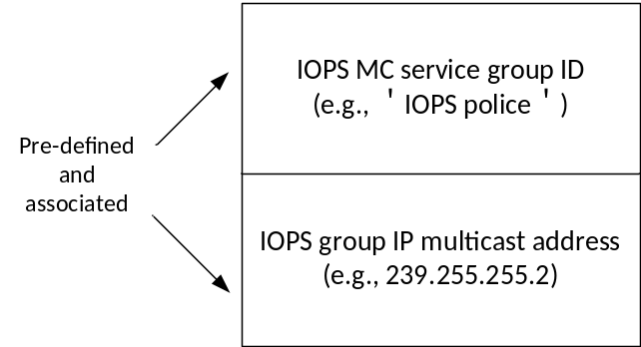
Figure 8.1.3.2-1: IOPS MC service group ID management (IP connectivity functionality)

9 Application of functional model to deployments

9.1 Overview
The IOPS architectural model includes application functions at the IOPS MC system and UEs to support MC services in the IOPS mode of operation during a backhaul failure. The IOPS MC system provides MC services support to the MC service UE via a single PLMN dedicated to the IOPS mode of operation. The IOPS mode of operation is described in 3GPP TS 23.401 [2].
The architectural model to support MC services in the IOPS mode of operation consists of a signalling control plane and an application plane. The signalling control plane provides the necessary signalling support for the related IOPS application layer transactions, e.g. the registration and discovery of UEs on the IOPS MC system. The IOPS application plane provides the necessary support for the transport of the IOPS operation related application data as well as the IP packets containing the MC service application data to be distributed via the IOPS MC system.
The MC service application data includes all signalling control data and application data (control and media) required to provide MC services between MC service clients. The IP related transmissions are established over the IOPS MC system via IP unicast and multicast transmissions.

9.2 IOPS architectural model diagram
Figure 9.2-1 shows the IOPS architectural model for the IOPS MC system solution in case of a backhaul failure.
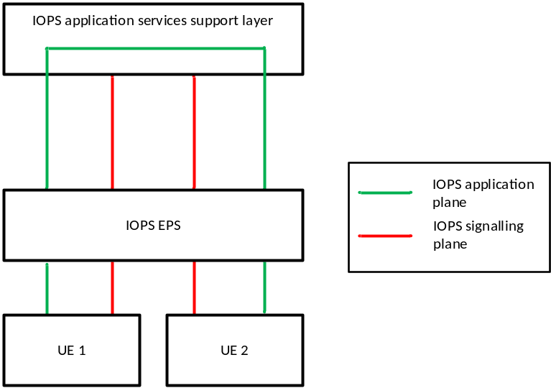
Figure 9.2-1 Architectural model in the IOPS mode of operation

9.2.1 IOPS application services support layer
The IOPS MC system is composed of the following functional entities for the support of MC services in the IOPS mode of operation:
- an IOPS MC connectivity function as described in clause 7.4.1.3, an IOPS distribution function as described in clause 7.4.1.4 and a signalling application server as described in clause 7.4.2.2.

9.2.2 IOPS EPS
The IOPS EPS provides point-to-point and point-to-multipoint bearer services with QoS in the IOPS mode of operation, as described in 3GPP TS 23.401 [2].

9.2.3 UE 1
The UE 1 is an MC service UE supporting the IOPS mode of operation. It supports bearer services and applications to provide MC services over the IOPS MC system. The UE 1 is composed of the following functional entities:
- for MC services over the IOPS MC system, MC service client(s) as described in clause 7.4.1.5;
- for IOPS application plane, an IOPS connectivity client as described in clause 7.4.1.2; and
- for IOPS signalling control, a signalling user agent as described in subclause 7.4.2.1.

9.2.4 UE 2
The UE 2 represents one or more UEs with the same functionality as UE 1.

10 Procedures and information flows

10.1 User authentication in the IOPS mode of operation

10.1.1 General
The following clause describes a high level procedure used for the user authentication in the IOPS mode of operation.
NOTE: The specific user authentication required in the IOPS mode of operation needs to be specified by SA3.
Editor's Note: Adding reference to the IOPS user authentication procedure in SA3 TS is FFS.

10.1.2 Procedure
A procedure for the user authentication in the IOPS mode of operation is illustrated in figure 10.1.2-1.
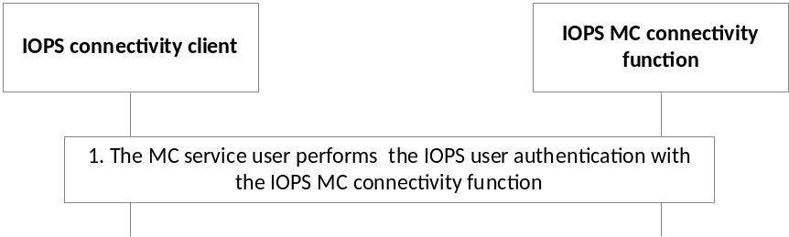
Figure 10.1.2-1 User authentication in the IOPS mode of operation
1. The IOPS connectivity client initiates the IOPS user authentication procedure with the IOPS MC connectivity function.

10.2 IOPS discovery (IP connectivity functionality)

10.2.1 General
The support of the IP connectivity functionality in the IOPS mode of operation enables that MC services are provided by the MC service clients via the IOPS MC connectivity function. An IOPS MC connectivity function provides IP connectivity for the communication among MC service users based on an IOPS discovery procedure.
The IOPS discovery procedure enables that the IOPS MC connectivity function discovers MC service users within the coverage of the system and receives connectivity information required to establish a communication between discovered users based on the IP connectivity functionality.
The following clauses specify the IOPS discovery procedure and information flows for the IP connectivity functionality in the IOPS mode of operation.

10.2.2 Information flows

10.2.2.1 IP connectivity request
Table 10.2.2.1-1 describes the information flow for the IP connectivity request from the IOPS connectivity client to the IOPS MC connectivity function.
Table 10.2.2.1-1: IP connectivity request
Information element | Status | Description
IOPS MC service ID | M | The IOPS MC service ID of the user requesting support of the IP connectivity functionality

10.2.2.2 IP connectivity response
Table 10.2.2.2-1 describes the information flow for the IP connectivity response from the IOPS MC connectivity function to the IOPS connectivity client.
Table 10.2.2.2-1: IP connectivity response
Information element | Status | Description
IOPS MC service ID | M | The IOPS MC service ID of the user requesting support of the IP connectivity functionality
IP connectivity support | M | It indicates if the IP connectivity functionality is supported or not for the user

10.2.2.3 IOPS discovery request
Table 10.2.2.3-1 describes the information flow for the IOPS discovery request from the IOPS connectivity client to the IOPS MC connectivity function.
Table 10.2.2.3-1: IOPS discovery request
Information element | Status | Description
IOPS MC service ID | M | The IOPS MC service ID of the requesting MC user
IP connectivity information | M | It includes the requesting MC service UE's IP address (NOTE 1)
List of IOPS MC service group ID (NOTE 2) | M | It includes the IOPS group (IOPS MC service group ID and its associated IOPS group IP multicast address) or list of IOPS groups the requesting MC user is configured with
Availability of connectivity information | O | It indicates if the connectivity information of the requesting MC user can be made available to other users on the system
List of IOPS MC service IDs (NOTE 2 and NOTE 3) | O | The specific list of IOPS MC service IDs that the requesting MC user's connectivity information can be shared with
Priority state | M | Indicates whether the requesting MC user is requesting higher priority or not
NOTE 1: The MC service UE's IP address is assigned by the IOPS EPS based on the PDN connection established by the MC user for the IOPS IP connectivity functionality.
NOTE 2: The list of IOPS MC service IDs or IOPS MC service group IDs shall be of the same MC service as the MC user requesting to be discovered.
NOTE 3: If present, the user's connectivity information availability can be only made available to the provided specific list of IOPS MC service IDs.

10.2.2.4 IOPS discovery response
Table 10.2.2.4-1 describes the information flow for the IOPS discovery response from the IOPS MC connectivity function to the IOPS connectivity client.
Table 10.2.2.4-1: IOPS discovery response
Information element | Status | Description
IOPS MC service ID | M | The IOPS MC service ID of the user requesting to be discovered
Connectivity status | M | It indicates the connectivity status of the requesting MC user on the system
IOPS discovery request periodicity | M | It indicates the periodicity at which the requesting MC user is required to transmit IOPS discovery requests (NOTE)
NOTE: An MC user is required to periodically transmit an IOPS discovery request. The periodic IOPS discovery requests are used by the IOPS MC connectivity function to verify the availability of the MC user and its IP connectivity information within the IOPS MC system.

10.2.3 Procedure
After an MC service user is authenticated on the IOPS MC connectivity function, the IOPS discovery procedure is initiated by the MC users requesting support of the IP connectivity functionality to the IOPS MC connectivity function. If the IOPS MC connectivity function indicates the support of the IP connectivity functionality, the MC service users can send an IOPS discovery request.
The procedure for requesting support of the IP connectivity functionality by the IOPS connectivity client to the IOPS MC connectivity function is described in figure 10.2.3-1.
NOTE 1: The procedure for requesting support of the IP connectivity functionality is only required when the IOPS connectivity client does not contain information about the support of this functionality by the serving IOPS MC connectivity function.
Pre-conditions:
- The MC service user is authenticated on the IOPS MC connectivity function.
- The MC service user has an active PDN connection to the IOPS MC connectivity function for the specific IP connectivity functionality procedure
- The IOPS connectivity client does not contain information about the support of the IP connectivity functionality by the serving IOPS MC connectivity function

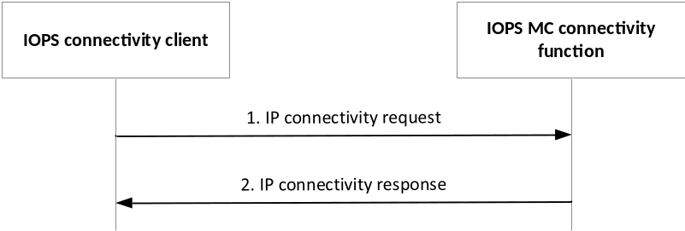
Figure 10.2.3-1 IP connectivity functionality request in the IOPS mode of operation
1. The IOPS connectivity client requests to the IOPS MC connectivity function the support of the IP connectivity functionality.
2. The IOPS MC connectivity function indicates to the IOPS connectivity client if the IP connectivity functionality is supported or not for the MC user.
The procedure for the discovery of MC users in the IOPS mode of operation is described in figure 10.2.3-2. The IOPS discovery is initiated by the MC users to support MC services based on the IP connectivity functionality.
As part of the IOPS discovery procedure, an MC user can request higher priority from the IOPS MC connectivity function by including a priority state indication within the IOPS discovery request. Based on this indication, the IOPS MC connectivity function can decide to handle with higher priority the transactions related to the MC user, e.g. the distribution of packets related to any MC communication from or to the corresponding MC user, subscriptions, and notifications. When an MC user intends to establish an IOPS emergency (group or private) call, the MC user can request a priority state from the IOPS MC connectivity function.
The MC user's priority state remains unchanged until the MC user explicitly changes it (i.e. by sending a new IOPS discovery request) or the discovery status of the MC user changes to not-discovered on the IOPS MC connectivity function.
Pre-conditions:
- The MC service user is authenticated on the IOPS MC connectivity function.
- The MC service user has an active PDN connection to the IOPS MC connectivity function for the specific IP connectivity functionality procedure
- The IOPS MC connectivity function has indicated to the IOPS connectivity client the support of the IP connectivity functionality.

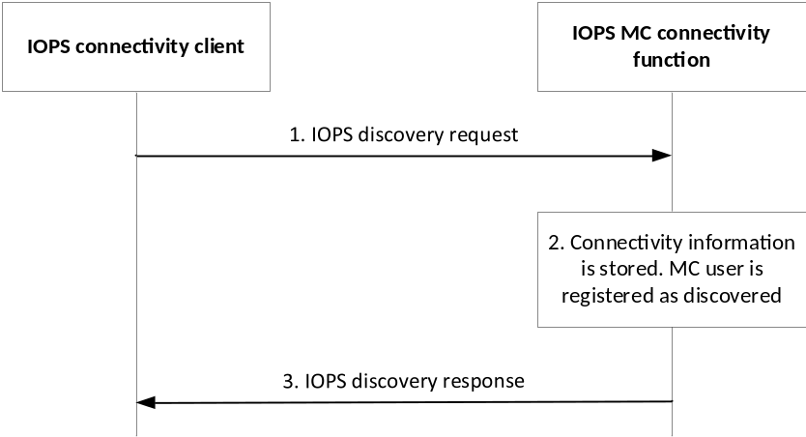
Figure 10.2.3-2 User discovery in the IOPS mode of operation
1. The MC user sends an IOPS discovery request to the IOPS MC connectivity function. The request includes providing connectivity information for the support of MC services based on the IP connectivity functionality.
2. The IOPS MC connectivity function stores the information received from the MC user and registers the user's connectivity status as discovered.
3. The IOPS MC connectivity function provides a response to the IOPS connectivity client indicating the success or failure of the discovery of the requesting MC user.
NOTE 2: The MC user shall send a new IOPS discovery request to update or modify information elements.
NOTE 3: The IOPS MC connectivity function shall send a new IOPS discovery response to the IOPS connectivity client for the case that the periodic IOPS discovery request has not been received yet or when the IOPS discovery request periodicity needs to be changed. The IOPS MC connectivity function can verify the availability and IP connectivity information of the discovered MC user within the IOPS MC system based on the reception of periodic IOPS discovery requests.

10.3 IOPS subscription and notification (IP connectivity functionality)

10.3.1 General
The support of the IP connectivity functionality in the IOPS mode of operation enables that MC services are provided by the MC service clients over the IOPS MC connectivity function. An MC user that has been discovered by the IOPS MC connectivity function can subscribe to be notified about the connectivity information of other discovered MC users on the IOPS MC connectivity function. Also, a discovered MC user can subscribe to be notified about the number of other discovered MC users on the IOPS MC connectivity function within its associated IOPS groups.
The following clauses specify the IOPS subscription and notification procedures and information flows for the IP connectivity functionality in the IOPS mode of operation.

10.3.2 Information flows

10.3.2.1 IP connectivity subscribe request
Table 10.3.2.1-1 describes the information flow for the IP connectivity subscribe request from the IOPS connectivity client to the IOPS MC connectivity function.
Table 10.3.2.1-1: IP connectivity subscribe request
Information element | Status | Description
IOPS MC service ID | M | The IOPS MC service ID of the requesting MC user
List of IOPS MC service IDs (NOTE 1) | O | List of IOPS MC service IDs the requesting MC user subscribes to receive connectivity information from
List of IOPS groups (NOTE 1 and NOTE 2) | O | List of IOPS groups (IOPS MC service group IDs) the requesting MC user subscribes to receive group connectivity information from
NOTE 1: The list of IOPS MC service IDs or IOPS MC service group IDs shall be of the same MC service as the MC user subscribing to receive the connectivity information. At least one should be present.
NOTE 2: The IOPS group(s) should belong to the list of IOPS groups the requesting MC user included in its IOPS discovery request.

10.3.2.2 IP connectivity subscribe response
Table 10.3.2.2-1 describes the information flow for the IP connectivity subscribe response from the IOPS MC connectivity function to the IOPS connectivity client.
Table 10.3.2.2-1: IP connectivity subscribe response
Information element | Status | Description
IOPS MC service ID | M | The IOPS MC service ID of the requesting MC user
Subscription status | M | It lists the subscription status, success or failure, of the requested subscription(s)

10.3.2.3 IP connectivity notify request
Table 10.3.2.3-1 describes the information flow for the IP connectivity notify request from the IOPS MC connectivity function to the IOPS connectivity client.
Table 10.3.2.3-1: IP connectivity notify request
Information element | Status | Description
IOPS MC service ID | M | The IOPS MC service ID of the MC user with active subscription(s)
IOPS MC service ID (NOTE 1) | M | The IOPS MC service ID associated to the active subscription for which connectivity information is being notified
Connectivity information (NOTE 1) | M | It provides connectivity information about the MC service ID of the corresponding subscription. It includes the MC service UE's IP address of the associated IOPS MC service ID in the system and its connectivity status on the system (see NOTE 2)
NOTE 1: It can be a list associated to multiple active subscriptions.
NOTE 2: Whether the IOPS MC connectivity function provides within the IP connectivity notify request the actual MC service UE's IP address or an associated application IP address assigned by the IOPS MC connectivity function is implementation specific. For the latter, it is up to the IOPS MC connectivity function to correctly maintain the defined association.

10.3.2.4 IP connectivity notify response
Table 10.3.2.4-1 describes the information flow for the IP connectivity notify response from the IOPS connectivity client to the IOPS MC connectivity function.
Table 10.3.2.4-1: IP connectivity notify response
Information element | Status | Description
IOPS MC service ID | M | The IOPS MC service ID of the responding MC user
IOPS MC service ID (NOTE) | M | The IOPS MC service ID for which connectivity information was received
NOTE: It can be a list associated to multiple active subscriptions.

10.3.2.5 IP connectivity group notify request
Table 10.3.2.5-1 describes the information flow for the IP connectivity group notify request from the IOPS MC connectivity function to the IOPS connectivity client.
Table 10.3.2.5-1: IP connectivity group notify request
Information element | Status | Description
IOPS MC service ID | M | The IOPS MC service ID of the MC user with active subscription(s)
IOPS group (NOTE) | M | The IOPS MC service group ID related to the active group subscription for which group connectivity information is being notified
Group connectivity information (NOTE) | M | It indicates the number of other discovered MC users on the IOPS MC connectivity function of the corresponding group subscription
NOTE: It can be a list associated to multiple active group subscriptions.

10.3.2.6 IP connectivity group notify response
Table 10.3.2.6-1 describes the information flow for the IP connectivity group notify response from the IOPS connectivity client to the IOPS MC connectivity function.
Table 10.3.2.6-1: IP connectivity group notify response
Information element | Status | Description
IOPS MC service ID | M | The IOPS MC service ID of the responding MC user
IOPS group (NOTE) | M | The IOPS MC service group ID for which group connectivity information was received
NOTE: It can be a list associated to multiple active group subscriptions.

10.3.3 Procedures
The procedure for the IP connectivity subscription of MC users in the IOPS mode of operation is described in figure 10.3.3-1.
Pre-conditions:
- The MC service user has an active PDN connection to the IOPS MC connectivity function for the specific IP connectivity functionality procedure
- The MC service user is discovered by the IOPS MC connectivity function to support MC services based on the IP connectivity functionality.
- The MC service user has decided to subscribe to receive connectivity information of other discovered MC users and/or IOPS groups on the IOPS MC connectivity function.
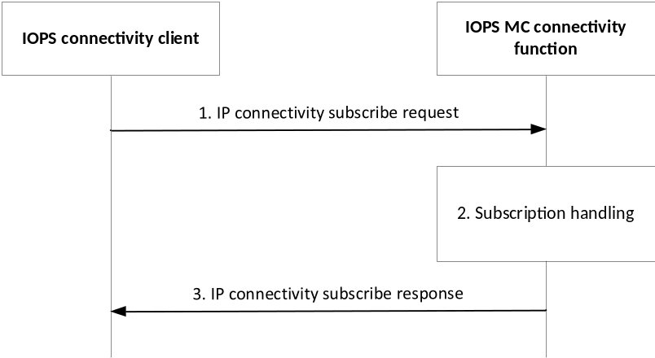
Figure 10.3.3-1 IP connectivity subscription in the IOPS mode of operation
1. The IOPS connectivity client subscribes to receive connectivity information of other discovered MC users and/or groups on the IOPS MC connectivity function.
2. The IOPS MC connectivity function checks if a subscription for the MC service ID(s) and/or IOPS group(s) included in the request can be activated for the requesting MC user.
NOTE: A subscription cannot be activated if an MC user associated to the requested MC service ID has indicated in its IOPS discovery request that its connectivity information is not available to other users on the IOPS MC connectivity function. Besides, a subscription may not be activated if a requested IOPS group does not belong to the list of IOPS groups the requesting MC user has included in its IOPS discovery request.
3. The IOPS MC connectivity function indicates to the IOPS connectivity client the subscription status associated to the request.
The procedure for the IP connectivity notification of MC users in the IOPS mode of operation is described in figure 10.3.3-2.
Pre-conditions:
- The MC service user has an active PDN connection to the IOPS MC connectivity function for the specific IP connectivity functionality procedure
- The MC service user has an active IP connectivity subscription associated to one or multiple MC service IDs.
- The IOPS MC connectivity function has available information related to an IP connectivity subscription associated to one or multiple MC service IDs.

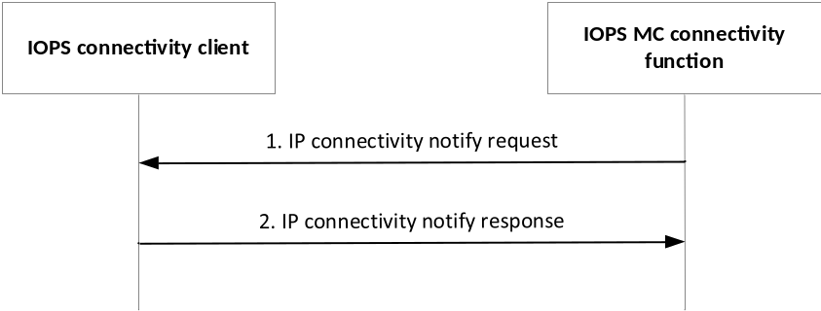
Figure 10.3.3-2 IP connectivity notification in the IOPS mode of operation
1. The IOPS MC connectivity function notifies to the IOPS connectivity client the connectivity information related to an active IP connectivity subscription associated to one or multiple MC service IDs. The connectivity information can be retrieved by the MC service client to establish an MC service communication based on the IP connectivity functionality.
2. The IOPS connectivity client provides an IP connectivity notify response to the IOPS MC connectivity function.
The procedure for the IP connectivity group notification of MC users in the IOPS mode of operation is described in figure 10.3.3-3.
Pre-conditions:
- The MC service user has an active PDN connection to the IOPS MC connectivity function for the specific IP connectivity functionality procedure
- The MC service user has an active IP connectivity subscription associated to one or multiple IOPS MC service group IDs.
- The IOPS MC connectivity function has available information related to an IP connectivity subscription associated to one or multiple IOPS MC service group IDs.

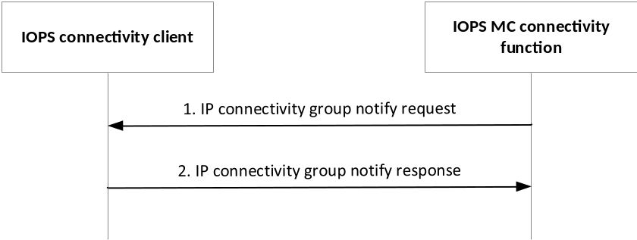
Figure 10.3.3-3 IP connectivity group notification in the IOPS mode of operation
1. The IOPS MC connectivity function notifies to the IOPS connectivity client the group connectivity information related to an active IP connectivity group subscription associated to one or multiple IOPS MC service group IDs. The group connectivity information can be retrieved by the MC service client to establish an MC service group communication based on the IP connectivity functionality.
2. The IOPS connectivity client provides an IP connectivity group notify response to the IOPS MC connectivity function.

10.4 Use of MBMS transmissions

10.4.1 General
An IOPS MC connectivity function can provide support for group communications based on MBMS transmissions. MBMS transmissions can be used for the downlink delivery of MC service application signalling and media to the MC service UEs over MBMS bearers.
The use of MBMS transmissions in the IOPS mode of operation are based on the related information flows and procedures specified in 3GPP TS 23.280 [3], 3GPP TS 23.379 [5], and 3GPP TS 23.282 [6].

10.4.2 Information flows

10.4.2.1 MapIOPSGroupToBearer (IP connectivity functionality)
Table 10.4.2.1-1 describes the information flow to associate a group session based on the IP connectivity functionality to an MBMS bearer. It is sent from the IOPS MC connectivity function to the MC service client.
Table 10.4.2.1-1: MapIOPSGroupToBearer (IP connectivity functionality)
Information element | Status | Description
IOPS MC service group ID | M | This element identifies the IOPS MC service group, in which the group session is started.
Media stream identifier | M | This element identifies the media stream of the SDP used for the group session (e.g. MBMS subchannel).
TMGI (NOTE) | O | The MBMS bearer identifier if the media of the group session is not sent on the same MBMS bearer as this MapIOPSGroupToBearer message.
Session acknowledgement indicator | O | Indication that the group session requires acknowledgement from receiving MC service clients.
NOTE: TMGI shall be present if this message is sent over a different MBMS bearer than the media of the group session; TMGI may be present if this message is sent over the same MBMS bearer as the media of the group session.

10.4.2.2 UnmapIOPSGroupFromBearer (IP connectivity functionality)
Table 10.4.2.2-1 describes the information flow to disconnect a group session based on the IP connectivity functionality from an MBMS bearer. It is sent from the IOPS MC connectivity function to the MC service client.
Table 10.4.2.2-1: UnmapIOPSGroupFromBearer
Information element | Status | Description
IOPS MC service group ID | M | This element identifies the IOPS MC service group, in which the group session is started.

10.4.3 Use of pre-established MBMS bearers
The MC services in the IOPS mode of operation shall support the procedure for using pre-established MBMS bearers as specified 3GPP TS 23.280 [3] with the following clarification:
- The MC service server is the IOPS MC connectivity function.
The MCPTT service shall use the MCPTT-IOPS-2, MCPTT-IOPS-4, and MC-IOPS-6 reference points for this procedure.
The MCData service shall use the MCData-IOPS-2, MCData-IOPS-4, and MC-IOPS-6 reference points for this procedure.
The IOPS MC system may use pre-established MBMS bearers for distributing the media associated to group sessions. Depending on the capacity of the MBMS bearer, the bearer can be used to broadcast one or more group sessions in parallel.

10.4.4 Use of dynamic MBMS bearer establishment
The MC services in the IOPS mode of operation shall support the procedure for using dynamic MBMS bearers as specified 3GPP TS 23.280 [3] with the following clarification:
- The MC service server is the IOPS MC connectivity function.
The MCPTT service shall use the MCPTT-IOPS-2, MCPTT-IOPS-4, and MC-IOPS-6 reference points for this procedure.
The MCData service shall use the MCData-IOPS-2, MCData-IOPS-4, and MC-IOPS-6 reference points for this procedure.
The IOPS MC system may use dynamic MBMS bearer establishment for distributing the media associated to group sessions.

10.4.5 Group session connect and disconnect over MBMS (IP connectivity functionality)

10.4.5.1 General
MBMS bearers can be used for group sessions based on the IP connectivity functionality. One MBMS bearer can be associated to one or more specific groups or group sessions. Before sending packets related to a group session, i.e. signalling and media, over an MBMS bearer, the IOPS MC connectivity function transmits the association information between the group session and the MBMS bearer. When the group session over the MBMS bearer is finished, this temporary association information of a group session to specific resources on a MBMS bearer is undone. Prior to the association of a group session to an MBMS bearer the MBMS bearer is activated and announced to the MC service clients.

10.4.5.2 Procedure

10.4.5.2.1 Group Session connect over MBMS
In figure 10.4.5.2.1-1 the MC service client 1 is the client that initiates a group session, e.g. an MCPTT client initiating a group call. The MC service client 1 may be within the MBMS service area. The MC service clients 2 … n represent MC service clients, e.g. MCPTT clients, receiving the group session packets over an MBMS bearer. There may be other receiving MC service clients both over unicast bearers and over this or other MBMS bearer(s), however, they are not illustrated in this figure.
Pre-conditions:
- The MC service user profile used for the IOPS mode of operation is pre-provisioned in the MC service UEs
- The IOPS MC service group ID and its associated IOPS group IP multicast address are pre-configured in the MC service clients
- The MC service users have an active PDN connection to the IOPS MC connectivity function for the communication based on the IP connectivity functionality
- The MC service users are discovered by the IOPS MC connectivity function to support MC services based on the IP connectivity functionality

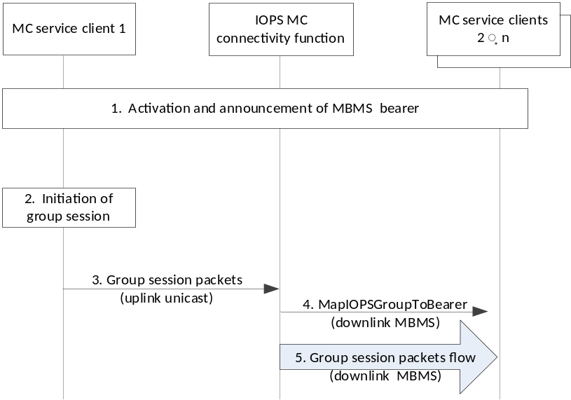
Figure 10.4.5.2.1-1: Group session connect on MBMS bearer (IP connectivity functionality)
1. Activation and announcement of MBMS bearer availability.
2. MC user at the MC service client 1 wants to initiate an MC service group session with a specific IOPS MC service group based on the IP connectivity functionality.
3. The MC service client 1 transmits the related group session packets via the IOPS MC connectivity function targeting the IOPS MC service group (i.e. using the corresponding IOPS group IP multicast address)
4. The IOPS MC connectivity function determines that the received packets correspond to a group session. Therefore, the IOPS MC connectivity function transmits a MapIOPSGroupToBearer message over a previously established MBMS bearer to all users monitoring the MBMS bearer. The MapIOPSGroupToBearer message includes association information between the group session and the MBMS bearer. It includes the corresponding IOPS MC service group ID associated to the IOPS group IP multicast address related to the group session.
5. The IOPS MC connectivity function distributes the received group session packets from the MC service client 1 to other MC service clients (e.g. MC service clients 2 … n) over the MBMS bearer.
NOTE: MC service clients receiving the group session packets over the MBMS bearer only decode the packets that are addressed to their pre-configured IOPS group IP multicast address(es). Otherwise, the MC service clients discard the packets.

10.4.5.2.2 Group session disconnect over MBMS
Figure 10.4.5.2.2-1 shows the high level procedure where an UnmapIOPSGroupFromBearer message is transmitted from the IOPS MC connectivity function to MC service clients to indicate that a group session is being disconnected or dissociated from the MBMS bearer.
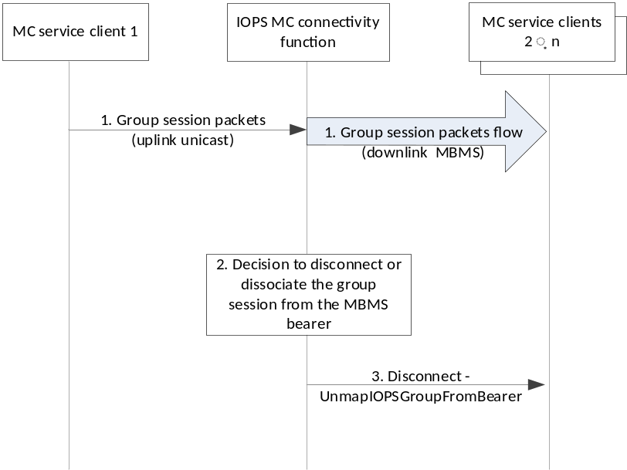
Figure 10.4.5.2.2-1: Group session disconnect on MBMS bearer (IP connectivity functionality)
1. A group session based on the IP connectivity functionality is ongoing; the group session packets received from the MC service client 1 are distributed over MBMS bearer to other MC service clients within the system.
2. The IOPS MC connectivity function has determined to disconnect the group session from the MBMS bearer for the MC service clients within the system.
NOTE: The IOPS MC connectivity function may decide to disconnect a group session from an MBMS bearer if group session packets are not anymore received addressing the corresponding IOPS MC service group (or IOPS group IP multicast address).
3. An UnmapGroupFromBearer message is transmitted from the IOPS MC connectivity function to the MC service clients and possibly to the MC service client 1 (if it is within the MBMS coverage area) on MBMS bearer(s).

10.5 MCPTT service

10.5.1 IOPS group call (IP connectivity functionality)

10.5.1.1 General
The support of MCPTT group calls based on the IP connectivity functionality in the IOPS mode of operation enables that the service is provided by the MCPTT clients over the IOPS MC connectivity function. The IOPS MC connectivity function provides IP connectivity for the communication among MCPTT users.
IOPS group calls based on the IP connectivity functionality can use pre-configured information provided to MCPTT clients prior to the IOPS group call. Therefore, when a MCPTT client initiates an IOPS group call it uses the pre-configured IOPS group IP multicast address associated to the target IOPS MCPTT group ID to establish the IOPS group call based on the IP connectivity functionality. The related packets, i.e. signalling and media, of the IOPS group call are transmitted to the IOPS MC connectivity function for distribution to the corresponding discovered MC users of the target IOPS MCPTT group.
The IOPS MC connectivity function can distribute the group session packets to the discovered MC users over MBMS bearers as described in clause 10.4.5.
The IOPS MC connectivity function can also replicate and distribute the group session packets over unicast transmissions to MCPTT UEs associated to the target IOPS MCPTT group. MCPTT UEs receiving the group session packets are associated to discovered MC users that included the target IOPS MCPTT group ID in the IOPS discovery request, as described in clause 10.5.2.3.
The following clauses specify the IOPS group call procedures and information flows for the IP connectivity functionality in the IOPS mode of operation.

10.5.1.2 Information flows

10.5.1.2.1 IOPS group call announcement
Table 10.5.1.2.1-1 describes the information flow for the IOPS group call announcement from one MCPTT client to other MCPTT clients. The packet(s) carrying the IOPS group call announcement are transmitted from the originating MCPTT client to the IOPS MC connectivity function for distribution to the target MCPTT clients.
Table 10.5.1.2.1-1: IOPS group call announcement
Information Element | Status | Description
IOPS MCPTT ID | M | The identity of the calling party
IOPS MCPTT group ID | M | The IOPS MCPTT group ID on which the call is to be conducted
SDP offer | M | Media parameters of the MCPTT client
Announcement period | M | Period of the group call announcement
Encryption parameters | O | Encryption parameters to be used for the call, if the call is to be encrypted
Confirm mode indicator | O | Indicates whether the MCPTT group call is to be confirmed
Emergency indicator | O | Indicates that the MCPTT group call is an MCPTT emergency call

10.5.1.2.2 IOPS group call response
Table 10.5.1.2.2-1 describes the information flow for the IOPS group call response from one MCPTT client to other MCPTT clients. The packet(s) carrying the IOPS group call response is transmitted from the called MCPTT client to the IOPS MC connectivity function for distribution to the target MCPTT clients.
Table 10.5.1.2.2-1: IOPS group call response
Information Element | Status | Description
IOPS MCPTT ID | M | The identity of the called party
IOPS MCPTT group ID | M | The IOPS MCPTT group ID of the group on which the call is requested
SDP answer | M | Media parameters selected
Result | M | Result of the group call announcement (success or failure)

10.5.1.2.3 IOPS emergency group call upgrade
Table 10.5.1.2.3-1 describes the information flow for the IOPS emergency group call upgrade from one MCPTT client to other MCPTT clients. The packet(s) carrying the IOPS emergency group call upgrade are transmitted from the originating MCPTT client to the IOPS MC connectivity function for distribution to the target MCPTT clients.
Table 10.5.1.2.3-1: IOPS emergency group call upgrade
Information Element | Status | Description
IOPS MCPTT ID | M | The identity of the upgrading MC user
IOPS MCPTT group ID | M | The IOPS MCPTT group ID on which the call is to be upgraded to emergency call

10.5.1.2.4 IOPS emergency group call state cancel
Table 10.5.1.2.4-1 describes the information flow for the IOPS emergency group call state cancel from one MCPTT client to other MCPTT clients. The packet(s) carrying the IOPS emergency group call state cancel are transmitted from the originating MCPTT client to the IOPS MC connectivity function for distribution to the target MCPTT clients.
Table 10.5.1.2.4-1: IOPS emergency group call state cancel
Information Element | Status | Description
IOPS MCPTT ID | M | The identity of the cancelling MC user
IOPS MCPTT group ID | M | The IOPS MCPTT group ID on which the emergency call state is to be cancelled

10.5.1.3 IOPS group call setup
The procedure in figure 10.5.1.3-1 illustrates the procedure for an IOPS MCPTT group call establishment based on the IP connectivity functionality. The procedure describes how an MCPTT client initiates and establishes an IOPS MCPTT group call with other MCPTT clients.
Pre-conditions:
- MCPTT user profile used for the IOPS mode of operation is pre-provisioned in the MCPTT UEs;
- The IOPS MCPTT group ID and its associated IOPS group IP multicast address are pre-configured in the MCPTT clients;
- MCPTT users have an active PDN connection to the IOPS MC connectivity function for the communication based on the IP connectivity functionality;
- MCPTT users affiliated to the target IOPS MCPTT group are discovered by the IOPS MC connectivity function supporting the IP connectivity functionality;
- The IOPC MC connectivity function may have established an MBMS bearer and announced it to the MCPTT clients;
- MCPTT client 1 may have retrieved group connectivity information from the IOPS connectivity client related to the target IOPS MCPTT group;
- MCPTT clients 1, 2 … n are configured within the same IOPS MCPTT group.
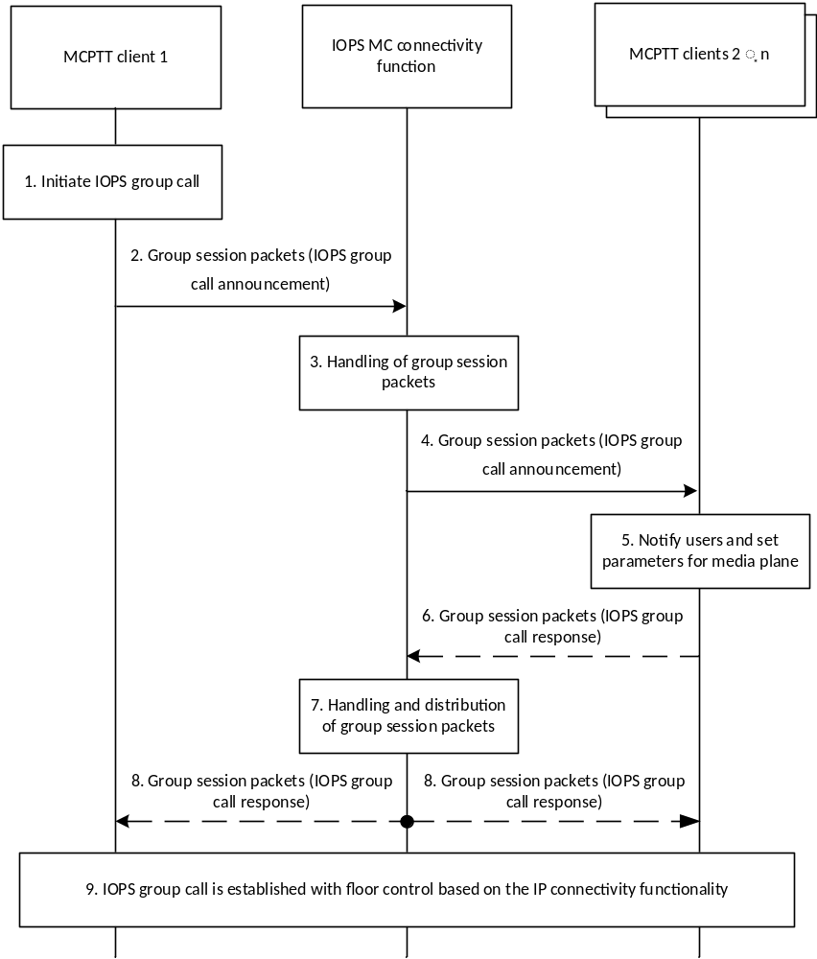
Figure 10.5.1.3-1: IOPS group call setup based on the IP connectivity functionality
1. The MCPTT user at MCPTT client 1 would like to initiate an IOPS group call with a specific IOPS MCPTT group based on the IP connectivity functionality.
2. The MCPTT client 1 sends an IOPS group call announcement to the target IOPS MCPTT group. The MCPTT client 1 transmits the group session packets carrying the IOPS group call announcement to the IOPS MC connectivity function for distribution to the corresponding IOPS group IP multicast address.
3. The IOPS MC connectivity function determines that the received packets correspond to a group session targeting a specific IOPS MCPTT group. The IOPS MC connectivity function decides distributing the received group session packets to the target MCPTT clients over MBMS and/or unicast transmissions.
4. The IOPS MC connectivity function distributes the group session packets carrying the IOPS group call announcement to the MCPTT clients from the target IOPS MCPTT group.
5. The MCPTT clients receiving the IOPS group call announcement join the IOPS group call and notify the target MCPTT users about the IOPS group call.
6. If confirm mode indication is included in the IOPS group call announcement, the receiving MCPTT clients respond to the IOPS MCPTT group indicating the result of the establishment of the announced IOPS group call. The receiving MCPTT clients transmit the group session packets carrying the IOPS group call response to the IOPS MC connectivity function for distribution to the corresponding IOPS group IP multicast address.
NOTE 1: Step 6 can also occur prior to step 5.
7. The IOPS MC connectivity function determines that the received packets correspond to a group session targeting a specific IOPS MCPTT group. The IOPS MC connectivity function decides distributing the received group session packets to the target MCPTT clients over MBMS and/or unicast transmissions.
8. The IOPS MC connectivity function distributes the group session packets carrying the IOPS group call response to the MCPTT clients from the target IOPS MCPTT group. The MCPTT clients recognize the IOPS group call originator through the IOPS group call announcement and can check the participants of the IOPS group call through the received response message.
9. The MCPTT clients have successfully established the IOPS group call with floor control based on the IP connectivity functionality.
NOTE 2: Due to the movement of the participants (in and out of the IOPS EPS coverage) during the IOPS group call, the IOPS group call announcement is periodically sent by the MCPTT client 1.
NOTE 3: The participating MCPTT clients do not need to respond to the periodic IOPS group call announcement.

10.5.1.4 IOPS emergency group call
The procedure in figure 10.5.1.4-1 illustrates the procedure for an IOPS MCPTT emergency group call establishment based on the IP connectivity functionality. The IOPS emergency group call is a special case of the IOPS group call setup procedure described in clause 10.5.1.3, wherein the IOPS group call announcement contains an indication that the IOPS group call is an IOPS emergency group call. The group call participants can become aware of the IOPS MCPTT group's in-progress emergency state based on the emergency indicator.
When an MCPTT client intends to initiate an IOPS emergency group call, the MCPTT client can request higher priority from the IOPS MC connectivity function via the IOPS discovery request.
An IOPS group call in-progress can be upgraded to an IOPS emergency group call by including the emergency indicator within the periodic IOPS group call announcement. An IOPS group call in-progress can also be upgraded by a participating MCPTT client by sending an IOPS emergency group call upgrade to the IOPS group.
The MCPTT user who initiated an IOPS emergency group call, or upgraded an IOPS group call to an emergency group call, or an authorized user can cancel the emergency state of the group call by sending an IOPS emergency group call state cancel to the IOPS MCPTT group. The emergency state of the IOPS group call remains active until the emergency group call ends or the in-progress emergency state is cancelled.
Pre-conditions:
- MCPTT user profile used for the IOPS mode of operation is pre-provisioned in the MCPTT UEs;
- The IOPS MCPTT group ID and its associated IOPS group IP multicast address are pre-configured in the MCPTT clients;
- MCPTT users have an active PDN connection to the IOPS MC connectivity function for the communication based on the IP connectivity functionality;
- MCPTT users affiliated to the target IOPS MCPTT group are discovered by the IOPS MC connectivity function supporting the IP connectivity functionality;
- The IOPC MC connectivity function may have established an MBMS bearer and announced it to the MCPTT clients;
- MCPTT client 1 may have retrieved group connectivity information from the IOPS connectivity client related to the target IOPS MCPTT group;
- MCPTT clients 1, 2 … n are configured within the same IOPS MCPTT group.
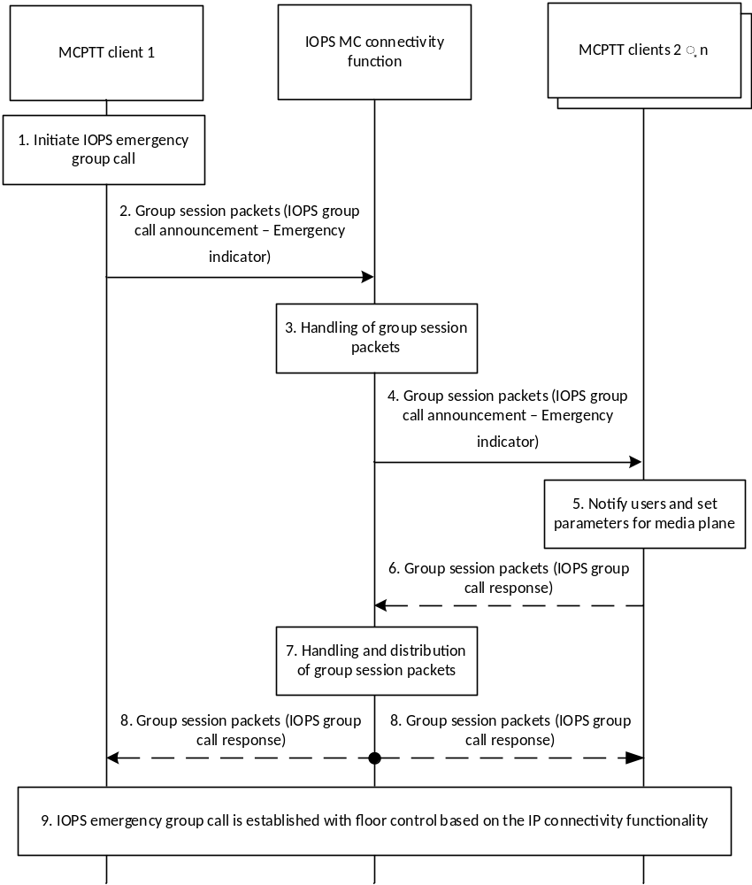
Figure 10.5.1.4-1: IOPS emergency group call setup based on the IP connectivity functionality
1. The MCPTT user at MCPTT client 1 would like to initiate an IOPS emergency group call with a specific IOPS MCPTT group based on the IP connectivity functionality.
NOTE 1: The MCPTT client 1 may have previously requested higher priority from the IOPS MC connectivity function using the IOPS discovery request.
2. The MCPTT client 1 sends an IOPS group call announcement to the target IOPS MCPTT group. The announcement contains an indication that the call is an IOPS emergency group call. The MCPTT client 1 transmits the group session packets carrying the IOPS group call announcement to the IOPS MC connectivity function for distribution to the corresponding IOPS group IP multicast address.
3. The IOPS MC connectivity function determines that the received packets correspond to a group session targeting a specific IOPS MCPTT group. The IOPS MC connectivity function decides to distribute the received group session packets to the target MCPTT clients over MBMS and/or unicast transmissions. If the MCPTT client 1 requested a priority state from the IOPS MC connectivity function, the IOPS MC connectivity function distributes the group session packets with higher priority.
4. The IOPS MC connectivity function distributes the group session packets carrying the IOPS group call announcement to the MCPTT clients from the target IOPS MCPTT group.
5. The MCPTT clients receiving the IOPS group call announcement with an emergency indicator join the IOPS emergency group call and notify the target MCPTT users about the IOPS emergency group call. The IOPS MCPTT group's emergency state is defined.
NOTE 2: Whilst the emergency state of the IOPS group call remains active, other participating MCPTT clients of the group call may also request higher priority from the IOPS MC connectivity function using the IOPS discovery request.
6. If confirm mode indication is included in the IOPS group call announcement, the receiving MCPTT clients respond to the IOPS MCPTT group indicating the result of the establishment of the announced IOPS emergency group call. The receiving MCPTT clients transmit the group session packets carrying the IOPS group call response to the IOPS MC connectivity function for distribution to the corresponding IOPS group IP multicast address.
NOTE 3: Step 6 can also occur prior to step 5.
7. The IOPS MC connectivity function determines that the received packets correspond to a group session targeting a specific IOPS MCPTT group. The IOPS MC connectivity function decides to distribute the received group session packets to the target MCPTT clients over MBMS and/or unicast transmissions. If any participating MCPTT client of the group call requested a priority state from the IOPS MC connectivity function, the IOPS MC connectivity function distributes the group session packets with higher priority.
8. The IOPS MC connectivity function distributes the group session packets carrying the IOPS group call response to the MCPTT clients from the target IOPS MCPTT group. The MCPTT clients recognize the IOPS emergency group call originator through the IOPS group call announcement and can check the participants of the IOPS group call through the received response message.
9. The MCPTT clients have successfully established the IOPS emergency group call based on the IP connectivity functionality.
NOTE 4: Due to the movement of the participants (in and out of the IOPS EPS coverage) during the IOPS emergency group call, the IOPS group call announcement is periodically sent by the MCPTT client 1.
NOTE 5: The participating MCPTT clients do not need to respond to the periodic IOPS group call announcement.

10.5.1.5 IOPS group call release
Each MCPTT client may release itself from an ongoing IOPS group call without the transmission of any signalling if the call has been inactive for a specific duration.
NOTE: Inactivity time can be set according to the policy of the MCPTT service provider.

10.5.2 IOPS private call (IP connectivity functionality)

10.5.2.1 General
The support of MCPTT private calls based on the IP connectivity functionality in the IOPS mode of operation enables that the service is provided by the MCPTT clients over the IOPS MC connectivity function. The IOPS MC connectivity function provides IP connectivity for the communication among MCPTT users.
When an MCPTT user wants to communicate with a specific target MCPTT user based on the IP connectivity functionality, the MCPTT client retrieves the connectivity information of the target MCPTT user (i.e. the MCPTT UE's IP address) from the IOPS connectivity client. Then, the MCPTT clients enable establishing the IOPS private call over the IOPS MC connectivity function. The related session packets, i.e. signalling and media, of the IOPS private call are transmitted to the IOPS MC connectivity function addressing the corresponding target MCPTT UE's IP address.
NOTE: The IOPS connectivity client can only provide connectivity information of the target MCPTT user if it is already available (see clauses 10.3 on IOPS subscription and notification procedures).
The IOPS MC connectivity function distributes the received session packets over unicast transmissions to the target MCPTT client.
IOPS private calls can be setup in two different commencement modes, automatic commencement mode and manual commencement mode.
The following clauses specify the IOPS private call procedures and information flows for the IP connectivity functionality in the IOPS mode of operation.

10.5.2.2 Information flows

10.5.2.2.1 IOPS call setup request
Table 10.5.2.2.1-1 describes the information flow for the IOPS call setup request from one MCPTT client to another MCPTT client. The packet(s) carrying the IOPS call setup request are transmitted from the calling MCPTT client to the IOPS MC connectivity function for distribution to the called MCPTT client.
Table 10.5.2.2.1-1: IOPS call setup request
Information element | Status | Description
IOPS MCPTT ID | M | The identity of the calling party
IOPS MCPTT ID | M | The identity of the called party
SDP offer for the IOPS private call | M | SDP with media information offered by (to) client
Location information | O | Location of the calling party
Requested commencement mode | O | An indication that is included if the user is requesting a particular commencement mode
Implicit floor request | O | An indication that the user is also requesting the floor.
Emergency indicator | O | Indicates that the MCPTT private call is an MCPTT emergency call

10.5.2.2.2 IOPS call setup response
Table 10.5.2.2.2-1 describes the information flow for the IOPS call setup response from one MCPTT client to another MCPTT client. The packet(s) carrying the IOPS call setup response are transmitted from the called MCPTT client to the IOPS MC connectivity function for distribution to the calling MCPTT client.
Table 10.5.2.2.2-1: IOPS call setup response
Information element | Status | Description
IOPS MCPTT ID | M | The identity of the calling party
IOPS MCPTT ID | M | The identity of the called party
SDP answer for private call | M | SDP with media parameters selected
Acceptance confirmation | O | An indication whether the user has positively accepted the call.

10.5.2.2.3 IOPS MCPTT ringing
Table 10.5.2.2.3-1 describes the information flow for the IOPS MCPTT ringing from one MCPTT client to another MCPTT client. The packet(s) carrying the IOPS MCPTT ringing are transmitted from the called MCPTT client to the IOPS MC connectivity function for distribution to the calling MCPTT client.
Table 10.5.2.2.3-1: IOPS MCPTT ringing information elements
Information Element | Status | Description
IOPS MCPTT ID | M | The MCPTT ID of the calling party
IOPS MCPTT ID | M | The MCPTT ID of the called party
Ringing indication | O | Indication to the caller.

10.5.2.2.4 IOPS call release request
Table 10.5.2.2.4-1 describes the information flow for the IOPS call release request from one MCPTT client to another MCPTT client. The packet(s) carrying the IOPS call release request are transmitted from one MCPTT client to the IOPS MC connectivity function for distribution to the other MCPTT client.
Table 10.5.2.2.4-1: IOPS call release request
Information element | Status | Description
IOPS MCPTT ID | M | The identity of the calling party
IOPS MCPTT ID | M | The identity of the called party
MCPTT private call release reason | O | This element indicates the reason for the private call release. e.g., Originating client requested.

10.5.2.2.5 IOPS call release response
Table 10.5.2.2.5-1 describes the information flow for the IOPS call release response from one MCPTT client to another MCPTT client. The packet(s) carrying the IOPS call release response are transmitted from one MCPTT client to the IOPS MC connectivity function for distribution to the other MCPTT client.
Table 10.5.2.2.5-1: IOPS call release response
Information element | Status | Description
IOPS MCPTT ID | M | The identity of the calling party
IOPS MCPTT ID | M | The identity of the called party

10.5.2.2.6 IOPS emergency private call upgrade
Table 10.5.2.2.6-1 describes the information flow for the IOPS emergency private call upgrade from one MCPTT client to another MCPTT client. The packet(s) carrying the IOPS emergency private call upgrade are transmitted from the originating MCPTT client to the IOPS MC connectivity function for distribution to the target MCPTT client.
Table 10.5.2.2.6-1: IOPS emergency private call upgrade
Information Element | Status | Description
IOPS MCPTT ID | M | The identity of the calling party
IOPS MCPTT ID | M | The identity of the called party

10.5.2.3 IOPS private call setup in automatic commencement mode procedure
The procedure in figure 10.5.2.3-1 is the basic procedure for an MCPTT client initiating the establishment of an IOPS MCPTT private call with a target MCPTT client based on the IP connectivity functionality.
The procedure focuses on the case of an IOPS MCPTT private call using an automatic commencement mode.
Pre-conditions:
- MCPTT user profile used for the IOPS mode of operation is pre-provisioned in the MCPTT UEs.
- MCPTT users have an active PDN connection to the IOPS MC connectivity function for the communication based on the IP connectivity functionality
- The MCPTT users are discovered by the IOPS MC connectivity function supporting the IP connectivity functionality.
- MCPTT clients have retrieved connectivity information from target MCPTT users.
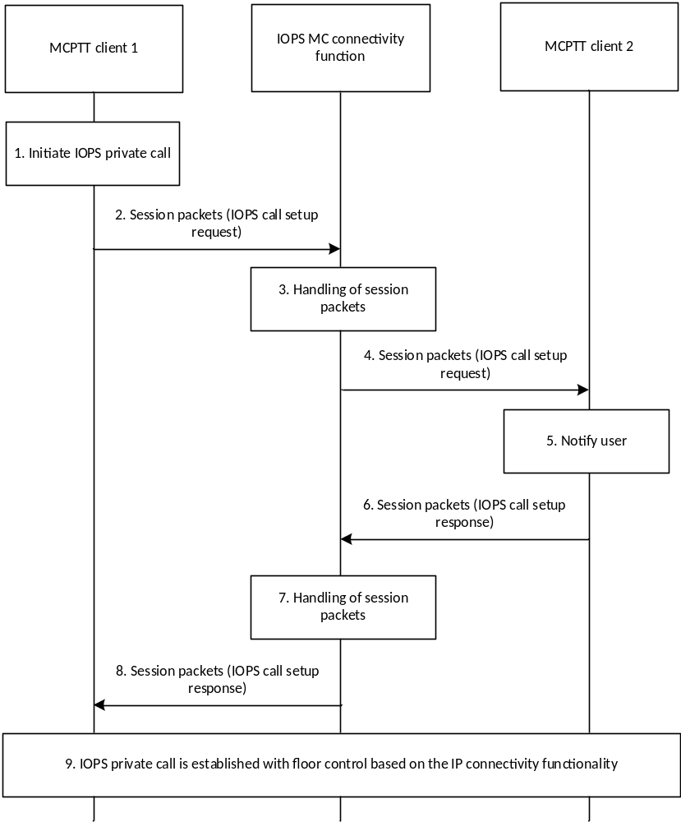
Figure 10.5.2.3-1: IOPS private call setup in automatic commencement mode based on the IP connectivity functionality
1. The MCPTT user at MCPTT client 1 would like to initiate an IOPS private call with the MCPTT user at MCPTT client 2 based on the IP connectivity functionality.
2. The MCPTT client 1 retrieves the connectivity information of the target MCPTT user from the IOPS connectivity client 1 (not shown in figure) and sends an IOPS call setup request towards the MCPTT client 2. The MCPTT client 1 transmits the session packets carrying the IOPS call setup request to the IOPS MC connectivity function for distribution to the corresponding target MCPTT UE 2's IP address.
The IOPS call setup request contains an SDP offer, an automatic commencement mode indication, and an element that indicates that MCPTT client 1 is requesting the floor. The IOPS private call request may include location information.
3. The IOPS MC connectivity function receives the session packets addressing the MCPTT UE 2's IP address. The IOPS MC connectivity function checks if the MCPTT UE 2's IP address corresponds to a discovered MC user in order to distribute the received session packets. If it does, the IOPS MC connectivity function distributes the received session packets to the target MCPTT client over unicast transmissions.
4. The IOPS MC connectivity function distributes the session packets carrying the IOPS call setup request to the MCPTT client 2.
5. The MCPTT client 2 notifies the target MCPTT user about the incoming IOPS private call.
6. The receiving MCPTT client 2 accepts the IOPS private call automatically, and an IOPS call setup response indicating the successful call establishment is sent to MCPTT client 1. The MCPTT client 2 transmits the session packet(s) carrying the IOPS call setup response to the IOPS MC connectivity function for distribution to the corresponding target MCPTT UE 1's IP address.
If MCPTT client 2 rejected the incoming call, the MCPTT client 2 sends an IOPS call setup response indicating the failure reason to the MCPTT client 1.
NOTE: Step 6 can also occur prior to step 5.
7. The IOPS MC connectivity function receives the session packets addressing the MCPTT UE 1's IP address. The IOPS MC connectivity function checks if the MCPTT UE 1's IP address corresponds to a discovered MC user in order to distribute the received session packets. If it does, the IOPS MC connectivity function distributes the received session packets to the target MCPTT client over unicast transmissions.
8. The IOPS MC connectivity function distributes the session packets carrying the IOPS call setup response to the MCPTT client 1.
9. The MCPTT client 1 and the MCPTT client 2 have successfully established the IOPS private call with floor control based on the IP connectivity functionality. The MCPTT client 1 is automatically granted the floor.

10.5.2.4 IOPS private call setup in manual commencement mode procedure
The procedure in figure 10.5.2.4-1 focuses on the case where an MCPTT user is initiating an IOPS MCPTT private call for communicating with another MCPTT user using a manual commencement mode. The IOPS MCPTT private call is based on the IP connectivity functionality.
Pre-conditions:
- MCPTT user profile used for the IOPS mode of operation is pre-provisioned in the MCPTT UEs.
- MCPTT users have an active PDN connection to the IOPS MC connectivity function for the communication based on the IP connectivity functionality.
- The MCPTT users are discovered by the IOPS MC connectivity function supporting the IP connectivity functionality.
- MCPTT clients have retrieved connectivity information from target MCPTT users.

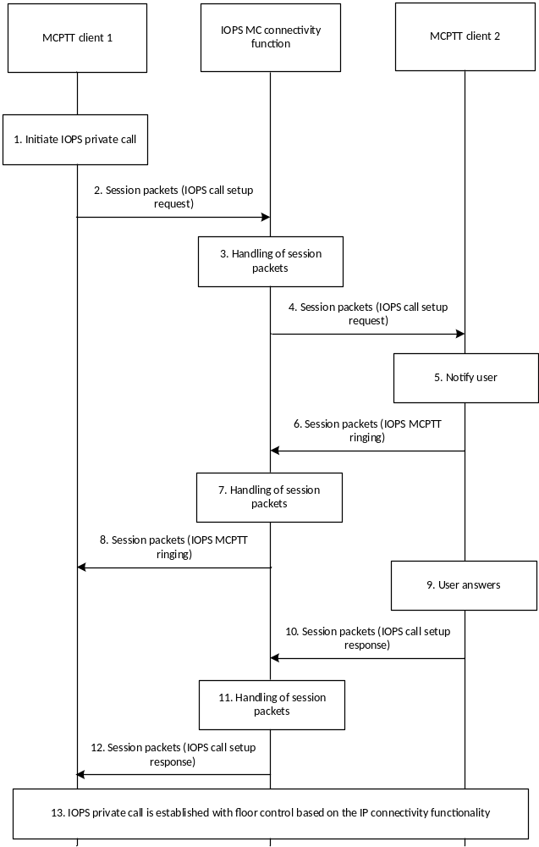
Figure 10.5.2.4-1: IOPS private call setup in manual commencement mode based on the IP connectivity functionality
1. The MCPTT user at MCPTT client 1 would like to initiate an IOPS MCPTT private call with the MCPTT user at MCPTT client 2 based on the IP connectivity functionality.
2. The MCPTT client 1 retrieves the connectivity information of the target MCPTT user from the IOPS connectivity client 1 (not shown in figure) and sends an IOPS call setup request towards the MCPTT client 2. The MCPTT client 1 transmits the session packets carrying the IOPS call setup request to the IOPS MC connectivity function for distribution to the corresponding target MCPTT UE 2's IP address.
The IOPS call setup request contains an SDP offer, a manual commencement mode indication, and an element that indicates that MCPTT client 1 is requesting the floor. The IOPS private call request may include location information.
3. The IOPS MC connectivity function receives the session packets addressing the MCPTT UE 2's IP address. The IOPS MC connectivity function checks if the MCPTT UE 2's IP address corresponds to a discovered MC user in order to distribute the received session packets. If it does, the IOPS MC connectivity function distributes the received session packets to the MCPTT client 2 over unicast transmissions.
4. The IOPS MC connectivity function distributes the session packets carrying the IOPS call setup request to the MCPTT client 2.
5. The MCPTT client 2 notifies the target MCPTT user about the incoming IOPS private call.
6. The MCPTT client 2 sends an IOPS MCPTT ringing message to the MCPTT client 1. The MCPTT client 2 transmits the session packet(s) carrying the IOPS MCPTT ringing to the IOPS MC connectivity function for distribution to the corresponding target MCPTT UE 1's IP address.
NOTE 1: Step 6 can also occur prior to step 5.
7. The IOPS MC connectivity function receives the session packets addressing the MCPTT UE 1's IP address. The IOPS MC connectivity function checks if the MCPTT UE 1's IP address corresponds to a discovered MC user in order to distribute the received session packets. If it does, the IOPS MC connectivity function distributes the received session packets to the MCPTT client 1 over unicast transmissions.
8. The IOPS MC connectivity function distributes the session packets carrying the IOPS MCPTT ringing to the MCPTT client 1.
9. The MCPTT user at the MCPTT client 2 has accepted the call using manual commencement mode (i.e., it has taken some action to accept it via the user interface). The MCPTT user may also reject or fail to answer the incoming call.
NOTE 2: Step 9 can also occur at any time between steps 6 and 8.
10. The MCPTT client 2 sends an IOPS call setup response indicating the successful call establishment to the MCPTT client 1. If the MCPTT client 2 rejected the call or the MCPTT user 2 rejected or failed to answer the incoming call, the MCPTT client 2 sends an IOPS call setup response indicating the failure reason to the MCPTT client 1. The MCPTT client 2 transmits the session packet(s) carrying the IOPS call setup response to the IOPS MC connectivity function for distribution to the corresponding target MCPTT UE 1's IP address.
11. The IOPS MC connectivity function receives the session packets addressing the MCPTT UE 1's IP address. The IOPS MC connectivity function checks if the MCPTT UE 1's IP address corresponds to a discovered MC user in order to distribute the received session packets. If it does, the IOPS MC connectivity function distributes the received session packets to the MCPTT client 1 over unicast transmissions.
12. The IOPS MC connectivity function distributes the session packets carrying the IOPS call setup response to the MCPTT client 1.
13. The MCPTT client 1 and the MCPTT client 2 have successfully established the IOPS private call with floor control based on the IP connectivity functionality. The MCPTT client 1 is automatically granted the floor.

10.5.2.5 IOPS private call release
The procedure in figure 10.5.2.5-1 focuses on the case where an MCPTT client is requesting to release an ongoing IOPS MCPTT private call based on the IP connectivity functionality. Either MCPTT client can initiate the call release procedure.
Pre-conditions:
- Two MCPTT users are currently engaged in an IOPS MCPTT private call based on the IP connectivity functionality.
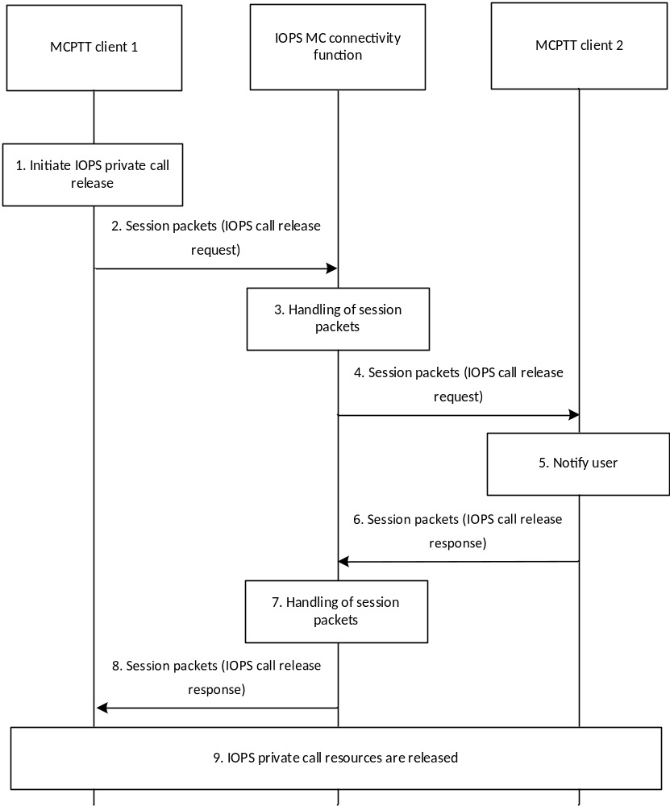
Figure 10.5.2.5-1: IOPS private call release based on the IP connectivity functionality
1. The MCPTT user at MCPTT client 1 would like to initiate an IOPS MCPTT private call release to the MCPTT user at MCPTT client 2 based on the IP connectivity functionality.
2. The MCPTT client 1 retrieves the connectivity information of the target MCPTT user from the IOPS connectivity client 1 (not shown in figure) and sends an IOPS call release request towards the MCPTT client 2. The MCPTT client 1 transmits the session packets carrying the IOPS call release request to the IOPS MC connectivity function for distribution to the corresponding target MCPTT UE 2's IP address.
3. The IOPS MC connectivity function receives the session packets addressing the MCPTT UE 2's IP address. The IOPS MC connectivity function checks if the MCPTT UE 2's IP address corresponds to a discovered MC user in order to distribute the received session packets. If it does, the IOPS MC connectivity function distributes the received session packets to the MCPTT client 2 over unicast transmissions.
4. The IOPS MC connectivity function distributes the session packets carrying the IOPS call release request to the MCPTT client 2.
5. The MCPTT client 2 notifies the MCPTT user about the IOPS private call release.
6. The MCPTT client 2 sends an IOPS call release response indicating the successful call release to the MCPTT client 1. The MCPTT client 2 transmits the session packet(s) carrying the IOPS call release response to the IOPS MC connectivity function for distribution to the corresponding target MCPTT UE 1's IP address.
NOTE: Step 6 can also occur prior to step 5.
7. The IOPS MC connectivity function receives the session packets addressing the MCPTT UE 1's IP address. The IOPS MC connectivity function checks if the MCPTT UE 1's IP address corresponds to a discovered MC user in order to distribute the received session packets. If it does, the IOPS MC connectivity function distributes the received session packets to the MCPTT client 1 over unicast transmissions.
8. The IOPS MC connectivity function distributes the session packets carrying the IOPS call release response to the MCPTT client 1.
9. The MCPTT client 1 and the MCPTT client 2 release all associated call resources from the private call communication based on the IP connectivity functionality.

10.5.2.6 IOPS emergency private call
The procedure in figure 10.5.2.6-1 is the basic procedure for an MCPTT client initiating the establishment of an IOPS emergency private call with a target MCPTT client based on the IP connectivity functionality. The IOPS emergency private call is a special case of the IOPS private call setup procedures described in clause 10.5.2.3, wherein the IOPS call setup request contains an indication that the IOPS private call is an IOPS emergency private call. The called MCPTT user can become aware of the emergency state of the calling MCPTT user based on the emergency indicator.
When an MCPTT client intends to initiate an IOPS emergency private call, the MCPTT client can request higher priority from the IOPS MC connectivity function via the IOPS discovery request.
For the case of an IOPS private call in-progress, either call participant can upgrade the call to an IOPS emergency private call by sending an IOPS emergency private call upgrade.
The emergency state of the call remains until the emergency call ends.
Pre-conditions:
- MCPTT user profile used for the IOPS mode of operation is pre-provisioned in the MCPTT UEs.
- MCPTT users have an active PDN connection to the IOPS MC connectivity function for the communication based on the IP connectivity functionality
- The MCPTT users are discovered by the IOPS MC connectivity function supporting the IP connectivity functionality.
- MCPTT clients have retrieved connectivity information from target MCPTT users.

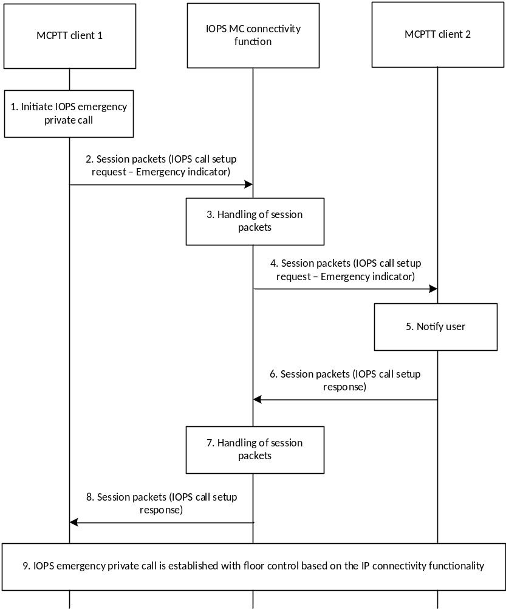
Figure 10.5.2.6-1: IOPS emergency private call setup based on the IP connectivity functionality
1. The MCPTT user at MCPTT client 1 would like to initiate an IOPS emergency private call with the MCPTT user at MCPTT client 2 based on the IP connectivity functionality.
NOTE 1: The MCPTT client 1 may have previously requested higher priority from the IOPS MC connectivity function using the IOPS discovery request.
2. The MCPTT client 1 retrieves the connectivity information of the target MCPTT user from the IOPS connectivity client 1 (not shown in figure) and sends an IOPS call setup request towards the MCPTT client 2. The request contains an indication that the call is an IOPS emergency private call. The MCPTT client 1 transmits the session packets carrying the IOPS call setup request to the IOPS MC connectivity function for distribution to the corresponding target MCPTT UE 2's IP address.
3. The IOPS MC connectivity function receives the session packets addressing the MCPTT UE 2's IP address. The IOPS MC connectivity function checks if the MCPTT UE 2's IP address corresponds to a discovered MC user in order to distribute the received session packets. If it does, the IOPS MC connectivity function distributes the received session packets to the target MCPTT client over unicast transmissions. If the MCPTT client 1 requested a priority state from the IOPS MC connectivity function, the IOPS MC connectivity function distributes the session packets with higher priority.
4. The IOPS MC connectivity function distributes the session packets carrying the IOPS call setup request to the MCPTT client 2.
5. The MCPTT client 2 notifies the target MCPTT user about the incoming IOPS emergency private call.
6. The receiving MCPTT client 2 accepts the IOPS emergency private call and an IOPS call setup response indicating the successful call establishment is sent to MCPTT client 1. The MCPTT client 2 transmits the session packet(s) carrying the IOPS call setup response to the IOPS MC connectivity function for distribution to the corresponding target MCPTT UE 1's IP address.
NOTE 2: Whilst the IOPS emergency private call is in progress, the MCPTT client 2 may also request higher priority from the IOPS MC connectivity function using the IOPS discovery request.
NOTE 3: Step 6 can also occur prior to step 5.
7. The IOPS MC connectivity function receives the session packets addressing the MCPTT UE 1's IP address. The IOPS MC connectivity function checks if the MCPTT UE 1's IP address corresponds to a discovered MC user in order to distribute the received session packets. If it does, the IOPS MC connectivity function distributes the received session packets to the target MCPTT client over unicast transmissions. If any participating MCPTT client of the call requested a priority state from the IOPS MC connectivity function, the IOPS MC connectivity function distributes the session packets with higher priority.
8. The IOPS MC connectivity function distributes the session packets carrying the IOPS call setup response to the MCPTT client 1.
9. The MCPTT client 1 and the MCPTT client 2 have successfully established the IOPS emergency private call based on the IP connectivity functionality.

10.5.3 IOPS floor control (IP connectivity functionality)

10.5.3.1 General
For MCPTT calls based on the IP connectivity functionality in the IOPS mode of operation, floor control is performed by using floor control messages among the MCPTT clients without a centralized MCPTT server. The MCPTT client can transmit voice packets over the IOPS MC connectivity function once it is granted the right to speak, either locally in the UE or by the reception of a floor granted message from another MCPTT client.
The MCPTT client currently speaking performs the temporary floor arbitrator during speaking since there is no centralized MCPTT floor control server. The floor arbitrator controls the floor whether or not queue is supported, and when floor is requested with override. If queue is supported, the MCPTT client performing floor arbitrator grants the right to speak to the next speaker and transfers the floor arbitrator role after completing the voice transfer and releasing the floor. For IOPS group calls, the floor arbitrator also transfers the floor control queue when granting the floor. The next MCPTT client receiving the right to speak becomes the new floor arbitrator and, for IOPS group calls, has the floor control queue.
For IOPS group calls, the group session packets carrying the floor control messages can be transmitted by the IOPS MC connectivity function over MBMS transmissions and can be monitored by all the members from the target IOPS MCPTT group.
The following clauses specify the floor control procedures and information flows for IOPS private calls and IOPS group calls based on the IP connectivity functionality in the IOPS mode of operation.

10.5.3.2 Information flows

10.5.3.2.1 IOPS floor request
Table 10.5.3.2.1-1 describes the information flow for the IOPS floor request, from the floor participant to another floor participant, which is used to request the floor for media transfer. The packet(s) carrying the IOPS floor request are transmitted from the requesting MCPTT client to the IOPS MC connectivity function for distribution to the target MCPTT client.
Table 10.5.3.2.1-1: IOPS floor request
Information element | Status | Description
IOPS MCPTT ID | M | Requester identity
Floor priority | M | Priority of the request

10.5.3.2.2 IOPS floor taken
Table 10.5.3.2.2-1 describes the information flow for the IOPS floor taken, from the floor participant to the floor participant, which is used to indicate the floor is granted to an MCPTT user. The packet(s) carrying the IOPS floor taken are transmitted from the originating MCPTT client to the IOPS MC connectivity function for distribution to target MCPTT client.
Table 10.5.3.2.2-1: IOPS floor taken
Information element | Status | Description
IOPS MCPTT ID | M | Identity for the granted party
Acknowledgement required | O | Indicates if acknowledgement from the floor participant is required

10.5.3.3 IOPS floor control during silence
If a floor arbitrator does not exist, figure 10.5.3.3-1 shows the successful high level floor control procedure during periods when there is no detectable talker in an IOPS group call based on the IP connectivity functionality.
NOTE 1: The description also applies to IOPS private calls.
Pre-conditions:
- MCPTT user profile used for the IOPS mode of operation is pre-provisioned in the MCPTT UEs.
- MCPTT users have an active PDN connection to the IOPS MC connectivity function for the communication based on the IP connectivity functionality
- The IOPS MCPTT group ID and its associated IOPS group IP multicast address are pre-configured in the MCPTT clients (for the case of an IOPS group call)
- The IOPC MC connectivity function may have established an MBMS bearer and announced it to the MCPTT clients
- The MCPTT users are discovered by the IOPS MC connectivity function supporting the IP connectivity functionality.
- MCPTT clients has retrieved connectivity information from the target MCPTT user (for the case of an IOPS private call).
- An IOPS private call or IOPS group call based on the IP connectivity functionality has been established. No participant is currently talking (i.e. the floor is idle) and no floor arbitrator is identified.
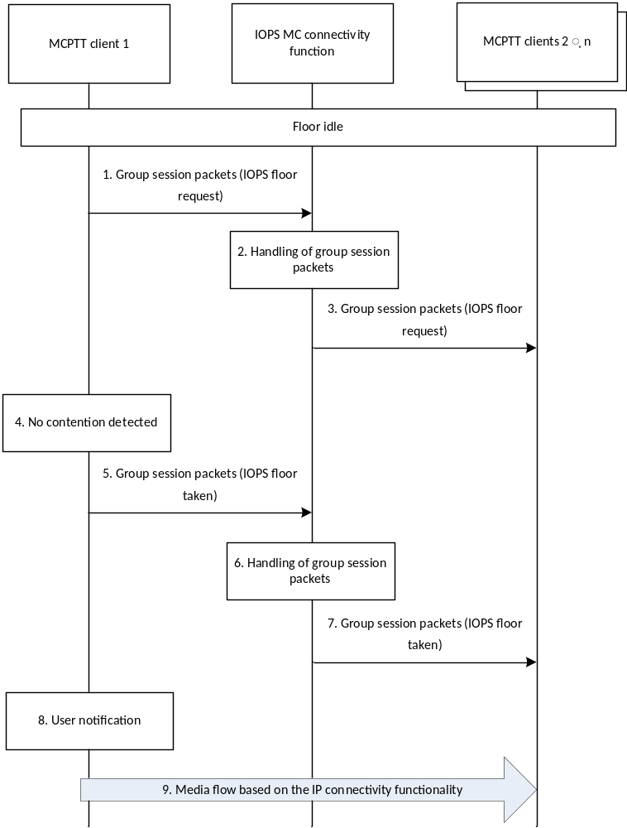
Figure 10.5.3.3-1: Successful floor taken flow in an IOPS group call based on the IP connectivity functionality (no floor contention)
1. The MCPTT client 1 sends the IOPS floor request message to the target IOPS MCPTT group. The MCPTT client 1 transmits the group session packets carrying the IOPS floor request message to the IOPS MC connectivity function for distribution to the corresponding IOPS group IP multicast address.
2. The IOPS MC connectivity function determines that the received packets correspond to a group session targeting a specific IOPS MCPTT group. The IOPS MC connectivity function decides distributing the received group session packets to the target MCPTT clients over MBMS and/or unicast transmissions.
3. The IOPS MC connectivity function distributes the group session packets carrying the IOPS floor request to the MCPTT clients from the target IOPS MCPTT group.

4. The MCPTT client 1 does not detect any floor contention. Floor contention occurs when multiple floor requests may exist simultaneously.
NOTE 2: The mechanism for detecting floor contention in the IOPS mode of operation is out of scope of the present document.
5. The MCPTT client 1 sends the IOPS floor taken message to the IOPS MCPTT group. The MCPTT client 1 transmits the group session packets carrying the IOPS floor taken message to the IOPS MC connectivity function for distribution to the corresponding IOPS group IP multicast address.
6. The IOPS MC connectivity function determines that the received packets correspond to a group session targeting a specific IOPS MCPTT group. The IOPS MC connectivity function decides distributing the received group session packets to the target MCPTT clients over MBMS and/or unicast transmissions.
7. The IOPS MC connectivity function distributes the group session packets carrying the IOPS floor taken message to the MCPTT clients from the target IOPS MCPTT group.
8. The MC user at MCPTT client 1 gets a notification that the IOPS floor request was successful (the floor has been granted).
NOTE 3: Step 8 can also occur prior to steps 6 and 7.
9. The MCPTT client 1 begins voice transmission with the target IOPS MCPTT group based on the IP connectivity functionality.

10.6 MCData service

10.6.1 IOPS short data service (IP connectivity functionality)

10.6.1.1 General
The support of the MCData short data service (SDS) based on the IP connectivity functionality in the IOPS mode of operation enables that the service is provided by the MCData clients over the IOPS MC connectivity function. The IOPS MC connectivity function provides IP connectivity for the communication among MCData users.

10.6.1.2 Information flows

10.6.1.2.1 IOPS MCData standalone data request
Table 10.6.1.2.1-1 describes the information flow for the IOPS MCData standalone data request from one MCData client to another MCData client. The packet(s) carrying the IOPS MCData standalone data request are transmitted from the sending MCData client to the IOPS MC connectivity function for distribution to the target MCData client.
Table 10.6.1.2.1-1: IOPS MCData standalone data request
Information element | Status | Description
IOPS MCData ID | M | The identity of the MCData user sending data
IOPS MCData ID | M | The identity of the MCData user towards which the data is sent
Conversation Identifier | M | Identifies the conversation
Transaction Identifier | M | Identifies the MCData transaction
Reply Identifier | O | Identifies the original MCData transaction to which the current transaction is a reply to
Disposition Type | O | Indicates the disposition type expected from the receiver (i.e., delivered or read or both)
Payload Destination Type | M | Indicates whether the payload is for application consumption or MCData user consumption
Application identifier (see NOTE) | O | Identifies the application for which the payload is intended (e.g. text string, port address, URI)
Payload | M | SDS content
NOTE: The application identifier shall be included only if the payload destination type indicates that the payload is for application consumption.

10.6.1.2.2 IOPS MCData data disposition notification
Table 10.6.1.2.2-1 describes the information flow for the IOPS MCData data disposition notification from one MCData client to another MCData client. The packet(s) carrying the IOPS MCData data disposition notification are transmitted from the sending MCData client to the IOPS MC connectivity function for distribution to the target MCData client.
Table 10.6.1.2.2-1: IOPS MCData data disposition notification
Information element | Status | Description
IOPS MCData ID | M | The identity of the MCData user towards which the notification is sent
IOPS MCData ID | M | The identity of the MCData user sending notification
Conversation Identifier | M | Identifies the conversation
Disposition association | M | Identity of the original MCData transaction
Disposition | M | Disposition which is delivered or read or both

10.6.1.2.3 IOPS MCData group standalone data request
Table 10.6.1.2.3-1 describes the information flow for the IOPS MCData group standalone data request from one MCData client to other MCData clients. The packet(s) carrying the IOPS MCData group standalone data request are transmitted from the sending MCData client to the IOPS MC connectivity function for distribution to the target MCData clients.
Table 10.6.1.2.3-1: IOPS MCData group standalone data request
Information element | Status | Description
IOPS MCData ID | M | The identity of the MCData user sending data
IOPS MCData group ID | M | The IOPS MCData group ID to which the data is to be sent
Conversation Identifier | M | Identifies the conversation
Transaction Identifier | M | Identifies the MCData transaction
Reply Identifier | O | Identifies the original MCData transaction to which the current transaction is a reply to
Disposition Type | O | Indicates the disposition type expected from the receiver (i.e., delivered or read or both)
Payload Destination Type | M | Indicates whether the payload is for application consumption or MCData user consumption
Application identifier (see NOTE) | O | Identifies the application for which the payload is intended (e.g. text string, port address, URI)
Payload | M | SDS content
NOTE: The application identifier shall be included only if the payload destination type indicates that the payload is for application consumption.

10.6.1.3 IOPS one-to-one standalone SDS using signalling control plane

10.6.1.3.1 General
When an MCData user initiates an IOPS standalone SDS data transfer with another MCData user using the signalling control plane based on the IP connectivity functionality, the MCData client retrieves the connectivity information of the target MCData user (i.e. the MCData UE's IP address) from the IOPS connectivity client. Then, the MCData client enables the IOPS SDS data transfer over the IOPS MC connectivity function. The related session packets, i.e. signalling messages, carrying the data are transmitted to the IOPS MC connectivity function addressing the corresponding target MCData UE's IP address.
NOTE: The IOPS connectivity client can only provide connectivity information of the target MCData user if it is already available (see clauses 10.3 on IOPS subscription and notification procedures).
The IOPS MC connectivity function distributes the received session packets over unicast transmissions to the target MCData client.

10.6.1.3.2 Procedure
The procedure in figure 10.6.1.3.2-1 describes the case where an MCData user is initiating an IOPS one-to-one MCData communication for sending standalone SDS data over signalling control plane to another MCData user, with or without disposition request. Standalone refers to sending unidirectional data in one transaction.
Pre-conditions:
- MCData user profile used for the IOPS mode of operation is pre-provisioned in the MCData UEs.
- MCData users have an active PDN connection to the IOPS MC connectivity function for the communication based on the IP connectivity functionality.
- The MCData users are discovered by the IOPS MC connectivity function supporting the IP connectivity functionality.
- MCData clients have retrieved connectivity information from target MCData users.
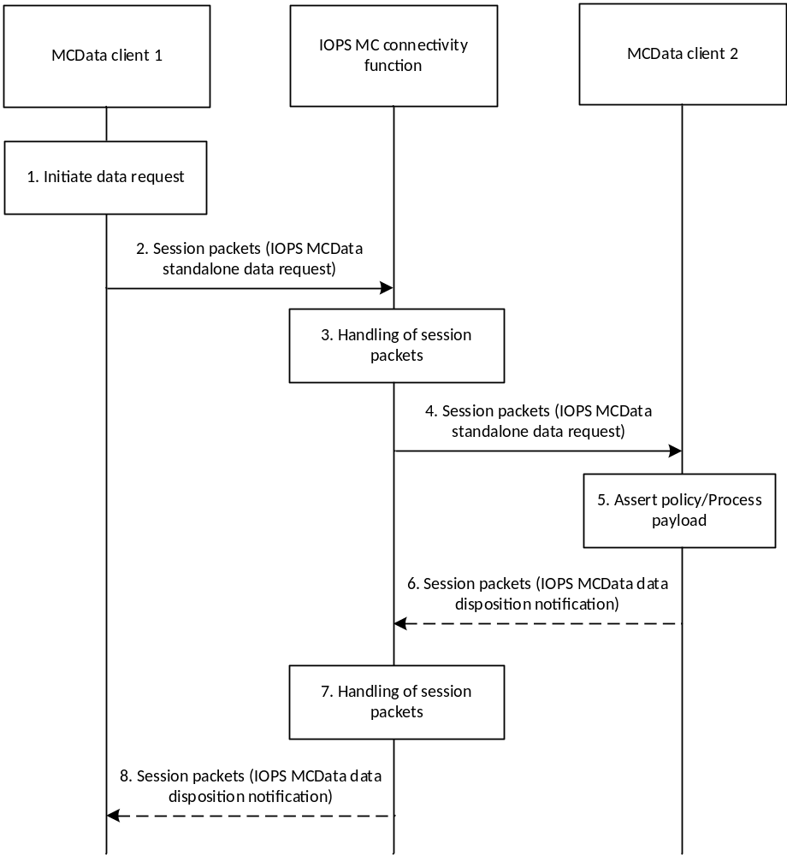
Figure 10.6.1.3.2-1: IOPS one-to-one standalone SDS using signalling control plane based on the IP connectivity functionality
1. The MCData user at MCData client 1 would like to initiate an IOPS SDS data transfer with the MCData user at MCData client 2 based on the IP connectivity functionality. The MCData client 1 checks whether the MCData user 1 is authorized to send an IOPS MCData standalone data request.
2. The MCData client 1 retrieves the connectivity information of the target MCData user from the IOPS connectivity client 1 (not shown in figure) and sends an IOPS MCData standalone data request towards the MCData client 2. The MCData client 1 transmits the session packets carrying the IOPS MCData standalone data request to the IOPS MC connectivity function for distribution to the corresponding target MCData UE 2's IP address.
The IOPS MCData standalone data request contains the data payload, i.e. the SDS content. The request also contains a conversation identifier for message thread indication and may contain a disposition request if indicated by the user at MCData client 1.
3. The IOPS MC connectivity function receives the session packets addressing the MCData UE 2's IP address. The IOPS MC connectivity function checks if the MCData UE 2's IP address corresponds to a discovered MC user in order to distribute the received session packets. If it does, the IOPS MC connectivity function distributes the received session packets to the target MCData client over unicast transmissions.
4. The IOPS MC connectivity function distributes the session packets carrying the IOPS MCData standalone data request to the MCData client 2.
5. Upon the receipt of the IOPS MCData standalone data request, the MCData client 2 checks whether any policy is to be asserted to limit certain types of message or content to certain members due to, for example, location or user privilege. If the policy assertion is positive and the payload is for MCData user consumption (e.g. it is not application data, not command instructions, etc.) then the MCData client 2 notifies the target MCData user.
The actions taken when the payload contains application data or command instructions are based on the payload content. Payload content received by MCData client 2 which is addressed to a known local non-MCData application that is not yet running shall cause the MCData client 2 to start the local non-MCData application (i.e., remote start application) and shall pass the payload content to the just started application.
NOTE: If the policy assertion was negative, the MCData client 2 sends an appropriate notification to MCData client 1.
6. If MCData data disposition was indicated (for delivery, read or both) within the request sent by the MCData client 1, then the receiving MCData client 2 initiates the corresponding IOPS MCData data disposition notification(s) towards the MCData client 1, i.e. addressing the MCData UE 1's IP address.
7. The IOPS MC connectivity function receives the session packets addressing the MCData UE 1's IP address. The IOPS MC connectivity function checks if the MCData UE 1's IP address corresponds to a discovered MC user in order to distribute the received session packets. If it does, the IOPS MC connectivity function distributes the received session packets to the target MCData client over unicast transmissions.
8. The IOPS MC connectivity function distributes the session packets carrying the IOPS MCData data disposition notification to the MCData client 1.

10.6.1.4 IOPS group standalone SDS using signalling control plane

10.6.1.4.1 General
IOPS group standalone SDS using signalling control plane based on the IP connectivity functionality can use pre-configured information provided to MCData clients prior to initiating the data service. When an MCData client initiates an IOPS group standalone SDS based on the IP connectivity functionality it uses the pre-configured IOPS group IP multicast address associated to the target IOPS MCData group ID. The related group session packets, i.e. signalling messages, carrying the data are transmitted to the IOPS MC connectivity function for distribution to the corresponding discovered MC users of the target IOPS MCData group.
The IOPS MC connectivity function can distribute the group session packets to the discovered MC users over MBMS bearers as described in clause 10.4.5.
The IOPS MC connectivity function can also replicate and distribute the group session packets over unicast transmissions to MCData UEs associated to the target IOPS MCData group. MCData UEs receiving the group session packets are associated to discovered MC users that included the target IOPS MCData group ID within the IOPS discovery request, as described in clause 10.5.2.3.

10.6.1.4.2 Procedure
The procedure in figure 10.6.1.4.2-1 describes the case where an MCData user is initiating an IOPS group MCData communication for sending standalone SDS data over signalling control plane to an IOPS MCData group, with or without disposition request. Standalone refers to sending unidirectional data in one transaction.
Pre-conditions:
- MCData user profile used for the IOPS mode of operation is pre-provisioned in the MCData UEs.
- The IOPS MCData group ID and its associated IOPS group IP multicast address are pre-configured in the MCData clients.
- MCData users have an active PDN connection to the IOPS MC connectivity function for the communication based on the IP connectivity functionality.
- MCData users affiliated to the target IOPS MCData group are discovered by the IOPS MC connectivity function supporting the IP connectivity functionality.
- The IOPS MC connectivity function may have established an MBMS bearer and announced it to the MCData clients.
- MCData client 1 may have retrieved group connectivity information from the IOPS connectivity client related to the target IOPS MCData group.
- MCData clients 1, 2 … n are configured within the same IOPS MCData group.
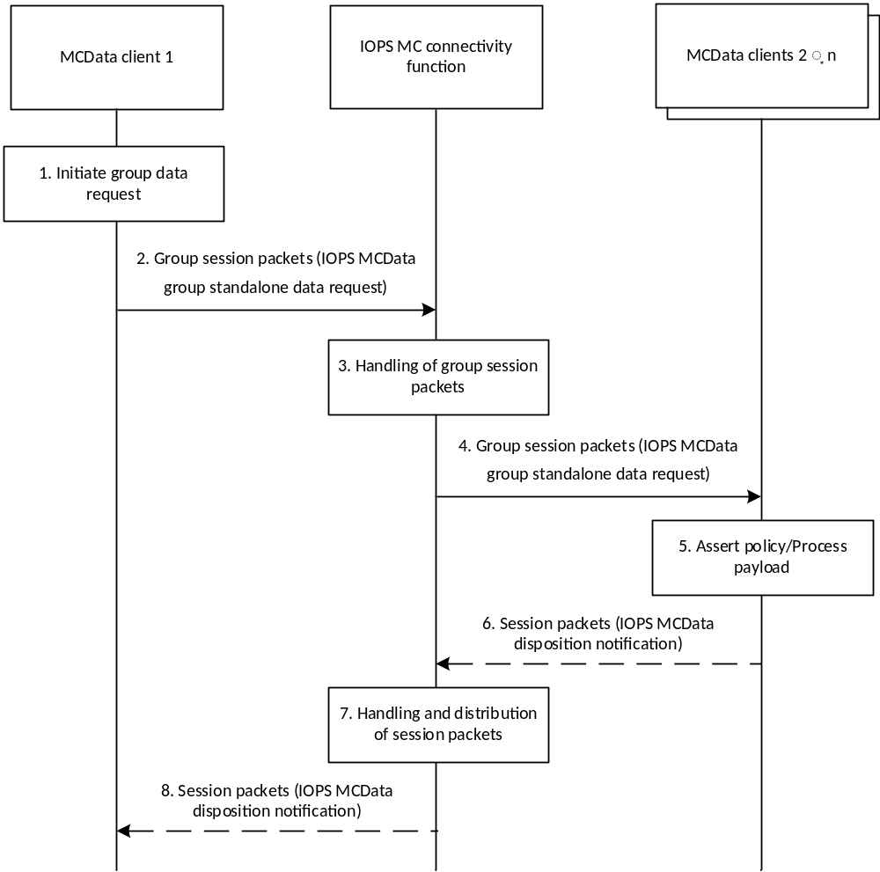
Figure 10.6.1.4.2-1: IOPS group standalone SDS using signalling control plane based on the IP connectivity functionality
1. The MCData user at MCData client 1 would like to initiate an IOPS SDS data transfer with a specific IOPS MCData group based on the IP connectivity functionality. The MCData client 1 checks whether the MCData user 1 is authorized to send an IOPS MCData group standalone data request.
2. The MCData client 1 sends an IOPS MCData group standalone data request to the target IOPS MCData group. The MCData client 1 transmits the group session packets carrying the IOPS MCData group standalone data request to the IOPS MC connectivity function for distribution to the corresponding IOPS group IP multicast address.
The IOPS MCData group standalone data request contains the data payload, i.e. the SDS content. The request also contains a conversation identifier for message thread indication and may contain a disposition request if indicated by the user at MCData client 1.
3. The IOPS MC connectivity function determines that the received packets correspond to a group session targeting a specific IOPS MCData group. The IOPS MC connectivity function decides distributing the received group session packets to the target MCData clients over MBMS and/or unicast transmissions.
4. The IOPS MC connectivity function distributes the group session packets carrying the IOPS MCData group standalone data request to the discovered MCData clients from the target IOPS MCData group.
5. The MCData clients receiving the IOPS MCData group standalone data request check whether any policy is to be asserted to limit certain types of message or content to certain members due to, for example, location or user privilege. If the policy assertion is positive and the payload is for MCData user consumption (e.g. it is not application data, not command instructions, etc.) then the MCData clients notify the target MCData users.
The actions taken when the payload contains application data or command instructions are based on the payload content. Payload content received by an MCData client which is addressed to a known local non-MCData application that is not yet running shall cause the MCData client to start the local non-MCData application (i.e., remote start application) and shall pass the payload content to the just started application.
NOTE: If the policy assertion was negative, the corresponding MCData client sends an appropriate notification to MCData client 1.
6. If MCData data disposition was indicated (for delivery, read or both) within the request sent by the MCData client 1, then the receiving MCData clients initiate the corresponding IOPS MCData data disposition notification(s) towards the MCData client 1, i.e. addressing the MCData UE 1's IP address.
7. The IOPS MC connectivity function receives the session packets addressing the MCData UE 1's IP address. The IOPS MC connectivity function checks if the MCData UE 1's IP address corresponds to a discovered MC user in order to distribute the received session packets. If it does, the IOPS MC connectivity function distributes the received session packets to the target MCData client over unicast transmissions.
8. The IOPS MC connectivity function distributes the session packets carrying the IOPS MCData data disposition notification to the MCData client 1.

10.7 MC IOPS notification

10.7.1 General
In the IOPS mode of operation, it is assumed that the IOPS MC system does not have connectivity to the primary MC system due to the backhaul failure. Therefore, the primary MC system cannot be aware of the initiation of the IOPS operation and the corresponding activation of an IOPS MC connectivity function within the primary MC system coverage.
When an IOPS MC system is active, MC service UEs can move around and may enter and leave the IOPS MC system coverage, i.e. the MC service users may switch from the active IOPS MC connectivity function to the MC service server of the primary MC system, and vice versa.
In order to notify the primary MC service server about the active IOPS MC connectivity function, when MC service users register to the primary MC service server after being recently registered to the IOPS MC connectivity function, the MC service users can provide information to the primary MC service server about the active IOPS MC connectivity function and optionally include associated dynamic information. The primary MC service server uses the provided information to become aware of the active IOPS MC connectivity function.
NOTE: Dynamic information can be, e.g., information about other available MC service users or active MC service groups that the MC service user identified while on the IOPS MC connectivity function. The primary MC service server can use the dynamic information to determine that affiliated MC service users might be registered on the active IOPS MC connectivity function and might not be reachable on the system.
Upon the receipt of the notification, the primary MC service server may notify other MC service users in the proximity of the IOPS MC system coverage about the corresponding active IOPS MC connectivity function. This information can be used by the MC service users to optimize the user experience, e.g. to improve the switching time between systems and to obtain information about the potential availability of other registered MC service users or active MC service groups on the IOPS MC connectivity function.

10.7.2 Information flows

10.7.2.1 MC IOPS notification
Table 10.7.2.1-1 describes the information flow MC IOPS notification from the MC service client to the primary MC service server.
Table 10.7.2.1-1: MC IOPS notification
Information element | Status | Description
MC service ID | M | The identity of the MC service user providing the notification
IOPS MC system information | M | Information related to the identified active IOPS MC connectivity function (see NOTE)
List of MC service group IDs | O | The list of groups identified by the MC service user as active on the IOPS MC connectivity function
List of MC service IDs | O | The list of other users identified by the MC service user as available on the IOPS MC connectivity function
NOTE: The IOPS MC system information consists of the following elements: IOPS PLMN ID, server URI of the IOPS MC connectivity function, and location information (set of coordinates including altitude, longitude and latitude, and time of measurement and optional accuracy) related to the MC service user registration on the IOPS MC connectivity function.

Table 10.7.2.1-2 describes the information flow MC IOPS notification from the primary MC service server to the MC service client.
Table 10.7.2.1-2: MC IOPS notification
Information element | Status | Description
MC service ID (see NOTE 1) | M | The identity of the MC service user receiving the notification
IOPS MC system information | M | Information related to the identified active IOPS MC connectivity function (see NOTE 2)
List of MC service group IDs (see NOTE 3) | O | The list of MC service groups identified as active on the IOPS MC connectivity function
List of MC service IDs (see NOTE 3) | O | The list of MC service users identified as available on the IOPS MC connectivity function
NOTE 1: This information element is not included if the notification is transmitted over MBMS.
NOTE 2: The IOPS MC system information consists of the following elements: server URI of the IOPS MC connectivity function, and location information (set of coordinates including altitude, longitude and latitude) where the IOPS MC connectivity function is identified as active.
NOTE 3: The MC service server may provide information about identified active MC service groups or available MC service users on the IOPS MC connectivity function. This information is only included if the MC service user receiving the notification is authorized, e.g. if the MC service user is a member of the corresponding MC service groups. This information element is not included if the notification is transmitted over MBMS.

10.7.3 MC IOPS notification procedure
Figure 10.7.3-1 describes the IOPS MC notification procedure when an MC service user has left an active IOPS MC system and enters the primary MC system.
Pre-conditions:
- There is an active IOPS MC connectivity function and the neighbouring cells of the IOPS MC system are part of the primary MC system.
- The MC service user 1 is initially registered to the IOPS MC connectivity function for the support of MC services in the IOPS mode of operation. The MC service user 1 is authorized to provide MC IOPS notifications to the primary MC service server.
- The MC service user 2 is registered to the primary MC service server and is in the proximity of the IOPS MC system coverage.
- MC server users 1 and 2 are members of the same MC service group or are authorized to have a one-to-one MC service communication.

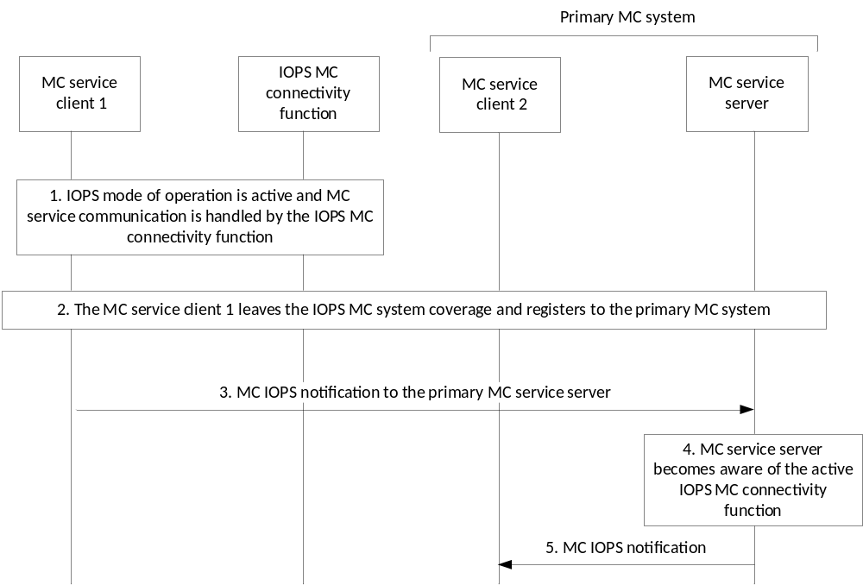
Figure 10.7.3-1: MC IOPS notification procedure
1. An IOPS mode of operation is active and the MC service communication is handled by the IOPS MC connectivity function. The MC service client 1 is registered to the IOPS MC connectivity function.
2. The MC service client 1 moves out of the coverage of the IOPS MC system and registers to the primary MC service server.
3. The MC service client 1 sends a MC IOPS notification to the primary MC service server to provide information about an active IOPS MC connectivity function in the area. This notification includes information about the active IOPS MC connectivity function such as server URI, associated IOPS PLMN ID, and location information. Also, the MC service client 1 may indicate which MC service groups and MC service users were identified as active and available on the IOPS MC connectivity function.
4. The primary MC service server becomes aware of the active IOPS MC connectivity function and can use the received information to determine that affiliated MC service users might be registered on the active IOPS MC connectivity function and might not be reachable on the system. If the primary MC service server determines that the IOPS MC connectivity function is active and identifies that affiliated MC service users are in the proximity of the IOPS MC system, the primary MC service server may notify the corresponding MC service users about the IOPS MC connectivity function.
NOTE 1: The primary MC service server can use received information from different MC IOPS notifications (e.g. location information including the time of measurement) and the information obtained from location information subscriptions (as described in 3GPP TS 23.280 [3]) to determine if the IOPS MC connectivity function might be still active. For instance, if information received from location information subscriptions indicates that MC service users are located within the notified active IOPS MC system coverage, the primary MC service server can determine that the IOPS MC connectivity function is no longer active.
5. If the primary MC service server determines that the IOPS MC connectivity function is active, it sends a MC IOPS notification to the MC service client 2 in proximity of the active IOPS MC system coverage. This information can be used by the MC service user to become aware of the active IOPS MC connectivity function. Hence, the MC service user might decide to not move into the IOPS MC system coverage or to improve the switching time between the systems. Also, the MC service user can be aware of the potential availability of MC service users or active MC service groups on the IOPS MC connectivity function.
NOTE 2: The MC IOPS notification can be sent on an MBMS bearer configured within the proximity of the active IOPS MC system to target multiple MC service users. In this case, information about the active MC service IDs and MC service group IDs is not included in the MC IOPS notification.

Annex A (normative):
Configuration data for the support of MC services in the IOPS mode of operation

A.1 General
This Annex provides information about the static configuration data needed for the support of MC services in the IOPS mode of operation.
The configuration data belong to one of the following categories:
- MC service UE configuration data (see subclause A.2);
- MC service user profile configuration data (see subclause A.3);
- MC service group configuration data (see subclause A.4); and
- MC service configuration data (see subclause A.5).
The configuration data in each configuration category corresponds to a single instance of the category type i.e. the MC service UE, MC service group, MC service user and MC service configuration data refers to the information that will be stored against each MC service UE, MC service group, MC service user and MC service.
NOTE: The configuration data described in this Annex together with corresponding configuration data provided in 3GPP TS 23.280 [3], 3GPP TS 23.379 [5] and 3GPP TS 23.282 [6] represent the complete set of data for each configuration data category element.
The columns in the tables have the following meanings:
- Reference: the reference of the corresponding requirement in 3GPP TS 22.346 [9] and 3GPP TS 22.280 [11] or the corresponding clause from either the present document or the referenced document.
- Parameter description: A short definition of the semantics of the corresponding item of data, including denotation of the level of the parameter in the configuration hierarchy.
- When it is not clear to which functional entities the parameter is configured, then one or more columns indicating this are provided where the following nomenclature is used:
- "Y" to denote "Yes" i.e. the parameter denoted for the row needs to be configured to the functional entity denoted for the column.
- "N" to denote "No" i.e. the parameter denoted for the row does not need to be configured to the functional entity denoted for the column.
Parameters within a set of configuration data have a level within a hierarchy that pertains only to that configuration data. The level of a parameter within the hierarchy of the configuration data is denoted by use of the character ">" in the parameter description field within each table, one per level. Parameters that are at the top-most level within the hierarchy have no ">" character. Parameters that have one or more ">" characters are child parameters of the first parameter above them that has one less ">" character. Parent parameters are parameters that have one or more child parameters. Parent parameters act solely as a "grouping" of their child parameters and therefore do not contain an actual value themselves i.e. they are just containers for their child parameters.
Each parameter that can be configured online shall only be configured through one online reference point. Each parameter that can be configured offline shall only be configured through one offline reference point. The most recent configuration data made available to the MC service UE shall always overwrite previous configuration data, irrespective of whether the configuration data was provided via the online or offline mechanism.

A.2 MC service UE configuration data
MC service UE configuration data has to be known by an MC service UE after MC service authorization. The CSC-4 reference point, specified in 3GPP TS 23.280 [3], is used for configuration between the configuration management server and the configuration management client on the MC service UE when the MC service UE is on-network.
MC service UE configuration data can be configured offline using the CSC-11 reference point specified in 3GPP TS 23.280 [3].
Within each MC service, the MC service UE configuration data can be the same or different across MC service UEs.
The MCPTT UE configuration data specified in table A.2-1 in 3GPP TS 23.379 [5] is also used, as needed, in the IOPS mode of operation for the MCPTT service.
The MCData UE configuration data specified in table A.2-1 in 3GPP TS 23.282 [6] is also used, as needed, in the IOPS mode of operation for the MCData service.

A.3 MC service user profile configuration data
The MC service user profile configuration data is stored in the MC service user database. The configuration management server is used to configure the MC service user profile configuration data to the MC service user database (CSC-13) and MC service UE (CSC-4), as specified in 3GPP TS 23.280 [3].
MC service user profile configuration data can be configured offline using the CSC-11 reference point specified in 3GPP TS 23.280 [3].
For the MCPTT service, the MCPTT user profile configuration data specified in table A.3-1 in 3GPP TS 23.379 [5] is also used, as needed, in the IOPS mode of operation, wherein the IOPS MCPTT user identity (IOPS MCPTT ID) can be the MCPTT user identity (MCPTT ID) or a specific ID configured for the IOPS mode of operation.
For the MCData service, the MCData user profile configuration data specified in table A.3-1 in 3GPP TS 23.282 [6] is also used, as needed, in the IOPS mode of operation, wherein the IOPS MCData user identity (IOPS MCData ID) can be the MCData user identity (MCData ID) or a specific ID configured for the IOPS mode of operation.
Table A.3-1 described below contains additional MC service user profile configuration required to support MC services in the IOPS mode of operation.
Table A.3-1: MC service user profile data (IOPS)
Reference | Parameter description | MC service UE | Configuration management server | MC service user database
[R-10-001] of 3GPP TS 22.280 [11] | List of IOPS MC service groups for use by an MC service user | Y | Y | Y
 | > IOPS MC service Group ID
 | > Application plane server identity information of group management server where group is defined
 | >> Server URI | Y | Y | Y
 | > Application plane server identity information of identity management server which provides authorization for group (see NOTE 1)
 | >> Server URI | Y | Y | Y
[R-10-001] of 3GPP TS 22.280 [11] | Authorization for participant to change an IOPS group call in-progress to IOPS emergency group call (see NOTE 2) | Y | Y | Y
[R-10-001] of 3GPP TS 22.280 [11] | Authorization for MC services in the IOPS mode of operation | Y | Y | Y
Clause 10.2.2.3 | Authorization for participant to indicate availability of connectivity information | Y | Y | Y
Clause 10.2.2.3 | Authorization for participant to request priority state | Y | Y | Y
NOTE 1: If this parameter is not configured, authorization to use the group shall be obtained from the identity management server identified in the initial MC service UE configuration data configured in 3GPP TS 23.280 [3].
NOTE 2: This parameter only applies for the MCPTT service.

A.4 Group configuration data
As specified in 3GPP TS 23.280 [3], the group configuration data is stored in the group management server. The group management server is used to configure the group configuration data to the MC service UE (CSC-2). The group configuration data can be configured offline using the CSC-12 reference point.
The common group configuration data specified in table A.4-1 in 3GPP TS 23.280 [3] is also used, as needed, in the IOPS mode of operation.
Table A.4-1 described below contains additional group configuration data required to support MC services in the IOPS mode of operation.
Table A.4-1: Group configuration data (IOPS)
Reference | Parameter description | MC service UE | Group management server
[R-10-001] of 3GPP TS 22.280 [11] | List of IOPS MC service groups | Y | Y
 | > IOPS MCPTT Group ID
Clause 8.1.3 | >> IOPS group IP multicast address | Y | Y
 | >> Preferred voice codecs for IOPS MCPTT group | Y | Y
 | >> Indication whether emergency group call is permitted on the IOPS MCPTT group | Y | Y
 | > IOPS MCData Group ID
Clause 8.1.3 | >> IOPS group IP multicast address | Y | Y
 | >> MCData sub-services and features enabled for the group
 | >>> Short data service enabled | Y | Y
 | >>> Whether MCData user is permitted to transmit data in the group | Y | Y
 | >>> Maximum amount of data that the MCData user can transmit in a single request during group communication | Y | Y
 | >>> Maximum amount of time that the MCData user can transmit in a single request during group communication | Y | Y

A.5 MC service configuration data
As specified in 3GPP TS 23.280 [3], the configuration management server is used to configure the MC service configuration data to the MC service UE (CSC-4). The MC service configuration data can be configured offline using the CSC-11 reference point.
Tables A.5-1 and A.5-2 describe the configuration data required to support in IOPS the use of MCPTT service and MCData service, respectively.
Table A.5-1: MCPTT service configuration data (IOPS)
Reference | Parameter description | MCPTT UE | Configuration management server
[R-10-001] of 3GPP TS 22.280 [11] | Max IOPS private call (with floor control) duration | Y | Y
[R-10-001] of 3GPP TS 22.280 [11] | Hang timer for private calls in IOPS | Y | Y
[R-10-001] of 3GPP TS 22.280 [11] | Priority hierarchy for floor control override in IOPS | Y | Y
[R-10-001] of 3GPP TS 22.280 [11] | Transmit time limit from a single request to transmit in a group or private call. | Y | Y
[R-10-001] of 3GPP TS 22.280 [11] | Configuration of warning time before time limit of transmission is reached in an IOPS call | Y | Y
[R-10-001] of 3GPP TS 22.280 [11] | Configuration of warning time before hang time is reached in an IOPS call | Y | Y
[R-10-001] of 3GPP TS 22.280 [11] | Configuration of metadata to log | Y | Y

Table A.5-2: MCData service configuration data (IOPS)
Reference | Parameter description | MCData UE | Configuration management server
[R-10-001] of 3GPP TS 22.280 [11] | Transmission and reception control
 | > Time limit for the temporarily stored data waiting to be delivered to a receiving user | Y | Y
 | > Timer for periodic announcement with the list of available recently invited data group communications | Y | Y

A.6 Initial MC service UE configuration data
Initial MC service UE configuration data is essential to the MC service UE to successfully connect to the MC system, as described in 3GPP TS 23.280 [3].
The configuration data defined in table A.6-1 is additionally provided to the MC service UE's clients to successfully connect to the IOPS MC system in the IOPS mode of operation. The MC service UE's clients (e.g. MC service client, IOPS connectivity client) obtain the data during the bootstrap process (described in clause 10.1.1 in 3GPP TS 23.280 [3]), and can be configured on the MC service UE offline using the CSC-11 reference point or via other means e.g. as part of the MC service client's provisioning on the UE, using a device management procedure.
Table A.6-1: Initial MC service UE configuration data (IOPS)
Reference | Parameter description
Clause 5.4.3 | PDN connectivity information in IOPS
 | > IOPS HPLMN ID and optionally IOPS VPLMN ID to which the data pertains
 | > MC services PDN in IOPS
 | >> APN
 | >> PDN access credentials
 | Application plane server identity information
 | > Indication of whether the UE shall use IPv4 or IPv6 for the support of MC services in IOPS
 | > IOPS MC connectivity function
 | >> Server URI

Annex B (informative):
Change history
Change history
Date | Meeting | TDoc | CR | Rev | Cat | Subject/Comment | New version
2019-09 | SA6#33 |  |  |  |  | TS skeleton | 0.0.0
2019-09 | SA6#33 |  |  |  |  | Implementation of the following pCRs approved by SA6:  S6-191814, S6-191821, S6-191815, S6-191816, S6-191817, S6-191818, S6-191851, S6-191820, S6-191822.  Editorial changes by the rapporteur. | 0.1.0
2019-11 | SA6#34 |  |  |  |  | Implementation of the following pCRs approved by SA6:  S6-192226, S6-192227, S6-192228, S6-192229, S6-192230, S6-192231, S6-192233, S6-192349, S6-192350.  Editorial changes by the rapporteur. | 0.2.0
2020-01 | SA6#35 |  |  |  |  | Implementation of the following pCRs approved by SA6:  S6-200280, S6-200185, S6-200186, S6-200187, S6-200097, S6-200098.  Editorial changes by the rapporteur. | 0.3.0
2020-04 | SA6#36 BIS-e |  |  |  |  | Implementation of the following pCRs approved by SA6:  S6-200588, S6-200589, S6-200590, S6-200591, S6-200561, S6-200562, S6-200563.  Editorial changes by the rapporteur. | 0.4.0
2020-05 | SA6#37-e |  |  |  |  | Implementation of the following pCRs approved by SA6:  S6-200928, S6-200933.  Editorial changes by the rapporteur. | 0.5.0
2020-06 | SA#88-e | SP-200334 |  |  |  | Presentation for information at SA#88-e | 1.0.0
2020-07 | SA6#38-e |  |  |  |  | Implementation of the following pCRs approved by SA6:  S6-201084, S6-201085, S6-201087, S6-201088, S6-201108, S6-201109, S6-201110.  Editorial changes by the rapporteur. | 1.1.0
2020-09 | SA6#39-e |  |  |  |  | Implementation of the following pCRs approved by SA6:  S6-201432, S6-201433, S6-201434, S6-201435, S6-201532.  Editorial changes by the rapporteur. | 1.2.0
2020-09 | SA#89-e | SP-200826 |  |  |  | Presentation for approval at SA#89-e | 2.0.0
2020-09 | SA#89-e | SP-200826 |  |  |  | MCC Editorial update for publication after TSG SA approval (SA#89) | 17.0.0
2024-05 |  |  |  |  |  | Update to Rel-18 version (MCC) | 18.0.0

