3GPP TS 29.504 V18.9.0 (2025-03)
Technical Specification

3rd Generation Partnership Project;
Technical Specification Group Core Network and Terminals;
5G System; Unified Data Repository Services;
Stage 3
(Release 18)
 | 
The present document has been developed within the 3rd Generation Partnership Project (3GPP TM) and may be further elaborated for the purposes of 3GPP.
The present document has not been subject to any approval process by the 3GPP Organizational Partners and shall not be implemented.
This Specification is provided for future development work within 3GPP only. The Organizational Partners accept no liability for any use of this Specification.
Specifications and Reports for implementation of the 3GPP TM system should be obtained via the 3GPP Organizational Partners' Publications Offices.

3GPP
Postal address

3GPP support office address
650 Route des Lucioles - Sophia Antipolis
Valbonne - FRANCE
Tel.: +33 4 92 94 42 00 Fax: +33 4 93 65 47 16
Internet
http://www.3gpp.org

Copyright Notification
No part may be reproduced except as authorized by written permission.
The copyright and the foregoing restriction extend to reproduction in all media.

© 2025, 3GPP Organizational Partners (ARIB, ATIS, CCSA, ETSI, TSDSI, TTA, TTC).
All rights reserved.

UMTS™ is a Trade Mark of ETSI registered for the benefit of its members
3GPP™ is a Trade Mark of ETSI registered for the benefit of its Members and of the 3GPP Organizational Partners
LTE™ is a Trade Mark of ETSI registered for the benefit of its Members and of the 3GPP Organizational Partners
GSM® and the GSM logo are registered and owned by the GSM Association

Contents
Foreword 6
1 Scope 7
2 References 7
3 Definitions and abbreviations 8
3.1 Definitions 8
3.2 Abbreviations 8
4 Overview 8
5 Services offered by the UDR 9
5.1 Introduction 9
5.2 Nudr_DataRepository Service 10
5.2.1 Service Description 10
5.2.1.1 Service and operation description 10
5.2.1.2 Service operation and data access authorization 10
5.2.2 Service Operations 11
5.2.2.1 Introduction 11
5.2.2.2 Query 11
5.2.2.2.1 General 11
5.2.2.2.2 Data retrieval 11
5.2.2.2.3 Retrieval of subset of a resource 12
5.2.2.3 Create 13
5.2.2.3.1 General 13
5.2.2.3.2 Data Creation using PUT 14
5.2.2.3.3 Data Creation using POST 14
5.2.2.4 Delete 15
5.2.2.4.1 General 15
5.2.2.4.2 Deleting Data 15
5.2.2.5 Update 15
5.2.2.5.1 General 15
5.2.2.5.2 Data Update using PATCH 15
5.2.2.5.3 Data Update using PUT 16
5.2.2.6 Subscribe 16
5.2.2.6.1 General 16
5.2.2.6.2 NF service consumer subscribes to notifications to UDR 17
5.2.2.6.3 Stateless UDM subscribes to notifications to UDR 17
5.2.2.7 Unsubscribe 18
5.2.2.7.1 General 18
5.2.2.7.2 Unsubscribe service operation 18
5.2.2.8 Notify 19
5.2.2.8.1 General 19
5.2.2.8.2 Notification to NF service consumer on data change 19
5.2.2.8.3 Notification to stateless UDM on data change 19
5.2.2.9 DataRestorationNotification 20
5.2.2.9.1 General 20
5.2.2.9.2 Notification on Data Restoration 20
5.3 Nudr_GroupIDmap Service 21
5.3.1 Service Description 21
5.3.1.1 Service and operation description 21
5.3.2 Service Operations 21
5.3.2.1 Introduction 21
5.3.2.2 Query 22
5.3.2.2.1 General 22
5.3.2.2.2 NF Group ID retrieval 22
5.3.2.3 QueryRID 22
5.3.2.3.1 General 22
5.3.2.3.2 Routing IDs retrieval 22
5.3.2.4 Subscribe 23
5.3.2.4.1 General 23
5.3.2.4.2 NF service consumer subscribes to notifications to UDR 23
5.3.2.5 Unsubscribe 24
5.3.2.5.1 General 24
5.3.2.5.2 Unsubscribe service operation 24
5.3.2.6 Notify 24
5.3.2.6.1 General 24
5.3.2.6.2 Notification to NF service consumer on data change 24
6 API Definitions 25
6.1 Nudr_DataRepository Service API 25
6.1.1 API URI 25
6.1.2 Usage of HTTP 25
6.1.2.1 General 25
6.1.2.2 HTTP standard headers 26
6.1.2.2.1 General 26
6.1.2.2.2 Content type 26
6.1.2.2.3 Cache-Control 26
6.1.2.2.4 ETag 26
6.1.2.2.5 If-None-Match 26
6.1.2.2.5a If-Match 26
6.1.2.2.6 Last-Modified 26
6.1.2.2.7 If-Modified-Since 27
6.1.2.2.8 When to Use Entity-Tags and Last-Modified Dates 27
6.1.2.3 HTTP custom headers 27
6.1.2.3.1 General 27
6.1.2.3.2 3gpp-Sbi-Message-Priority 27
6.1.2.3.3 3gpp-Sbi-Notification-Correlation 27
6.1.2.3.4 3gpp-Sbi-Etags 27
6.1.3 Resources 28
6.1.3.1 Overview 28
6.1.3.2 SubscriptionData 29
6.1.3.3 PolicyData 29
6.1.3.4 StructuredDataForExposure 29
6.1.3.5 ApplicationData 29
6.1.3.6 Resource: DataRestorationEvents 29
6.1.3.6.1 Description 29
6.1.3.6.2 Resource Definition 29
6.1.3.6.3 Resource Standard Methods 29
6.1.4 Custom Operations without associated resources 30
6.1.5 Notifications 30
6.1.5.1 General 30
6.1.5.2 Data Change Notification 30
6.1.5.3 Data Restoration Notification 30
6.1.5a Data Model 32
6.1.5a.1 General 32
6.1.5a.2 Structured data types 32
6.1.5a.2.1 Introduction 32
6.1.5a.2.2 Type: DataRestorationNotification 33
6.1.6 Error Handling 33
6.1.7 Security 34
6.1.8 Feature negotiation 38
6.2 Nudr_GroupIDmap Service API 43
6.2.1 API URI 43
6.2.2 Usage of HTTP 43
6.2.2.1 General 43
6.2.2.2 HTTP standard headers 43
6.2.2.2.1 General 43
6.2.2.2.2 Content type 43
6.2.2.2.3 Cache-Control 43
6.2.2.2.4 ETag 44
6.2.2.2.5 If-None-Match 44
6.2.2.2.6 Last-Modified 44
6.2.2.2.7 If-Modified-Since 44
6.2.2.2.8 When to Use Entity-Tags and Last-Modified Dates 44
6.2.2.3 HTTP custom headers 44
6.2.2.3.1 General 44
6.2.3 Resources 45
6.2.3.1 Overview 45
6.2.3.2 Resource NfGroupIds 45
6.2.3.2.1 Description 45
6.2.3.2.2 Resource Definition 45
6.2.3.2.3 Resource Standard Methods 46
6.2.3.3 Resource RoutingIds 46
6.2.3.3.1 Description 46
6.2.3.3.2 Resource Definition 46
6.2.3.3.3 Resource Standard Methods 47
6.2.3.4 Resource Subscriptions 47
6.2.3.4.1 Description 47
6.2.3.4.2 Resource Definition 47
6.2.3.4.3 Resource Standard Methods 47
6.2.3.5 Resource IndividualSubscription 48
6.2.3.5.1 Description 48
6.2.3.5.2 Resource Definition 48
6.2.3.5.3 Resource Standard Methods 48
6.2.4 Custom Operations without associated resources 50
6.2.5 Notifications 50
6.2.5.1 General 50
6.2.5.2 Data Change Notification 50
6.2.6 Data Model 50
6.2.6.1 General 50
6.2.6.2 Structured data types 51
6.2.6.2.1 Introduction 51
6.2.6.2.2 Type: NfGroupIdMapResult 51
6.2.6.2.3 Type: RoutingIdResult 51
6.2.6.2.4 Type: SubscriptionData 52
6.2.6.2.5 Type: GroupIdMapNotify 53
6.2.6.3 Simple data types and enumerations 53
6.2.6.3.1 Introduction 53
6.2.6.3.2 Simple data types 53
6.2.7 Error Handling 54
6.2.7.1 General 54
6.2.7.2 Protocol Errors 54
6.2.7.3 Application Errors 54
6.2.8 Security 54
6.2.9 Feature Negotiation 54
Annex A (normative): OpenAPI specification 55
A.1 General 55
A.2 Nudr_DataRepository API 55
A.3 Nudr_GroupIDmap API 62
Annex B (Normative): ABNF grammar for 3GPP SBI HTTP custom headers 69
B.1 General 69
B.2 ABNF definitions (Filename: "TS29504_CustomHeaders.abnf") 69
Annex C (informative): Change history 71

Foreword
This Technical Specification has been produced by the 3rd Generation Partnership Project (3GPP).
The contents of the present document are subject to continuing work within the TSG and may change following formal TSG approval. Should the TSG modify the contents of the present document, it will be re-released by the TSG with an identifying change of release date and an increase in version number as follows:
Version x.y.z
where:
x the first digit:
1 presented to TSG for information;
2 presented to TSG for approval;
3 or greater indicates TSG approved document under change control.
y the second digit is incremented for all changes of substance, i.e. technical enhancements, corrections, updates, etc.
z the third digit is incremented when editorial only changes have been incorporated in the document.
In the present document, modal verbs have the following meanings:
shall indicates a mandatory requirement to do something
shall not indicates an interdiction (prohibition) to do something
The constructions "shall" and "shall not" are confined to the context of normative provisions, and do not appear in Technical Reports.
The constructions "must" and "must not" are not used as substitutes for "shall" and "shall not". Their use is avoided insofar as possible, and they are not used in a normative context except in a direct citation from an external, referenced, non-3GPP document, or so as to maintain continuity of style when extending or modifying the provisions of such a referenced document.
should indicates a recommendation to do something
should not indicates a recommendation not to do something
may indicates permission to do something
need not indicates permission not to do something
The construction "may not" is ambiguous and is not used in normative elements. The unambiguous constructions "might not" or "shall not" are used instead, depending upon the meaning intended.
can indicates that something is possible
cannot indicates that something is impossible
The constructions "can" and "cannot" are not substitutes for "may" and "need not".
will indicates that something is certain or expected to happen as a result of action taken by an agency the behaviour of which is outside the scope of the present document
will not indicates that something is certain or expected not to happen as a result of action taken by an agency the behaviour of which is outside the scope of the present document
might indicates a likelihood that something will happen as a result of action taken by some agency the behaviour of which is outside the scope of the present document
might not indicates a likelihood that something will not happen as a result of action taken by some agency the behaviour of which is outside the scope of the present document
In addition:
is (or any other verb in the indicative mood) indicates a statement of fact
is not (or any other negative verb in the indicative mood) indicates a statement of fact
The constructions "is" and "is not" do not indicate requirements.

1 Scope
The present document specifies the stage 3 protocol and high level data model for the Nudr Service Based Interface. It provides stage 3 protocol definitions and message flows, and specifies the API for each service offered by the Unified Data Repository (UDR). The data model and usage of the subscription data is specified in 3GPP TS 29.505 [2], and the data model and usage of the policy data, structured data for exposure and application data are specified in 3GPP TS 29.519 [3].
The 5G System architecture is specified in 3GPP TS 23.501 [4]. The stage 2 definition and related procedures for Nudr SBI service are specified in 3GPP TS 23.502 [5] and 3GPP TS 23.503 [6].
The Technical Realization of the Service Based Architecture is specified in 3GPP TS 29.500 [7] and the Principles and Guidelines for Services Definition is specified in 3GPP TS 29.501 [8].

2 References
The following documents contain provisions which, through reference in this text, constitute provisions of the present document.
- References are either specific (identified by date of publication, edition number, version number, etc.) or non-specific.
- For a specific reference, subsequent revisions do not apply.
- For a non-specific reference, the latest version applies. In the case of a reference to a 3GPP document (including a GSM document), a non-specific reference implicitly refers to the latest version of that document in the same Release as the present document.
[1] 3GPP TR 21.905: "Vocabulary for 3GPP Specifications".
[2] 3GPP TS 29.505: "5G System; Usage of the Unified Data Repository Services for Subscription Data; Stage 3".
[3] 3GPP TS 29.519: "5G System; Usage of the Unified Data Repository Service for Policy Data, Structured Data for Exposure and Application Data; Stage 3".
[4] 3GPP TS 23.501: "System Architecture for the 5G System; Stage 2".
[5] 3GPP TS 23.502: "Procedures for the 5G System; Stage 2".
[6] 3GPP TS 23.503: "Policy and Charging Control Framework for the 5G System; Stage 2".
[7] 3GPP TS 29.500: "5G System; Technical Realization of Service Based Architecture; Stage 3".
[8] 3GPP TS 29.501: "5G System; Principles and Guidelines for Services Definition; Stage 3".
[9] IETF RFC 6901(April 2013): "JavaScript Object Notation (JSON) Pointer".
[10] 3GPP TS 29.571: "5G System; Common Data Types for Service Based Interfaces Stage 3".
[11] IETF RFC 8259: "The JavaScript Object Notation (JSON) Data Interchange Format".
[12] 3GPP TS 33.501: "Security architecture and procedures for 5G system".
[13] IETF RFC 6749: "The OAuth 2.0 Authorization Framework".
[14] 3GPP TS 29.510: "Network Function Repository Services; Stage 3".
[15] IETF RFC 9110: "HTTP Semantics ".
[16] IETF RFC 9111: "HTTP Caching".
[17] IETF RFC 9457: "Problem Details for HTTP APIs".
[18] IETF RFC 7396: "JSON Merge Patch".
[19] IETF RFC 6902: "JavaScript Object Notation (JSON) Patch".
[20] 3GPP TR 21.900: "Technical Specification Group working methods".
[21] OpenAPI Initiative, "OpenAPI Specification Version 3.0.0", https://spec.openapis.org/oas/v3.0.0
[22] IETF RFC 9113: "HTTP/2".
[23] IETF RFC 3986: "Uniform Resource Identifier (URI): Generic Syntax".

3 Definitions and abbreviations

3.1 Definitions
For the purposes of the present document, the terms and definitions given in 3GPP TR 21.905 [1] and the following apply. A term defined in the present document takes precedence over the definition of the same term, if any, in 3GPP TR 21.905 [1].

3.2 Abbreviations
For the purposes of the present document, the abbreviations given in 3GPP TR 21.905 [1] and the following apply. An abbreviation defined in the present document takes precedence over the definition of the same abbreviation, if any, in 3GPP TR 21.905 [1].
GPSI Generic Public Subscription Identifier
NEF Network Exposure Function
PCF Policy Control Function
SUPI Subscription Permanent Identifier
UDM Unified Data Management
UDR Unified Data Repository

4 Overview
The Unified Data Repository (UDR) is the network entity in the 5G Core Network (5GC) supporting the following functionalities:
- Storage and retrieval of subscription data as specified in 3GPP TS 29.505 [2];
- Storage and retrieval of policy data as specified in 3GPP TS 29.519 [3];
- Storage and retrieval of structured data for exposure as specified in 3GPP TS 29.519 [3];
- Storage and retrieval of application data (including Packet Flow Descriptions (PFDs) for application detection, application request information for multiple UEs) as specified in 3GPP TS 29.519 [3];
- Subscription to notification and the notification of subscribed data changes.
- Storage and retrieval of NF-Group Id mapping data.
Figures 4-1 shows the data storage architecture for the 5GC:
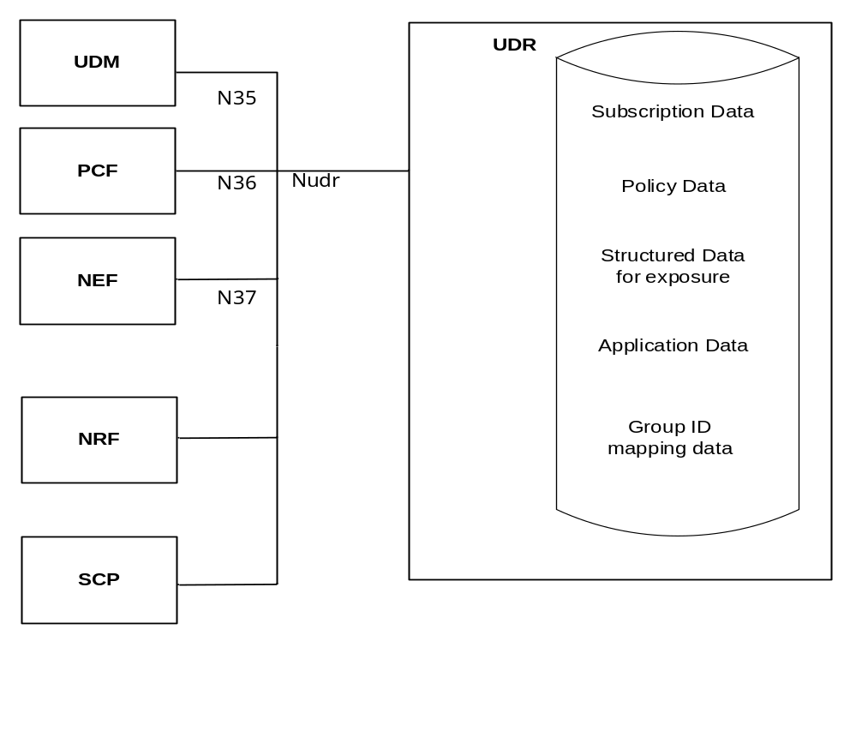
Figure 4-1: Data storage architecture
The Nudr interface is used by the network functions (i.e. UDM, PCF, NEF and NRF) to access a particular set of the data stored in the UDR.
NOTE: Services offered by the UDR via the Nudr service-based interface can also be consumed by the HSS as specified in 3GPP TS 23.632 clause 5.2.4.

5 Services offered by the UDR

5.1 Introduction
The UDR offers the following services via the Nudr interface:
- Nudr_DataRepository Service
NOTE: This service corresponds to the Nudr_DataManagement service in 3GPP TS 23.501 [4], 3GPP TS 23.502 [5] and 3GPP TS 23.503 [6].
- Nudr_GroupIDmap Service
Table 5.1-1 summarizes the corresponding APIs defined for this specification.
Table 5.1-1: API Descriptions
Service Name | Clause | Description | OpenAPI Specification File | apiName | Annex
Nudr_DataRepository | 6.1 | Unified Data Repository Service | TS29504_Nudr_DR.yaml | nudr-dr | A.2
Nudr_GroupIDmap | 6.2 | Unified Data Repository Service for NF-Group ID retrieval | TS29504_Nudr_GroupIDmap.yaml | nudr-group-id-map | A.3

5.2 Nudr_DataRepository Service

5.2.1 Service Description

5.2.1.1 Service and operation description
The UDR is acting as NF Service Producer. It provides Unified Data Repository service to the NF service consumer. The known NF Service Consumers are the UDM, PCF and NEF.
For the Nudr_DataRepository service, the following service operations are defined:
- Query
- Create
- Delete
- Update
- Subscribe
- Unsubscribe
- Notify
- DataRestorationNotification
This service allows NF service consumers to retrieve, create, update, modify and delete data stored in the UDR.
This service allows the NF service consumers to subscribe/unsubscribe the data change notification and to be notified of the data change.
This service allows the NF service consumers to be notified upon the UDR restoration.

5.2.1.2 Service operation and data access authorization
UDR provides one Nudr_DataRepository service to all of the NF consumers, while different types of data may have different data access authorizations, the UDR shall be able to have the authorization management mechanism to guarantee the safety of data access.
And the information in the Nudr_DataRepository service operation should be able to identify the NF type of the consumer and the service operation type or name, and to indicate the requested data information including the data set and data subset, and the resource/data identifier. All HTTP methods for the service operation shall include the information in the appropriate place of the HTTP message.
If there is an illegal service operation or data access request initiated by a NF consumer, the service failure response should be returned through the Nudr interface with an explicit cause value.
NOTE: For allowed service operations or data access requests initiated by an NF consumer it is not expected (unless explicitly specified otherwise) that the UDR performs any consumer-specific application logic to check whether a requested service operation should be rejected.

5.2.2 Service Operations

5.2.2.1 Introduction
This clause specifies the generic Nudr_DataRepository service operations towards the different data sets as shown in Figure 4-1.
The HTTP request of the service operations contains a resource URI where the {apiSpecificResourceUriPart} (see clause 4.4.2 in 3GPP TS 29.501 [8]) consists of a top-level segment and sub-level segment(s), followed by query parameters (optional or required).
If multiple query parameters are defined for a method on the resource, the default logical relationship between the different query parameters shall be the logical "AND", unless explicitly indicated on each specific resource and operation on the Nudr_DataRepository API.
NOTE: Not all query parameters imply necessarily a logical relationship with other parameters (e.g. "supported-features"); whether or not such logical relationship exists, is determined by the semantics of the different query parameters in each resource and operation.
For Create, Query, Update and Delete operations, the top-level segment indicates one top level resource representing one of the data sets, which are defined as "/subscription-data", "/policy-data", "/exposure-data" and "/application-data" in Figure 6.1.3.1-1. And a certain child resource is indicated by of the end URI of the sub-level segments, which are defined in 3GPP TS 29.505 [2] for use when the top-level segment is "/subscription-data" and in 3GPP TS 29.519 [3] for use when the top-level segment is "/policy-data", "/exposure-data" or "/application-data".
For Subscribe/Unsubscribe to data change notification operations, the resource of the subscription to the notification should be as the child resource of each of the data sets (i.e. "/subscription-data", "/policy-data", "/exposure-data" and "/application-data"), which are indicated by the top-level segment in the URI. And the resource representation of the subscription to the notification should be indicated by the sub-level segment of each data set.
The following procedures for each operation should be taken as the common procedures and applicable to corresponding detail procedures with the same service operation in 3GPP TS 29.505 [2] and 3GPP TS 29.519 [3].

5.2.2.2 Query

5.2.2.2.1 General
The Query service operation is used to retrieve the data stored in the UDR. HTTP GET method shall be used for the service operation to request the certain data record(s). One piece of data records should be a data set, a data subset, a group of data in one data subset, or a specific data. If the data record(s) are the attribute(s), query parameter or the combination of query parameters should be used as the filters to control the content of result.

5.2.2.2.2 Data retrieval
Figure 5.2.2.2.2-1 shows a scenario where the NF service consumer (e.g. UDM, PCF or NEF) sends a request to the UDR to retrieve data.
Query parameters may be used for data retrieval:
i) Clause 5.2.2.2.3 specifies the query parameter used for retrieving subset of a resource;
ii) Other query parameters are defined in 3GPP TS 29.505 [2] and 3GPP TS 29.519 [3].

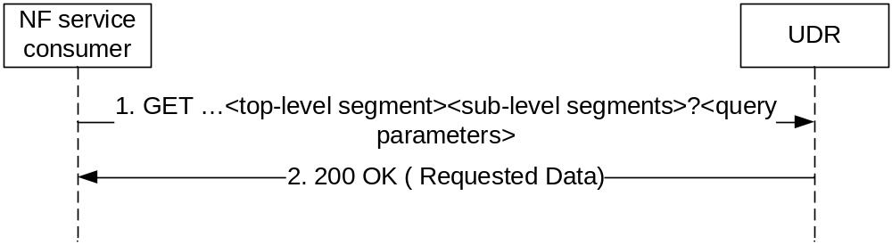
Figure 5.2.2.2.2-1: Retrieving Data
1. The NF service consumer shall send a GET request to the resource representing the data. Query parameters may be used to restrict the response to the requested data record(s) of the resource's representation. Query parameters may also indicate the features that the NF service consumer supports as described in clause 6.6.2 of 3GPP TS 29.500 [7].
2. On success, the UDR shall respond with "200 OK" with the message body containing the requested data record(s) restricted to the query parameters. (and thus also to the indicated features supported by the NF service consumer).
On failure, the UDR shall return an appropriated error code with the error cause information.
The error codes of corresponding service operations in 3GPP TS 29.505 [2] and 3GPP TS 29.519 [3] shall align and comply with the failure response mechanism which is defined in 3GPP TS 29.500 [7].

5.2.2.2.3 Retrieval of subset of a resource
When a resource has multiple attributes, it is allowed for the NFs to retrieve a subset of the attributes. When the attribute is of type map, it is allowed for the NFs to retrieve individual member(s) of that map. For retrieval of subset of a resource, a new query parameter "fields" is defined to carry the identities of the attributes to be retrieved. The definition of "fields" query parameter is:
1) "fields" query parameter is of type array; and
2) each element of the array is of type string encoded as a JSON pointer as defined IETF RFC 6901 [9].
NOTE: identifying an individual element in the array is supported by JSON pointer, however it is not recommended to use this feature if the client is not exactly aware of the order of the members in the array.
If retrieval of subset of a particular resource is supported, then all the attributes of the corresponding data type of that resource shall be optional or conditional.
EXAMPLE 1:
Given the following representation of ExResource:
{
"lv1Attr1": "value1"
"lv1Attr2": "value2"
"lv1Attr3": {
"lv2Attr1": "value3"
"lv2Attr2": "value4"
}
}
To retrieve "lv1Attr1" and "lv2Attr2", the NF sends the following request:
GET /ExResource?fields=/lv1Attr1, /lv1Attr3/lv2Attr2
Upon success, the UDR then returns the following representation:
{
"lv1Attr1": "value1"
"lv1Attr3": {
"lv2Attr2": "value4"
}
}

EXAMPLE 2:
Given the following representation of ExResource:
{
"Attr1": "value1"
"Attr2": "value2"
"AttrMap": {
"Key1": {ExObject1}
"Key2": {ExObject2}
}
}
To retrieve "Attr1" and the second member of "AttrMap ", the NF sends the following request:
GET /ExResource?fields=/Attr1, /AttrMap/Key2
Upon success, the UDR then returns the following representation:
{
"Attr1": "value1"
"AttrMap": {
"Key2": {ExObject2}
}
}

5.2.2.3 Create

5.2.2.3.1 General
The Create service operation is used by the NF service consumer (e.g. NEF) to create the data into the UDR.
The following procedures using the Create service operation are supported:
- Data creation using PUT
- Data creation using POST

5.2.2.3.2 Data Creation using PUT
Figure 5.2.2.3.2-1 shows a scenario where the NF service consumer (e.g. NEF) sends a request to the UDR to create data. The parent resource of the resource identified by the resource URI shall be of archetype Store (see clause C.3 in 3GPP TS 29.501 [8]).
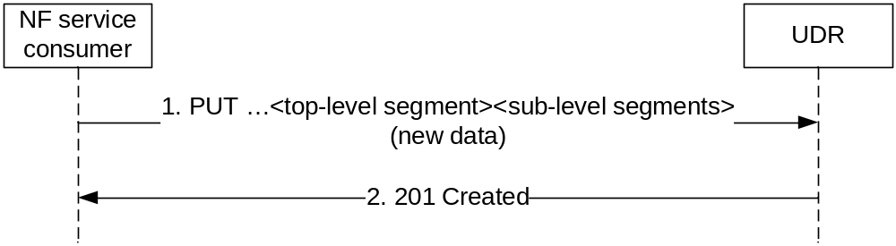
Figure 5.2.2.3.2-1: Creating Data using PUT
1. The NF service consumer shall send a PUT request to the resource representing the data. The content of the PUT request shall contain the representation of the new data.
2. On success, the UDR shall respond with "201 Created" with the content containing the representation of the created data, and the "Location" header shall be present and contains the URI of the created data.
On failure, the UDR shall return an appropriated error code with the error cause information.

5.2.2.3.3 Data Creation using POST
Figure 5.2.2.3.3-1 shows a scenario where the NF service consumer (e.g. NEF) sends a request to the UDR to create data. The resource identified by the resource URI shall be of archetype Collection (see clause C.2 in 3GPP TS 29.501 [8]).

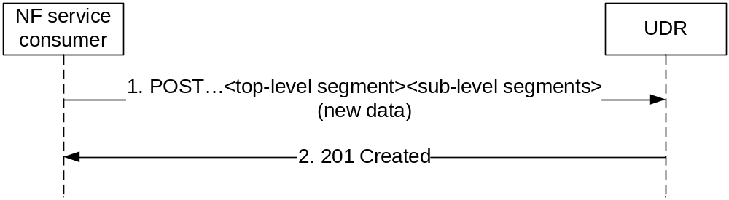
Figure 5.2.2.3.3-1: Creating Data using POST
1. The NF service consumer shall send a POST request to create the new data record as the child resource of the parent resource in the UDR. The content of the POST request shall contain the representation of the new data.
2. The UDR generates the data identifier and constructs the URI for the created data record by appending the data identifier to the parent resource URI received as request URI of the POST request.
On success, the UDR shall respond with "201 Created" with the content containing the representation of the created data, and the "Location" header shall be present and contains the URI of the created data.
On failure, the UDR shall return an appropriated error code with the error cause information.

5.2.2.4 Delete

5.2.2.4.1 General
The Delete service operation is used by the NF service consumer (e.g. NEF) to remove the data from the UDR.
The following procedures using the Delete service operation are supported:
- Data Deletion
HTTP DELETE method shall be used.

5.2.2.4.2 Deleting Data
Figure 5.2.2.4.2-1 shows a scenario where the NF service consumer (e.g. NEF) sends a request to the UDR to delete a data record.
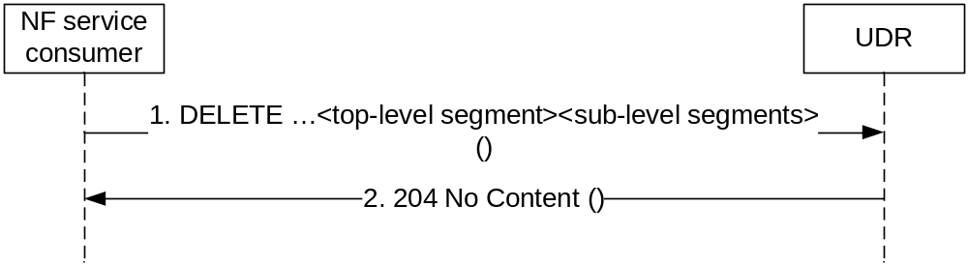
Figure 5.2.2.4.2-1: Deleting Data
1. The NF service consumer shall send a DELETE request to the resource representing the data. The content of the request shall be empty.
2. On success, the UDR shall respond with "204 No Content", the content of the DELETE response shall be empty.
On failure, the UDR shall return an appropriated error code with the error cause information.

5.2.2.5 Update

5.2.2.5.1 General
The Update service operation is used by the NF service consumer (e.g. UDM, PCF or NEF) to update the data stored in the UDR.
The following procedures using the Update service operation are supported:
- Data Update using PATCH
- Data Update using PUT
HTTP PATCH method shall be used to add/create, delete or modify part of the value(s) in the data record (e.g. a specific data or a group of data in one data subset). HTTP PUT method shall be used to replace a complete data record.

5.2.2.5.2 Data Update using PATCH
Figure 5.2.2.5.2-1 shows a scenario where the NF service consumer (e.g. UDM, PCF or NEF) sends a request to the UDR to update some parts of the data record.
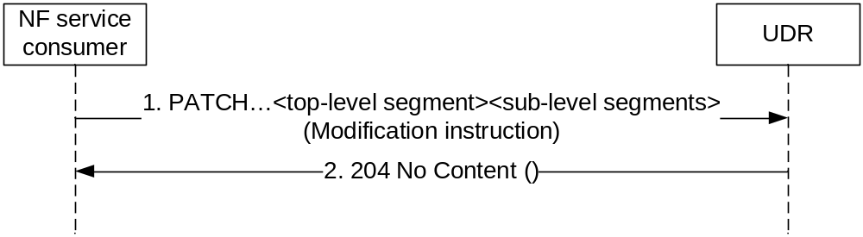
Figure 5.2.2.5.2-1: Data Updating using PATCH
1. The NF service consumer shall send a PATCH request to the resource representing the data record. The content contains the modification instruction towards the data record.
2. On success, the UDR shall respond with "204 No Content".
On failure, the UDR shall return an appropriated error code with the error cause information.

5.2.2.5.3 Data Update using PUT
Figure 5.2.2.5.3-1 shows a scenario where the NF service consumer (e.g. UDM, PCF or NEF) sends a request to the UDR to update the whole data record.
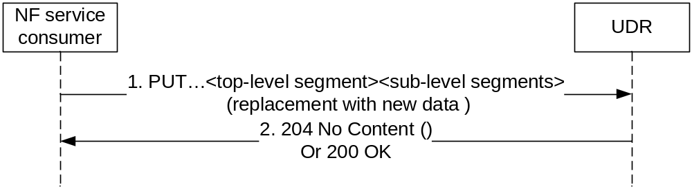
Figure 5.2.2.5.3-1: Data Updating using PUT
1. The NF service consumer shall send a PUT request to the resource representing the data record. The content contains the new data for the resource.
2. On success, the UDR shall respond with "204 No Content" or "200 OK".
On failure, the UDR shall return an appropriated error code with the error cause information.

5.2.2.6 Subscribe

5.2.2.6.1 General
The Subscribe service operation is used for the NF service consumer to explicitly subscribe to the data change notification from the UDR.
Permanent Subscription Data i.e. sub-resources of the ProvisionedData resource (see 3GPP TS 29.505 [2]) can be modified only by means of provisioning at the UDR and may be (as a deployment option) implicitly subscribed by the UDM as described in 3GPP TS 29.501 [8] clause 4.6.2.2.1. If so and when a data modification of permanent subscription data occurs by means of provisioning and there is the need to notify at least one serving node (e.g. AMF, SMF, SMSF), the UDR shall select one of the suitable and available UDMs (as discovered via the NRF) and send a notification using the callback URI provided by the NRF during UDM discovery.

5.2.2.6.2 NF service consumer subscribes to notifications to UDR
Figure 5.2.2.6.2-1 shows a scenario where the NF service consumer (e.g. UDM, PCF or NEF) sends a request to the UDR to subscribe to data change notifications.
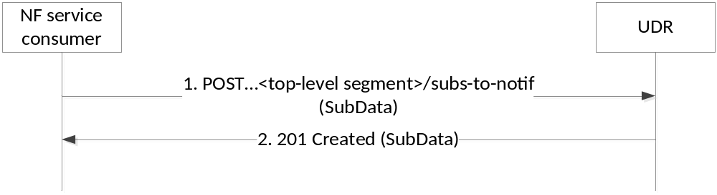
Figure 5.2.2.6.2-1: subscribing to data change notifications
1. The NF service consumer sends a POST request to the parent resource (...<top-level segment>/subs-to-notif). The NF service consumer describes the notifications it wants to receive, and it also indicates the features it supports (see clause 6.6.2 of 3GPP TS 29.500 [7]). The request may contain an expiry time, suggested by the NF Service Consumer as a hint, representing the time upto which the subscription is desired to be kept active.
2. On success, the UDR responds with "201 Created" with the message body containing a representation of the created subscription and indicating the supported features (see clause 6.6.2 of 3GPP TS 29.500 [7]). The Location HTTP header shall contain the URI of the created subscription. In subsequent notifications according to clause 5.2.2.8.2, the UDR only uses the indicated supported features.
The response based on operator policies and taking into account the expiry time included in the request, may contain an expiry time (i.e a future timestamp), as determined by the UDR, after which the subscription becomes invalid. If an expiry time was included in the request, then the expiry time returned in the response should be less than or equal to that value. Once the subscription expires, if the NF Service Consumer wants to keep receiving notifications, it shall create a new subscription in the UDR. The UDR shall not provide the same expiry time (i.e a future timestamp) for many subscriptions in order to avoid all of them expiring and recreating the subscription at the same time. If the expiry time is not included in the response, the NF Service Consumer shall consider the subscription to be valid without an expiry time.
On failure, the UDR returns an appropriated error code with the error cause information.
Once the subscription has been created, an NF Service Consumer may request the update of the subscription in UDR (e.g., to request an extension of the subscription lifetime before the subscription expires) by issuing a PUT or PATCH request, as described in 3GPP TS 29.501 [8], clause 4.6.2.2.3.

5.2.2.6.3 Stateless UDM subscribes to notifications to UDR
Figure 5.2.2.6.3-1 shows a scenario where the stateless UDM subscribes to notification to the UDR.
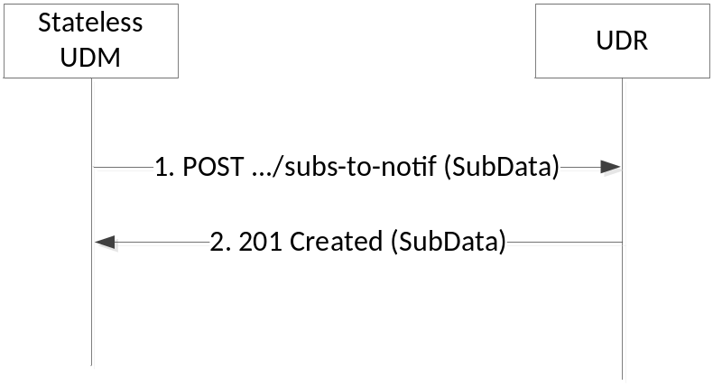
Figure 5.2.2.6.3-1: subscribing to data change notifications via stateless UDM
1. The stateless UDM sends a POST request to the UDR to subscribe to the notifications.
The SubData in the POST request body shall indicate the same data for which a change will trigger a notification.
The SubData in the POST request body shall contain a callbackReference URI to which the notifications will be sent to. The host part of the callbackReference URI shall be set to the FQDN of the UDM set to which the stateless UDM belongs.
The SubData in the POST request body shall contain an original callbackReference URI of the NF which initially triggers the subscription.
The request may contain an expiry time, suggested by the NF Service Consumer as a hint, representing the time upto which the subscription is desired to be kept active.
2. On success, the UDR responds with "201 Created" with the message body containing a representation of the created subscription. The Location HTTP header shall contain the URI of the created subscription and that URI shall contain the subscription ID allocated by the UDR.
The response based on operator policies and taking into account the expiry time included in the request, may contain an expiry time (i.e a future timestamp), as determined by the UDR, after which the subscription becomes invalid. If an expiry time was included in the request, then the expiry time returned in the response should be less than or equal to that value. Once the subscription expires, if the NF Service Consumer wants to keep receiving notifications, it shall create a new subscription in the UDR. The UDR shall not provide the same expiry time (i.e a future timestamp) for many subscriptions in order to avoid all of them expiring and recreating the subscription at the same time. If the expiry time is not included in the response, the NF Service Consumer shall consider the subscription to be valid without an expiry time.
On failure, the UDR returns an appropriated error code with the error cause information.
Once the subscription has been created, the stateless UDM may request the update of the subscription in UDR (e.g., to request an extension of the subscription lifetime before the subscription expires) by issuing a PUT or PATCH request, as described in 3GPP TS 29.501 [8], clause 4.6.2.2.3.

5.2.2.7 Unsubscribe

5.2.2.7.1 General
The Unsubscribe service operation is used for the NF service consumer to unsubscribe to the data change notification from the UDR.

5.2.2.7.2 Unsubscribe service operation
Figure 5.2.2.7.2-1 shows a scenario where the NF service consumer (e.g. UDM, PCF or NEF) sends a request to the UDR to unsubscribe to data change notifications.

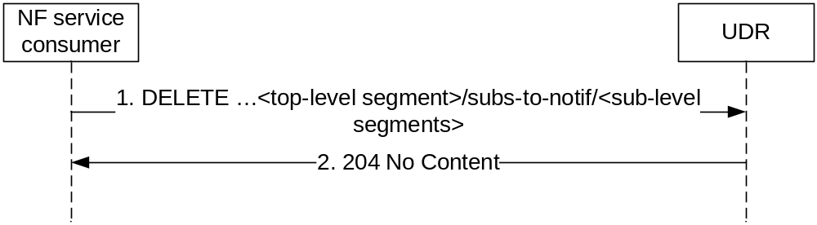
Figure 5.2.2.7.2-1: Unsubscribing to the data change notifications
1. The NF service consumer sends a DELETE request to the resource identified by the URI previously received during subscription creation, i.e. in the Location header field of the HTTP 201 Created response.
2. On success, the UDR responds with "204 No Content".
On failure, the UDR returns an appropriated error code with the error cause information.

5.2.2.8 Notify

5.2.2.8.1 General
The Notify service operation is used for the UDR to notify the data change notification to the previous subscribe operation requestor.

5.2.2.8.2 Notification to NF service consumer on data change
Figure 5.2.2.8.2-1 shows a scenario where the UDR notifies the NF service consumer about the subscribed data change. The request contains the CallbackReference URI as previously received in the subscribe operation (see clause 5.2.2.6).
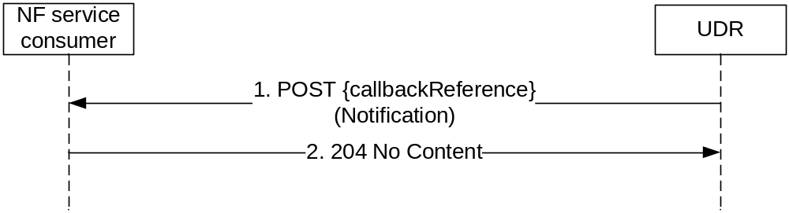
Figure 5.2.2.8.2-1: Data Change Notification
1. The UDR sends a POST request to the callbackReference URI as provided by the NF service consumer in the subscribe operation.
2. On success, the NF service consumer responds with "204 No Content".
On failure, the NF service consumer responds an appropriated error code with the error cause information.

5.2.2.8.3 Notification to stateless UDM on data change
Figure 5.2.2.8.3-1 shows a scenario where the UDR notifies the NF service consumer about the subscribed data change.
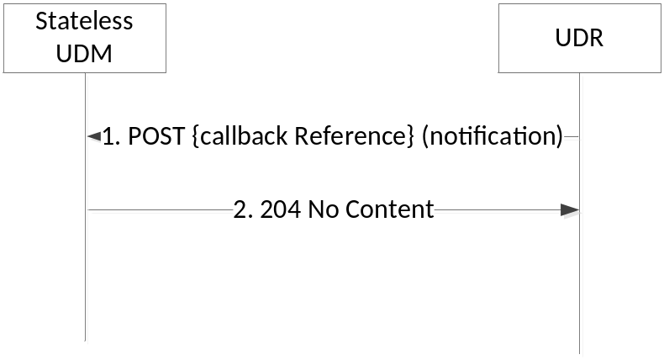
Figure 5.2.2.8.3-1: Data Change Notification to stateless UDM
1. The UDR sends a POST request to the callbackReference URI as provided by the stateless UDM in the subscribe operation.
The notification in the POST request body shall contain the original callbackReference URI which is received in step 1 of Figure 5.2.2.6.3-1.
When the notification in the POST request body includes one or more arrays, the UDR shall use the complete replacement representation of the arrays, see 3GPP TS29.501 [4], Annex E.
When the notification in the POST request body includes one or more arrays where all the array elements have been removed, the UDR shall include the original array representation, i.e. in the origValue attribute of the ChangeItem.
2. On success, the stateless UDM responds with "204 No Content".
On failure, the stateless UDM responds an appropriated error code with the error cause information.

5.2.2.9 DataRestorationNotification

5.2.2.9.1 General
The DataRestorationNotification service operation is used for the UDR to send notfications on UDR restoration event to one or a set of NFs which are subject to the data restoration procedure.

5.2.2.9.2 Notification on Data Restoration
The notification on data restoration may be based on implicit subscription to data restoration event. When the NF service consumer (e.g. UDM) access UDR (i.e. to access the data stored in the UDR) for the first time, the UDR shall identify the identity of the NF service consumer via the NF instance ID contained in the 3gpp-Sbi-NF-Peer-Info header field of the request, then the UDR may create a default subscription on data restoration for that NF service consumer accordingly.
Figure 5.2.2.9.2-1 shows a scenario where the UDR notifies the NF service consumer about the need to restore data due to a potential data-loss event occurred at the UDR. The dataRestorationCallbackUri contained in the request is the default callback URI as discovered from NRF.
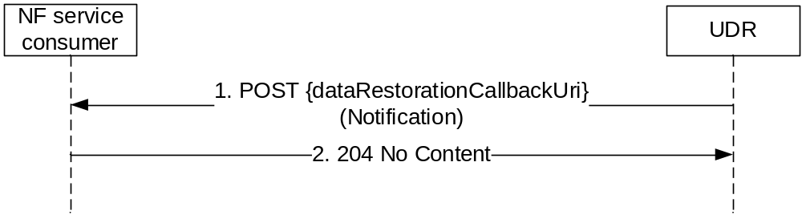
Figure 5.2.2.9.2-1: Data Restoration Notification
1. The UDR sends a POST request to the dataRestorationCallbackUri as discovered from NRF.
2. On success, the NF service consumer responds with "204 No Content".
On failure, the NF service consumer responds an appropriated error code with the error cause information.

5.3 Nudr_GroupIDmap Service

5.3.1 Service Description

5.3.1.1 Service and operation description
The Nudr_GroupIDmap service may be used by NF service consumers (e.g. NRF or SCP) to retrieve the NF Group ID for a given NF type and subscriber identifier (or information related to a set of subscribers served by a same NF Group ID, such as the Routing Indicator); see 3GPP TS 23.501 [4] and 3GPP TS 23.502 [5].
It may also be used to retrieve the list of Routing Indicators served by a given NF Group.
For the Nudr_GroupIDmap service, the following service operations are defined:
- Query
- Subscribe
- Unsubscribe
- Notify
This service allows NF service consumers to retrieve, NF GroupID data stored in the UDR.
This service allows the NF service consumers to subscribe/unsubscribe to changes on user ID to NF Group ID mapping, and to be notified on changes of such mapping.
- QueryRID
This service allows NF service consumers to retrieve Routing Indicator data stored in the UDR.

5.3.2 Service Operations

5.3.2.1 Introduction
The service operations defined for the Nudr_GroupIDmap service are as follows:
- Query: It allows an NF consumer (e.g. NRF) to retrieve the NF Group ID for a given NF type and subscriber-related information.

5.3.2.2 Query

5.3.2.2.1 General
The following procedure using the Query service operation is supported:
- NF-Group ID Retrieval

5.3.2.2.2 NF Group ID retrieval
Figure 5.3.2.2.2-1 shows a scenario where the NF service consumer (e.g. NRF) sends a request to the UDR to retrieve the NF Group ID.

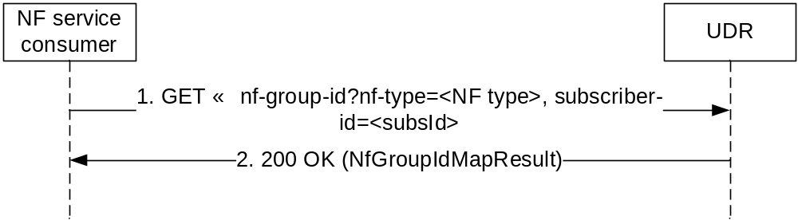
Figure 5.3.2.2.2-1: Retrieving NF Group ID
1. The NF service consumer shall send a GET request to the resource representing the data. Query parameters shall be used to identify the NF type (e.g. UDM) of the requested NF Group ID (e.g. UDM Group ID) and the subscriber-id, or information related to a set of subscribers.
2. On success, the UDR shall respond with "200 OK" with the message body containing the requested data
On failure, the UDR shall return an appropriated error code with the error cause information.

5.3.2.3 QueryRID

5.3.2.3.1 General
The following procedure using the QueryRID service operation is supported:
- Routing IDs Retrieval

5.3.2.3.2 Routing IDs retrieval
Figure 5.3.2.x.2-1 shows a scenario where the NF service consumer (e.g. NRF) sends a request to the UDR to retrieve the Routing Indicators served by a given NF Group (identified by its NF type and its NF Group ID).

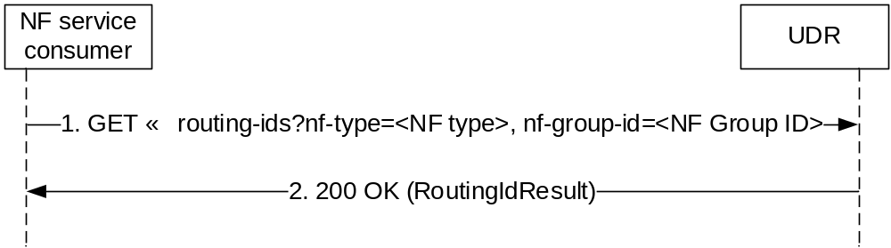
Figure 5.3.2.3.2-1: Retrieving Routing Ids
1. The NF service consumer shall send a GET request to the resource representing the data. Query parameters shall be used to identify the NF type (e.g. UDM) and the NF Group ID (e.g. UDM Group ID).
2. On success, the UDR shall respond with "200 OK" with the message body containing the requested data.
On failure, the UDR shall return an appropriated error code with the error cause information.

5.3.2.4 Subscribe

5.3.2.4.1 General
The Subscribe service operation is used for the NF service consumer to subscribe to notifications from the UDR when there is a change in the mapping between a subscriber ID and an NF Group ID.

5.3.2.4.2 NF service consumer subscribes to notifications to UDR
Figure 5.3.2.4.2-1 shows a scenario where the NF service consumer (e.g. NRF or SCP) sends a request to the UDR to subscribe to NF Group ID mapping changes.
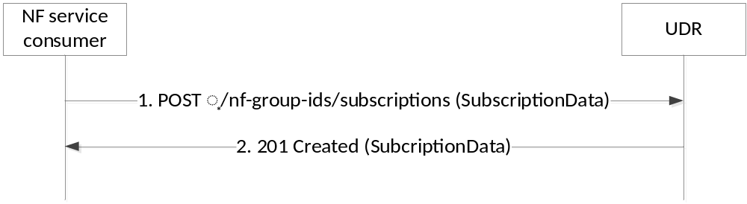
Figure 5.3.2.4.2-1: Subscribing to NF Group ID mapping changes
1. The NF service consumer sends a POST request to the resource (…/nf-group-ids/subscriptions). The NF service consumer describes the notifications it wants to receive (i.e., the NF type and NF Group ID to be monitored for changes on mapping to subscriber IDs) and provides a notification URI. The request may contain an expiry time, suggested by the NF Service Consumer as a hint, representing the time upto which the subscription is desired to be kept active.
2. On success, the UDR responds with "201 Created" with the message body containing a representation of the created subscription. The Location HTTP header shall contain the URI of the created subscription.
The response based on operator policies and taking into account the expiry time included in the request, may contain an expiry time (i.e a future timestamp), as determined by the UDR, after which the subscription becomes invalid. If an expiry time was included in the request, then the expiry time returned in the response should be less than or equal to that value. Once the subscription expires, if the NF Service Consumer wants to keep receiving notifications, it shall create a new subscription in the UDR. The UDR shall not provide the same expiry time (i.e a future timestamp) for many subscriptions in order to avoid all of them expiring and recreating the subscription at the same time. If the expiry time is not included in the response, the NF Service Consumer shall consider the subscription to be valid without an expiry time.
On failure, the UDR returns an appropriated error code with the error cause information.
Once the subscription has been created, an NF Service Consumer may request the update of the subscription in UDR (e.g., to request an extension of the subscription lifetime before the subscription expires) by issuing a PATCH request.

5.3.2.5 Unsubscribe

5.3.2.5.1 General
The Unsubscribe service operation is used for the NF service consumer to unsubscribe to NF Group ID mapping changes from the UDR.

5.3.2.5.2 Unsubscribe service operation
Figure 5.3.2.5.2-1 shows a scenario where the NF service consumer (e.g. NRF or SCP) sends a request to the UDR to unsubscribe to NF Group ID mapping changes.

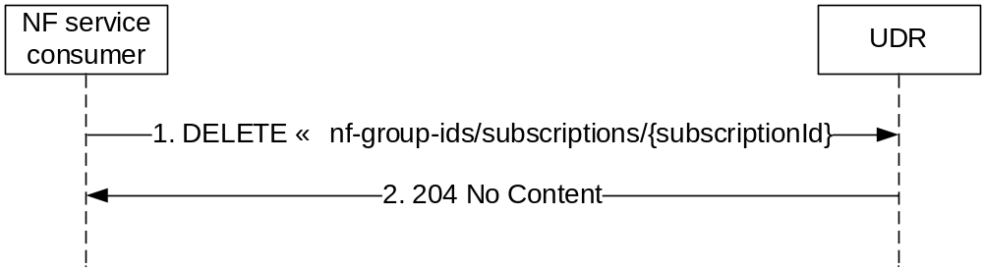
Figure 5.3.2.5.2-1: Unsubscribing to NF Group ID mapping changes
1. The NF service consumer sends a DELETE request to the resource identified by the URI previously received during subscription creation in the Location header field of the HTTP 201 Created response.
2. On success, the UDR responds with "204 No Content".
On failure, the UDR returns an appropriated error code with the error cause information.

5.3.2.6 Notify

5.3.2.6.1 General
The Notify service operation is used for the UDR to notify the NF Group ID mapping change to the previous subscribe operation requestor.

5.3.2.6.2 Notification to NF service consumer on data change
Figure 5.3.2.6.2-1 shows a scenario where the UDR notifies the NF service consumer about the NF Group ID mapping change. The request is sent to the notificationURI as previously received in the subscribe operation (see clause 5.3.2.4.2).
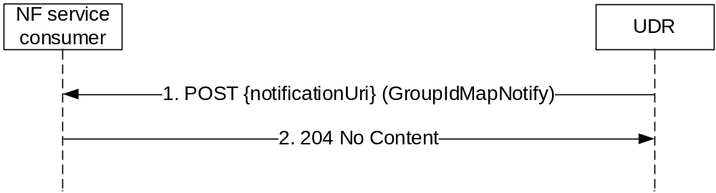
Figure 5.3.2.6.2-1: NF Group ID mapping change notification
1. The UDR sends a POST request to the notificationUri as provided by the NF service consumer in the subscribe operation. The content of the notification includes the identities whose mapping to a given NF Group ID has changed.
NOTE: For a subscriber identity that currently does not have any NF Group ID assigned, the notification is not needed, and the UDR can decide, based on implementation choice, to only send notifications when the mapping has changed from a given NF Group ID to a different one. Nonetheless, it can be reasonable to send such notifications, for example, when they are related to a large range of subscriber identities, no matter if the individual subscriber identities had, or not, a previous NF Group ID assigned.
2. On success, the NF service consumer responds with "204 No Content".
On failure, the NF service consumer responds an appropriated error code with the error cause information.

6 API Definitions

6.1 Nudr_DataRepository Service API

6.1.1 API URI
The Nudr-dr shall use the Nudr-dr API.
The request URI used in HTTP request from the NF service consumer towards the NF service producer shall have the structure defined in clause 4.4.1 of 3GPP TS 29.501 [8], i.e.:
{apiRoot}/<apiName>/<apiVersion>/<apiSpecificResourceUriPart>
with the following components:
- The {apiRoot} shall be set as described in 3GPP TS 29.501 [8].
- The <apiName> shall be "nudr-dr".
- The <apiVersion> shall be "v2".
- The <apiSpecificResourceUriPart> shall be set as described in clause 6.1.3.

6.1.2 Usage of HTTP

6.1.2.1 General
Nudr service shall comply with the usage of HTTP/2.0 protocol over Service Based Interfaces. (See Clause 5, 3GPP TS 29.500[7]).

6.1.2.2 HTTP standard headers

6.1.2.2.1 General
The usage of HTTP standard headers shall be supported on Nudr interface as defined in clause 5.2.2 of 3GPP TS 29.500 [7].

6.1.2.2.2 Content type
The following content types shall be supported:
- JSON, as defined in IETF RFC 8259 [11], shall be used as content type of the HTTP bodies specified in the present specification as indicated in clause 5.4 of 3GPP TS 29.500 [7].
- The Problem Details JSON Object (IETF RFC 9457 [17]). The use of the Problem Details JSON object in a HTTP response body shall be signalled by the content type "application/problem+json".
- JSON Merge Patch (IETF RFC 7396 [18]. The use of the JSON Merge Patch format in a HTTP request body shall be signalled by the content type "application/merge-patch+json".
- JSON Patch (IETF RFC 6902 [19]). The use of the JSON Patch format in a HTTP request body shall be signalled by the content type "application/json-patch+json".

6.1.2.2.3 Cache-Control
As described in IETF RFC 9111 [16] clause 5.2, a "Cache-Control" header should be included in HTTP responses carrying a representation of cacheable resources (e.g. SessionManagementSubscriptionData). If it is included, it shall contain a "max-age" value, indicating the amount of time in seconds after which the received response is considered stale.
The "max-age" value shall be configurable by operator policy.

6.1.2.2.4 ETag
As described in IETF RFC 9110 [15] clause 8.8.3, an "ETag" (entity-tag) header should be included in HTTP responses carrying a representation of cacheable resources (e.g. AccessAndMobilitySubscriptionData) or modifyable resources (e.g. Amf3GppAccessRegistration) to allow an NF Service Consumer performing a conditional GET request with "If-None-Match" header or a conditional POST / PUT / PATCH / DELETE request with "If-Match" header. If it is included, it shall contain a server-generated strong validator, that allows further matching of this value (included in subsequent client requests) with a given resource representation stored in the server or in a cache.

6.1.2.2.5 If-None-Match
As described in IETF RFC 9110 [15] clause 13.1.2, an NF Service Consumer may issue conditional GET request towards UDR by including an "If-None-Match" header in HTTP requests containing one or several entity tags received in previous responses for the same resource.

6.1.2.2.5a If-Match
As described in IETF RFC 9110 [15] clause 13.1.1, an NF Service Consumer may issue conditional POST / PUT / PATCH / DELETE request towards UDR by including an "If-Match" header in HTTP requests containing an entity tag received in previous responses for the same resource.

6.1.2.2.6 Last-Modified
As described in IETF RFC 9110 [15] clause13.1.3, a "Last-Modified" header should be included in HTTP responses carrying a representation of cacheable resources (e.g. SmfSelectionSubscriptionData) to allow an NF Service Consumer performing a conditional request with "If-Modified-Since" header.

6.1.2.2.7 If-Modified-Since
As described in IETF RFC 7232 [15] clause 3.3, an NF Service Consumer may issue conditional GET request towards UDR, by including an "If-Modified-Since" header in HTTP requests.

6.1.2.2.8 When to Use Entity-Tags and Last-Modified Dates
Both "ETag" and "Last-Modified" headers should be sent in the same HTTP response as stated in IETF RFC 9110 [15] clause 15.3.1.
NOTE: "ETag" is a stronger validator than "Last-Modified" and is preferred.
If the UDR included an "ETag" header with the resource then a conditional GET request for this resource shall be performed with the "If-None-Match" header, and a POST / PUT / PATCH / DELETE request for this resource shall be performed with the "If-Match" header.

6.1.2.3 HTTP custom headers

6.1.2.3.1 General
The custom HTTP headers applicable to Nudr service are specified in the following clauses.

6.1.2.3.2 3gpp-Sbi-Message-Priority
Nudr interface shall support 3gpp-Sbi-Message-Priority custom header. The header contains the HTTP/2 message priority value. See details in Clause 5.2.3.2.2 of 3GPP TS 29.500 [7].

6.1.2.3.3 3gpp-Sbi-Notification-Correlation
The 3gpp-Sbi-Notification-Correlation header field is used by a NF in a UDR resource create/update/delete request to indicate the subscription context(s) whose notification needs to be disabled when triggered as consequence of a request including this header. Subsequent create/update/delete requests that do not include the 3gpp-Sbi-Notification-Correlation header trigger the corresponding notifications as per currently defined procedures.
This header contains subscription identifier(s), as provided by the UDR during the subscribe operation.
The encoding of the header follows the ABNF as defined in IETF RFC 9110 [15].
Sbi-Notification-Correlation-Header = "3gpp-Sbi-Notification-Correlation:" OWS subscriptionId *(OWS "," OWS subscriptionId ) OWS
subscriptionId = token
See clause 5.6.2 of IETF RFC 9110 [15] for the "token" definition.
EXAMPLE: 3gpp-Sbi-Notification-Correlation: subsid123, subsid345.

6.1.2.3.4 3gpp-Sbi-Etags
The 3gpp-Sbi-Etags header field is used by the UDR in 200 OK responses to GET requests for multiple data set retrieval, allowing to convey one Etag per retrieved data set. The consumer may make use of a received Etag for a given data set in If-Match/If-None-Match headers of subsequent requests individually accessing the given data set.
The encoding of the header follows the ABNF as defined in IETF RFC 9110 [15].
Sbi-Etags-Header = "3gpp-Sbi-Etags:" OWS datasetEtag *(OWS "," OWS datasetEtag) OWS

datasetEtag = dataSetName "=" entity-tag

dataSetName = UeSubscribedDataSetName

UeSubscribedDataSetName = 1*( ALPHA / DIGIT / "_" )

See clause 5.4.3.11 of 3GPP TS 29.505 [2] for the "UeSubscribedDataSetName" definition.
See IETF RFC 9110 [15] section 8.8.3 for the "entity-tag" definition.
EXAMPLE: 3gpp-Sbi-Etags: AM="xxx", SM="yyy"

6.1.3 Resources

6.1.3.1 Overview
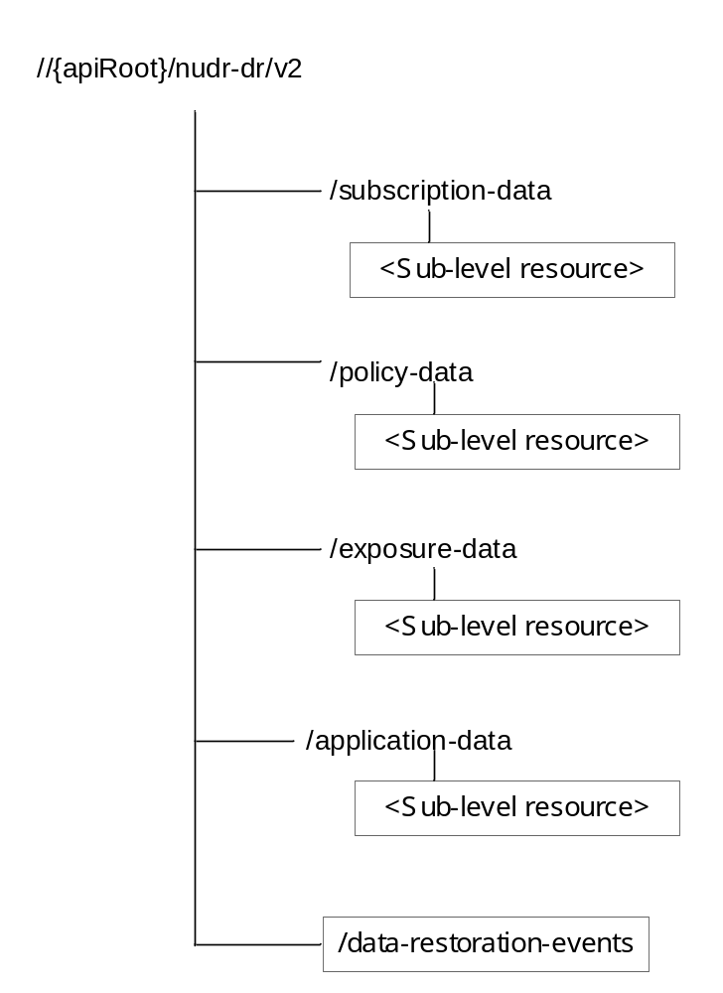

Figure 6.1.3.1-1: Resource URI structure of the Nudr_DataRepository API
Table 6.1.3.1-1 provides an overview of the resources and applicable HTTP methods.

Table 6.1.3.1-1: Resources and methods overview
Resource name | Resource URI | HTTP method or custom operation | Description
SubscriptionData | /subscription-data | none | For sub-level resource names, resource URIs and HTTP methods see 3GPP TS 29.505 [2]
PolicyData | /policy-data | none | For sub-level resource names, resource URIs and HTTP methods see 3GPP TS 29.519 [3]
StructuredDataForExposure | /exposure-data | none | For sub-level resource names, resource URIs and HTTP methods see 3GPP TS 29.519 [3]
ApplicationData | /application-data | none | For sub-level resource names, resource URIs and HTTP methods see 3GPP TS 29.519 [3]
DataRestorationEvents | /data-restoration-events | POST | This is a pseudo operation.

6.1.3.2 SubscriptionData
See 3GPP TS 29.505 [2].

6.1.3.3 PolicyData
See 3GPP TS 29.519 [3].

6.1.3.4 StructuredDataForExposure
See 3GPP TS 29.519 [3].

6.1.3.5 ApplicationData
See 3GPP TS 29.519 [3].

6.1.3.6 Resource: DataRestorationEvents

6.1.3.6.1 Description

6.1.3.6.2 Resource Definition
Resource URI: {apiRoot}/nudr-dr/<apiVersion>/data-restoration-events
This resource shall support the resource URI variables defined in table 6.1.3.6.2-1.
Table 6.1.3.6.2-1: Resource URI variables for this resource
Name | Data type | Definition
apiRoot | string | See clause 6.1.1
apiVersion | string | See clause 6.1.1

6.1.3.6.3 Resource Standard Methods
6.1.3.6.3.1 POST
This method will not be actually invoked.
This method shall support the URI query parameters specified in table 6.1.3.6.3.1-1.
Table 6.1.3.6.3.1-1: URI query parameters supported by the POST method on this resource
Name | Data type | P | Cardinality | Description | Applicability
n/a

This method shall support the request data structures specified in table 6.1.3.6.3.1-2 and the response data structures and response codes specified in table 6.1.3.6.3.1-3.
Table 6.1.3.6.3.1-2: Data structures supported by the POST Request Body on this resource
Data type | P | Cardinality | Description
Any

Table 6.1.3.6.3.1-3: Data structures supported by the POST Response Body on this resource
Data type | P | Cardinality | Response  codes | Description
n/a

6.1.4 Custom Operations without associated resources
In this release of this specification, no custom operations without associated resources are defined for the Nudr_DataRepository Service.

6.1.5 Notifications

6.1.5.1 General
This clause specifies the general mechanism of notifications in the following scenarios:
- notification of changed data which are stored in the UDR;
- notification of data restoration.
The mechanism shall be applicable to the data specified in 3GPP TS 29.505[2] and 3GPP TS 29.519[3].

6.1.5.2 Data Change Notification
The POST method shall be used for Data Change Notifications and the URI shall be as provided during the subscription procedure.
Resource URI: {callbackReference}
Support of POST request data structures should contain the object of changed data and conditionally the URI of original Callback reference, which is received from the original subscribed NF.

6.1.5.3 Data Restoration Notification
The POST method shall be used to inform the NF Service Consumer about a potential data-loss event occurred at the UDR, and the callback URI shall be dynamically discovered by UDR by querying NRF for a default notification URI.
Resource URI: {dataRestorationCallbackUri}
Support of URI query parameters is specified in table 6.1.5.3-1.
Table 6.1.5.3-1: URI query parameters supported by the POST method
Name | Data type | P | Cardinality | Description
n/a

Support of request data structures is specified in table 6.1.5.3-2 and of response data structures and response codes is specified in table 6.1.5.3-3.
Table 6.1.5.3-2: Data structures supported by the POST Request Body
Data type | P | Cardinality | Description
DataRestorationNotification | M | 1 | Contains identifiers representing those UEs potentially affected by a data-loss event at the UDR.

Table 6.1.5.3-3: Data structures supported by the POST Response Body
Data type | P | Cardinality | Response  codes | Description
n/a |  |  | 204 No Content | Upon success, an empty response body shall be returned.
RedirectResponse | O | 0..1 | 307 Temporary Redirect | Temporary redirection. The response shall include a Location header field containing a different URI. The URI shall be an alternative URI of the resource located on an alternative service instance within the same NF or NF (service) set.  If an SCP redirects the message to another SCP then the location header field shall contain the same URI or a different URI pointing to the endpoint of the NF service consumer to which the notification should be sent.
RedirectResponse | O | 0..1 | 308 Permanent Redirect | Permanent redirection. The response shall include a Location header field containing a different URI. The URI shall be an alternative URI of the resource located on an alternative service instance within the same NF or NF (service) set.  If an SCP redirects the message to another SCP then the location header field shall contain the same URI or a different URI pointing to the endpoint of the NF service consumer to which the notification should be sent.
ProblemDetails | O | 0..1 | 404 Not Found | The "cause" attribute may be used to indicate one of the following application errors:  - CONTEXT_NOT_FOUND
NOTE: In addition, common data structures as listed in table 5.2.7.1-1 of 3GPP TS 29.500 [7] are supported.

Table 6.1.5.3-4: Headers supported by the 307 Response Code on this resource
Name | Data type | P | Cardinality | Description
Location | string | M | 1 | Contains the Callback URI of the target NF Service Consumer (e.g. UDM) to which the request is redirected
3gpp-Sbi-Target-Nf-Id | string | O | 0..1 | Identifier of the target NF (service) instance ID towards which the request is redirected

Table 6.1.5.3-5: Headers supported by the 308 Response Code on this resource
Name | Data type | P | Cardinality | Description
Location | string | M | 1 | Contains the Callback URI of the target NF Service Consumer (e.g. AMF) to which the request is redirected
3gpp-Sbi-Target-Nf-Id | string | O | 0..1 | Identifier of the target NF (service) instance ID towards which the request is redirected

6.1.5a Data Model

6.1.5a.1 General
This clause specifies the application data model supported by the API.
Table 6.1.5a.1-1 specifies the data types defined for the Nudr_DataRepository API.
Table 6.1.5a.1-1: Nudr_DataRepository specific Data Types
Data type | Clause defined | Description
DataRestorationNotification | 6.2.5a.2.2 | Contains identities representing those UEs potentially affected by a data-loss event at the UDR

Table 6.1.5a.1-2 specifies data types re-used by the Nudr_DataRepository service-based interface protocol from other specifications, including a reference to their respective specifications and when needed, a short description of their use within the Nudr_DataRepository service-based interface.
Table 6.1.5a.1-2: Nudr_DataRepository re-used Data Types
Data type | Reference | Comments
Dnn | 3GPP TS 29.571 [10] | Data Network Name with Network Identifier only.
Snssai | 3GPP TS 29.571 [10] | Single NSSAI
NfGroupId | 3GPP TS 29.571 [10] | NF Group ID
IdentityRange | 3GPP TS 29.510 [14] | Identity Range
SupiRange | 3GPP TS 29.510 [14] | SUPI Range

6.1.5a.2 Structured data types

6.1.5a.2.1 Introduction
This clause defines the structures to be used in resource representations.

6.1.5a.2.2 Type: DataRestorationNotification
Table 6.2.5a.2.2-1: Definition of type DataRestorationNotification
Attribute name | Data type | P | Cardinality | Description
supiRanges | array(SupiRange) | O | 1..N | If present, it contains the list of SUPIs potentially subject to a data-loss event at the UDR.
gpsiRanges | array(IdentityRange) | O | 1..N | If present, it contains the list of GPSIs potentially subject to a data-loss event at the UDR.
resetIds | array(string) | O | 1..N | If present, it contains the list of Reset-IDs of those UEs potentially subject to a data-loss event at the UDR.
sNssaiList | array(Snssai) | O | 1..N | If present, it contains the list of slices (S-NSSAIs) potentially subject to a data-loss event at the UDR.
dnnList | array(Dnn) | O | 1..N | If present, it contains the list of DNNs potentially subject to a data-loss event at the UDR.
lastReplicationTime | DateTime | O | 0..1 | If present, it contains the timestamp of the most recent instant when the data was assumed to be consistent at UDR (i.e. the potential data loss event at UDR did not occur before this instant).
recoveryTime | DateTime | O | 0..1 | If present, it contains the timestamp of the instant when the potential data loss event was recovered at UDR (i.e. all data records stored by UDR after this time are assumed to be consistent).
udrGroupId | NfGroupId | O | 0..1 | If present, it contains the ID of the UDR Group whose UEs have been potentially subject to a data loss event at the UDR.

6.1.6 Error Handling
Table 6.1.6-1 lists common response body data structures used within the nudr-dr (Nudr_DataRepository) API

Table 6.1.6-1: Common Response Body Data Structures
Data type | P | Cardinality | Response  codes | Description
ProblemDetails | O | 0..1 | 4xx, 5xx responses | For error status codes, the UDR may provide detailed information.
NOTE: In addition common data structures as defined in 3GPP TS 29.500 [7] are supported.

The "ProblemDetails" data structure may contain a "cause" attribute to indicate the application error, see 3GPP TS 29.571 [10]. The values for "cause" attribute are defined in table 6.1.6-2.

Table 6.1.6-2: Application Errors
Application Error | HTTP status code | Description
NF_TYPE_NOT_ALLOWED | 403 Forbidden | The target data set is not permitted to access for the NF type of the NF consumer.
UNSUPPORTED_MONITORED_URI | 501 Not Implemented | The subscribe service operation is not able to be implemented due to invalid resource URI to be monitored).
USER_NOT_FOUND | 404 Not Found | The user indicated in the HTTP/2 request does not exist in the UDR.
DATA_NOT_FOUND | 404 Not Found | The data indicated in the HTTP/2 request is unavailable in the UDR.
INCORRECT_CONDITIONAL_REQUEST | 412 Precondition Failed | One or more conditions given in the request header fields evaluated to false when tested in the UDR.
UNPROCESSABLE_REQUEST | 422 Unprocessable Entity | The request cannot be procesed due to semantic errors when trying to process a patch method.
DATABASE INCONSISTENCY | 500 Internal Server Error | Requested data cannot be returned due to database inconsistency
RESOURCE_TEMP_MOVED | 307 Temporary Redirect | The resource is unavailable in the current target URI but can be temporarily found in an alternative URI.
RESOURCE_MOVED | 308 Permanent Redirect | The resource is unavailable in the current target URI but can be permanently found in an alternative URI.
GROUP_IDENTIFIER_NOT_FOUND | 404 Not Found | The group identifier does not exist.
MODIFICATION_NOT_ALLOWED | 403 Forbidden | Modification of the target resource representation is not permitted.
PLMN_NOT_FOUND | 404 Not Found | The 'servingPlmnId' indicated in the HTTP/2 query is unavailable in the UDR. This status code is also used when 'servingPlmnId' path variable contains SNPN ID, see Table 5.2.3.2-1 in 3GPP TS 29.505 [2].
INTERNAL_GROUP_ID_NOT_UNIQUE | 403 Forbidden | The internal group ID allocated by the UDM for a newly created 5G VN Group already exists in the UDR.
NOTE: The error codes shall apply to both 3GPP TS 29.505 [2] and 3GPP TS 29.519 [3]. In addition error codes shall comply with the definition in clause 5.2.7.2 of 3GPP TS 29.500 [7].

6.1.7 Security
As indicated in 3GPP TS 33.501 [12], the access to the Nudr_DataRepository API may be authorized by means of the OAuth2 protocol (see IETF RFC 6749 [13]), using the "Client Credentials" authorization grant, where the NRF (see 3GPP TS 29.510 [14]) plays the role of the authorization server.
If Oauth2 authorization is used, an NF Service Consumer, prior to consuming services offered by the Nudr_DataRepository API, shall obtain a "token" from the authorization server, by invoking the Access Token Request service, as described in 3GPP TS 29.510 [14], clause 5.4.2.2.
NOTE: When multiple NRFs are deployed in a network, the NRF used as authorization server is the same NRF that the NF Service Consumer used for discovering the Nudr_DataRepository service.
The Nudr_DataRepository API defines the following scopes for OAuth2 authorization:
Table 6.1.7-1: OAuth2 scopes defined in Nudr_DataRepository API
Scope | Description
"nudr-dr" | Access to the Nudr DataRepository API
"nudr-dr:subscription-data" | Access to the SubscriptionData data set.
"nudr-dr:subscription-data:authentication-subscription:read" | Access to read the AuthenticationSubscription resource of the SubscriptionData data set.
"nudr-dr:subscription-data:authentication-subscription:modify" | Access to update the AuthenticationSubscription resource of the SubscriptionData data set.
"nudr-dr:subscription-data:registrations:write" | Write access to NF registration resources of the SubscriptionData data set.
"nudr-dr:policy-data" | Access to the PolicyData data set.
"nudr-dr:policy-data:ues:read" | Access to read the UEs resource.
"nudr-dr:policy-data:ues:am-data:read" | Access to read the UEs Access and Mobility Policy data.
"nudr-dr:policy-data:ues:ue-policy-set:read" | Access to read the UEs Policy Set data.
"nudr-dr:policy-data:ues:ue-policy-set:create" | Access to create the UEs Policy Set data.
"nudr-dr:policy-data:ues:ue-policy-set:modify" | Access to update the UEs Policy Set data.
"nudr-dr:policy-data:ues:sm-data:read" | Access to read the UEs Session Management policy data.
"nudr-dr:policy-data:ues:sm-data:modify" | Access to update the UEs Session Management policy data.
"nudr-dr:policy-data:ues:sm-data:create" | Access to create the UEs Session Management policy data.
"nudr-dr:policy-data:sponsor-connectivity-data:read" | Access to read the sponsored connectivity data.
"nudr-dr:policy-data:bdt-data:read" | Access to read the BDT data resource.
"nudr-dr:policy-data:bdt-data:create" | Access to create the BDT data resource.
"nudr-dr:policy-data:bdt-data:modify" | Access to update the BDT data resource.
"nudr-dr:policy-data:subs-to-notify:read" | Access to read Subscriptions resources.
"nudr-dr:policy-data:subs-to-notify:create" | Access to create Subscriptions resources.
"nudr-dr:policy-data:subs-to-notify:modify" | Access to update Subscriptions resources.
"nudr-dr:policy-data:ues:operator-specific-data:read" | Access to read the UEs operator specific policy data.
"nudr-dr:policy-data:ues:operator-specific-data:modify" | Access to update the UEs operator specific policy data.
"nudr-dr:policy-data:ues:operator-specific-data:create" | Access to create the UEs operator specific policy data.
"nudr-dr:policy-data:plmns:ue-policy-set:read" | Access to read UE Policy SET
"nudr-dr:policy-data:slice-control-data:read" | Access to read Slice specific Policy Control Data.
"nudr-dr:policy-data:slice-control-data:modify" | Access to update Slice specific Policy Control Data.
"nudr-dr:policy-data:mbs-session-pol-data:read" | Access to read MBS Session Policy Data
"nudr-dr:policy-data:group-control-data:read" | Access to read Group Control Data.
"nudr-dr:policy-data:group-control-data:modify" | Access to update Group Control Data.
"nudr-dr:policy-data:pdtq-data:read" | Access to read PDTQ Data
"nudr-dr:policy-data:pdtq-data:create" | Access to create PDTQ Data
"nudr-dr:policy-data:pdtq-data:modify" | Access to update PDTQ Data
"nudr-dr:exposure-data" | Access to the ExposureData data set.
"nudr-dr:exposure-data:access-and-mobility-data:create" | Access to create Access and Mobility data.
"nudr-dr:exposure-data:access-and-mobility-data:read" | Access to read Access and Mobility data.
"nudr-dr:exposure-data:access-and-mobility-data:modify" | Access to update Access and Mobility data.
"nudr-dr:exposure-data:session-management-data:create" | Access to create Session Management data.
"nudr-dr:exposure-data:session-management-data:read" | Access to read Session Management data.
"nudr-dr:exposure-data:session-management-data:modify" | Access to update Session Management data.
"nudr-dr:exposure-data:subs-to-notify:create" | Access to create Subscriptions resources.
"nudr-dr:exposure-data:subs-to-notify:modify" | Access to update Subscriptions resources.
"nudr-dr:application-data" | Access to the ApplicationData data set.
"nudr-dr:application-data:pfds:read" | Access to read PFDData.
"nudr-dr:application-data:pfds:modify" | Access to update PFDData.
"nudr-dr:application-data:pfds:create" | Access to create PFDData.
"nudr-dr:application-data:influence-data:read" | Access to read Traffic Influence Data.
"nudr-dr:application-data:influence-data:create" | Access to create Traffic Influence Data.
"nudr-dr:application-data:influence-data:modify" | Access to update Traffic Influence Data.
"nudr-dr:application-data:influence-data:subscriptions:create" | Access to create Traffic Influence Data Subscriptions.
"nudr-dr:application-data:influence-data:subscriptions:read" | Access to read Traffic Influence Data Subscriptions.
"nudr-dr:application-data:influence-data:subscriptions:modify" | Access to update Traffic Influence Data Subscriptions.
"nudr-dr:application-data:bdt-policy-data:read" | Access to read BDT Policy Data.
"nudr-dr:application-data:bdt-policy-data:create" | Access to create BDT Policy Data.
"nudr-dr:application-data:bdt-policy-data:modify" | Access to update BDT Policy Data.
"nudr-dr:application-data:iptv-config-data:read" | Access to read IPTV Configuration Data.
"nudr-dr:application-data:iptv-config-data:create" | Access to create IPTV Configuration Data.
"nudr-dr:application-data:iptv-config-data:modify" | Access to update IPTV Configuration Data.
"nudr-dr:application-data:service-param-data:read" | Access to read Service Parameter Data.
"nudr-dr:application-data:service-param-data:create" | Access to create Service Parameter Data.
"nudr-dr:application-data:service-param-data:modify" | Access to update Service Parameter Data.
"nudr-dr:application-data:am-influence-data:read" | Access to read AM Influence Data.
"nudr-dr:application-data:am-influence-data:create" | Access to create AM Influence Data.
"nudr-dr:application-data:am-influence-data:modify" | Access to update AM Influence Data.
"nudr-dr:application-data:subs-to-notify:create" | Access to create Subscriptions resources.
"nudr-dr:application-data:subs-to-notify:read" | Access to read Subscriptions resources.
"nudr-dr:application-data:subs-to-notify:modify" | Access to update Subscriptions resources.
"nudr-dr:application-data:eas-deploy-data:read" | Access to read EAS Deployment Information Data.
"nudr-dr:application-data:eas-deploy-data:create" | Access to create EAS Deployment Information Data.
"nudr-dr:application-data:eas-deploy-data:modify" | Access to update EAS Deployment Information Data.
"nudr-dr:application-data:ecs-address-roaming:read" | Access to read ECS Address Roaming Data resources
"nudr-dr:application-data:ecs-address-roaming:create" | Access to create ECS Address Roaming Data resources
"nudr-dr:application-data:ecs-address-roaming:modify" | Access to update ECS Address Roaming Data resources
"nudr-dr:application-data:dnai-eas:read" | Access to read DNAI-EAS mapping resources.
"nudr-dr:application-data:af-qos-data-sets:read | Access to read AF QoS Data Sets
"nudr-dr:application-data:af-qos-data-sets:create | Access to create AF QoS Data Sets
"nudr-dr:application-data:af-qos-data-sets:modify | Access to update AF QoS Data Sets
"nudr-dr:application-data:ueid-mappings:read" | Access to read UE Id Mappings
"nudr-dr:application-data:ueid-mappings:create" | Access to create UE Id Mappings
"nudr-dr:application-data:ueid-mappings:delete" | Access to delete UE Id Mappings

6.1.8 Feature negotiation
The optional features in table 6.1.8-1 are defined for the Nudr_DataRepository API. They shall be negotiated using the extensibility mechanism defined in clause 6.6 of 3GPP TS 29.500 [7].
Table 6.1.8-1: Supported Features
Feature number | Feature Name | Description
1 | ResourceRemovalNotificationPolicyData | This feature indicates the support of the complete removal of a Policy Data resource.
2 | ResourceNotificationExposureDataFix | This feature indicates the support of corrections to Notifications of data changes in the Exposure Data resource.
3 | DomainNameProtocol | This feature supports the additional protocol matching condition for the domain name in PFD data.
4 | EnhancedBackgroundDataTransfer | This feature indicates the support of applying the Background Data Transfer Policy to a future PDU session requested by the AF for Policy Data resource and Application Data resource as defined in 3GPP TS 29.519 [3]. This feature requires the support of SessionManagementPolicyDataPatch feature to update Background Data Transfer data within the Session Management Policy Data.
5 | MacAddressRange | This feature indicates the support of a set of MAC addresses with a specific range for the traffic filter in the application data resource as specified in 3GPP TS 29.519 [3].
6 | MultiTemporalCondition | This feature indicates the support of multiple temporal validity conditions in the Traffic Influence Data resource as specified in 3GPP TS 29.519 [3].
7 | PatchReport | If some of the modifications included in the PATCH request are not successfully implemented, the UDM reports the result of PATCH request execution to the consumer. See clause 5.2.7.2 of 3GPP TS 29.500 [7].
8 | URLLC | This feature indicates support of Ultra Reliable Low Latency Communication (URLLC) requirements, i.e. AF application relocation and UE address(es) preservation in the Application Data resource as specified in 3GPP TS 29.519 [3].
9 | SessionManagementPolicyDataPatch | This feature indicates the support of the HTTP PATCH method to update the session management policy data defined in a Policy Data resource as specified in 3GPP TS 29.519 [3].
10 | ConditionalSubscriptionwithPartialNotification | This feature indicates the support of subscription to notification of resource data changes conditioned to the change occurs in a fragment of the resource. It applies for Policy Data resources as specified in 3GPP TS 29.519 [3].
11 | EnhancedInfluDataNotification | This feature indicates the support of enhancement of data change Notifications in the Influence Data resource as specified in 3GPP TS 29.519 [3].
12 | PerUePerSnAuthStatus | This feature indicates the support of the Individual authentication status per UE per serving network as specified in 3GPP TS 29.505 [2].
13 | OpSpecDataMapNotification | This feature indicates the support of the notification of data changes in the OperatorSpecificData resource by including the complete map of Operator Specific Data Containers. It applies to Policy Data resources as specified in 3GPP TS 29.519 [3].
14 |  | Reserved
15 | OSDResource_Create_Delete | This feature indicates the support of the creation and the removal of the OperatorSpecificData resource by a Policy Data NF service consumer. It applies to Policy Data resources as specified in 3GPP TS 29.519 [3].
16 | AF_latency | This feature indicates the support for Edge relocation considering user plane latency. It applies for Influence Data resource as specified in 3GPP TS 29.519 [3].
17 | CHFsetSupport | This feature indicates the support of CHF redundancy and failover mechanisms based on CHF instance availability within a CHF Set, (i.e. secondary CHF address may be omitted). It applies to Policy Data resources as specified in 3GPP TS 29.519 [3].
18 | ConditionalSubscriptionWithExcludeNotification | This feature indicates the support in the subscription to notification of data changes of the indication of the properties whose changes do not trigger a notification. It applies to Policy Data resources as specified in 3GPP TS 29.519 [3]. It requires the support of OpSpecDataMapNotification feature
19 | ProSe | This feature indicates the support of UE 5G ProSe policies and subscription information. It applies for Policy Data resources as specified in 3GPP TS 29.519 [3].
20 | NSAC | This feature indicates the support of NSAC (Network Slice Admission Control) related policy subscription information. It applies to Policy Data resources as specified in 3GPP TS 29.519 [3].
21 | UESubDataSetRetrieve | This feature indicates the support of the UE Subscription Data Sets Retrieve as specified in clause 5.2.47 of 3GPP TS 29.505 [2].
22 | SharedSmSubsData | This feature indicates the support of shared Session Management Subscription Data. If the NF consumer (UDM) does not support this feature, the UDR shall not take the alternative to include extendedSmSubsData in SmSubsData.  It applies to Subscription Data resources as specified in 3GPP TS 29.505 [2]
23 | DeliveryOutcome | This feature indicates the support of functionality to allow PCF notifications about the outcome of the UE Policy delivery related to the invocation of AF provisioned service parameters as specified in 3GPP TS 29.519 [3].
24 | AfGuideURSP | This feature indicates the support of Application guidance for URSP determination related application data as specified in 3GPP TS 29.519 [3].
25 | EasDeployment | This feature indicates the support of EAS Deployment Information Data and Subscription related application data as specified in 3GPP TS 29.519 [3].
26 | DCAMP | This feature indicates the support of DCAMP related application data. It applies to Application Data resources as specified in 3GPP TS 29.519 [3].
27 | FilterAnyUE | This feature indicates the support of queries and subscriptions to service parameter data resource filtered by the any UE indication as specified in 3GPP TS 29.519 [3].
28 | SimultConnectivity | This feature indicates the support of temporary simultaneously connectivity at edge relocation. It applies for Influence Data resource as specified in 3GPP TS 29.519 [3].
29 | EeSubscriptionExt | This feature indicates the support of handling EE subscription data along with associated subscription resources as specified in 3GPP TS 29.505 [2].
30 | PeiResource | This feature indicates the support of storing PEI in the PeiInfo resource as specified in 3GPP TS 29.505 [2].
31 | ImmediateReportPcc | This feature indicates support of ImmediateReport within a PolicyDataSubscription in 3GPP TS 29.519 [3]. When a UDR consumer detects that the UDR supports the ImmediateReportPcc feature, it can indicate an immediateReport flag when invoking the Subscribe service operation. If the UDR receives the ImmediateReport flag in the received Subscribe service operation request, it shall return the resource's representation(s) of the monitored resource(s) in the service operation response body.
32 | ImmediateReport | This feature indicates support of ImmediateReport within an SubscriptionDataSubscription in 3GPP TS 29.505 [2]. When a UDR consumer detects that the UDR supports the ImmediateReport feature, it can indicate an immediateReport flag when invoking the Subscribe service operation. If the UDR receives the ImmediateReport flag in the received Subscribe service operation request, it shall return the resource's representation(s) of the monitored resource(s) in the service operation response body.
33 | UESubDataSetRetrieveExt | This feature indicates the support of the Extended UE Subscription Data Sets Retrieve as specified in clause 5.2.47 of 3GPP TS 29.505 [2].
34 | SFC | This feature indicates support of Service Function Chaining functionality. It applies for Influence Data resource as specified in 3GPP TS 29.519 [3].
35 | SubscribedV2XPolicy | This feature indicates the support of subscribed V2X policy data as specified in 3GPP TS 29.519 [3].
36 | CommonEASDNAI | This feature indicates the support of the common EAS/DNAI selection as specified in 3GPP TS 29.519 [3].
37 | PolSubscRetrieval | This feature indicates the support of the indication, within the PolicyDataSubscription data type, of the variable part of the Individual Policy Data subscription. It applies to Policy Data subscription resources as specified in 3GPP TS 29.519 [3].
38 | A2X | This feature indicates the support of A2X communication as specified in 3GPP TS 29.519 [3].
39 | EpsUrsp | This feature indicates support of epsUrspInd within UePolicySet and UePolicySetPatch in 3GPP TS 29.519 [3].
40 | DCAMP_Roaming_LBO | This feature indicates support for dynamically changing AM policy for inbound roaming UE using LBO as specified in 3GPP TS 29.519 [3].
41 | GMEC | This feature indicates support of Generic Group Management, Exposure and Communication functionality. It applies to Policy Data resource and Application Data resource as specified in 3GPP TS 29.519 [3].
42 | PatchCorrection | This feature introduces the correction to the PATCH method to support the service parameter urspGuidance to guide the URSP as specified in 3GPP TS 29.519 [3].
43 | EnhancedUePolicy | This feature indicates the support of enhancement of the UE policy (e.g. Tracing Requirements). It applies to Policy Data resource as specified in 3GPP TS 29.519 [3].
44 | ProSe_Ph2 | This feature indicates the support of UE 5G ProSe policies and subscription information for UE-to-UE relay service. It applies for Policy Data resources as specified in 3GPP TS 29.519 [3].
45 | OpSpecAmPolicyData | This feature indicates the support of the operator specific data changes in the AccessAndMobilityPolicyData resource. It applies to AM Policy Data resource as specified in 3GPP TS 29.519 [3].
46 | CHFInformation | This feature indicates the support of provisioning of CHF information. It applies to Policy Data resource as specified in 3GPP TS 29.519 [3].
47 | SLAMUP | This feature indicates support of Spending Limits for AM and UE Policies in the 5GC. It applies to Policy Data resource as specified in 3GPP TS 29.519 [3].  This feature requires the support of the CHFInformation feature.
48 | AfGuideTNAPs | This feature is used in 3GPP TS 29.519 [3] and indicates the support of AF-provided guidance to the HPLMN of the UE of the list of TNAP(s) collocated with a 5G-RG.
49 | URSPEnforcement | This feature indicates support of urspEnfInd within UePolicySet and UePolicySetPatch in 3GPP TS 29.519 [3].
50 | VPLMNSpecificURSP | This feature indicates support of the provisioning of VPLMN Specific URSP rules within ServiceParameterData and ServiceParameterDataPatch data types and the storage of vpsUrspInd within UePolicySet and UePolicySetPatch as defined in 3GPP TS 29.519 [3].  It requires the support of AfGuideURSP feature.
51 | DnaiEasMappings | This feature indicates support of OAM-configured DNAI-EAS mapping information as specified in 3GPP TS 29.519 [3].
52 | HR-SBO | This feature indicates support of provisioning ECS Address Configuration Information for Roaming UEs to the V-NEF for the support of Home-Routed deployments with Session Breakout in 3GPP TS 29.519 [3].  This feature requires the support of the “TrafficInfluSubExt” feature.
53 | FinerGranUEs | This feature indicates support of finer granular UE sets as specified in 3GPP TS 29.519 [3].
54 | CachingTimer | This feature indicates the support of storing caching timer with unit of duration second as specified in 3GPP TS 29.519 [3].
55 | AccessAndMobilityPolicyDataModify | This feature indicates the support of the HTTP PATCH method to update the access and mobility policy data defined in a Policy Data resource as specified in 3GPP TS 29.519 [3].
56 | Ranging_SL | This feature indicates the support of the ranging and sidelink positioning functionality. It applies to Application Data resources as specified in 3GPP TS 29.519 [3].
57 | PDTQ | This feature indicates the support of Planned Data Transfer with QoS requirements Data. It applies to Policy Data resources as specified in 3GPP TS 29.519 [3].
58 | PfdDetermination | This feature inidicates the support of including the source NF type of the PFD in PFD Data as specified in 3GPP TS 29.519 [3].
59 |  | Reserved
60 | TrafficInfluSubExt | This feature indicates support of subscriptions to Traffic Influence Data using various combinations of query parameters as specified in 3GPP TS 29.519 [3].
61 | MultiPduSessInfo | This feature indicates support of multiple PDU Session Info query parameters as specified in 3GPP TS 29.519 [3].

6.2 Nudr_GroupIDmap Service API

6.2.1 API URI
URIs of this API shall have the following root:
{apiRoot}/<apiName>/<apiVersion>
where "apiRoot" is defined in clause 4.4.1 of 3GPP TS 29.501 [8], the "apiName" shall be set to "nudr-group-id-map" and the "apiVersion" shall be set to "v1" for the current version of this specification.

6.2.2 Usage of HTTP

6.2.2.1 General
HTTP/2, as defined in IETF RFC 9113 [22], shall be used as specified in clause 5 of 3GPP TS 29.500 [7].
HTTP/2 shall be transported as specified in clause 5.3 of 3GPP TS 29.500 [7].
HTTP messages and bodies for the Nudr_GroupIDmap service shall comply with the OpenAPI [21] specification contained in Annex A3.

6.2.2.2 HTTP standard headers

6.2.2.2.1 General
The usage of HTTP standard headers shall be supported on Nudr interface as defined in clause 5.2.2 of 3GPP TS 29.500 [7].

6.2.2.2.2 Content type
The following content types shall be supported:
- JSON, as defined in IETF RFC 8259 [11], shall be used as content type of the HTTP bodies specified in the present specification as indicated in clause 5.4 of 3GPP TS 29.500 [7].
- The Problem Details JSON Object (IETF RFC 9457 [17]). The use of the Problem Details JSON object in a HTTP response body shall be signalled by the content type "application/problem+json".
- JSON Patch (IETF RFC 6902 [19]). The use of the JSON Patch format in a HTTP request body shall be signalled by the content type "application/json-patch+json".

6.2.2.2.3 Cache-Control
As described in IETF RFC 9111 [16] clause 5.2, a "Cache-Control" header should be included in HTTP responses carrying a representation of cacheable resources. If it is included, it shall contain a "max-age" value, indicating the amount of time in seconds after which the received response is considered stale.
The "max-age" value shall be configurable by operator policy.

6.2.2.2.4 ETag
As described in IETF RFC 9110 [15] clause 8.8.3, an "ETag" (entity-tag) header should be included in HTTP responses carrying a representation of cacheable resources to allow an NF Service Consumer performing a conditional GET request with "If-None-Match" header. If it is included, it shall contain a server-generated strong validator, that allows further matching of this value (included in subsequent client requests) with a given resource representation stored in the server or in a cache.

6.2.2.2.5 If-None-Match
As described in IETF RFC 9110 [15] clause 13.1.2, an NF Service Consumer may issue conditional GET request towards UDR by including an "If-None-Match" header in HTTP requests containing one or several entity tags received in previous responses for the same resource.

6.2.2.2.6 Last-Modified
As described in IETF RFC 9110 [15] clause 8.8.2, a "Last-Modified" header should be included in HTTP responses carrying a representation of cacheable resources (e.g. SmfSelectionSubscriptionData) to allow an NF Service Consumer performing a conditional request with "If-Modified-Since" header.

6.2.2.2.7 If-Modified-Since
As described in IETF RFC 9110 [15] clause 13.1.3, an NF Service Consumer may issue conditional GET request towards UDR, by including an "If-Modified-Since" header in HTTP requests.

6.2.2.2.8 When to Use Entity-Tags and Last-Modified Dates
Both "ETag" and "Last-Modified" headers should be sent in the same HTTP response as stated in IETF RFC 9110 [15] clause 15.3.1.
NOTE: "ETag" is a stronger validator than "Last-Modified" and is preferred.
If the UDR included an "ETag" header with the resource then a conditional GET request for this resource shall be performed with the "If-None-Match" header.

6.2.2.3 HTTP custom headers

6.2.2.3.1 General
In this release of this specification, no custom headers specific to the Nudr_GroupIDmap service are defined. For 3GPP specific HTTP custom headers used across all service-based interfaces, see clause 5.2.3 of 3GPP TS 29.500 [7].

6.2.3 Resources

6.2.3.1 Overview
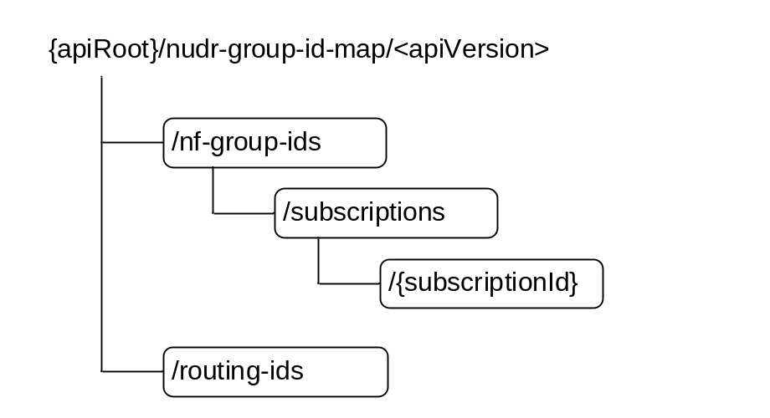

Figure 6.2.3.1-1: Resource URI structure of the nudr-group-id-map API
Table 6.2.3.1-1 provides an overview of the resources and applicable HTTP methods.

Table 6.2.3.1-1: Resources and methods overview
Resource name | Resource URI | HTTP method | Description
NfGroupIds | /nf-group-ids | GET | Obtain the NF Group ID for a given subscriber ID
Subscriptions | /nf-group-ids/subscriptions | POST | Create a subscription
IndividualSubscription | /nf-group-ids/subscriptions/{subscriptionId} | GET | Retrieve an individual subscription
IndividualSubscription | /nf-group-ids/subscriptions/{subscriptionId} | PATCH | Modify an individual subscription
IndividualSubscription | /nf-group-ids/subscriptions/{subscriptionId} | DELETE | Delete an individual subscription
RoutingIds | /routing-ids | GET | Obtain the list of Routing IDs served by a given NF Group

6.2.3.2 Resource NfGroupIds

6.2.3.2.1 Description
This resource represents the NF Group IDs for the provided subscriber information (e.g. the subscriber identifier, or information related to a set of subscribers, such as the Routing Indicator).

6.2.3.2.2 Resource Definition
Resource URI: {apiRoot}/nudr-group-id-map/<apiVersion>/nf-group-ids
This resource shall support the resource URI variables defined in table 6.2.3.2.2-1.
Table 6.2.3.2.2-1: Resource URI variables for this resource
Name | Definition
apiRoot | See clause 6.2.1

6.2.3.2.3 Resource Standard Methods
6.2.3.2.3.1 GET
This method shall support the URI query parameters specified in table 6.2.3.2.3.1-1.
Table 6.2.3.2.3.1-1: URI query parameters supported by the GET method on this resource
Name | Data type | P | Cardinality | Description
nf-type | array(NFType) | M | 1..N | see 3GPP TS 29.510 [14]
subscriberId | SubscriberId | M | 1 | Represents the Subscription Identifier SUPI or GPSI or IMPI or IMPU (see 3GPP TS 23.501 [4] clause 5.9.2 and clause 5.9.8) or Routing Indicator  pattern: ^(imsi-[0-9]{5,15}|nai-.+|msisdn-[0-9]{5,15}|extid-[^@]+@[^@]+|impi-.+|impu-.+|rid-[0-9]{1,4}|.+)$
NOTE 1: The format of the query parameter subscriberId is in line with the yaml and thus does not follow the lower-with-hyphen format specified in 3GPP TS 29.501 [8].
NOTE 2: If the UDR does not support a certain alternative in the regular expression pattern of the subscriberId query parameter (e.g. "rid-xxxx"), it returns an HTTP 404 error response.
This method shall support the request data structures specified in table 6.2.3.2.3.1-2 and the response data structures and response codes specified in table 6.2.3.2.3.1-3.
Table 6.2.3.2.3.1-2: Data structures supported by the GET Request Body on this resource
Data type | P | Cardinality | Description
n/a

Table 6.2.3.2.3.1-3: Data structures supported by the GET Response Body on this resource
Data type | P | Cardinality | Response  codes | Description
NfGroupIdMapResult | M | 1 | 200 OK | Upon success, a response body containing the NF Group IDs for the requested NF types shall be returned.
ProblemDetails | O | 0..1 | 404 Not Found | The "cause" attribute may be set to one of the following application errors:  - USER_NOT_FOUND
NOTE: In addition, common data structures as listed in table 5.2.7.1-1 of 3GPP TS 29.500 are supported.

6.2.3.3 Resource RoutingIds

6.2.3.3.1 Description
This resource represents the Routing Indicators served by an NF Group.

6.2.3.3.2 Resource Definition
Resource URI: {apiRoot}/nudr-group-id-map/<apiVersion>/routing-ids
This resource shall support the resource URI variables defined in table 6.2.3.3.2-1.
Table 6.2.3.3.2-1: Resource URI variables for this resource
Name | Definition
apiRoot | See clause 6.2.1

6.2.3.3.3 Resource Standard Methods
6.2.3.3.3.1 GET
This method shall support the URI query parameters specified in table 6.2.3.3.3.1-1.
Table 6.2.3.3.3.1-1: URI query parameters supported by the GET method on this resource
Name | Data type | P | Cardinality | Description
nf-type | NFType | M | 1 | see 3GPP TS 29.510 [14]
nf-group-id | NfGroupId | M | 1 | Contains the identity of the NF Group

This method shall support the request data structures specified in table 6.2.3.3.3.1-2 and the response data structures and response codes specified in table 6.2.3.3.3.1-3.
Table 6.2.3.3.3.1-2: Data structures supported by the GET Request Body on this resource
Data type | P | Cardinality | Description
n/a

Table 6.2.3.3.3.1-3: Data structures supported by the GET Response Body on this resource
Data type | P | Cardinality | Response  codes | Description
RoutingIdResult | M | 1 | 200 OK | Upon success, a response body containing the Routing IDs for the requested NF type and NF Group ID shall be returned.
NOTE: In addition, common data structures as listed in table 5.2.7.1-1 of 3GPP TS 29.500 are supported.

6.2.3.4 Resource Subscriptions

6.2.3.4.1 Description
This resource represents the subscriptions to changes on the mapping between user ID and NF Group ID.

6.2.3.4.2 Resource Definition
Resource URI: {apiRoot}/nudr-group-id-map/<apiVersion>/nf-group-ids/subscriptions
This resource shall support the resource URI variables defined in table 6.2.3.4.2-1.
Table 6.2.3.4.2-1: Resource URI variables for this resource
Name | Definition
apiRoot | See clause 6.2.1

6.2.3.4.3 Resource Standard Methods
6.2.3.4.3.1 POST
This method shall support the URI query parameters specified in table 6.2.3.4.3.1-1.
Table 6.2.3.4.3.1-1: URI query parameters supported by the POST method on this resource
Name | Data type | P | Cardinality | Description
supported-features | SupportedFeatures | O | 0..1 | see 3GPP TS 29.500 [7] clause 6.6

This method shall support the request data structures specified in table 6.2.3.4.3.1-2 and the response data structures and response codes specified in table 6.2.3.4.3.1-3.
Table 6.2.3.4.3.1-2: Data structures supported by the POST Request Body on this resource
Data type | P | Cardinality | Description
SubscriptionData | M | 1 | Identifies the input data to create a subscription.

Table 6.2.3.4.3.1-3: Data structures supported by the POST Response Body on this resource
Data type | P | Cardinality | Response  codes | Description
SubscriptionData | M | 1 | 200 OK | Upon success, a response body containing the Routing IDs for the requested NF type and NF Group ID shall be returned.
NOTE: In addition, common data structures as listed in table 5.2.7.1-1 of 3GPP TS 29.500 [7] are supported.

6.2.3.5 Resource IndividualSubscription

6.2.3.5.1 Description
This resource represents an individual subscription to changes on the mapping between user ID and NF Group ID.

6.2.3.5.2 Resource Definition
Resource URI: {apiRoot}/nudr-group-id-map/<apiVersion>/nf-group-ids/subscriptions/{subscriptionId}
This resource shall support the resource URI variables defined in table 6.2.3.5.2-1.
Table 6.2.3.5.2-1: Resource URI variables for this resource
Name | Definition
apiRoot | See clause 6.2.1
subscriptionId | It identifies an individual subscription to notifications. The value is allocated by the UDR during creation of the IndividualSubscription resource.

6.2.3.5.3 Resource Standard Methods
6.2.3.5.3.1 GET
This method shall support the URI query parameters specified in table 6.2.3.5.3.1-1.
Table 6.2.3.5.3.1-1: URI query parameters supported by the GET method on this resource
Name | Data type | P | Cardinality | Description
n/a

This method shall support the request data structures specified in table 6.2.3.5.3.1-2 and the response data structures and response codes specified in table 6.2.3.5.3.1-3.
Table 6.2.3.5.3.1-2: Data structures supported by the GET Request Body on this resource
Data type | P | Cardinality | Description
n/a

Table 6.2.3.5.3.1-3: Data structures supported by the GET Response Body on this resource
Data type | P | Cardinality | Response  codes | Description
SubscriptionData | M | 1 | 200 OK | Upon success, a response body containing the data that represents an individual subscription shall be returned.
NOTE: In addition, common data structures as listed in table 5.2.7.1-1 of 3GPP TS 29.500 [7] are supported.

6.2.3.5.3.2 PATCH
This method shall support the URI query parameters specified in table 6.2.3.5.3.2-1.
Table 6.2.3.5.3.2-1: URI query parameters supported by the PATCH method on this resource
Name | Data type | P | Cardinality | Description
supported-features | SupportedFeatures | O | 0..1 | see 3GPP TS 29.500 [7] clause 6.6

This method shall support the request data structures specified in table 6.2.3.5.3.2-2 and the response data structures and response codes specified in table 6.2.3.5.3.2-3.
Table 6.2.3.5.3.2-2: Data structures supported by the PATCH Request Body on this resource
Data type | P | Cardinality | Description
array(PatchItem) | M | 1..N | Contains the delta data to the Individual Subscription.

Table 6.2.3.5.3.2-3: Data structures supported by the PATCH Response Body on this resource
Data type | P | Cardinality | Response  codes | Description
n/a |  |  | 204 No Content | Upon successful modification, when all the modification instructions in the PATCH request have been implemented, there is no body in the response message.
SubscriptionData | C | 1 | 200 OK | Upon partial success, if any of the requested modifications have not been accepted, but the server has set different values than those requested by the client, in any of the attributes of the resource, the modified individual SubscriptionData is returned with the accepted/confirmed values, e.g. the confirmed expiry time.
NOTE: In addition, common data structures as listed in table 5.2.7.1-1 of 3GPP TS 29.500 [7] are supported.

6.2.3.5.3.3 DELETE
This method shall support the URI query parameters specified in table 6.2.3.5.3.3-1.
Table 6.2.3.5.3.3-1: URI query parameters supported by the DELETE method on this resource
Name | Data type | P | Cardinality | Description
n/a

This method shall support the request data structures specified in table 6.2.3.5.3.3-2 and the response data structures and response codes specified in table 6.2.3.5.3.3-3.
Table 6.2.3.5.3.3-2: Data structures supported by the DELETE Request Body on this resource
Data type | P | Cardinality | Description
n/a |  |  | The request body shall be empty.

Table 6.2.3.5.3.3-3: Data structures supported by the DELETE Response Body on this resource
Data type | P | Cardinality | Response  codes | Description
n/a |  |  | 204 No Content | Upon success, an empty response body shall be returned.
NOTE: In addition, common data structures as listed in table 5.2.7.1-1 of 3GPP TS 29.500 [7] are supported.

6.2.4 Custom Operations without associated resources
In this release of this specification, no custom operations without associated resources are defined for the Nudr_GroupIDmap Service.

6.2.5 Notifications

6.2.5.1 General
This clause specifies the general mechanism of notifications in the following scenarios:
- notification of changed data of mapping between a subscriber ID and an NF Group ID

6.2.5.2 Data Change Notification
The POST method shall be used to inform the NF Service Consumer about a change on the mapping between a subscriber ID and an NF Group ID.
Resource URI: {notificationUri}
Support of URI query parameters is specified in table 6.2.5.2-1.
Table 6.2.5.2-1: URI query parameters supported by the POST method
Name | Data type | P | Cardinality | Description
n/a

Support of request data structures is specified in table 6.2.5.2-2 and of response data structures and response codes is specified in table 6.2.5.2-3.
Table 6.2.5.2-2: Data structures supported by the POST Request Body
Data type | P | Cardinality | Description
GroupIdMapNotify | M | 1 | Contains the subscriber ID(s) whose mapping has changed, and the new NF Group ID (and NF type).

Table 6.2.5.2-3: Data structures supported by the POST Response Body
Data type | P | Cardinality | Response  codes | Description
n/a |  |  | 204 No Content | Upon success, an empty response body shall be returned.
NOTE: In addition, common data structures as listed in table 5.2.7.1-1 of 3GPP TS 29.500 [7] are supported.

6.2.6 Data Model

6.2.6.1 General
This clause specifies the application data model supported by the API.
Table 6.2.6.1-1 specifies the structured data types defined for the Nudr_GroupIDmap service API. For simple data types defined for the Nudr_GroupIDmap service API see table 6.2.6.3.2-1.
Table 6.2.6.1-1: Nudr_GroupIDmap specific Data Types
Data type | Clause defined | Description
NfGroupIdMapResult | 6.2.6.2.2 | NF-Group IDs for the requested NF types
RoutingIdResult | 6.2.6.2.3 | Routing Indicators for the requested NF type and NF Group ID
SubscriptionData | 6.2.6.2.4 | Information of a subscription to notifications to UDR GroupIDmap service, included in subscription requests and responses
GroupIdMapNotify | 6.2.6.2.5 | Data sent in notifications from UDR to entities subscribed to UDR GroupIDmap service
SubscriberId | 6.2.6.3.2 | Represents the Subscription Identifier SUPI or GPSI or IMPI or IMPU or Routing Indicator

Table 6.2.6.1-2 specifies data types re-used by the Nudr_GroupIDmap service API from other specifications, including a reference to their respective specifications and when needed, a short description of their use within the Nudr_GroupIDmap service API.
Table 6.2.6.1-2: Nudr_GroupIDmap re-used Data Types
Data type | Reference | Comments
ProblemDetails | 3GPP TS 29.571 [10] | Common data type used in response bodies
SupportedFeatures | 3GPP TS 29.571 [10]
NFType | 3GPP TS 29.510 [14]
NfGroupId | 3GPP TS 29.571 [10]
IdentityRanges | 3GPP TS 29.571 [10]

6.2.6.2 Structured data types

6.2.6.2.1 Introduction
This clause defines the structures to be used in resource representations.

6.2.6.2.2 Type: NfGroupIdMapResult
Table 6.2.6.2.2-1: Definition of type NfGroupIdMapResult
Attribute name | Data type | P | Cardinality | Description
nfGroupIDs | map(NfGroupId) | M | 1..N | A map (list of key-value pairs where NFType serves as key) of NFGroupIds

6.2.6.2.3 Type: RoutingIdResult
Table 6.2.6.2.3-1: Definition of type NfGroupIdMapResult
Attribute name | Data type | P | Cardinality | Description
routingIndicators | array(string) | M | 1..N | An array of Routing Indicators.  pattern (of each item): '^[0-9]{1,4}$'

6.2.6.2.4 Type: SubscriptionData
Table 6.2.6.2.4-1: Definition of type SubscriptionData
Attribute name | Data type | P | Cardinality | Description
notificationUri | Uri | M | 1 | Identifies the URI of the NF Service Consumer where the notification shall be sent by UDR.
nfType | NFType | M | 1 | NF type of the NF Group ID that shall be monitored for changes on the mapping with subscriber IDs.
nfGroupId | NfGroupId | M | 1 | NF Group ID that shall be monitored for changes on the mapping with subscriber IDs.
subscriptionId | string | C | 0..1 | Identity of the individual subscripton, as allocated by the UDR, and sent to the NF Service Consumer in the response message. It shall be absent in request messages and shall be present in response messages.  readOnly: true
expiry | DateTime | O | 0..1 | This IE shall be included in a subscription response if, based on operator policy and taking into account the expiry time included in the request, the UDR needs to include an expiry time.  This IE may be included in a subscription request. When present, this IE shall represent the time after which the subscription becomes invalid.  The absence of this attribute in the subscription response means the subscription to be valid without an expiry time.

6.2.6.2.5 Type: GroupIdMapNotify
Table 6.2.6.2.5-1: Definition of type GroupIdMapNotify
Attribute name | Data type | P | Cardinality | Description
subscriberId | SubscriberId | M | 1 | Identity of the subscriber whose mapping to an NF Group ID has changed.  If multiple subscriber identities are reported (by including the "identityRanges" attribute), the "subscriberId" attribute shall contain any of the identities included in those ranges.
nfType | NFType | M | 1 | NF type of the NF Group that starts handling the subscribers identified by this notification.
nfGroupId | NfGroupId | M | 1 | NF Group ID that starts handling the subscribers identified by this notification.
identityRanges | array(IdentityRanges) | O | 1..N | Ranges of identities whose mapping to an NF Group ID has changed.  Absence of this attribute indicates that only the user identified by the "subscriberId" attribute is affected by the NF Group ID mapping change.  See NOTE.
NOTE: The type of identity shall be the same for all elements of the IdentityRanges array, and it shall be the same as the type of identity indicated by the "subscriberId" attribute.

EXAMPLE:
- If the following SUPI ranges: [ imsi-12345600000 to imsi-12345600099 ] (100 subscribers) and [ imsi-12345699990 to imsi-12345699999 ] (10 subscribers) have been migrated from UDM Group ID "UDM_GROUP_1" to "UDM_GROUP_2", the notification shall contain the following data:
{
"subscriberId": "imsi-12345600000",
"nfType": "UDM",
"nfGroupId": "UDM_GROUP_2",
"identityRanges": [
{ "start": "12345600000", "end": "12345600099" },
{ "start": "12345699990", "end": "12345699999" }
]
}

6.2.6.3 Simple data types and enumerations

6.2.6.3.1 Introduction
This clause defines simple data types and enumerations that can be referenced from data structures defined in the previous clauses.

6.2.6.3.2 Simple data types
The simple data types defined in table 6.2.6.3.2-1 shall be supported.
Table 6.2.6.3.2-1: Simple data types
Type Name | Type Definition | Description
SubscriberId | string | Pattern: ^(imsi-[0-9]{5,15}|nai-.+|msisdn-[0-9]{5,15}|extid-[^@]+@[^@]+|impi-.+|impu-.+|rid-[0-9]{1,4}|.+)$

6.2.7 Error Handling

6.2.7.1 General
HTTP error handling shall be supported as specified in clause 5.2.4 of 3GPP TS 29.500 [7].

6.2.7.2 Protocol Errors
Protocol errors handling shall be supported as specified in clause 5.2.7 of 3GPP TS 29.500 [7].

6.2.7.3 Application Errors
The common application errors defined in the Table 5.2.7.2-1 in 3GPP TS 29.500 [7] may also be used for the Nudr_GroupIDmap service. The following application errors listed in Table 6.2.7.3-1 are specific for the Nudr_GroupIDmap service.
Table 6.2.7.3-1: Application errors
Application Error | HTTP status code | Description
USER_NOT_FOUND | 404 Not Found | The user does not exist in the HPLMN

6.2.8 Security
As indicated in 3GPP TS 33.501 [12], the access to the Nudr_GroupIDmap API may be authorized by means of the OAuth2 protocol (see IETF RFC 6749 [13]), using the "Client Credentials" authorization grant, where the NRF (see 3GPP TS 29.510 [14]) plays the role of the authorization server.
If Oauth2 authorization is used, an NF Service Consumer, prior to consuming services offered by the Nudr_GroupIDmap API, shall obtain a "token" from the authorization server, by invoking the Access Token Request service, as described in 3GPP TS 29.510 [14], clause 5.4.2.2.
NOTE: When multiple NRFs are deployed in a network, the NRF used as authorization server is the same NRF that the NF Service Consumer used for discovering the Nudr_GroupIDmap service.
The Nudr_GroupIDmap API defines scopes for OAuth2 authorization as specified in 3GPP TS 33.501 [12]; it defines a single scope consisting on the name of the service (i.e., "nudr-group-id-map"), and it does not define any additional scopes at resource or operation level.

6.2.9 Feature Negotiation
The optional features in table 6.2.9-1 are defined for the Nudr_GroupIDmap API. They shall be negotiated using the extensibility mechanism defined in clause 6.6 of 3GPP TS 29.500 [7].
Table 6.2.9-1: Supported Features
Feature number | Feature Name | Description

Annex A (normative):
OpenAPI specification

A.1 General
This document specifies the common service operations and the top level data model for Nudr_DataRepository Service Based Interface. There are no specific HTTP methods or custom operations on the four top level resources in Table 6.1.3.1-1. Hence, the top level OpenAPI specification is not needed.
This Annex takes precedence when being discrepant to other parts of the specification with respect to the encoding of information elements and methods within the API(s).
NOTE: The semantics and procedures, as well as conditions, e.g. for the applicability and allowed combinations of attributes or values, not expressed in the OpenAPI definitions but defined in other parts of the specification also apply.
Informative copies of the OpenAPI specification files contained in this 3GPP Technical Specification are available on a Git-based repository, that uses the GitLab software version control system (see 3GPP TS 29.501 [8] clause 5.3.1 and 3GPP TR 21.900 [20] clause 5B).

A.2 Nudr_DataRepository API
This Annex specifies the formal definition of the Nudr_DataRepository service. It consists of OpenAPI 3.0.0 specifications, in YAML format.
The OpenAPI 3.0.0 definition related to SubscriptionData shall comply with the definition in 3GPP TS 29.505 [2].
The OpenAPI 3.0.0 definition related to PolicyData, StructuredDataForExposure and ApplicationData shall comply with the definition in 3GPP TS 29.519 [3].
The OpenAPI file for the Nudr_DataRepository API is defined as follows:

openapi: 3.0.0

info:
version: 2.3.3
title: 'Nudr_DataRepository API OpenAPI file'
description: |
Unified Data Repository Service.
© 2025, 3GPP Organizational Partners (ARIB, ATIS, CCSA, ETSI, TSDSI, TTA, TTC).
All rights reserved.

externalDocs:
description: 3GPP TS 29.504 V18.9.0; 5G System; Unified Data Repository Services; Stage 3
url: 'https://www.3gpp.org/ftp/Specs/archive/29_series/29.504/'

servers:
- description: API root
url: '{apiRoot}/nudr-dr/v2'
variables:
apiRoot:
default: https://example.com

security:
- {}
- oAuth2ClientCredentials:
- nudr-dr

paths:
/subscription-data/{ueId}/authentication-data/authentication-subscription:
$ref: 'TS29505_Subscription_Data.yaml#/paths/~1subscription-data~1%7BueId%7D~1authentication-data~1authentication-subscription'
/subscription-data/{ueId}/authentication-data/authentication-status:
$ref: 'TS29505_Subscription_Data.yaml#/paths/~1subscription-data~1%7BueId%7D~1authentication-data~1authentication-status'
/subscription-data/{ueId}/authentication-data/authentication-status/{servingNetworkName}:
$ref: 'TS29505_Subscription_Data.yaml#/paths/~1subscription-data~1%7BueId%7D~1authentication-data~1authentication-status~1%7BservingNetworkName%7D'
/subscription-data/{ueId}/ue-update-confirmation-data/sor-data:
$ref: 'TS29505_Subscription_Data.yaml#/paths/~1subscription-data~1%7BueId%7D~1ue-update-confirmation-data~1sor-data'
/subscription-data/{ueId}/ue-update-confirmation-data/upu-data:
$ref: 'TS29505_Subscription_Data.yaml#/paths/~1subscription-data~1%7BueId%7D~1ue-update-confirmation-data~1upu-data'
/subscription-data/{ueId}/ue-update-confirmation-data/subscribed-cag:
$ref: 'TS29505_Subscription_Data.yaml#/paths/~1subscription-data~1%7BueId%7D~1ue-update-confirmation-data~1subscribed-cag'
/subscription-data/{ueId}/ue-update-confirmation-data/subscribed-snssais:
$ref: 'TS29505_Subscription_Data.yaml#/paths/~1subscription-data~1%7BueId%7D~1ue-update-confirmation-data~1subscribed-snssais'
/subscription-data/{ueId}/{servingPlmnId}/provisioned-data:
$ref: 'TS29505_Subscription_Data.yaml#/paths/~1subscription-data~1%7BueId%7D~1%7BservingPlmnId%7D~1provisioned-data'
/subscription-data/{ueId}/{servingPlmnId}/provisioned-data/am-data:
$ref: 'TS29505_Subscription_Data.yaml#/paths/~1subscription-data~1%7BueId%7D~1%7BservingPlmnId%7D~1provisioned-data~1am-data'
/subscription-data/{ueId}/{servingPlmnId}/provisioned-data/smf-selection-subscription-data:
$ref: 'TS29505_Subscription_Data.yaml#/paths/~1subscription-data~1%7BueId%7D~1%7BservingPlmnId%7D~1provisioned-data~1smf-selection-subscription-data'
/subscription-data/{ueId}/{servingPlmnId}/provisioned-data/sm-data:
$ref: 'TS29505_Subscription_Data.yaml#/paths/~1subscription-data~1%7BueId%7D~1%7BservingPlmnId%7D~1provisioned-data~1sm-data'
/subscription-data/{ueId}/{servingPlmnId}/provisioned-data/lcs-bca-data:
$ref: 'TS29505_Subscription_Data.yaml#/paths/~1subscription-data~1%7BueId%7D~1%7BservingPlmnId%7D~1provisioned-data~1lcs-bca-data'
/subscription-data/{ueId}/context-data:
$ref: 'TS29505_Subscription_Data.yaml#/paths/~1subscription-data~1%7BueId%7D~1context-data'
/subscription-data/{ueId}/context-data/amf-3gpp-access:
$ref: 'TS29505_Subscription_Data.yaml#/paths/~1subscription-data~1%7BueId%7D~1context-data~1amf-3gpp-access'
/subscription-data/{ueId}/context-data/amf-non-3gpp-access:
$ref: 'TS29505_Subscription_Data.yaml#/paths/~1subscription-data~1%7BueId%7D~1context-data~1amf-non-3gpp-access'
/subscription-data/{ueId}/context-data/smf-registrations:
$ref: 'TS29505_Subscription_Data.yaml#/paths/~1subscription-data~1%7BueId%7D~1context-data~1smf-registrations'
/subscription-data/{ueId}/context-data/smf-registrations/{pduSessionId}:
$ref: 'TS29505_Subscription_Data.yaml#/paths/~1subscription-data~1%7BueId%7D~1context-data~1smf-registrations~1%7BpduSessionId%7D'
/subscription-data/{ueId}/operator-specific-data:
$ref: 'TS29505_Subscription_Data.yaml#/paths/~1subscription-data~1%7BueId%7D~1operator-specific-data'
/subscription-data/{ueId}/context-data/smsf-3gpp-access:
$ref: 'TS29505_Subscription_Data.yaml#/paths/~1subscription-data~1%7BueId%7D~1context-data~1smsf-3gpp-access'
/subscription-data/{ueId}/context-data/smsf-non-3gpp-access:
$ref: 'TS29505_Subscription_Data.yaml#/paths/~1subscription-data~1%7BueId%7D~1context-data~1smsf-non-3gpp-access'
/subscription-data/{ueId}/context-data/location:
$ref: 'TS29505_Subscription_Data.yaml#/paths/~1subscription-data~1%7BueId%7D~1context-data~1location'
/subscription-data/{ueId}/context-data/ip-sm-gw:
$ref: 'TS29505_Subscription_Data.yaml#/paths/~1subscription-data~1%7BueId%7D~1context-data~1ip-sm-gw'
/subscription-data/{ueId}/context-data/mwd:
$ref: 'TS29505_Subscription_Data.yaml#/paths/~1subscription-data~1%7BueId%7D~1context-data~1mwd'
/subscription-data/{ueId}/context-data/roaming-information:
$ref: 'TS29505_Subscription_Data.yaml#/paths/~1subscription-data~1%7BueId%7D~1context-data~1roaming-information'
/subscription-data/{ueId}/context-data/pei-info:
$ref: 'TS29505_Subscription_Data.yaml#/paths/~1subscription-data~1%7BueId%7D~1context-data~1pei-info'
/subscription-data/{ueId}/{servingPlmnId}/provisioned-data/sms-mng-data:
$ref: 'TS29505_Subscription_Data.yaml#/paths/~1subscription-data~1%7BueId%7D~1%7BservingPlmnId%7D~1provisioned-data~1sms-mng-data'
/subscription-data/{ueId}/{servingPlmnId}/provisioned-data/sms-data:
$ref: 'TS29505_Subscription_Data.yaml#/paths/~1subscription-data~1%7BueId%7D~1%7BservingPlmnId%7D~1provisioned-data~1sms-data'
/subscription-data/{ueId}/lcs-privacy-data:
$ref: 'TS29505_Subscription_Data.yaml#/paths/~1subscription-data~1%7BueId%7D~1lcs-privacy-data'
/subscription-data/{ueId}/lcs-mo-data:
$ref: 'TS29505_Subscription_Data.yaml#/paths/~1subscription-data~1%7BueId%7D~1lcs-mo-data'
/subscription-data/{ueId}/lcs-subscription-data:
$ref: 'TS29505_Subscription_Data.yaml#/paths/~1subscription-data~1%7BueId%7D~1lcs-subscription-data'
/subscription-data/{ueId}/pp-data:
$ref: 'TS29505_Subscription_Data.yaml#/paths/~1subscription-data~1%7BueId%7D~1pp-data'
/subscription-data/{ueId}/context-data/ee-subscriptions:
$ref: 'TS29505_Subscription_Data.yaml#/paths/~1subscription-data~1%7BueId%7D~1context-data~1ee-subscriptions'
/subscription-data/{ueId}/context-data/ee-subscriptions/{subsId}:
$ref: 'TS29505_Subscription_Data.yaml#/paths/~1subscription-data~1%7BueId%7D~1context-data~1ee-subscriptions~1%7BsubsId%7D'
/subscription-data/{ueId}/context-data/ee-subscriptions/{subsId}/amf-subscriptions:
$ref: 'TS29505_Subscription_Data.yaml#/paths/~1subscription-data~1%7BueId%7D~1context-data~1ee-subscriptions~1%7BsubsId%7D~1amf-subscriptions'
/subscription-data/{ueId}/context-data/ee-subscriptions/{subsId}/smf-subscriptions:
$ref: 'TS29505_Subscription_Data.yaml#/paths/~1subscription-data~1%7BueId%7D~1context-data~1ee-subscriptions~1%7BsubsId%7D~1smf-subscriptions'
/subscription-data/{ueId}/context-data/ee-subscriptions/{subsId}/hss-subscriptions:
$ref: 'TS29505_Subscription_Data.yaml#/paths/~1subscription-data~1%7BueId%7D~1context-data~1ee-subscriptions~1%7BsubsId%7D~1hss-subscriptions'
/subscription-data/group-data/{ueGroupId}/ee-subscriptions:
$ref: 'TS29505_Subscription_Data.yaml#/paths/~1subscription-data~1group-data~1%7BueGroupId%7D~1ee-subscriptions'
/subscription-data/group-data/{ueGroupId}/ee-subscriptions/{subsId}:
$ref: 'TS29505_Subscription_Data.yaml#/paths/~1subscription-data~1group-data~1%7BueGroupId%7D~1ee-subscriptions~1%7BsubsId%7D'
/subscription-data/group-data/{ueGroupId}/ee-subscriptions/{subsId}/amf-subscriptions:
$ref: 'TS29505_Subscription_Data.yaml#/paths/~1subscription-data~1group-data~1%7BueGroupId%7D~1ee-subscriptions~1%7BsubsId%7D~1amf-subscriptions'
/subscription-data/group-data/{ueGroupId}/ee-subscriptions/{subsId}/smf-subscriptions:
$ref: 'TS29505_Subscription_Data.yaml#/paths/~1subscription-data~1group-data~1%7BueGroupId%7D~1ee-subscriptions~1%7BsubsId%7D~1smf-subscriptions'
/subscription-data/group-data/{ueGroupId}/ee-subscriptions/{subsId}/hss-subscriptions:
$ref: 'TS29505_Subscription_Data.yaml#/paths/~1subscription-data~1group-data~1%7BueGroupId%7D~1ee-subscriptions~1%7BsubsId%7D~1hss-subscriptions'
/subscription-data/group-data/{ueGroupId}/ee-profile-data:
$ref: 'TS29505_Subscription_Data.yaml#/paths/~1subscription-data~1group-data~1%7BueGroupId%7D~1ee-profile-data'
/subscription-data/group-data/5g-vn-groups:
$ref: 'TS29505_Subscription_Data.yaml#/paths/~1subscription-data~1group-data~15g-vn-groups'
/subscription-data/group-data/5g-vn-groups/{externalGroupId}:
$ref: 'TS29505_Subscription_Data.yaml#/paths/~1subscription-data~1group-data~15g-vn-groups~1%7BexternalGroupId%7D'
/subscription-data/group-data/5g-vn-groups/internal:
$ref: 'TS29505_Subscription_Data.yaml#/paths/~1subscription-data~1group-data~15g-vn-groups~1internal'
/subscription-data/group-data/5g-vn-groups/pp-profile-data:
$ref: 'TS29505_Subscription_Data.yaml#/paths/~1subscription-data~1group-data~15g-vn-groups~1pp-profile-data'
/subscription-data/group-data/mbs-group-membership:
$ref: 'TS29505_Subscription_Data.yaml#/paths/~1subscription-data~1group-data~1mbs-group-membership'
/subscription-data/group-data/mbs-group-membership/{externalGroupId}:
$ref: 'TS29505_Subscription_Data.yaml#/paths/~1subscription-data~1group-data~1mbs-group-membership~1%7BexternalGroupId%7D'
/subscription-data/group-data/mbs-group-membership/internal:
$ref: 'TS29505_Subscription_Data.yaml#/paths/~1subscription-data~1group-data~1mbs-group-membership~1internal'
/subscription-data/group-data/mbs-group-membership/pp-profile-data:
$ref: 'TS29505_Subscription_Data.yaml#/paths/~1subscription-data~1group-data~1mbs-group-membership~1pp-profile-data'
/subscription-data/{ueId}/ee-profile-data:
$ref: 'TS29505_Subscription_Data.yaml#/paths/~1subscription-data~1%7BueId%7D~1ee-profile-data'
/subscription-data/{ueId}/context-data/sdm-subscriptions:
$ref: 'TS29505_Subscription_Data.yaml#/paths/~1subscription-data~1%7BueId%7D~1context-data~1sdm-subscriptions'
/subscription-data/{ueId}/context-data/sdm-subscriptions/{subsId}:
$ref: 'TS29505_Subscription_Data.yaml#/paths/~1subscription-data~1%7BueId%7D~1context-data~1sdm-subscriptions~1%7BsubsId%7D'
/subscription-data/{ueId}/context-data/nidd-authorizations:
$ref: 'TS29505_Subscription_Data.yaml#/paths/~1subscription-data~1%7BueId%7D~1context-data~1nidd-authorizations'
/subscription-data/{ueId}/context-data/sdm-subscriptions/{subsId}/hss-sdm-subscriptions:
$ref: 'TS29505_Subscription_Data.yaml#/paths/~1subscription-data~1%7BueId%7D~1context-data~1sdm-subscriptions~1%7BsubsId%7D~1hss-sdm-subscriptions'
/subscription-data/shared-data:
$ref: 'TS29505_Subscription_Data.yaml#/paths/~1subscription-data~1shared-data'
/subscription-data/shared-data/{sharedDataId}:
$ref: 'TS29505_Subscription_Data.yaml#/paths/~1subscription-data~1shared-data~1%7BsharedDataId%7D'
/subscription-data/subs-to-notify:
$ref: 'TS29505_Subscription_Data.yaml#/paths/~1subscription-data~1subs-to-notify'
/subscription-data/subs-to-notify/{subsId}:
$ref: 'TS29505_Subscription_Data.yaml#/paths/~1subscription-data~1subs-to-notify~1%7BsubsId%7D'
/subscription-data/{ueId}/{servingPlmnId}/provisioned-data/trace-data:
$ref: 'TS29505_Subscription_Data.yaml#/paths/~1subscription-data~1%7BueId%7D~1%7BservingPlmnId%7D~1provisioned-data~1trace-data'
/subscription-data/{ueId}/identity-data:
$ref: 'TS29505_Subscription_Data.yaml#/paths/~1subscription-data~1%7BueId%7D~1identity-data'
/subscription-data/{ueId}/operator-determined-barring-data:
$ref: 'TS29505_Subscription_Data.yaml#/paths/~1subscription-data~1%7BueId%7D~1operator-determined-barring-data'
/subscription-data/{ueId}/nidd-authorization-data:
$ref: 'TS29505_Subscription_Data.yaml#/paths/~1subscription-data~1%7BueId%7D~1nidd-authorization-data'
/subscription-data/{ueId}/service-specific-authorization-data/{serviceType}:
$ref: 'TS29505_Subscription_Data.yaml#/paths/~1subscription-data~1%7BueId%7D~1service-specific-authorization-data~1%7BserviceType%7D'
/subscription-data/{ueId}/v2x-data:
$ref: 'TS29505_Subscription_Data.yaml#/paths/~1subscription-data~1%7BueId%7D~1v2x-data'
/subscription-data/{ueId}/pp-profile-data:
$ref: 'TS29505_Subscription_Data.yaml#/paths/~1subscription-data~1%7BueId%7D~1pp-profile-data'
/subscription-data/{ueId}/coverage-restriction-data:
$ref: 'TS29505_Subscription_Data.yaml#/paths/~1subscription-data~1%7BueId%7D~1coverage-restriction-data'
/subscription-data/group-data/group-identifiers:
$ref: 'TS29505_Subscription_Data.yaml#/paths/~1subscription-data~1group-data~1group-identifiers'
/subscription-data/{ueId}/prose-data:
$ref: 'TS29505_Subscription_Data.yaml#/paths/~1subscription-data~1%7BueId%7D~1prose-data'
/subscription-data/{ueId}/pp-data-store:
$ref: 'TS29505_Subscription_Data.yaml#/paths/~1subscription-data~1%7BueId%7D~1pp-data-store'
/subscription-data/{ueId}/context-data/service-specific-authorizations/{serviceType}:
$ref: 'TS29505_Subscription_Data.yaml#/paths/~1subscription-data~1%7BueId%7D~1context-data~1service-specific-authorizations~1%7BserviceType%7D'
/subscription-data/{ueId}/5mbs-data:
$ref: 'TS29505_Subscription_Data.yaml#/paths/~1subscription-data~1%7BueId%7D~15mbs-data'
/subscription-data/{ueId}/uc-data:
$ref: 'TS29505_Subscription_Data.yaml#/paths/~1subscription-data~1%7BueId%7D~1uc-data'
/subscription-data/{ueId}/time-sync-data:
$ref: 'TS29505_Subscription_Data.yaml#/paths/~1subscription-data~1%7BueId%7D~1time-sync-data'
/subscription-data/{ueId}/ranging-slpos-data:
$ref: 'TS29505_Subscription_Data.yaml#/paths/~1subscription-data~1%7BueId%7D~1ranging-slpos-data'
/subscription-data/{ueId}/a2x-data:
$ref: 'TS29505_Subscription_Data.yaml#/paths/~1subscription-data~1%7BueId%7D~1a2x-data'
/subscription-data/{ueId}/rangingsl-privacy-data:
$ref: 'TS29505_Subscription_Data.yaml#/paths/~1subscription-data~1%7BueId%7D~1rangingsl-privacy-data'
/policy-data/ues/{ueId}:
$ref: 'TS29519_Policy_Data.yaml#/paths/~1policy-data~1ues~1%7BueId%7D'
/policy-data/ues/{ueId}/am-data:
$ref: 'TS29519_Policy_Data.yaml#/paths/~1policy-data~1ues~1%7BueId%7D~1am-data'
/policy-data/ues/{ueId}/ue-policy-set:
$ref: 'TS29519_Policy_Data.yaml#/paths/~1policy-data~1ues~1%7BueId%7D~1ue-policy-set'
/policy-data/ues/{ueId}/sm-data:
$ref: 'TS29519_Policy_Data.yaml#/paths/~1policy-data~1ues~1%7BueId%7D~1sm-data'
/policy-data/ues/{ueId}/sm-data/{usageMonId}:
$ref: 'TS29519_Policy_Data.yaml#/paths/~1policy-data~1ues~1%7BueId%7D~1sm-data~1%7BusageMonId%7D'
/policy-data/sponsor-connectivity-data/{sponsorId}:
$ref: 'TS29519_Policy_Data.yaml#/paths/~1policy-data~1sponsor-connectivity-data~1%7BsponsorId%7D'
/policy-data/bdt-data:
$ref: 'TS29519_Policy_Data.yaml#/paths/~1policy-data~1bdt-data'
/policy-data/bdt-data/{bdtReferenceId}:
$ref: 'TS29519_Policy_Data.yaml#/paths/~1policy-data~1bdt-data~1%7BbdtReferenceId%7D'
/policy-data/subs-to-notify:
$ref: 'TS29519_Policy_Data.yaml#/paths/~1policy-data~1subs-to-notify'
/policy-data/subs-to-notify/{subsId}:
$ref: 'TS29519_Policy_Data.yaml#/paths/~1policy-data~1subs-to-notify~1%7BsubsId%7D'
/policy-data/ues/{ueId}/operator-specific-data:
$ref: 'TS29519_Policy_Data.yaml#/paths/~1policy-data~1ues~1%7BueId%7D~1operator-specific-data'
/application-data/pfds:
$ref: 'TS29519_Application_Data.yaml#/paths/~1application-data~1pfds'
/application-data/pfds/{appId}:
$ref: 'TS29519_Application_Data.yaml#/paths/~1application-data~1pfds~1%7BappId%7D'
/application-data/influenceData:
$ref: 'TS29519_Application_Data.yaml#/paths/~1application-data~1influenceData'
# The path segment is left not following the naming convention as defined in 3GPP TS 29.501 due to backward compatibility consideration.
/application-data/influenceData/{influenceId}:
$ref: 'TS29519_Application_Data.yaml#/paths/~1application-data~1influenceData~1%7BinfluenceId%7D'
# The path segment is left not following the naming convention as defined in 3GPP TS 29.501 due to backward compatibility consideration.
/policy-data/plmns/{plmnId}/ue-policy-set:
$ref: 'TS29519_Policy_Data.yaml#/paths/~1policy-data~1plmns~1%7BplmnId%7D~1ue-policy-set'
/application-data/bdtPolicyData:
$ref: 'TS29519_Application_Data.yaml#/paths/~1application-data~1bdtPolicyData'
# The path segment is left not following the naming convention as defined in 3GPP TS 29.501 due to backward compatibility consideration.
/application-data/bdtPolicyData/{bdtPolicyId}:
$ref: 'TS29519_Application_Data.yaml#/paths/~1application-data~1bdtPolicyData~1%7BbdtPolicyId%7D'
# The path segment is left not following the naming convention as defined in 3GPP TS 29.501 due to backward compatibility consideration.
/application-data/iptvConfigData:
$ref: 'TS29519_Application_Data.yaml#/paths/~1application-data~1iptvConfigData'
# The path segment is left not following the naming convention as defined in 3GPP TS 29.501 due to backward compatibility consideration.
/application-data/iptvConfigData/{configurationId}:
$ref: 'TS29519_Application_Data.yaml#/paths/~1application-data~1iptvConfigData~1%7BconfigurationId%7D'
# The path segment is left not following the naming convention as defined in 3GPP TS 29.501 due to backward compatibility consideration.
/application-data/serviceParamData:
$ref: 'TS29519_Application_Data.yaml#/paths/~1application-data~1serviceParamData'
# The path segment is left not following the naming convention as defined in 3GPP TS 29.501 due to backward compatibility consideration.
/application-data/serviceParamData/{serviceParamId}:
$ref: 'TS29519_Application_Data.yaml#/paths/~1application-data~1serviceParamData~1%7BserviceParamId%7D'
# The path segment is left not following the naming convention as defined in 3GPP TS 29.501 due to backward compatibility consideration.
/application-data/influenceData/subs-to-notify:
$ref: 'TS29519_Application_Data.yaml#/paths/~1application-data~1influenceData~1subs-to-notify'
# The path segment is left not following the naming convention as defined in 3GPP TS 29.501 due to backward compatibility consideration.
/application-data/influenceData/subs-to-notify/{subscriptionId}:
$ref: 'TS29519_Application_Data.yaml#/paths/~1application-data~1influenceData~1subs-to-notify~1%7BsubscriptionId%7D'
# The path segment is left not following the naming convention as defined in 3GPP TS 29.501 due to backward compatibility consideration.
/application-data/subs-to-notify:
$ref: 'TS29519_Application_Data.yaml#/paths/~1application-data~1subs-to-notify'
/application-data/subs-to-notify/{subsId}:
$ref: 'TS29519_Application_Data.yaml#/paths/~1application-data~1subs-to-notify~1%7BsubsId%7D'
/exposure-data/{ueId}/access-and-mobility-data:
$ref: 'TS29519_Exposure_Data.yaml#/paths/~1exposure-data~1%7BueId%7D~1access-and-mobility-data'
/exposure-data/{ueId}/session-management-data/{pduSessionId}:
$ref: 'TS29519_Exposure_Data.yaml#/paths/~1exposure-data~1%7BueId%7D~1session-management-data~1%7BpduSessionId%7D'
/exposure-data/subs-to-notify:
$ref: 'TS29519_Exposure_Data.yaml#/paths/~1exposure-data~1subs-to-notify'
/exposure-data/subs-to-notify/{subId}:
$ref: 'TS29519_Exposure_Data.yaml#/paths/~1exposure-data~1subs-to-notify~1%7BsubId%7D'
/data-restoration-events:
post:
# This is a pseudo operation, clients shall NOT invoke this method!
summary: subscribe to data restoration notifications
operationId: CreateIndividualSubcription
tags:
- Subscriptions (Collection)
requestBody:
required: true
content:
application/json:
schema: {}
responses:
default:
$ref: 'TS29571_CommonData.yaml#/components/responses/default'
callbacks:
restorationNotification:
'{dataRestorationCallbackUri}':
# The URI in {dataRestorationCallbackUri} is the default endpoint discovered from NRF.
post:
requestBody:
required: true
content:
application/json:
schema:
$ref: '#/components/schemas/DataRestorationNotification'
responses:
'204':
description: No Content, Notification was succesfull
'307':
description: Temporary Redirect
content:
application/json:
schema:
$ref: 'TS29571_CommonData.yaml#/components/schemas/RedirectResponse'
headers:
Location:
description: 'The URI pointing to the resource located on the redirect target NF service consumer'
required: true
schema:
type: string
'308':
description: Permanent Redirect
content:
application/json:
schema:
$ref: 'TS29571_CommonData.yaml#/components/schemas/RedirectResponse'
headers:
Location:
description: 'The URI pointing to the resource located on the redirect target NF service consumer'
required: true
schema:
type: string
'404':
$ref: 'TS29571_CommonData.yaml#/components/responses/404'
default:
$ref: 'TS29571_CommonData.yaml#/components/responses/default'

components:
securitySchemes:
oAuth2ClientCredentials:
type: oauth2
flows:
clientCredentials:
tokenUrl: '{nrfApiRoot}/oauth2/token'
scopes:
nudr-dr: Access to the Nudr_DataRepository API
nudr-dr:subscription-data: Access to the SubscriptionData data set
nudr-dr:subscription-data:authentication-subscription:read: Access to read the AuthenticationSubscription resource of the SubscriptionData data set
nudr-dr:subscription-data:authentication-subscription:modify: Access to update the AuthenticationSubscription resource of the SubscriptionData data set
nudr-dr:subscription-data:registrations:write: Write access to NF registration resources of the SubscriptionData data set
nudr-dr:policy-data: Access to the PolicyData data set
nudr-dr:policy-data:ues:read: Access to read the UEs resource
nudr-dr:policy-data:ues:am-data:read: Access to read the UEs Access and Mobility policy data
nudr-dr:policy-data:ues:ue-policy-set:read: Access to read the UEs Policy Set data
nudr-dr:policy-data:ues:ue-policy-set:create: Access to create the UEs Policy Set data
nudr-dr:policy-data:ues:ue-policy-set:modify: Access to update the UEs Policy Set data
nudr-dr:policy-data:ues:sm-data:read: Access to read the UEs Session Management Policy data
nudr-dr:policy-data:ues:sm-data:modify: Access to update the UEs Session Management Policy data
nudr-dr:policy-data:ues:sm-data:create: Access to create the UEs Session Management Policy data
nudr-dr:policy-data:sponsor-connectivity-data:read: Access to read the sponsored Connectivity Data
nudr-dr:policy-data:bdt-data:read: Access to read the BDT data resource
nudr-dr:policy-data:bdt-data:create: Access to create the BDT data resource
nudr-dr:policy-data:bdt-data:modify: Access to update the BDT data resource
nudr-dr:policy-data:subs-to-notify:read: Access to read Subscription to Notification
nudr-dr:policy-data:subs-to-notify:create: Access to create Subscriptions resources
nudr-dr:policy-data:subs-to-notify:modify: Access to update Subscriptions resources
nudr-dr:policy-data:ues:operator-specific-data:read: Access to read the UEs operator specific policy data
nudr-dr:policy-data:ues:operator-specific-data:modify: Access to update the UEs operator specific policy data
nudr-dr:policy-data:ues:operator-specific-data:create: Access to create the UEs operator specific policy data
nudr-dr:policy-data:plmns:ue-policy-set:read: Access to read UE Policy SET
nudr-dr:policy-data:slice-control-data:read: Access to read Slice specific Policy Control Data
nudr-dr:policy-data:slice-control-data:modify: Access to update Slice specific Policy Control Data
nudr-dr:policy-data:mbs-session-pol-data:read: Access to read MBS Session Policy Data
nudr-dr:policy-data:group-control-data:read: Access to read Group Control Data
nudr-dr:policy-data:group-control-data:modify: Access to update Group Control Data
nudr-dr:policy-data:pdtq-data:read: Access to read PDTQ Data
nudr-dr:policy-data:pdtq-data:create: Access to create PDTQ Data
nudr-dr:policy-data:pdtq-data:modify: Access to update PDTQ Data
nudr-dr:exposure-data: Access to the ExposureData data set
nudr-dr:exposure-data:access-and-mobility-data:create: Access to create ExposureData
nudr-dr:exposure-data:access-and-mobility-data:read: Access to read ExposureData
nudr-dr:exposure-data:access-and-mobility-data:modify: Access to update ExposureData
nudr-dr:exposure-data:session-management-data:create: Access to create ExposureData
nudr-dr:exposure-data:session-management-data:read: Access to read ExposureData
nudr-dr:exposure-data:session-management-data:modify: Access to update ExposureData
nudr-dr:exposure-data:subs-to-notify:create: Access to create Subscriptions resources
nudr-dr:exposure-data:subs-to-notify:modify: Access to update Subscriptions resources
nudr-dr:application-data: Access to the ApplicationData data set
nudr-dr:application-data:pfds:read: Access to read PFDData
nudr-dr:application-data:pfds:modify: Access to update PFDData
nudr-dr:application-data:pfds:create: Access to create PFDData
nudr-dr:application-data:influence-data:read: Access to read Traffic Influence Data
nudr-dr:application-data:influence-data:create: Access to create Traffic Influence Data.
nudr-dr:application-data:influence-data:modify: Access to update Traffic Influence Data
nudr-dr:application-data:influence-data:subscriptions:read: Access to read Traffic Influence Data Subscriptions
nudr-dr:application-data:influence-data:subscriptions:create: Access to create Traffic Influence Data Subscriptions
nudr-dr:application-data:influence-data:subscriptions:modify: Access to update Traffic Influence Data Subscriptions
nudr-dr:application-data:bdt-policy-data:read: Access to read BDT Policy Data
nudr-dr:application-data:bdt-policy-data:create: Access to create BDT Policy Data
nudr-dr:application-data:bdt-policy-data:modify: Access to update BDT Policy Data
nudr-dr:application-data:iptv-config-data:read: Access to read IPTV Configuration Data
nudr-dr:application-data:iptv-config-data:create: Access to create IPTV Configuration Data
nudr-dr:application-data:iptv-config-data:modify: Access to update IPTV Configuration Data
nudr-dr:application-data:service-param-data:read: Access to read Service Parameter Data
nudr-dr:application-data:service-param-data:create: Access to create Service Parameter Data
nudr-dr:application-data:service-param-data:modify: Access to update Service Parameter Data
nudr-dr:application-data:am-influence-data:read: Access to read AM Influence Data
nudr-dr:application-data:am-influence-data:create: Access to create AM Influence Data
nudr-dr:application-data:am-influence-data:modify: Access to update AM Influence Data
nudr-dr:application-data:subs-to-notify:create: Access to create Subscriptions resources
nudr-dr:application-data:subs-to-notify:read: Access to read Subscriptions resources
nudr-dr:application-data:subs-to-notify:modify: Access to update Subscriptions resources
nudr-dr:application-data:eas-deploy-data:read: Access to read EAS Deployment Information Data
nudr-dr:application-data:eas-deploy-data:create: Access to create EAS Deployment Information Data
nudr-dr:application-data:eas-deploy-data:modify: Access to update EAS Deployment Information Data
nudr-dr:application-data:ecs-address-roaming:read: Access to read ECS Address Roaming Data
nudr-dr:application-data:ecs-address-roaming:create: Access to create ECS Address Roaming Data
nudr-dr:application-data:ecs-address-roaming:modify: Access to update ECS Address Roaming Data
nudr-dr:application-data:dnai-eas:read: Access to read DNAI-EAS Mapping Data
nudr-dr:application-data:af-qos-data-sets:read: Access to read AF Qos Data Sets
nudr-dr:application-data:af-qos-data-sets:create: Access to create AF Qos Data Sets
nudr-dr:application-data:af-qos-data-sets:modify: Access to update AF Qos Data Sets
nudr-dr:application-data:ueid-mappings:read: Access to read UE Id Mappings
nudr-dr:application-data:ueid-mappings:create: Access to create UE Id Mappings
nudr-dr:application-data:ueid-mappings:delete: Access to delete UE Id Mappings

schemas:
DataRestorationNotification:
description: Contains identities representing those UEs potentially affected by a data-loss event at the UDR
type: object
properties:
supiRanges:
type: array
items:
$ref: 'TS29510_Nnrf_NFManagement.yaml#/components/schemas/SupiRange'
minItems: 1
gpsiRanges:
type: array
items:
$ref: 'TS29510_Nnrf_NFManagement.yaml#/components/schemas/IdentityRange'
minItems: 1
resetIds:
type: array
items:
type: string
minItems: 1
sNssaiList:
type: array
items:
$ref: 'TS29571_CommonData.yaml#/components/schemas/Snssai'
minItems: 1
dnnList:
type: array
items:
$ref: 'TS29571_CommonData.yaml#/components/schemas/Dnn'
minItems: 1
udrGroupId:
$ref: 'TS29571_CommonData.yaml#/components/schemas/NfGroupId'

A.3 Nudr_GroupIDmap API

openapi: 3.0.0

info:
version: 1.2.0
title: 'Nudr_GroupIDmap'
description: |
Unified Data Repository Service for NF-Group ID retrieval.
© 2024, 3GPP Organizational Partners (ARIB, ATIS, CCSA, ETSI, TSDSI, TTA, TTC).
All rights reserved.

externalDocs:
description: 3GPP TS 29.504 V18.6.0; 5G System; Unified Data Repository Services; Stage 3
url: 'https://www.3gpp.org/ftp/Specs/archive/29_series/29.504/'

servers:
- description: API root
url: '{apiRoot}/nudr-group-id-map/v1'
variables:
apiRoot:
default: https://example.com

security:
- {}
- oAuth2ClientCredentials:
- nudr-group-id-map

paths:
/nf-group-ids:
get:
summary: Retrieves NF-Group IDs for provided Subscriber and NF types
operationId: GetNfGroupIDs
tags:
- NF Group IDs (Document)
parameters:
- name: nf-type
in: query
description: Type of NF
required: true
style: form
explode: false
schema:
type: array
items:
$ref: 'TS29510_Nnrf_NFManagement.yaml#/components/schemas/NFType'
minItems: 1
- name: subscriberId
# The name of this query parameter is left not following the naming convention as defined in 3GPP TS 29.501 due to backward compatibility consideration.
in: query
description: Identifier of the subscriber
required: true
schema:
$ref: '#/components/schemas/SubscriberId'
responses:
'200':
description: Expected response to a valid request
content:
application/json:
schema:
$ref: '#/components/schemas/NfGroupIdMapResult'
'400':
$ref: 'TS29571_CommonData.yaml#/components/responses/400'
'401':
$ref: 'TS29571_CommonData.yaml#/components/responses/401'
'403':
$ref: 'TS29571_CommonData.yaml#/components/responses/403'
'404':
$ref: 'TS29571_CommonData.yaml#/components/responses/404'
'406':
$ref: 'TS29571_CommonData.yaml#/components/responses/406'
'429':
$ref: 'TS29571_CommonData.yaml#/components/responses/429'
'500':
$ref: 'TS29571_CommonData.yaml#/components/responses/500'
'502':
$ref: 'TS29571_CommonData.yaml#/components/responses/502'
'503':
$ref: 'TS29571_CommonData.yaml#/components/responses/503'
default:
description: Unexpected error

/nf-group-ids/subscriptions:
post:
summary: Create subscription to NF Group ID mapping
operationId: CreateGroupIdSubscription
tags:
- NF Group ID Subscriptions (Collection)
parameters:
- name: supported-features
in: query
description: Features required to be supported by the target NF
schema:
$ref: 'TS29571_CommonData.yaml#/components/schemas/SupportedFeatures'
requestBody:
content:
application/json:
schema:
$ref: '#/components/schemas/SubscriptionData'
required: true
responses:
'201':
description: Expected response to a valid request
content:
application/json:
schema:
$ref: '#/components/schemas/SubscriptionData'
headers:
Location:
description: >
Contains the URI of the newly created resource, according to the structure:
{apiRoot}/nudr-grup-id-map/<apiVersion>/nf-group-ids/subscriptions/{subscriptionId}
required: true
schema:
type: string
'400':
$ref: 'TS29571_CommonData.yaml#/components/responses/400'
'401':
$ref: 'TS29571_CommonData.yaml#/components/responses/401'
'403':
$ref: 'TS29571_CommonData.yaml#/components/responses/403'
'404':
$ref: 'TS29571_CommonData.yaml#/components/responses/404'
'411':
$ref: 'TS29571_CommonData.yaml#/components/responses/411'
'413':
$ref: 'TS29571_CommonData.yaml#/components/responses/413'
'415':
$ref: 'TS29571_CommonData.yaml#/components/responses/415'
'429':
$ref: 'TS29571_CommonData.yaml#/components/responses/429'
'500':
$ref: 'TS29571_CommonData.yaml#/components/responses/500'
'502':
$ref: 'TS29571_CommonData.yaml#/components/responses/502'
'503':
$ref: 'TS29571_CommonData.yaml#/components/responses/503'
default:
$ref: 'TS29571_CommonData.yaml#/components/responses/default'
callbacks:
onGroupIdMapChange:
'{$request.body#/notificationUri}':
post:
requestBody:
required: true
content:
application/json:
schema:
$ref: '#/components/schemas/GroupIdMapNotify'
responses:
'204':
description: Expected response to a valid request
'400':
$ref: 'TS29571_CommonData.yaml#/components/responses/400'
'401':
$ref: 'TS29571_CommonData.yaml#/components/responses/401'
'403':
$ref: 'TS29571_CommonData.yaml#/components/responses/403'
'404':
$ref: 'TS29571_CommonData.yaml#/components/responses/404'
'411':
$ref: 'TS29571_CommonData.yaml#/components/responses/411'
'413':
$ref: 'TS29571_CommonData.yaml#/components/responses/413'
'415':
$ref: 'TS29571_CommonData.yaml#/components/responses/415'
'429':
$ref: 'TS29571_CommonData.yaml#/components/responses/429'
'500':
$ref: 'TS29571_CommonData.yaml#/components/responses/500'
'502':
$ref: 'TS29571_CommonData.yaml#/components/responses/502'
'503':
$ref: 'TS29571_CommonData.yaml#/components/responses/503'
default:
$ref: 'TS29571_CommonData.yaml#/components/responses/default'

/nf-group-ids/subscriptions/{subscriptionId}:
get:
summary: Retrieves a individual subscription to NF Group ID mapping
operationId: QueryGroupIdSubscription
tags:
- NF Group ID Subscription (Document)
parameters:
- name: subscriptionId
in: path
required: true
description: Unique ID of the subscription to retrieve
schema:
type: string
responses:
'200':
description: Expected response to a valid request
content:
application/json:
schema:
$ref: '#/components/schemas/SubscriptionData'
'400':
$ref: 'TS29571_CommonData.yaml#/components/responses/400'
'401':
$ref: 'TS29571_CommonData.yaml#/components/responses/401'
'403':
$ref: 'TS29571_CommonData.yaml#/components/responses/403'
'404':
$ref: 'TS29571_CommonData.yaml#/components/responses/404'
'406':
$ref: 'TS29571_CommonData.yaml#/components/responses/406'
'429':
$ref: 'TS29571_CommonData.yaml#/components/responses/429'
'500':
$ref: 'TS29571_CommonData.yaml#/components/responses/500'
'502':
$ref: 'TS29571_CommonData.yaml#/components/responses/502'
'503':
$ref: 'TS29571_CommonData.yaml#/components/responses/503'
default:
$ref: 'TS29571_CommonData.yaml#/components/responses/default'

patch:
summary: Modify an individual subscription to NF Group ID mapping
operationId: ModifyGroupIdSubscription
tags:
- NF Group ID Subscription (Document)
parameters:
- name: subscriptionId
in: path
required: true
schema:
type: string
- name: supported-features
in: query
description: Features required to be supported by the target NF
schema:
$ref: 'TS29571_CommonData.yaml#/components/schemas/SupportedFeatures'
requestBody:
content:
application/json-patch+json:
schema:
type: array
items:
$ref: 'TS29571_CommonData.yaml#/components/schemas/PatchItem'
minItems: 1
required: true
responses:
'204':
description: Successful response
'200':
description: Expected response to a valid request
content:
application/json:
schema:
$ref: '#/components/schemas/SubscriptionData'
'400':
$ref: 'TS29571_CommonData.yaml#/components/responses/400'
'401':
$ref: 'TS29571_CommonData.yaml#/components/responses/401'
'403':
$ref: 'TS29571_CommonData.yaml#/components/responses/403'
'404':
$ref: 'TS29571_CommonData.yaml#/components/responses/404'
'411':
$ref: 'TS29571_CommonData.yaml#/components/responses/411'
'413':
$ref: 'TS29571_CommonData.yaml#/components/responses/413'
'415':
$ref: 'TS29571_CommonData.yaml#/components/responses/415'
'429':
$ref: 'TS29571_CommonData.yaml#/components/responses/429'
'500':
$ref: 'TS29571_CommonData.yaml#/components/responses/500'
'502':
$ref: 'TS29571_CommonData.yaml#/components/responses/502'
'503':
$ref: 'TS29571_CommonData.yaml#/components/responses/503'
default:
$ref: 'TS29571_CommonData.yaml#/components/responses/default'

delete:
summary: Deletes a subscription to NF Group ID mapping
operationId: RemoveGroupIdSubscription
tags:
- NF Group ID Subscription (Document)
parameters:
- name: subscriptionId
in: path
required: true
description: Unique ID of the subscription to remove
schema:
type: string
responses:
'204':
description: Expected response to a successful subscription removal
'400':
$ref: 'TS29571_CommonData.yaml#/components/responses/400'
'401':
$ref: 'TS29571_CommonData.yaml#/components/responses/401'
'403':
$ref: 'TS29571_CommonData.yaml#/components/responses/403'
'404':
$ref: 'TS29571_CommonData.yaml#/components/responses/404'
'429':
$ref: 'TS29571_CommonData.yaml#/components/responses/429'
'500':
$ref: 'TS29571_CommonData.yaml#/components/responses/500'
'502':
$ref: 'TS29571_CommonData.yaml#/components/responses/502'
'503':
$ref: 'TS29571_CommonData.yaml#/components/responses/503'
default:
$ref: 'TS29571_CommonData.yaml#/components/responses/default'

/routing-ids:
get:
summary: Retrieves Routing Indicators for the provided NF type and NF Group ID
operationId: GetRoutingIDs
tags:
- Routing IDs (Document)
parameters:
- name: nf-type
in: query
description: Type of NF
required: true
schema:
$ref: 'TS29510_Nnrf_NFManagement.yaml#/components/schemas/NFType'
- name: nf-group-id
in: query
description: Identifier of the NF Group
required: true
schema:
$ref: 'TS29571_CommonData.yaml#/components/schemas/NfGroupId'
responses:
'200':
description: Expected response to a valid request
content:
application/json:
schema:
$ref: '#/components/schemas/RoutingIdResult'
'400':
$ref: 'TS29571_CommonData.yaml#/components/responses/400'
'401':
$ref: 'TS29571_CommonData.yaml#/components/responses/401'
'403':
$ref: 'TS29571_CommonData.yaml#/components/responses/403'
'404':
$ref: 'TS29571_CommonData.yaml#/components/responses/404'
'406':
$ref: 'TS29571_CommonData.yaml#/components/responses/406'
'429':
$ref: 'TS29571_CommonData.yaml#/components/responses/429'
'500':
$ref: 'TS29571_CommonData.yaml#/components/responses/500'
'502':
$ref: 'TS29571_CommonData.yaml#/components/responses/502'
'503':
$ref: 'TS29571_CommonData.yaml#/components/responses/503'
default:
description: Unexpected error

components:
securitySchemes:
oAuth2ClientCredentials:
type: oauth2
flows:
clientCredentials:
tokenUrl: '{nrfApiRoot}/oauth2/token'
scopes:
nudr-group-id-map: Access to the Nudr_GroupIDmap API

schemas:

# STRUCTURED TYPES:

NfGroupIdMapResult:
description: >
Contains the NFGroupIds for the requested NF types. The NFType is the key of the map.
type: object
additionalProperties:
$ref: 'TS29571_CommonData.yaml#/components/schemas/NfGroupId'
minProperties: 1

RoutingIdResult:
description: >
Contains the Routing Indicators for the requested NF type and NF Group ID.
type: object
properties:
routingIndicators:
type: array
items:
type: string
pattern: '^[0-9]{1,4}$'
minItems: 1

SubscriptionData:
description: >
Information of a subscription to notifications to UDR GroupIDmap service,
included in subscription requests and responses
type: object
required:
- notificationUri
- nfType
- nfGroupId
properties:
notificationUri:
$ref: 'TS29571_CommonData.yaml#/components/schemas/Uri'
nfType:
$ref: 'TS29510_Nnrf_NFManagement.yaml#/components/schemas/NFType'
nfGroupId:
$ref: 'TS29571_CommonData.yaml#/components/schemas/NfGroupId'
subscriptionId:
type: string
readOnly: true
expiry:
$ref: 'TS29571_CommonData.yaml#/components/schemas/DateTime'

GroupIdMapNotify:
description: >
Data sent in notifications from UDR to entities subscribed
to UDR GroupIDmap service
type: object
required:
- subscriberId
- nfType
- nfGroupId
properties:
subscriberId:
$ref: '#/components/schemas/SubscriberId'
nfType:
$ref: 'TS29510_Nnrf_NFManagement.yaml#/components/schemas/NFType'
nfGroupId:
$ref: 'TS29571_CommonData.yaml#/components/schemas/NfGroupId'
identityRanges:
type: array
items:
$ref: 'TS29510_Nnrf_NFManagement.yaml#/components/schemas/IdentityRange'
minItems: 1

# SIMPLE TYPES:

SubscriberId:
description: >
Represents the Subscription Identifier SUPI or GPSI or IMPI or IMPU, or Routing Indicator.
type: string
pattern: '^(imsi-[0-9]{5,15}|nai-.+|msisdn-[0-9]{5,15}|extid-[^@]+@[^@]+|impi-.+|impu-.+|rid-[0-9]{1,4}|.+)$'

# ENUMS:

Annex B (Normative):
ABNF grammar for 3GPP SBI HTTP custom headers

B.1 General
This Annex contains a self-contained set of ABNF rules, comprising the re-used rules from IETF RFCs, and the rules defined by the 3GPP custom headers defined in this specification (see clause 6.1.2.3).
This grammar may be used as input to existing tools to help implementations to parse 3GPP custom headers.

B.2 ABNF definitions (Filename: "TS29504_CustomHeaders.abnf")
; ----------------------------------------
; RFC 5234
; ----------------------------------------

HTAB = %x09 ; horizontal tab

LF = %x0A ; linefeed

CR = %x0D ; carriage return

SP = %x20

DQUOTE = %x22 ; " (Double Quote)

DIGIT = %x30-39 ; 0-9

ALPHA = %x41-5A / %x61-7A ; A-Z / a-z

VCHAR = %x21-7E ; visible (printing) characters

WSP = SP / HTAB ; white space

CRLF = CR LF ; Internet standard newline

; ----------------------------------------
; RFC 5322
; ----------------------------------------

obs-FWS = 1*WSP *( CRLF 1*WSP )

FWS = ( [ *WSP CRLF ] 1*WSP ) / obs-FWS

obs-NO-WS-CTL = %d1-8 / %d11 / %d12 / %d14-31 / %d127

obs-ctext = obs-NO-WS-CTL

ctext = %d33-39 / %d42-91 / %d93-126 / obs-ctext

obs-qp = "\" ( obs-NO-WS-CTL / LF / CR )

quoted-pair = ( "\" ( VCHAR / WSP ) ) / obs-qp

ccontent = ctext / quoted-pair / comment

comment = "(" *( [ FWS ] ccontent ) [ FWS ] ")"

; ----------------------------------------
; RFC 9110
; ----------------------------------------

OWS = *( SP / HTAB )

tchar = "!" / "#" / "$" / "%" / "&" / "'" / "*" / "+" / "-"
/ "." / "^" / "_" / "`" / "|" / "~" / DIGIT / ALPHA

token = 1*tchar

obs-text = %x80-FF

entity-tag = [ weak ] opaque-tag

weak = %x57.2F ; "W/", case-sensitive

opaque-tag = DQUOTE *etagc DQUOTE

etagc = %x21 / %x23-7E / obs-text ; VCHAR except double quotes, plus obs-text

; ----------------------------------------
; 3GPP TS 29.504
;
; Version: 18.5.0 (March 2024)
;
; (c) 2024, 3GPP Organizational Partners (ARIB, ATIS, CCSA, ETSI, TSDSI, TTA, TTC).
; ----------------------------------------

;
; Header: 3gpp-Sbi-Notification-Correlation
;

Sbi-Notification-Correlation-Header = "3gpp-Sbi-Notification-Correlation:" OWS subscriptionId
*( OWS "," OWS subscriptionId ) OWS

subscriptionId = token

;
; Header: 3gpp-Sbi-Etags
;

Sbi-Etags-Header = "3gpp-Sbi-Etags:" OWS datasetEtag *( OWS "," OWS datasetEtag ) OWS

datasetEtag = dataSetName "=" entity-tag

dataSetName = UeSubscribedDataSetName

UeSubscribedDataSetName = 1*( ALPHA / DIGIT / "_" )

Annex C (informative):
Change history

Change history
Date | Meeting | TDoc | CR | Rev | Cat | Subject/Comment | New version
2018-01 | CT4#82 | C4-181365 |  |  |  | TS skeleton | 0.0.0
2018-01 | CT4#82 | C4-181396 |  |  |  | Inclusion of pCRs agreed at CT4#82, including C4-181366, C4-181367, C4-181323 and C4-181385. | 0.1.0
2018-03 | CT4#83 | C4-182441 |  |  |  | Inclusion of pCRs agreed at CT4#83, including C4-182337, C4-182429. | 0.2.0
2018-04 | CT4#84 | C4-183522 |  |  |  | Inclusion of pCRs agreed at CT4#84, including C4-183497, C4-183295, C4-183296, C4-183297, C4-183102, C4-183420, C4-183498. | 0.3.0
2018-05 | CT4#85 | C4-184636 |  |  |  | Inclusion of pCRs agreed at CT4#85, including C4-184482, C4-184484, C4-184167, C4-184168, C4-184489, C4-184564, C4-184637. | 0.4.0
2018-06 | CT#80 | CP-181102 |  |  |  | Presented for information and approval | 1.0.0
2018-06 | CT#80 |  |  |  |  | Approved in CT#80. | 15.0.0
2018-09 | CT#81 | CP-182057 | 0002 | 1 | F | Service Name | 15.1.0
2018-09 | CT#81 | CP-182057 | 0006 | 2 | F | Supported Features Negotiation | 15.1.0
2018-09 | CT#81 | CP-182057 | 0004 | 2 | F | Error handling in UDR | 15.1.0
2018-09 | CT#81 | CP-182211 | 0003 | 4 |  | OpenAPI file for Nudr_DataRepository API | 15.1.0
2018-10 | CT#82 | CP-183015 | 0008 | - | F | Update the Reference point name | 15.2.0
2018-10 | CT#82 | CP-183015 | 0009 | - | F | Introduction of Barring of Roaming in 5GC | 15.2.0
2018-10 | CT#82 | CP-183015 | 0010 | 1 | F | Shared Data | 15.2.0
2018-10 | CT#82 | CP-183015 | 0011 | - |  | Get multiple datasets for ProvsionedData | 15.2.0
2018-10 | CT#82 | CP-183015 | 0012 | 1 | F | Definition of Authentication Data | 15.2.0
2018-12 | CT#82 | CP-183015 | 0013 | 1 | F | Adding headers for cache control and conditional request to the Nudr Services API | 15.2.0
2018-12 | CT#82 | CP-183015 | 0014 | - |  | APIRoot Clarification | 15.2.0
2018-12 | CT#82 | CP-183015 | 0015 | 2 | F | lifetime of subscription | 15.2.0
2018-12 | CT#82 | CP-183015 | 0016 | 1 | F | Authorized Event Types | 15.2.0
2018-12 | CT#82 | CP-183015 | 0017 | - |  | Group Subscription Path | 15.2.0
2018-12 | CT#82 | CP-183177 | 0018 | 2 | F | PLMN ID as key for UE data sets | 15.2.0
2018-12 | CT#82 | CP-183241 | 0020 | 1 | F | Correction to Nudr_DataRepository service OpenAPI | 15.2.0
2019-03 | CT#83 | CP-190020 | 0021 | 1 |  | CR 0018r2 was not implemented | 15.3.0
2019-03 | CT#83 | CP-190020 | 0022 | 2 |  | Corrections on openAPI | 15.3.0
2019-03 | CT#83 | CP-190020 | 0023 |  |  | UDR Application Errors | 15.3.0
2019-03 | CT#83 | CP-190020 | 0025 | 1 |  | Missing URLs in UDR API | 15.3.0
2019-03 | CT#83 | CP-190172 | 0026 | 1 |  | 3GPP TS 29.504 API version update | 15.3.0
2019-06 | CT#84 | CP-191031 | 0027 | - | F | Content Type | 15.4.0
2019-06 | CT#84 | CP-191031 | 0028 | - | F | UE Parameter Update (UPU) | 15.4.0
2019-06 | CT#84 | CP-191031 | 0030 | 1 | F | Group Identifier Translation | 15.4.0
2019-06 | CT#84 | CP-191031 | 0032 | 2 | F | Storage of OpenAPI specification files | 15.4.0
2019-06 | CT#84 | CP-191031 | 0034 | 1 | F | Missing Context Path | 15.4.0
2019-06 | CT#84 | CP-191031 | 0035 | - | F | Copyright Note in YAML file | 15.4.0
2019-06 | CT#84 | CP-191031 | 0038 | - | F | 3GPP TS 29.504 API version update | 15.4.0
2019-06 | CT#84 | CP-191031 | 0036 | 1 | F | Resource notification featurres for Policy and Exposure Data | 15.4.0
2019-06 | CT#84 | CP-191048 | 0037 | - | F | 3GPP TS 29.504 API version update | 16.0.0
2019-06 | CT#84 | CP-191051 | 0029 | 1 | B | PFD extension for domain name | 16.0.0
2019-09 | CT#85 | CP-192133 | 0040 | - | B | Closed Access Group | 16.1.0
2019-09 | CT#85 | CP-192133 | 0041 | - | B | VN-Group parameter provisioning | 16.1.0
2019-09 | CT#85 | CP-192123 | 0042 | - | B | Conditional POST / PUT / PATCH / DELETE requests | 16.1.0
2019-09 | CT#85 | CP-192190 | 0048 | 1 | B | New supported features for xBDT | 16.1.0
2019-09 | CT#85 | CP-192123 | 0049 | 1 | B | Support a set of MAC addresses in traffic filter | 16.1.0
2019-09 | CT#85 | CP-192123 | 0050 | 1 | B | Multiple temporal validity conditions for AF traffic influence | 16.1.0
2019-09 | CT#85 | CP-192123 | 0039 | 1 | B | Network Slicing Subscription Change | 16.1.0
2019-09 | CT#85 | CP-192123 | 0044 | 1 | F | UDR Application Errors | 16.1.0
2019-09 | CT#85 | CP-192104 | 0054 | 1 | A | Correction on Feature numbers | 16.1.0
2019-09 | CT#85 | CP-192120 | 0056 | - | F | 3GPP TS 29.504 API version update | 16.1.0
2019-10 | - | - | - | - | - | TS outlook fixed | 16.1.1
2019-12 | CT#86 | CP-193028 | 0066 |  | A | Wrong YAML Structure of OpenAPI 'info' Clause | 16.2.0
2019-12 | CT#86 | CP-193028 | 0068 |  | A | CR 0026r1 was not correctly implemented | 16.2.0
2019-12 | CT#86 | CP-193039 | 0070 | 1 | B | Update Application Data Resources | 16.2.0
2019-12 | CT#86 | CP-193044 | 0073 |  | F | 3GPP TS 29.504 API version update | 16.2.0
2019-12 | CT#86 | CP-193049 | 0069 | 1 | B | NIDD Authorization Data | 16.2.0
2019-12 | CT#86 | CP-193055 | 0060 | 1 | B | LCS Private | 16.2.0
2019-12 | CT#86 | CP-193055 | 0061 | 1 | B | Mobile Originated Data | 16.2.0
2019-12 | CT#86 | CP-193060 | 0058 | 1 | B | Missed URLLC feature from Application Data | 16.2.0
2019-12 | CT#86 | CP-193063 | 0059 |  | B | Patch Report Feature | 16.2.0
2019-12 | CT#86 | CP-193063 | 0057 | 2 | F | Clarification on Implicit Subscriptions to Notifications | 16.2.0
2019-12 | CT#86 | CP-193130 | 0064 | 2 | B | Nudr_GroupIDmap Service | 16.2.0
2019-12 | CT#86 | CP-193064 | 0063 | 1 | B | Definition of SessionManagementPolicyDataPatch feature | 16.2.0
2020-03 | CT#87 | CP-200020 | 0079 |  | B | Mute Notifications | 16.3.0
2020-03 | CT#87 | CP-200039 | 0074 | 2 | F | Add Corresponding API descriptions in clause 5.1 | 16.3.0
2020-03 | CT#87 | CP-200020 | 0080 | 1 | B | Definition of ConditionalSubscription and NotificationResourceFragment features | 16.3.0
2020-03 | CT#87 | CP-200052 | 0082 |  | F | 3GPP TS 29.504 Rel16 API version and External doc update | 16.3.0
2020-03 | CT#87 | CP-200098 | 0083 |  | B | Definition of EnhancedInfluDataNotification feature | 16.3.0
2020-06 | CT#88-e | CP-201046 | 0084 |  | B | Coverage restriction data resource | 16.4.0
2020-06 | CT#88-e | CP-201032 | 0086 |  | B | Location information retrieval for GMLC | 16.4.0
2020-06 | CT#88-e | CP-201032 | 0087 |  | B | Resource LcsPrivacySubscriptionData | 16.4.0
2020-06 | CT#88-e | CP-201071 | 0088 |  | F | Storage of YAML files in ETSI Forge | 16.4.0
2020-06 | CT#88-e | CP-201020 | 0090 |  | A | Definition of OpSpecDataMapNotification feature | 16.4.0
2020-06 | CT#88-e | CP-201049 | 0091 |  | B | Correction on V2X Subscription data | 16.4.0
2020-06 | CT#88-e | CP-201034 | 0093 |  | F | Cardinality of ProblemDetails | 16.4.0
2020-06 | CT#88-e | CP-201034 | 0094 |  | B | Resource Level Authorization | 16.4.0
2020-06 | CT#88-e | CP-201033 | 0095 |  | B | Support of SMSoIP | 16.4.0
2020-06 | CT#88-e | CP-201032 | 0096 |  | F | Mobile Originated Data retrieval | 16.4.0
2020-06 | CT#88-e | CP-201034 | 0097 |  | F | New feature of per UE per serving network authEvent | 16.4.0
2020-06 | CT#88-e | CP-201073 | 0098 |  | F | 29.504 Rel16 API version and External doc update | 16.4.0
2020-09 | CT#89-e | CP-202110 | 100 |  | F | Scopes for Resource Level Authorization | 16.5.0
2020-09 | CT#89-e | CP-202112 | 104 |  | F | Store Broadcast Location Assistance Data | 16.5.0
2020-09 | CT#89-e | CP-202110 | 105 | 1 | F | Corrections with regard to references | 16.5.0
2020-09 | CT#89-e | CP-202096 | 107 |  | F | API version and External doc update | 16.5.0
2020-09 | CT#89-e | CP-202123 | 101 |  | B | Resource Level Authorization for Data Sets | 17.0.0
2020-09 | CT#89-e | CP-202123 | 102 |  | B | Resource Level Authorization for registrations | 17.0.0
2020-09 | CT#89-e | CP-202120 | 106 |  | B | API version and External doc update | 17.0.0
2020-12 | CT#90-e | CP-203049 | 0111 | 1 | A | HSS can consume UDR services | 17.1.0
2020-12 | CT#90-e | CP-203042 | 0113 |  | A | 5G VN Groups | 17.1.0
2020-12 | CT#90-e | CP-203035 | 0115 |  | A | Storage of YAML files in 3GPP Forge | 17.1.0
2020-12 | CT#90-e | CP-203061 | 0117 |  | B | Data retrieval of multiple policy data sets | 17.1.0
2020-12 | CT#90-e | CP-203055 | 0119 |  | F | Rel17 API version and External doc update | 17.1.0
2021-03 | CT#91-e | CP-210021 | 0120 |  | F | SCP may consume Nudr service | 17.2.0
2021-03 | CT#91-e | CP-210043 | 0122 | 1 | A | Incorrect NfGroupIds definition and missing UDR access paths | 17.2.0
2021-03 | CT#91-e | CP-210021 | 0123 | 1 | B | Add Feature for Session Management Policy Data per PLMN | 17.2.0
2021-03 | CT#91-e | CP-210034 | 0124 | 1 | F | OpenAPI Reference and description field for map data types | 17.2.0
2021-03 | CT#91-e | CP-210048 | 0126 |  | A | SMF Events Storage Resource Path | 17.2.0
2021-03 | CT#91-e | CP-210029 | 0127 |  | F | 29.504 Rel-17 API version and External doc update | 17.2.0
2021-06 | CT#92-e | CP-211028 | 0130 | 1 | F | Change Notification of Array to Stateless UDM | 17.3.0
2021-06 | CT#92-e | CP-211028 | 0142 |  | F | Data Types Descriptions | 17.3.0
2021-06 | CT#92-e | CP-211031 | 0131 | 1 | B | Support of User Plane Latency requirements | 17.3.0
2021-06 | CT#92-e | CP-211039 | 0132 |  | B | Store ProSe Subscription Data | 17.3.0
2021-06 | CT#92-e | CP-211039 | 0144 |  | B | Add new ProSe feature | 17.3.0
2021-06 | CT#92-e | CP-211045 | 0141 |  | B | Correction to OSD Handling | 17.3.0
2021-06 | CT#92-e | CP-211045 | 0143 |  | B | New feature ConditionalSubscriptionWithExcludeNotification | 17.3.0
2021-06 | CT#92-e | CP-211050 | 0145 |  | F | 29.504 Rel-17 API version and External doc update | 17.3.0
2021-06 | CT#92-e | CP-211059 | 0140 | 1 | F | Correction to Charging Information | 17.3.0
2021-06 | CT#92-e | CP-211079 | 0134 |  | A | Subscribed EE profile data for a group | 17.3.0
2021-06 | CT#92-e | CP-211079 | 0136 |  | A | Subscribed PP profile data for 5g-VN-group | 17.3.0
2021-06 | CT#92-e | CP-211079 | 0138 |  | A | Subscribed PP profile data | 17.3.0
2021-09 | CT#93-e | CP-212030 | 0148 | 1 | B | New feature for NSAC | 17.4.0
2021-09 | CT#93-e | CP-212049 | 0150 | 1 | B | Get the PP data of mutiple Afs | 17.4.0
2021-09 | CT#93-e | CP-212059 | 0151 |  | F | 29.504 Rel-17 API version and External doc update | 17.4.0
2021-09 | CT#93-e | CP-212064 | 0154 |  | A | SharedDataId Resource | 17.4.0
2021-12 | CT#94-e | CP-213085 | 0156 |  | B | UE Subscription Data Sets Retrieve | 17.5.0
2021-12 | CT#94-e | CP-213085 | 0157 |  | F | Corrections to the API URI | 17.5.0
2021-12 | CT#94-e | CP-213085 | 0159 |  | B | Share Session Management Subscription Data | 17.5.0
2021-12 | CT#94-e | CP-213086 | 0163 |  | F | NIDD Authorization data storage | 17.5.0
2021-12 | CT#94-e | CP-213086 | 0167 |  | F | Subscription update | 17.5.0
2021-12 | CT#94-e | CP-213087 | 0168 |  | B | Update Roaming Status in EPC | 17.5.0
2021-12 | CT#94-e | CP-213087 | 0162 | 1 | F | Consumer service logic | 17.5.0
2021-12 | CT#94-e | CP-213088 | 0166 | 1 | A | Naming Convention | 17.5.0
2021-12 | CT#94-e | CP-213093 | 0155 | 1 | B | Support for Service Specific Authorization | 17.5.0
2021-12 | CT#94-e | CP-213093 | 0164 |  | B | Supported Features needed for the Enhanced Edge Computing functionality | 17.5.0
2021-12 | CT#94-e | CP-213097 | 0158 |  | B | Store 5MBS Subscription Data | 17.5.0
2021-12 | CT#94-e | CP-213121 | 0169 |  | F | 29.504 Rel-17 API version and External doc update | 17.5.0
2021-12 | CT#94-e | CP-213136 | 0161 |  | A | Path definitions | 17.5.0
2022-03 | CT#95-e | CP-220023 | 0176 |  | F | Resource paths in Group Subscription Storage | 17.6.0
2022-03 | CT#95-e | CP-220031 | 0179 | 1 | B | Handling of supported features for Edge Computing | 17.6.0
2022-03 | CT#95-e | CP-220036 | 0174 | 1 | B | UDR restoration notification | 17.6.0
2022-03 | CT#95-e | CP-220041 | 0173 |  | B | SOR-AF as NF consumer of UDR | 17.6.0
2022-03 | CT#95-e | CP-220042 | 0178 | 1 | B | UDR features for TSC and DCAMP | 17.6.0
2022-03 | CT#95-e | CP-220047 | 0172 | 1 | B | New value for 404 status code | 17.6.0
2022-03 | CT#95-e | CP-220049 | 0175 | 1 | B | User Consent subscription | 17.6.0
2022-03 | CT#95-e | CP-220066 | 0181 |  | F | 29.504 Rel-17 API version and External doc update | 17.6.0
2022-03 | CT#95-e | CP-220090 | 0180 |  | F | Update incorrect NOTE format | 17.6.0
2022-06 | CT#96-e | CP-221025 | 0191 | 1 | F | UDR Restoration | 17.7.0
2022-06 | CT#96-e | CP-221028 | 0185 | 1 | F | Logical Relationship of Query Parameters | 17.7.0
2022-06 | CT#96-e | CP-221028 | 0186 | 1 | F | OAuth2 scopes for policy data | 17.7.0
2022-06 | CT#96-e | CP-221028 | 0189 |  | F | OAuth2 scopes for exposure data | 17.7.0
2022-06 | CT#96-e | CP-221029 | 0188 | 1 | F | OAuth2 scopes for application data | 17.7.0
2022-06 | CT#96-e | CP-221029 | 0190 | 1 | F | UDM to support Optimized EventExposure Subscriptions Data access over Nudr | 17.7.0
2022-06 | CT#96-e | CP-221034 | 0184 | 1 | F | Missing supported features in Nudr service | 17.7.0
2022-06 | CT#96-e | CP-221051 | 0193 |  | F | 29.504 Rel-17 API version and External doc update | 17.7.0
2022-06 | CT#96-e | CP-221052 | 0192 |  | F | Update of description of feature ConditionalSubscriptionWithExcludeNotification | 17.7.0
2022-06 | CT#96-e | CP-221057 | 0183 |  | F | FilterAnyUE feature | 17.7.0
2022-09 | CT#97-e | CP-222057 | 0194 |  | F | PEI Information | 17.8.0
2022-09 | CT#97-e | CP-222058 | 0195 |  | F | 29.504 Rel-17 API version and External doc update | 17.8.0
2022-12 | CT#98-e | CP-223027 | 0198 |  | B | Immediate reporting for policy data | 18.0.0
2022-12 | CT#98-e | CP-223027 | 0197 | 1 | F | Missing Mandatory Status Codes in OpenAPI | 18.0.0
2022-12 | CT#98-e | CP-223029 | 0196 | 1 | B | Immediate Report in subscribe response | 18.0.0
2022-12 | CT#98-e | CP-223033 | 0199 |  | F | 29.504 Rel-18 API version and External doc update | 18.0.0
2023-03 | CT#99 | CP-230029 | 0204 |  | B | Retrieval of Provisioned data and Context data with a single GET request | 18.1.0
2023-03 | CT#99 | CP-230029 | 0205 | 1 | B | SuppFeatExt feature | 18.1.0
2023-03 | CT#99 | CP-230029 | 0206 | 2 | B | Granular UE Sets | 18.1.0
2023-03 | CT#99 | CP-230042 | 0201 |  | B | Time Sync Subscription Data | 18.1.0
2023-03 | CT#99 | CP-230044 | 0208 |  | B | Service Function Chaining support in Nudr interface | 18.1.0
2023-03 | CT#99 | CP-230071 | 0209 |  | F | 29.504 Rel-18 API version and External doc update | 18.1.0
2023-03 | CT#99 | CP-230072 | 0203 | 1 | A | Removing of unnecessary feature | 18.1.0
2023-06 | CT#100 | CP-231025 | 0213 |  | F | InternalGroupIdentifier in 5GVnGroupConfiguration | 18.2.0
2023-06 | CT#100 | CP-231026 | 0216 |  | B | Definition of PolSubsRetrieval feature for Policy Data | 18.2.0
2023-06 | CT#100 | CP-231029 | 0222 | 2 | B | Multiple Data Set retrieval with Etags | 18.2.0
2023-06 | CT#100 | CP-231031 | 0212 | 1 | B | Storage and Retrieval of LCS Subscription Data | 18.2.0
2023-06 | CT#100 | CP-231033 | 0215 |  | B | Add CommonEASDNAI feature | 18.2.0
2023-06 | CT#100 | CP-231049 | 0223 | 1 | B | Support of new feature “GMEC” in UDR | 18.2.0
2023-06 | CT#100 | CP-231051 | 0210 | 1 | B | Support for A2X service parameters provisioning | 18.2.0
2023-06 | CT#100 | CP-231052 | 0224 |  | B | Ranging Sidelink Positioning Subscription data | 18.2.0
2023-06 | CT#100 | CP-231054 | 0214 | 2 | B | New feature URSP provisioning in EPS | 18.2.0
2023-06 | CT#100 | CP-231060 | 0211 |  | B | Support for subscribed V2X policy data | 18.2.0
2023-06 | CT#100 | CP-231068 | 0221 |  | B | DCAMP Roaming LBO feature | 18.2.0
2023-06 | CT#100 | CP-231070 | 0225 |  | F | 29.504 Rel-18 API version and External doc update | 18.2.0
2023-06 | CT#100 | CP-231076 | 0220 | 1 | A | Update on Multicast MBS group membership management parameters | 18.2.0
2023-09 | CT#101 | CP-232033 | 0227 | 1 | F | Custom Header ABNF | 18.3.0
2023-09 | CT#101 | CP-232052 | 0236 | 1 | B | New feature for URSP enforcement and VPLMN specific URSP | 18.3.0
2023-09 | CT#101 | CP-232056 | 0228 | 1 | B | TNAP IDs support | 18.3.0
2023-09 | CT#101 | CP-232057 | 0233 | 1 | B | Add new feature for 5G ProSe_Ph2 | 18.3.0
2023-09 | CT#101 | CP-232058 | 0234 |  | B | New feature EnhancedUePolicy for Policy Data | 18.3.0
2023-09 | CT#101 | CP-232058 | 0237 | 1 | B | Feature support for Operator Specific Data in AccessandMobilityPolicyData | 18.3.0
2023-09 | CT#101 | CP-232058 | 0235 | 1 | B | New feature SLAMUP for Policy Data | 18.3.0
2023-09 | CT#101 | CP-232060 | 0238 |  | F | 29.504 Rel-18 API version and External doc update | 18.3.0
2023-09 | CT#101 | CP-232067 | 0232 | 1 | A | Correction to ServiceParameterDataPatch data type | 18.3.0
2023-12 | CT#102 | CP-233029 | 0248 |  | F | 3gpp-Sbi-Etags header clarification | 18.4.0
2023-12 | CT#102 | CP-233030 | 0252 |  | F | ProblemDetails RFC 7807 obsoleted by 9457 | 18.4.0
2023-12 | CT#102 | CP-233030 | 0245 | 2 | F | HTTP RFCs obsoleted by IETF RFC 9110, 9111 and 9113 | 18.4.0
2023-12 | CT#102 | CP-233031 | 0255 |  | F | Granular UE Sets | 18.4.0
2023-12 | CT#102 | CP-233038 | 0241 | 1 | B | DNAI-EAS Mappings data subset in the UDR | 18.4.0
2023-12 | CT#102 | CP-233038 | 0251 |  | B | ECSAddressRoaming data subset | 18.4.0
2023-12 | CT#102 | CP-233047 | 0247 | 1 | B | Support the change of the PDU Session Type for a 5G VN group | 18.4.0
2023-12 | CT#102 | CP-233047 | 0249 |  | B | Security Scopes for access to AF QoS Data | 18.4.0
2023-12 | CT#102 | CP-233047 | 0250 |  | F | Security Scopes for group policy control data | 18.4.0
2023-12 | CT#102 | CP-233059 | 0244 | 1 | B | Mapping between Routing Indicator and NF Group ID | 18.4.0
2023-12 | CT#102 | CP-233059 | 0253 | 1 | B | Mapping between NF Group ID and list of Routing Indicators | 18.4.0
2023-12 | CT#102 | CP-233060 | 0256 |  | F | 29.504 Rel-18 API version and External doc update | 18.4.0
2023-12 | CT#102 | CP-233068 | 0243 |  | A | Removal of SOR-AF as UDR consumer | 18.4.0
2024-03 | CT#103 | CP-240028 | 0261 |  | F | ABNF Corrections | 18.5.0
2024-03 | CT#103 | CP-240028 | 0264 |  | B | GroupIdmap Subscriptions | 18.5.0
2024-03 | CT#103 | CP-240028 | 0258 | 1 | F | Application errors for 412 Precondition Failed | 18.5.0
2024-03 | CT#103 | CP-240031 | 0260 |  | F | Roaming ECS Address Provisioning feature | 18.5.0
2024-03 | CT#103 | CP-240056 | 0265 |  | F | 29.504 Rel-18 API version and External doc update | 18.5.0
2024-03 | CT#103 | CP-240071 | 0263 |  | A | Missing Caching Timer feature in Nudr service | 18.5.0
2024-06 | CT#104 | CP-241028 | 0271 | 1 | F | Support of URI reference | 18.6.0
2024-06 | CT#104 | CP-241031 | 0273 |  | B | Feature support TrafficInfluSubExt | 18.6.0
2024-06 | CT#104 | CP-241041 | 0269 | 1 | F | Adding feature PfdDetermination | 18.6.0
2024-06 | CT#104 | CP-241045 | 0270 |  | F | Feature support | 18.6.0
2024-06 | CT#104 | CP-241045 | 0272 | 2 | F | UE RangingSL Positioning privacy profile | 18.6.0
2024-06 | CT#104 | CP-241050 | 0268 | 1 | F | New feature AccessAndMobilityPolicyDataModify for Policy Data | 18.6.0
2024-06 | CT#104 | CP-241052 | 0274 |  | F | 29.504 Rel-18 API version and External doc update | 18.6.0
2024-09 | CT#105 | CP-242039 | 0277 |  | F | Missing OAuth2 Scopes | 18.7.0
2024-09 | CT#105 | CP-242039 | 0282 | 1 | F | Removal of URI-reference feature | 18.7.0
2024-09 | CT#105 | CP-242039 | 0285 | 3 | F | Correction to VPLMNSpecificURSP feature | 18.7.0
2024-09 | CT#105 | CP-242047 | 0279 |  | F | Feature support MultiPduSessInfo | 18.7.0
2024-09 | CT#105 | CP-242054 | 0289 |  | F | 29.504 Rel-18 API version and External doc update | 18.7.0
2024-12 | CT#106 | CP-243068 | 0298 |  | F | 29.504 Rel-18 API version and External doc update | 18.8.0
2025-03 | CT#107 | CP-250136 | 0305 |  | F | 29.504 Rel-18 API version and External doc update | 18.9.0

