Name: Lê Quang Nhật
Roll number: CE190875

Screenshot 1: Screenshot of project in VsCode with the terminal command `npm run dev`. (Result display: “Connection successful”)

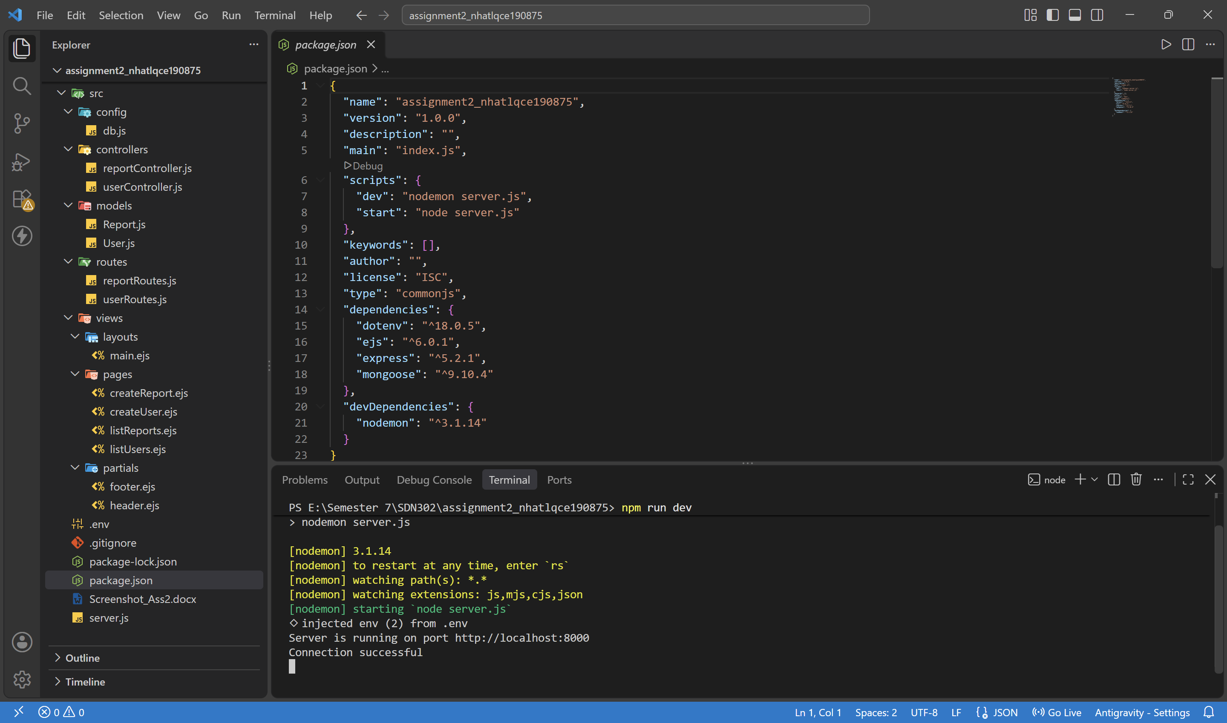

Screenshot 2: Screenshot of MongoDB Compass with database bug_reports (has a collection of reports and users.)

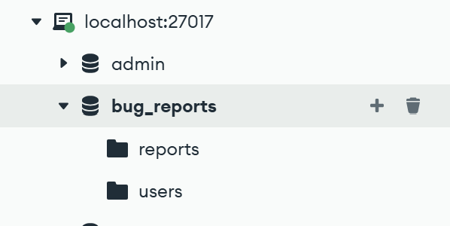

Screenshot 3: Accessing the homepage http://localhost:8000/ will redirect you to the list of reports

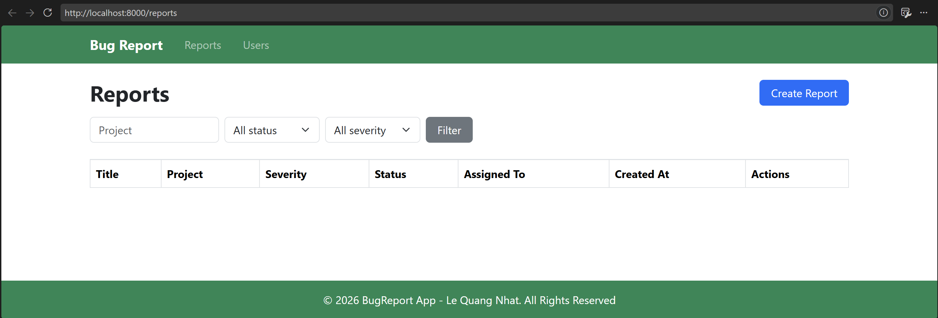
Screenshot 4: Select the Users menu to add a new user (using the student’s own information for the assignment).

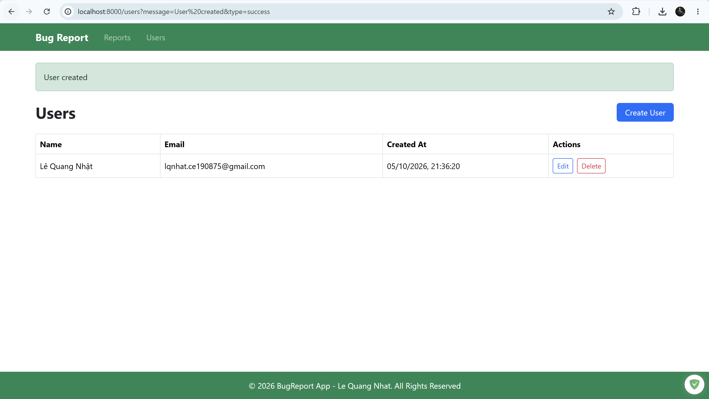

Screenshot 5: Create a bug report with optional information. At least 2 bug reports with different severity fields (low, medium, high).

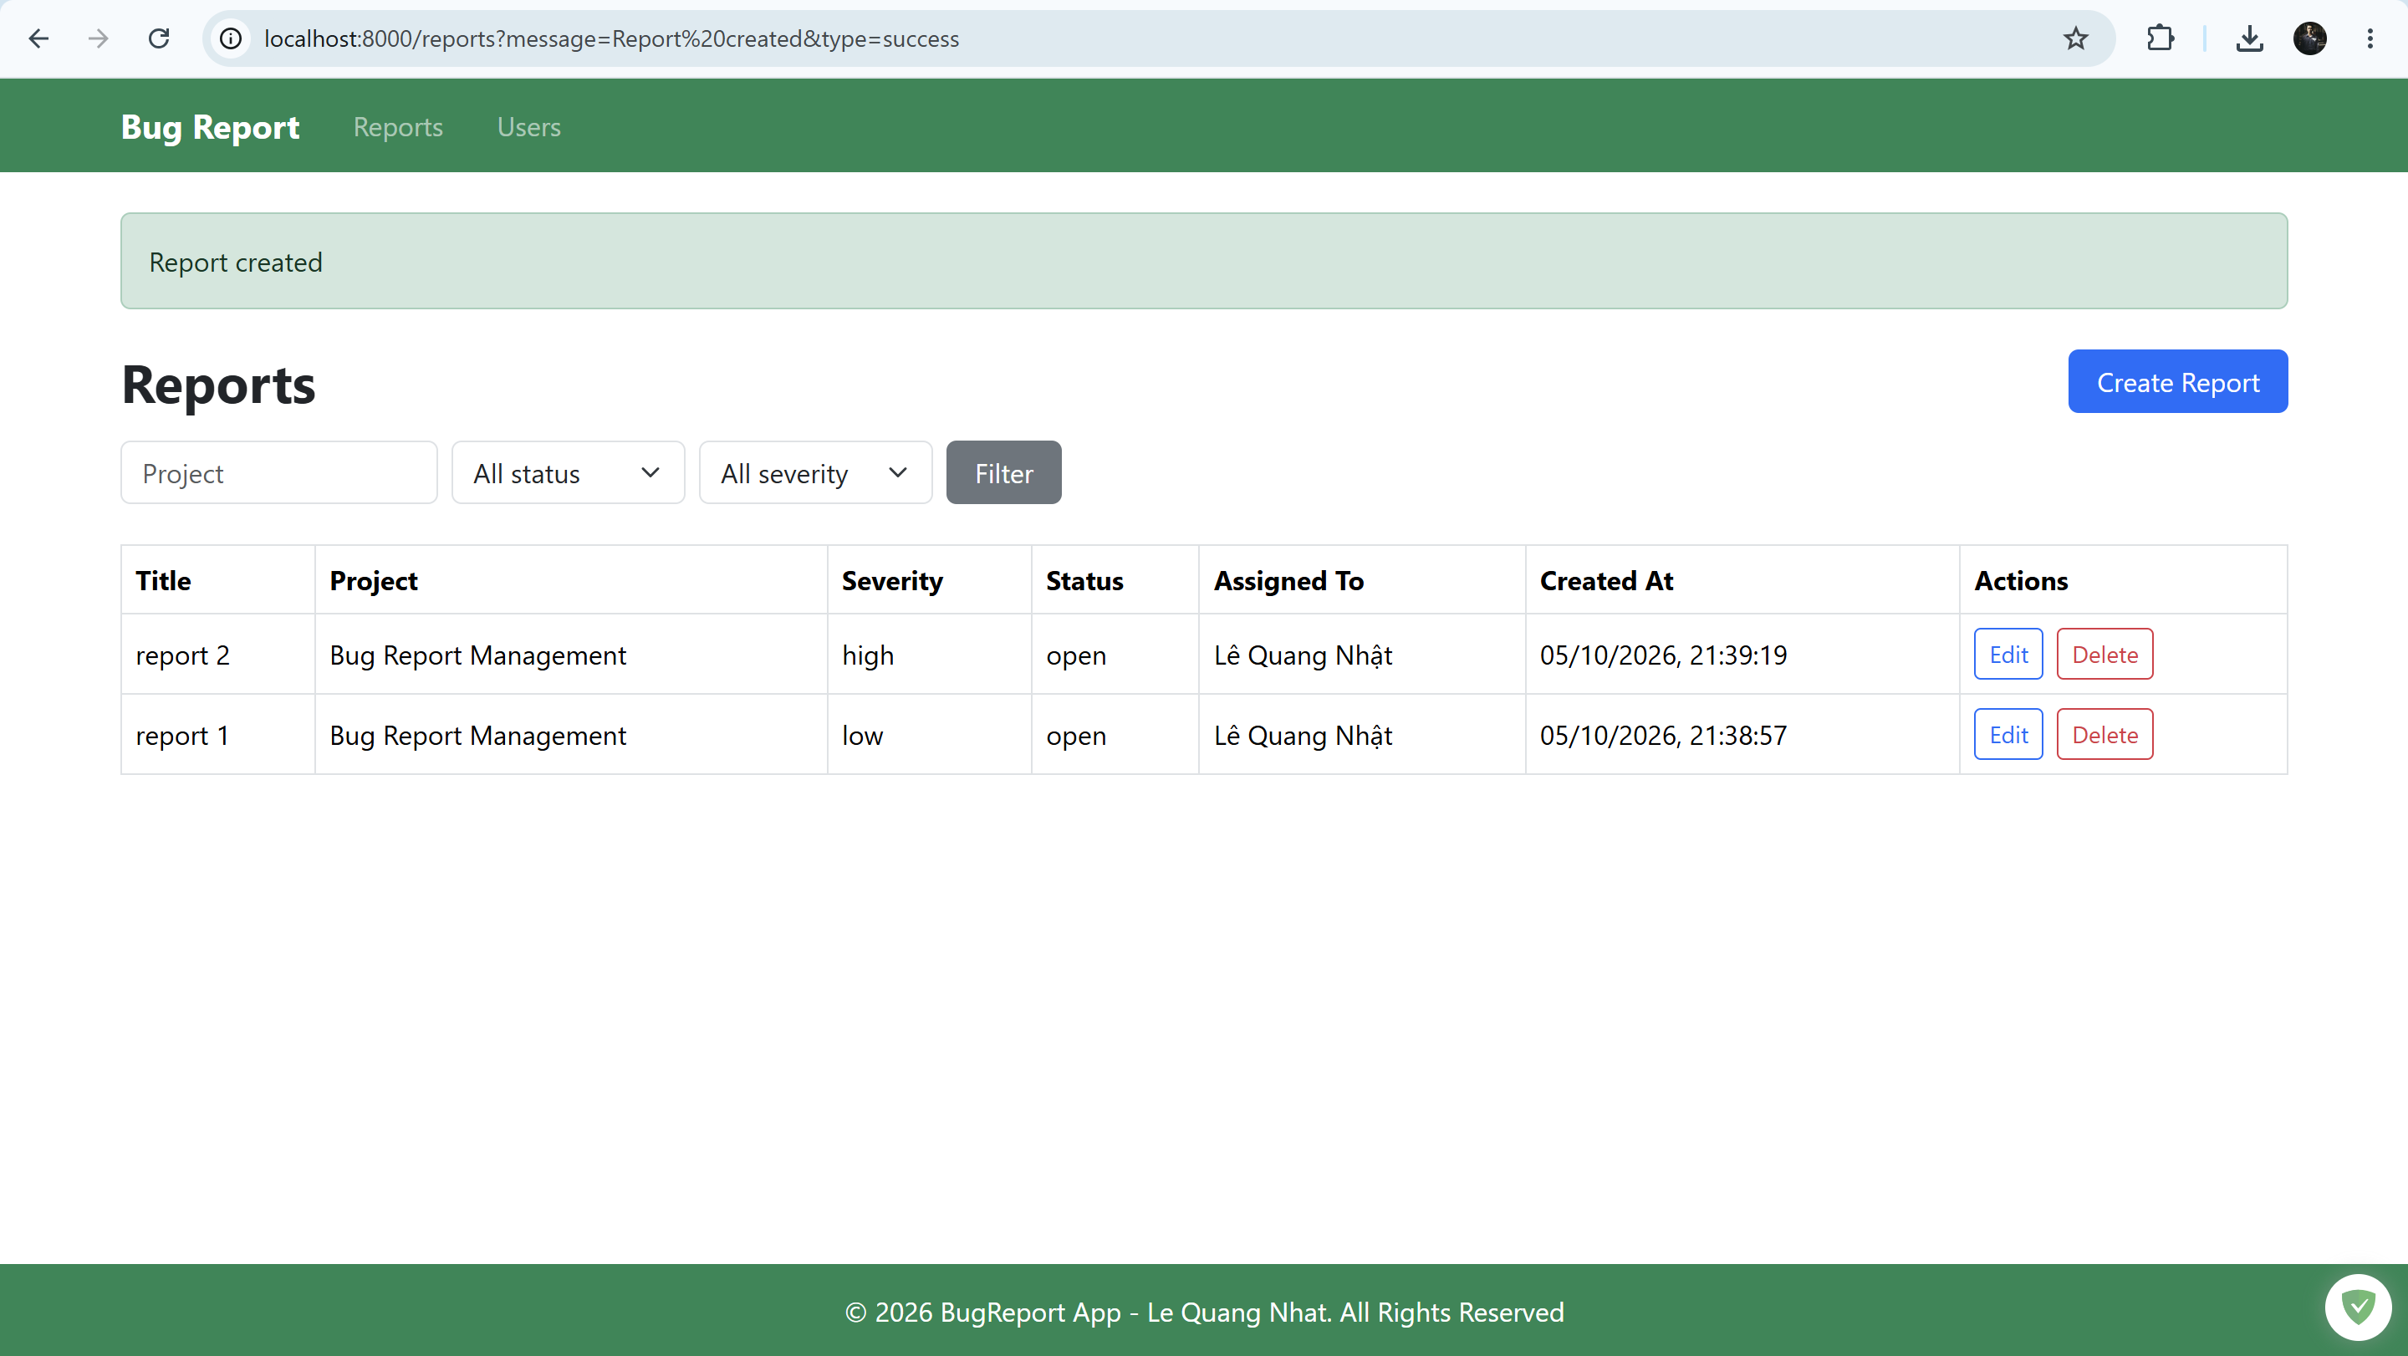

Screenshot 6: Use filters to filter bug report information by severity with low, medium, high

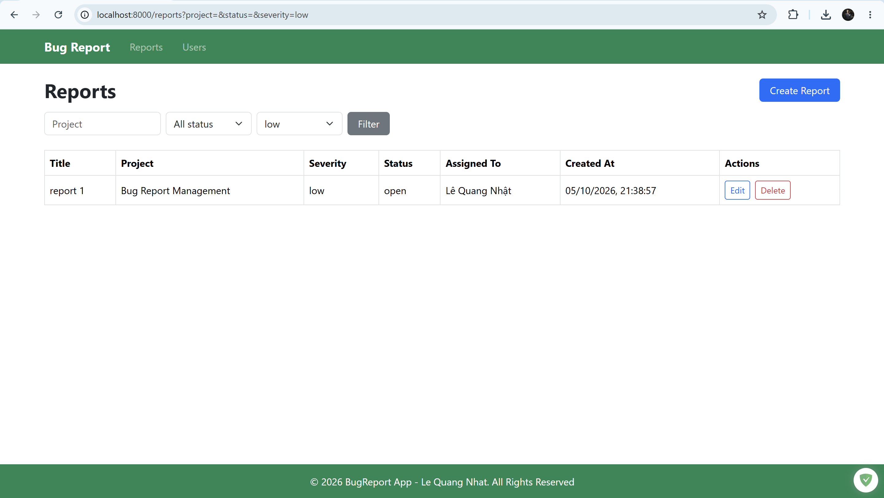
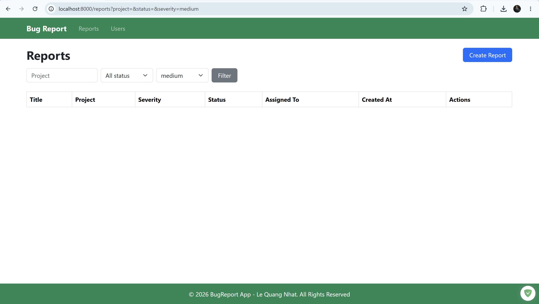
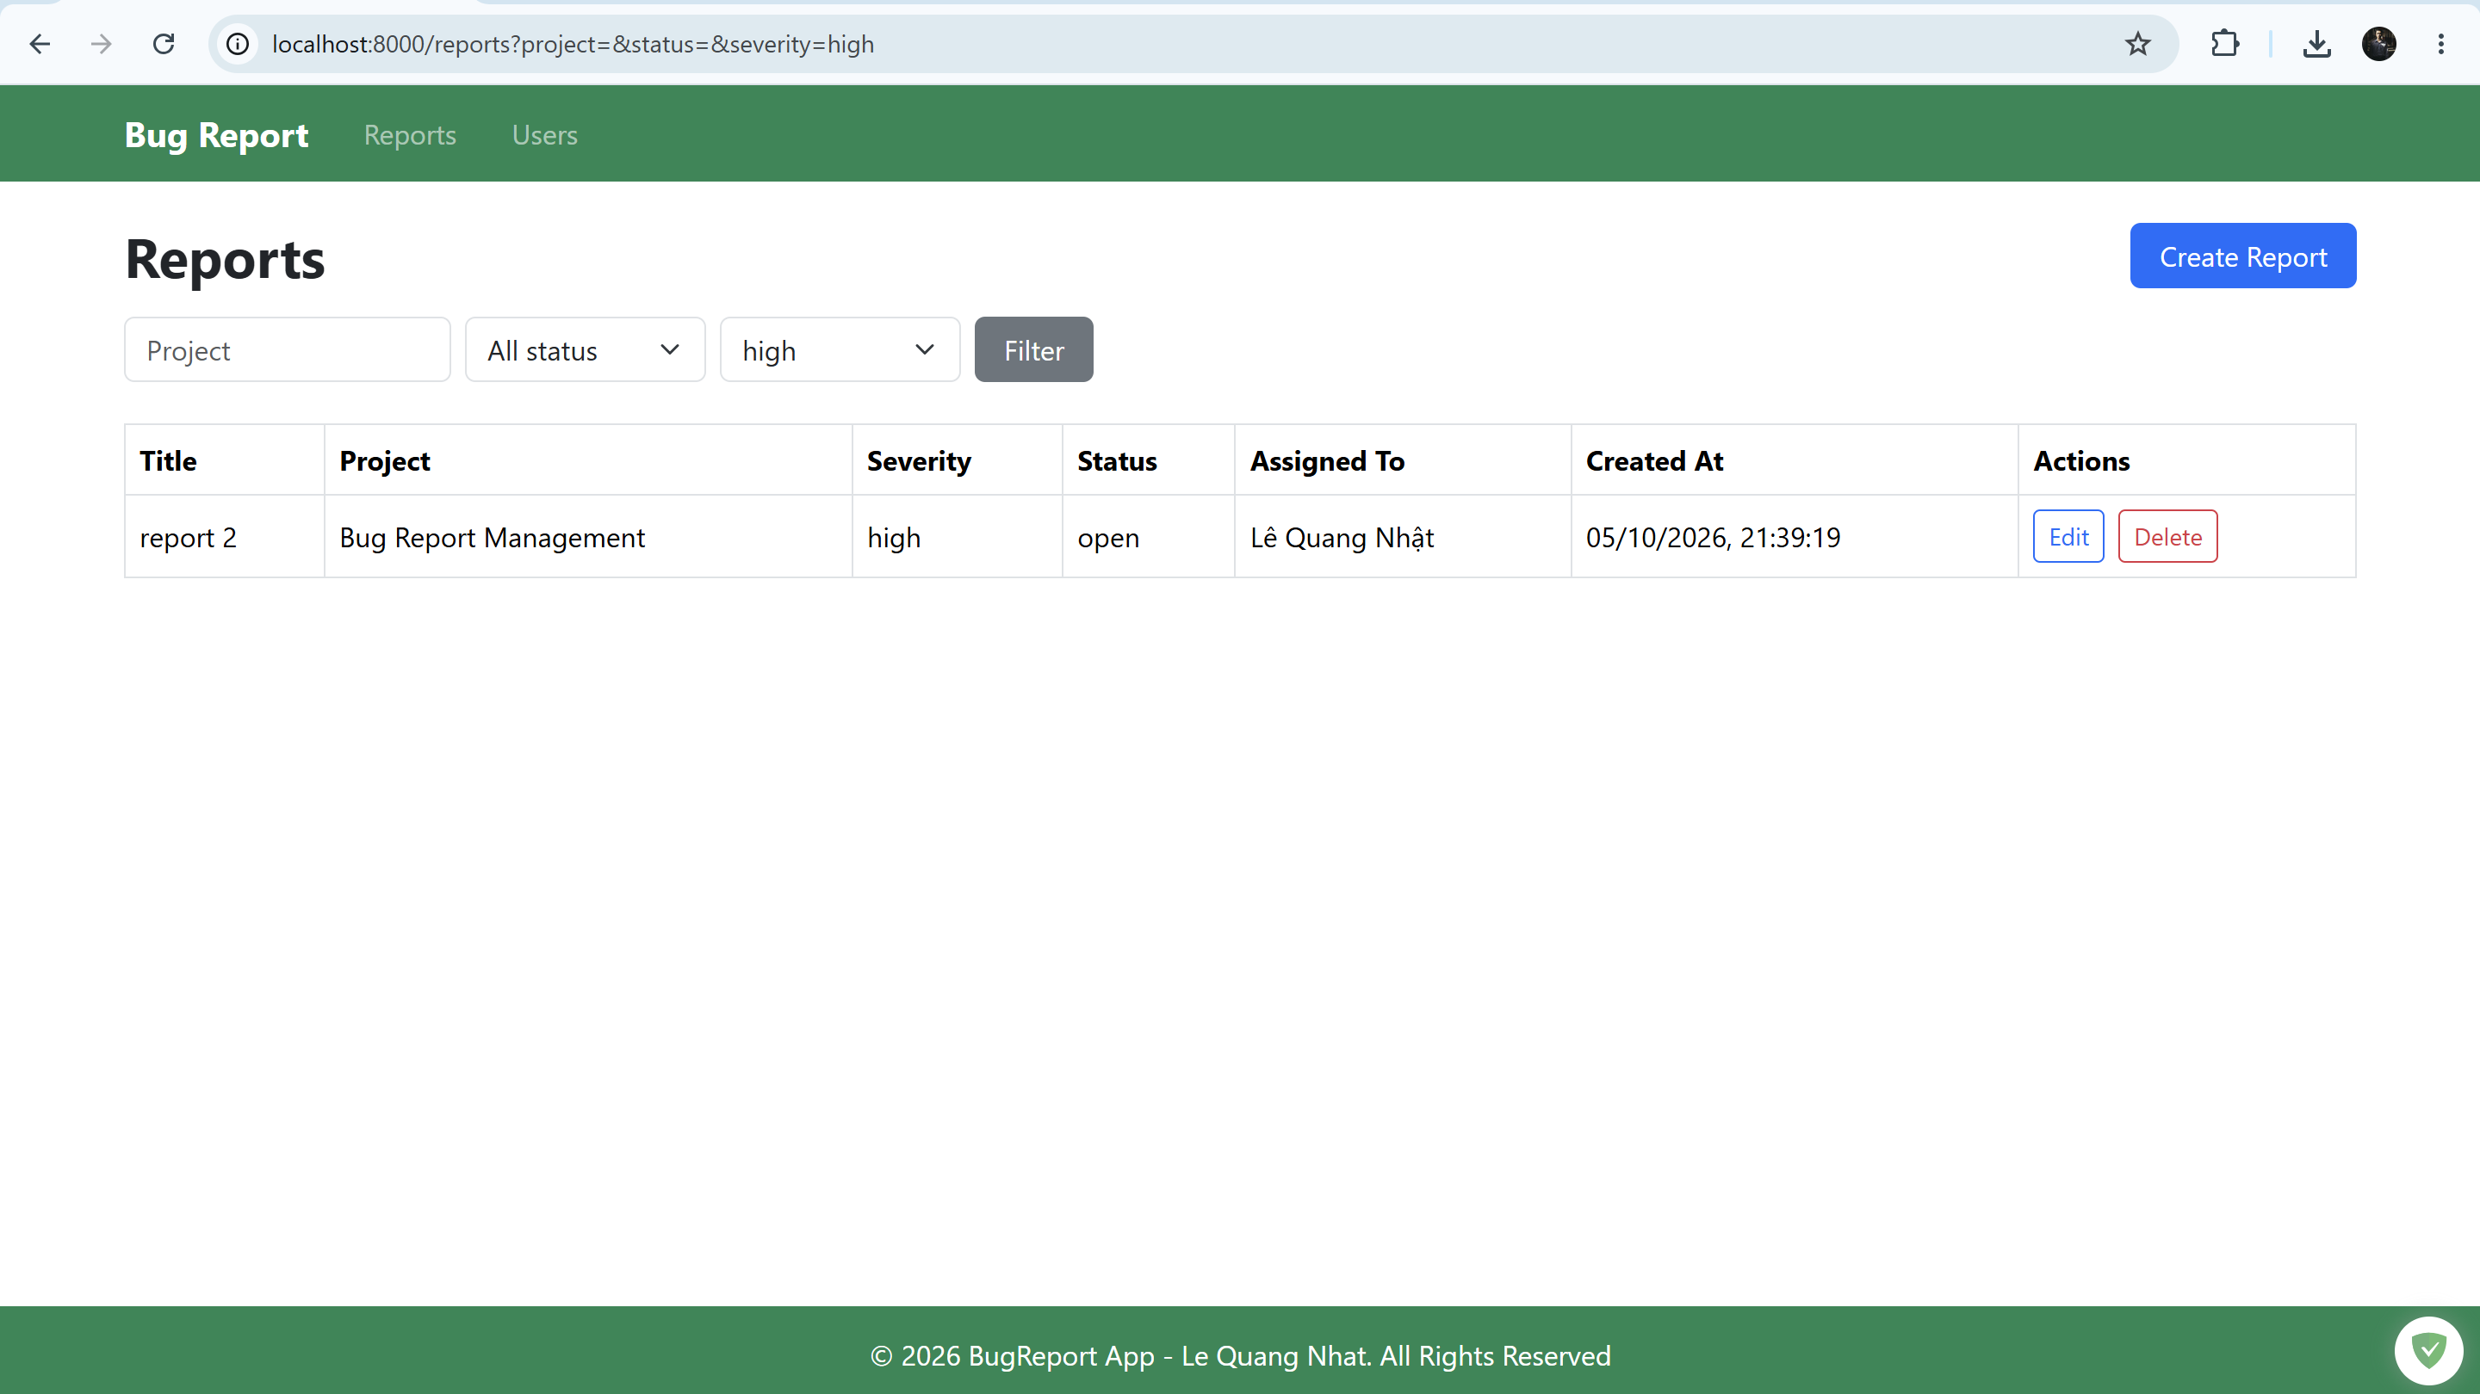

Screenshot 7: Edit a bug report with status = closed

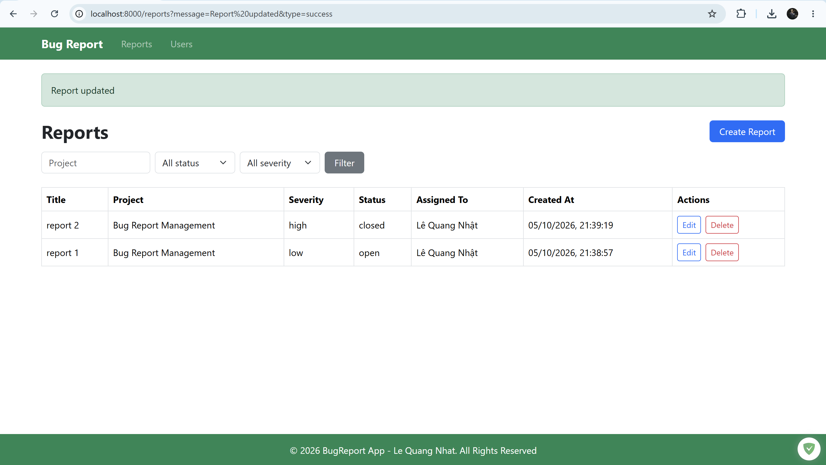
Screenshot 8: Delete a bug report

