Patch-Content Fungibility in Vision Transformers: Functional Geometry and Operator-Aware Compression
Nghiem Nhat Minh, Dang Tri Dung, Do Tri Cuong

Abstract
Vision transformers represent an image as a fixed sequence of patch slots, yet the role of each slot’s image-specific content in late layers remains unclear. We causally replace selected late-layer patch activations with class-agnostic calibration surrogates while preserving token slots, sequence length, model weights, and all subsequent computation. In the tested models, this fixed-slot content replacement reveals conditional fungibility bounded by feature geometry and token diversity, distinct from token pruning or merging. Mechanistic audits associate replaceability with anisotropic downstream transmission, coherent accumulation and cancellation through the attention value path, and growth of a threshold-defined near-null subspace in an empirical margin-gradient feature metric at later layers. For compression, an end-to-end downstream Jacobian serves as an offline, per-image oracle for the operator-aware objective; we evaluate the resulting variants on 1,000 held-out images per architecture. At the most aggressive tested budgets, operator-aware variants improve classification accuracy by 4.2–12.0 percentage points over the strongest pruning baseline for each architecture; the accuracy-token frontier shifts on three of four architectures, while a strong merging baseline remains competitive. Together, these findings provide a mechanistic account of late-layer patch-content fungibility through downstream functional geometry and attention-mediated cancellation, and demonstrate how this understanding can guide operator-aware token compression.

1. Introduction
Transformers use self-attention to mix token representations [1], while vision transformers (ViTs) represent an image as a sequence of patch embeddings [2]. Published ViT families include data-efficient supervised training [3], self-supervised representations [4], [5], hierarchical attention [6], masked pretraining [7], scaling [8], training regularization [9], and register tokens [10]. Token-reduction methods lower computation by changing which tokens are processed or how they are combined. We ask a different question: when does the remaining network require the image-specific content carried by a late patch slot?
We answer with a controlled content intervention. At a selected late layer, image-specific patch activations are causally removed and replaced with class-agnostic calibration surrogates while token slots, sequence length, model weights, and all downstream computation are held fixed. The intervention isolates content dependence while preserving the structure of the sequence received by later layers. Replaceability is conditional on feature geometry and token diversity; the intervention tests content substitution with fixed token slots rather than token deletion. Fig. 1 summarizes the fixed-slot intervention, geometric and diversity constraints, and selective transmission through anisotropic sensitivity and Value-path cancellation.
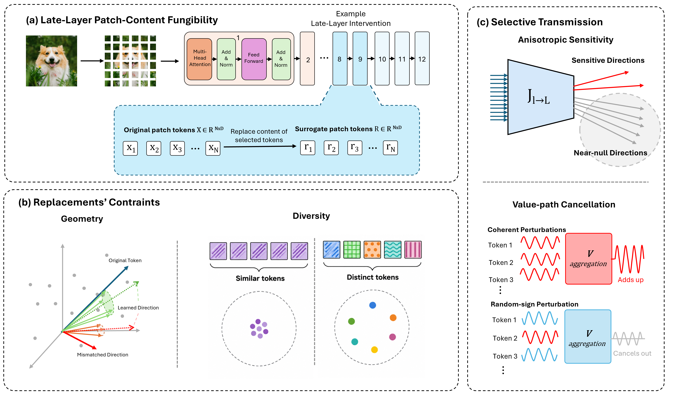
Fig. 1. Fixed-slot late-layer patch-content substitution (a), geometric and diversity constraints (b), and anisotropic sensitivity with Value-path cancellation (c).
We develop a connected ViT-specific account of Patch-Content Fungibility (PCF): fixed-slot substitution is constrained by feature geometry and token diversity, while Value-mediated coherence and cancellation shape downstream functional transmission. We then use this structure to formulate operator-aware token compression and evaluate it on confirmatory classification benchmarks. A separate carrier study tests how far operator-space corrections translate to nonlinear classification and measured throughput.

2. Related Work
Token-reduction methods change the sequence or the computation applied to it. DynamicViT and Expediting Vision Transformers via Token Reorganizations (EViT) score or reorganize tokens [11], [12]; Token Merging (ToMe) combines similar tokens [13]; A-ViT (Adaptive Tokens for Efficient Vision Transformer) and AdaViT (Adaptive Vision Transformers for Efficient Image Recognition) use adaptive token computation [14], [15]; and TokenLearner and Token Pooling form smaller, learned or pooled representations [16], [17]. Adaptive Token Sampling (ATS) and Interpretability-Aware Redundancy Reduction (IA-RED²) select tokens using sampling or redundancy criteria [18], [19]. Other approaches include PatchDropout, X-Pruner, and global structural pruning [20]–[22]; joint pruning and squeezing [23]; and early-exit pruning for dense prediction [24]. Evo-ViT, Dynamic Grained Encoder, and SPViT adapt token computation or selection [25]–[27], while Patch Slimming, Dynamic Transformers, end-to-end sparsity, activation sparsity, and structure-aware pruning explore complementary efficiency settings [28]–[32]. These methods provide strong efficiency baselines through token selection, token merging, or adaptive computation. PCF asks a complementary causal question: whether image-specific late patch content can be replaced while token slots, sequence length, model weights, and downstream computation remain fixed.
Compression by weight or structure pruning has a longer history. Optimal Brain Damage and Optimal Brain Surgeon use sensitivity-based approximations to remove parameters [33], [34]. Later work studies connection pruning, resource-aware pruning, sparse trainable subnetworks, and movement-based pruning [35]–[38]. SparseGPT and Wanda study one-shot pruning of large language models (LLMs), while SliceGPT removes dimensions. Singular value decomposition (SVD) is also used for large-language-model compression in the published SVD-LLM method, which applies a truncation-aware variant [39]–[42]. PCF complements these methods by using the downstream pre-classifier readout Jacobian to evaluate and optimize fixed-slot patch carriers while preserving the token sequence structure.
Interpretability research cautions that attention weights alone need not explain a model’s decision. Controlled studies examine whether attention is explanation and how explanation changes under interventions [43]–[45]. Attention flow, Integrated Gradients, saliency-map sanity checks, and transformer-specific relevance propagation provide complementary methods for tracing or attributing model behavior [46]–[49]. Causal abstraction offers a framework for connecting interventions to model-level causal structure [50]. Our evidence uses direct activation interventions and held-out prediction of perturbation damage; it is bounded to the tested models, readouts, and cohorts. A close methodological precedent is Parodi et al.’s zero-ablation study of specialized DINO register tokens: mean, noise, and cross-image register-shuffling substitutions preserve frozen-feature task performance within 1 percentage point of the unmodified baseline. We study ordinary spatial patch slots and characterize how replacement validity varies with depth, replacement fraction, learned feature geometry, and token diversity [51].

3. Experimental Setup and Interventions
The paper draws on distinct evidence cohorts; Table I summarizes each primary finding and its sampling unit without pooling. N denotes the count of the stated unit, which differs across image-based and perturbation-based studies. Top-1 accuracy is the fraction of evaluated images whose highest-scoring predicted class matches the ground-truth label; margin, feature-geometry, and operator-space measures are separate endpoints. Image-based studies use frozen pretrained models and ImageNet-1k validation images with protocol-specific preprocessing and splits. The strict confirmatory benchmark evaluates DeiT-Tiny and DeiT-Small at block 8, ViT-B/16 AugReg at block 7, and DINOv2 ViT-S/14 at block 8. It uses 1,000 held-out images per architecture, one per class (evaluation seed 9201), and a disjoint 1,000-image calibration set (seed 9101); no tuning uses held-out images. The remaining audits retain their own cohorts and sampling units as shown in Table I.
TABLE I
PRIMARY RESULTS AND EVIDENCE SCOPE
Study family | Evaluation unit | Key controls | Main finding
Fixed-slot patch replacement | N=1,000 images/model per study; cohorts separate | 25%, 50%, and 100% replacement; study-specific calibration | Tolerance varies with depth, surrogate geometry, diversity, and feature direction; learned directions outperform energy-matched random directions in tested DeiT settings.
Functional and joint-stream geometry | Functional pilot: N=100 images; joint-stream audit: N=100 images/model (separate cohort) | Margin-gradient feature metric; coherent and sign-varying token patterns | The threshold-defined near-null subspace expands with depth in the pilot; damage depends jointly on feature direction and token coherence.
Attention Value-path audit | N=100 images | Frozen-attention comparison across coherent and sign-varying patterns | Coherent Value contributions accumulate; sign-varying contributions partially cancel.
Multi-block operator prediction | N=100 held-out perturbations | Held-out single-block vs. multi-block prediction | The multi-block operator predicts downstream damage more closely than the single-block operator.
Strict confirmatory compression | N=1,000 held-out images/architecture | Frozen protocol and architecture-specific budgets | At the most aggressive tested budgets, operator-aware methods beat the strongest pruning baselines by 4.2–12.0 pp; ToMe remains competitive.
Practical carrier evaluation | Classifier: N=1,000 held-out images/architecture; operator-space: N=100 held-out operator-space images (separate) | Separate classifier/throughput and operator-space protocols | Classifier and throughput gains are mixed; operator-space gains do not establish reliable classification or general deployment improvement.

Table I. Rows group related analyses to summarize the main findings without pooling their cohorts or endpoints. The multi-block unit counts held-out perturbations; classifier and operator-space carrier results use separate units and endpoints.
In the equations, N_{img} denotes the number of image samples, $n_{p}$ the number of spatial patch slots, and D the feature dimension; Table I reports N alongside each study's sampling unit. For the fixed-slot intervention, let $P_{l}$∈$R^{n_{p}×D}$ contain the patch activations at layer ℓ, with $p_{l,i}$∈$R^{D}$ as row i and $r_{l,i}$ its class-agnostic calibration surrogate. The binary indicator $u_{i}$ selects the slots to replace:
 | $$p\sim _{l,i}=(1-u_{i})p_{l,i}+u_{i} r_{l,i}, u_{i}∈\{0,1\}, i=1, …, n_{p}.$$ | (1)
Thus, when $u_{i}$=0 the original activation remains, and when $u_{i}$=1 it is replaced by the corresponding surrogate. The class token, position indices, number of rows, model weights, and subsequent computation remain unchanged. The intervention isolates dependence on image-specific content while keeping token slots fixed.
Surrogate values and replacement masks are protocol-specific: audited controls include calibration centroids, diagonal-Gaussian samples, and geometry or learned-direction variants. The mask identifies the selected patch positions and replacement fraction; calibration-derived quantities are estimated only from calibration data. Section 4 reports the layer, fraction, and control used in each replacement study.
For compression, the end-to-end Jacobian maps a patch-matrix perturbation at layer ℓ to the pre-classifier readout u defined in Section 6, not directly to Top-1 accuracy. Evaluated at the unperturbed activation, its product with a flattened perturbation predicts the readout change to first order; classification outcomes are measured by applying the actual classifier to the compressed model output. The full-J oracle uses a per-image Jacobian as an offline reference, not a deployable inference procedure. Section 6 defines the operator objective and grouping variables.

4. Geometric and Diversity Constraints on Patch-Content Fungibility

4.1 Depth-Dependent Replacement Tolerance
We examine how patch-content replacement tolerance varies across transformer depths. We replace 25% of spatial patch activations with class-agnostic surrogates and evaluate classification accuracy on 1,000 images per architecture. Across the tested depths, later-layer replacements are generally better tolerated, although performance depends on the replacement distribution. At depth 6, centroid and Gaussian replacements achieve 73.9% and 74.9% Top-1 accuracy on ViT-B/16 AugReg, compared with 71.5% under zero replacement. On DINOv2, the corresponding accuracies are 70.6%, 74.6%, and 28.8%, respectively. Gaussian results are averaged over three seeds. Depth 6 was evaluated in a subsequent follow-up using the same replacement conditions and split seeds as the initial depth sweep, with 1,000-image calibration and evaluation sets. Fig. 2 summarizes the initial depth sweep and depth-6 follow-up. These results are conditional on the tested models, layers, replacement fraction, surrogates, and readouts.
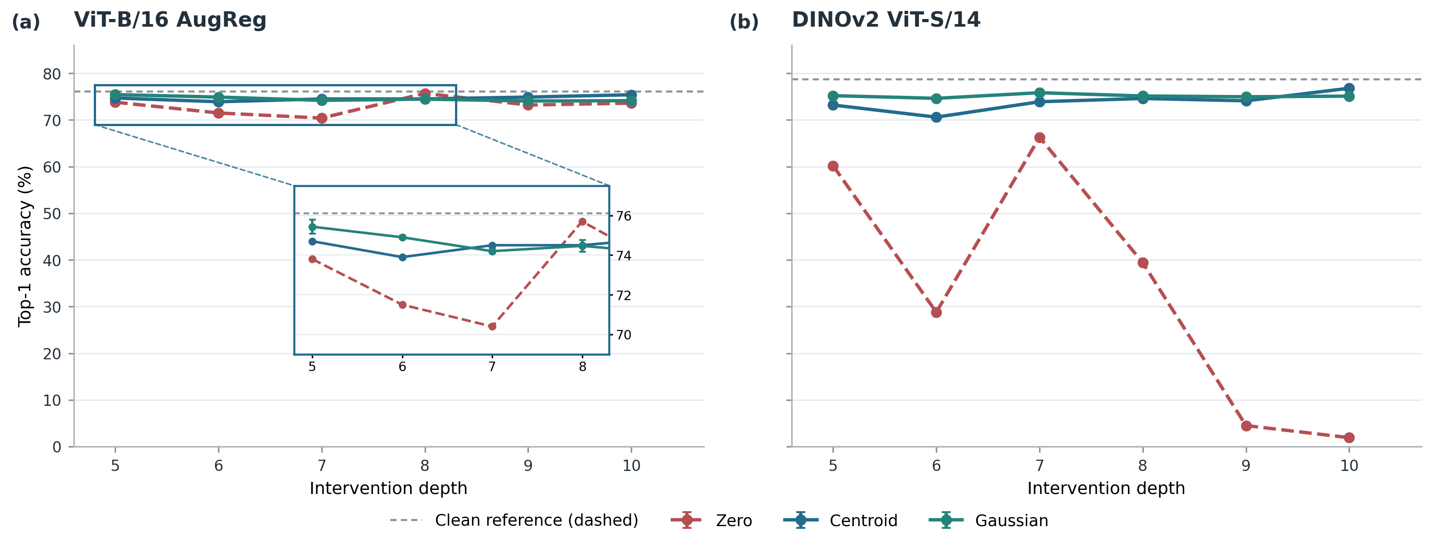
Fig. 2. Depth-wise replacement accuracy for ViT-B/16 AugReg and DINOv2 under 25% spatial-patch replacement. The initial study measured depths 5, 7, 8, 9, and 10; depth 6 is a separately recorded follow-up. Each evaluation uses N=1,000 images per model. Error bars show Gaussian seed-level standard deviation; dashed lines mark clean accuracy.

4.2 Geometric and Diversity Constraints
Geometry and diversity constrain replacement. In a separate activation-replacement geometry-control experiment (N=1,000 images per model; 50% replacement), coordinate permutation changes Top-1 accuracy from 66.3% to 52.2% on DeiT-Tiny and from 75.6% to 62.6% on DeiT-Small; sign inversion reduces it to 0.7% and 1.1%, respectively. These are classifier outcomes from the N=1,000 replacement study. A distinct N=100 DeiT-Small operator-space control finds that shuffling principal component analysis (PCA) coordinates increases mean ‖J E‖ by 1.474 (from 6.602 to 8.076); this is linearized operator-space evidence, not Top-1 accuracy. Fig. 3 compares the audited geometry and token-diversity controls.
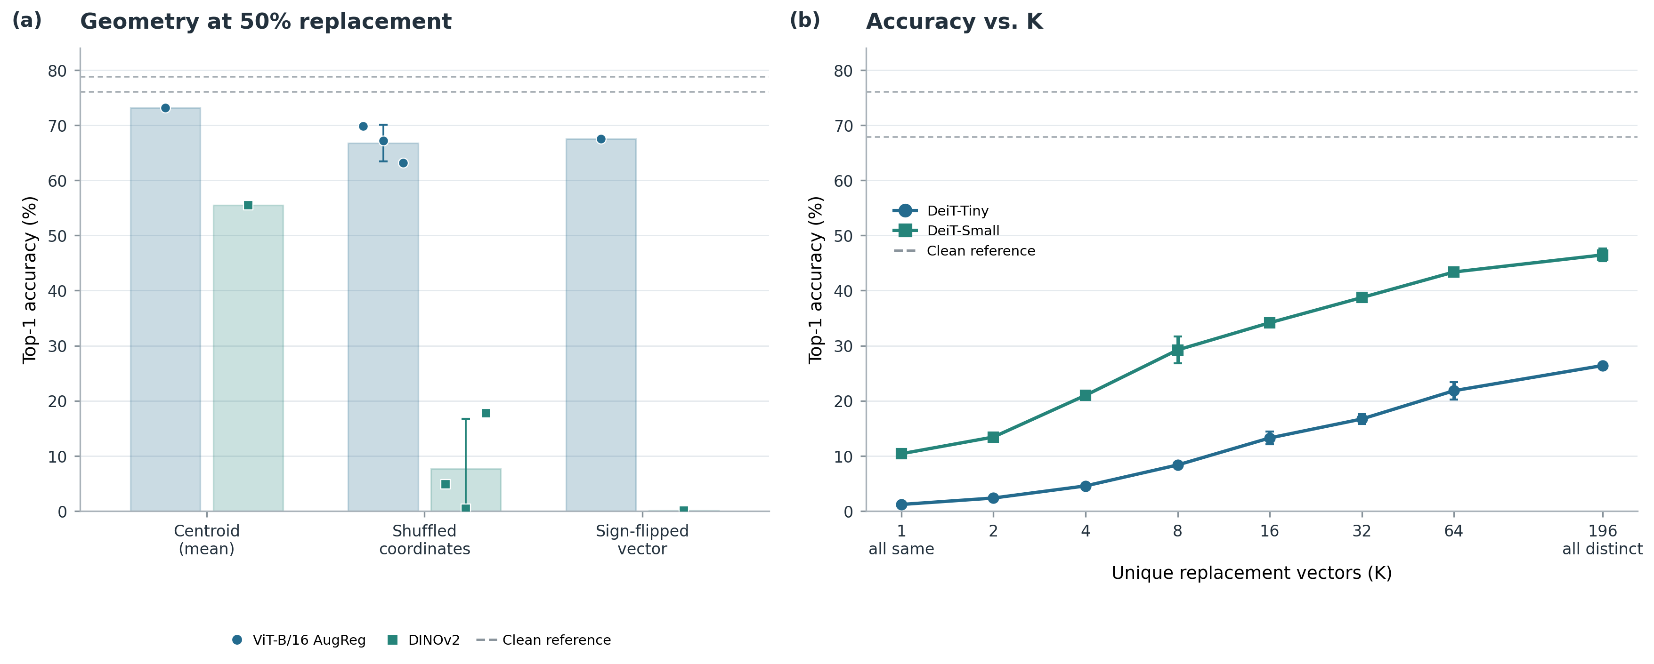
Fig. 3. (a) Cross-architecture geometry controls at 50% replacement for ViT-B/16 AugReg and DINOv2 ViT-S/14 compare a calibration centroid, a coordinate-shuffled centroid, and a sign-inverted centroid. (b) The grouped token-diversity sweep on DeiT-Tiny and DeiT-Small varies K, the number of distinct replacement vectors across all 196 patch positions. Gray dashed lines mark each model’s clean Top-1 accuracy. Bars and line markers show means; dots show recorded runs; error bars show across-seed standard deviation where repeated seeds are available. Each model uses N=1,000 evaluation images and separate calibration data. These are distinct study cohorts, so conditions should be compared within each panel rather than treated as a matched-model contrast.
In a separate learned-direction replacement experiment, with 100% patch replacement, N=1,000 evaluation images and a disjoint N=1,000 calibration set per DeiT model, learned low-dimensional variation is more compatible than energy-matched random directions. This advantage depends on model and amplitude and does not establish rank-1 sufficiency. Complementary token-diversity experiments show that low-dimensional variation alone does not restore full performance; the tested setting requires higher-dimensional structure. Together, these interventions show that late-layer replaceability is structured by feature geometry and token diversity, rather than implying universal interchangeability or cost-free token deletion.

5. Functional Geometry and Attention-Mediated Transmission

5.1 Anisotropy and Functional Geometry
Functional transmission is direction-dependent. Fig. 4 summarizes the audited depth-wise sensitivity pattern.
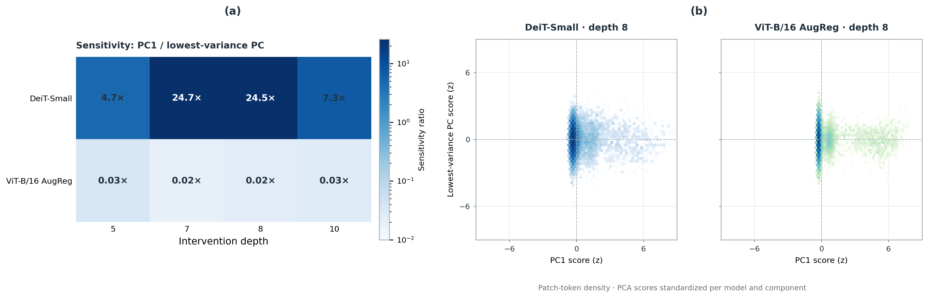
Fig. 4. (a) Ratio of the empirical margin-gradient metric sensitivity $v^{T}M_{l}$v along PC1 to that along PC-bottom across depths in the N=100 functional-geometry pilot. The PCs are eigenvectors of the centered calibration-activation covariance, separate from $M_{l}$. (b) Depth-8 PCA score-density maps for DeiT-Small and ViT-B/16 AugReg. Each observation is a patch activation from the 100-image pilot cohort; axes are standardized per model and component to show score distributions, so the plotted spread does not represent their raw variance difference. Patch tokens are not independent image samples; panel (a) is not computed from the full downstream readout Jacobian used in compression.
For image s, let $y_{s}$ and $r_{s}$ be the clean predicted and runner-up classes, and let $z_{s}$ denote its final logits. The functional-geometry pilot differentiates this scalar class margin with respect to each patch feature, then averages the per-patch gradient outer products:
 | $$g_{s,i}={grad}_{p_{l,s,i}}(z_{s,y_{s}}-z_{s,r_{s}}),$$  $$M_{l}=(1/(N_{img} n_{p}))Σ_{s=1}^{N_{img}}Σ_{i=1}^{n_{p}}g_{s,i} g_{s,i}^{T}.$$ | (2)
Here $M_{l}$∈$R^{D×D}$ is an uncentered second moment of scalar margin gradients, not the Gram matrix of the full downstream readout Jacobian $J_{l→L}^{T}J_{l→L}$. The pilot counts nonnegative eigenvalues no greater than ${10}^{-3}$ times the largest as near-null. Its effective rank is exp(−$Σ_{k:p_{k}>10-12}p_{k}$ log $p_{k}$), where $p_{k}$ is eigenvalue k divided by the eigenvalue sum. Thus $M_{l}$ pools per-token margin gradients without cross-token or full readout-Jacobian structure. PCA uses the separate sample covariance $Σ_{act,l}$ of centered calibration patch-feature rows, with denominator $M_{c}$al−1 for $M_{c}$al calibration patch observations. This count is the number of calibration patch tokens, not N_{img}. This covariance is distinct from both $M_{l}$ and the readout-space solver Gram matrix $H_{J}$.

5.2 Value-Path Coherence and Cancellation
In the attention causal audit (N=100 evaluation images), the frozen-attention Value-only path reproduces approximately 97.4% and 99.3% of the immediate readout disturbance in DeiT-Small and ViT-B/16 AugReg, respectively. It also explains 70.8% and 102.2% of the defined coherence-gap margin effect. The ViT-B/16 ratio exceeds 100% because a secondary contribution partially opposes the Value-path effect. With attention frozen, patch-key perturbations leave the unperturbed classification-token query unchanged, so the immediate query contribution is zero; key-mediated rerouting is outside this decomposition. Fig. 5 compares coherent with sign-varying Value-path transmission.
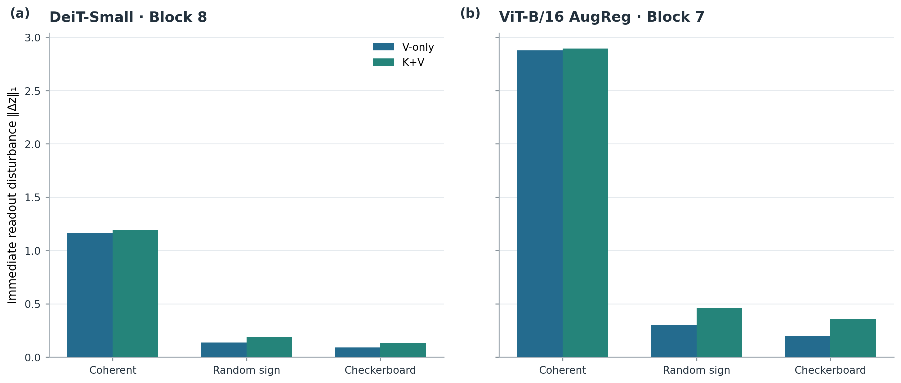
Fig. 5. Immediate readout disturbance for Value-only and key-plus-value pathways under coherent, random-sign, and checkerboard patterns in two N=100 attention-audit settings.
For one image and a CLS readout, let $w_{h,i}^{clean}$ be the clean attention weight from patch i to the readout in head h. The signed attention-weighted token pattern and frozen-attention Value-context change are
 | $$Γ_{h}(a)=Σ_{i=1}^{n_{p}}w_{h,i}^{clean}a_{i},$$  $${Δc}_{h}^{(V)}=Σ_{i=1}^{n_{p}}w_{h,i}^{clean}{Δv}_{h,i}∈R^{d_{h}}.$$ | (3)
Here ${Δv}_{h,i}$ is the measured change in the post-normalization Value projection for patch i. $Γ_{h}$(a) summarizes how the token pattern aligns with clean attention weights; the second expression retains token-specific Value changes and is the pre-output-projection head context audited in code. With attention frozen, coherent signed contributions can add and varying signs can cancel. This frozen-attention decomposition isolates Value-path transmission while leaving nonlinear attention rerouting and other causal paths outside its scope.

5.3 End-to-End Functional Transmission
On N=100 held-out perturbations, the multi-block operator predicts downstream damage more closely than the single-block operator (Pearson r=0.975, Spearman ρ=0.945 vs. r=0.753, ρ=0.735). The mean principal angle from block 8 to block 9 is 49.0 degrees (Fig. 6). Separately, in the N=100-image functional-geometry pilot, the threshold-defined near-null subspace of$M_{l}$ expands with depth as entropy effective rank declines in late layers; distinct replacement interventions also show greater late-layer tolerance. This depth-wise correspondence is an empirical mechanistic association, not a universal explanation.
Token–feature interaction. A distinct joint-stream geometry audit (N=100 images per model) selects feature directions using its own per-image mean patch-margin-gradient metric, separate from $M_{l}$ in the functional-geometry pilot and from the pre-classifier readout Jacobian$J_{l→L}$ used in compression. It finds that downstream damage depends jointly on feature direction and token-space coherence: sensitive feature directions are most damaging under coherent token patterns, whereas functionally near-null directions remain comparatively tolerated across the tested patterns. The audit injects the norm-matched rank-one perturbation
 | $${ΔP}_{l}={αav}^{T}, a∈R^{n_{p}}, v∈R^{D}, ‖a‖_{2}=‖v‖_{2}=1, ‖{ΔP}_{l}‖_{F}=α.$$ | (4)
with α=${sσ}_{l}$≥0; consequently α is the Frobenius norm of the injected patch perturbation.
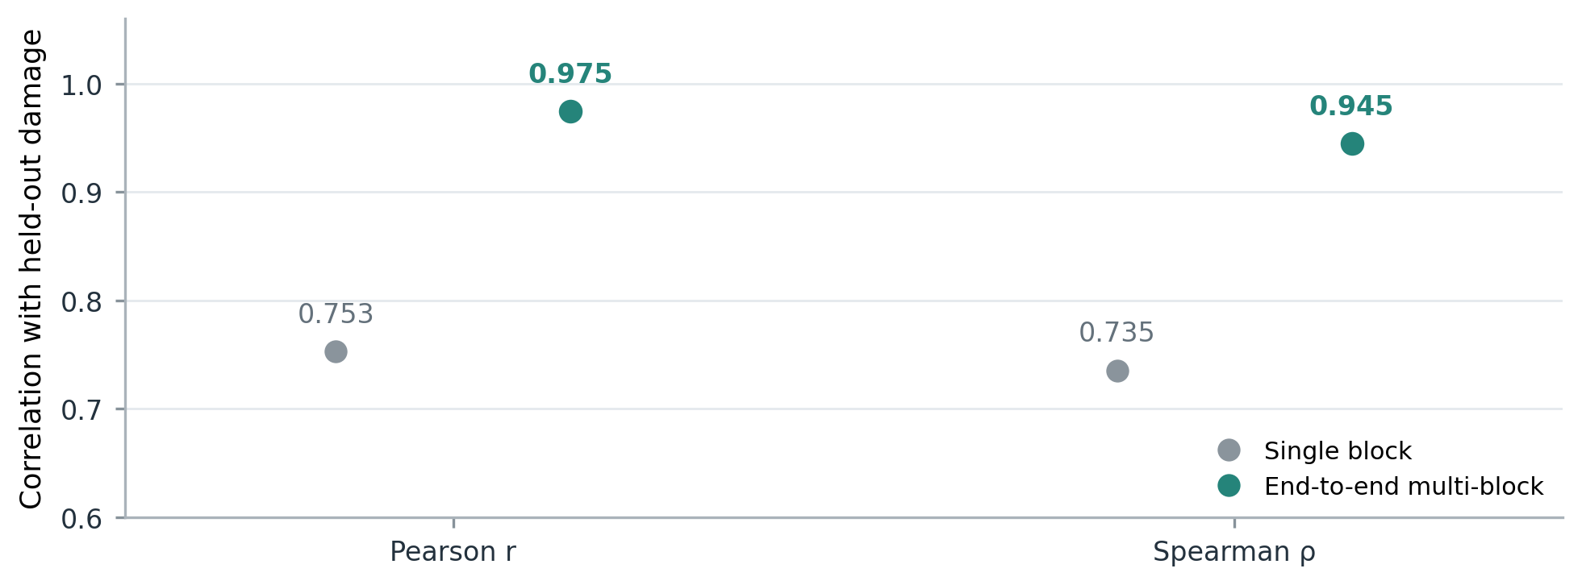
Fig. 6. Pearson and Spearman correlations between the single-block operator A₈ and end-to-end readout Jacobian J_{8→12} predictions and measured final-logit L2 damage on N=100 held-out perturbations. J_{8→12} composes blocks 9–12 and the final normalization/CLS readout. The mean principal angle from block 8 to block 9 is 49.0°.
The end-to-end linearization maps all patch features at layer ℓ to the pre-classifier readout vector u∈$R^{d_{u}}$:
 | $$J_{l→L}=∂u/∂rvec(P_{l})∈R^{d_{u}×n_{p} D}, Δu≈J_{l→L} rvec({ΔP}_{l}),$$  $$rvec(X)=vec(X^{T}).$$ | (5)
The implementation reshapes each $n_{p}$×D patch matrix in row-major order, which equals the conventional column-vectorization vec($X^{T}$) used by rvec. The confirmatory implementation returns normalized CLS for DeiT-Tiny, DeiT-Small, and ViT-B/16 AugReg; DINOv2 concatenates normalized CLS with mean normalized patch features. The readout dimension $d_{u}$ is D for CLS readouts and 2D for DINOv2. The Jacobian covers the remaining transformer blocks and pre-classifier readout, excluding the linear classification head; Top-1 and logit-L2 outcomes are measured through the actual downstream classifier. Its product is a first-order approximation at the unperturbed activation, not an exact identity for large perturbations. This all-patch readout Jacobian is distinct from the pooled margin-gradient feature metric $M_{l}$ in Eq. (2).

6. Operator-Aware Token Compression

6.1 Carrier Grouping and Optimization
For each image, $n_{p}$ patch tokens are assigned to B carriers. Let S∈${\{0,1\}}^{n_{p}×B}$ be the assignment matrix, with exactly one nonzero per row, and let C∈$R^{B×D}$ contain the carrier vectors. The reconstructed patch matrix is P̂=SC. The set $G_{j}$ contains the patch indices assigned to carrier j, and $m_{j}$=|$G_{j}$| is its membership count. The Group Mean baseline sets each carrier to the average of the patches assigned to that group:
 | $$c_{j}^{mean}=(1/m_{j})Σ_{i∈G_{j}} p_{i}, m_{j}=|G_{j}|.$$ | (6)
The residual matrix E=P−SC is the difference between the original and reconstructed patch features. Low-rank operator approximation. The full-J oracle uses $J_{s}$=$J_{l→L}$; for a rank-r approximation, the solver instead uses $J_{s}$=$U_{r}^{T}J_{l→L}$, where $U_{r}$ contains the leading left singular vectors. In either case, the solver minimizes
 | $$C^{*}=arg \min_{C} ‖J_{s} rvec(P-SC)‖_{2}^{2} + λ‖P-SC‖_{F}^{2}.$$ | (7)
The first term penalizes the readout change predicted by the selected operator, while the second is a trace-scaled Tikhonov penalty. Let $d_{s}$ be the row dimension of $J_{s}$ ($d_{z}$ for the full operator and r for a rank-r solve), and let ${(J_{s})}_{i}$ be its D-column block for patch i. The solver constructs the readout-space Gram matrix and regularization scale
 | $$K_{j}=Σ_{i∈G_{j}}{(J_{s})}_{i}, H_{J}=Σ_{j=1}^{B}(1/m_{j})K_{j} K_{j}^{T}, λ=10 · tr(H_{J})/d_{s}.$$ | (8)
$H_{J}$ is a positive-semidefinite Gram matrix of grouped Jacobian blocks, not a feature-activation covariance. It is distinct from the centered calibration-activation covariance that defines PCA directions. The per-image closed-form carrier update is
 | $$r_{mean}=J_{s} rvec(E_{mean}),$$  $$c_{j}^{*}=c_{j}^{mean}+(1/m_{j})K_{j}^{T}{(H_{J}+{λI}_{d_{s}})}^{-1}r_{mean}.$$ | (9)
Because the Group Mean residual sums to zero within each group, these normal equations give the exact minimizer of the stated quadratic objective. This exactness applies to the local linearized objective, not to the nonlinear classifier loss. The full-J solution is computed per image and is an offline oracle; low-rank solves are evaluated against the full J on the same confirmatory cohort.
Each compressed key also carries the number $s_{t}$ of original tokens represented by that key. With T=B+1 compressed tokens and $d_{h}$ dimensions per head, the compressed attention adds log multiplicity to each key's attention logit:
 | $$A^{(h)}={softmax}_{key}(Q^{(h)}K^{(h)T}/√d_{h}+1_{T}{(log s)}^{T}), s_{0}=1, s_{j}=m_{j}.$$ | (10)
The vector s includes multiplicity one for the class token and $m_{j}$=|$G_{j}$| for patch carriers; $1_{T}$ broadcasts the log-size bias over query positions. This proportional-attention correction is used in Token Merging (ToMe) to account for merged-token size [13]. The implementation applies the same key bias in each compressed downstream attention block.

6.2 Confirmatory Compression Results
Strict $confirmatory com$pression uses N=1,000 held-out images per architecture. At each architecture’s most aggressive tested token budget, Table II reports the exact Top-1 comparison among the best pruning baseline, Group Mean, ToMe, the full-J oracle, and its rank-16 and rank-32 approximations. The selected budgets differ by architecture (32 retained tokens for DeiT-Tiny, DeiT-Small, and ViT-B/16 AugReg; 42 for DINOv2 ViT-S/14), so the rows are within-architecture comparisons rather than a matched token-count experiment. Fig. 7 presents the full accuracy-token curves.
TABLE II
STRICT CONFIRMATORY TOP-1 ACCURACY AT THE MOST AGGRESSIVE TESTED BUDGET
Architecture | Budget | Best pruning baseline | Group Mean | ToMe | Full-J oracle | Rank-16 | Rank-32
DeiT-Tiny | 32 | Random, 58.6% | 66.5% | 65.8% | 67.1% | 67.1% | 67.9%
DeiT-Small | 32 | Attention, 71.6% | 76.4% | 76.4% | 75.8% | 76.5% | 76.5%
ViT-B/16 AugReg | 32 | Random, 69.2% | 73.2% | 73.0% | 74.4% | 73.7% | 74.2%
DINOv2 ViT-S/14 | 42 | Random, 61.5% | 72.2% | 69.4% | 73.5% | 73.2% | 73.0%

Table II. Top-1 accuracy on N=1,000 held-out images per architecture. The pruning entry is the strongest among Random, Norm, and Attention Pruning at the listed budget. The architecture-specific budgets are the lowest budgets evaluated in the strict confirmatory sweep.
Across 30,000 method/budget/seed condition rows per architecture, the same 1,000 held-out images are reused across conditions. $Operator residual ‖J E‖ is associated with measured logit-L2 distortion: per-architecture Pearson r ranges from 0.739 to 0.866, and Spe$arman ρ ranges from 0.792 to 0.916. These are condition-level associations, not 120,000 independent images. Rank-16 and rank-32 outcomes vary by architecture and budget; the confirmatory data do not support a universal recovery fraction. Fig. 7 reports the measured accuracy-token curves, while Table II lists rank-16 and rank-32 Top-1 at each architecture's most aggressive tested budget.
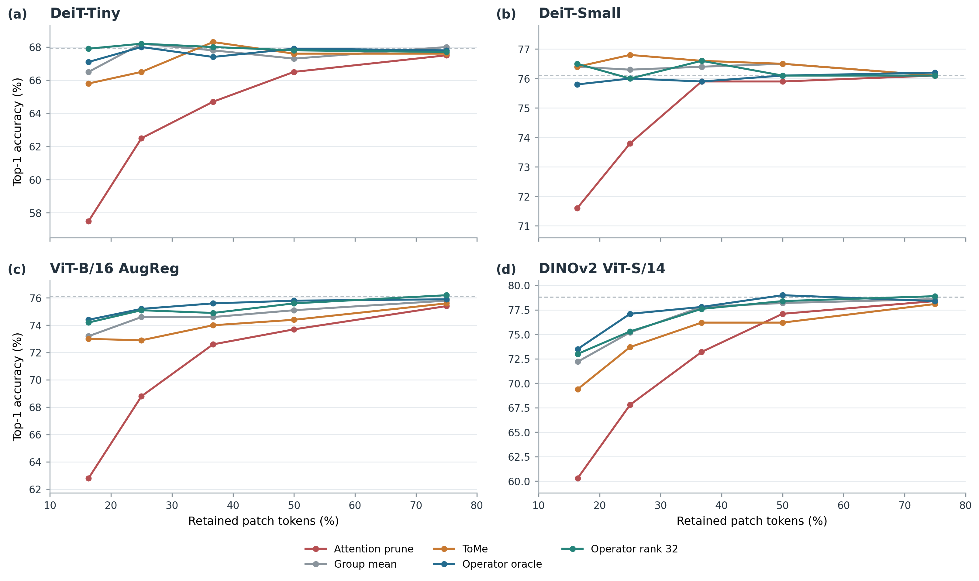
Fig. 7. Confirmatory Top-1 accuracy versus retained patch-token fraction for four architectures. Curves show pruning, Group Mean, ToMe, the full-J oracle, and rank-32; rank-16 Top-1 is listed in Table II at the most aggressive tested budget. Each architecture uses N=1,000 held-out images.

7. Practical Carrier Evaluation

7.1 Static Feature-PCA Corrections
The separate carrier branch tests whether corrections can be amortized in a compact feature-PCA basis. Here, q is the number of feature directions in the correction basis, extracted from centered calibration patch activations with covariance $Σ_{act,l}$; these directions are not obtained from the Jacobian. This feature-space covariance is distinct from the readout-space solver Gram matrix $H_{J}$ in Eq. (8). Separately, calibration uses a low-rank subspace derived from downstream-Jacobian targets to estimate a fixed coefficient vector α, which sets the correction weight along each PCA direction. For held-out classifier evaluation, the basis and coefficients are frozen, and no per-image Jacobian or evaluation-label fitting is used. The operator-space experiment uses N=100 held-out operator-space images and does not measure classification. For DeiT-Small at q=16, static Feature-PCA recovers 54.91% of the restricted-oracle ‖J E‖ gain; this remains linearized operator-space evidence only.

7.2 Classification and Throughput Evaluation
The held-out classifier-carrier evaluation measures actual model predictions on N=1,000 held-out images per architecture. Table III reports the separate real classifier-carrier results at the selected budgets.
TABLE III
REAL CLASSIFIER-CARRIER COUNTS AT REPORTED BUDGETS
Architecture | Budget | Hybrid Group Mean | Static Feature-PCA, q=16 | Static Feature-PCA, q=32
DeiT-Small | 98 | 764/1,000 (76.4%) | 763/1,000 (76.3%; −0.1 pp) | 760/1,000 (76.0%; −0.4 pp)
DeiT-Small | 49 | 755/1,000 (75.5%) | 740/1,000 (74.0%; −1.5 pp) | 740/1,000 (74.0%; −1.5 pp)
DINOv2 ViT-S/14 | 42 | 613/1,000 (61.3%) | 568/1,000 (56.8%; −4.5 pp) | 570/1,000 (57.0%; −4.3 pp)
ViT-B/16 AugReg | 49 | 712/1,000 (71.2%) | 719/1,000 (71.9%; +0.7 pp) | 716/1,000 (71.6%; +0.4 pp)

Table III. Correct predictions out of 1,000 held-out images and Top-1 accuracy for the separate real classifier-carrier benchmark. Parenthetical differences are percentage-point (pp) changes from Hybrid Group Mean at the same architecture and budget. This benchmark is distinct from the N=100 operator-space study.
On held-out classification, Compact Feature-PCA does not consistently improve on Hybrid Group Mean: both DeiT-Small budgets and the aggressive DINOv2 budget are at or below it, while ViT-B/16 AugReg has a limited positive case. Fig. S1 reports measured full-model throughput; q=16 adds a narrow ViT-B/16 AugReg point at some batch sizes, without establishing a general deployment speedup.
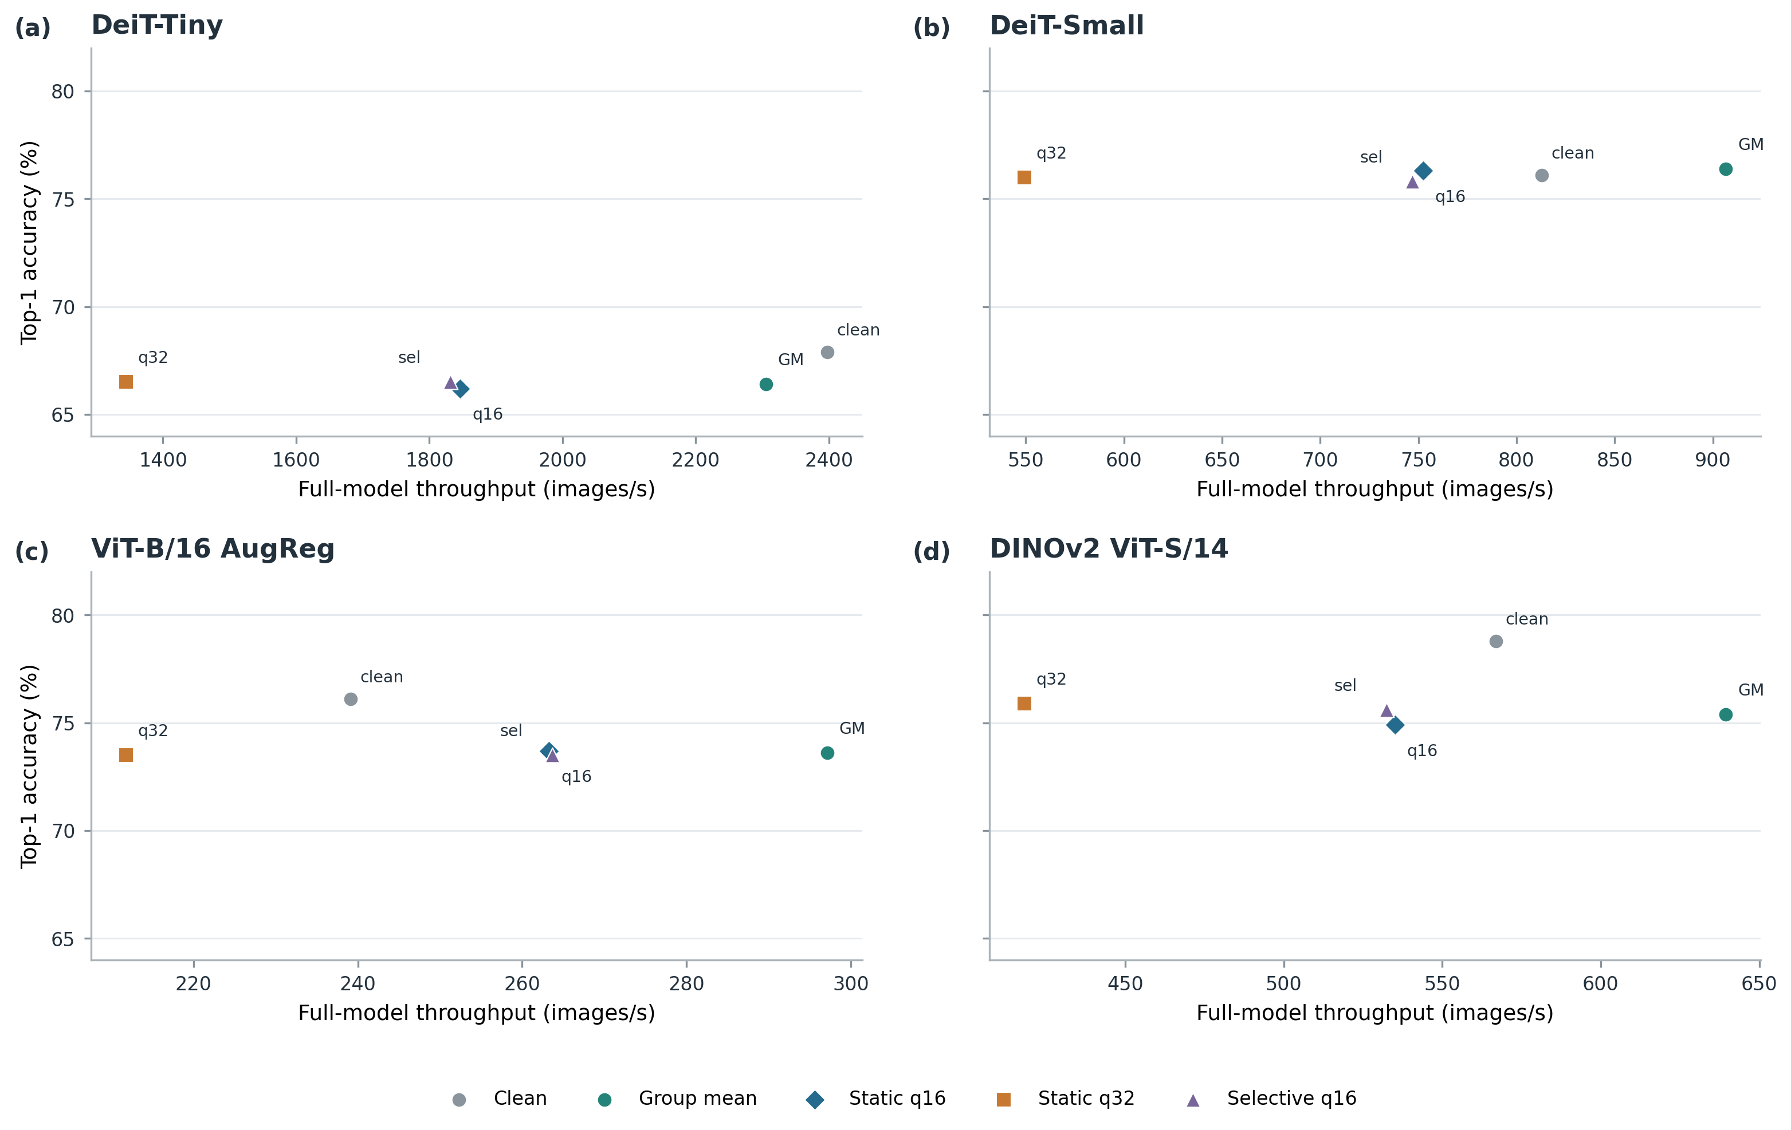
Fig. S1. Held-out classifier-carrier accuracy and full-model throughput at batch size 64; q=16 has a narrow ViT-B/16 AugReg frontier contribution.
Selective risk gating is also bounded. Its historical operator-space area under the receiver operating characteristic curve (AUROC) is 0.784 and is exploratory; the calibration-frozen real classifier gate does not consistently improve accuracy (DeiT-Small budget 98: 75.8% versus Hybrid Group Mean 76.4%; DINOv2 budget 42: 58.5% versus Hybrid Group Mean 61.3%). In the measured accuracy-throughput frontier, Clean is non-dominated in several regimes, Group Mean is a practical batched baseline, and static q=16 adds a narrow ViT-B/16 AugReg point at some batch sizes. q=32 and selective q=16 do not establish a general frontier improvement. Full-call measurements are not isolated operator overhead.
Beyond the static Feature-PCA results, exploratory carriers show that single-token attempts fail; scalar layer prediction and out-of-sample dynamic-α prediction do not generalize; a shared linear envelope with K≤64 captures little of the tested operator subspace; and dynamic-operator prediction is costly. Feature-PCA can reduce linearized operator error without reliably improving Top-1, while selective gating does not yield a general deployment frontier.

8. Limitations
The mechanism studies are finite: N=100 images for the attention causal audit and functional-geometry pilot, N=100 images per model for joint-stream geometry, and N=100 held-out perturbations for multi-block operator prediction. Their conclusions should not be generalized beyond the tested architectures, layers, perturbations, or readouts. Confirmatory results cover four pretrained vision-transformer families and a specific ImageNet validation subset of N=1,000 held-out images per architecture; broader model and task coverage remains untested. The Jacobian objective is a local linearization, and the full-J oracle requires per-image downstream-Jacobian construction. Real carrier classification shows that reducing linearized error is not sufficient for a deployment gain; measured full-call runtime is also specific to the tested hardware, batch sizes, and implementations and does not isolate operator overhead.

9. Conclusion
Across the tested ViTs, late-layer patch content is conditionally replaceable under feature-geometry and token-diversity constraints. The N=100 mechanism audits connect this behavior to anisotropic transmission, coherent Value-path accumulation and cancellation, and depth-wise expansion of the threshold-defined near-null subspace in the margin-gradient metric. On N=100 held-out perturbations, the end-to-end pre-classifier readout Jacobian predicts measured logit damage more closely than the single-block operator. In the N=1,000-per-architecture confirmatory benchmark, operator-aware compression improves on the strongest pruning baseline by 4.2–12.0 percentage points at the most aggressive tested budgets and shifts the accuracy-token frontier in three of four architectures, while ToMe remains competitive; rank-16/32 results vary by architecture and budget. The per-image Jacobian is an offline oracle, and carrier corrections and throughput results do not establish a general deployment gain. Together, these findings connect fixed-slot patch-content fungibility to downstream functional geometry and attention-mediated cancellation, and show how this structure can guide operator-aware compression.

Reproducibility and Evidence
Code and audited data supporting the confirmatory compression and real classifier-carrier benchmarks are available in the [Patch-Content-Fungibility repository](https://github.com/nhatminh-115/Patch-Content-Fungibility).

References
[1] A. Vaswani, N. Shazeer, N. Parmar, J. Uszkoreit, L. Jones, A. N. Gomez, et al., “Attention is All you Need,” in Advances in Neural Information Processing Systems, vol. 30, pp. 5998–6008, 2017. Available: https://proceedings.neurips.cc/paper_files/paper/2017/hash/3f5ee243547dee91fbd053c1c4a845aa-Abstract.html.
[2] A. Dosovitskiy, L. Beyer, A. Kolesnikov, D. Weissenborn, X. Zhai, T. Unterthiner, et al., “An Image is Worth 16x16 Words: Transformers for Image Recognition at Scale,” in Proc. Int. Conf. Learn. Represent., 2021. Available: https://openreview.net/forum?id=YicbFdNTTy.
[3] H. Touvron, M. Cord, M. Douze, F. Massa, A. Sablayrolles, H. Jégou, “Training data-efficient image transformers & distillation through attention,” in Proc. 38th Int. Conf. Mach. Learn., vol. 139, pp. 10347–10357, 2021. Available: https://proceedings.mlr.press/v139/touvron21a.html.
[4] M. Caron, H. Touvron, I. Misra, H. Jégou, J. Mairal, P. Bojanowski, et al., “Emerging Properties in Self-Supervised Vision Transformers,” in Proc. IEEE/CVF Int. Conf. Comput. Vis., pp. 9650–9660, 2021. DOI: 10.1109/ICCV48922.2021.00951.
[5] M. Oquab, T. Darcet, T. Moutakanni, H. Vo, M. Szafraniec, V. Khalidov, et al., “DINOv2: Learning Robust Visual Features without Supervision,” in Transactions on Machine Learning Research, 2024. Available: https://openreview.net/forum?id=a68SUt6zFt.
[6] Z. Liu, Y. Lin, Y. Cao, H. Hu, Y. Wei, Z. Zhang, et al., “Swin Transformer: Hierarchical Vision Transformer Using Shifted Windows,” in Proc. IEEE/CVF Int. Conf. Comput. Vis., pp. 10012–10022, 2021. DOI: 10.1109/ICCV48922.2021.00986.
[7] K. He, X. Chen, S. Xie, Y. Li, P. Dollár, R. Girshick, “Masked Autoencoders Are Scalable Vision Learners,” in Proc. IEEE/CVF Conf. Comput. Vis. Pattern Recognit., pp. 16000–16009, 2022. DOI: 10.1109/CVPR52688.2022.01553.
[8] X. Zhai, A. Kolesnikov, N. Houlsby, L. Beyer, “Scaling Vision Transformers,” in Proc. IEEE/CVF Conf. Comput. Vis. Pattern Recognit., pp. 12104–12113, 2022. DOI: 10.1109/CVPR52688.2022.01179.
[9] A. Steiner, A. Kolesnikov, X. Zhai, R. Wightman, J. Uszkoreit, L. Beyer, “How to Train Your ViT? Data, Augmentation, and Regularization in Vision Transformers,” in Transactions on Machine Learning Research, 2022. Available: https://openreview.net/forum?id=4nPswr1KcP.
[10] T. Darcet, M. Oquab, J. Mairal, P. Bojanowski, “Vision Transformers Need Registers,” in Proc. Int. Conf. Learn. Represent., 2024. Available: https://openreview.net/forum?id=L6T2bA1sJN.
[11] Y. Rao, W. Zhao, B. Liu, J. Lu, J. Zhou, C.-J. Hsieh, “DynamicViT: Efficient Vision Transformers with Dynamic Token Sparsification,” in Advances in Neural Information Processing Systems, vol. 34, pp. 13937–13949, 2021. Available: https://proceedings.neurips.cc/paper/2021/hash/747d3443e319a22747fbb873e8b2f9f2-Abstract.html.
[12] Y. Liang, C. Ge, Z. Tong, Y. Song, J. Wang, P. Xie, “Not All Patches Are What You Need: Expediting Vision Transformers via Token Reorganizations,” in Proc. Int. Conf. Learn. Represent., 2022. Available: https://openreview.net/forum?id=I90fplp5b3.
[13] D. Bolya, C.-Y. Fu, X. Dai, P. Zhang, C. Feichtenhofer, J. Hoffman, “Token Merging: Your ViT But Faster,” in Proc. Int. Conf. Learn. Represent., 2023. Available: https://openreview.net/forum?id=JroZRaRw7Eu.
[14] H. Yin, A. Vahdat, J. M. Alvarez, A. Mallya, J. Kautz, P. Molchanov, “A-ViT: Adaptive Tokens for Efficient Vision Transformer,” in Proc. IEEE/CVF Conf. Comput. Vis. Pattern Recognit., pp. 10809–10818, 2022. DOI: 10.1109/CVPR52688.2022.01054.
[15] L. Meng, H. Li, B.-C. Chen, S. Lan, Z. Wu, Y.-G. Jiang, et al., “AdaViT: Adaptive Vision Transformers for Efficient Image Recognition,” in Proc. IEEE/CVF Conf. Comput. Vis. Pattern Recognit., pp. 12309–12318, 2022. DOI: 10.1109/CVPR52688.2022.01199.
[16] M. S. Ryoo, A. J. Piergiovanni, A. Arnab, M. Dehghani, A. Angelova, “TokenLearner: Adaptive Space-Time Tokenization for Videos,” in Advances in Neural Information Processing Systems, vol. 34, pp. 12786–12797, 2021. Available: https://proceedings.neurips.cc/paper/2021/hash/6a30e32e56fce5cf381895dfe6ca7b6f-Abstract.html.
[17] D. Marin, J.-H. R. Chang, A. Ranjan, A. Prabhu, M. Rastegari, O. Tuzel, “Token Pooling in Vision Transformers for Image Classification,” in Proc. IEEE/CVF Winter Conf. Appl. Comput. Vis., pp. 12–21, 2023. DOI: 10.1109/WACV56688.2023.00010.
[18] M. Fayyaz, S. A. Koohpayegani, F. R. Jafari, S. Sengupta, H. R. V. Joze, E. Sommerlade, et al., “Adaptive Token Sampling for Efficient Vision Transformers,” in Computer Vision – ECCV 2022, vol. 13671, pp. 396–414, 2022. DOI: 10.1007/978-3-031-20083-0_24.
[19] B. Pan, R. Panda, Y. Jiang, Z. Wang, R. Feris, A. Oliva, “IA-RED²: Interpretability-Aware Redundancy Reduction for Vision Transformers,” in Advances in Neural Information Processing Systems, vol. 34, 2021. Available: https://proceedings.neurips.cc/paper/2021/hash/d072677d210ac4c03ba046120f0802ec-Abstract.html.
[20] Y. Liu, C. Matsoukas, F. Strand, H. Azizpour, K. Smith, “PatchDropout: Economizing Vision Transformers Using Patch Dropout,” in Proc. IEEE/CVF Winter Conf. Appl. Comput. Vis., pp. 3953–3962, 2023. DOI: 10.1109/WACV56688.2023.00394.
[21] L. Yu, W. Xiang, “X-Pruner: eXplainable Pruning for Vision Transformers,” in Proc. IEEE/CVF Conf. Comput. Vis. Pattern Recognit., pp. 24355–24363, 2023. DOI: 10.1109/CVPR52729.2023.02333.
[22] H. Yang, H. Yin, M. Shen, P. Molchanov, H. Li, J. Kautz, “Global Vision Transformer Pruning With Hessian-Aware Saliency,” in Proc. IEEE/CVF Conf. Comput. Vis. Pattern Recognit., pp. 18547–18557, 2023. DOI: 10.1109/CVPR52729.2023.01779.
[23] S. Wei, T. Ye, S. Zhang, Y. Tang, J. Liang, “Joint Token Pruning and Squeezing Towards More Aggressive Compression of Vision Transformers,” in Proc. IEEE/CVF Conf. Comput. Vis. Pattern Recognit., pp. 2092–2101, 2023. DOI: 10.1109/CVPR52729.2023.00208.
[24] Q. Tang, B. Zhang, J. Liu, F. Liu, Y. Liu, “Dynamic Token Pruning in Plain Vision Transformers for Semantic Segmentation,” in Proc. IEEE/CVF Int. Conf. Comput. Vis., pp. 777–786, 2023. DOI: 10.1109/ICCV51070.2023.00078.
[25] Y. Xu, Z. Zhang, M. Zhang, K. Sheng, K. Li, W. Dong, et al., “Evo-ViT: Slow-Fast Token Evolution for Dynamic Vision Transformer,” in Proc. AAAI Conf. Artif. Intell., vol. 36, no. 3, pp. 2964–2972, 2022. DOI: 10.1609/aaai.v36i3.20202.
[26] L. Song, S. Zhang, S. Liu, Z. Li, X. He, H. Sun, et al., “Dynamic Grained Encoder for Vision Transformers,” in Advances in Neural Information Processing Systems, vol. 34, 2021. Available: https://proceedings.neurips.cc/paper/2021/hash/2d969e2cee8cfa07ce7ca0bb13c7a36d-Abstract.html.
[27] Z. Kong, P. Dong, X. Ma, X. Meng, W. Niu, M. Sun, et al., “SPViT: Enabling Faster Vision Transformers via Latency-Aware Soft Token Pruning,” in Computer Vision – ECCV 2022, vol. 13671, pp. 620–640, 2022. DOI: 10.1007/978-3-031-20083-0_37.
[28] Y. Tang, K. Han, Y. Wang, C. Xu, J. Guo, C. Xu, et al., “Patch Slimming for Efficient Vision Transformers,” in Proc. IEEE/CVF Conf. Comput. Vis. Pattern Recognit., pp. 12165–12174, 2022. DOI: 10.1109/CVPR52688.2022.01185.
[29] Y. Wang, R. Huang, S. Song, Z. Huang, G. Huang, “Not All Images Are Worth 16x16 Words: Dynamic Transformers for Efficient Image Recognition,” in Advances in Neural Information Processing Systems, vol. 34, 2021. Available: https://proceedings.neurips.cc/paper/2021/hash/64517d8435994992e682b3e4aa0a0661-Abstract.html.
[30] T. Chen, Y. Cheng, Z. Gan, L. Yuan, L. Zhang, Z. Wang, “Chasing Sparsity in Vision Transformers: An End-to-End Exploration,” in Advances in Neural Information Processing Systems, vol. 34, 2021. Available: https://proceedings.neurips.cc/paper/2021/file/a61f27ab2165df0e18cc9433bd7f27c5-Abstract.html.
[31] X. Chen, Z. Liu, H. Tang, L. Yi, H. Zhao, S. Han, “SparseViT: Revisiting Activation Sparsity for Efficient High-Resolution Vision Transformer,” in Proc. IEEE/CVF Conf. Comput. Vis. Pattern Recognit., pp. 2061–2070, 2023. DOI: 10.1109/CVPR52729.2023.00205.
[32] C. Zheng, Z. Li, K. Zhang, Z. Yang, W. Tan, J. Xiao, et al., “SAViT: Structure-Aware Vision Transformer Pruning via Collaborative Optimization,” in Advances in Neural Information Processing Systems, vol. 35, pp. 9010–9023, 2022. DOI: 10.52202/068431-0655.
[33] Y. LeCun, J. S. Denker, S. A. Solla, “Optimal Brain Damage,” in Advances in Neural Information Processing Systems, vol. 2, pp. 598–605, 1989. Available: https://proceedings.neurips.cc/paper/1989/hash/6c9882bbac1c7093bd25041881277658-Abstract.html.
[34] B. Hassibi, D. G. Stork, “Optimal Brain Surgeon and general network pruning,” in Proceedings of the IEEE Proc. IEEE Int. Conf. Neural Netw., vol. 1, pp. 293–299, 1993. DOI: 10.1109/ICNN.1993.298572.
[35] S. Han, J. Pool, J. Tran, W. J. Dally, “Learning Both Weights and Connections for Efficient Neural Networks,” in Advances in Neural Information Processing Systems, vol. 28, 2015. Available: https://proceedings.neurips.cc/paper/2015/hash/ae0eb3eed39d2bcef4622b2499a05fe6-Abstract.html.
[36] P. Molchanov, S. Tyree, T. Karras, T. Aila, J. Kautz, “Pruning Convolutional Neural Networks for Resource Efficient Inference,” in Proc. Int. Conf. Learn. Represent., 2017. Available: https://openreview.net/forum?id=SJGCiw5gl.
[37] J. Frankle, M. Carbin, “The Lottery Ticket Hypothesis: Finding Sparse, Trainable Neural Networks,” in Proc. Int. Conf. Learn. Represent., 2019. Available: https://openreview.net/forum?id=rJl-b3RcF7.
[38] V. Sanh, T. Wolf, A. M. Rush, “Movement Pruning: Adaptive Sparsity by Fine-Tuning,” in Advances in Neural Information Processing Systems, vol. 33, pp. 20378–20389, 2020. Available: https://proceedings.neurips.cc/paper/2020/hash/eae15aabaa768ae4a5993a8a4f4fa6e4-Abstract.html.
[39] E. Frantar, D. Alistarh, “SparseGPT: Massive Language Models Can Be Accurately Pruned in One-Shot,” in Proc. 40th Int. Conf. Mach. Learn., vol. 202, pp. 10323–10337, 2023. Available: https://proceedings.mlr.press/v202/frantar23a.html.
[40] M. Sun, Z. Liu, A. Bair, J. Z. Kolter, “A Simple and Effective Pruning Approach for Large Language Models,” in Proc. Int. Conf. Learn. Represent., 2024. Available: https://openreview.net/forum?id=PxoFut3dWW.
[41] S. Ashkboos, M. L. Croci, M. Gennari do Nascimento, T. Hoefler, J. Hensman, “SliceGPT: Compress Large Language Models by Deleting Rows and Columns,” in Proc. Int. Conf. Learn. Represent., 2024. Available: https://openreview.net/forum?id=vXxardq6db.
[42] X. Wang, Y. Zheng, Z. Wan, M. Zhang, “SVD-LLM: Truncation-aware Singular Value Decomposition for Large Language Model Compression,” in Proc. Int. Conf. Learn. Represent., 2025. Available: https://proceedings.iclr.cc/paper_files/paper/2025/hash/3104e1ab39875cf54fe1eb4473e7c5a1-Abstract-Conference.html.
[43] S. Jain, B. C. Wallace, “Attention Is Not Explanation,” in Proceedings of the 2019 Conference of the North American Chapter of the Association for Computational Linguistics: Human Language Technologies, pp. 3543–3556, 2019. DOI: 10.18653/v1/N19-1357.
[44] S. Serrano, N. A. Smith, “Is Attention Interpretable?,” in Proceedings of the 57th Annual Meeting of the Association for Computational Linguistics, pp. 2931–2951, 2019. DOI: 10.18653/v1/P19-1282.
[45] S. Wiegreffe, Y. Pinter, “Attention Is Not Not Explanation,” in Proceedings of the 2019 Conference on Empirical Methods in Natural Language Processing and the 9th International Joint Conference on Natural Language Processing, pp. 11–20, 2019. DOI: 10.18653/v1/D19-1002.
[46] S. Abnar, W. Zuidema, “Quantifying Attention Flow in Transformers,” in Proceedings of the 58th Annual Meeting of the Association for Computational Linguistics, pp. 4190–4197, 2020. DOI: 10.18653/v1/2020.acl-main.385.
[47] M. Sundararajan, A. Taly, Q. Yan, “Axiomatic Attribution for Deep Networks,” in Proc. 34th Int. Conf. Mach. Learn., vol. 70, pp. 3319–3328, 2017. Available: https://proceedings.mlr.press/v70/sundararajan17a.html.
[48] J. Adebayo, J. Gilmer, M. Muelly, I. Goodfellow, M. Hardt, B. Kim, “Sanity Checks for Saliency Maps,” in Advances in Neural Information Processing Systems, vol. 31, pp. 9505–9515, 2018. Available: https://proceedings.neurips.cc/paper/2018/hash/294a8ed24b1ad22ec2e7efea049b8737-Abstract.html.
[49] H. Chefer, S. Gur, L. Wolf, “Transformer Interpretability Beyond Attention Visualization,” in Proc. IEEE/CVF Conf. Comput. Vis. Pattern Recognit., pp. 782–791, 2021. DOI: 10.1109/CVPR46437.2021.00084.
[50] A. Geiger, Z. Wu, C. Potts, T. Icard, N. Goodman, “Inducing Causal Structure for Interpretable Neural Networks,” in Proc. 39th Int. Conf. Mach. Learn., vol. 162, pp. 7324–7338, 2022. Available: https://proceedings.mlr.press/v162/geiger22a.html.
[51] F. Parodi, J. K. Matelsky, M. Segado, “Zero-Ablation Overstates Register Content Dependence in DINO Vision Transformers,” in Proc. IEEE/CVF Conf. Comput. Vis. Pattern Recognit. Workshops (CVPRW), pp. 4164–4170, Jun. 2026. Available: https://openaccess.thecvf.com/content/CVPR2026W/HOW/html/Parodi_Zero-Ablation_Overstates_Register_Content_Dependence_in_DINO_Vision_Transformers_CVPRW_2026_paper.html.

