EXAM 1 – ISTQB FOUNDATION

# CHAPTER 1

Question #1 (1 pt)

Which of the following is the activity that removes the cause of a failure?

a. Testing

b. Dynamic testing

c. Debugging

d. Reverse engineering

Question #2 (1 pt)

As a tester, which of the following is a key to effectively communicating and maintaining positive

relationships with developers when there is disagreement over the prioritization of a defect?

a. Escalate the issue to human resources and stress the importance of mutual respect

b. Communicate in a setting with senior management to ensure everyone understands

c. Convince the developer to accept the blame for the mistake

d. Remind them of the common goal of creating quality systems

Question #3 (1 pt)

Why is software testing sometimes required for legal reasons?

a. It prevents developers from suing testers

b. Contracts may specify testing requirements that must be fulfilled

c. International laws require software testing for exported products

d. Testing across systems must be accompanied by legal documentation

Question #4 (1 pt)

In what way does root cause analysis contribute to process improvement?

a. Helps to better identify and correct the root cause of defects

b. Outlines how development teams can code faster

c. Specifies the desired root causes to be achieved by other teams

d. Contributes to the justification of future project funding

Question #5 (1 pt)

Why is it important to avoid the pesticide paradox?

a. Dynamic testing is less reliable in finding bugs

b. Pesticides mixed with static testing can allow bugs to escape detection

c. Tests should not be context dependent

d. Running the same tests over and over will reduce the chance of finding new defects

Question #6 (1 pt)

Which of the following is the activity that compares the planned test progress to the actual test

progress?

a. Test monitoring

b. Test planning

c. Test closure

d. Test control

Question #7 (1 pt)

Which of the following is the correct statement?

a. An error causes a failure which results in a defect

b. A defect causes a failure which results in an error

c. A failure is observed as an error and the root cause is the defect

d. An error causes a defect which is observed as a failure

Question #8 (1 pt)

What type of activity is normally used to find and fix a defect in the code?

a. Regression testing

b. Debugging

c. Dynamic analysis

d. Static analysis

# CHAPTER 2

Question #9 (1 pt)

During which level of testing should non-functional tests be executed?

a. Unit and integration only

b. System testing only

c. Integration, system and acceptance only

d. Unit, integration, system and acceptance only

Question #10 (1 pt)

When a system is targeted for decommissioning, what type of maintenance testing may be required?

a. Retirement testing

b. Regression testing

c. Data migration testing

d. Patch testing

Question #11 (1 pt)

If impact analysis indicates that the overall system could be significantly affected by system

maintenance activities, why should regression testing be executed after the changes?

a. To ensure the system still functions as expected with no introduced issues

b. To ensure no unauthorized changes have been applied to the system

c. To assess the scope of maintenance performed on the system

d. To identify any maintainability issues with the code

Question #12 (1 pt)

In an iterative lifecycle model, which of the following is an accurate statement about testing activities?

a. For every development activity, there should be a corresponding testing activity

b. For every testing activity, appropriate documentation should be produced, versioned and stored

c. For every development activity resulting in code, there should be a testing activity to document

test cases

d. For every testing activity, metrics should be recorded and posted to a metrics dashboard for all

stakeholders

Question #13 (1 pt)

Use cases are a test basis for which level of testing?

a. Unit

b. System

c. Load and performance

d. Usability

# CHAPTER 3

Question #14 (1 pt)

Which of the following techniques is a form of static testing?

a. Error guessing

b. Automated regression testing

c. Providing inputs and examining the resulting outputs

d. Code review

Question #15 (1 pt)

Which of the following is a benefit of static analysis?

a. Defects can be identified that might not be caught by dynamic testing

b. Early defect identification requires less documentation

c. Early execution of the code provides a gauge of code quality

d. Tools are not needed because reviews are used instead of executing code

Question #16 (1 pt)

What is the main difference between static and dynamic testing?

a. Static testing is performed by developers; dynamic testing is performed by testers

b. Manual test cases are used for dynamic testing; automated tests are used for static testing

c. Static testing must be executed before dynamic testing

d. Dynamic testing requires executing the software; the software is not executed during static

testing

Question #17 (1 pt)

If a review session is led by the author of the work product, what type of review is it?

a. Ad hoc

b. Walkthrough

c. Inspection

d. Audit

Question #18 (1 pt)

You are preparing for a review of a mobile application that will allow users to transfer money between

bank accounts from different banks. Security is a concern with this application and the previous version

of this application had numerous security vulnerabilities (some of which were found by hackers). It is

very important that this doesn’t happen again.

Given this information, what type of review technique would be most appropriate?

a. Ad hoc

b. Role-based

c. Checklist-based

d. Scenario

# CHAPTER 4

Question #19 (1 pt)

Which of the following is an experience-based testing technique?

a. Error guessing

b. Intuitive testing

c. Oracle-based testing

d. Exhaustive testing

Question #20 (1 pt)

Which of the following test techniques uses the requirements specifications as a test basis?

a. Structure-based

b. Black-box

c. White-box

d. Exploratory

Question #21 (1 pt)

How is statement coverage determined?

a. Number of test decision points divided by the number of test cases

b. Number of decision outcomes tested divided by the total number of executable statements

c. Number of possible test case outcomes divided by the total number of function points

d. Number of executable statements tested divided by the total number of executable statements

Question #22 (1 pt)

If you have a section of code that has one simple IF statement, how many tests will be needed to

achieve 100% decision coverage?

a. 1

b. 2

c. 5

d. Unknown with this information

Question #23 (1 pt)

What is error guessing?

a. A testing technique used to guess where a developer is likely to have made a mistake

b. A technique used for assessing defect metrics

c. A development technique to verify that all error paths have been coded

d. A planning technique used to anticipate likely schedule variances due to faults

Question #24 (1 pt)

When exploratory testing is conducted using time-boxing and test charters, what is it called?

a. Schedule-based testing

b. Session-based testing

c. Risk-based testing

d. Formal chartering

Question #25 (1 pt)

You are testing a scale system that determines shipping rates for a regional web-based auto parts

distributor. You want to group your test conditions to minimize the testing.

Identify how many equivalence classes are necessary for the following range. Weights are rounded to

the nearest pound.



a. 8

b. 6

c. 5

d. 4

Question #26 (1 pt)

You are testing a scale system that determines shipping rates for a regional web-based auto parts

distributor. Due to regulations, shipments cannot exceed 100 lbs. You want to include boundary value

analysis as part of your black-box test design.

How many tests will you need to execute to achieve 100% two-value boundary value analysis?



a. 4

b. 8

c. 10

d. 12

Question #27 (1 pt)

Which of the following is the correct decision table for the following pseudocode for ordering a

hamburger? Note: if you add or delete items from the basic burger, you no longer get the basic burger.

Start

Select basic burger

If customer adds items

While items to be added

Ask customer which item

Add item

End while

Endif

If customer deletes items

While items to be deleted

Ask customer which item

Delete item

End while

Endif

If customer wants fries

Add fries to order

Endif

Complete order

End

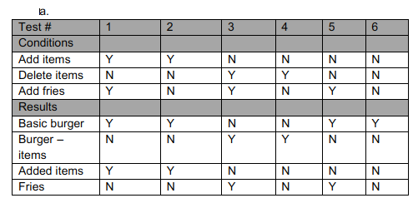d

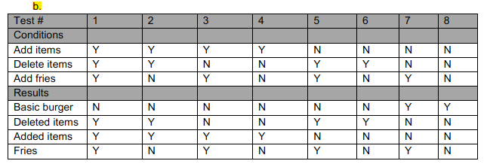

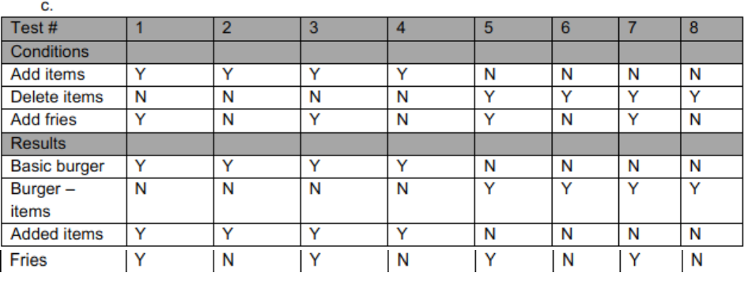

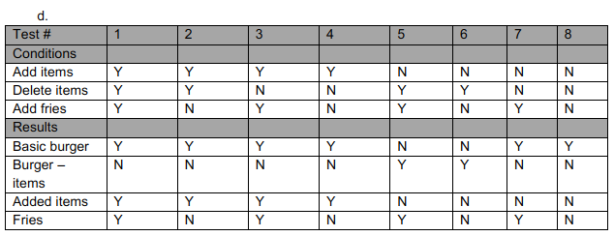

Question #28 (1 pt)

You are testing an e-commerce transaction that has the following states and transitions:

1. Login (invalid) > Login

2. Login > Search

3. Search > Search

4. Search > Shopping Cart

5. Shopping Cart > Search

6. Shopping Cart > Checkout

7. Checkout > Search

8. Checkout > Logout

For a state transition diagram, how many transitions should be shown?

a. 4

b. 6

c. 8

d. 16

Question #29 (1 pt)

You are testing a banking application that allows a customer to withdraw 20, 100 or 500 dollars in a

single transaction. The values are chosen from a drop-down list and no other values may be entered.

How many equivalence partitions need to be tested to achieve 100% equivalence partition coverage?

a. 1

b. 2

c. 3

d. 4

# CHAPTER 5

Question #30 (1 pt)

Level of risk is determined by which of the following?

a. Likelihood and impact

b. Priority and risk rating

c. Probability and practicality

d. Risk identification and mitigation

Question #31 (1 pt)

Who normally writes the test plan for a project?

a. The project manager

b. The product owner

c. The test manager

d. The tester

Question #32 (1 pt)

What is the biggest problem with a developer testing his own code?

a. Developers are not good testers

b. Developers are not quality focused

c. Developers are not objective about their own code

d. Developers do not have time to test their own code

Question #33 (1 pt)

Which of the following is a project risk?

a. A defect that is causing a performance issue

b. A duplicate requirement

c. An issue with a data conversion procedure

d. A schedule that requires work during Christmas shutdown

Question #34 (1 pt)

If your test strategy is based off the list of the ISO 25010 quality characteristics, what type of strategy is

it?

a. Regulatory

b. Analytical

c. Methodical

d. Reactive

Question #35 (1 pt)

If the developers are releasing code for testing that is not version controlled, what process is missing?

a. Configuration management

b. Debugging

c. Test and defect management

d. Risk analysis

Question #36 (1 pt)

You are getting ready to test another upgrade of an ERP system. The previous upgrade was tested by

your team and has been in production for several years. For this situation, which of the following is the

most appropriate test effort estimation technique?

a. Effort-based

b. Expert-based

c. Metric-based

d. Schedule-based

Question #37 (1 pt)

You have been testing software that will be used to track credit card purchases. You have found a

defect that causes the system to crash, but only if a person has made and voided 10 purchases in a

row. What is the proper priority and severity rating for this defect?

a. Priority high, severity high

b. Priority high, severity low

c. Priority low, severity low

d. Priority low, severity high

Question #38 (1 pt)

Consider the following test cases that are used to test an accounting system:

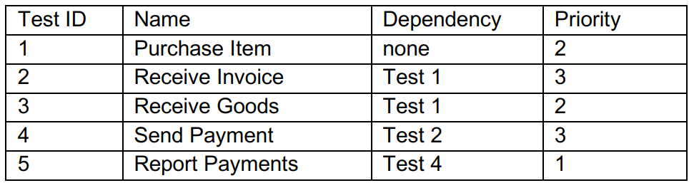

Given this information, what is the proper order in which to execute these test cases?

a. 5, 1, 3, 2, 4

b. 1, 2, 4, 5, 3

c. 1, 3, 2, 4, 5

d. 3, 4, 5, 1, 2

1. **What is not the primary data given by the tester in test execution (C5)**

| A | Total number of tests |
| --- | --- |
| B | Number of test cases written for change request |
| C | Number of test executed to date |
| D | Number of tests executed successfully to date |

# CHAPTER 6

Question #39 (1 pt)

Which of the following are major objectives of a pilot project for a tool introduction?

a. Roll out, adapt, train, implement

b. Monitor, support, revise, implement

c. Learn, evaluate, decide, assess

d. Evaluate, adapt, monitor, support

Question #40 (1 pt)

What is the primary purpose of a test execution tool?

a. It runs automated test scripts to test the test object

b. It automatically records defects in the defect tracking system

c. It analyzes code to determine if there are any coding standard violations

d. It tracks test cases, defects and requirements traceability