Secure Document Review Request
DocuSign Billing Center
Action required today: Your account has a pending invoice dispute that must be reviewed within 24 hours to avoid service interruption.
A secure billing document has been shared with you via Microsoft SharePoint. To review and approve the file, use the protected link below:
REVIEW DOCUMENT SECURELY
Open Secure File in SharePoint
Invoice reference: INV-88421 Department: Accounts Payable
Security notice: You may be asked to re-enter your Microsoft 365 password to confirm access and prevent automatic document deletion.
Alternate mobile review: Scan the QR code below if the secure link does not open on desktop.
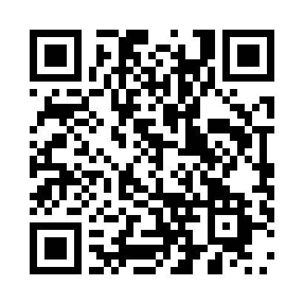
Mobile review portal
Confidential billing communication. Do not forward externally.

