# Reproducible Research: Peer Assessment 1

## Loading and preprocessing the data

unzip(zipfile="activity.zip")  
data <- read.csv("activity.csv")

## What is mean total number of steps taken per day?

library(ggplot2)  
## Calculate the total number of steps taken per day  
total.steps <- tapply(data$steps, data$date, FUN=sum, na.rm=TRUE)  
## Using qplot to make a histogram  
qplot(total.steps, binwidth=1000, xlab="Mean Total Number of Steps Taken Each Day")

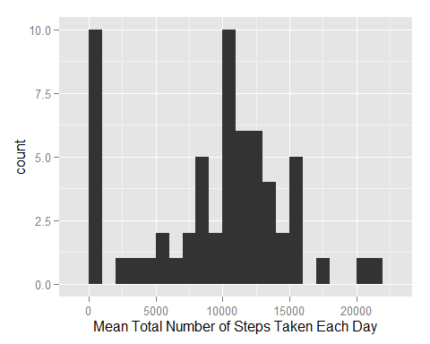

## Calculate and report the mean and median of the total number of steps taken per day  
mean(total.steps, na.rm=TRUE)

## [1] 9354.23

median(total.steps, na.rm=TRUE)

## [1] 10395

## What is the average daily activity pattern?

library(ggplot2)  
## Make a time series plot (i.e. type = "l") of the 5-minute interval (x-axis) and the  
## average number of steps taken, averaged across all days (y-axis)  
averages <- aggregate(x=list(steps=data$steps), by=list(interval=data$interval),  
 FUN=mean, na.rm=TRUE)  
ggplot(data=averages, aes(x=interval, y=steps)) +  
 geom_line() +  
 xlab("5-minute interval") +  
 ylab("Average Number of Steps Taken")

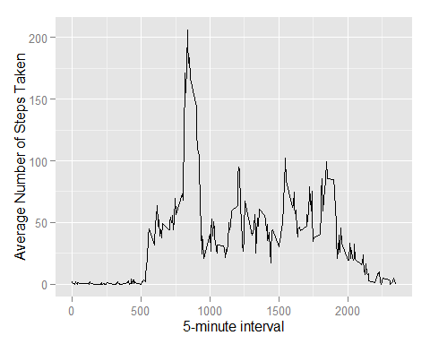

## Which 5-minute interval, on average across all the days in the dataset, contains the maximum number of steps?  
averages[which.max(averages$steps),]

## interval steps  
## 104 835 206.1698

## Imputing missing values

There are many days/intervals where there are missing values (coded as NA). The presence of missing days may introduce bias into some calculations or summaries of the data.

## Calculate and report the total number of missing values in the dataset (i.e. the total number of rows with NAs)  
missing <- is.na(data$steps)  
# How many missing  
table(missing)

## missing  
## FALSE TRUE   
## 15264 2304

The strategy to fill in missing value: Now try to fill all of the missing values in with mean value for that 5-minute interval.

# Replace each missing value with the mean value of its 5-minute interval  
fill.value <- function(steps, interval) {  
 filled <- NA  
 if (!is.na(steps))  
 filled <- c(steps)  
 else  
 filled <- (averages[averages$interval==interval, "steps"])  
 return(filled)  
}  
filled.data <- data  
filled.data$steps <- mapply(fill.value, filled.data$steps, filled.data$interval)

Now, Make a histogram of the total number of steps taken each day and Calculate and report the mean and median total number of steps taken per day.

total.steps <- tapply(filled.data$steps, filled.data$date, FUN=sum)  
qplot(total.steps, binwidth=1000, xlab="Total Number of Steps Taken Each Day")

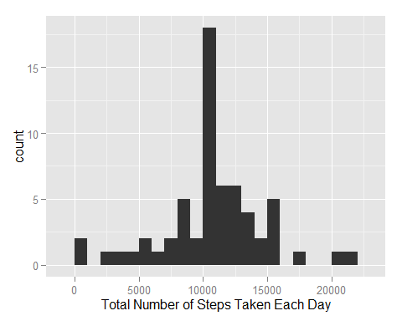

mean(total.steps)

## [1] 10766.19

median(total.steps)

## [1] 10766.19

Do these values differ from the estimates from the first part of the assignment? What is the impact of imputing missing data on the estimates of the total daily number of steps?

As you can see: Mean and median values are higher after inputing missing data. The reason is that in the original data, there are some days with steps values NA for any interval. The total number of steps taken in such days are set to 0s by default. However, after replacing missing steps values with the mean steps of associated interval value, these 0 values are removed from the histogram of total number of steps taken each day. The missing values take effects to our result before. That's why we've got the new results (and seem more clearly) after inputting the value for missing data.

## Are there differences in activity patterns between weekdays and weekends?

First, let's find the day of the week for each measurement in the dataset. In this part, we use the dataset with the filled-in values above.

## Create a new factor variable in the dataset with two levels - "weekday" and "weekend"  
## indicating whether a given date is a weekday or weekend day.  
weekday.or.weekend <- function(date) {  
 day <- weekdays(date)  
 if (day %in% c("Monday", "Tuesday", "Wednesday", "Thursday", "Friday"))  
 return("weekday")  
 else if (day %in% c("Saturday", "Sunday"))  
 return("weekend")  
 else  
 stop("invalid date")  
}  
filled.data$date <- as.Date(filled.data$date)  
filled.data$day <- sapply(filled.data$date, FUN=weekday.or.weekend)

Now, let's make a panel plot containing plots of average number of steps taken on weekdays and weekends.

## Make a panel plot containing a time series plot (i.e. type = "l") of the 5-minute interval  
## (x-axis) and the average number of steps taken, averaged across all weekday days or  
## weekend days (y-axis).  
averages <- aggregate(steps ~ interval + day, data=filled.data, mean)  
ggplot(averages, aes(interval, steps)) + geom_line() + facet_grid(day ~ .) +  
 xlab("5-minute interval") + ylab("Number of steps")

