INTERNATIONAL PROGRAMMERSTRAINING CENTER

SOFTECH APTECH

🙣🙣🕮🙡🙡



**FINAL PROJECT**

**ePROJECT JAVA-J2SE**

**PROJECT:**

**SALE MANAGEMENT**

Instructor : Mr. Nguyen Duc Thao

Batch : 153+154

Members : Le Thai Bao

*Da Nang, June, 2020*

**TEACHER’S EVALUATION**

……………………………………………………………………………………….

……………………………………………………………………………………….

……………………………………………………………………………………….

……………………………………………………………………………………….

……………………………………………………………………………………….

……………………………………………………………………………………….

……………………………………………………………………………………….

……………………………………………………………………………………….

……………………………………………………………………………………….

……………………………………………………………………………………….

……………………………………………………………………………………….

……………………………………………………………………………………….

……………………………………………………………………………………….

……………………………………………………………………………………….

……………………………………………………………………………………….

……………………………………………………………………………………….

……………………………………………………………………………………….

……………………………………………………………………………………….

……………………………………………………………………………………….

……………………………………………………………………………………….

……………………………………………………………………………………….

……………………………………………………………………………………….

……………………………………………………………………………………….

……………………………………………………………………………………….

……………………………………………………………………………………….

……………………………………………………………………………………….

……………………………………………………………………………………….

……………………………………………………………………………………….

**TABLE OF CONTENTS**

1. ACKNOWLEDGEMENTS 1

2. PREFACE 1

3. INTRODUCTION 2

3.1. Customer’s Request 2

3.2. The Technical Requirements 2

4. TARGETS AND OBJECT OF THE RESEARCH 2

4.1. Research Targets 2

4.2. Research Objects 2

5. FUNCTIONS DEFINITION 3

5.1. Login, Logout 3

5.2. Register 3

5.3. Manage Employee 3

5.4. Manage Warehouse 3

5.5. Manage Supplier 3

5.6. Manage Customer 3

5.7. Manage Sales Order 3

5.8. Mange to Import Bills 3

5.9. Manage Salary 3

6. THE TECHNOLOGY USED 3

6.1. Tools used 3

6.2. Language used 4

7. DESIGN DATEILS 4

7.1. Algorithm Flowchart 4

7.2. Database Diagrams 4

7.3. Tables 4

7.3.1. Table Employee 4

7.3.2. Table Account 5

7.3.3. Table Bill 5

7.3.4. Table BillDetail 5

7.3.5. Table Customers 5

7.3.6. Table Position 6

7.3.7. Table Product 6

7.3.8. Table ProductDetails 6

7.3.9. Table Provider 6

7.3.10. Table Receipt Note 7

7.3.11. Table Receipt Note Detail 7

8. PROJECT PLANNING 7

8.1. Task breakdown 7

8.1.1. Inception Phase 7

8.1.2. Elaboration Phase 8

9. GUI PROTOTYPE 8

10. GUI OF LOG IN 9

11. GUI MAIN FORM AFTER LOG IN 11

12. EMPLOYEE FORM 12

13. PRODUCT AND PRODUCT DETAIL FORM 12

13.1. Product Form 12

13.2. Product Detail Form 13

14. IMPORT BILL, IMPORT BILL DETAIL, PROVIDER FORM 13

14.1. Import Bill Form 13

14.2. Add Import Bill Form 14

14.3. Import Bill Detail Form 15

14.4. Provider Form 16

14.5. Add Provider Form 16

15. BILL, BILL DETAIL AND CUSTOMER FORM 17

15.1. Bill Form 17

15.2. Add Bill Form 17

15.3. Customer Form 19

15.4. Add Customer Form 19

16. REVENUE STATISTICS, PRODUCT STATISTICS FORM 20

16.1. Revenue Statistics Form 20

16.2. Product Statistics Form 21

1. ACKNOWLEDGEMENTS

First, we would like to thanks the teachers who helped us make a successful project. Esecially Mr. Nguyen Duc Thao was very enthusuastic to help us complete this software project. Thanks for the time he has suggest or fix wrong for us, and teach us things unknown, help us to better understand and develop code skills for us to finish software the most successfully way. Without the guidance of the teacher, then we think we will not be able to complete our software perfect.

Although we’ve had a lot of effort and hard work as well as work groups and individuals to complete the software but because of the time limit, the software may not be able to avoid mistakes and deficiencies. So we look forward to receiving the comments of all the teachers and friends to be able to gradually build the program more complete and mor efficient.

Again, our group would like to sincerely thank the teachers and all yoi have suggestions for improve this software.

1. PREFACE

In the current development trend in the world of science and technology which have changed drastically. Part of which is the application of Information Technology in the daily life of people. We human beings are aiming at establishing a smart planet. Today, with the strong development of IT combined with the development of the Internet has connected the world together into a unified whole. It has become an effective tool for many sectors: transporttation, military, medicine… and especially in the management in general and in partcular the Sales Manager.

Previously when the computer has not been widely used in the management of the work is done by hand so it takes time, human resources and finance. Today, with the strong development of information technology has helped the management is done to more easily, reducing the cost, time…

Through the process of surveying a few store, we realized the needed a simpler, convenient and less error-prone sales management solution. So we decided to design a sales management software to help them.

1. INTRODUCTION
   1. Customer’s Request

The software must be easily accessible, operate and use.

Achieving and fit the user’s purpose, consistent with the user’s level means anyone can use it.

Must have computer hierarchy to users to easily grasp the frame of the entire system. At the same time stable, certainly, has the ability to provide information to meet the needs of users when they need it. Easy maintenance, improvements, quickly pointed out the need to adjust errors.

The interface is easy to look at the fit client workspace, there are aesthetic.

Using written language to match the current computer generation that's Windows XP, Windows 7, 8, 10...

* 1. The Technical Requirements

Handle blocks of work, great info. The volume of information increasingly, information updates are usually, needs to be stored.

Handled correctly. If handled incorrectly even just a few small details alone would cause damage to the customer or the owner, will affect the reputation and quality.

1. TARGETS AND OBJECT OF THE RESEARCH
   1. Research Targets

The primary purpose of the project is to create a management software solve and overcome the difficulties in the business for the purpose of getting power savings, time and financial resources to the store to give store operations more efficient.

* 1. Research Objects

With a small company, the data is not very big. They need information such as employee, customer, supplier, inventory, order, receipt...

Each item has the following information:

- Employee: name, address, phone number, position, salary.

- Customer, Supplier: name, address, phone number, goods, time.

- Warehouse: goods, number, time.

1. FUNCTIONS DEFINITION
   1. Login, Logout

* Manage role of each account
* Admin account: manage all function
* User account: view, add, edit, delete (limit)
  1. Register
* Create new account with decentralization
  1. Manage Employee
* Add, Edit, Delete.
  1. Manage Warehouse
* Add, Edit, Delete goods information
  1. Manage Supplier
* Add, Edit, Delete supplier's information
  1. Manage Customer
* Add, Edit, Delete customer's information
  1. Manage Sales Order
* Add, Edit, Delete sales order's information
  1. Mange to Import Bills
* Add, Edit, Delete Import bill information
  1. Manage Salary
* Add, Edit, Delete salary information

1. THE TECHNOLOGY USED
   1. Tools used

* NetBeans IDE 8.2, SQL Server 2016
  1. Language used
* JAVA, SQL

1. DESIGN DATEILS
   1. Algorithm Flowchart
   2. Database Diagrams

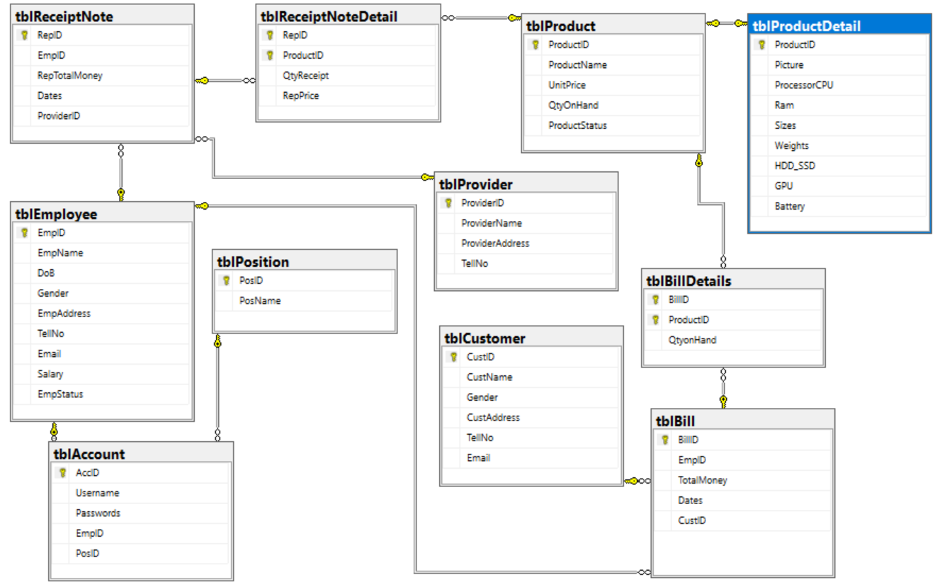

* 1. Tables
     1. Table Employee

This table will manage the code, name, birthday, gender, address, phone, Email, salary, status of the employee.

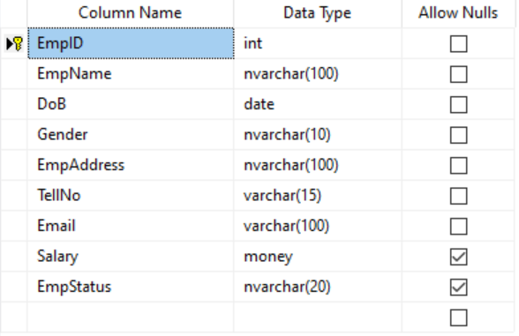

* + 1. Table Account

This table will manage code, user name , password, employee code and position code.

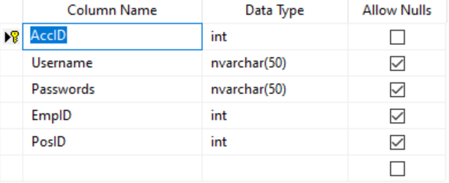

* + 1. Table Bill

This table will manage bill code, employee code, total money, date of bill and customer code.

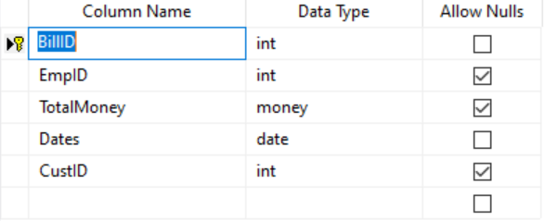

* + 1. Table BillDetail

This table will manage the bill code, product code and QtyonHand.

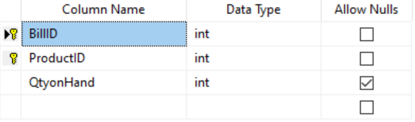

* + 1. Table Customers

This table will manage customer code, name, gender, address, phone and Email of customers.

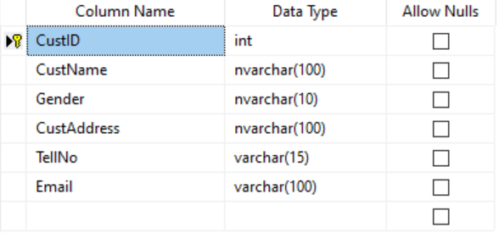

* + 1. Table Position

This table will manage Position code and name.

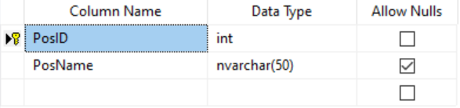

* + 1. Table Product

This table will manage product code, name, unit price, QtyonHand and status.

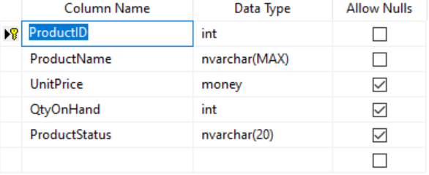

* + 1. Table ProductDetails

This table will manage product code, picture, processor CPU, ram, sizes, weigth, kind of memory, card GPU and battery of product.

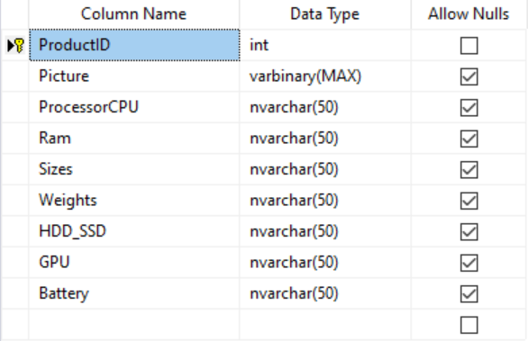

* + 1. Table Provider

This table will manage provider code, name, address and phone of provider.

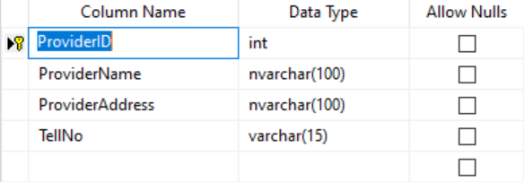

* + 1. Table Receipt Note

This table will manage receipt code, employee code, receipt total money, date and provider code.

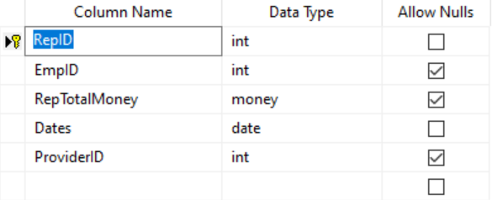

* + 1. Table Receipt Note Detail

This table will manage receipt code, product code, quantity on hand receipt and receipt price.

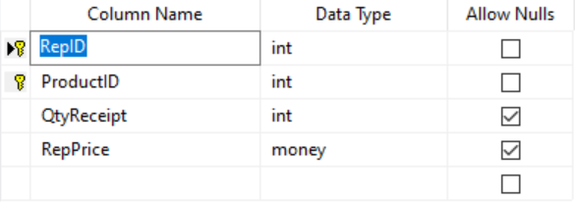

1. PROJECT PLANNING
   1. Task breakdown
      1. Inception Phase

The inception phase will define all the project's requirements. This phase will include the production of a vision document, a Project Plan, a Software Quality Assurance Plan, and a demonstration. Vision document will include the project's requirements and overview. It includes overview of the project, its purpose, goals, risks, constraints, and direction. It gives a listing of the main requirements and their respective Use case models to illustrate the functionality. Project Plan will detail the phases, iterations, and milestones that will comprise the project. It will include a timeline for the project for completing this project. It includes the Architecture Elaboration plan will define the activities and actions that must be accomplished before the Architecture Presentation.

Project plan describes the required documentation, standards and conventions test tracking and problem reporting, and tools used during the project. The plan will also identify the set of quality metrics used to assess product reliability. Demonstration of at least one executable prototype is required. Projects with a graphical user interface will include an executable prototype of the user interface. This phase will be complete once supervisory committee has approved all the above work.

* + 1. Elaboration Phase

The elaboration phase defines the project's architecture. This phase will include the production of revisions to the Project Plan and the vision document, an architecture design plan, a formal specification, test plan, formal technical inspection and architecture prototype. Revision of Vision document will be an updated version to provide a complete representation of all requirements. These requirements will be ranked according to importance, and a set of critical requirements identified. Appropriate changes that were suggested by the teacher and members at the end of phase one will also be updated in the updated version of vision document. Revision of project plan will include updated timline estimate for the project. It also includes the implementation plan which will define the activities and actions that must be accomplished during implementation.

1. GUI PROTOTYPE

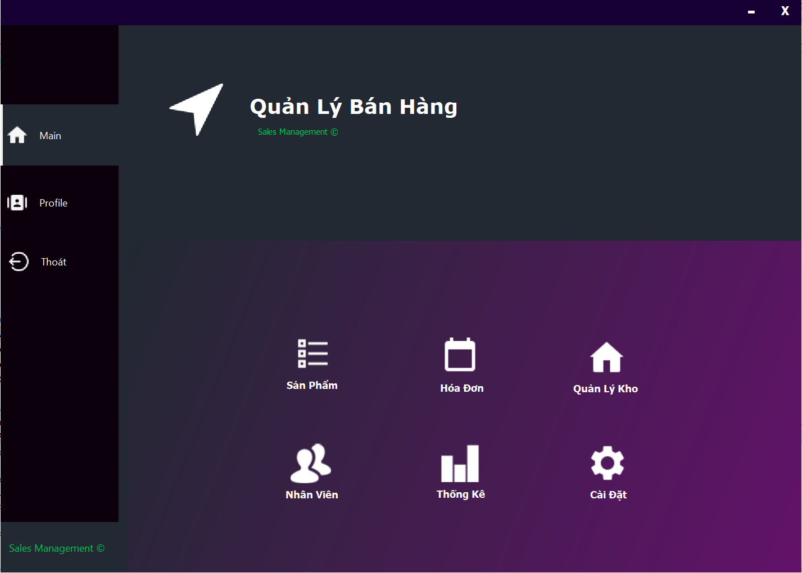

* The technical used to build the software:
* SQL
* JAVA

1. GUI OF LOG IN

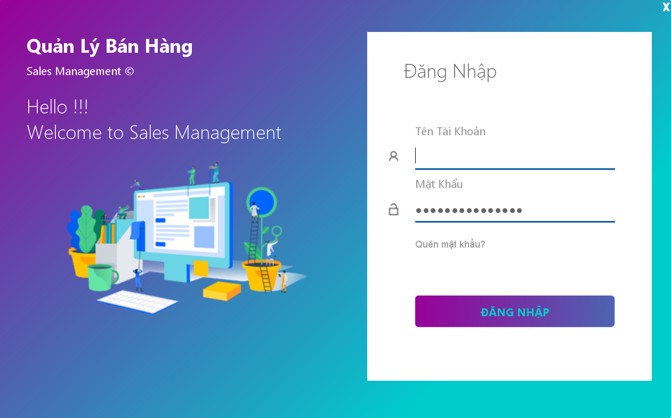

* If you forget your Password you can click here and reset your password

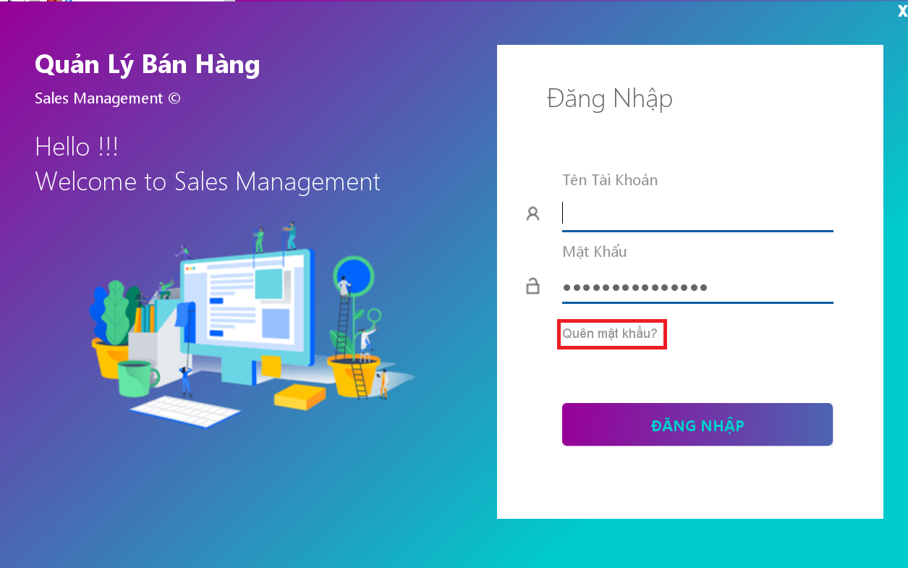

* A form will appear like this and fill your Email then we give you a link to reset your password

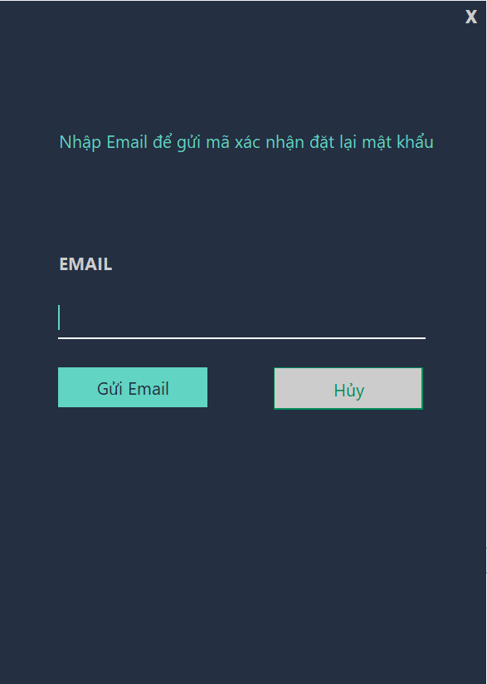

1. GUI MAIN FORM AFTER LOG IN

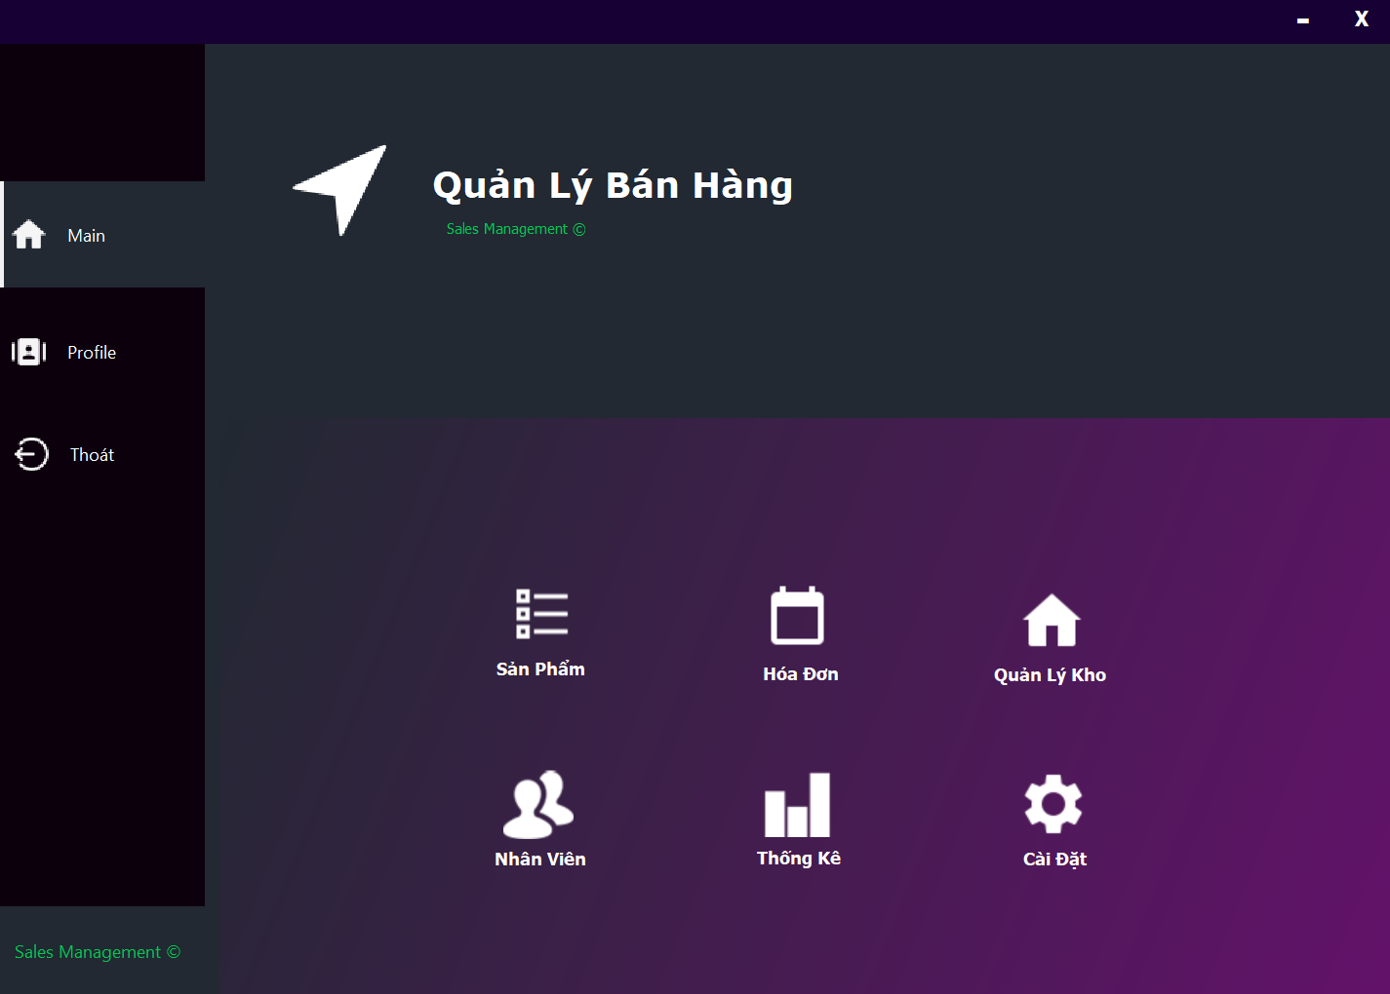

* Click Profile to see all information about you

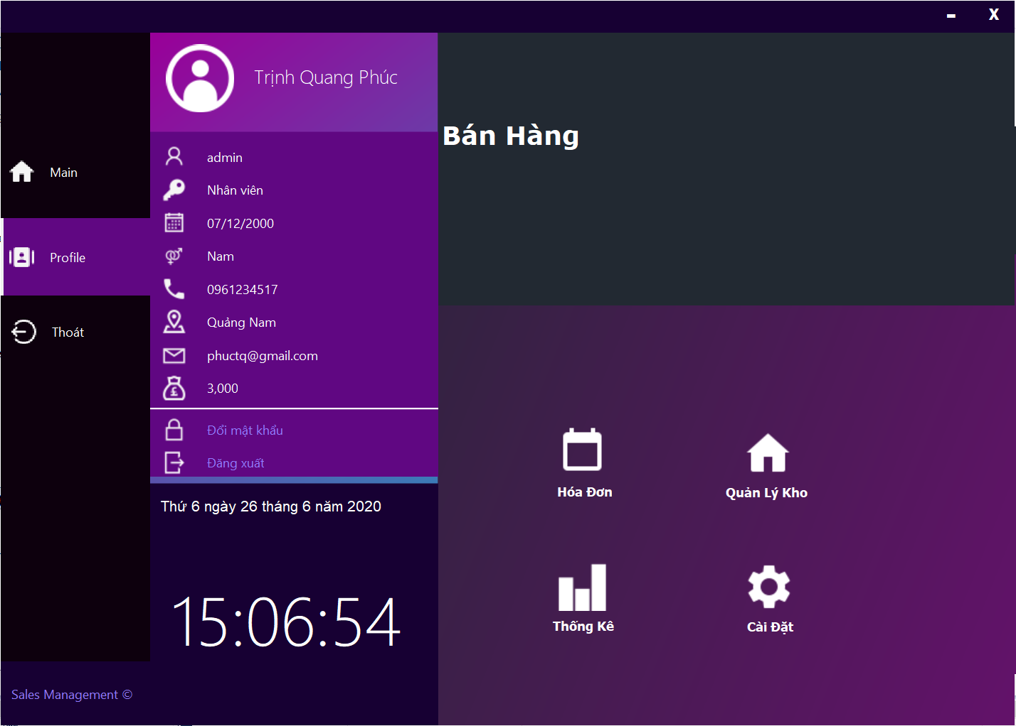

1. EMPLOYEE FORM

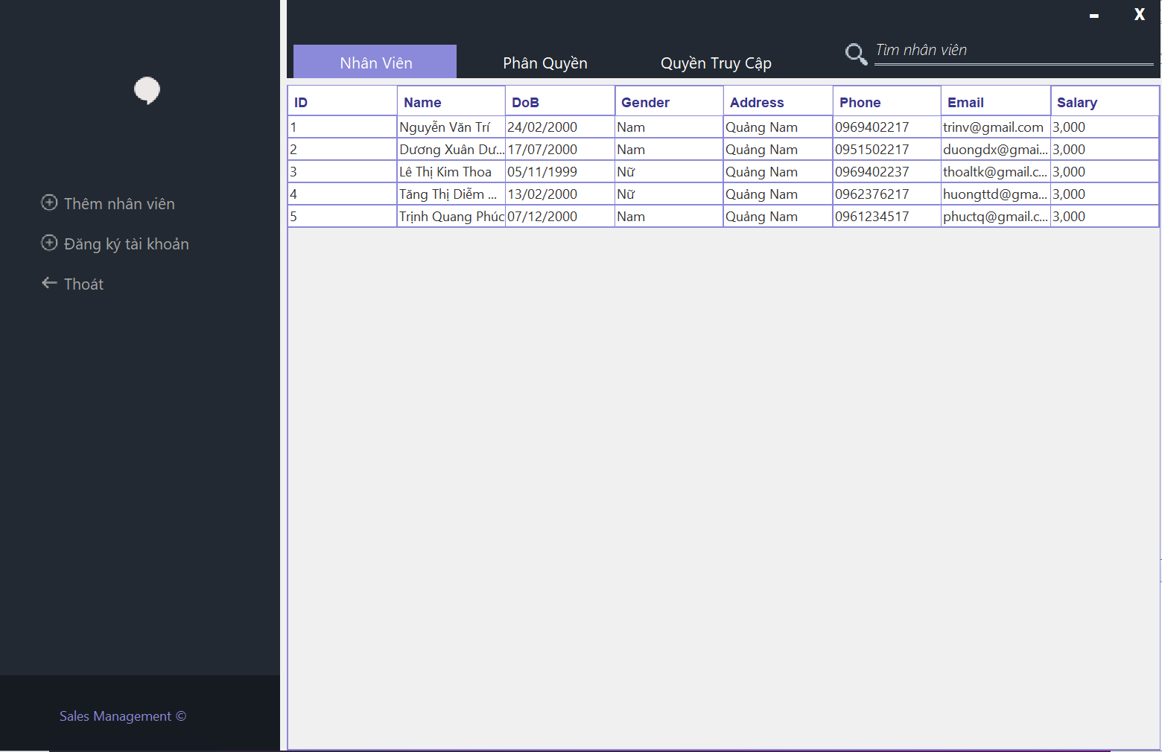

* In this form, you can see all information of employee. If you want to add a new employee, click “Thêm nhân viên” in the left of form, you also edit or delete employee if you right click on an employee in employee table

1. PRODUCT AND PRODUCT DETAIL FORM

* Both of two forms below display list of product or product detail and all information of each product or product detail. Administrator or employee can add, edit or delete in two forms.
  1. Product Form

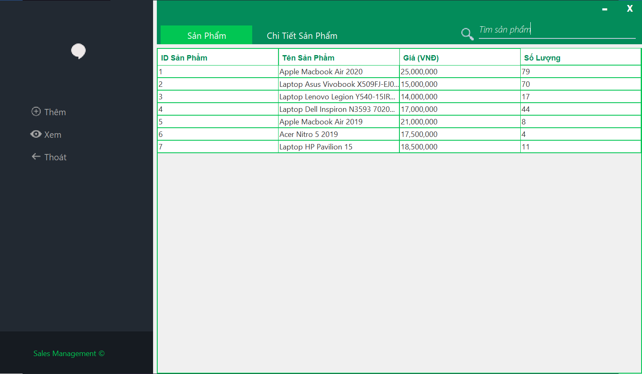

* 1. Product Detail Form

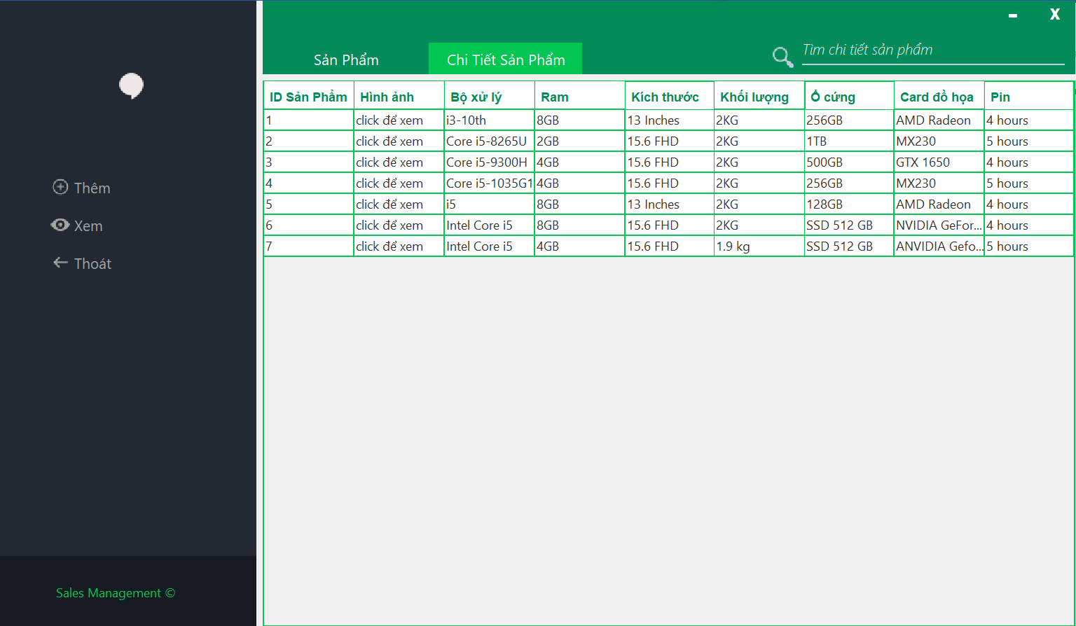

1. IMPORT BILL, IMPORT BILL DETAIL, PROVIDER FORM
   1. Import Bill Form

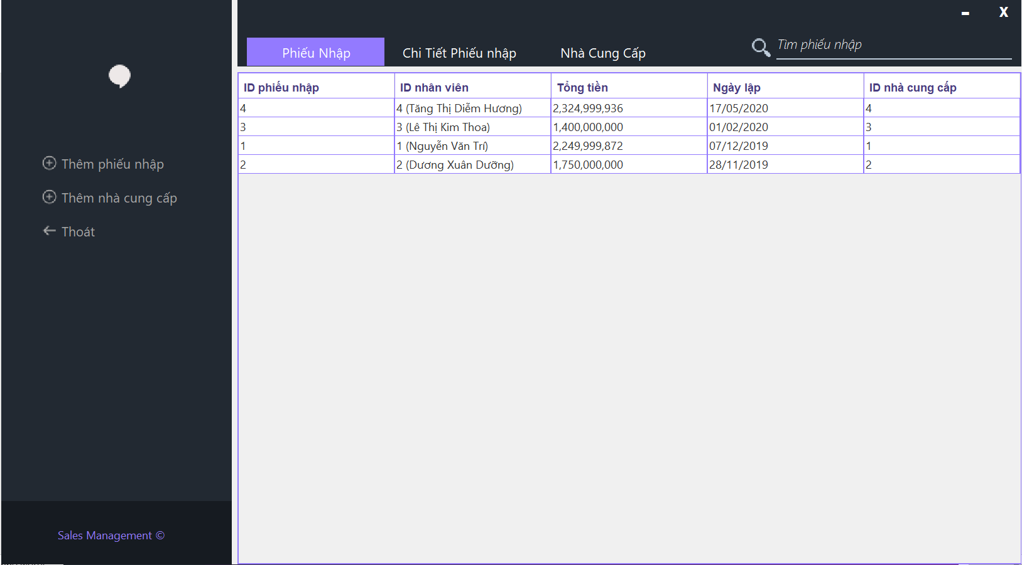

* 1. Add Import Bill Form

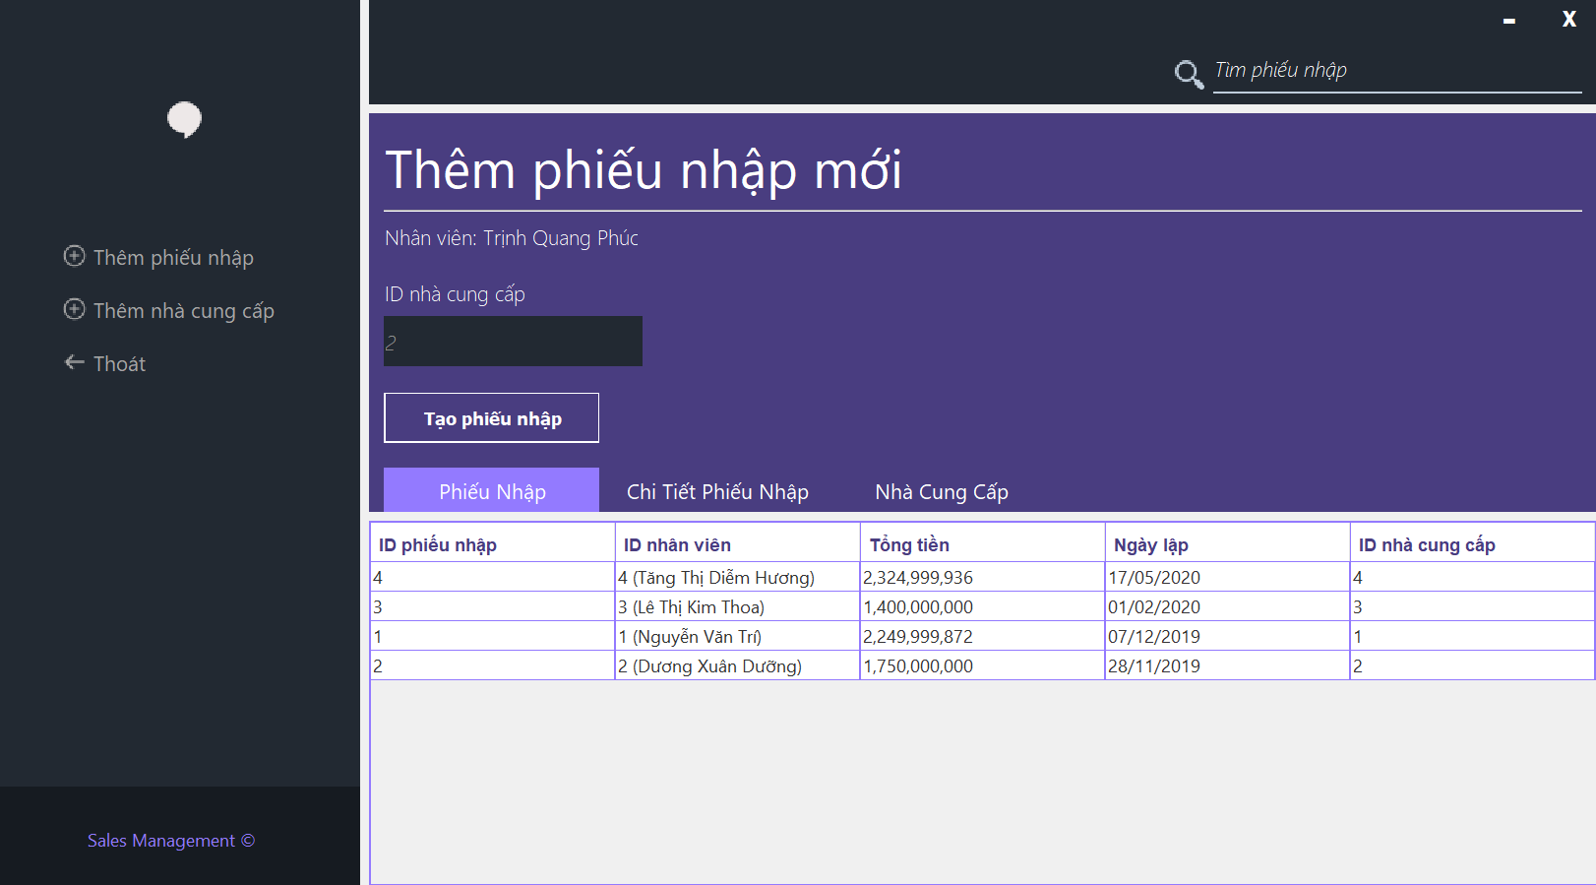

* Click in text box below “ID nhà cung cấp” to create a new Provider or use available Provider
* After fill provider code, right click at new row and click add new import bill

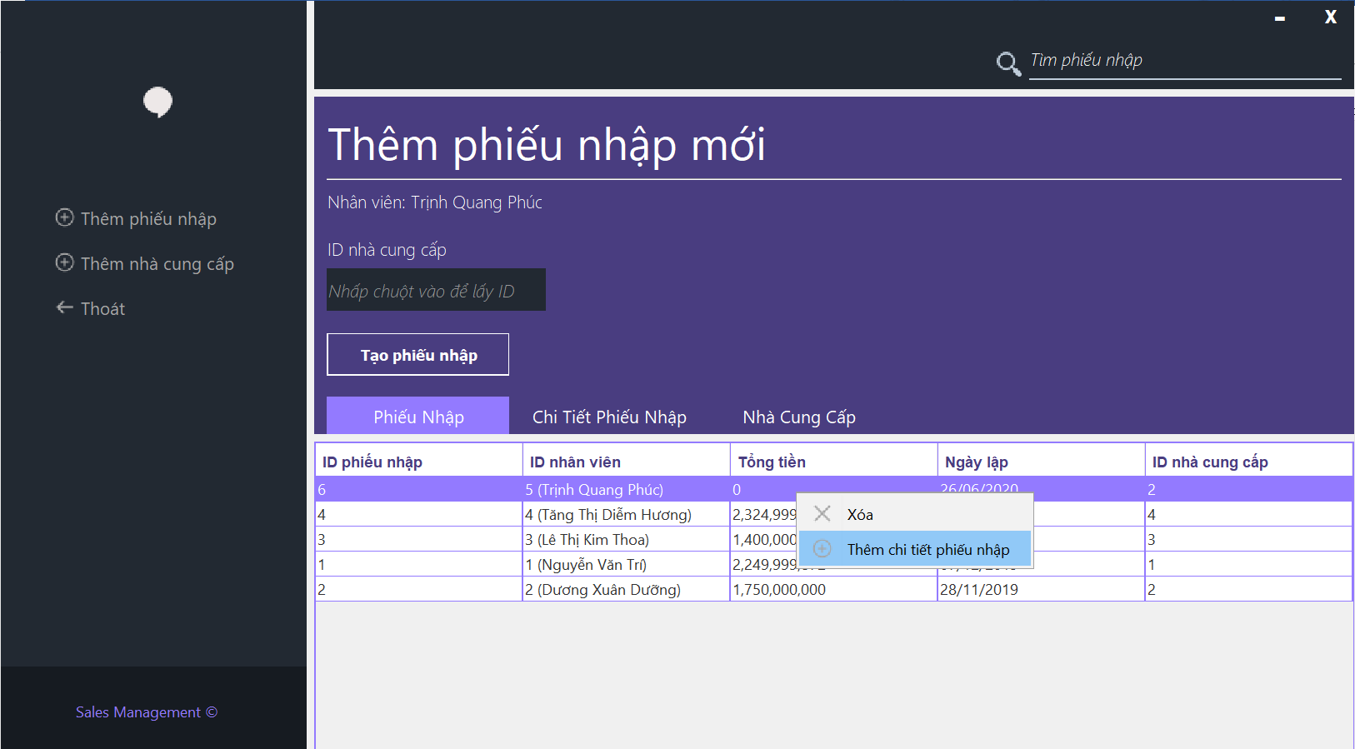

* Fill all information and click add to create a new import bill

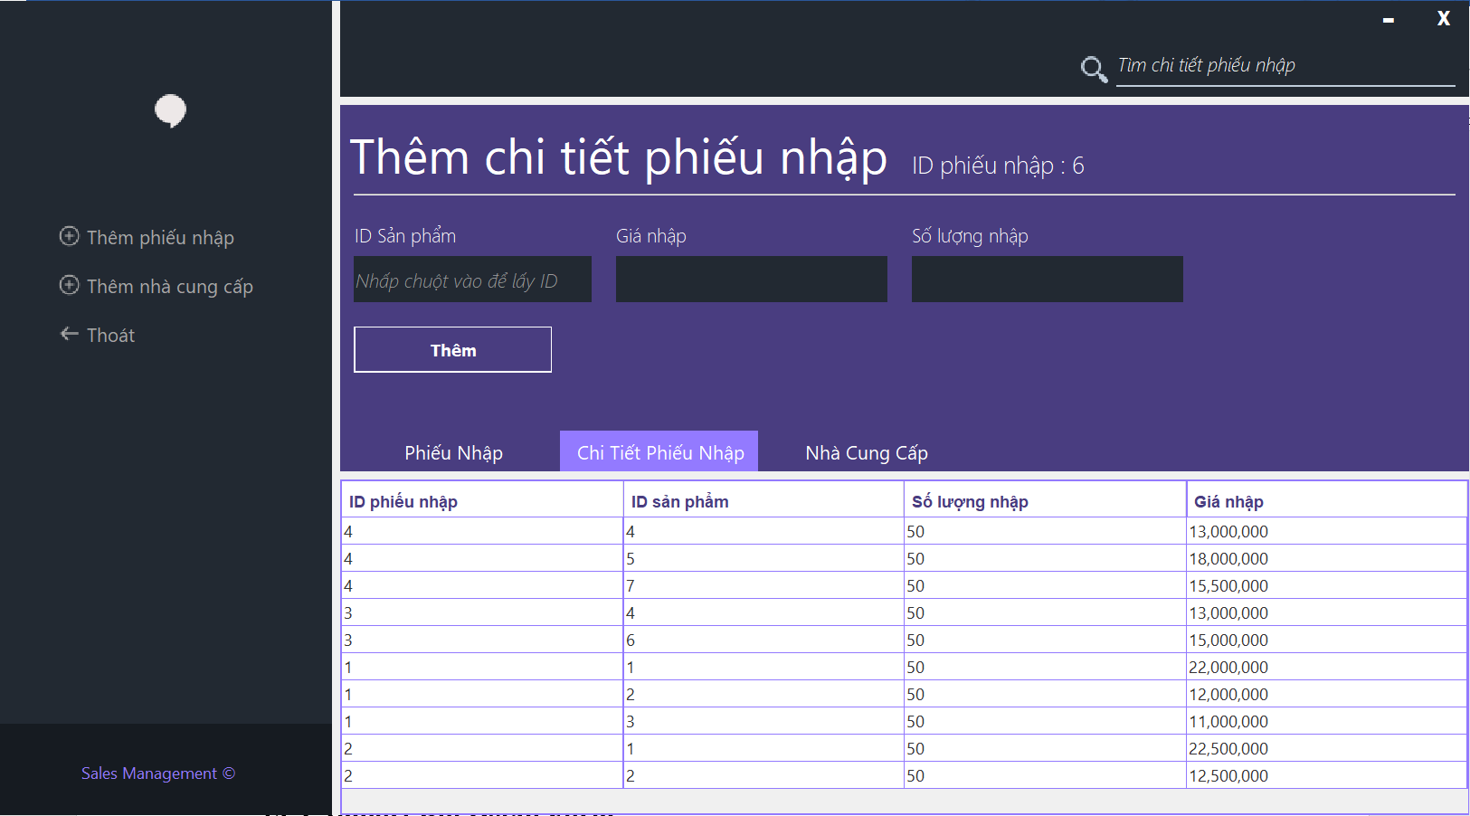

* 1. Import Bill Detail Form

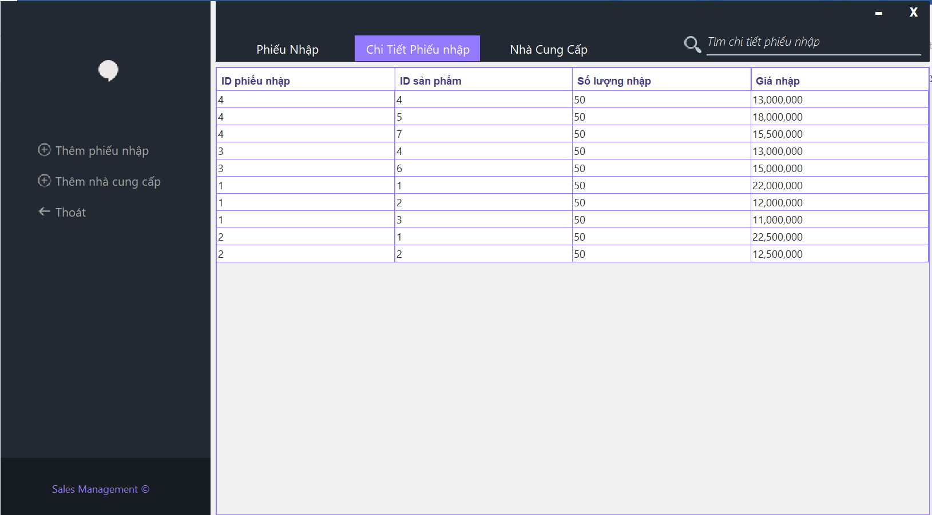

* You can edit or delete one by right click at any row
  1. Provider Form

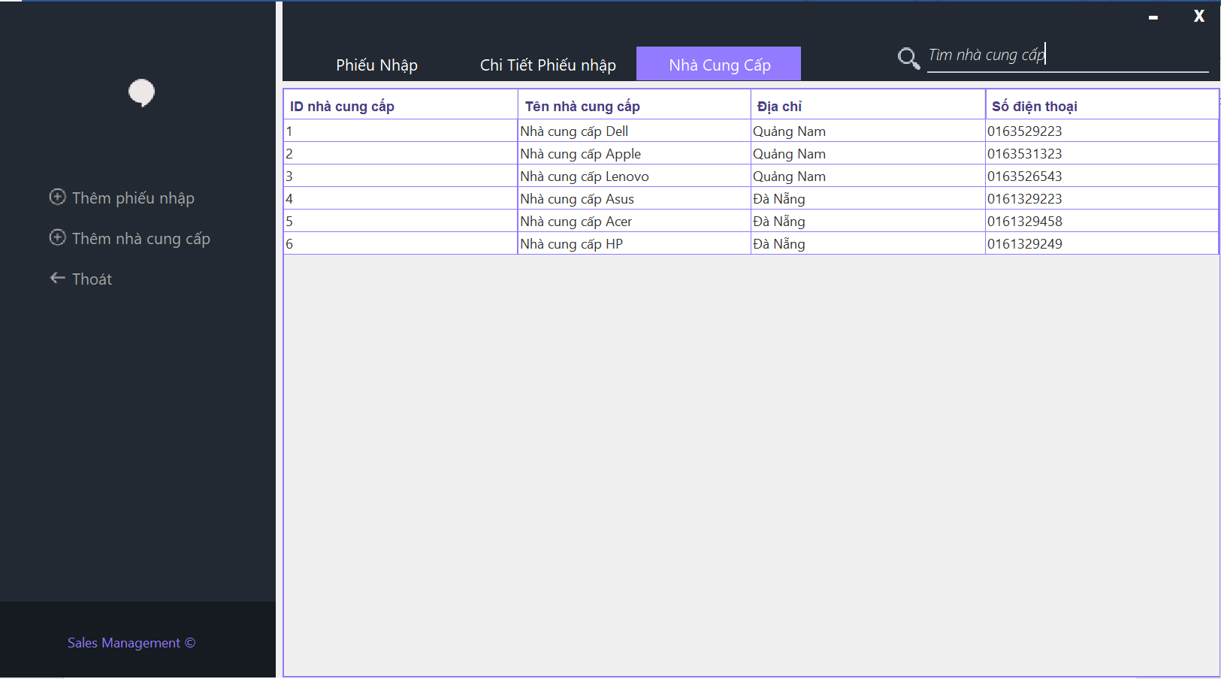

* 1. Add Provider Form
* After click “Thêm nhà cung cấp”, a form will appare like this, then fill all information and click “Thêm” to create a new Provider

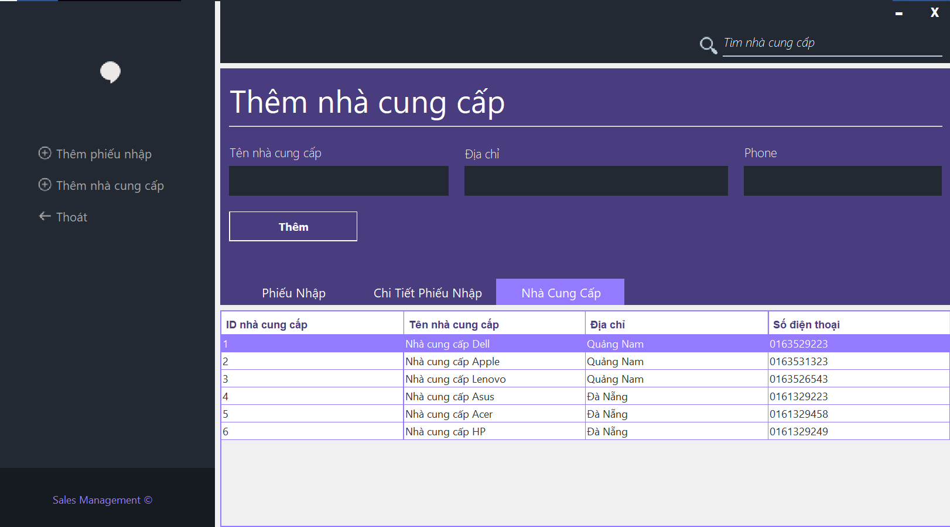

1. BILL, BILL DETAIL AND CUSTOMER FORM
   1. Bill Form

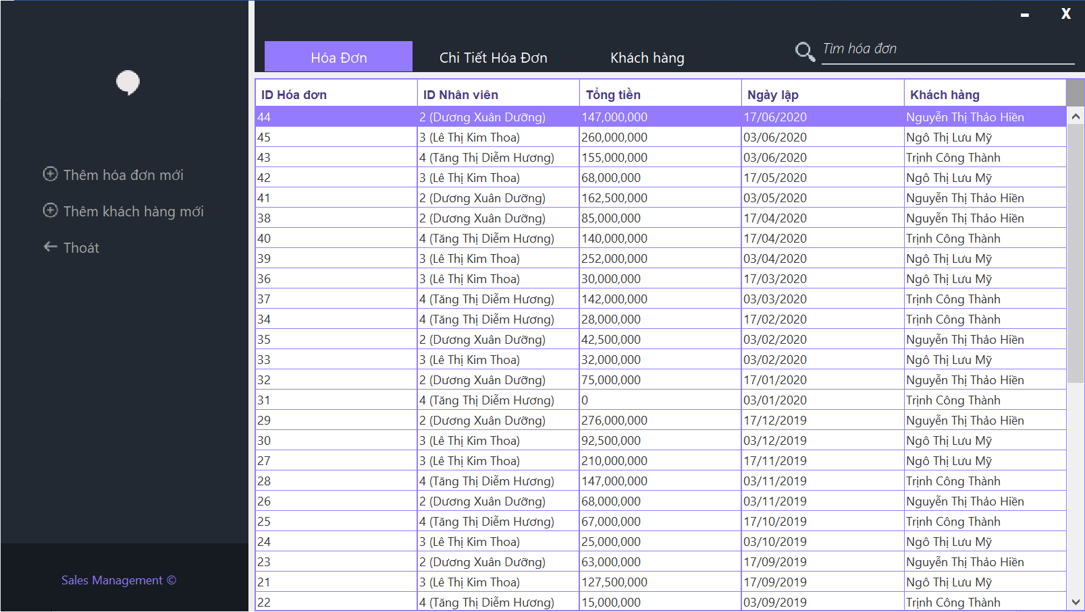

* 1. Add Bill Form
* Click “Thêm hóa đơn mới” and click in text box to create a new customer or get available customer

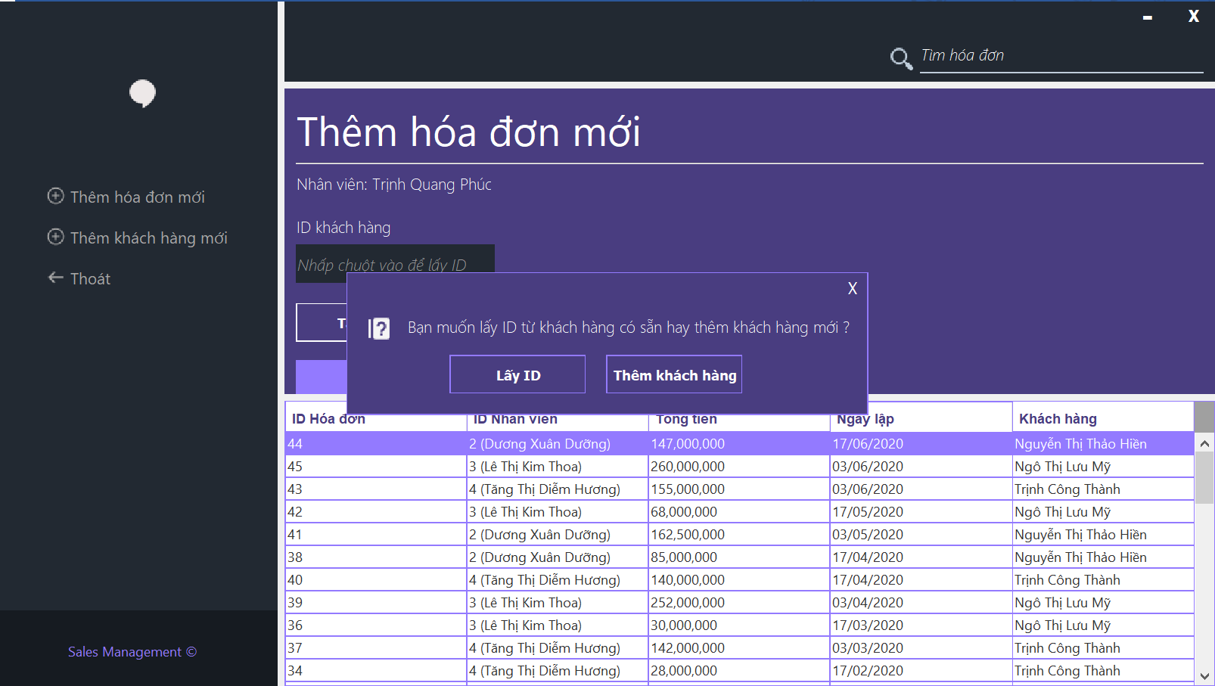

* After get or create customer, right click on new customer and click “thêm chi tiết hóa đơn” to create new bill

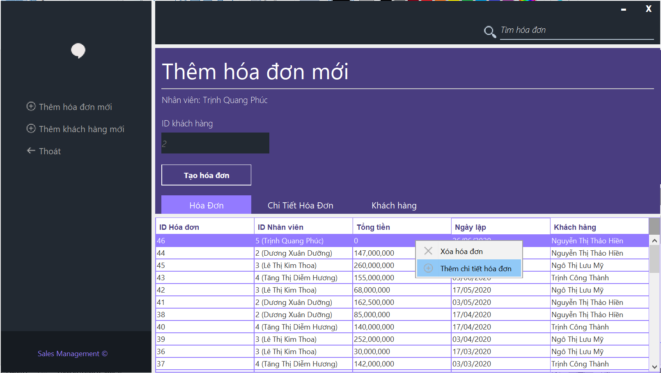

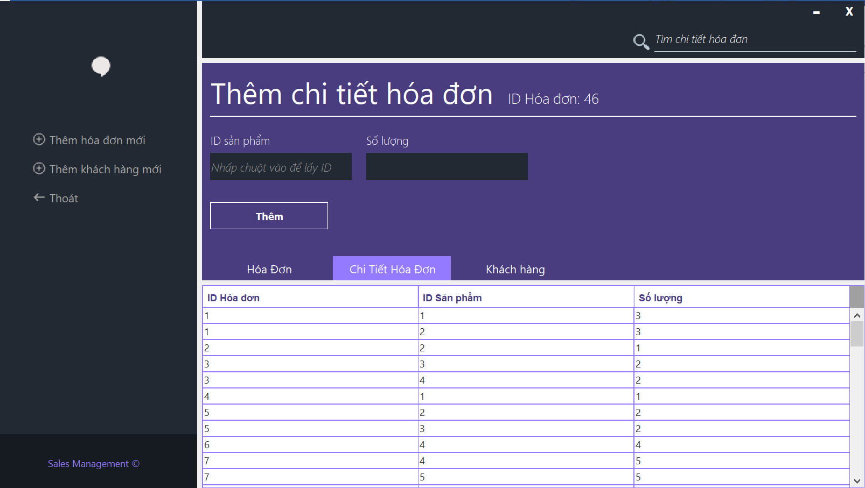

* 1. Customer Form

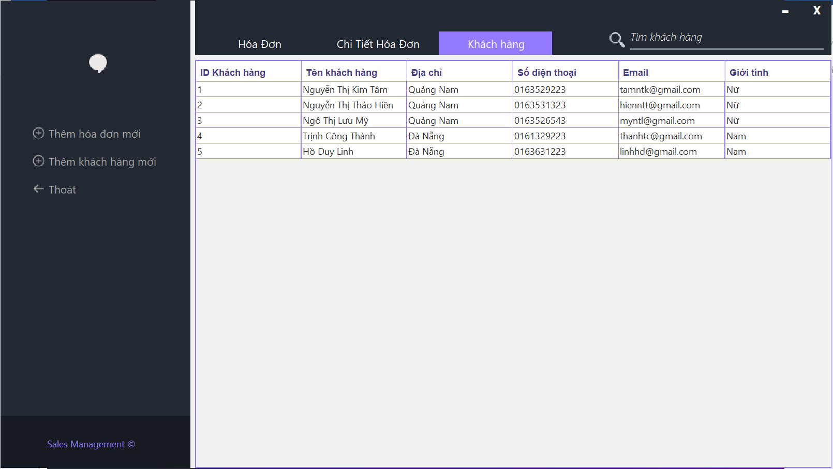

* In this form, you can edit customer by right click at row you want to edit
  1. Add Customer Form
* Click “Thêm khách hang mới” and a form appare like this, then fill all information and click “Thêm” to create a new customer

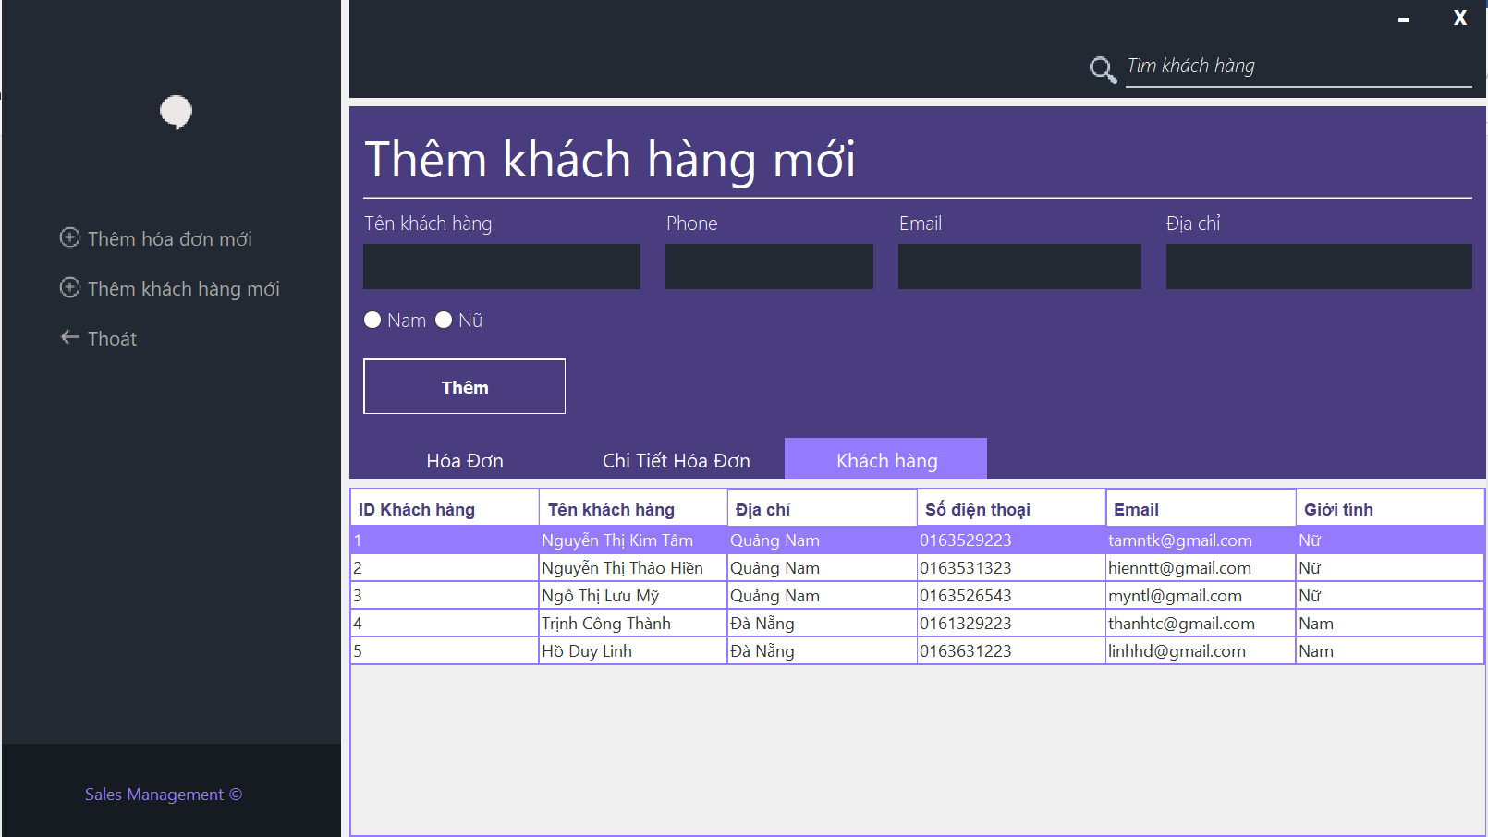

1. REVENUE STATISTICS, PRODUCT STATISTICS FORM
   1. Revenue Statistics Form

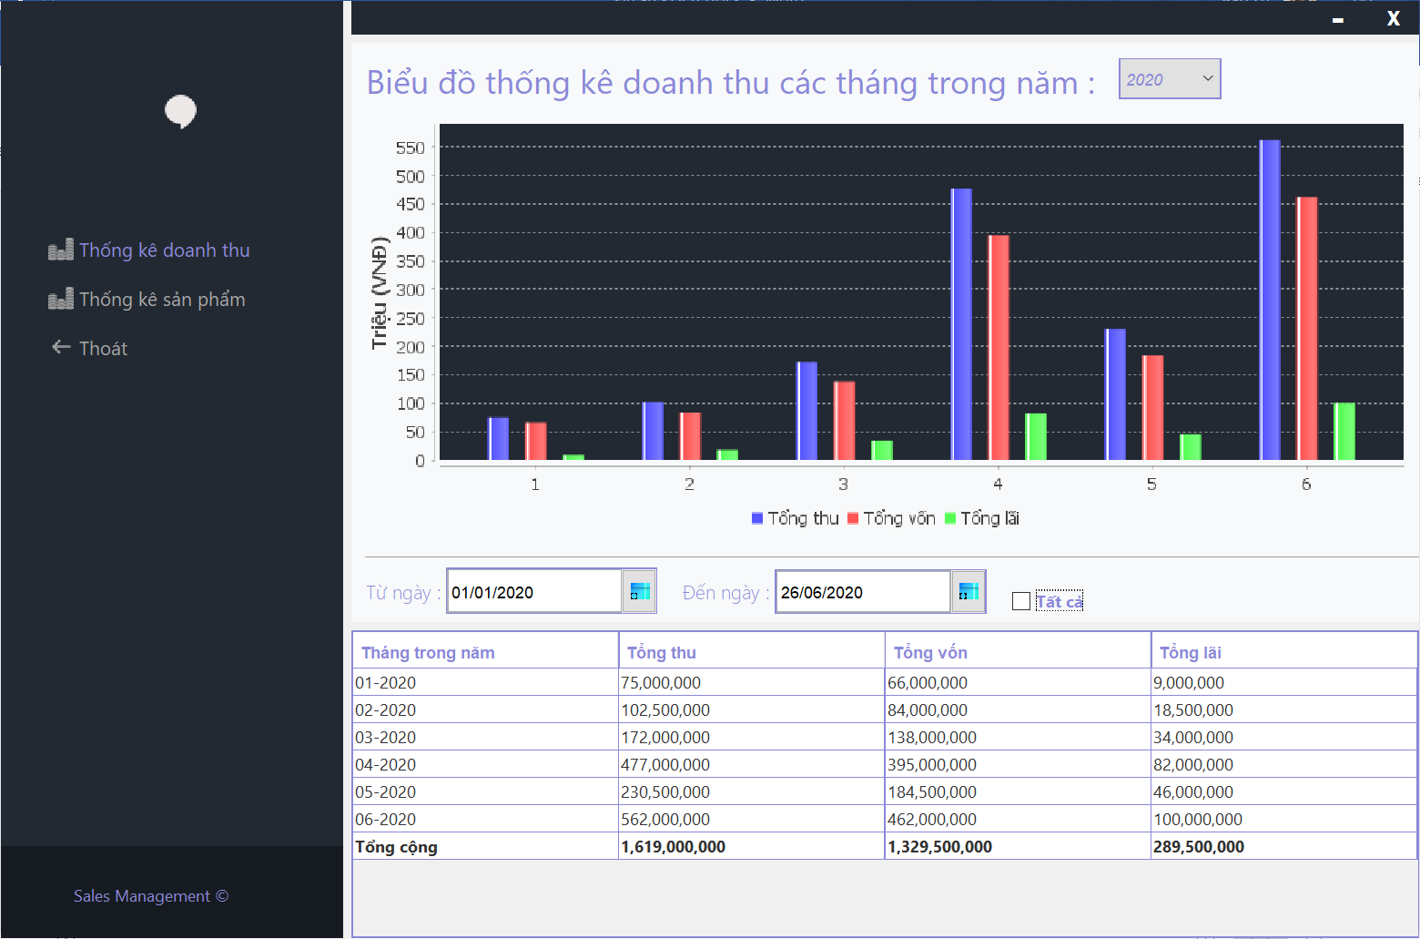

* In this form, you can see statistics of revenue in year you want or choose time of year to see in form below
  1. Product Statistics Form

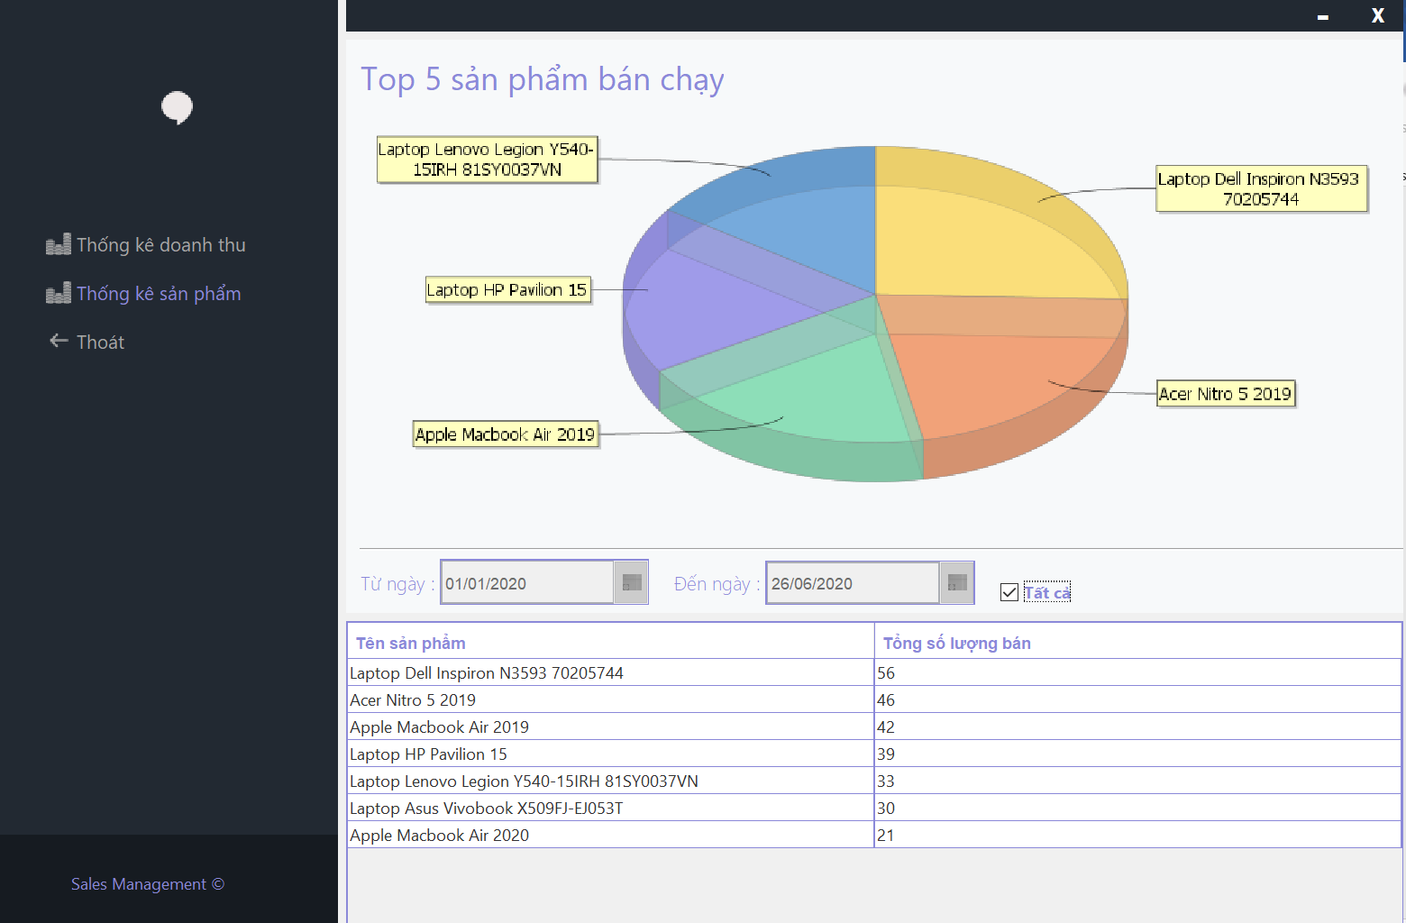

* This form will show you top 5 best selling products in time of year you choose or all the time