Step 1:

How to create Git Repo using GITHUB online portal.:

1. Login to github.com, create your account to get authenticate in the git hub.

Below is my login account in git hub.

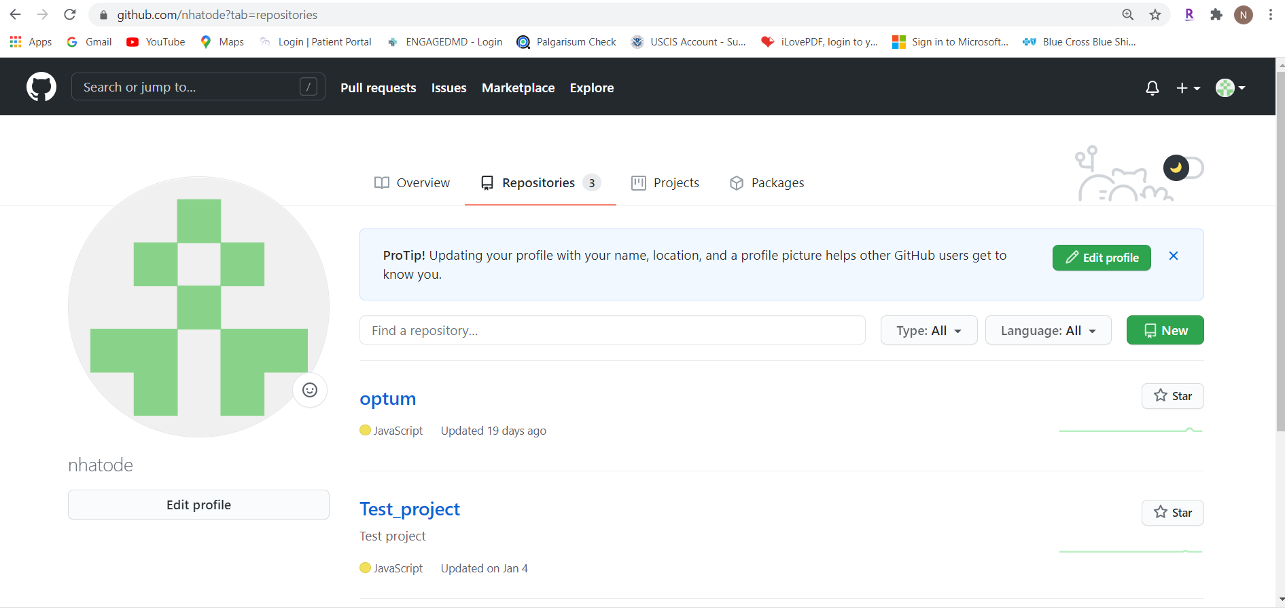



1. Create your own Repository (REPO) by clicking this button.

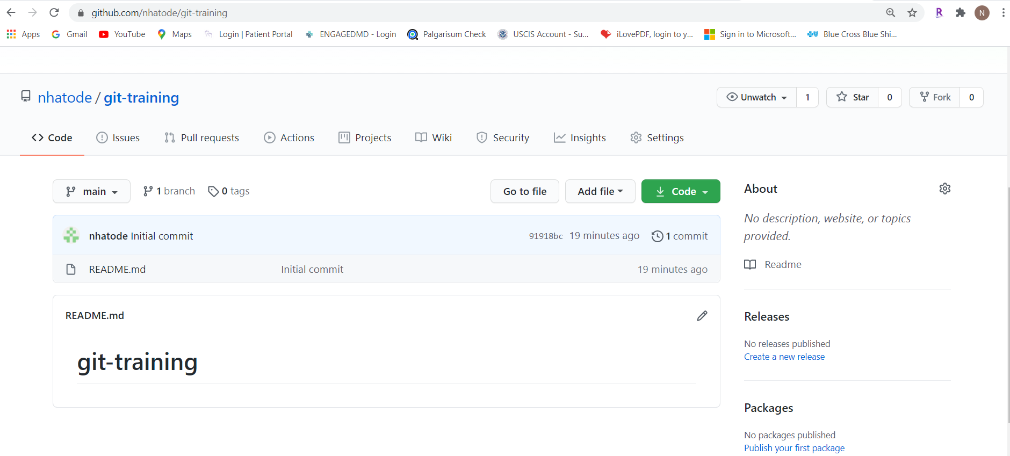

C) we have to clone this repo into our local machine. Click on the Code tab

Copy the link in SSH table like below:

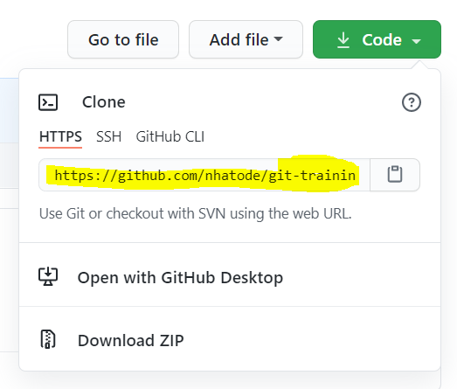

1. Go the command prompt from your windows or terminal from MacOS.

Type below command from command prompt

>> git clone <<Link from the github>> (Please refer below diagram)

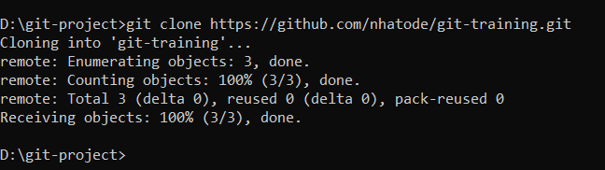

1. The repository will get cloned in your local machine

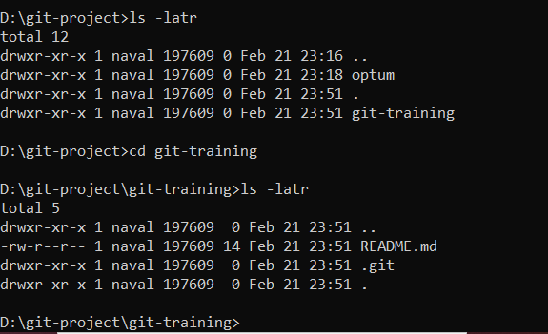

1. If you want to push the file to GitHub repo you need to do below steps: