TRẮC NGHIỆM

1. Which of following list is a valid type of Service Level Agreement (SLA) ?

* Service Level SLA
* Customer based SLA
* Multi-level SLA

1. ITIL directly maps / integrates which COBIT
2. CMM stand for

* Capability Maturity Model

1. Cobit stands for control objectives for information and related?

Cobit stands for:

* Control Objectives for Information and Related Technology

1. Role of ITIL within IT Service Management

* Maintain and improve IT service quality through a constant cycle of agreeing,monitoring, reporting and reviewing IT service achievement.

1. Who is a ‘Six Sigma Champion’ ?
2. Which of the following is a service desk activity?

* Support, contact with customer

1. What are models for quick change ?

* ODA: Obseve Decide Act ( tao cung deo biet dung hay sai nua ) ☺

1. Arrange she six sigma process improvement approach in the correct squence 1.measure,2.define,3.control,4.improve,5.analyze?

* Define🡪Measure🡪Analyze🡪Improve🡪Control

1. Risk management consist of….

* Identify the Risk
* Analyze the risk.
* Evaluate or Rank the Risk.
* Treat the Risk.
* Monitor and Review the risk.

1. What are the elements of Quality Management ?

* Ethics
* Integrity
* Trust
* Training
* Teamwork
* Leadership
* Recognition
* Communication

1. To achieve maturity level 5 of the CMMi ?

* Pass to level 4 ?

1. Which company in credited to propse “Six Sigma” model?

* Motorola

1. Quality tools can be used to ….
3. In which of the following stages are project objectives established, team formed, and major responsibilities assigned

* Defining

1. Which of the following is not a maturity level in CMM?

Các maturity level in CMM:

* Requirement management;
* Project planning;
* Project monitoring and control;
* Supplier agreement management;
* Measurement and analysis;
* Process and product quality assurance

1. Maturity level 3 of CMMi has……… KPAs ?

* 7 KPAs

1. Cobit makes user of the deming cycle this make up of Plan,Do,Check

* Action

1. Which of the following choices is not one of the stages of a project life cycle?

* Conceptualizing

1. The Work Planning Process area belongs to
2. In SMART-Q frame work what does the term ‘A’ denotes

* Aligned ( có thể đạt được bằng chính khả năng của mình)

1. Current Version of ISO 9001 ?

* ISO 9001:2000

1. Maturity level 4 of CMMI®has...Kpas

* Có 2KPAs,tổng=18KPAs cho 5 level

1. In CMMI, the life cycle activities of requirement analysis, design,code, & test are described in….

* Maturity Model

1. Which of following is not basic step of Six Sigma

Đây là các cái cơ bản, cái nào khác cái này là ko pải

* Define
* Measure
* Analyze
* Improve
* Control

1. In which stage of Six sigma – optimize KPOVs & Test the KPIVs, Redesign process, Visual Controls are associated?

* Improve

1. According to ISO 9001, the causes of nonconforming product should be?

* It’s not product standards.

1. The ITIL v3 core iss structured around?

* Service life cycle

1. What are different levels of Six Sigma?
2. IDEF 3 Process flow has 5 basic descripive building blocks are Activity, Unit of Behavior, Object State, State Transaction, …. ? Identify the fifth one ?

* Logic

1. What is defined as “The documentation of a process which records the tasks, the roles and the entities used”?

* Process modelling

1. Who is eligible to become the part of “ Six Sigma implementation “ team

* Implementer, Manager , Leader.

1. Which is the following are regarded as Dimension of Quality

* Process Quality, satisfaction level

1. A computer operator notices the full storage capicity of their disk will soon be used, to which ITIL must his situation be reported
2. Quality also can be looked at in terms of user satisfaction which includes

* a) A compliant product  
  b) Good quality output  
  c) Delivery within budget and schedule  
  d) All of the mentioned

🡪 D

1. In COBIT, which of the following is concerned with “Protection of sensitive information from unauthorized disclosure”?

* Confidentiality

1. Services are a means of delivering value to customer by facilitating the outcomes customers want to achieve without the ownership of specific cost and risks “ with entity owns the risk “?
2. Combit present the governance cube the three main areas this and risk.which entity owns the risks
3. A professional organization for project manament specialist in the…
4. The IDEAL model consists of five phases

* Initiating
* Diagnosing
* Establishing
* Acting
* Learning

1. Statement A: An ISO 9001 system can be implemented for the internal benefits, as an organization can benefit from the system without being certified (self-declared)

Statement B: ISO 9001:2008 is the latest, improved version and the only standard in the ISO 9000 family which can be used for certification

* All true

1. Which of the following iso standard fives the requirements for what the organization must do to manage processes affecting quality of its products and services ?

* ISO 9001.

1. Intergration of all project process and practices to improve project management is due to?

* Centralization

1. Which of following ISO Standard is concerned with quality management system

* ISO 9001

1. Which of the following company proposed ETVX model
2. Number of errors found per person hours expended is an example of a ……metrics……………..
3. According to IDEF0 model components, which one is not required for every activity ?

* CONTROL, MECHANISM , INPUT , OUTPUT ngoai may cai nay la sai

1. Six Sigma can best be define as?

* A customer-focused problem solving methodology used exclusively within the manufacturing sector

1. Which of following constraints is not typically found managing project

* People

1. CMMI is the acronym for….

* Capability Maturity Model Integration

1. What are process change stages?

* Mesure 🡪 Analyse 🡪 Change

2. What are the elements of the SMART-Q framwork ?

* Specific , Measured , Aligned , Realistic, Timeframe , Quality .

1. Total quality management is a common term applied to a quality management system.total quality management is

* The continual process of detecting and reducing or eliminating errors in manufacturing
* ý 2:  an extensive and **structured organization management approach** that focuses on **continuous quality improvement** of products and services by using **continuous feedback**

1. What’re the benefit of ISO 9000 verification

* “Regulared products” health, safety and the invironment.

1. Information Criteria is Effectiveness Efficiency, Confidentiality, Integrity, Availability, Comphiance and ……

* Reliability of Information

1. Who has the primary responsibility of setting the quality culture in the organization.

* Senior managerment

70. Which of the following terminology is regarded as “ making the change requirement “ ?

- Refreezing model

71/what are the ISO 9000 services of quality management standards

72. Maturity lv5 of CMMI® has ____ KPAs

2

74. Maturity Level 5 of CMMI has … KPAs

3 KPAs

75/ According to ISO 9001, inspection and testing comes under which management responsibility?

Process Control

76/ Which of the following model is regarded as upgrade to ODA model by checking the results against a plan?

Shewhart Cycle (Deming)

77/which is regarded as.A quantitative measure of dergree to which a system,component or process a give a attribute

-> A Metric

78.in CMMI®, the name of Maturity lv5 is_______

80. Quality Assurance methods are usually considered

* a) detective  
  b) corrective  
  c) preventive  
  d) proactive

🡪 C

81/ The management of ABC Inc, has insisted that each request for a new work station installation be handled with optimum efficiency and effectiveness. Which ITIL process is designed to achieve this desired out come?

Service Operation

82/ What kind of quality cost is incurred when an error is detected in a product prior to shipment?

Appraisal Costs

83/which question is being answered when an organization specifies its vision and business objectives

->where do we want to be?

84.which stage of ideal model is concerned with determining where you are relative to where you went to be.

86. Process Attributes are …

* Process Attributes are captured in a tool in order to organise, analyse and manage an organisation’s portfolio of processes

87/ Which is the domain of COBIT is concerned with “Actual delivery of required services, which range from traditional operational over security and continuity aspects to training”?

Delivery & Support

88. From a worker perspective, work processes are important to ?

89/inspections and testing are what kinds of quality costs

->Appraisal

->Explanation: Inspections, equipment calibration, maintenance and testing appraisal costs is quality management.

90.Maturing lv2 of has ….. KPAs.

6

92. ISO 9001 is not concerned with ___ of quality records

* a) collection  
  b) maintenance  
  c) verification  
  d) dis-positioning

🡪 C

93/ Which ITIL process uses Mean Time Between Failures (MTBF)

Service Design

94 Basic process of managing organizational change ?

CMMi

95/complete the following vision+skill+….+ resoures+Action=slow change

🡪incentives

CHÚ Ý THÊM

2. ____ models are graphical representations of functions and processes?

3/ ……Improvement plan….. is regarded as Assessing the current situation, determine the priorities based on stategy and best practices and developing a plan to close gap?

4 .------COBIT-------- model is regarded as the highest level of IT govermance

6. There are ______ number standard in ISO

8. Cobit uses ___ appoach for Quality Management and Effective process Management

PDCA

9/ Complete the formula: D*V*..F…> R  
10------PDCA-------- type of process is required for larg system managerment

FULL FORMS

2. DMAIC = Define , Measure , Analyze , Improve , Control

3/ SPI = Software Process Improvement

4. IDEAL: 'International Digital Electronic Access Library'

5/CMMI= Capability Maturity Model Integration

6. PDCA= Plan - Do - Check – Act

# 8. CoBit = Control Objectives for Information and Related Technology

9/ SDLC = Software Development Life Cycle

10 COQ: Cost of Quality

TRUE / FALSE

2. SPM involves proactive management of the investment across the service lifecycle, including those services in the concept, design and transaction pipeline, as well as live services defined in various service catalogues and retired services

3/ Service Transition is not regarded as central component of ITIL? False

4. Software process improvement is concerned with practical action to improve the processes in the organization to ensure that they meet business goals efficiently and effectively ? True

5/the highest belt of six sigma is”Green Belt” False

6. Indirect Measurement of an attribute is measurement which involes the measurement of one or more attribute.

8. Service utility is concerned with that the customer gets in terms of out comes supported and constraints removed ?

9/ ISO Standards were established in the year 2009? False

10/software process ,software product abd software Engineering are all connected to data collection metrics computation and metrics Evaluation?True

TỰ LUẬN

3/ Explain reasons Why organization need to change?

* Crisis
* Performance Gaps
* New Technology
* Identification of Opportunities
* Reaction to Internal & External Pressure
* Mergers & Acquisitions
* Change for the Sake of Change

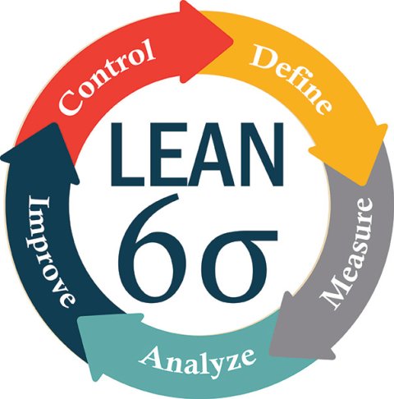

* Sounds Good
* Planned Abandonment

Vẽ mô hình Six Sigma / IDEF 3

Mô hình Six Sigma

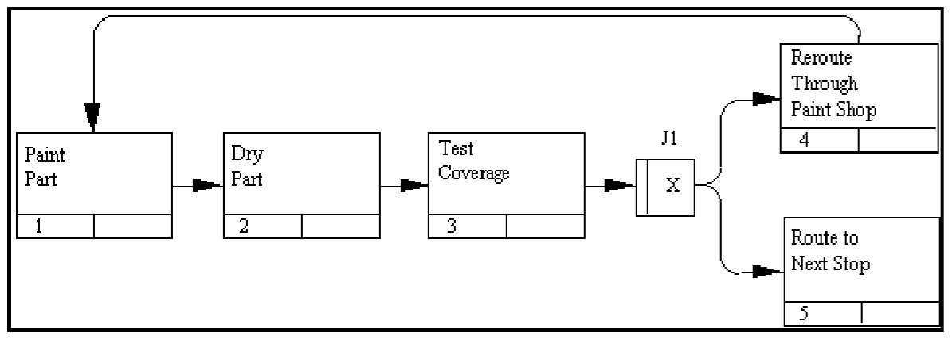

Mô hình IDEF 3