**ĐẠI HỌC BÁCH KHOA HÀ NỘI  
TRƯỜNG CÔNG NGHỆ THÔNG TIN VÀ TRUYỀN THÔNG**

----- 🙡 🕮 🙣 -----



BÁO CÁO THỰC HÀNH  
IT3103 – 744529 - 2024.1

BÀI THỰC HÀNH 4

Họ và tên sinh viên: Đoàn Nhật Quang

MSSV: 20225911

Lớp: Việt Nhật 05 – K67

GVHD: Lê Thị Hoa

HTGD: Bùi Trọng Dũng

Hà Nội 12/2024

# BÁO CÁO THỰC HÀNH LAB 4

# LẬP TRÌNH HƯỚNG ĐỐI TƯỢNG

Mục lục nội dung

1. Create the Book class 6

2. Creating the abstract Media class 8

3. Creating the CompactDisc class 11

3.1. Create the Disc class extending the Media class 11

3.2. Create the Track class 13

3.3. Open the CompactDisc class 14

4. Create the Playable interface 15

5. Update the Cart class to work with Media 17

6. Update the Store class to work with Media 19

7. Constructors of whole classes and parent classes 20

8. Unique item in a list 21

9. Polymorphism with toString() method 21

10. Sort media in the cart 23

11. Create a complete console application in the Aims class 25

11.1. View store 26

11.1.1. See a media’s details 27

11.1.2. Add a media to cart 27

11.1.3. Play a media 28

11.1.4. See current cart 28

11.2. Update store 29

11.2.1. Add a media 29

11.2.2. Remove a media 29

11.3. See current cart 30

11.3.1. Filter medias in cart 30

11.3.2. Sort medias in cart 31

11.3.3. Remove media from cart 32

11.3.4. Play a media 33

11.3.5. Place order 34

12. Class Diagram 35

13. UseCase Diagram 36

Mục lục hình ảnh

Hình 1: Book Class 1 6

Hình 2: Book Class 2 7

Hình 3: Media Class 1 8

Hình 4: Media Class 2 9

Hình 5: Book Class extends Media 9

Hình 6: DigitalVideoDisc Class extends Media 1 10

Hình 7: DigitalVideoDisc Class extends Media 2 10

Hình 8: Disc Class 11

Hình 9: DigitalVideoDisc Class extends Disc 12

Hình 10: CompactDisc Class extends Disc 12

Hình 11: Track Class 13

Hình 12: CompactDisc Class using Track 14

Hình 13: Method getLength of CompactDisc 14

Hình 14: Playable interface 15

Hình 15: Implement the Playable with CompactDisc 15

Hình 16: Implement the Playable with DigitalVideoDisc 15

Hình 17: Implement the Playable with Track 15

Hình 18: Implement play() for DigitalVideoDisc 16

Hình 19: Implement play() for Track 16

Hình 20: Implement play() for CompactDisc 16

Hình 21: Update the Cart class to work with Media 1 17

Hình 22: Update the Cart class to work with Media 2 18

Hình 23: Update the Store class to work with Media 19

Hình 24: Constructor of Track 20

Hình 25: Constructor of CompactDisc 20

Hình 26: Constructor of Media 20

Hình 27: Constructor of Disc 20

Hình 28: Override equals in Media class 21

Hình 29: Override equals in Track class 21

Hình 30: Override toString in Media Class 21

Hình 31: Sample code for Polymorphism 22

Hình 32: Result of Polymorphism 22

Hình 33: Media Comparator by title-cost 23

Hình 34: Media Comparator by cost-title 23

Hình 35: Add two Comparators to Media 23

Hình 36: Sample code for Sorting media in cart 24

Hình 37: Result of sorting 25

Hình 38: Main menu 25

Hình 39: View store menu 26

Hình 40: See a media’s details 27

Hình 41: Add a media to cart 27

Hình 42: Play a media 28

Hình 43: See current cart 28

Hình 44: Update store menu 29

Hình 45: Add a media 29

Hình 46: Remove a media 29

Hình 47: See current cart 30

Hình 48: Filter by ID 30

Hình 49: Filter by title 31

Hình 50: Sort by title 31

Hình 51: Sort by cost 32

Hình 52: Remove media from cart 32

Hình 53: Result of remove media from cart 33

Hình 54: Play a media 33

Hình 55: Place order 34

Hình 56: Result of Place order 34

Hình 57: Class Diagram 35

Hình 58: UseCase Diagram 36

# Create the Book class

Hình : Book Class 1

Hình : Book Class 2

# Creating the abstract Media class

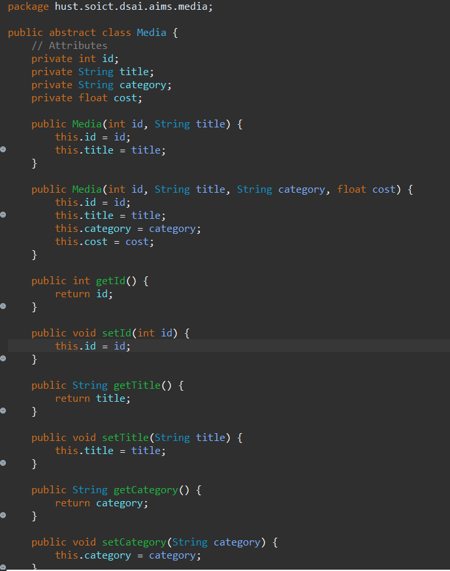

Hình : Media Class 1

Hình : Media Class 2

Hình : Book Class extends Media

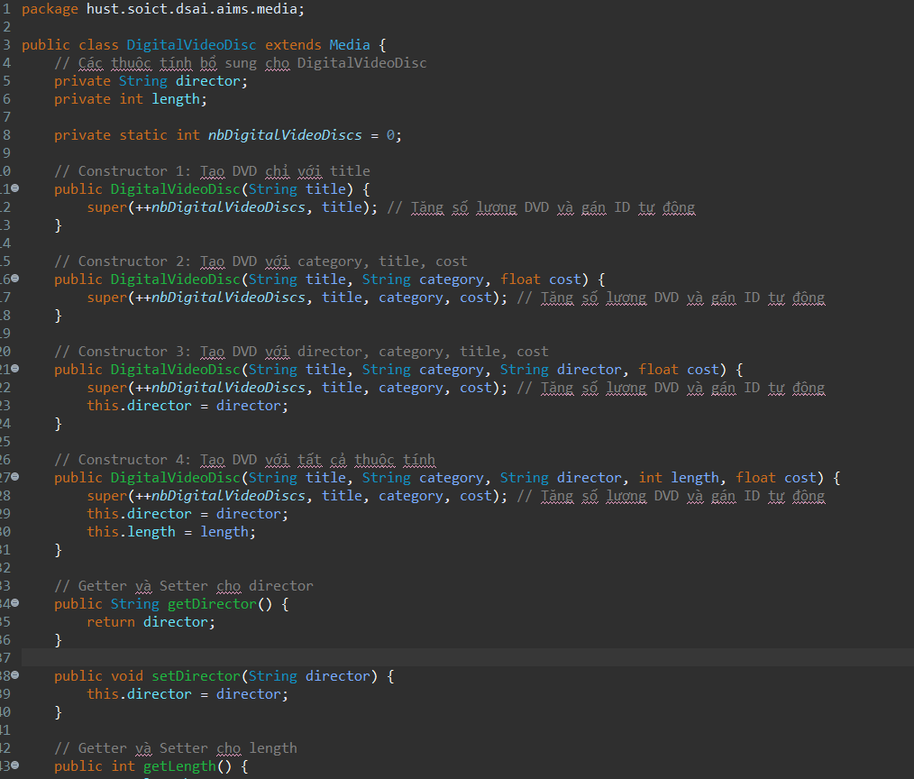

Hình : DigitalVideoDisc Class extends Media 1

Hình : DigitalVideoDisc Class extends Media 2

# Creating the CompactDisc class

## Create the Disc class extending the Media class

Hình : Disc Class

Hình : DigitalVideoDisc Class extends Disc

Hình : CompactDisc Class extends Disc

## Create the Track class

Hình : Track Class

## Open the CompactDisc class

Hình : CompactDisc Class using Track

Hình : Method getLength of CompactDisc

# Create the Playable interface

Hình : Playable interface

Hình : Implement the Playable with CompactDisc

Hình : Implement the Playable with DigitalVideoDisc

Hình : Implement the Playable with Track

Hình : Implement play() for DigitalVideoDisc

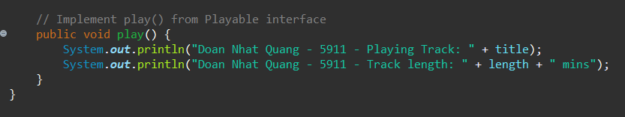

Hình : Implement play() for Track

Hình : Implement play() for CompactDisc

# Update the Cart class to work with Media

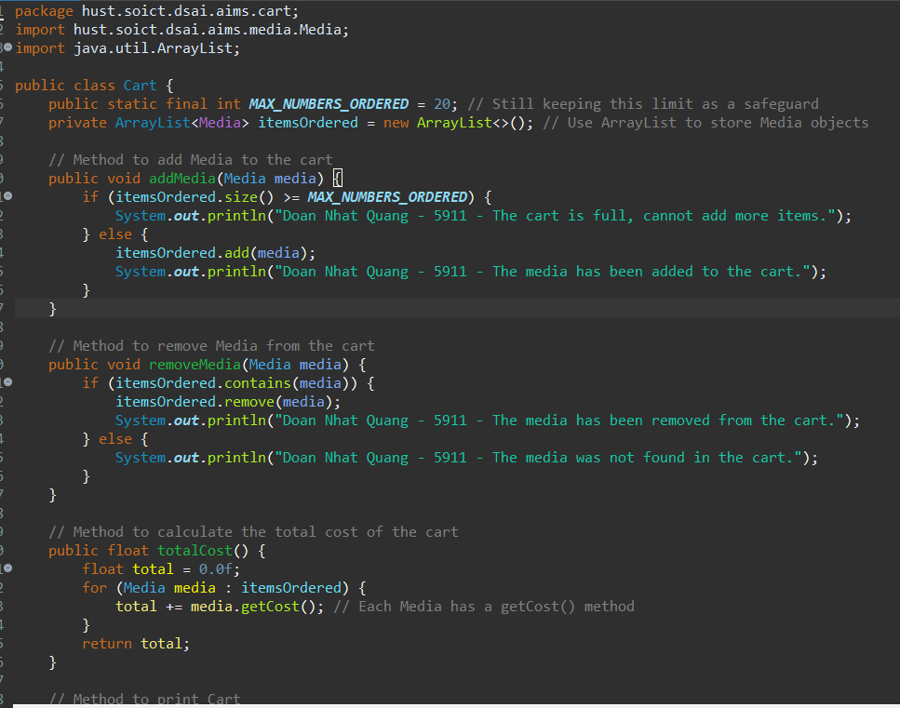

Hình : Update the Cart class to work with Media 1

Hình : Update the Cart class to work with Media 2

# Update the Store class to work with Media

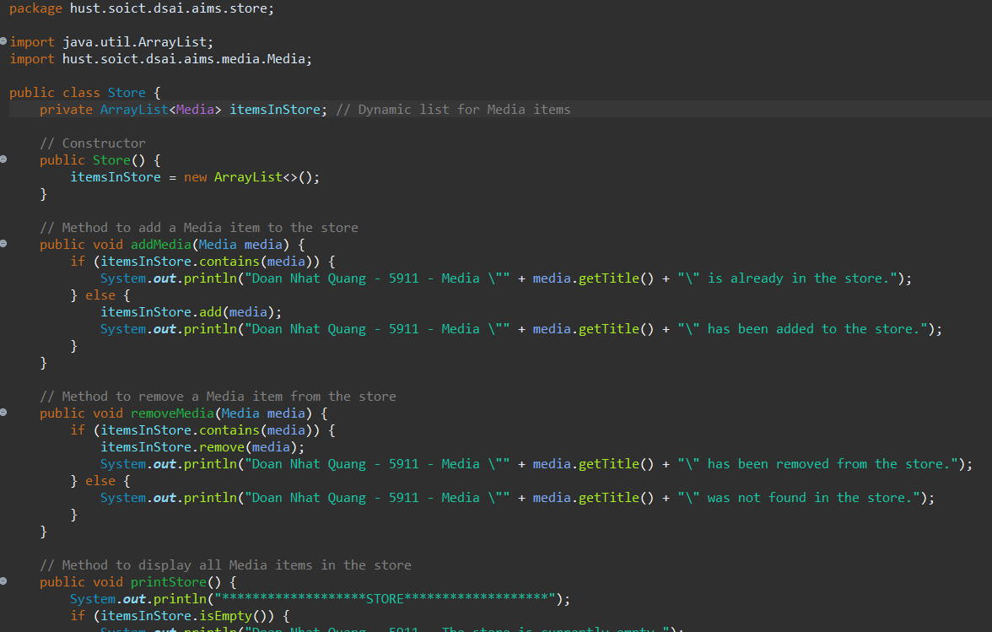

Hình : Update the Store class to work with Media

# Constructors of whole classes and parent classes

Hình : Constructor of Track

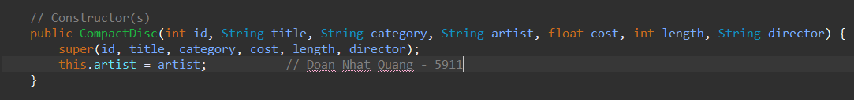

Hình : Constructor of CompactDisc

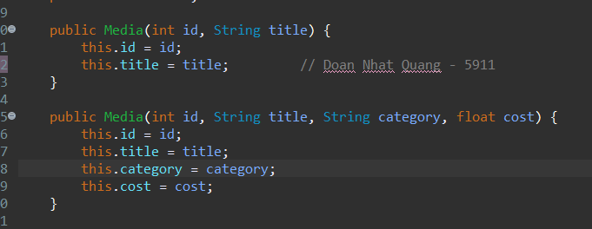

Hình : Constructor of Media

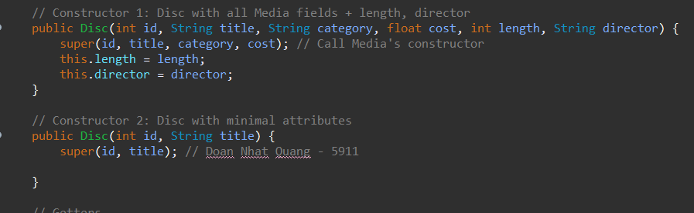

Hình : Constructor of Disc

# Unique item in a list

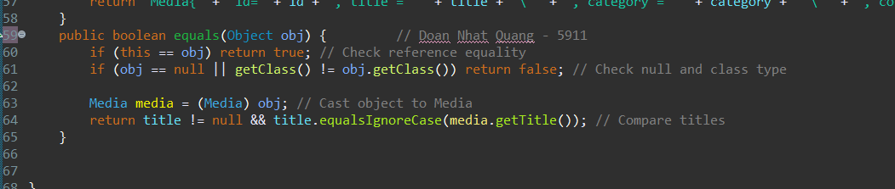

Hình : Override equals in Media class

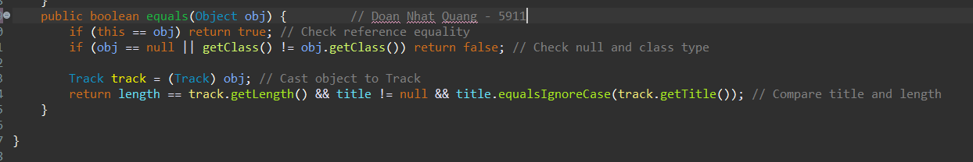

Hình : Override equals in Track class

# Polymorphism with toString() method

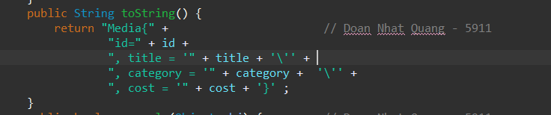

Hình : Override toString in Media Class

Hình : Sample code for Polymorphism

Hình : Result of Polymorphism

# Sort media in the cart

Hình : Media Comparator by title-cost

Hình : Media Comparator by cost-title

Hình : Add two Comparators to Media

Hình : Sample code for Sorting media in cart

Hình : Result of sorting

# Create a complete console application in the Aims class

Hình : Main menu

## View store

Hình : View store menu

### See a media’s details

Hình : See a media’s details

### Add a media to cart

Hình : Add a media to cart

### Play a media

Hình : Play a media

### See current cart

Hình : See current cart

## Update store

Hình : Update store menu

### Add a media

Hình : Add a media

### Remove a media

Hình : Remove a media

## See current cart

Hình : See current cart

### Filter medias in cart

Hình : Filter by ID

Hình : Filter by title

### Sort medias in cart

Hình : Sort by title

Hình : Sort by cost

### Remove media from cart

Hình : Remove media from cart

Hình : Result of remove media from cart

### Play a media

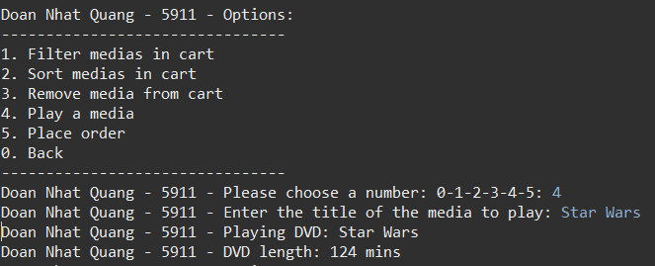

Hình : Play a media

### Place order

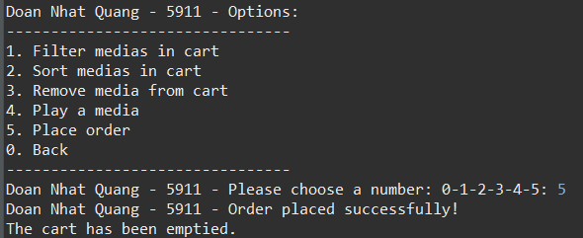

Hình : Place order

Hình : Result of Place order

# Class Diagram

Hình : Class Diagram

# UseCase Diagram

Hình : UseCase Diagram