There are 3 project each worth 33.3%

1. Turn to page 311 and complete #10

Print screen the running application below here

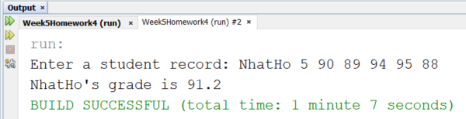

Copy and paste your code below here

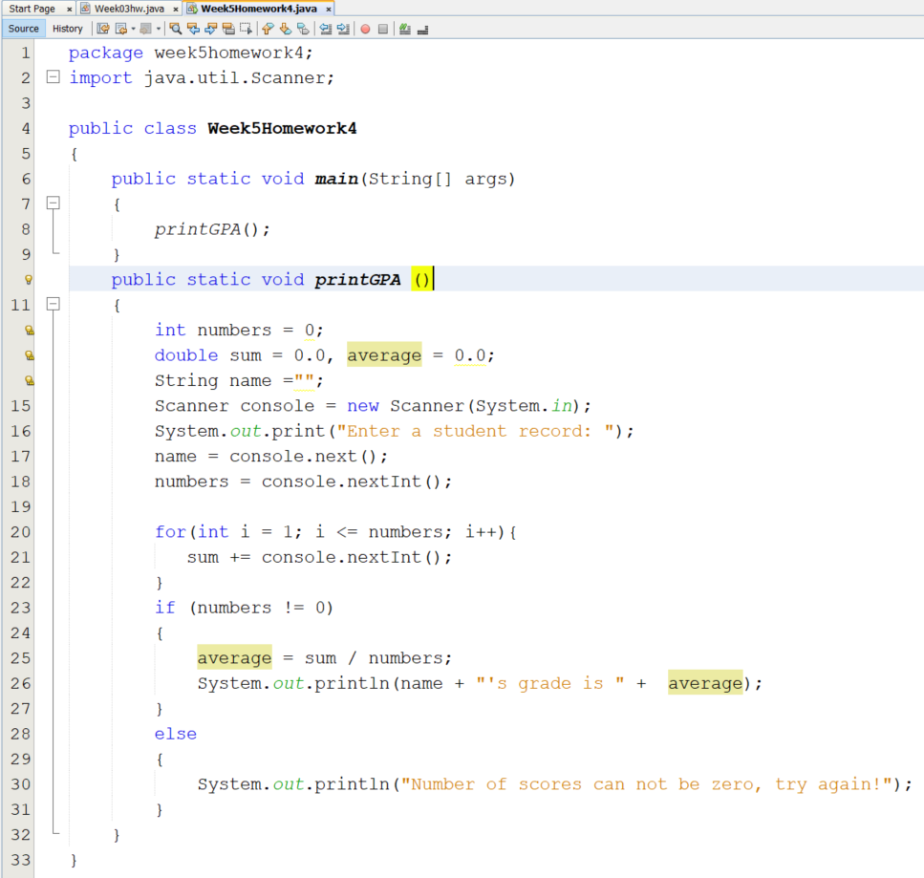

1. Write a program that completes the following below:

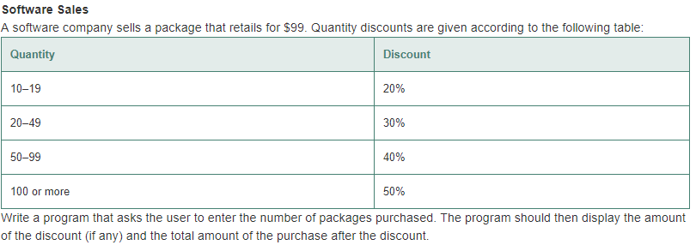

Print screen the running application below here

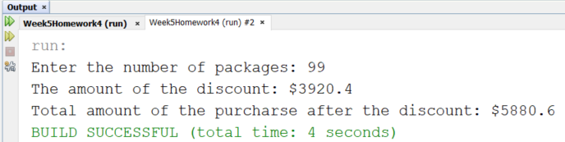

Copy and paste your code below here

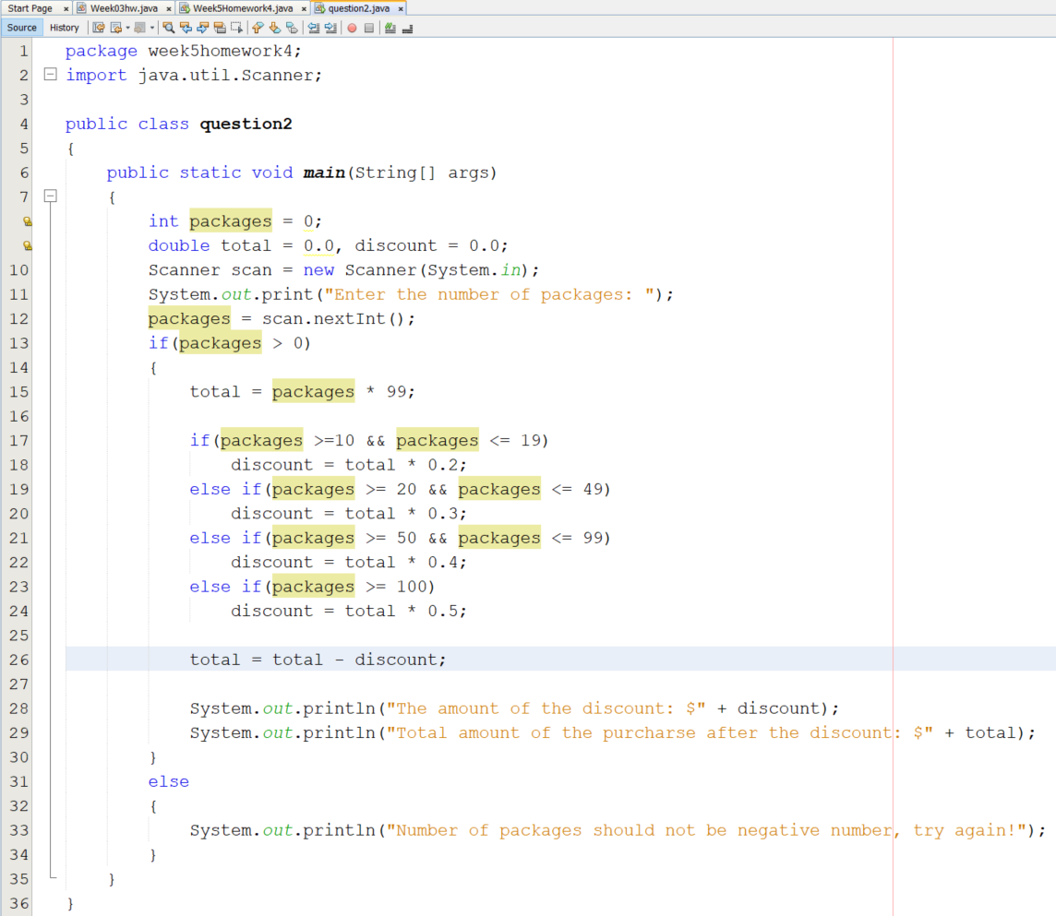

1. Write a program that completes the following below:

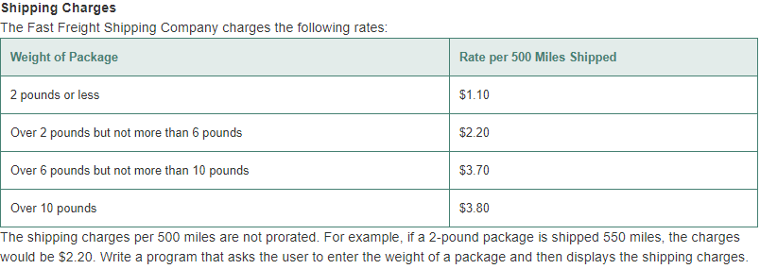

Print screen the running application below here

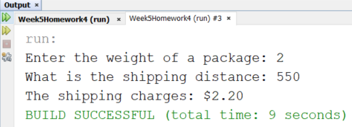

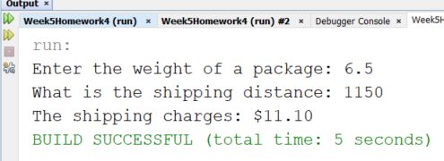

Copy and paste your code below here

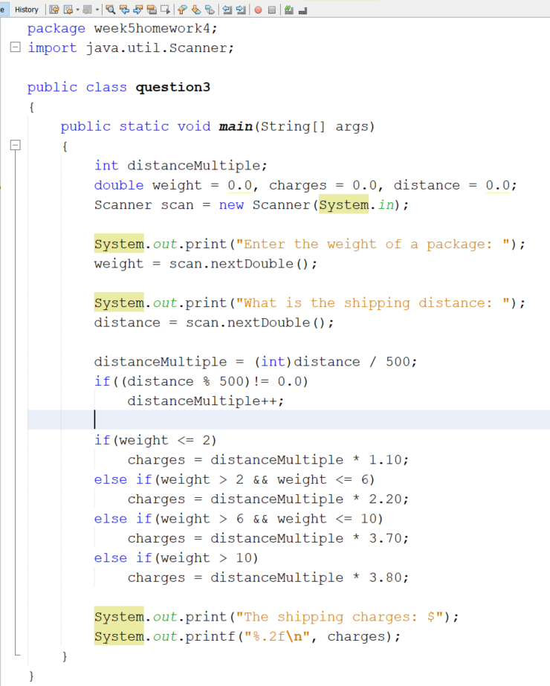

Submit this document to week 5 homework in Canvas