There are 3 tasks each worth 33.3%

Task #1

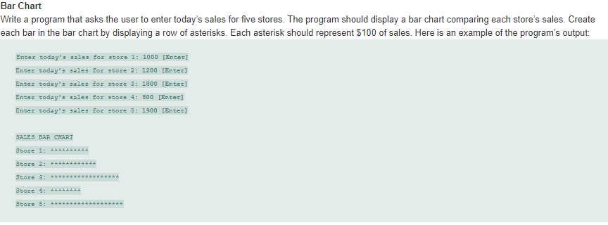

Print screen your running app below here

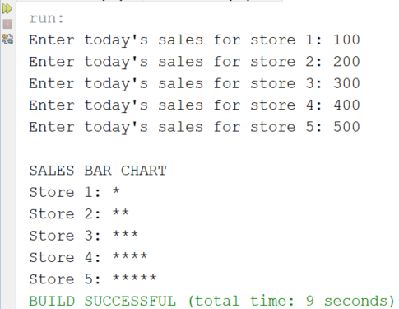

Copy and paste your code below here

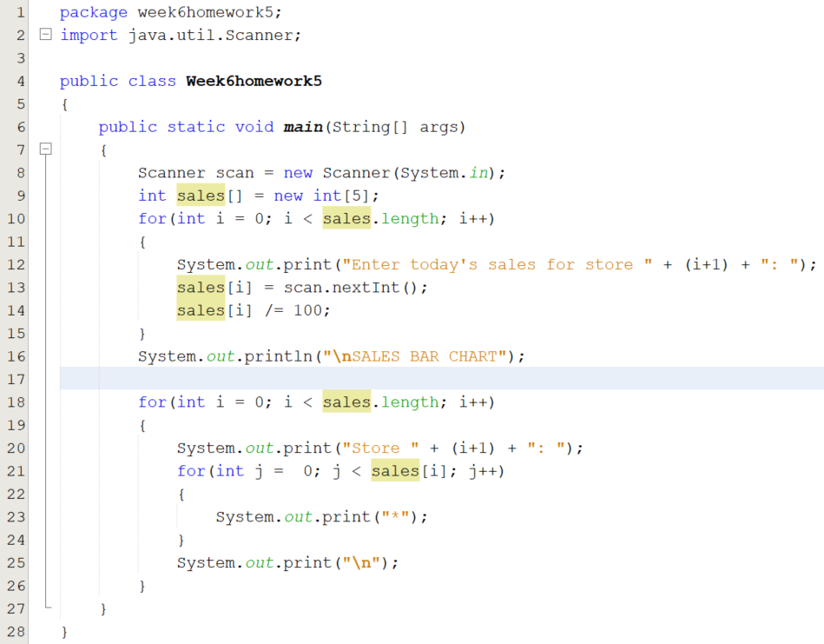

Task #2



Print screen your running app below here

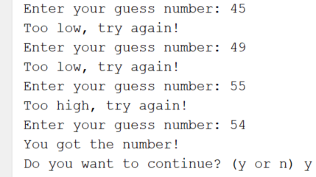

Copy and paste your code below here

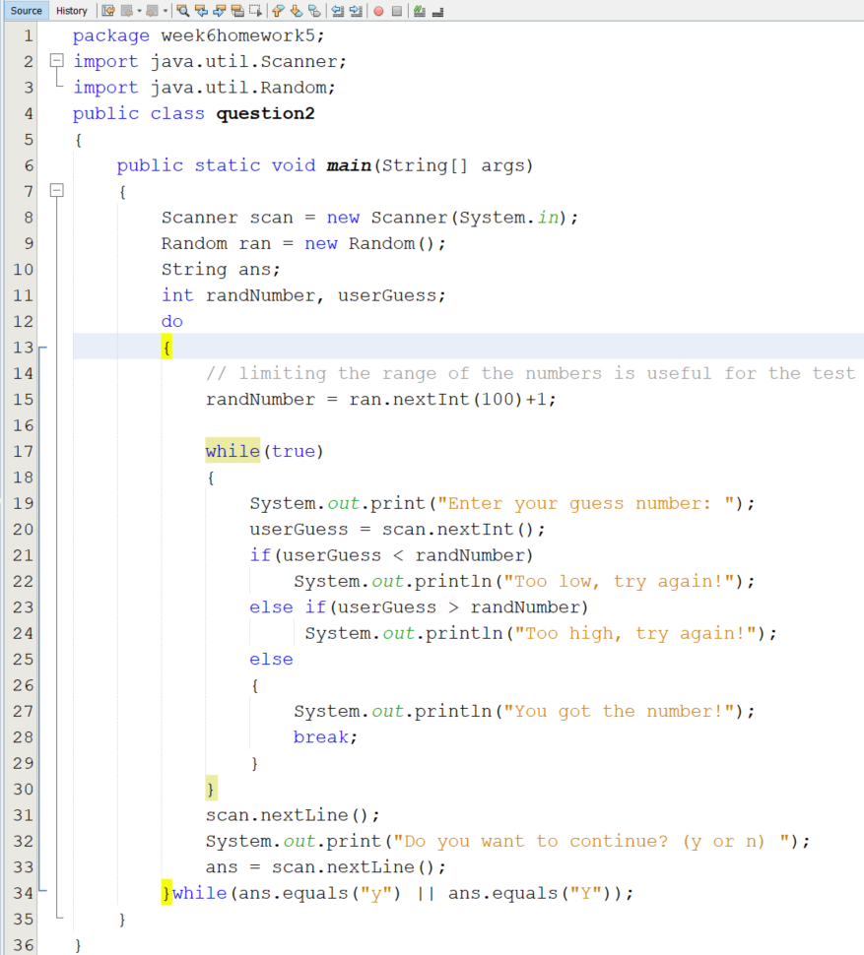

Task #3

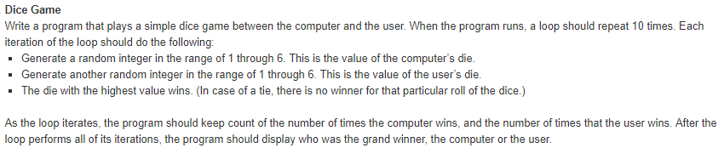

Print screen your running app below here

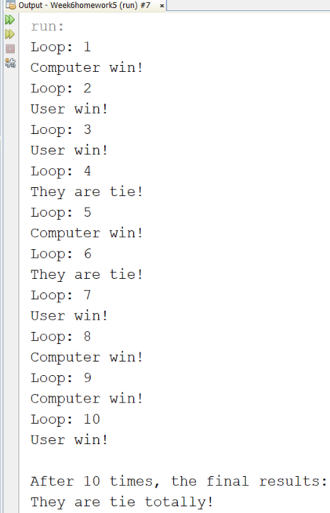

Copy and paste your code below here

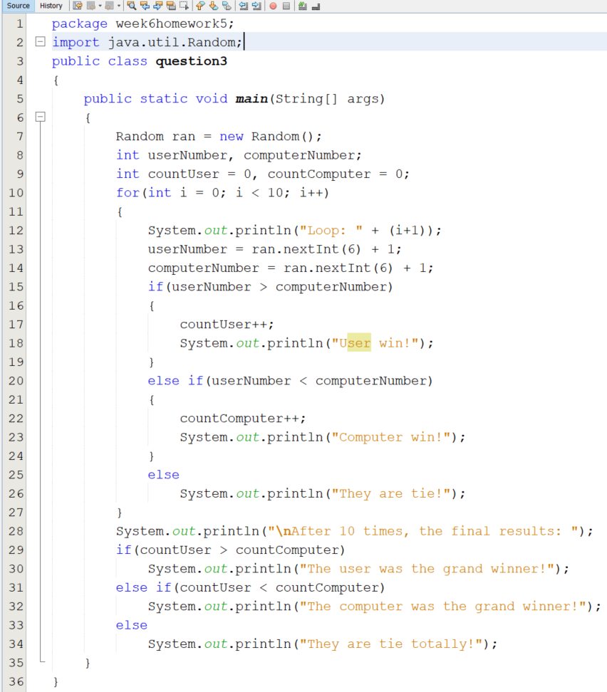

Submit this document to Week 6 homework