Complete the following tasks below, there are 3 tasks each worth 33.3%

Note: for each of the following tasks you must use separate classes and call the classes in the main method

Task #1

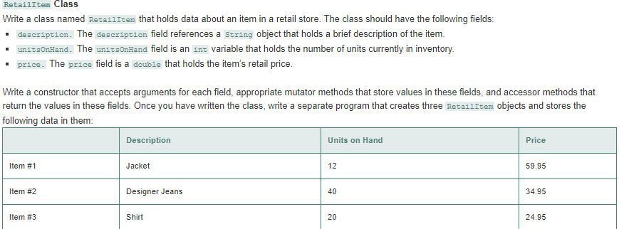

Print screen the running app below here with the result(s)

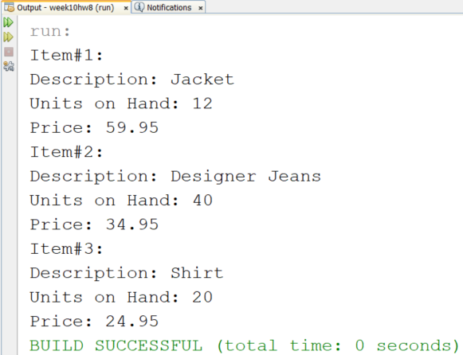

Copy and paste your code below here

package week10hw8;

public class RetailItem

{

String description;

int unitsOnHand;

double price;

public RetailItem()

{

description = "";

unitsOnHand = 0;

price = 0;

}

public RetailItem(String newDescription, int newUnits, double newPrice)

{

description = newDescription;

unitsOnHand = newUnits;

price = newPrice;

}

public void setDescription(String newDescription)

{

description = newDescription;

}

public void setUnits(int newUnitsOnHand)

{

unitsOnHand = newUnitsOnHand;

}

public void setPrice(double newPrice)

{

price = newPrice;

}

public String getDescription()

{

return description;

}

public int getUnits()

{

return unitsOnHand;

}

public double getPrice()

{

return price;

}

public void showInfo()

{

System.out.println("Description: " + getDescription());

System.out.println("Units on Hand: " + getUnits());

System.out.println("Price: " + getPrice());

}

}

package week10hw8;

public class Week10hw8

{

public static void main(String[] args)

{

RetailItem item1 = new RetailItem("Jacket", 12, 59.95);

RetailItem item2 = new RetailItem("Designer Jeans", 40, 34.95);

RetailItem item3 = new RetailItem();

item3.setDescription("Shirt");

item3.setUnits(20);

item3.setPrice(24.95);

System.out.println("Item#1:");

item1.showInfo();

System.out.println("Item#2:");

item2.showInfo();

System.out.println("Item#3:");

item3.showInfo();

}

}

Task #2 Complete the following exercises below, be sure to name the classes as shown.

**Creating a class to write to a file**

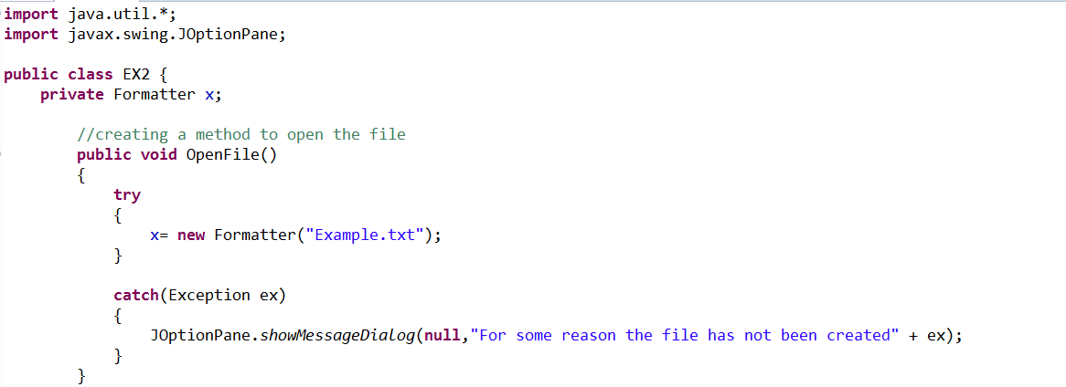 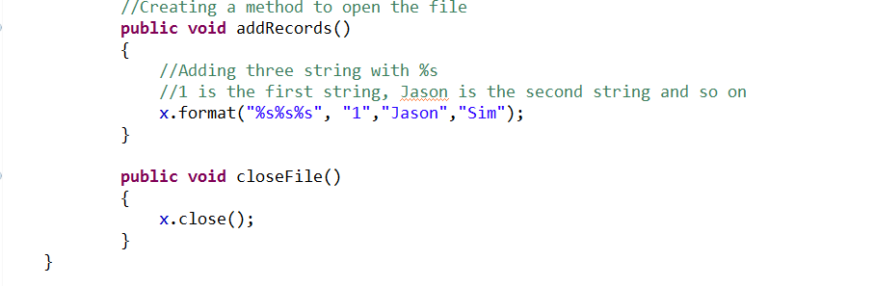

**Calling the EX2 class from a Main Method that is named EX3**

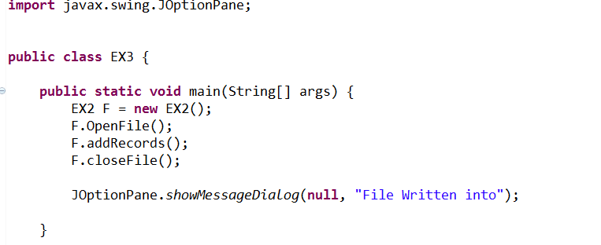

Print screen the running app below here with the result(s)

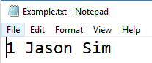

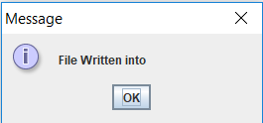

Copy and paste your code below here

package week10hw8;

import java.util.*;

import javax.swing.JOptionPane;

public class EX2

{

private Formatter x;

// Creating a method to open the file

public void OpenFile()

{

try

{

x = new Formatter("Example.txt");

}

catch(Exception ex)

{

JOptionPane.showMessageDialog(null, "For some reason the file has not been created" + ex);

}

}

// Creating a method to open the file

public void addRecords()

{

// Adding three string with %s

// 1 is the first string, Jason is the second string and so on

x.format("%s%s%s", "1", " Jason"," Sim");

}

public void closeFile()

{

x.close();

}

}

package week10hw8;

import javax.swing.JOptionPane;

public class EX3

{

public static void main(String[] args)

{

EX2 F = new EX2();

F.OpenFile();

F.addRecords();

F.closeFile();

JOptionPane.showMessageDialog(null, "File Written into");

}

}

Task #3 Complete the following exercises below, be sure to name the classes as shown.

**Creating a class to Read from a File**

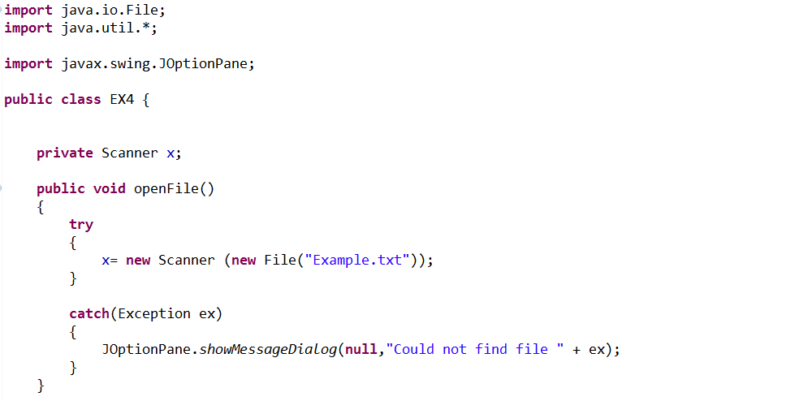 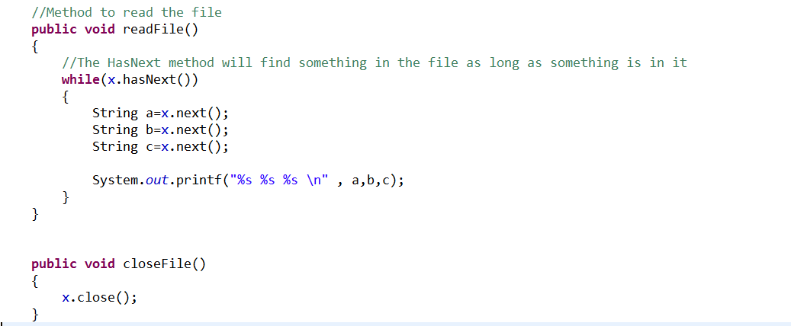

**Calling the EX4 class from a Main Method named EX5**

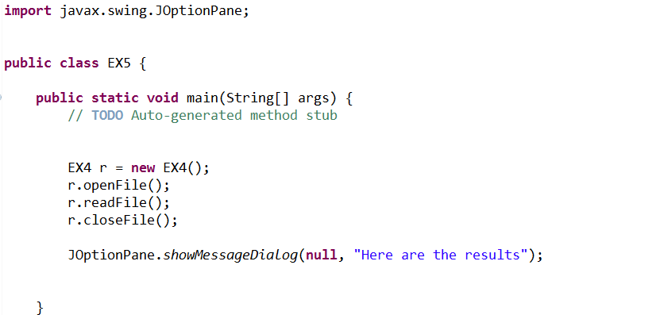

Print screen the running app below here with the result(s)

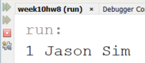

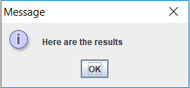

Copy and paste your code below here

package week10hw8;

import java.io.File;

import java.util.*;

import javax.swing.JOptionPane;

public class EX4

{

private Scanner x;

public void openFile()

{

try

{

x = new Scanner(new File("Example.txt"));

}

catch(Exception ex)

{

JOptionPane.showMessageDialog(null,"Could not find file " + ex);

}

}

// Method to read the file

public void readFile()

{

while(x.hasNext())

{

String a = x.next();

String b = x.next();

String c = x.next();

System.out.printf("%s %s %s \n", a,b,c);

}

}

public void closeFile()

{

x.close();

}

}

package week10hw8;

import javax.swing.JOptionPane;

public class EX5

{

public static void main(String[] args)

{

// TODO Auto-generated method stub

EX4 r = new EX4();

r.openFile();

r.readFile();

r.closeFile();

JOptionPane.showMessageDialog(null, "Here are the results");

}

}

Submit this document to Week 10 Homework