There are 3 tasks each worth 33.3%

Be sure to write the code and output the results

**Task #1**

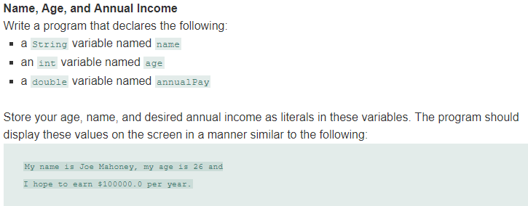

Print screen your code and results below here

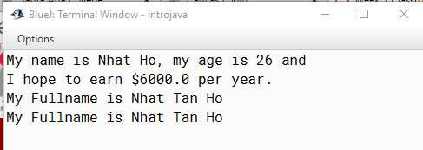

**Task #2**

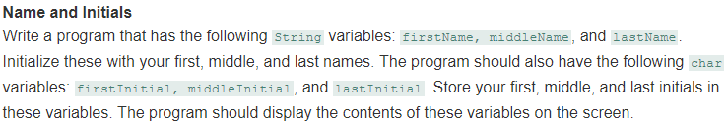

Print screen your code and results below here



**Task #3**

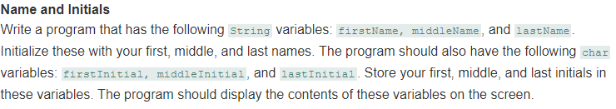

Print screen your code and results below here



Submit this document to Canvas Week 1 Classroom Exercise #1