Week 10 Classroom Exercise #8 Part I from Canvas and when complete, save the document in a safe place and submit it on our 2nd meeting with Classroom Exercise Part II

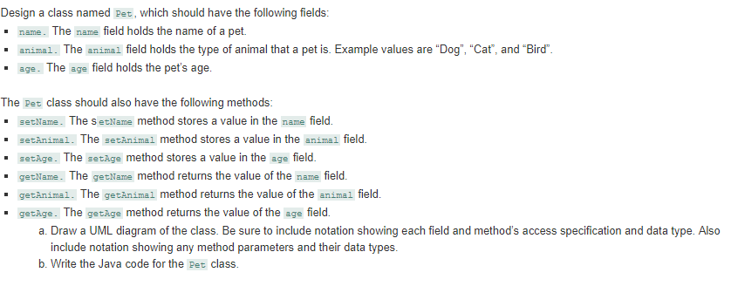

Note: disregard letter (b) DO NOT draw a UML diagram.

Print screen the running app below here with the result(s)

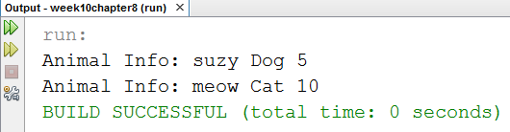

Copy and paste your code below here

package week10chapter8;

public class Pet

{

String name;

String animal;

int age;

public void setName(String newName)

{

name = newName;

}

public void setAnimal(String newAnimal)

{

animal = newAnimal;

}

public void setAge(int newAge)

{

age = newAge;

}

public String getName()

{

return name;

}

public String getAnimal()

{

return animal;

}

public int getAge()

{

return age;

}

}

------------------------------------------------------------------------------------------------------------------------------------------

package week10chapter8;

public class GetPetInfo

{

public static void main(String[] args)

{

Pet p1 = new Pet();

// get the date into the object

p1.name = "suzy";

p1.animal = "Dog";

p1.age = 5;

Pet p2 = new Pet();

p2.setName("meow");

p2.setAnimal("Cat");

p2.setAge(10);

// output the data

System.out.println("Animal Info: " + p1.name + " " + p1.animal + " " + p1.age);

System.out.println("Animal Info: " + p2.name + " " + p2.animal + " " + p2.age);

}

}