Complete the following 4 tasks, each worth 25%

Task #1. Be sure to complete the program and get an output after finding the error.

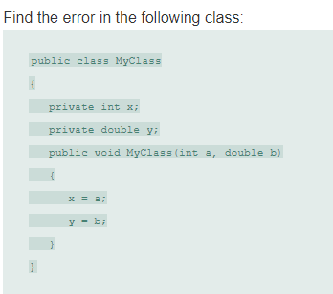

Print screen the running app below here with the result(s)

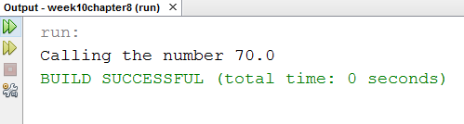

Copy and paste your code below here

package week10chapter8;

public class MyClass

{

private int x;

private double y;

public double MyClass(int a, double b)

{

x = a;

y = b;

return (x+y);

}

}

package week10chapter8;

public class MyClassMain

{

public static void main(String[] args)

{

MyClass m = new MyClass();

m.MyClass(0,0);

System.out.println("Calling the number " + m.MyClass(35,35.0));

}

}

Task #2. Be sure to complete the program and get an output after finding the error.

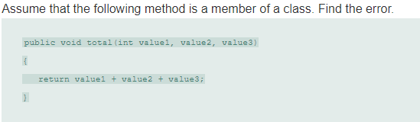

Print screen the running app below here with the result(s)

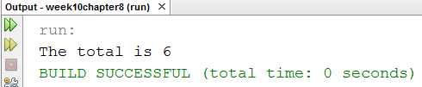

Copy and paste your code below here

package week10chapter8;

public class C1

{

public int total(int value1, int value2, int value3)

{

return (value1 + value2 + value3);

}

}

package week10chapter8;

public class C2

{

public static void main(String[] args)

{

C1 var = new C1();

var.total(0,0,0);

System.out.println("The total is " + var.total(1,2,3));

}

}

Task #3

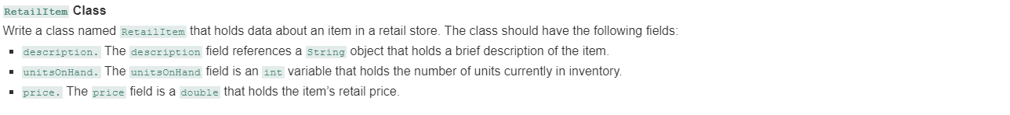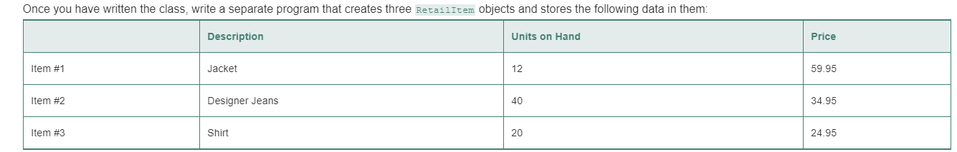

Print screen the running app below here with the result(s)

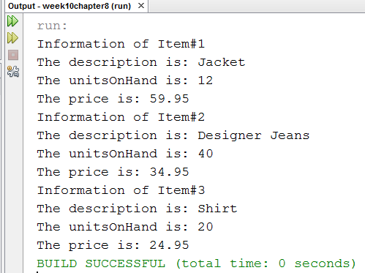

Copy and paste your code below here

package week10chapter8;

public class RetailItem

{

String description;

int unitsOnHand;

double price;

public void RetailItem(String newDescription, int newUnits, double newPrice)

{

description = newDescription;

unitsOnHand = newUnits;

price = newPrice;

}

public void ShowInfo()

{

System.out.println("The description is: " + description);

System.out.println("The unitsOnHand is: " + unitsOnHand);

System.out.println("The price is: " + price);

}

}

package week10chapter8;

public class task3

{

public static void main(String[] args)

{

RetailItem[] Item = new RetailItem[3];

for(int i = 0; i < 3; i++)

{

Item[i] = new RetailItem();

}

Item[0].RetailItem("Jacket", 12, 59.95);

Item[1].RetailItem("Designer Jeans", 40, 34.95);

Item[2].RetailItem("Shirt", 20, 24.95);

for(int i = 0; i < 3; i++)

{

System.out.println("Information of Item#" + (i+1));

Item[i].ShowInfo();

}

}

}

Task #4

Create the 2 classes below, the first class will be the SUB class.

Class#1: Create a new class and name it **Rooms** without the main method

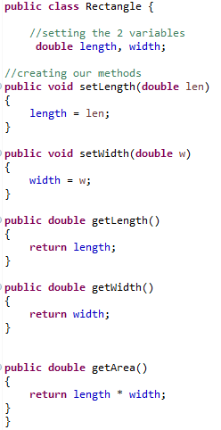

Class#2: Create a 2nd class and name it **RoomAreas** with the main method

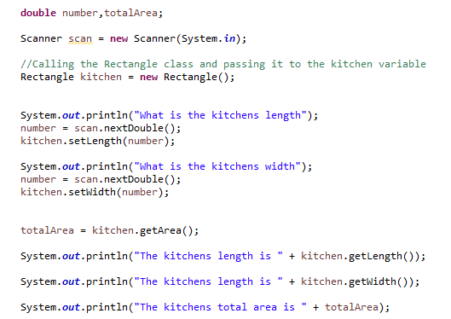

Print screen the running app below here with the result(s)

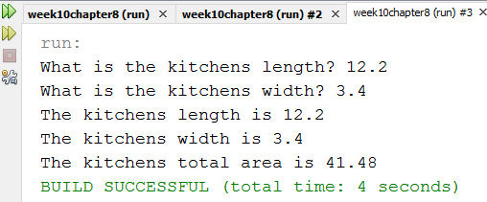

Copy and paste your code below here

package week10chapter8;

public class Rooms

{

// setting the 2 variables

double length, width;

// creating our methods

public void setLength(double len)

{

length = len;

}

public void setWidth(double w)

{

width = w;

}

public double getLength()

{

return length;

}

public double getWidth()

{

return width;

}

public double getArea()

{

return length * width;

}

}

package week10chapter8;

import java.util.Scanner;

public class RoomAreas

{

public static void main(String[] args)

{

double number, totalArea;

Scanner scan = new Scanner(System.in);

// Calling the Rectangle class and passing it to the kitchen variable

Rooms kitchen = new Rooms();

System.out.print("What is the kitchens length? ");

number = scan.nextDouble();

kitchen.setLength(number);

System.out.print("What is the kitchens width? ");

number = scan.nextDouble();

kitchen.setWidth(number);

totalArea = kitchen.getArea();

System.out.println("The kitchens length is " + kitchen.getLength());

System.out.println("The kitchens width is " + kitchen.getWidth());

System.out.print("The kitchens total area is ");

System.out.printf("%.2f\n",totalArea);

}

}

Submit this document with to Canvas, REMEMBER to submit your Part I also