Continuing from the Class1, Class2 and Class3 create a Class4 , with a Scanner class and ask the user to input the Address, City, State with Zip code and from the Class3 inherit Class1 where it will also inherit Class2 because Class1 extends to Class2..

#1 Print screen your results below here

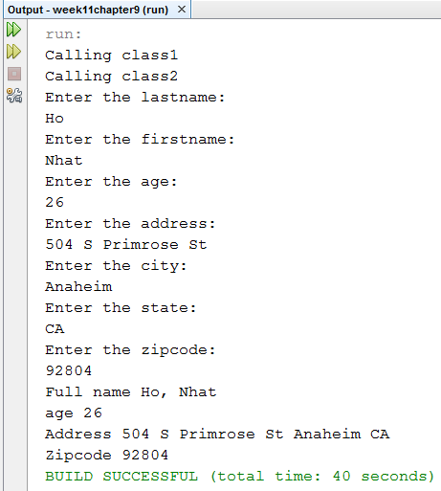

Copy and paste the code for your class1 below here

package week11chapter9;

import java.util.Scanner;

public class Class1 extends Class2

{

public void CallClass1()

{

System.out.println("Calling class1");

}

public String InputNames()

{

String lastName, firstName;

Scanner scan = new Scanner(System.in);

System.out.println("Enter the lastname: ");

lastName = scan.nextLine();

System.out.println("Enter the firstname: ");

firstName = scan.nextLine();

return lastName + ", " + firstName;

}

}

Copy and paste the code for your class2 below here

package week11chapter9;

import java.util.Scanner;

public class Class2 extends Class4

{

public void CallClass2()

{

System.out.println("Calling class2");

}

public int InputAge()

{

int age;

Scanner scan = new Scanner(System.in);

System.out.println("Enter the age: ");

age = scan.nextInt();

return age;

}

}

Copy and paste the code for your class3 below here

package week11chapter9;

public class Class3

{

public static void main(String[] args)

{

Class1 c1 = new Class1();

c1.CallClass1();

c1.CallClass2();

Class2 c2 = new Class2();

System.out.println("Full name " + c1.InputNames() + "\n" + "age " + c1.InputAge() + "\n" + "Address " + c2.InputAddressCityState() + "\n" + "Zipcode " + c2.zip());

}

}

Copy and paste the code for your class4 below here

package week11chapter9;

import java.util.Scanner;

public class Class4

{

public String InputAddressCityState()

{

Scanner scan = new Scanner(System.in);

String address, city, state;

System.out.println("Enter the address: ");

address = scan.nextLine();

System.out.println("Enter the city: ");

city = scan.nextLine();

System.out.println("Enter the state: ");

state = scan.nextLine();

return address + " " + city + " " + state;

}

public int zip()

{

int zip;

Scanner scan = new Scanner(System.in);

System.out.println("Enter the zipcode: ");

zip = scan.nextInt();

return zip;

}

}

Save this document somewhere safe and upload this on our 2nd meeting with Class Room Exercise Part 2