There are 3 tasks each worth 33.3%

**Task #1**

Create 4 different classes and name them Lastname, Middlename, Firstname and GetAllNames (which will be the main method) Use a Scanner or a JOPTION PANE where the user will have the ability to enter the last, first and middlename

Ensure to EXTEND a class, you can choose which class to extend.

Below is a sample output:

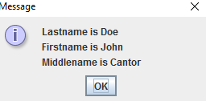

Print screen your results below here

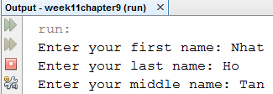

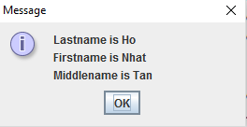

Copy and paste all class codes below here

package week11chapter9;

public class Firstname extends Lastname

{

public void callFirstName()

{

System.out.println("This is call for enter first name");

}

}

package week11chapter9;

import java.util.Scanner;

public class Middlename

{

public String setMiddleName()

{

Scanner scan = new Scanner(System.in);

String last;

System.out.print("Enter your middle name: ");

last = scan.nextLine();

return last;

}

}

package week11chapter9;

import java.util.Scanner;

public class Lastname

{

public String setLastName()

{

Scanner scan = new Scanner(System.in);

String last;

System.out.print("Enter your last name: ");

last = scan.nextLine();

return last;

}

public String setFirstName()

{

Scanner scan = new Scanner(System.in);

String first;

System.out.print("Enter your first name: ");

first = scan.nextLine();

return first;

}

}

package week11chapter9;

import javax.swing.JOptionPane;

public class GetAllNames

{

public static void main(String[] args)

{

String lastName, middleName, firstName;

String result;

Firstname first = new Firstname();

firstName = first.setFirstName();

lastName = first.setLastName();

Middlename middle = new Middlename();

middleName = middle.setMiddleName();

result = "Lastname is " + lastName + "\n" +

"Firstname is " + firstName + "\n" +

"Middlename is " + middleName;

JOptionPane.showMessageDialog(null, result);

}

}

**Task #2**

For Task #3 create the classes as shown and type in the exact code as shown also

**Dog Class**

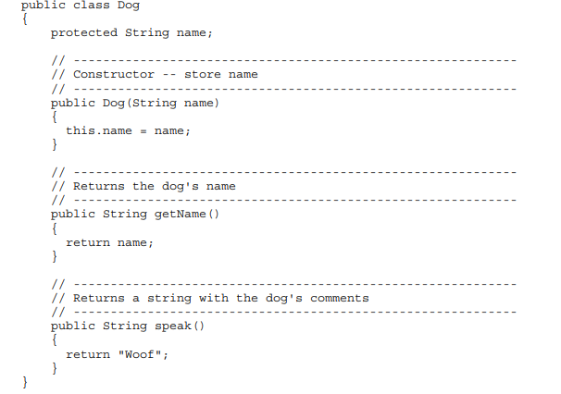

**Labrador Class that extends the Dog Class**

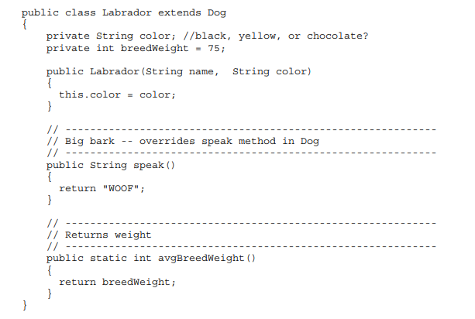

**Yorkshire Class that extends the Dog Class**

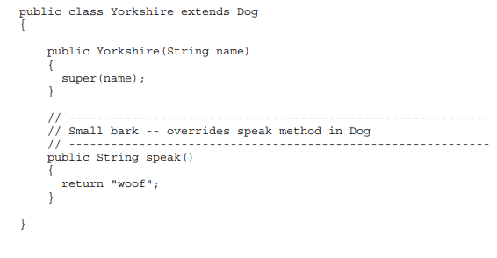

**The Main Method Class**

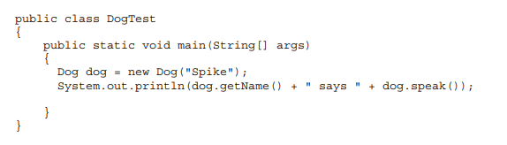

Print screen your results below here

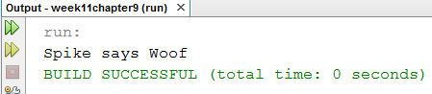

Copy and paste all class codes below here

package week11chapter9;

public class Dog

{

protected String name;

//--------------------------------------------------------------------------

// Constructor -- store name

//--------------------------------------------------------------------------

public Dog(String name)

{

this.name = name;

}

//--------------------------------------------------------------------------

// Returns the dog's name

//--------------------------------------------------------------------------

public String getName()

{

return name;

}

//--------------------------------------------------------------------------

// Returns a string with the dog's comments

//--------------------------------------------------------------------------

public String speak()

{

return "Woof";

}

}

package week11chapter9;

public class Labrador extends Dog

{

private String color; //black, yellow, or chocolate?

private int breedWeight = 75;

public Labrador(String name)

{

super(name);

}

public String Labrador(String color)

{

this.color = color;

return this.color;

}

//--------------------------------------------------------------------------

// Big bank -- overrides speak method in Dog

//--------------------------------------------------------------------------

public String speak()

{

return "WOOF";

}

//--------------------------------------------------------------------------

// Returns weight

//--------------------------------------------------------------------------

public int avgBreedWeight()

{

return breedWeight;

}

}

package week11chapter9;

public class Yorkshire extends Dog

{

public Yorkshire(String name)

{

super(name);

}

//--------------------------------------------------------------------------

// Small bark -- override speak method in Dog

//--------------------------------------------------------------------------

public String speak()

{

return "woof";

}

}

package week11chapter9;

public class DogTest

{

public static void main(String[] args)

{

Dog dog = new Dog("Spike");

System.out.println(dog.getName() + " says " + dog.speak());

}

}

**Task #3**

Create and write the 4 different classes as shown below, when completed create the 5th class the main method that will call all classes with an output.

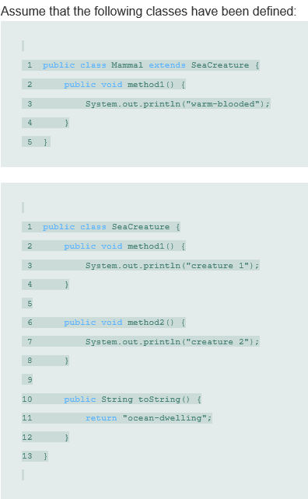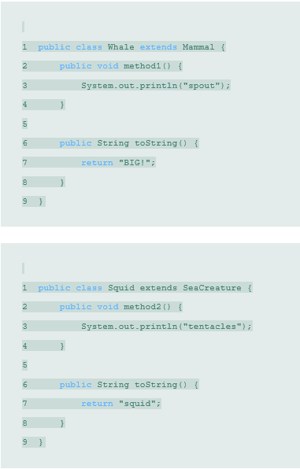

Print screen your results below here

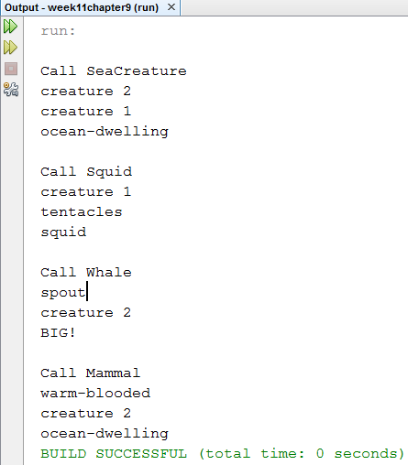

Copy and paste all class codes below here

package week11chapter9;

public class Mammal

{

public class Mammal extends SeaCreature

{

public void method1()

{

System.out.println("warm-blooded");

}

}

}

package week11chapter9;

public class SeaCreature

{

public void method1()

{

System.out.println("creature 1");

}

public void method2()

{

System.out.println("creature 2");

}

public String toString()

{

return "ocean-dwelling";

}

}

package week11chapter9;

public class Whale extends Mammal

{

public void method1()

{

System.out.println("spout");

}

public String toString()

{

return "BIG!";

}

}

package week11chapter9;

public class Squid extends SeaCreature

{

public void method2()

{

System.out.println("tentacles");

}

public String toString()

{

return "squid";

}

}

package week11chapter9;

public class Main_method

{

public static void main(String[] args)

{

System.out.println("\nCall SeaCreature");

SeaCreature sea = new SeaCreature();

sea.method2();

sea.method1();

System.out.println(sea.toString());

System.out.println("\nCall Squid");

Squid squid = new Squid();

squid.method1();

squid.method2();

System.out.println(squid.toString());

System.out.println("\nCall Whale");

Whale whale = new Whale();

whale.method1();

whale.method2();

System.out.println(whale.toString());

System.out.println("\nCall Mammal");

Mammal mammal = new Mammal();

mammal.method1();

mammal.method2();

System.out.println(mammal.toString());

}

}

Submit this document ***with*** the Class Exercise #1 to Week 11 Class Exercises