Complete the following tasks below

There are 2 tasks each worth 50%

Task #1



Print screen your results below here

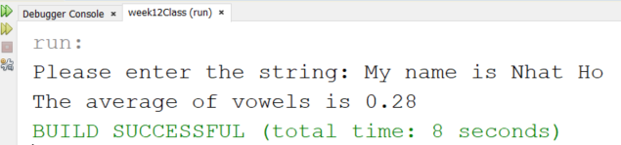

Copy and paste your code below here

import java.util.ArrayList;

import java.util.Scanner;

public class Task1

{

public static void main(String[] args)

{

Scanner scan = new Scanner(System.in);

System.out.print("Please enter the string: ");

String line = scan.nextLine();

ArrayList<String> arr = new ArrayList<String>();

arr.add(line);

double average = averageVowels(arr);

System.out.print("The average of vowels is ");

System.out.printf("%.2f\n", average);

}

public static double averageVowels(ArrayList<String> arr)

{

String line = arr.get(0);

if(line.length() > 0)

{

double count = 0;

char character;

for(int i = 0; i < line.length(); i++)

{

character = Character.toLowerCase(line.charAt(i));

if(character == 'u'

|| character == 'e'

|| character == 'o'

|| character == 'a'

|| character == 'i')

{

count++;

}

}

return count/line.length();

}

else

return 0;

}

}

Task #2



Print screen your results below here

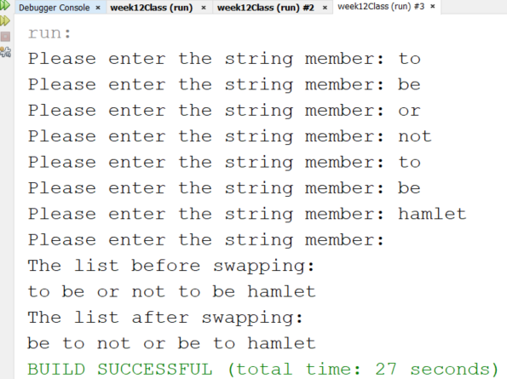

Copy and paste your code below here

import java.util.ArrayList;

import java.util.Scanner;

public class Task2

{

public static void main(String[] args)

{

Scanner scan = new Scanner(System.in);

ArrayList<String> arr = new ArrayList<String>();

String line;

while(true)

{

System.out.print("Please enter the string member: ");

line = scan.nextLine();

if (line.equals(""))

break;

else

arr.add(line);

}

System.out.println("The list before swapping: ");

showList(arr);

swapPairs(arr);

System.out.println("The list after swapping: ");

showList(arr);

}

public static void swapPairs(ArrayList<String> arr)

{

String temp;

for(int i = 0; i < arr.size() && i+2 <= arr.size(); i=i+2)

{

temp = arr.get(i);

arr.set(i, arr.get(i+1));

arr.set(i+1, temp);

}

}

public static void showList(ArrayList<String> arr)

{

for(int i = 0; i < arr.size(); i++)

{

System.out.print(arr.get(i) + " ");

}

System.out.print("\n");

}

}